Insert your centre number, name and candidate number into the header above.
Save this evidence document as evidence_ followed by your centre number_ candidate number. For example: evidence_ zz999_9999
Screenshots or program listings must be copied into appropriate cells in the following table.
Examiners must be able to read the contents including any screenshots without the use of a magnifying glass. Answers that are not readable or missing will not be awarded any marks.
Save this evidence document at regular intervals, for example every 10 minutes.
Question 1 – 24/25
Part 1(a) – 2/3
global StackData, StackPointer
StackPointer = 0
StackData:list = [None for _ in range(10)] # 100 integers
Part 1(b) – 3/3
def OutputAll():
global StackData, StackPointer
for element in StackData:
print(element)
print("stack pointer:",StackPointer)
Part 1(c) – 6/6
def Push(target:int) -> bool:
global StackData, StackPointer
if StackPointer > 9:
return False
else:
StackData[StackPointer] = target
StackPointer = StackPointer + 1
return True
Part 1(d)(i) – 5/5
for _ in range(11):
target = int(input("Enter a number to add to the stack: "))
result = Push(target)
if result is True:
print(f"{target} has been added")
else:
print(f"{target} could not be added as stack is full")
OutputAll()
Part 1(d)(ii) – 1/1
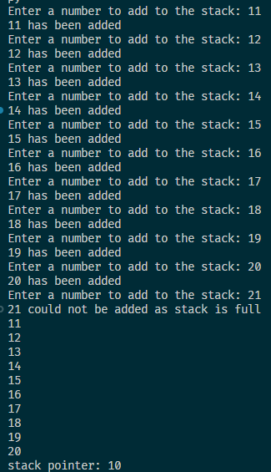
Part 1(e)(i) – 5/5
def Pop() -> int:
global StackData, StackPointer
if StackPointer == 0:
return -1
else:
item = StackData[StackPointer-1]
StackPointer = StackPointer - 1
return item
Part 1(e)(ii) – 2/2
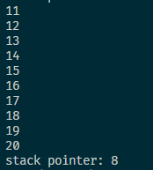
Question 2 – 23/23
Part 2(a) – 4/4
# a
from random import randint

ArrayData = [[randint(1,100) for _ in range(10)] for _ in range(10)] # 2D array of integer
Part 2(b)(i) – 5/5
ArrayLength = 10

for X in range(0, ArrayLength-1):
for Y in range(0, ArrayLength - 2):
for Z in range(0, ArrayLength - Y - 2):
if ArrayData[X][Z] > ArrayData[X][Z+1]:
TempValue = ArrayData[X][Z]
ArrayData[X][Z] = ArrayData[X][Z+1]
ArrayData[X][Z+1] = TempValue
Part 2(b)(ii) – 3/3
# b ii
def Output():
for row in ArrayData:
for column in row:
print(column, end=" ")
print("")

# b ii (second part)
print("Before Sorting")
Output()

# b i
ArrayLength = 10

for X in range(0, ArrayLength-1):
for Y in range(0, ArrayLength - 2):
for Z in range(0, ArrayLength - Y - 2):
if ArrayData[X][Z] > ArrayData[X][Z+1]:
TempValue = ArrayData[X][Z]
ArrayData[X][Z] = ArrayData[X][Z+1]
ArrayData[X][Z+1] = TempValue

# b ii (second part)
print('After Sorting')
Output()
Part 2(b)(iii) – 1/1
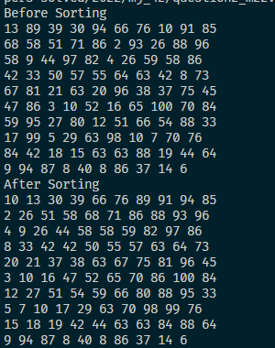

Part 2(c)(i) – 8/8
def BinarySearch(SearchArray:list[list[int]], Lower, Upper, SearchValue) -> int:
if Upper >= Lower:
Mid = (Lower + Upper) // 2
if SearchArray[0][Mid] == SearchValue:
return Mid
else:
if SearchArray[0][Mid] > SearchValue:
return BinarySearch(SearchArray, Lower, Mid - 1, SearchValue)
else:
return BinarySearch(SearchArray, Mid + 1 , Upper, SearchValue)

return -1
Part 2(c)(ii) – 2/2 (I had this take my word gng)
{Copy and paste the screenshot for Question 2(c)(ii) here}

Question 3 – 26/27
Part 3(a) – 5/5
# a
class Card:
def __init__(self, Number:int, Colour:str) -> None:
self.__Number = Number # INTEGER
self.__Colour = Colour # STRING
Part 3(b) – 3/3
def GetColour(self):
return self.__Colour

def GetNumber(self):
return self.__Number
Part 3(c) - 7/7 (thank god extra marks were there – need to add 30 elements)
CardArray:list[Card] = []
try:
file = open("2022/mj_42/CardValues.txt", 'r')
while file:
number = file.readline().strip()
color = file.readline().strip()
if number == "" or color == "":
break
CardArray.append(Card(int(number), color))
file.close()
except FileNotFoundError or IOError as e:
print(f"Exception - unable to access file: {e}")

Part 3(d) – 6/6
ChosenCards = []
def ChooseCard():
selection_number = -1
loop = True
while selection_number < 0 or selection_number > 29 or loop:
selection_number = int(input('enter number to choose the card: '))
if CardArray[selection_number] in ChosenCards:
print("Sorry, card has already been chosen")
else:
ChosenCards.append(CardArray[selection_number])
loop = False
return selection_number
Part 3(e)(i) – 5/5
Player1:list[Card] = []
for _ in range(4):
Player1.append(CardArray[ChooseCard()])
ChosenCards = []
for card in Player1:
print(f"Number: {card.GetNumber()}\nColor: {card.GetColour()}")

Part 3(e)(ii) – 0/1 (did cambridge forget 0 indexing in py?)
