Insert your name, centre number and candidate number into the header above.
Save this evidence document as evidence_ followed by your centre number_ candidate number. For example: evidence_ zz999_9999
Screenshots or program listings must be copied into appropriate cells in the following tables.
Examiners must be able to read the contents including any screenshots without the use of a magnifying glass. Answers that are not readable or missing will not be awarded any marks.
Save this evidence document at regular intervals, for example, every 10 minutes.
Question 1
Part 1(a)
class node():
def __init__(self, data, next_node) -> None:
self.data = data
self.next_node = next_node

Part 1(b)
linkedList:list[node] = [
node(1,1),
node(5,4),
node(6,7),
node(7,-1),
node(2,2),
node(0,6),
node(0,8),
node(56,3),
node(0,9),
node(0,-1),
]

startPointer = 0
emptyList = 5

Part 1(c)(i)
def outputNodes(array:list[node], start_pointer:int) -> None:
current_pointer = start_pointer
if current_pointer != -1:
print(array[current_pointer].data)
outputNodes(array=array, start_pointer=array[current_pointer].next_node)

Part 1(c)(ii)
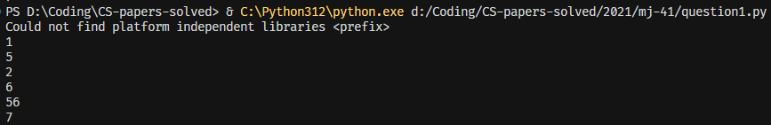

Part 1(d)(i)
def addNode(array:list[node], start_pointer:int, empty_list_pointer:int) -> bool:
value = int(input("What value to add to the linked list: "))

# Free node operations
if empty_list_pointer == -1:
return False # no free list
else:
array[empty_list_pointer].data = value
target_node = empty_list_pointer
empty_list_pointer = array[empty_list_pointer].next_node

# insertion
if start_pointer == -1:
return False # empty list
current_node = start_pointer
prev_node = -1
while current_node != -1:
prev_node = current_node
current_node = array[current_node].next_node

array[prev_node].next_node = target_node
array[target_node].next_node = -1
return True

Part 1(d)(ii)
# d ii
result = addNode(linkedList, startPointer, emptyList)
if addNode:
print("Element added successfully")
else:
print("Element could not be added")

outputNodes(linkedList, startPointer)

Part 1(d)(iii)
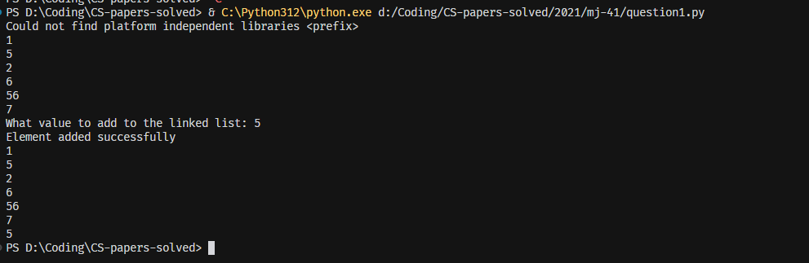

Question 2
Part 2(a)
# a
arrayData:list[int] = [10,5,6,7,1,12,13,15,21,8]

Part 2(b)(i)
def linearSearch(target:int) -> bool:
for i in range(len(arrayData)):
if arrayData[i] == target:
return True
return False

Part 2(b)(ii)
value = int(input("Enter the value that should be searched: "))
result = linearSearch(value)
if result:
print(f"{value} was found")
else:
print(f"{value} was NOT found")

Part 2(b)(iii)

Part 2(c)
def bubbleSort():
temp:int
for x in range(0, 9):
for y in range(0,9-x):
if arrayData[y] > arrayData[y+1]:
temp = arrayData[y]
arrayData[y] = arrayData[y+1]
arrayData[y+1] = temp

Question 3
Part 3(a)
# a
class TreasureChest():
def __init__(self, question:str, answer:str, points:int) -> None:
# string self.__question
# string self.__answer
# integer self.__points
self.__question: str = question
self.__answer: str = answer
self.__points: int = points

Part 3(b)
# arrayTreasure ARRAY of TreasureChest
arrayTreasure:list[TreasureChest] = []
def readData() -> None:
try:
with open("./2021/mj-41/TreasureChestData.txt", 'r') as f:
content = f.read()
content = content.split('\n')
count = 0
question = ""
answer = ""
points = 0
for line in content:
count +=1
match count:
case 1:question = line
case 2: answer = line
case 3:
points = int(line)
arrayTreasure.append(TreasureChest(question, answer, points))

if count == 3:
count = 0
except FileNotFoundError:
print("File not able to be found")

Part 3(c)(i)
def getQuestion(self) -> str:
return(self.__question)

Part 3(c)(ii)
def checkAnswer(self, answer:str) -> bool:
if answer == self.__answer:
return True
return False

Part 3(c)(iii)
def getPoints(self, attempt_count:int) -> int:
if attempt_count > 4 or attempt_count < 1:
return 0
return self.__points//attempt_count

Part 3(c)(iv)
readData()

question_number = -1
while question_number < 1 or question_number > 5:
question_number = int(input("Enter a number between 1 to 5 to get a question: "))

Treasure = arrayTreasure[question_number-1]

print(Treasure.getQuestion())

correct = False
attempts = 0
while not correct:
answer = input("answer: ")
correct = Treasure.checkAnswer(answer)
attempts = attempts + 1

points = Treasure.getPoints(attempts)

print(f"You have been awarded with {points} points!")

Part 3(c)(v)
