**CSCI 4041, Fall 2018, Written Assignment 9**

1. MAYBE_MST_A(G, w):

This graph does return a MST. We can build a max priority queue to sort the edges in decreasing order, and make T that queue. We can then check if T is still a connected graph when removing an edge (u, v) from T by implementing a variation breadth-first-search that starts on the node u and finishes when/if it finds the node v. If it does, we simply remove the edge from T by running Heap-Extract-Max. The sort runs in O(ElgE) time, and the connection check runs in O(E(V+E)) time since the search occurs E times. Thus the algorithm runs in O(ElgE + E(V +E)) time.

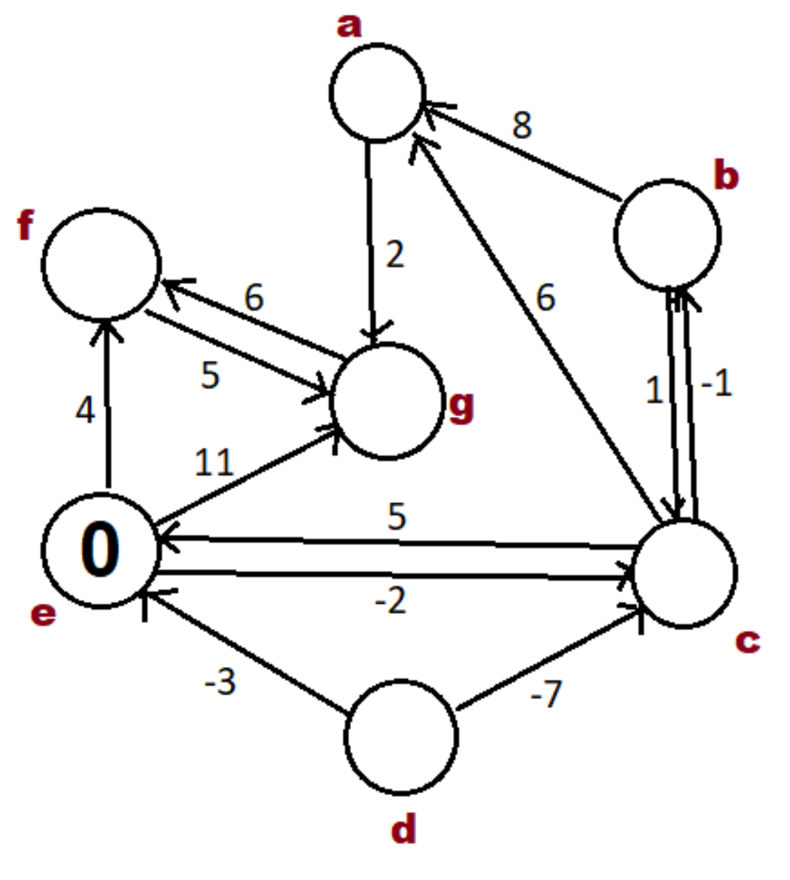

-2

6

-3

4

∞

4

Node d is not in a valid shortest path starting at e since there are no paths from e that can reach it. Nodes b and c create a zero weight cycle so they can exist in the shortest path, however it should be noted that there exists an equally short path without the cycle.