Moti Begna

CSCI 3081

4/5/2019

Iteration 2 Preliminary 2

**Doxy Generated UML for Observer Pattern**

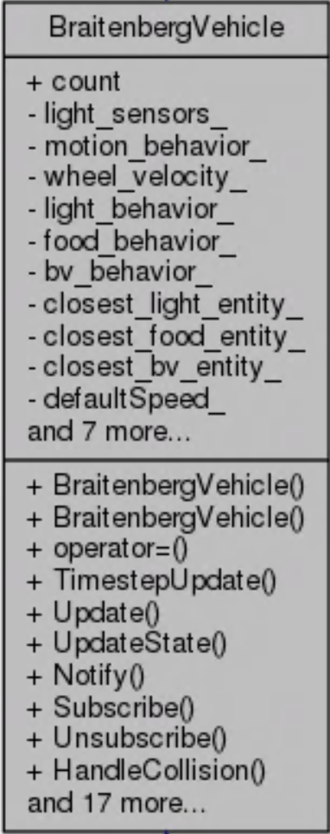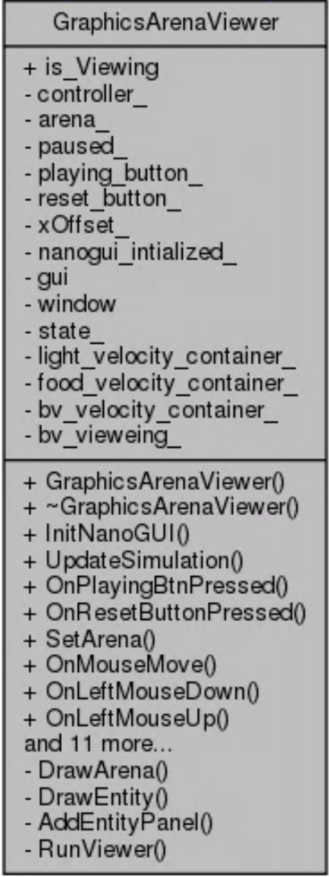My implementation of the Observer pattern involved adding necessary methods and elements to the BraiternbergVehicle and GraphicsArenaViewer classes in order to make them a Subject and Observer respectively.

+ Update() is not shown

Notify() calls Update()

Uses Unsubscribe()

Uses Subscribe()

**Coode Snippet of GraphicArenaViewer’s Update Method**

|  |
| --- |
| void GraphicsArenaViewer::Update(const State& state){ |
| //setting GAV's state variable |
| state_.light_l = state.light_l; |
| state_.light_r = state.light_r; |
| state_.food_l = state.food_l; |
| state_.food_r = state.food_r; |
| state_.bv_l = state.bv_l; |
| state_.bv_r = state.bv_r; |
|  |
| //Converting state values |
| std::stringstream ll; |
| ll << std::setprecision(2) << state_.light_l; |
| std::stringstream lr; |
| lr << std::setprecision(2) << state_.light_r; |
| std::stringstream fl; |
| fl << std::setprecision(2) << state_.food_l; |
| std::stringstream fr; |
| fr << std::setprecision(2) << state_.food_r; |
| std::stringstream bl; |
| bl << std::setprecision(2) << state_.bv_l; |
| std::stringstream br; |
| br << std::setprecision(2) << state_.bv_r; |
|  |
| //setting values displayed on GUI |
| light_velocity_container_[0]->setValue(std::string (ll.str())); |
| light_velocity_container_[1]->setValue(std::string (lr.str())); |
| food_velocity_container_[0]->setValue(std::string (fl.str())); |
| food_velocity_container_[1]->setValue(std::string (fr.str())); |
| bv_velocity_container_[0]->setValue(std::string (bl.str())); |
| bv_velocity_container_[1]->setValue(std::string (br.str())); |
| } |

**Coode Snippet of BraitenbergVehicle’s Notify Method**

|  |
| --- |
| void BraitenbergVehicle::Notify(){ |
| for (auto obs : observers_) { |
| obs->Update(state_); |
| } |
| } |

**Doxy Generated UML for Predator Class**

