Moti Begna

CSCI 3081

4/25/2019

Iteration 3 Preliminary 1

**Doxy Generated UML for Decorator Pattern**

My implementation of the Decorator pattern involves having a parent DisguiseDecorator class inheriting from a Predator, which derived disguises inherit from.

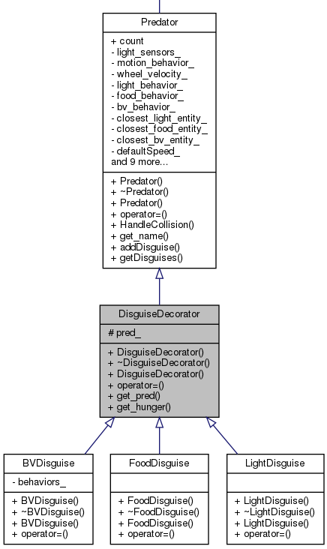

**Code snippet of decorator implementation and hunger implementation**

|  |
| --- |
| void Arena::UpdateEntitiesTimestep() { |
|  |
| … |
| for (auto ent : entities_) { |
| ent->TimestepUpdate(1); |
| } |
|  |
| /* Determine if any mobile entity is colliding with wall. |
| * Adjust the position accordingly so it doesn't overlap. |
| */ |
| for (auto &ent1 : mobile_entities_) { |
|  |
| // initialize disguise |
| if (ent1->get_type() == kPredator){ |
| Predator* pred = static_cast<Predator*>(ent1); |
| // increment hunger |
| pred->set_hunger(pred->get_hunger() + 1); |
| if (pred->get_hunger() == 150){ |
| int disguisetype = rand() % 3; |
| pred->addDisguise(disguisetype); |
| switch(disguisetype){ |
| case 0: |
| ent1 = new FoodDisguise(pred, pred->get_hunger()); |
| break; |
| case 1: |
| ent1 = new LightDisguise(pred, pred->get_hunger()); |
| break; |
| case 2: |
| ent1 = new BVDisguise(pred, pred->get_hunger()); |
| break; |
| default: |
| break; |
| } |
| } |
| } |
| if (ent1->get_is_disguised() == true) { |
| Predator* pred = static_cast<DisguiseDecorator*>(ent1)->get_pred(); |
| // increment hunger |
| pred->set_hunger(pred->get_hunger() + 1); |
|  |
| if (pred->get_hunger() == 300) { |
| int disguisetype = rand() % 3; |
| std::vector<int> vec = pred->getDisguises(); |
| // don't select a previous disguise |
| while (std::count(vec.begin(), vec.end(), disguisetype)) { |
| disguisetype = rand() % 3; |
| } |
| pred->addDisguise(disguisetype); |
| // delete old disguise |
| ArenaEntity* container = ent1; |
| ent1 = static_cast<DisguiseDecorator*>(ent1)->get_pred(); |
| delete container; |
|  |
| switch(disguisetype){ |
| case 0: |
| ent1 = new FoodDisguise(pred, pred->get_hunger()); |
| break; |
| case 1: |
| ent1 = new LightDisguise(pred, pred->get_hunger()); |
| break; |
| case 2: |
| ent1 = new BVDisguise(pred, pred->get_hunger()); |
| break; |
| default: |
| break; |
| } |
| } |
|  |
| if (pred->get_hunger() == 450) { |
| int disguisetype = rand() % 3; |
| std::vector<int> vec = pred->getDisguises(); |
| // don't select a previous disguise |
| while (std::count(vec.begin(), vec.end(), disguisetype)) { |
| disguisetype = rand() % 3; |
| } |
| pred->addDisguise(disguisetype); |
| // delete old disguise |
| ArenaEntity* container = ent1; |
| ent1 = static_cast<DisguiseDecorator*>(ent1)->get_pred(); |
| delete container; |
|  |
| switch(disguisetype){ |
| case 0: |
| ent1 = new FoodDisguise(pred, pred->get_hunger()); |
| break; |
| case 1: |
| ent1 = new LightDisguise(pred, pred->get_hunger()); |
| break; |
| case 2: |
| ent1 = new BVDisguise(pred, pred->get_hunger()); |
| break; |
| default: |
| break; |
| } |
| } |
|  |
| // kill predator aftet 600 iterations |
| if (pred->get_hunger() == 600) { |
| pred->set_type(kPredator); |
| pred->set_is_alive(false); |
| } |
| } |

…