Moti Begna

CSCI 3081

4/1/2019

Iteration 2 Preliminary 1

**Doxy Generated UML for Strategy Pattern**

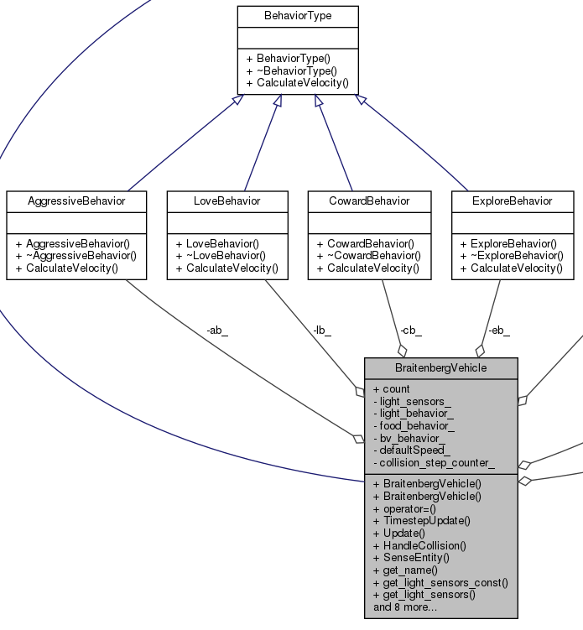

**BV method using Strategy/Behavior**

|  |  |  |
| --- | --- | --- |
| void BraitenbergVehicle::Update() {  WheelVelocity light_wheel_velocity = WheelVelocity(0, 0); | | |
|  |  | | | |
| int numBehaviors = 3; | |
|  | | | |
| switch (light_behavior_) { | | | |
| case kExplore: | | | |
| light_wheel_velocity = eb_.CalculateVelocity( | | | |
| closest_light_entity_, defaultSpeed_, light_sensors_); | | | |
| break; | | | |
| case kAggressive: | | | |
| light_wheel_velocity = ab_.CalculateVelocity( | | | |
| closest_light_entity_, defaultSpeed_, light_sensors_); | | | |
| break; | | | |
| case kLove: | | | |
| light_wheel_velocity = lb_.CalculateVelocity( | | | |
| closest_light_entity_, defaultSpeed_, light_sensors_); | | | |
| break; | | | |
| case kCoward: | | | |
| light_wheel_velocity = cb_.CalculateVelocity( | | | |
| closest_light_entity_, defaultSpeed_, light_sensors_); | | | |
| break; | | | |
| case kNone: | | | |
| default: | | | |
| numBehaviors--; | | | |
| break; | | | |
| } | | | |
|  | | | |
| WheelVelocity food_wheel_velocity = WheelVelocity(0, 0); | | | |
|  | | | |
| switch (food_behavior_) { | | | |
| case kExplore: | | | |
| food_wheel_velocity = eb_.CalculateVelocity( | | | |
| closest_food_entity_, defaultSpeed_, light_sensors_); | | | |
| break; | | | |
| case kAggressive: | | | |
| food_wheel_velocity = ab_.CalculateVelocity( | | | |
| closest_food_entity_, defaultSpeed_, light_sensors_); | | | |
| break; | | | |
| case kLove: | | | |
| food_wheel_velocity = lb_.CalculateVelocity( | | | |
| closest_food_entity_, defaultSpeed_, light_sensors_); | | | |
| break; | | | |
| case kCoward: | | | |
| food_wheel_velocity = cb_.CalculateVelocity( | | | |
| closest_food_entity_, defaultSpeed_, light_sensors_); | | | |
| break; | | | |
| case kNone: | | | |
| default: | | | |
| numBehaviors--; | | | |
| break; | | | |
| } | | | |
|  |
|  |  | | | |

…

**BV method using BV “sensor”**

|  |  |
| --- | --- |
| void BraitenbergVehicle::SenseEntity(const ArenaEntity& entity) { | |
| const ArenaEntity** closest_entity_ = NULL; | |
| if (entity.get_type() == kLight) { | |
| closest_entity_ = &closest_light_entity_; | |
| } else if (entity.get_type() == kFood) { | |
| closest_entity_ = &closest_food_entity_; | |
| } else if (entity.get_type() == kBraitenberg) { | |
| closest_entity_ = &closest_bv_entity_; | |
| }  …  void BraitenbergVehicle::Update() {  … | |
|  |
| WheelVelocity bv_wheel_velocity = WheelVelocity(0, 0); |
|  |  | |
| switch (bv_behavior_) { |
| case kExplore: |
| bv_wheel_velocity = eb_.CalculateVelocity( |
| closest_bv_entity_, defaultSpeed_, light_sensors_); |
| break; |
| case kAggressive: |
| bv_wheel_velocity = ab_.CalculateVelocity( |
| closest_bv_entity_, defaultSpeed_, light_sensors_); |
| break; |
| case kLove: |
| bv_wheel_velocity = lb_.CalculateVelocity( |
| closest_bv_entity_, defaultSpeed_, light_sensors_); |
| break; |
| case kCoward: |
| bv_wheel_velocity = cb_.CalculateVelocity( |
| closest_bv_entity_, defaultSpeed_, light_sensors_); |
| break; |
| case kNone: |
| default: |
| numBehaviors--; |
| break; |
| } |
| … |
| if (numBehaviors) { |
| wheel_velocity_ = WheelVelocity( |
| (light_wheel_velocity.left + food_wheel_velocity.left + |
| bv_wheel_velocity.left)/numBehaviors, |
| (light_wheel_velocity.right + food_wheel_velocity.right + |
| bv_wheel_velocity.right)/numBehaviors, |
| defaultSpeed_); |
| } else { |
| wheel_velocity_ = WheelVelocity(0, 0); |
| } |
| } |
|  |  | |