Repo: https://github.com/begumakkas/bikelanes

Does Network Connectivity Matter More Than Coverage? Simulating Bike Lane Effects on Cycling Adoption

There has been a lot of ABM work on deciding where to place bike lanes and the cost-benefit analysis of adding lanes. What has been less explored is whether the connectivity of bike lanes impacts whether people choose to bike to and from work. Relatedly, what is the level of connectivity that results in an equilibrium where the majority of people do not change their transit preferences? The research question explored in this paper is as follows: Does the connectivity of a bike lane network have a greater effect on cycling mode share than total lane coverage?

While empirical studies have identified associations between connectivity and cycling rates, the independent effect of connectivity cannot be cleanly isolated from coverage in observational data. Cities with more connected networks also tend to have more total infrastructure. Existing ABMs address related questions but are calibrated to specific cities and infrastructure configurations, making it difficult to disentangle the effect of spatial arrangement from total lane quantity. This paper uses a stylized ABM to hold coverage constant while varying connectivity, providing a controlled test of whether arrangement alone drives mode share differences.

- Literature Review and Social Mechanism

The most direct support for connected bike lanes comes from Hwang et al. (2024), who developed an algorithm to connect fragmented bike lane segments in Atlanta and evaluated the resulting networks through simulated trip analysis. Their key finding was that a strategically connected network of shorter total length performed comparably to a planned network twice its size, with the combined connected network raising the proportion of trip routes covered by bike lanes from 23.6% to 62.7% and reducing average cycling stress. This provides compelling evidence that how bike lanes are arranged, rather than simply how many exist, may be a primary driver of both network performance and transportation choice.

This finding is situated within a broader literature on cycling network connectivity. Schön et al. (2024), in a scoping review of connectivity measures and their effects on cycling, distinguish between area-based metrics such as lane-miles per unit area and network-based metrics that capture reachability and path directness. They find that while lane coverage is associated with higher cycling rates, network-based measures provide additional explanatory power that coverage counts alone cannot capture. This distinction is central to the research question of this paper: lane coverage and connectivity are related but separable properties of a bike lane network, and their independent effects on mode choice remain underexplored.

The infrastructure-mode choice relationship is further supported by Marshall and Ferenchak (2019), who analyzed 13 years of traffic data across 12 major US cities and found that increased prevalence of protected bicycle facilities was the primary driver of improved road safety outcomes for all users. This evidence supports treating safety improvement as a function of infrastructure presence in mode choice modeling and provides empirical basis for capturing safety as a parameter in the model.

Agent-based modeling has emerged as a well-suited methodology for studying cycling behavior precisely because it can represent individual heterogeneity and emergent dynamics that aggregate models cannot. Kaziyeva et al. (2021) demonstrated this in a regional ABM of bicycle flows in Salzburg, Austria, showing that demographically parameterized agent behavior outperforms stochastic null models and that safety-oriented routing better reproduces observed cycling patterns than shortest-path routing alone. While Kaziyeva et al. show that demographic parameterization improves model realism, this paper focuses on infrastructure connectivity and safety as the primary drivers of mode choice, leaving demographic heterogeneity as a direction for future work.

Aziz et al. (2018) extended the ABM approach to infrastructure investment decisions in New York City, finding that increasing total bike lane length and the share of protected lanes raises the likelihood of active transportation mode choice. Critically for this paper, they also found that social interactions among agents sharing home and work locations further amplify mode uptake. This points to a social reinforcement mechanism in which agents observe the transportation choices of their neighbors and update their own probability of cycling accordingly. When more agents in a local area choose to bike, their neighbors become more likely to do the same, thereby creating a feedback loop that can compound over time. It is precisely this dynamic that motivates the second half of the research question: if social reinforcement amplifies infrastructure-induced cycling adoption, there may exist a connectivity threshold above which adoption becomes self-sustaining, no longer requiring additional infrastructure investment to maintain a high-cycling equilibrium.

More recently, Jafari et al. (2025) developed a city-scale ABM for Greater Melbourne to evaluate the impact of the city's Strategic Cycling Corridors, a planned network of connected high-priority routes. Their simulations found that full corridor implementation produced an approximately 30% increase in cycling use, yet even after full implementation, about half of the lengths of routed bikeable trips still occurred on roads without any cycling infrastructure. This underscores that lane connectivity, while impactful, is insufficient on its own. Their finding that travel time significantly influenced mode choice across all demographic clusters also informs the cost function used in this model, where biking is assumed to take longer than driving for equivalent distances, creating a realistic tradeoff that infrastructure quality must partially offset.

- The Model
Agents in this model represent urban commuters making a daily mode choice between biking and driving. Each agent has a fixed home and work location on the grid, a precomputed commute path between them, and a probability of choosing to bike that updates each step based on infrastructure quality and social observation. The model does not represent specific individuals or a specific city; it is a stylized abstraction designed to isolate the effect of bike lane connectivity on aggregate mode share. The environment represents a generic urban grid in which the spatial arrangement of bike lane infrastructure varies across scenarios while total lane coverage is held constant.
Grid and Zone Structure
The city is represented as a 20x20 single grid in which each cell corresponds to one city block. Cells are assigned one of two zone types at initialization: downtown (central cells within distance 4 from the grid center) or residential (all remaining cells). Zone assignment is fixed for the duration of a run and stored as a property layer on the grid. Two lists of cell coordinates — downtown_cells and residential_cells — are precomputed at initialization and used to assign agent home and work locations.
Work locations are sampled primarily from downtown cells, reflecting the concentration of employment in city centers, but 10% of agents are assigned a work location in a residential cell to capture mixed-use patterns. Home locations follow the inverse: 90% are assigned to residential cells, with 10% drawn from downtown cells to reflect the realistic minority of agents who live near the city center. No agent is assigned identical home and work coordinates.
Bike Lane Placement
Bike lane presence is stored as a Boolean property layer on the grid, initialized to False for all cells. Two placement procedures generate the high- and low-connectivity scenarios:
- For connected placement, a BFS expansion begins from a randomly selected cell near the grid center and iteratively adds adjacent cells to the lane network until N lane cells have been placed. This produces a single large contiguous component of lane cells.
- For fragmented placement, N cells are sampled uniformly at random from all grid cells without regard for adjacency, producing spatially dispersed isolated lane segments.
Both procedures place the same total number of lane cells N, allowing direct comparison of connectivity effects while holding coverage constant. Bike lanes are fixed at initialization and do not change during a run.
Connectivity Measurement
Connectivity is measured at the scenario level as the size of the largest connected component (LCC) of lane cells, where adjacency is defined using Von Neumann neighborhoods (four cardinal neighbors, no diagonals). LCC is computed once after lane placement and reported as a summary statistic for each run. At the agent level, lane coverage on a given commute path is computed as the fraction of cells along that path that have the bike lane Boolean set to True.
Agent Initialization
Each of the 200 agents are initialized with the following attributes:
- A home cell sampled from the zone distribution described above
- A work cell sampled from the inverse distribution
- A fixed commute path precomputed via Manhattan distance on the grid from home to work and stored as an ordered list of cell coordinates
- A fixed lane_coverage_on_path, which takes cells with bike lanes as a fraction of total cells in commute path
- Travel time constants time_bike and time_car derived from path length
- A baseline probability of biking p_bike sampled from a uniform distribution over [0, 1].
Agents are placed on their home cell at initialization. Travel times are computed as:
time_bike = path_length × bike_speed_constant
time_car = path_length × car_speed_constant
where car_speed_constant > bike_speed_constant, reflecting that driving is faster than cycling for equivalent distances. Both constants are fixed parameters of the model. time_car also includes a flat car_cost penalty representing parking and fuel costs, applied uniformly across all agents.
Step Logic
At each step, agents execute the following sequence:
First, the agent computes a route cost difference between biking and driving:
cost_bike = time_bike − safety_bonus × lane_coverage_on_path
cost_car = time_car + car_cost
cost_difference = cost_car − cost_bike
where lane_coverage_on_path is the fraction of the agent's precomputed commute path covered by bike lanes, and safety_bonus is a global model parameter representing the perceived safety and comfort benefit of biking on lanes. This parameter is constant within a batch run but is varied across batch runs to examine how the interaction between safety sensitivity and connectivity affects equilibrium mode share.
Second, the agent observes the current mode choices of all agents in its Von Neumann neighborhood (radius R=1, the four surrounding cells) and computes social_fraction as the share of neighboring agents currently biking.
Third, the agent updates its probability of biking using a binary logistic function:
p_bike = 1 / (1 + exp(−(β × cost_difference + γ × social_fraction)))
where β controls sensitivity to the cost difference between modes and γ controls the weight placed on social observation. This functional form is grounded in the binary logit model, a standard discrete choice framework in transportation research, and ensures that p_bike remains bounded between 0 and 1.
Finally, the agent’s choice to bike is deterministic if their probability of biking (p_bike) is greater than 50%.

Scenarios and Batch Design
Five scenarios are evaluated by varying two parameters: total lane coverage (N lane cells) and placement strategy (connected vs. fragmented), while holding all other parameters constant. Parameter values were selected to produce realistic baseline mode shares.
Scenario | Lane Count | Connectivity
Baseline | 0 | 0
Low coverage, fragmented | 50 | Low
Low coverage, connected | 50 | High
High coverage, fragmented | 100 | Low
High coverage, connected | 100 | High
The core comparison is between the two middle scenarios: low coverage connected versus high coverage fragmented. If a smaller but spatially coherent network produces higher equilibrium mode share than a larger fragmented one, this supports the primacy of connectivity over coverage in driving mode shift. A secondary comparison — high coverage fragmented versus high coverage connected — isolates the effect of spatial arrangement by holding total lane coverage constant. If the connected structure outperforms the fragmented one at equal coverage, this provides direct evidence that connectivity independently drives cycling adoption beyond what infrastructure quantity alone can explain.
Stopping Condition
Ideally, each run continues until mode share stabilizes. Since the model converges within five to ten steps across all scenarios, a maximum of 100 steps was sufficient to capture equilibrium behavior.

- Results
Simulations were run across the four scenarios described above, with 20 runs per scenario using different random seeds. All runs used a fixed parameter set (β=0.5, γ=1.0, safety_bonus=2.0, car_cost=4.0) and a stopping condition of 100 steps, reflecting the model's rapid convergence to equilibrium typically within the first five to ten steps.

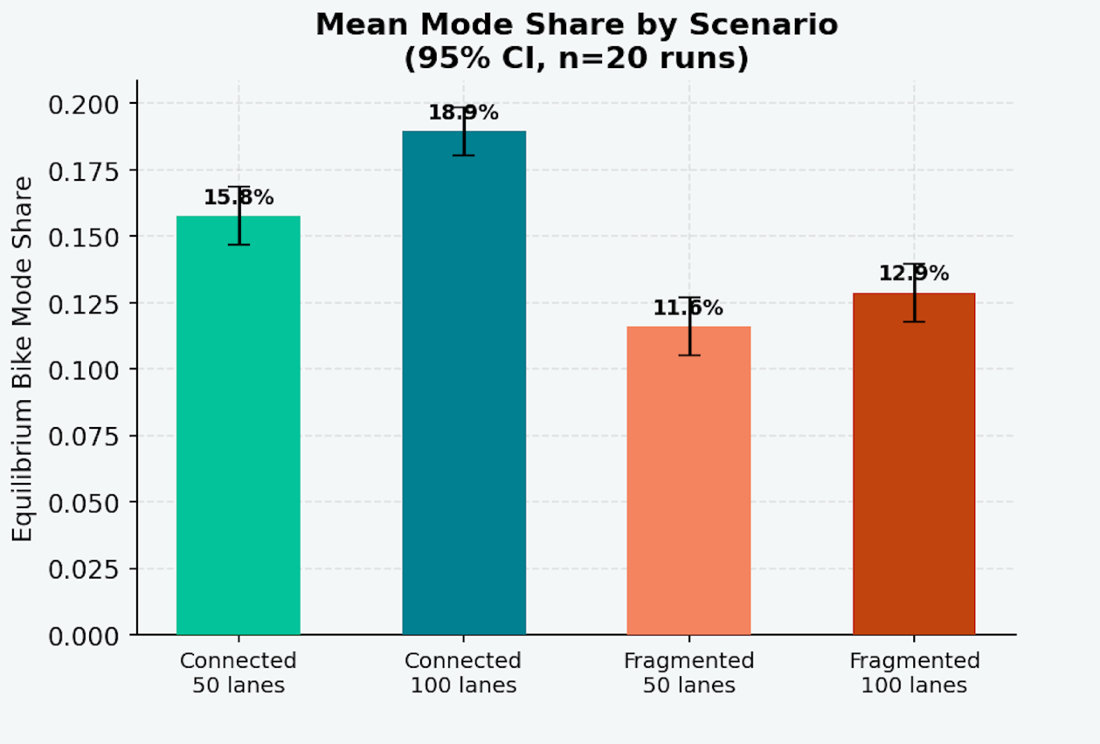
Figure 1: Mean Mode Share by Scenario
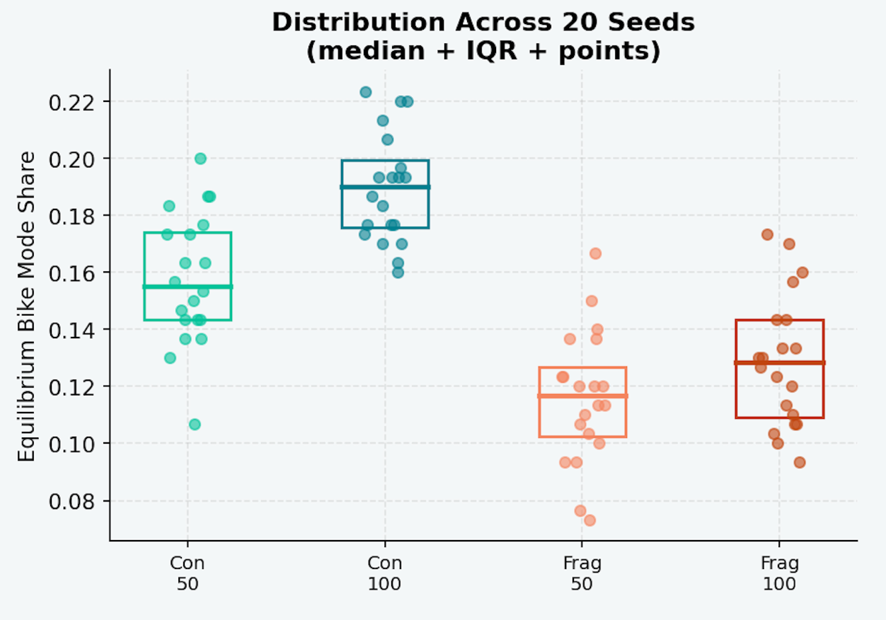
Figure 2: Bike Mode Share Distribution Across 20 Seeds
Primary finding: connectivity outperforms coverage
The core comparison (low coverage connected (50 lanes) versus high coverage fragmented (100 lanes) produces a statistically significant difference in equilibrium cycling mode share. Seen in Figure 1, connected placement at half the lane count achieves a mean mode share of 15.8%, compared to 12.9% for fragmented placement at double the coverage (p<0.001). This result supports the primary hypothesis: the spatial arrangement of bike lane infrastructure has a greater effect on cycling adoption than total lane quantity alone. The distribution plots in Figure 2 further confirm this finding, showing that connected scenarios exhibit higher means. Additionally, for high coverage (100 lanes), the distributions across seeds are tighter, suggesting that at high lane count, connected networks produce more predictable and stable cycling equilibria than fragmented ones.
At equal coverage levels, the connectivity advantage persists. Connected placement at 50 lanes (15.8%) outperforms fragmented placement at 50 lanes (11.6%), and connected placement at 100 lanes (18.9%) outperforms fragmented at 100 lanes (12.9%). Across both coverage levels, connected networks consistently generate higher equilibrium mode share, indicating that the connectivity effect is robust and not a product of lane count. Notably, the magnitude of the connectivity gain is approximately equal at both coverage levels: switching from fragmented to connected placement adds roughly four percentage points regardless of whether 50 or 100 lanes are placed. This parallel pattern suggests that connectivity and coverage operate as largely independent drivers of mode share rather than interacting effects, though formally testing this interaction would require a broader parameter sweep across additional coverage levels.
Role of safety bonus and car cost
Two parameters proved particularly consequential for the magnitude of the connectivity effect. The car cost penalty similarly shaped overall mode share levels. Higher car costs shifted the cost difference term positive for more agents, producing meaningfully higher baseline cycling rates across all scenarios. Having a more realistic car cost parameter would make this model more robust.
The safety bonus parameter, which captures the perceived safety benefit of biking on dedicated infrastructure, had a large impact on whether connected outperformed fragmented lanes. At safety_bonus=1.0, the two scenarios produced comparable mode shares; while raising safety_bonus to 2.0 produced the significant gap reported above. This sensitivity is worth noting as a policy implication: the improved safety from bike lanes should be substantial for the results of this model to hold. In other words, lane connectivity effect is conditional on the infrastructure providing meaningful safety improvements over riding without lanes.
Convergence and social dynamics
All scenarios converged rapidly, typically within five steps, reflecting the small grid size and simultaneous agent updating. The social influence mechanism (γ) produced emergent feedback dynamics in which early adopters increased the probability of adjacent agents switching to biking, but the speed of convergence limited the visibility of diffusion over time. A secondary question motivating this model was whether a connectivity threshold exists above which cycling adoption becomes self-sustaining. While the social feedback mechanism produces emergent mode share dynamics, the model's stylized parameter space and small grid size make it difficult to identify a robust threshold. This remains an important direction for future work with empirically calibrated parameters and larger grid environments where social diffusion can unfold slower and across more steps.

Bibliography
Aziz, H. M. A., Park, B. H., Morton, A., Stewart, R. N., Hilliard, M., & Maness, M. (2018). A high resolution agent-based model to support walk-bicycle infrastructure investment decisions: A case study with New York City. Transportation Research Part C: Emerging Technologies, 86, 280–299. https://doi.org/10.1016/j.trc.2017.11.008
Hwang, U., Kim, I., Guhathakurta, S., & Van Hentenryck, P. (2024). Comparing different methods for connecting bike lanes to generate a complete bike network and identify potential complete streets in Atlanta. Journal of Cycling and Micromobility Research, 2, 100028. https://doi.org/10.1016/j.jcmr.2024.100015
Jafari, A., Pemberton, S., Singh, D., Saghapour, T., Both, A., Gunn, L., & Giles-Corti, B. (2025). Understanding the impact of city-wide cycling corridors on cycling mode share among different demographic clusters in Greater Melbourne, Australia. Transportation. https://doi.org/10.1007/s11116-025-10599-5
Kaziyeva, D., Loidl, M., & Wallentin, G. (2021). Simulating Spatio-Temporal Patterns of Bicycle Flows with an Agent-Based Model. ISPRS International Journal of Geo-Information, 10(2), 88. https://doi.org/10.3390/ijgi10020088
Marshall, W. E., & Ferenchak, N. N. (2019). Why cities with high bicycling rates are safer for all road users. Journal of Transport & Health, 13, 100539. https://doi.org/10.1016/j.jth.2019.03.004
Schön, P., Heinen, E., & Manum, B. (2024). A scoping review on cycling network connectivity and its effects on cycling. Transport Reviews, 44(4), 912–936. https://doi.org/10.1080/01441647.2024.2337880

External Resources
- Used matplotlib cheat sheets from course repo for visualizations
- Course Sugarscape model code
- Mesa documentation
- Used AI for the following:
  - How to extract coordinates from several variables

