What do social media users care about? Social media has influenced people’s agenda

With the introduction of smartphones and tablets into our lives, people can reach news and can follow the news day by day easily. This means that social media is reachable 24/7.

Accessibility of social media might affect people’s feelings such as depression, anxiety, and stress.

Briefly, these days, most of us access social media via our devices and the reactions to the news and the headlines actually affect how the news is reflected.

“Half of all kids aged 10 to 18 obtain their reading from digital news, according to Common Sense Media’s research, News and America’s Kids: How Young People Perceive and Are Impacted by the News. While incorporating a social component into news has undoubtedly increased young people’s interest in current events, it has also exacerbated divisions.”

**Most used words in news titles**

The most titled words in the first 3 weeks of April 2017:

metin, gazete içeren bir resim

Açıklama otomatik olarak oluşturuldu

**Good news beated bad on Social Media**

People can found more positive news than negative ones. But it does not mean that they prefer positive news. Readers are tended to share articles that they found funny not news that left them sad.

Analysis result according to the rank system given by social media users to news headlines:

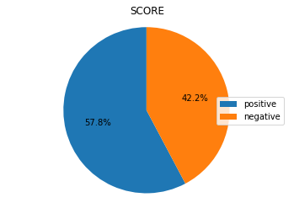

**Some things never change**

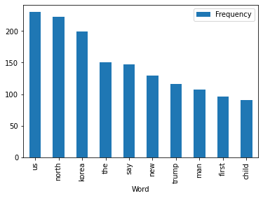

Word frequency list for 2017

In 2017, we have seen which words are used most in the news on social media. So what news do people read these days? Do people only learn about the news with the headlines or tweets they see on social media, or do they read the rest of the news content from the newspaper?

**2021 most used words in news titles**

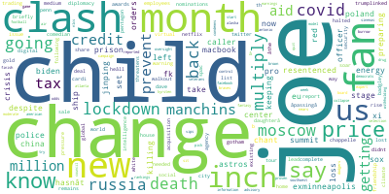

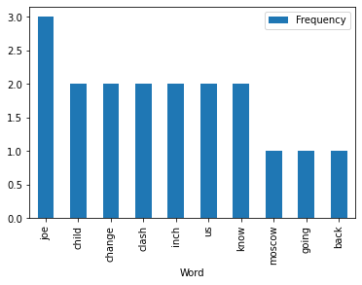

Word frequency list for 2021

So what did we notice when we compared the two tables? We see that there are subjects that do not chaange on the agenda, that is, while some concepts are still up to date, some subjects have also changed. What did they say after all? History is not just about the past. It also reveals the present!