MY WORD IS MY BOND
An AI-Supported Self-Control Application Against Digital Addiction
Literature, Data, and Technology Review
Capstone Project
Group 5 | Çağan Erdem Üstündağ – Begüm Somay
October 12, 2026

TABLE OF CONTENTS
Part 1: Literature Review 4
1. Introduction 4
2. Thematic Literature Review 5
2.1. Classification of digital addiction and diagnostic criteria 6
2.2. Definition of the problem and its relationship with daily life 6
2.3. Measurement of usage behavior and scales 8
2.4. Personal goals, commitments, and self-control 9
2.5. Pre-use interventions and reminders 10
2.6. Prevention approaches 10
2.7. Adaptive interventions and data-driven personalization 11
3. Comparison and Synthesis of Studies 12
4. Research Gap and Conclusion 14
5. References 16
Part 2: Data Research 19
1. Introduction 19
2. Organization of the Research 20
3. Data Definition 20
3.1. Data source and scope 20
3.2. Data fields 21
3.3. Rationale for selection and access conditions 22
4. Ethics and Data Privacy 22
5. Data Analysis and Findings 24
5.1. Patterns found in the preliminary examination 24
5.2. Descriptive statistics published by the researchers 25
5.3. Data quality and issues to be addressed 25
5.4. Visualizations 26
5.5. Promise simulation and modeling plan 29
5.6. Initial modeling findings 30
6. Conclusion 31
7. References 31
Part 3: Technology Review 33
1. Introduction 33
2. Overview of Technologies 33
2.1. Python and pandas: Data preparation 33
2.2. Logistic regression: Explainable baseline model 33
2.3. LightGBM: Main prediction model 34
2.4. Survival analysis: Probability of continued use 34
2.5. Ready-made large language model: Weekly AI coach 35
2.6. Mobile usage tracking and development tools 35
3. Relationship of Technologies to the Project 36
4. Comparison and Evaluation 37
4.1. Model options 37
4.2. Mobile development options 38
5. Use Cases 38
6. Limitations and Research Opportunities 39
7. Conclusion 41
8. References — APA 7 42

List of Figures
Figure 1. Distribution of event types.
Figure 2. Change in the number of records by month.
Figure 3. Distribution of session durations (histogram).
Figure 4. The ten applications with the most records.
Figure 5. Distribution of usage by hour.

Part 1: Literature Review
My Word Is My Bond: A Literature Review on Self-Control, Personal Commitments, and Adaptive Interventions in Digital Use
Group 5 | Çağan Erdem Üstündağ – Begüm Somay

1. Introduction
The My Word Is My Bond project focuses on the problem that users stay longer than initially planned in smartphone applications and find it difficult to comply with the usage limits they set for themselves. Particularly in applications such as social media that can be opened repeatedly, a mismatch can arise between the intention to start using and the decision about when to end that use. The project's behavioral target group consists of users who experience this mismatch and wish to regulate their digital use in line with their own preferences.
The project's primary target group is adults aged 18–70. This group includes individuals who intensively use social media, short video (for example, TikTok, Instagram Reels, YouTube Shorts), messaging, and gaming applications as part of daily life and who want to keep this use within limits they define themselves. The broad age range means that the usage patterns and self-control needs of different age groups (young adults, working adults, and older adults) may differ. For this reason, My Word Is My Bond will address users not according to their age but according to their own past usage behavior, and will personalize duration suggestions.
In this review, the problem is addressed within the framework of problematic smartphone use and difficulty with self-control in digital use. Panova and Carbonell (2018) argue against treating intensive smartphone use directly as an addiction and state that the context and functional outcomes of use should be considered. Therefore, the behavioral problem that My Word Is My Bond addresses is not merely high screen time but the difference between the use the user intends and the use that actually occurs.
The importance of the problem stems from the consequences of digital use for daily life. Han et al. (2024) show that an association exists between electronic media use and more negative sleep outcomes. However, this association alone does not prove that digital use causes sleep problems or that any reduction in screen time will improve health. The main aim of My Word Is My Bond is to support users' control over their own usage decisions; the possible benefits for sleep and well-being should be evaluated separately.
The importance of the problem is not limited to sleep. It has been shown that problematic smartphone and social media use is associated with symptoms of anxiety and depression (Elhai et al., 2017); that using the phone in a distracting manner during classes and work is negatively associated with academic performance (Bjerre-Nielsen et al., 2020); and that turning to the phone during face-to-face interaction, that is, phubbing behavior, can reduce relationship satisfaction and feelings of closeness (Al-Saggaf & O’Donnell, 2019).
An important part of these findings is cross-sectional, self-report-based, and correlational; therefore, they should not by themselves be taken as evidence of causality. Nevertheless, when considered together, they indicate that difficulty with self-control in digital use can have a multidimensional sphere of influence on an individual's mental health, academic and working life, and social relationships. My Word Is My Bond does not claim to directly eliminate these outcomes; its aim is to contribute to reducing possible negative effects in these areas by supporting users' control over their own usage decisions.
The core mechanism of the project is that the user makes a brief promise before opening an application. The system, learning from usage history, is planned to estimate the probability that the promise will be kept, to suggest more attainable durations, and to offer a reminder at an appropriate time when necessary. Before designing this approach, reviewing the literature is necessary in order to understand under which conditions personal goals work, the limitations of reminders, and the difference between behavior prediction and behavior change.
Accordingly, the review focuses on three main research questions:
- How can the usage goals users set for themselves help them regulate their digital use?
- Under which conditions can pre-use interventions and in-use reminders be effective?
- How can usage history and contextual information be used for personalized duration suggestions and intervention timing?

2. Thematic Literature Review
The literature is organized under seven themes: classification of digital addiction and diagnostic criteria; definition of the problem and its consequences; measurement of behavior and scales; personal goals and self-control; the effect and acceptability of interventions; prevention approaches; and finally adaptive and data-driven support.

2.1. Classification of digital addiction and diagnostic criteria
World Health Organization (2019) and American Psychiatric Association (2013): Gaming disorder and internet gaming disorder
The question of under which circumstances digital use problems fall within diagnostic scope is a fundamental question for intervention design. The World Health Organization, in the ICD-11 classification, defined gaming disorder (6C51) as a behavioral addiction and tied the diagnosis to the criteria of impaired control over gaming, gaming taking precedence over other life activities, and continuation despite negative consequences. For the diagnosis to be made, this pattern must generally be evident for at least 12 months and must lead to significant impairment in personal, family, social, educational, or occupational areas (World Health Organization, 2019).
In DSM-5, by contrast, internet gaming disorder is included not yet as an official diagnosis but as a condition proposed for further research (American Psychiatric Association, 2013). This dual situation is even more pronounced for digital behaviors other than gaming: no independent diagnosis defined in ICD-11 or DSM-5 exists for social media or smartphone use.
Within the context of our project, this situation has an important consequence. The project does not diagnose users and does not treat a user exceeding their promise as an indicator of a clinical disorder. Exceeding the promise is an observable behavioral output and can be used as an intervention signal; however, it does not replace a diagnosis explaining the person's mental state. This distinction defines the ethical and scientific boundaries of the application.
Problematic use: A non-diagnostic concept
Although difficulty with self-control in smartphone and social media use is recognized as a common problem, it is mostly addressed with non-diagnostic concepts such as problematic use or problematic social media use. Estimates of the prevalence of this use vary greatly depending on the criterion, scale, and sampling used, and self-report-based measurements can reflect real use in a biased way (Parry et al., 2021). Therefore, My Word Is My Bond is positioned not as placing users into a diagnostic category but as a non-diagnostic support tool that works on their own behavioral data.

2.2. Definition of the problem and its relationship with daily life
Panova and Carbonell (2018): The distinction between intensive use and addiction
The aim of this study is to assess whether the concept of smartphone addiction is sufficiently supported by existing research. The authors critically examined the methods and results of quantitative and qualitative studies. Since the study is not research that collects data from new participants, it has no single participant sample.
It was concluded that the reviewed literature does not offer sufficient support to classify problems related to smartphone use directly as addiction. The contribution of the study is to separate the amount of use from problematic use. However, this conceptual review does not test the effect of a specific intervention.
The conclusion to be drawn here is not to treat exceeding a duration promise as a clinical addiction symptom. Exceeding the promise can be used as a behavioral outcome that the project will track; it does not replace a diagnosis explaining the person's general psychological state.
The prevalence of problematic use also shows the scale of the problem. Sohn et al. (2019) evaluated problematic smartphone use in the youth population through a systematic review and meta-analysis and revealed its relationship with mood symptoms. This finding supports that the self-control difficulty targeted by My Word Is My Bond is a widespread rather than marginal problem.
Han et al. (2024): Electronic media use and sleep
This systematic review and meta-analysis compares the relationship between the use of different types of electronic media and sleep outcomes. The research brought together 55 publications covering 41,716 participants from more than 20 countries. General use and problematic use were evaluated in separate groups, and relationships were analyzed with correlation-based effect sizes.
The findings show that there is an association between electronic media use and more negative sleep outcomes; the association can vary by media type and cultural context. The study's strength is that it combines evidence covering broad and diverse countries. Its main limitations are the methodological differences between studies and the inability to draw causal conclusions from correlations.
The meaning of these results for My Word Is My Bond is that they provide a rationale for taking nighttime use into account. However, adding nighttime use to the model will not show that the application improves sleep; such a conclusion would require separate evaluation.

2.3. Measurement of usage behavior and scales
Parry et al. (2021): The discrepancy between self-report and device logs
Parry et al. (2021) investigated the extent to which the digital media use users report overlaps with use recorded by the device. Within a preregistered meta-analysis, 106 effect sizes were evaluated. This number refers not to the number of participants but to the comparisons obtained from different studies.
The results show that reported use and logged use are only moderately correlated and that self-reports often do not accurately reflect the actual amount of use. The relationship of problematic-use scales with usage logs is even weaker. The study exposes the limitations of assessments based only on the durations users remember; however, it does not offer a single measurement solution for all digital media types.
These findings support comparing the promised duration with the actual duration from usage logs in My Word Is My Bond. They also show that logs alone cannot explain a person's purpose of use, regret, or experienced difficulty.
Kwon et al. (2013), Andreassen et al. (2016), and Pontes and Griffiths (2015): Validated scales
Understanding how problematic digital use is measured in quantitative research is important for positioning the target variable of My Word Is My Bond. One of the most widely used instruments in the literature is the Smartphone Addiction Scale–Short Version (SAS-SV; Kwon et al., 2013), a brief screening scale for smartphone addiction; a Turkish validity and reliability study of the scale has also been conducted (Noyan et al., 2015). For social media use, the Bergen Social Media Addiction Scale (BSMAS; Andreassen et al., 2016), and for gaming use, the Internet Gaming Disorder Scale–Short Form (IGDS9-SF; Pontes & Griffiths, 2015) are widely used.
These scales were developed to screen for problematic use and are mostly based on self-report. For example, the recommended cut-off scores for SAS-SV can vary across different samples and cultures, which makes it difficult to make a definite classification as addicted or not addicted. The relationship of these scales with usage logs is also generally found to be weak (Parry et al., 2021).
In our application, the role of these scales is limited. The project's target variable is whether the user keeps the duration promise they made; this is not an addiction or problem-severity score. The scales can be used only as an aid to describe the level of problematic use of users participating in a study and, when necessary, to define an exclusion criterion; they should not be substituted for promise-keeping behavior.

2.4. Personal goals, commitments, and self-control
Allcott et al. (2022): Habit and self-control in digital use
This study examines habit formation and self-control problems in digital use through an economic model and a randomized experiment. The main analysis sample of the study, conducted in the US, consists of 1,933 participants. The interventions included temporary monetary incentives to reduce use and the ability of users to set limits on their future screen time.
The finding that temporary incentives showed persistent effects on subsequent use was consistent with habit formation, while the finding that the limits users set reduced use was consistent with self-control difficulty. The economic model estimates that self-control problems may account for about 31% of social media use. This rate is not an addiction rate that can be applied to all users.
The study provides a basis for the benefit of deciding in advance for future behavior. However, the restriction system used and the non-locking duration promise of My Word Is My Bond are not the same intervention. Therefore, the research provides a rationale supporting the project's mechanism; it does not directly prove the effect of My Word Is My Bond.
Hiniker et al. (2016): User-defined usage goals
The MyTime study aims to develop an intervention that will support the smartphone use users want to reduce. In the design process, an online survey of 232 people was used; the developed application was evaluated with 23 participants in a two-week usage study.
The time participants spent in applications they regarded as a waste of time decreased by about 21%, while use of applications they regarded as useful did not change significantly. The study's contribution is that it offers an approach that takes users' own priorities into account instead of reducing all phone use in the same way. The small sample, the short follow-up period, and the comparison of the baseline week with the intervention week limit the generalizability of the results.
This study shows the importance of user preferences regarding which application and how much use should be limited. Personalized suggestions must support the user's goals.

2.5. Pre-use interventions and reminders
Grüning et al. (2023): Brief interventions at application launch
This study examines the effect of the one sec application in reducing automated application use. A six-week field study with 280 participants and a preregistered online experiment with 500 participants that compared the intervention components were conducted.
In the field study, with the intervention combining a brief delay, a reflective message, and a decline-to-open option, a reduction of about 57% was reported in the actual launches of the target applications. This result does not mean a 57% reduction in screen time. In the controlled experiment, the strongest component was the decline-to-consume option; the reflective message alone was not found to be effective.
The study shows that interventions at application launch can influence behavior. However, the lack of a control group in the field part, the characteristics of the volunteer users, and the developer being one of the authors should be taken into account in the evaluation. These findings support the pre-launch decision moment of the application and require not assuming that a “remember your promise” message alone will be sufficient.
Lyngs et al. (2020): The benefit of reminders and the burden on the user
This research examines the effect of changes in the Facebook interface on self-control and distraction. 58 university students were assigned to goal reminders, removal of the news feed, or a control condition; use was logged for six weeks. The interventions were applied in the middle weeks of the study, and user experience was assessed through surveys.
Goal reminders and removal of the news feed supported participants' focus on their goals. However, the reminders were often found annoying; removal of the news feed created a fear of missing information in some participants. The study's contribution is that it shows behavioral benefit and user acceptance must be evaluated together. The student sample and the focus on a single platform limit generalizability.
For My Word Is My Bond, this study supports evaluating not only reminder timing but also its frequency and the burden on the user. More reminders do not automatically mean more benefit.

2.6. Prevention approaches
Another heading as important as intervention is approaches aimed at preventing the emergence of problematic use. Prevention studies in the literature mostly focus on programs conducted in schools and with young individuals that aim to strengthen digital literacy and self-control skills. The review by Throuvala et al. (2019) shows that school-based programs can contribute to students' skills in regulating smartphone and social media use, but that the effect of the programs varies according to design and implementation context.
Prevention approaches encompass not only individual skills but also environmental arrangements. Some studies suggest that excessive use can be reduced by changing elements such as attention-grabbing notifications and infinite scroll in application design (Lyngs et al., 2020). In Turkey, Yeşilay provides training and resources on prevention, awareness, and digital parenting in the fight against addiction (Yeşilay, 2024). At the national level, TÜİK publishes regular statistics on digital technology use (TÜİK, 2024).
Prevention approaches are instructive for My Word Is My Bond in two respects. First, they show that the intervention should consider not only the user but also the context of use; accordingly, the system aims to offer the user accessible and non-judgmental options. Second, they remind us that the effect of prevention studies may remain limited and that the project must therefore evaluate its own effect separately. Since prevention programs are generally implemented in large and heterogeneous groups, a single intervention of My Word Is My Bond should not be confused with claims of that scope.

2.7. Adaptive interventions and data-driven personalization
Nahum-Shani et al. (2018): Adaptive support at the right time
This article explains the key components and design principles of the Just-in-Time Adaptive Interventions (JITAI) approach. Rather than an experiment conducted with a new participant sample, it is a conceptual study built on behavioral theories and intervention examples from various health domains.
The approach aims to adapt support according to the person's changing state and context. The design includes long-term outcomes, short-term outcomes, decision points, tailoring variables, intervention options, and decision rules. The important point is that, in addition to the person needing support, whether they are in a state suitable to receive that support should also be assessed.
In My Word Is My Bond, offering a reminder according to the risk of exceeding the promise is related to this framework. However, the article does not test the effect of the project's reminders. Estimating high risk from usage logs will not by itself show that the user is open to a reminder at that moment.
Aliannejadi et al. (2021): Prediction based on context and usage history
The aim of this study is to improve application selection and the recommendation of the next application to be used for mobile assistants. The LSApp part of the research contains the application usage logs of 292 users. Models that take usage order, time, and user information into account were compared.
Models that use context and personal usage history were found more successful in the application recommendation task than the baseline models compared. The study's contribution is that it shows personal and sequential patterns in application use can be useful for prediction. However, the research does not examine adherence to a duration promise or the reduction of addiction.
Therefore, LSApp can help My Word Is My Bond model usage patterns; it cannot be assumed to represent real user commitments. The official description of the dataset reports 599,635 application usage records. Since the duration promises to be generated within the project will be a simulation, the results obtained from them should not be presented as evidence of real promise-keeping behavior or intervention effect.

3. Comparison and Synthesis of Studies
The studies reviewed complement one another on the point that digital use should not be evaluated solely through total duration. While Panova and Carbonell (2018) raise the conceptual problem regarding the classification of intensive use directly as addiction, Parry et al. (2021) show the difficulties in measuring the amount of use. Together, these two studies support the conclusion that exceeding a duration promise is an observable behavior, but does not by itself explain why a person's use is problematic.
Allcott et al. (2022) and Hiniker et al. (2016) show that limits and goals users set in advance can change usage behavior. However, the ways the interventions are implemented and the research designs differ. The effectiveness of limit-setting tools in a randomized experiment does not have the same strength of evidence as results from a small and short-term usage study. When these findings are considered together, personal goals are a reasonable starting point for My Word Is My Bond; the effect of the project's own mechanism must be tested separately.
Regarding reminders, the findings are more conditional. Lyngs et al. (2020) show that goal reminders can be useful but can also create annoyance. Grüning et al. (2023), in their own experiment, did not find the reflective message alone to be effective. This difference points to the importance of the message content, the moment it is presented, and the options provided to the user; it cannot be said that every reminder will produce the same effect.
The scope, method, and meaning for My Word Is My Bond of the reviewed studies are summarized in the following table:
Study | Method and scope | Key finding | Meaning for My Word Is My Bond
WHO (2019); APA (2013) | Official diagnostic classifications | Diagnosis is defined only for gaming behavior | The application tracks behavior instead of making a diagnosis
Panova and Carbonell (2018) | Conceptual review | Intensive use cannot be equated with addiction | Does not use the duration promise as a clinical label
Sohn et al. (2019) | Systematic review and meta-analysis | Problematic use is common in the youth population and related to mood | Shows the scale of the problem and the limit of self-report
Han et al. (2024) | Meta-analysis | Electronic media use is inversely related to sleep outcomes | Justifies monitoring nighttime use separately
Parry et al. (2021) | Survey–device log comparison | Self-report is moderately consistent with logged use | Supports calculating duration from logs
Kwon et al. (2013); Andreassen et al. (2016); Pontes and Griffiths (2015) | Validated scale development | Problematic use is screened with self-report scales | The target variable was defined behaviorally rather than by a scale
Allcott et al. (2022) | Economic model and randomized experiment | Habit is strong; deciding in advance is effective | The promise works as a decision made in advance
Hiniker et al. (2016) | Intervention design (MyTime) | User-defined target durations can reduce use | The restriction decision is left to the user
Grüning et al. (2023) | Measurement study and field intervention | A brief delay at launch reduces automatic use | Exemplifies the pre-launch intervention flow
Lyngs et al. (2020) | Facebook feature-change experiment | Goal reminders are useful but can create burden | Reminder frequency and burden must be balanced
Nahum-Shani et al. (2018) | Design framework (JITAI) | Adapting support to context is recommended | Reminder timing is designed according to risk prediction
Aliannejadi et al. (2021) | Sequential usage data and model | Provides information in context and past behavior | The basis of feature extraction from usage history
Nahum-Shani et al. (2018) provide the design framework of adaptive support, and Aliannejadi et al. (2021) provide the technical basis for generating predictions from usage history. Combining these two contributions justifies the approach of My Word Is My Bond. However, being able to predict behavior and being able to change it through well-timed intervention are separate research questions. Prediction success cannot be substituted for behavior-change success.

4. Research Gap and Conclusion
The reviewed literature provides a basis for personal goal setting, brief interventions at application launch, and context-adapted support. However, the studies covered within this review do not evaluate, within the same system, a duration promise given before the session begins, a duration suggestion based on the probability of keeping the promise, and a risk-based reminder during use. This statement is not a claim that no example of such a system exists in the literature; it is a definition of a research gap based on the scope of the studies reviewed.
The proposed contribution of My Word Is My Bond is to combine these mechanisms around a brief commitment made by the user. The project aims to investigate, through usage history, which durations are more attainable for particular users and applications, and to adapt goals gradually according to the user's progress. In this way, personal goal setting is transformed from a one-time setting into a support process that learns from past behavior.
An important balance the project will investigate is between the goal being attainable and its contributing to a reduction in use. Achieving a high promise-keeping rate by suggesting very long durations will not by itself mean successful behavior change. Therefore, alongside the promise-keeping rate, the actual usage duration and the extent to which the promised duration is exceeded should also be considered.
In the current project plan, rather than collecting data from real participants, promise simulation will be performed on LSApp records. At this stage, the contribution the research can show is the extent to which adherence to simulated duration goals can be predicted from usage history. Users' real promise-making behavior, whether reminders increase promise-keeping, or their effect on reducing digital use cannot be determined with this data alone. An offline comparison of fixed-time and model-timed reminders will also not prove real intervention effect.
The generative AI coach, trust score, badges, promise tree, social profile, and Hook Score are supporting components of the project proposal. The sources covered in this review do not directly confirm the effect of these components within My Word Is My Bond. Therefore, they should be presented not as features with demonstrated effectiveness but as design elements to be evaluated separately. In particular, how the Hook Score is constructed should be explained; it should not be used as a validated addiction measure.
In conclusion, the literature provides a rationale for My Word Is My Bond to investigate the approach of personal duration promises and adaptive support. The project's contribution at the current stage is to clearly define the behavioral logic of this approach and to examine its predictability through usage logs. Whether it provides sustainable improvement in digital use is a result that must be shown through subsequent user evaluations.
In practice, by using personalized goals and data-driven reminders instead of strict prohibitions, it will directly contribute to helping users exit the digital addiction cycle and gain sustainable self-control.
A recent piece of field evidence supporting this preference is a randomized experiment conducted in a high school in Turkey. Bastani et al. (2025) showed that an AI-supported tool without protective design rules could lead to negative outcomes when users were left on their own, and that the same tool, when used with protective rules, largely prevented this negative effect. This finding supports that what is decisive is not whether there is an intervention but its design, and supports My Word Is My Bond's principle of “guidance, not restriction.”

5. References
Aliannejadi, M., Zamani, H., Crestani, F., & Croft, W. B. (2021). Context-aware target apps selection and recommendation for enhancing personal mobile assistants. ACM Transactions on Information Systems, 39(3), Article 29. https://doi.org/10.1145/3447678
Allcott, H., Gentzkow, M., & Song, L. (2022). Digital addiction. American Economic Review, 112(7), 2424–2463. https://doi.org/10.1257/aer.20210867
Al-Saggaf, Y., & O’Donnell, S. B. (2019). Phubbing: Perceptions, reasons behind, predictors, and impacts. Human Behavior and Emerging Technologies, 1(2), 132–140. https://doi.org/10.1002/hbe2.137
American Psychiatric Association. (2013). Diagnostic and statistical manual of mental disorders (5th ed.). https://doi.org/10.1176/appi.books.9780890425596
Andreassen, C. S., Billieux, J., Griffiths, M. D., Kuss, D. J., Demetrovics, Z., Mazzoni, E., & Pallesen, S. (2016). The relationship between addictive use of social media and video games and symptoms of psychiatric disorders: A large-scale cross-sectional study. Psychology of Addictive Behaviors, 30(2), 252–262. https://doi.org/10.1037/adb0000160
Bjerre-Nielsen, A., Andersen, A., Minor, K., & Lassen, D. D. (2020). The negative effect of smartphone use on academic performance may be overestimated: Evidence from a 2-year panel study. Psychological Science, 31(11), 1351–1362. https://doi.org/10.1177/0956797620955209
Bastani, H., Bastani, O., Sungu, A., Ge, H., Kabakcı, Ö., & Mariman, R. (2025). Generative AI without guardrails can harm learning: Evidence from high school mathematics. Proceedings of the National Academy of Sciences, 122(26), e2422633122. https://doi.org/10.1073/pnas.2422633122
Elhai, J. D., Dvorak, R. D., Levine, J. C., & Hall, B. J. (2017). Problematic smartphone use: A conceptual overview and systematic review of relations with anxiety and depression psychopathology. Journal of Affective Disorders, 207, 251–259. https://doi.org/10.1016/j.jad.2016.08.030
Grüning, D. J., Riedel, F., & Lorenz-Spreen, P. (2023). Directing smartphone use through the self-nudge app one sec. Proceedings of the National Academy of Sciences, 120(8), e2213114120. https://doi.org/10.1073/pnas.2213114120
Han, X., Zhou, E., & Liu, D. (2024). Electronic media use and sleep quality: Updated systematic review and meta-analysis. Journal of Medical Internet Research, 26, e48356. https://doi.org/10.2196/48356
Hiniker, A., Hong, S. R., Kohno, T., & Kientz, J. A. (2016). MyTime: Designing and evaluating an intervention for smartphone non-use. In Proceedings of the 2016 CHI Conference on Human Factors in Computing Systems (pp. 4746–4757). Association for Computing Machinery. https://doi.org/10.1145/2858036.2858403
Kwon, M., Kim, D.-J., Cho, H., & Yang, S. (2013). The Smartphone Addiction Scale: Development and validation of a short version for adolescents. PLOS ONE, 8(12), e83558. https://doi.org/10.1371/journal.pone.0083558
Lyngs, U., Lukoff, K., Slovak, P., Seymour, W., Webb, H., Jirotka, M., Zhao, J., Van Kleek, M., & Shadbolt, N. (2020). “I just want to hack myself to not get distracted”: Evaluating design interventions for self-control on Facebook. In Proceedings of the 2020 CHI Conference on Human Factors in Computing Systems. Association for Computing Machinery. https://doi.org/10.1145/3313831.3376672
Nahum-Shani, I., Smith, S. N., Spring, B. J., Collins, L. M., Witkiewitz, K., Tewari, A., & Murphy, S. A. (2018). Just-in-time adaptive interventions (JITAIs) in mobile health: Key components and design principles for ongoing health behavior support. Annals of Behavioral Medicine, 52(6), 446–462. https://doi.org/10.1007/s12160-016-9830-8
Noyan, C. O., Darçın, A. E., Nurmedov, S., Yılmaz, O., & Dilbaz, N. (2015). Turkish validity and reliability study of the Smartphone Addiction Scale–Short Form among university students [Akıllı Telefon Bağımlılığı Ölçeği–Kısa Formunun üniversite öğrencilerinde Türkçe geçerlilik ve güvenilirlik çalışması]. Anadolu Psikiyatri Dergisi, 16(1), 73–81. https://doi.org/10.5455/apd.176101
Panova, T., & Carbonell, X. (2018). Is smartphone addiction really an addiction? Journal of Behavioral Addictions, 7(2), 252–259. https://doi.org/10.1556/2006.7.2018.49
Parry, D. A., Davidson, B. I., Sewall, C. J. R., Fisher, J. T., Mieczkowski, H., & Quintana, D. S. (2021). A systematic review and meta-analysis of discrepancies between logged and self-reported digital media use. Nature Human Behaviour, 5(11), 1535–1547. https://doi.org/10.1038/s41562-021-01117-5
Pontes, H. M., & Griffiths, M. D. (2015). Measuring DSM-5 Internet gaming disorder: Development and validation of a short psychometric scale. Computers in Human Behavior, 45, 137–143. https://doi.org/10.1016/j.chb.2014.12.006
Sohn, S. Y., Rees, P., Wildridge, B., Kalk, N. J., & Carter, B. (2019). Prevalence of problematic smartphone usage and associated mental health outcomes amongst children and young people: A systematic review, meta-analysis and GRADE of the evidence. BMC Psychiatry, 19, Article 356.
Throuvala, M. A., Griffiths, M. D., Rennoldson, M., & Kuss, D. J. (2019). School-based prevention for adolescent internet addiction: Prevention is the key. A systematic literature review. Current Neuropharmacology, 17(6), 507–525. https://doi.org/10.2174/1570159X16666180813153806
Turkish Statistical Institute. (2024). Survey on information and communication technology (ICT) usage in households, 2024 [Hanehalkı bilişim teknolojileri (BT) kullanım araştırması, 2024]. https://data.tuik.gov.tr
World Health Organization. (2019). ICD-11: International classification of diseases 11th revision – Gaming disorder. https://www.who.int/news-room/questions-and-answers/item/addictive-behaviours-gaming-disorder
Yeşilay. (2024). Turkish Green Crescent Addiction Prevention Education Program (TBM) [Türkiye Bağımlılıkla Mücadele Eğitim Programı (TBM)]. https://www.yesilay.org.tr

Part 2: Data Research
My Word Is My Bond: Data Research

1. Introduction
The data research of the My Word Is My Bond project aims to develop personalized duration suggestions and well-timed reminders by examining users' application usage patterns. In the project, the user will make a promise regarding the usage duration before opening an application; the system will estimate the probability that this duration will be exceeded by drawing on past behavior.
The data will be used to evaluate the following research questions:
Research question | Scope | Section addressed
How do application usage durations vary by user, application, and time of use? | Descriptive patterns | 5.1–5.4
Can past usage behaviors help predict exceeding a set duration goal? | Promise simulation and modeling | 5.5–5.6
How can the durations suggested to the user be personalized according to past usage patterns? | Converting model output into a suggestion | 5.5 and Section 6
How can patterns related to continued use contribute to the development of reminder timing? | Continuation probability and timing | Part 3, §2.4 and Section 6
A detailed examination of the data is necessary to understand what the records represent and to construct reliable usage durations. In particular, an event record, a phone usage session, and the uninterrupted time spent in a single application must be distinguished from one another. Target variables constructed without making this distinction may not accurately represent the behavior the project intends.

2. Organization of the Research
The data research is organized in four stages:
- Examination of the data source, its scope, and access conditions.
- Assessment of the structure of the raw file and data quality.
- Construction of usage durations and preparation of simulated duration promises.
- Determination of variables and the evaluation method for the prediction models.
This report presents verified findings for the first two stages. Matching usage durations, promise simulation, and model evaluation are subsequent work stages.

3. Data Definition

3.1. Data source and scope
The main data source of the project is the LSApp — Large Dataset of Sequential Mobile App Usage dataset published by Aliannejadi et al. (2021). The data was collected with the consent of users via the uSearch application that participants installed on their Android phones. The research was carried out for the purpose of application selection and recommendation; it is not an assessment of a digital addiction intervention. The dataset was collected between September 9, 2017, and May 17, 2018; therefore, the dates mentioned in the report (for example, April 2018) reflect the period in which the data itself was collected, not the year the project was conducted. The study is conducted on this openly available dataset that was collected in the past. Therefore, the currency of the patterns derived from the 2017–2018 data is limited; it will be verified on current behavior with the planned user pilot.
The preliminary examination of the raw file downloaded on October 12, 2026, produced the following results:
All calculations in the report belong to this downloaded version; if the repository is updated, the accessed version and date will be recorded, the numbers will be regenerated, and consistency will be re-verified.
Feature | Value observed in the raw file
File format | Gzip-compressed TSV
Compressed file size | About 6.99 MiB
Data rows read | 3,658,590
Unique users | 292
Unique applications | 87
Unique user–session pairs | 76,247
First timestamp | September 9, 2017
Last timestamp | May 17, 2018
Exact duplicate extra rows | 2,185,366
Rows with missing fields | 1
Event records remaining after removing missing rows and exact duplicates | 1,473,223
Source: Calculations made for this report on the raw file in the official repository. The number in the last row is not the number of completed application sessions.
The summary published by the researchers, however, reports 599,635 usage records. The article explains the merging of usage records repeated at short intervals and the filtering of background system applications. Therefore, the raw row count, the event count with only exact duplicates removed, and the published processed record count are not the same measure. The figure of approximately 3.6 million in the project proposal is consistent with the size of the raw file; the number of usable application durations must be calculated separately.

3.2. Data fields
The official data description defines five basic fields:
Field | Meaning | Use in the project
user_id | User identifier | Combining usage history at the user level
session_id | Session identifier | Grouping related events
timestamp | Time the event was recorded | Ordering and time features
app_name | Application name | Application-specific patterns
event_type | Open, close, interaction, or Broken event | Construction of usage durations
In the downloaded file, the header of the first column appears as lsapp.tsv instead of user_id. In the preliminary examination, this column was named user_id according to its counterpart in the official description. In addition, the Broken event type is not the same as the “promise broken” target variable in My Word Is My Bond.

3.3. Rationale for selection and access conditions
LSApp was chosen because it contains users' application behavior over time. The repeated observations allow for the examination of personal habits and differences between applications.
However, the dataset does not contain real duration promises, reminder responses, or intervention outcomes. In addition, the published TSV fields do not include age, sleep, or well-being scores at the user level. Therefore, the relationships between these variables cannot be analyzed from the existing file.
The data can be accessed from the official GitHub repository. In the repository view examined, no explicit data license could be found. Public access will not be interpreted as permission for unlimited redistribution or commercial use. The terms of use will be clarified, and the academic citation requested by the data owners will be provided.

4. Ethics and Data Privacy
At the current stage, no data collection from new participants is planned. However, since application names and detailed timestamps may carry information about people's daily habits, openly accessible records will also be handled with care.
Displaying users with numeric identifiers does not by itself prove that the data is completely anonymous against re-identification. According to the KVKK's explanation, anonymization must prevent reaching the individual even through matching with other data.
The following measures will be implemented within the project:
- No attempt will be made to identify users or to match records with other personal sources.
- Access to study files will be limited to the project team, and secure and encrypted storage will be used.
- Aggregated results will be presented in reports instead of individual usage charts.
- Personal information not necessary for modeling will not be used.
- No user identifiers and detailed raw usage records will be sent to the generative AI coach.
- The retention period and the deletion method at the end of the study will be determined.
This approach is consistent with the requirement to take appropriate technical and administrative measures for data security.
If a pilot study is conducted with users in the future, informed consent will be obtained for participation in the research; the data controller, the purpose of processing, the legal basis, and the conditions of retention and transfer will be explained. If processing is based on explicit consent, the information and explicit consent procedures will be carried out separately. Since the project's primary target group is adults over the age of 18, special consent processes for minors are not needed at this stage, which facilitates KVKK compliance. The pilot is planned to be conducted with participants aged 18 and over, with informed consent obtained and with evaluation by the university ethics committee.
The prototype application developed places KVKK compliance at the center of its design. On first access to the application, a full disclosure text and an explicit consent screen are shown within the scope of Article 10 of the KVKK; the application does not work unless the user gives explicit consent, and the approval is stored only on the device. Under “Data Rights” in the settings section, data access (downloading as JSON) and permanent deletion rights based on Article 11 of the KVKK, and withdrawal of consent based on Article 7, are offered. The “Delete my data” action permanently deletes all data, including explicit consent, from the device and returns the application to the consent screen on the next launch.
All user data is kept only in the browser's local storage (localStorage); no name, photo, or contact information is collected under any circumstances. When the generative AI coach is invoked, only an anonymous session summary and the last messages of the chat are sent to the server; this is limited to non-identifying summaries in a manner consistent with the restrictions of Articles 8–9 on the transfer of personal data abroad. If a signal of suicide or self-harm is detected in the chat, the model does not make a diagnosis; the user is directed to the Yeşilay Counseling Line (115) and 112. All AI outputs carry the statement “generated by artificial intelligence” and the warning “for awareness purposes, not medical.”

5. Data Analysis and Findings

5.1. Patterns found in the preliminary examination
After removing missing rows and exact duplicates, the distribution of event types is as follows:
Event type | Number of records
Opened | 652,859
Closed | 674,423
User Interaction | 143,654
Broken | 2,287
Total | 1,473,223
Source: Preliminary examination conducted on the downloaded raw file.
The fact that the numbers of openings and closings are not equal shows that each opening cannot be matched directly with a closing. Therefore, calculating the number of application sessions by dividing the total number of events by two would not be correct.
In the same preliminary examination, the highest number of event records was found in Facebook at 179,509, in Google Chrome at 120,854, and in Twitter at 111,661. These are not a ranking of usage duration; frequent generation of events does not necessarily mean longer use.
Records are not evenly distributed across months. For example, in April 2018 there are 860,941, and in January 2018 174,964 unique and complete events. This difference cannot be interpreted as a seasonal change in use without controlling for the number of active users and the observation coverage.
A pattern also stands out according to the starting application of sessions. About 30% of the cleaned application sessions belong to feed-type (social media and video streaming) applications, and 23% to functional (task-oriented) applications. In 21.6% of sessions that started with a task-oriented application (3,524 of 16,310 sessions), a transition to a feed application within the same session was observed. The total duration of sessions with this transition is about twice the median of sessions starting directly with a feed (~482 seconds versus ~243 seconds). This finding shows that the promise should be considered together with the session-level flow, not just a single application launch.

5.2. Descriptive statistics published by the researchers
Measure | Published value
Average observation period per user | 15 days
Mean session duration | 5 minutes 26 seconds
Median session duration | 1 minute 46 seconds
Mean number of different applications per session | 2.18
Mean number of application switches per session | 5.46
These values were not recalculated in this report but are quoted from the researchers' summary.
The fact that the mean duration is higher than the median is consistent with a distribution in which long sessions influence the mean. Therefore, in duration suggestions, median and percentiles will be evaluated instead of relying solely on the mean.
In addition, in the source, a session can contain more than one application. The promise in My Word Is My Bond, however, concerns the use of a specific application. Therefore, the published session duration will not be used directly as the promise duration to be given for that application.

5.3. Data quality and issues to be addressed
Issue | Finding or scope | Planned action
Exact duplicates | About 59.73% of raw rows are extra duplicates | Filter out duplicates carrying the same five fields
Missing fields | Basic fields are missing in one row | Exclude the row from analysis
Unmatched events | The numbers of openings and closings differ | Create matching rules by user, application, and time order
Zero or very short durations | To be measured after matching | Compare the effect of thresholds on the result
Different observation periods of users | The source reports an average of 15 days per user | Take user contribution and observation days into account
Class imbalance | After promise labeling, the promise-keeping rate is 53.5%; classes are not significantly imbalanced | Report PR-AUC and probability calibration (ECE) in addition to AUC
Time zone uncertainty | Could not be clarified in the examined documentation | Verify timestamps before any local night/day interpretation
Old data period | Records are from the 2017–2018 period | Keep generalization to current user behavior limited
Observation coverage | About 0.1% of openings cannot be matched with a counterpart closing; the first four sessions in each user–application pair are excluded for median calculation (1.5% of samples) | Absence of records does not mean zero use; reported in the thresholds and matching rules section
Usage logs can reduce the problems of measurement based on remembering duration. However, logs do not directly show a person's purpose of use or experienced difficulty with control. Parry et al. (2021) also show that the reported amount of use and device logs do not fully overlap. In addition, using device logs eliminates the self-report bias problem frequently encountered in survey studies. The class distribution in the data was examined; the promise-keeping rate of simulated promises was found to be relatively balanced at about 53.5%. However, in the event of encountering a more imbalanced distribution in the future, it is planned to address the imbalance with methods such as class weighting or resampling.

5.4. Visualizations
In this section, the basic patterns of the data are visualized. Figure 1 presents the distribution of event types (Opened, Closed, User Interaction, and Broken), Figure 2 the change in the number of records by month, and Figure 3 the histogram of session durations. In the preliminary examination, the median session duration was calculated as 118 seconds, the 90th percentile as 867 seconds, and the mean of 76,247 sessions as 319 seconds; this distribution indicates a long-tailed structure with a majority of short sessions. In addition, Figure 4 gives the ten applications with the most records, and Figure 5 the distribution of usage by hour; the share of records falling in nighttime hours (22:00–06:00) is about 34.7%.
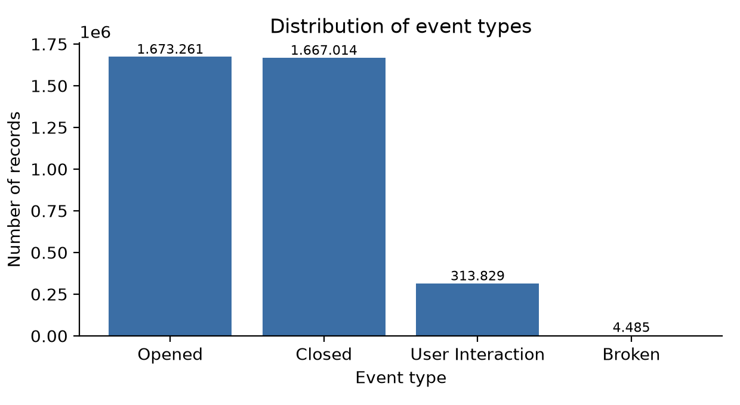
Figure 1. Distribution of event types.
Comment: Opening and closing records are almost balanced; interaction events are a small part of the distribution. Usage duration should therefore be based on opening–closing matching.
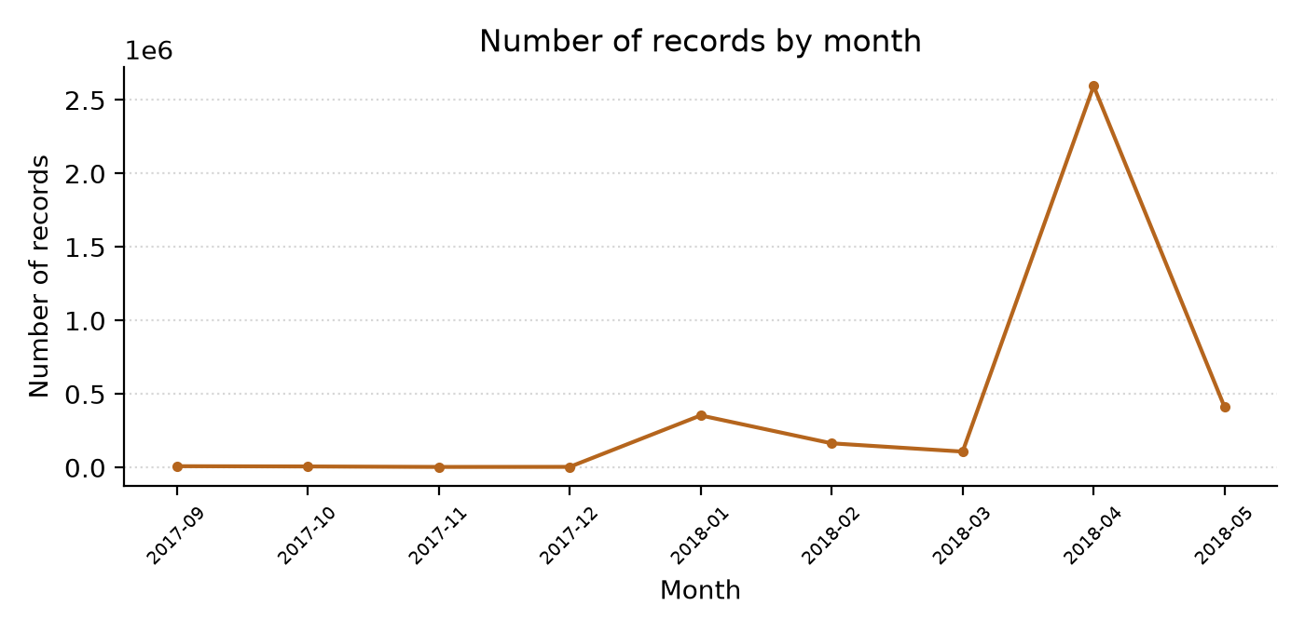
Figure 2. Change in the number of records by month.
Comment: Record density varies markedly across months; the increase in 2018-04 illustrates why a chronological training/test split was used.
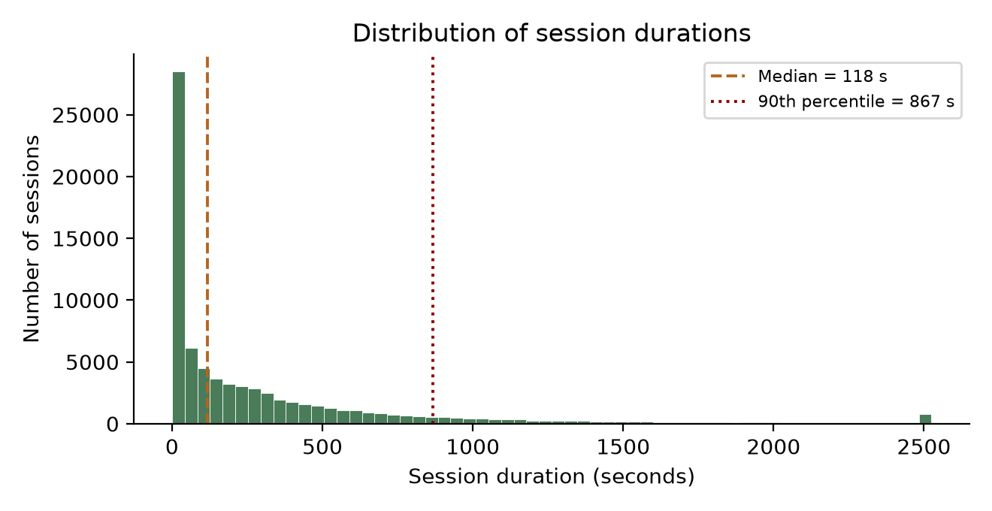
Figure 3. Distribution of session durations (histogram).
Comment: Session duration shows a right-skewed distribution; the median is about two minutes, while the long tail must be addressed separately in modeling.
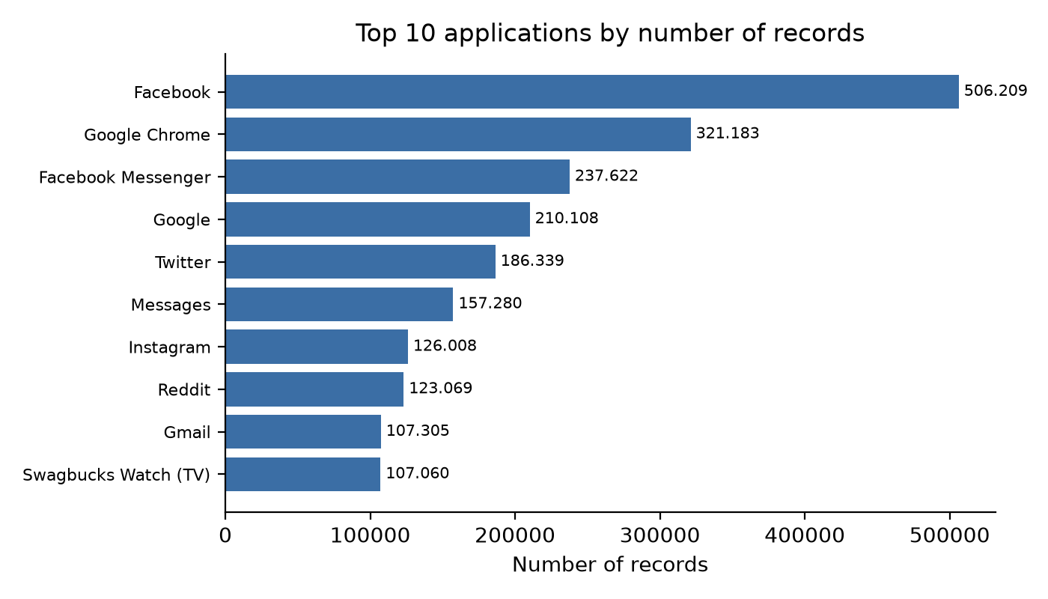
Figure 4. The ten applications with the most records.
Comment: The most intense records are in social and browser applications that continuously provide content; these applications are the main target of promise tracking.
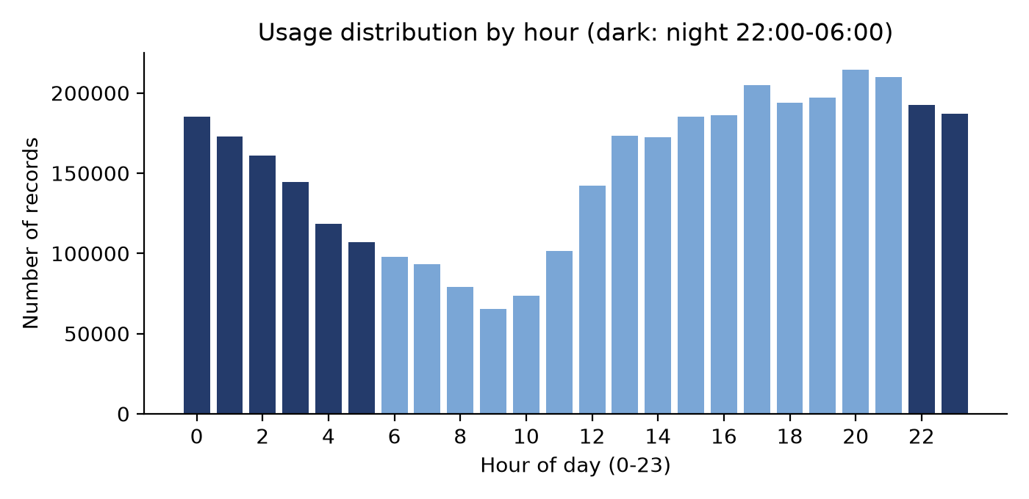
Figure 5. Distribution of usage by hour (dark color: nighttime hours).
Comment: Use continues during nighttime hours; the share of sessions in this region is about 35%. In the user-weighted calculation the rate does not change (~36%), meaning nighttime use is not specific to heavy users; the share spreads over a wide range across users (~8%–58%). Since timestamps do not contain local time information, this interpretation should be read together with the uncertainty in the data quality table. Nighttime use alone should not be regarded as a problem; Katevas et al. (2018) state that intense and nighttime-extending use is not directly an indicator of low well-being.

5.5. Promise simulation and modeling plan
After reliable application usage durations are constructed, a duration promise based on past behavior will be simulated for each use. For example, the median of the user's previous usage durations in the same application could be an initial option. Different promise-generation rules will also be compared.
The target variable will be defined as follows:
Promise kept = actual usage duration ≤ simulated promise duration.
The model inputs will include the promised duration, application, hour, day of the week, previous usage durations, time elapsed since the last use, and compliance with previous simulated promises. Including the promise duration in the model is important; in the same usage pattern, the probabilities of exceeding a 5-minute and a 20-minute goal differ.
To prevent data leakage:
- Promise and past usage features will be constructed only from records prior to the relevant use.
- Training, validation, and test splits will be separated chronologically.
- Cleaning and model settings will not be selected based on test results.
- The success of predicting the same user's future behavior and generalization to a new user will be evaluated separately.
At a later stage, generalization to new users will also be reported via person-level cross-validation ensuring that the same user is not in both the training and test sets.
In accordance with the project proposal, logistic regression and LightGBM will be compared; ROC-AUC and probability calibration will be evaluated. For the survival approach, the suitability of durations and incomplete observations will also be examined. At this stage, no model performance value or real promise-keeping rate has been calculated.

5.6. Initial modeling findings
After the preliminary examination and simulation preparation, a baseline model and the main model were trained comparatively on the LSApp data. The number of cleaned application sessions is 1,096,411; the number of samples with at least five past sessions and a simulatable promise is 1,076,135. The promise-keeping rate of the simulated promises was calculated as about 53.5%.
Since the promise does not actually exist in the data, it is a proxy value derived from the median of the user's past session durations in the relevant application; therefore, it does not include the psychological effect of a real promise, and the results should be evaluated with this limitation. To prevent data leakage, the training and test sets were separated chronologically (80%/20%); the series and median features were calculated only from records prior to the relevant use.
In the chronological test set, logistic regression achieved AUC = 0.784, while LightGBM achieved AUC = 0.881. After probability calibration, LightGBM's ECE value is 0.012 and its Brier score is 0.132; this means that when the model says “your probability of keeping your promise is 80%,” this value actually corresponds to about 80%. LightGBM provides about 0.10 higher discrimination power than the baseline model and produces reliable probabilities for the suggested durations. In the test set (n = 215,227), the 95% confidence interval for LightGBM was calculated as [0.880; 0.883]; the accuracy of the majority baseline that always assumes the promise was “kept” is only 53.4%. This shows that the model distinguishes markedly from chance.

6. Conclusion
The preliminary examination shows that LSApp is a suitable starting source for investigating repeated behaviors at the user and application level. However, the raw file contains intense duplication, and opening–closing events do not match one-to-one directly. Constructing reliable usage durations is the fundamental step that must be resolved before modeling.
The data research clarifies which information My Word Is My Bond can use for personalized duration suggestions and how predictions will be evaluated. With the existing data, the predictability of adherence to simulated duration goals can be investigated. Real promise-making behavior, the effect of reminders, and the reduction of digital use should be evaluated through subsequent user studies.
The analyses within the scope of this report reflect the current prototype stage of the project. At later stages, the data source can be expanded as needed: along with the existing LSApp dataset, other open datasets (for example, screen-time/daily usage logs or publicly available survey data) or our own survey and application-diary data could be added. Decisions to add to the dataset, add new features to the project, and add new logic (model/rule) are envisaged to be made through joint evaluation during the mentorship process. In this context, candidate headings are currently kept in a list, and the list is open to updating with mentor feedback. In this direction, opinions and responses are awaited for mentorship support.
In future work, the person-specific adaptation of the shared model (cold start) will be examined: how many days of personal usage logs are sufficient for a personalized duration suggestion will be observed in a small user pilot.

7. References
Aliannejadi, M. (n.d.). LSApp: Large dataset of sequential mobile app usage [Data set and documentation]. GitHub. Retrieved October 12, 2026. https://github.com/aliannejadi/LSApp
Aliannejadi, M., Zamani, H., Crestani, F., & Croft, W. B. (2021). Context-aware target apps selection and recommendation for enhancing personal mobile assistants. ACM Transactions on Information Systems, 39(3), Article 29. https://doi.org/10.1145/3447678
Katevas, K., Arapakis, I., & Pielot, M. (2018). Typical phone use habits: Intense use does not necessarily predict high well-being. In Proceedings of the 20th International Conference on Human-Computer Interaction with Mobile Devices and Services (MobileHCI ’18). ACM.
Personal Data Protection Authority. (2018). Communiqué on the procedures and principles to be followed in the fulfilment of the obligation to inform [Aydınlatma yükümlülüğünün yerine getirilmesinde uyulacak usul ve esaslar hakkında tebliğ]. https://www.kvkk.gov.tr/Icerik/4132/aydinlatma-yukumlulugunun-yerine-getirilmesinde-uyulacak-usul-ve-esaslar-hakkinda-teblig
Personal Data Protection Authority. (n.d.-a). Deletion, destruction, or anonymization of personal data [Kişisel verilerin silinmesi, yok edilmesi veya anonim hale getirilmesi]. https://www.kvkk.gov.tr/Icerik/2038/kisisel-verilerin-silinmesi-yok-edilmesi-veya-anonim-hale-getirilmesi
Personal Data Protection Authority. (n.d.-b). Obligations regarding data security [Veri güvenliğine ilişkin yükümlülükler]. https://www.kvkk.gov.tr/Icerik/2040/Veri-Guvenligine-Iliskin-Yukumlulukler
Parry, D. A., Davidson, B. I., Sewall, C. J. R., Fisher, J. T., Mieczkowski, H., & Quintana, D. S. (2021). A systematic review and meta-analysis of discrepancies between logged and self-reported digital media use. Nature Human Behaviour, 5(11), 1535–1547. https://doi.org/10.1038/s41562-021-01117-5

Part 3: Technology Review
My Word Is My Bond: Technology Review

1. Introduction
The My Word Is My Bond project aims to support users in keeping the duration promises they make before opening applications. The technological approach consists of processing usage logs, estimating the probability that the promise will be kept, personalized duration suggestions, well-timed reminders, and an AI coach that provides weekly evaluations.
The aim of this review is to evaluate which tasks the technologies in the project proposal can perform and which limits they have. In particular, the model predicting behavior, the mobile system observing this behavior in time, and the intervention providing benefit to the user are issues that must be examined separately. Technology choices will be evaluated in terms of cost, explainability, data privacy, and ease of use alongside prediction success.

2. Overview of Technologies
Classical time-series models were also evaluated; however, LightGBM and Survival Analysis were preferred because they can better capture a single user's sequential usage patterns and nonlinear relationships. In this way, both whether the promise will be kept and the session duration can be modeled together (Aliannejadi et al., 2021).

2.1. Python and pandas: Data preparation
A Python-based data processing environment will be used for cleaning the LSApp records and building the modeling table. pandas supports operations such as reading TSV files, processing dates, and grouping at the user and application level. Large files can be read in chunks when necessary (pandas Development Team, n.d.).
In My Word Is My Bond, the task of these tools is to transform raw event records into reliable usage durations and to generate model features only from past information. Data preparation rules will be recorded so that analyses on the same data can be reproduced.

2.2. Logistic regression: Explainable baseline model
Logistic regression is a classification method that produces probability estimates for binary targets. The scikit-learn implementation supports regularization options and the calculation of class probabilities (scikit-learn Developers, n.d.-a).
In the project, the target is whether the actual usage exceeds the promised duration. Logistic regression will be used as the baseline model to examine the relationship of promise duration, application, usage time, and past behaviors with this outcome.
The coefficients are interpretable under appropriate coding and scaling. However, the model may not comprehensively capture nonlinear patterns and interactions between variables by itself. In addition, the coefficients do not show the causal effect of the variables on behavior.

2.3. LightGBM: Main prediction model
LightGBM is a gradient boosting library based on decision trees. It offers histogram-based learning, categorical variable support, and efficient training features. The leaf-wise growth method can lead to overfitting when appropriate restrictions are not used (LightGBM, n.d.).
In My Word Is My Bond, LightGBM is planned as the main model to learn the nonlinear usage patterns that users exhibit in different applications and at different times. For example, the information carried jointly by usage time and past usage duration can be evaluated.
In a preliminary trial with chronological validation, LightGBM surpassed the logistic regression value of 0.784 with a ROC-AUC of 0.881 in promise-keeping prediction; after probability calibration, the expected calibration error (ECE) dropped to 0.012 (Brier 0.132). The results were obtained on the LSApp records with 1,076,135 simulated promises (promise-keeping rate 53.5%; train/test split 04/25/2018) and cannot be generalized to real promise behavior.

2.4. Survival analysis: Probability of continued use
Survival analysis models the time until an event occurs. The survival function expresses the probability that the event will occur after a certain point in time. scikit-survival offers methods for duration data and appropriately defined censored observations (scikit-survival Developers, n.d.).
In My Word Is My Bond, the event that can be modeled is the termination of application use. In this way, the probability that use continues until the promised duration can be investigated.
Here there is an important definition: When the user makes a fixed duration promise, the threshold at which the promise will be exceeded is already known. The issue the model will investigate is whether the user exits the application before reaching this threshold. Updating predictions for ongoing use requires appropriate conditioning or dynamic modeling.
The absence of a closing record will also not automatically count as a valid censored observation; why the observation process ended must be evaluated.

2.5. Ready-made large language model: Weekly AI coach
In accordance with the project proposal, the AI coach will be built on a ready-made large language model used without additional training. The prompts will guide the model to produce short, clear, and non-judgmental weekly evaluations.
The coach will be given limited summaries computed by the system instead of raw usage records. Numerical results such as the promise-keeping rate and usage duration will be calculated by the application; the language model will explain them. The basis of the duration suggestion and the reminder decision will be formed by the prediction models and the rules determined.
Large language models can present false information in confident language and carry data privacy risks. NIST (2024) recommends that these risks be assessed in the context of use. Therefore, prompt engineering alone will not be considered sufficient; outputs will be tested for accuracy, language, and appropriateness. The model provider has not yet been determined.

2.6. Mobile usage tracking and development tools
Android — UsageStatsManager
UsageStatsManager can be used to query application usage statistics and usage events. Most methods require usage access; in addition to the permission being declared by the application, the user must grant access from settings (Google, n.d.-d).
This API can contribute to usage tracking. However, by itself it is not a mechanism that stops another application from opening and shows a promise screen beforehand. Android also restricts screen launches from the background. Therefore, the pre-launch promise flow and the timely delivery of reminders will also be verified on the prototype (Google, n.d.-a).
iOS — Screen Time API family
Apple's Family Controls, Device Activity, and Managed Settings tools can be used to monitor and manage use within the permitted scope. Apple describes usage scenarios that protect individual authorization and privacy. The distribution of applications using Family Controls additionally requires obtaining the relevant entitlement (Apple, 2022; Apple, n.d.). It will not be assumed that Android and iOS will provide the same data access or intervention flow.
Kotlin and Flutter
Kotlin is an officially supported option for Android development. Flutter, on the other hand, allows shared interface development; it supports communicating with native code for platform-specific functions. However, shared interface code does not eliminate operating-system permissions (Google, n.d.-b; Flutter, n.d.).
Since no mobile development framework was chosen in the project proposal, these are candidates under evaluation.

3. Relationship of Technologies to the Project
Need in the project | Technology | Contribution it will provide
Preparing usage logs | Python and pandas | Cleaning, event matching, and generating past features
Predicting the probability that the promise will be kept | Logistic regression and LightGBM | Comparison of the baseline model with the main model
Evaluating continued use | Survival analysis | Examining continuation probabilities over time
Choosing a reminder based on risk information | Prediction model and decision rules | Determining timing, frequency, and intervention options
Providing a weekly evaluation | Ready-made large language model | Explaining computed results understandably
Observing real usage data | Mobile platform APIs | Usage tracking within the scope of user permission
The Hook Score and trust score can also be evaluated as model inputs or feedback elements. However, their calculation rules must be defined in advance and their additional predictive value measured. These scores will not be presented as a validated addiction measure or an assessment of the user's personality.

4. Comparison and Evaluation

4.1. Model options
Option | Strength | Limitation | Cost and resource need | Suitability for the project
Logistic regression | Relatively easy interpretation and simple implementation; high ease of use. | May require additional features for complex relationships | Relatively low | Baseline comparison model
LightGBM | Can learn nonlinear relationships and interactions; high performance. | Requires tuning, overfitting control, and additional explanation | Depends on model size | Planned main model
Survival model | Addresses the time to termination and continuation probability | The event and observation process must be defined correctly | Depends on the chosen method | Timing research
Ready-made large language model | Can generate flexible and understandable text | Incorrect output, variable cost, and privacy risk | Depends on the provider and amount of use | Weekly coaching text
Rule-based feedback | Predictable and auditable | Limited variety of expression | Relatively low | Comparison and fallback option for the coach
The evaluation used the criteria of cost, ease of use, performance, scalability, data privacy, explainability, and accessibility. Logistic regression is ahead in ease of use and explainability, while LightGBM has high performance in nonlinear patterns. Since LightGBM and the ready-made large language model can work with cloud-based APIs, they provide scalability at high user numbers.
The table is an evaluation made over technology features and project requirements; preliminary trial results are reported in 4.1.
Classification models will be evaluated with probability calibration in addition to ROC-AUC. This is because in personalized suggestions not only the risk ranking but also the agreement of the estimated probability with actual outcomes is important. Calibration curves will be used; Brier score and log loss will be evaluated as complementary measures. Brier score alone does not measure only calibration (scikit-learn Developers, n.d.-b).

4.2. Mobile development options
Option | Advantage | Limitation
Native Android development — Kotlin | Direct work with Android APIs and lifecycle | Requires separate development for iOS
Flutter | Shared interface development for Android and iOS | Requires platform-specific integration for functions such as usage tracking
Kotlin is a suitable candidate for the first Android-focused technical prototype. If the two platforms are targeted together, Flutter can be considered. The final choice will be based on the team's development experience and the verification of required functions on devices.
On-device prediction can reduce data transfer. Server-side prediction, on the other hand, can facilitate model updates; it requires connectivity, latency, and data transfer. It will not be claimed that LightGBM provides low resource consumption on mobile without measurement on the device.
For accessibility, short Turkish descriptions, readable text, indicators that convey meaning beyond color, and adjustable notifications will be targeted.

5. Use Cases
Google Digital Wellbeing
Digital Wellbeing shows application usage durations and offers daily application timers. When the time is up, the application closes; the timers reset at midnight. This product is an operating-system-level example of usage tracking and restriction. My Word Is My Bond, by contrast, investigates the pre-session duration promise and support adapted according to past behavior (Google, n.d.-c).
one sec
Grüning et al. (2023) examined the one sec application, which combines a brief delay, a reflective message, and a decline-to-open option at application launch. The study shows that interventions at the launch moment can be effective on behavior. However, My Word Is My Bond's duration promise, prediction models, or personalized reminders were not tested in this research.
Adaptive mobile interventions
Nahum-Shani et al. (2018) describe the JITAI approach, in which support is arranged according to the person's changing state and context. This framework provides a basis for the reminder timing of My Word Is My Bond. However, the need for a reminder and the person's suitability to receive a reminder must be evaluated separately.
Public health and awareness programs
In Turkey, Yeşilay provides information, prevention, and counseling services in digital addiction through the Turkish Green Crescent Addiction Prevention (TBM) program and YEDAM (115 Counseling Line) (Yeşilay, 2024; YEDAM, n.d.). At the international level, the Center for Humane Technology conducts awareness work on the effect of technology design on attention; Google's Digital Wellbeing Experiments platform, in turn, offers experimental tools that support healthier digital habits (Google, n.d.-c).
Risk-prediction-based models and products
Sequential models that predict the next behavior from usage history have a real application area for personalized interventions. Aliannejadi et al. (2021) showed that models using sequential and contextual features exceeded the baseline models in application recommendation on the LSApp dataset. one sec (Grüning et al., 2023), in turn, is a commercial example that achieves measured behavior change through pre-launch intervention.

6. Limitations and Research Opportunities
Feasibility of the pre-launch promise flow: Usage tracking does not guarantee that a promise is obtained before every launch. A prototype flow in which the user launches the target application from within My Word Is My Bond could be considered. Opening the application through another path and platform constraints must also be tested.
Transition from simulation to real behavior: Achieving good prediction success on LSApp does not show that real users will keep their promises more or that reminders will be effective. The behavioral effect of fixed and model-timed reminders requires a user study.
Meaningfulness of goals: Increasing the promise-keeping probability by suggesting longer durations may not contribute to a reduction in use. Suggestions must take attainability and the user's reduction goal into account together.
Notification and gamification burden: The possibility that badges, the promise tree, streaks, and social profile features create a desire to check the application repeatedly will be evaluated. The number of notifications will be limited, social comparison will be adjustable, and missed goals will not be presented in an accusatory language. Success will not be measured solely by an increase in in-app engagement.
Accuracy and privacy of the coach: The coach will be prevented from altering numerical results, making diagnoses, or giving unverified health advice; output checks and test scenarios will be used for this. The transfer of raw records to external services will not be the default.
Referral to professional support: The coach will not replace professional support. When necessary, a verified, fixed referral will be presented to the user. YEDAM provides service for support and information related to addiction through the 115 Counseling Line (YEDAM, n.d.).
In the prototype-level application, ethical boundaries were protected with the following principles: directing to Yeşilay 115 and 112 without making a diagnosis in expressions containing crisis or self-harm signals; not using stigmatizing and medical expressions such as “addicted,” “patient,” or “treatment”; adding the note “This information is for awareness purposes and is not a medical diagnosis or treatment recommendation.” at the end of every output; and not transferring raw usage records to external services. These principles aim to ensure that the coach does not replace professional support and that user data is protected.
The risks considered in the design of My Word Is My Bond and the measures against these risks in the application are summarized in the following table:
Risk | Scope of the risk | Measure in the application
Notification fatigue turning into compulsion | Consecutive alerts in the same session can annoy the user | At most one reminder per session; a cooldown between notifications; details are left to the weekly summary
False alarm | Risk prediction is not certain for every launch | The alert explains the “why” part of high risk; it can be dismissed with the “continue deliberately” option; the decision threshold is adjusted per person
Privacy breach | The raw usage log is sensitive | Feature extraction and prediction run on the device; only aggregated statistics are sent outside
Use for surveillance | The data could be controlled by other people | There is no parent/employer surveillance mode; only the user decides who sees what
Stigma and labeling | A high-risk output can create a perception of being “addicted” | The application does not diagnose; the language is behavior-focused (see Part 1, §2.1)
Substitution of professional support | The coach may be perceived as replacing health support | Referral to channels such as YEDAM (115) in case of crisis signals; the coach explains only computed summaries
The technology evaluation in this section is also limited to the prototype nature of the project and has been left open to expansion. When necessary, new components can be added to the technology stack and the application; for example, real-time reminder scheduling logic, different modeling approaches, a sleep/well-being-oriented module, or multilingual support could be considered. Such additions will be planned by joint decision during the mentorship process. Candidate features and new logic are currently kept in a list; a response is awaited for mentorship support. Thus, the design has been kept flexible so that additions can be made to both the dataset and the project and new logic can be developed.

7. Conclusion
The logistic regression and LightGBM planned for My Word Is My Bond are suitable starting options for producing adherence predictions to the duration target from tabular usage features. Survival analysis can investigate the probability of continued use; the ready-made large language model, in turn, can transform computed results into short weekly evaluations.
Technological success depends on these tools working reliably together. In particular, the mobile launch flow, reminder latency, device resources, and user acceptance must be evaluated on the prototype. Final choices will be based on the project's own data and the results obtained from device tests.

8. References — APA 7
Apple. (2022). What’s new in Screen Time API [Video]. https://developer.apple.com/videos/play/wwdc2022/110336/
Apple. (n.d.). Requesting the Family Controls entitlement. https://developer.apple.com/documentation/familycontrols/requesting-the-family-controls-entitlement
Flutter. (n.d.). Writing custom platform-specific code. https://docs.flutter.dev/platform-integration/platform-channels
Google. (n.d.-a). Activity security. Android Developers. https://developer.android.com/guide/components/activities/secure-bal
Google. (n.d.-b). Kotlin and Android. Android Developers. https://developer.android.com/kotlin
Google. (n.d.-c). Manage how you spend time on your Android phone with Digital Wellbeing. https://support.google.com/android/answer/9346420
Google. (n.d.-d). UsageStatsManager. Android Developers. https://developer.android.com/reference/android/app/usage/UsageStatsManager
Grüning, D. J., Riedel, F., & Lorenz-Spreen, P. (2023). Directing smartphone use through the self-nudge app one sec. Proceedings of the National Academy of Sciences, 120(8), e2213114120. https://doi.org/10.1073/pnas.2213114120
LightGBM. (n.d.). Features. https://lightgbm.readthedocs.io/en/latest/Features.html
Nahum-Shani, I., Smith, S. N., Spring, B. J., Collins, L. M., Witkiewitz, K., Tewari, A., & Murphy, S. A. (2018). Just-in-time adaptive interventions (JITAIs) in mobile health: Key components and design principles for ongoing health behavior support. Annals of Behavioral Medicine, 52(6), 446–462. https://doi.org/10.1007/s12160-016-9830-8
National Institute of Standards and Technology. (2024). Artificial intelligence risk management framework: Generative artificial intelligence profile (NIST AI 600-1). https://doi.org/10.6028/NIST.AI.600-1
pandas Development Team. (n.d.). pandas.read_table. https://pandas.pydata.org/docs/reference/api/pandas.read_table.html
scikit-learn Developers. (n.d.-a). LogisticRegression. https://scikit-learn.org/stable/modules/generated/sklearn.linear_model.LogisticRegression.html
scikit-learn Developers. (n.d.-b). Probability calibration. https://scikit-learn.org/stable/modules/calibration.html
scikit-survival Developers. (n.d.). Introduction to survival analysis with scikit-survival. https://scikit-survival.readthedocs.io/en/stable/user_guide/00-introduction.html
YEDAM. (n.d.). Telephone counseling [Telefon ile danışmanlık]. https://www.yedam.org.tr/telefon-ile-danismanlik

