DATA SCIENCE INTERNSHIP REPORT

Submitted By:
Name: Vaheeda Begum
Qualification: B.Sc (Computer Science)
College: Akkineni Nageswara Rao College
Academic Year: 2020–2023
Internship Details:
Organization: Cognifyz Technologies
Domain: Data Science Internship
Duration: 14-06-2026 to 14-07-2026
Letter Reference No.: CTI/A1/C372727
Levels Completed:
- Level 1
- Level 2

Page 2: INDEX
S.No | Contents
1 | Cover Page
2 | Index
3 | Level 1 – Task 1: Data Exploration and Preprocessing
4 | Level 1 – Task 2: Descriptive Analysis
5 | Level 1 – Task 3: Geospatial Analysis
6 | Level 2 – Task 1: Table Booking and Online Delivery
7 | Level 2 – Task 2: Price Range Analysis
8 | Level 2 – Task 3: Feature Engineering
9 | Conclusion

LEVEL1 TASK1:
Objective:
To understand the dataset structure and identify missing values and data types.
Dataset Shape:
The dataset was successfully loaded using Pandas. It contains 9551 rows and 21 columns.
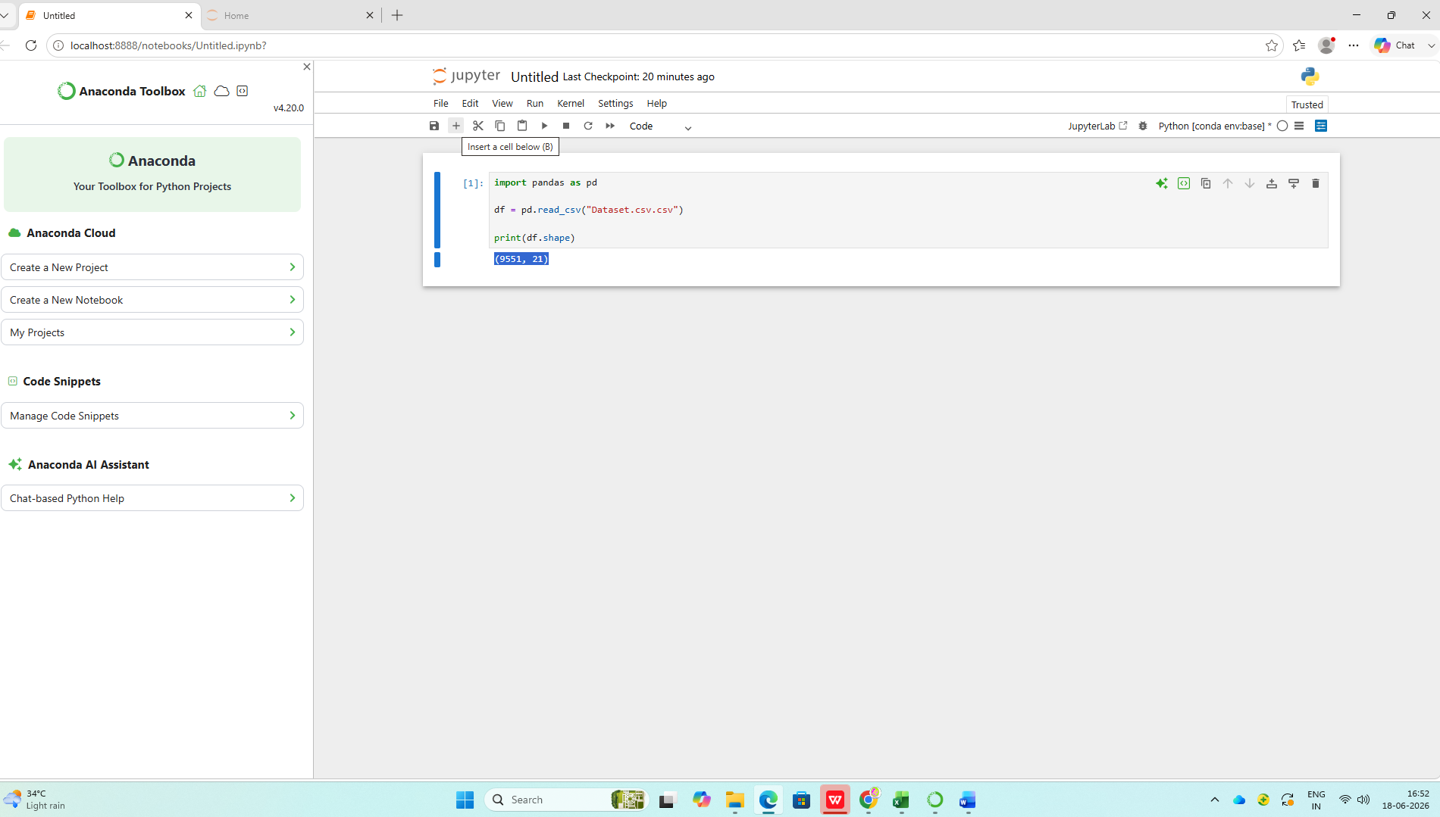

Observation:
The dataset contains 9551 records and 21 attributes, providing sufficient information for exploratory data analysis.

Missing Value Analysis
Missing values were checked across all columns of the dataset using the isnull() function. The analysis revealed that only the Cuisines column contains missing values (9 records), while all other columns have no missing values.
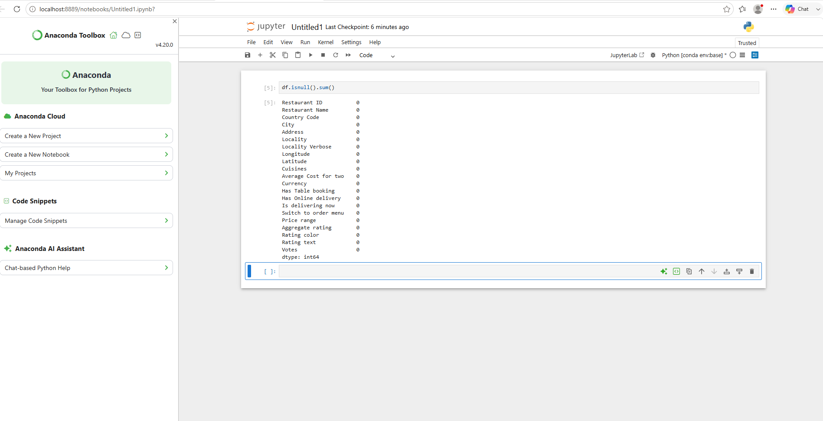

Observation
The dataset is now complete and free from missing values. This improves data quality and ensures accurate analysis in subsequent tasks.

Data Type Analysis
The data types of all columns were examined to identify numerical and categorical variables in the dataset. The dataset contains a combination of integer, float, and object data types.
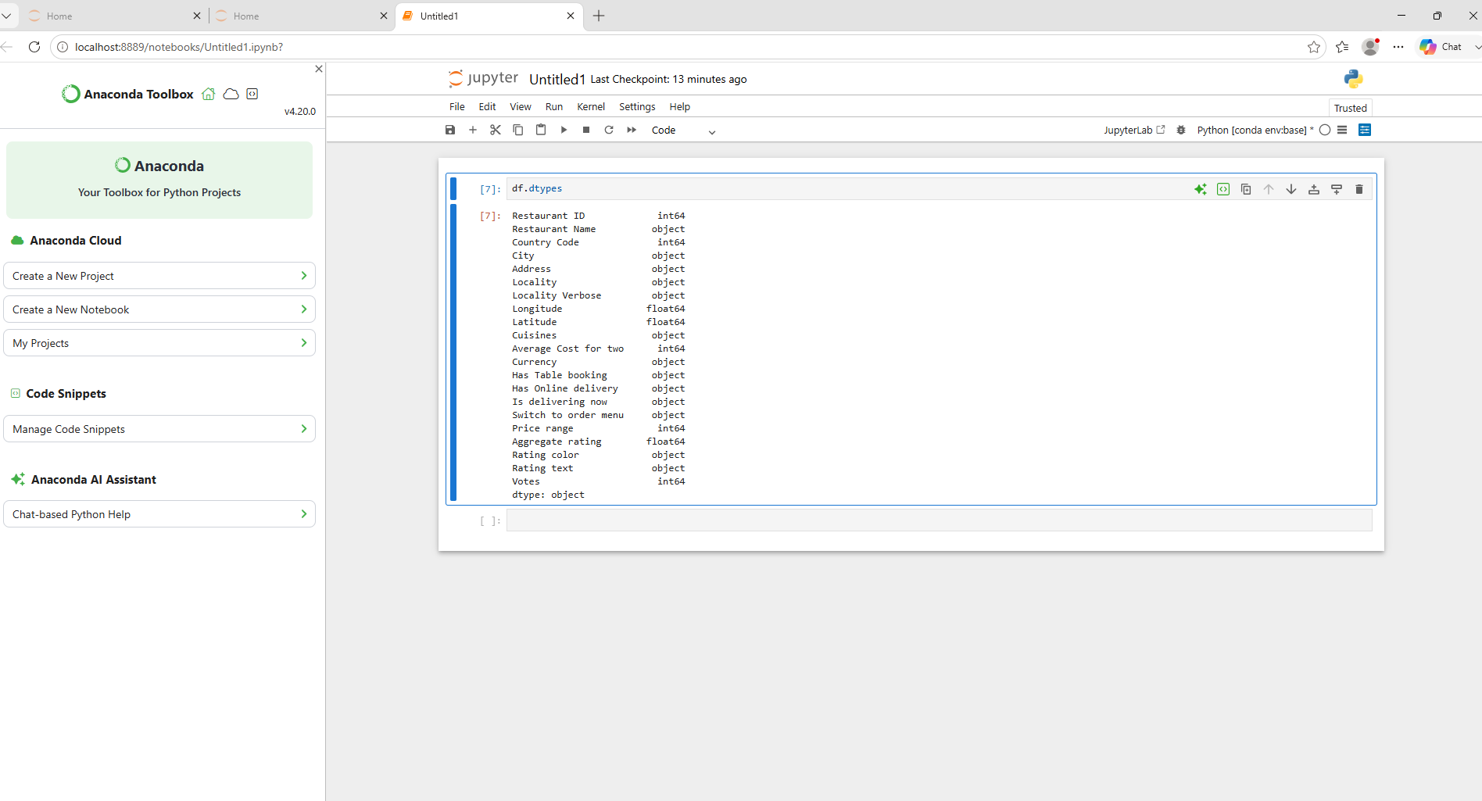

Observation
- Integer (int64) columns include Restaurant ID, Country Code, Average Cost for Two, Price Range, and Votes.
- Float (float64) columns include Longitude, Latitude, and Aggregate Rating.
- Object (object) columns include Restaurant Name, City, Address, Cuisines, Currency, Rating Text, and other categorical features.
- The dataset contains both numerical and categorical variables, making it suitable for statistical analysis and visualization.

Aggregate Rating Analysis
The Aggregate Rating column was analyzed using descriptive statistics to understand the distribution of restaurant ratings.
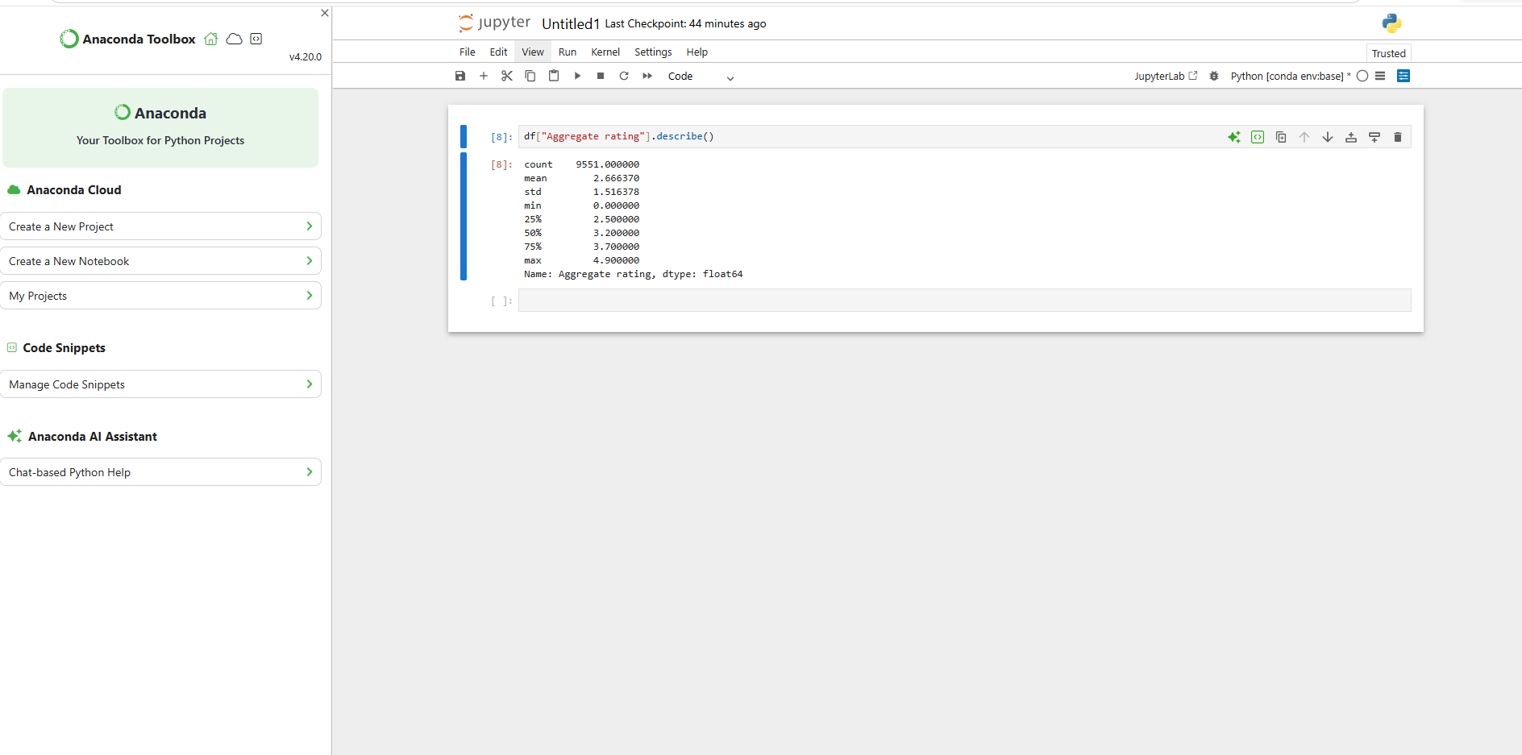
Results
- Count: 9551
- Mean Rating: 2.67
- Standard Deviation: 1.52
- Minimum Rating: 0.0
- Maximum Rating: 4.9
- Median Rating: 3.2
- 75% of restaurants have ratings below 3.7
Observation
The average restaurant rating is 2.67, while the median rating is 3.2. Ratings range from 0.0 to 4.9, indicating variation in restaurant performance. Most restaurants have ratings between 2.5 and 3.7.

Task 1 Conclusion
The dataset was successfully explored and preprocessed. It contains 9551 rows and 21 columns. Missing values were identified and handled appropriately. Data types were examined, and the Aggregate Rating variable was analyzed using descriptive statistics. The dataset is clean and ready for further analysis and visualization.

Task 2: Descriptive Analysis
Objective
To perform descriptive analysis and identify key patterns in the restaurant dataset.
Statistical Summary
A statistical summary was generated for the numerical columns to understand the distribution of values and overall dataset characteristics.

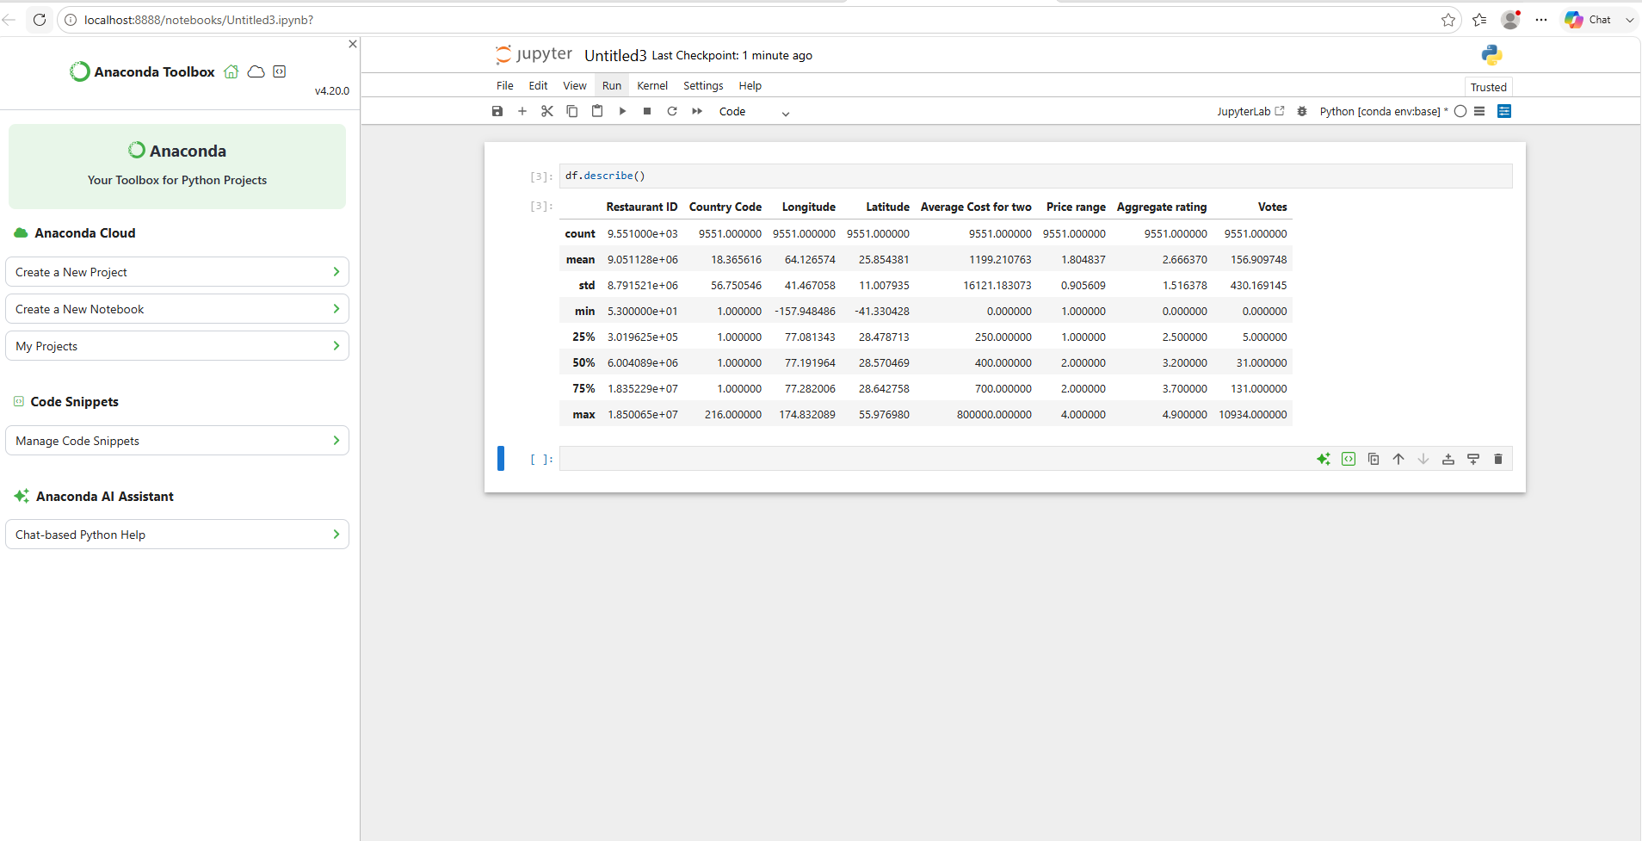

Observation
The dataset contains a wide range of values across different numerical features such as Aggregate Rating, Votes, Price Range, and Average Cost for Two. Descriptive statistics help in understanding the overall distribution of data.

City-wise Analysis
A city-wise analysis was performed to identify the cities with the highest number of restaurants in the dataset.

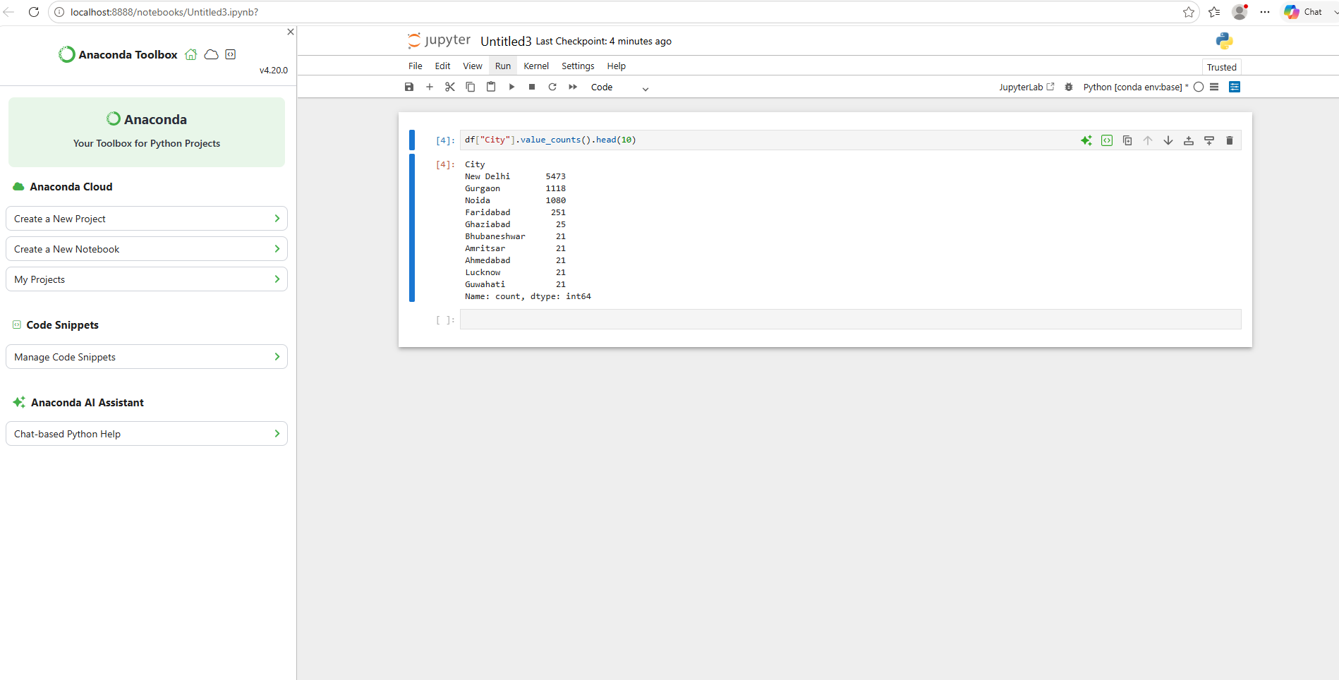

Observation
The analysis revealed that New Delhi has the highest number of restaurants (5473), followed by Gurgaon (1118) and Noida (1080). These three cities contribute a major portion of the restaurants in the dataset. Other cities such as Faridabad, Ghaziabad, Bhubaneshwar, Amritsar, Ahmedabad, Lucknow, and Guwahati have comparatively fewer restaurants.

Cuisine Analysis
A cuisine-wise analysis was performed to identify the most popular cuisines among restaurants in the dataset.

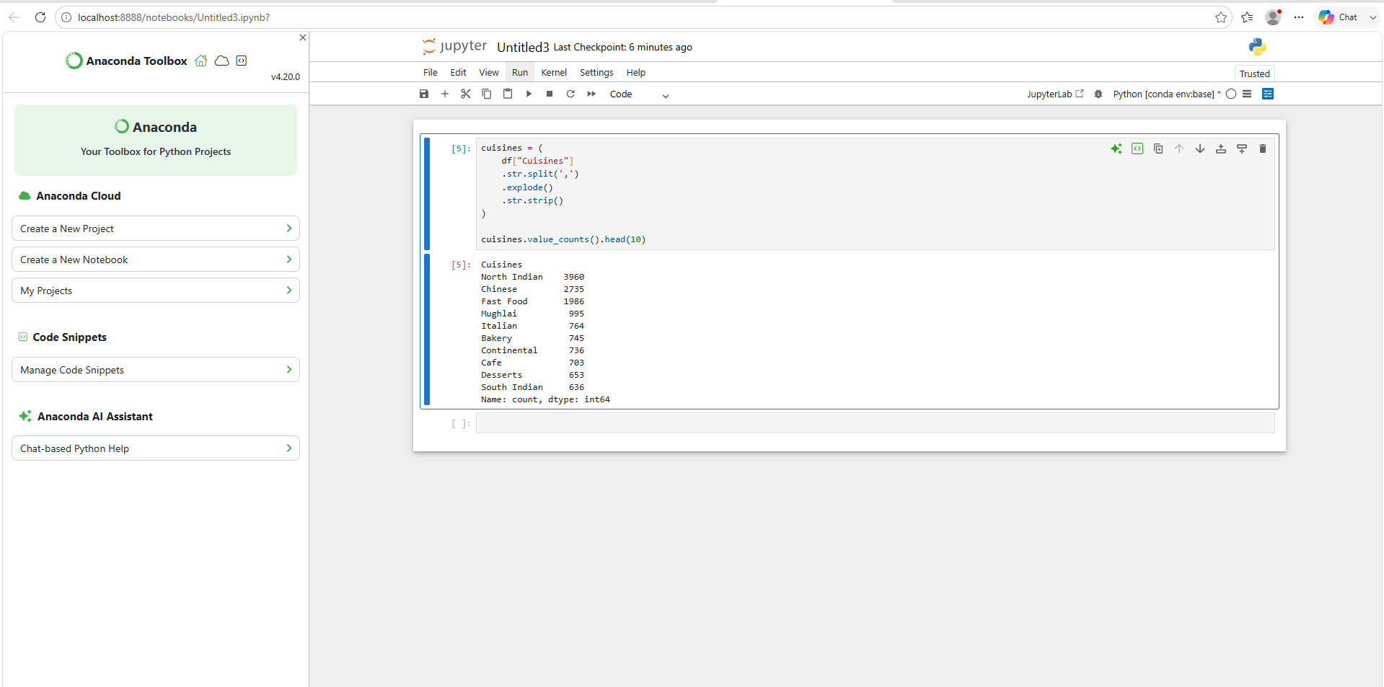

Observation
The analysis shows that North Indian cuisine is the most popular cuisine with 3960 occurrences, followed by Chinese (2735) and Fast Food (1986). Other commonly available cuisines include Mughlai, Italian, Bakery, Continental, Cafe, Desserts, and South Indian. This indicates that Indian and Asian cuisines dominate the restaurant market in the dataset.

Key Findings
- The dataset contains 9551 restaurant records.
- New Delhi has the highest number of restaurants, followed by Gurgaon and Noida.
- North Indian cuisine is the most popular cuisine in the dataset.
- Chinese and Fast Food cuisines are also widely available.
- Restaurant distribution is concentrated in a few major cities.

Task 2 Conclusion
Descriptive analysis was performed to understand the dataset and identify important trends. The analysis revealed that New Delhi has the largest number of restaurants and North Indian cuisine is the most frequently served cuisine. The findings provide valuable insights into restaurant distribution and customer food preferences.
Objective
To analyze the geographical distribution of restaurants using latitude and longitude coordinates.
Restaurant Location Analysis
A scatter plot was created using restaurant latitude and longitude values to visualize restaurant locations.
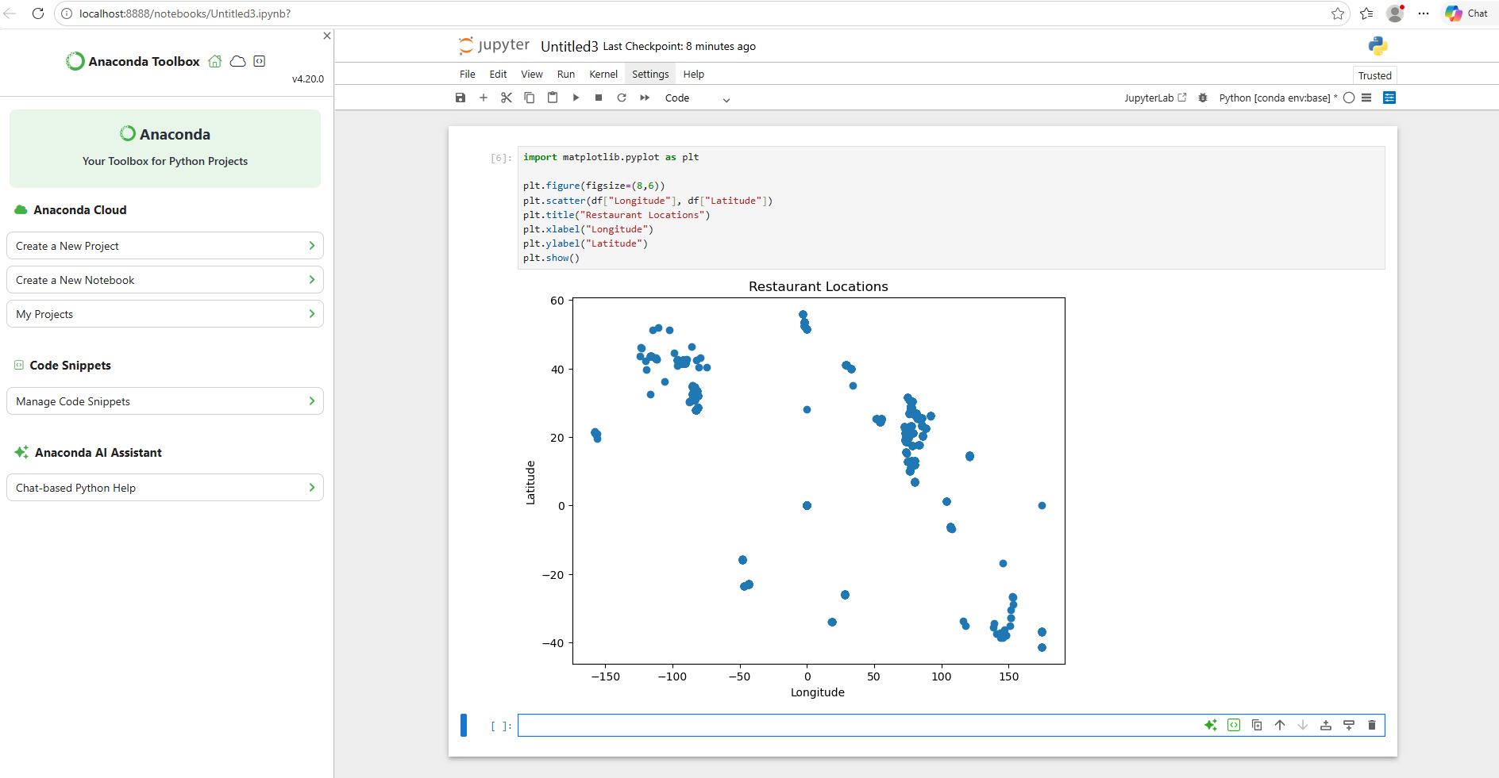

Observation
The scatter plot shows the geographical distribution of restaurants across different locations. Restaurants are concentrated in specific regions, indicating higher restaurant density in major cities and urban areas.

Key Findings
- Restaurants are not evenly distributed across all locations.
- Higher concentrations of restaurants are visible in major urban regions.
- Geographic coordinates help identify restaurant clusters and areas with high restaurant activity.
- Location plays an important role in restaurant distribution.

Conclusion
Geospatial analysis was performed using latitude and longitude data. The visualization revealed that restaurants are concentrated in specific geographic regions, particularly major cities. This analysis provides insights into restaurant density and location-based trends.

Level 2 – Task 1 Report
Table Booking and Online Delivery Analysis
The percentage of restaurants offering table booking and online delivery services was calculated.

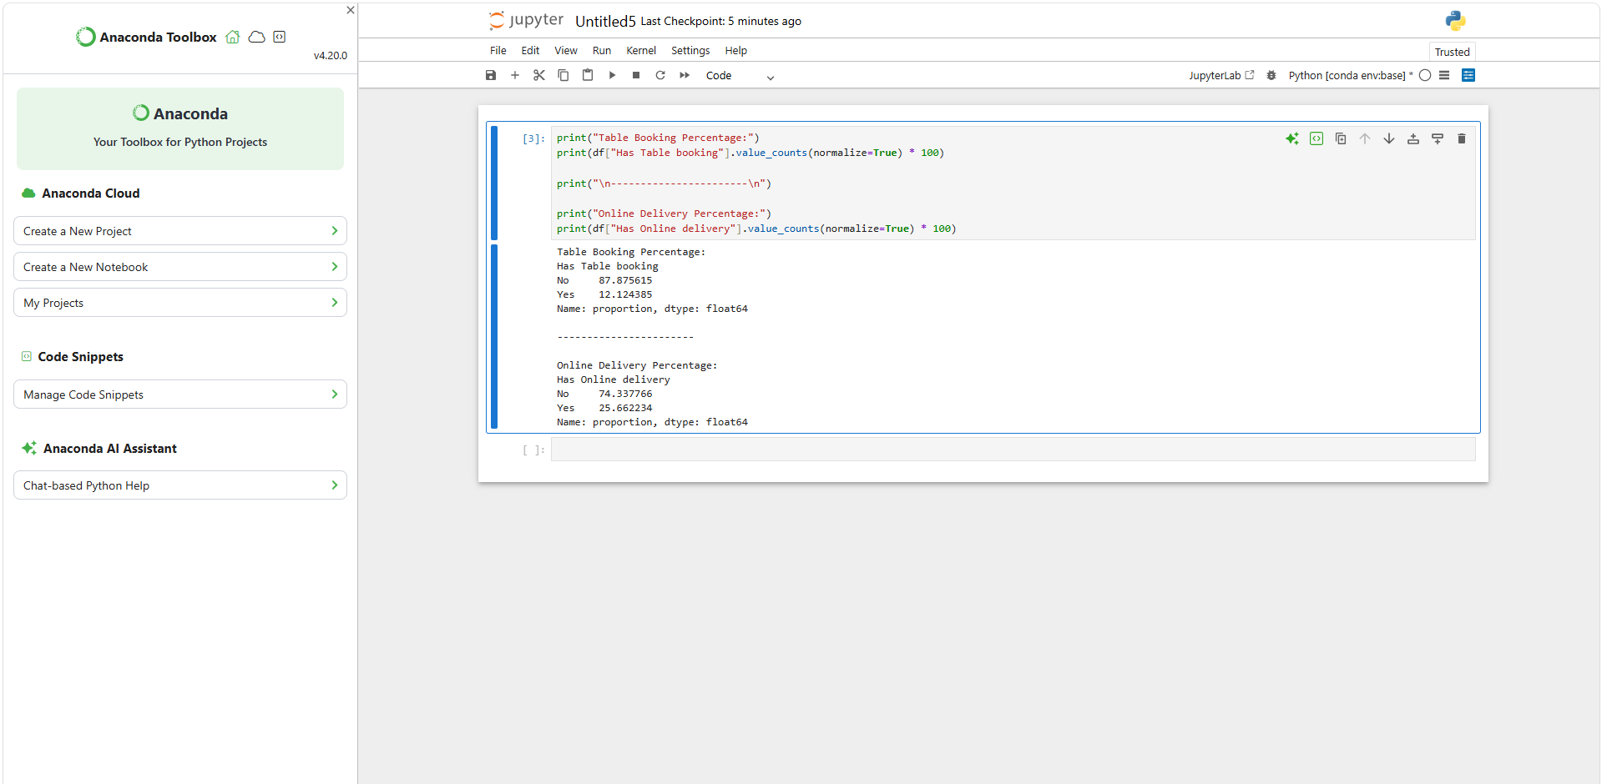

Results
- Restaurants with Table Booking: 12.12%
- Restaurants without Table Booking: 87.88%
- Restaurants with Online Delivery: 25.66%
- Restaurants without Online Delivery: 74.34%
Observation
The majority of restaurants do not provide table booking facilities. Only 12.12% of restaurants offer table booking services. Similarly, online delivery is available in 25.66% of restaurants, while most restaurants do not provide online delivery. This indicates that traditional dine-in services are more common in the dataset.

Average Rating Comparison
The average ratings of restaurants with and without table booking facilities were compared.

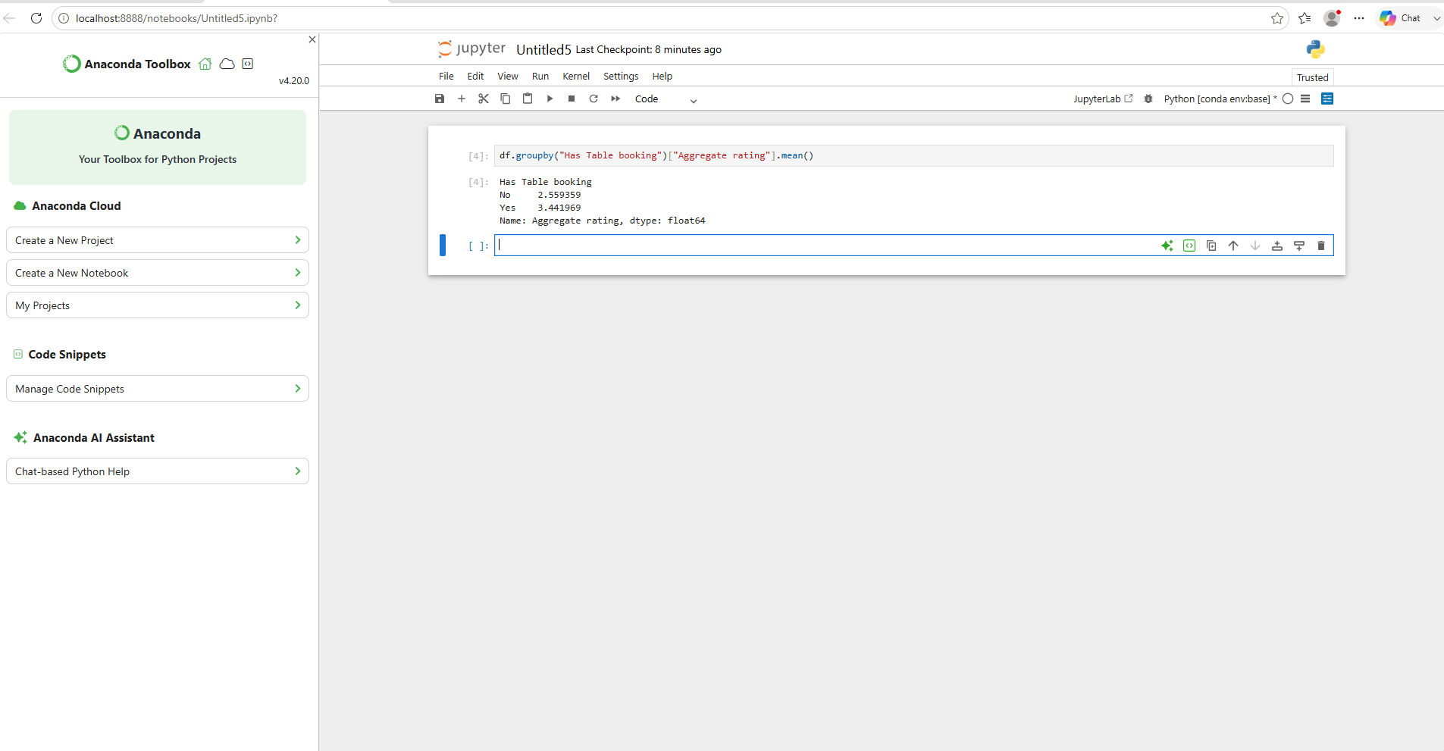

Results
- Average Rating (Without Table Booking): 2.56
- Average Rating (With Table Booking): 3.44
Observation
Restaurants that offer table booking have a significantly higher average rating (3.44) compared to restaurants that do not offer table booking (2.56). This suggests that restaurants providing table booking services may offer a better customer experience and receive higher customer satisfaction ratings.
Online Delivery Availability by Price Range
The availability of online delivery services was analyzed across different price ranges.

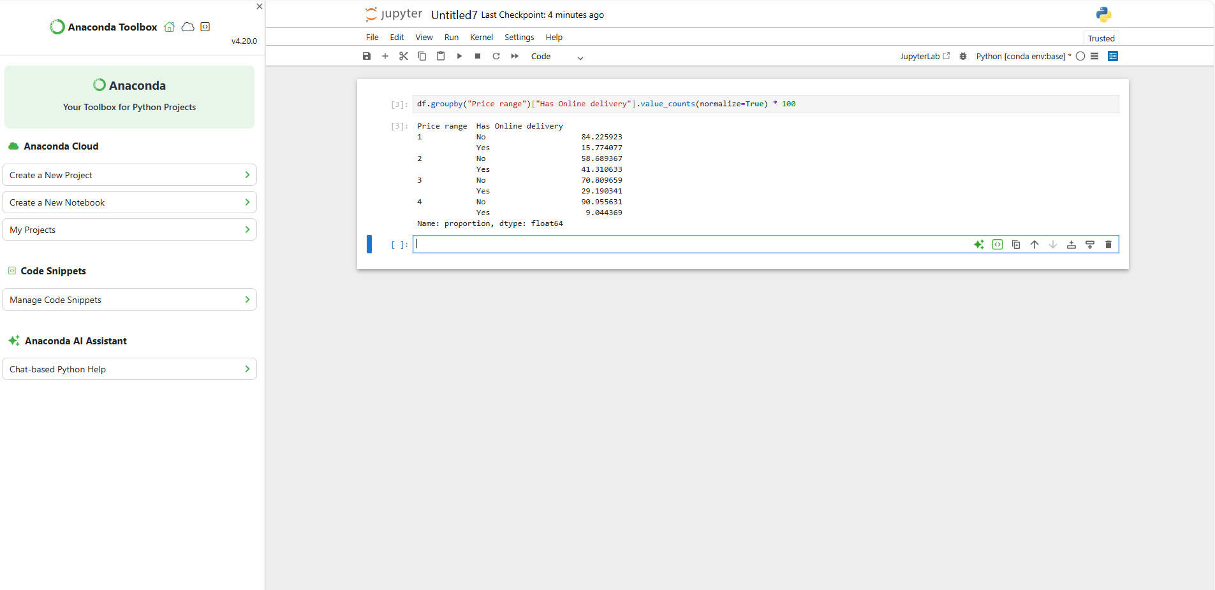

Results
Price Range | Online Delivery Available
1 | 15.77%
2 | 41.31%
3 | 29.19%
4 | 9.04%
Observation
- Restaurants in Price Range 2 have the highest online delivery availability (41.31%).
- Restaurants in Price Range 4 have the lowest online delivery availability (9.04%).
- Mid-priced restaurants are more likely to offer online delivery services than premium restaurants.
- Online delivery is most common among affordable and mid-range restaurants.
- Level 2 – Task 1 Conclusion
- The analysis revealed that only a small percentage of restaurants offer table booking services, while online delivery is available in approximately one-fourth of restaurants. Restaurants with table booking facilities tend to have higher average ratings. Online delivery services are most commonly available among mid-priced restaurants.

Level 2 – Task 3: Feature Engineering
Restaurant Name and Address Length Analysis
New features were created by calculating the length of restaurant names and addresses.

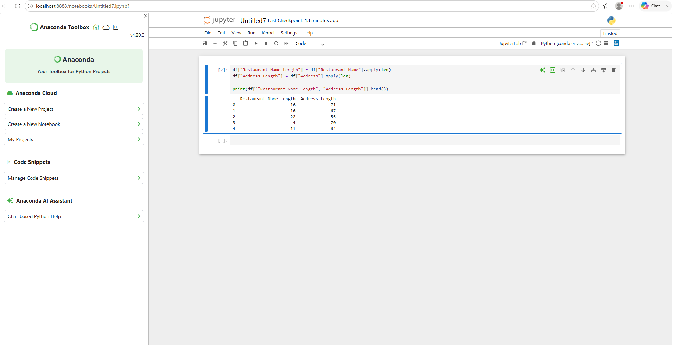

Observation
Two new features were generated:
- Restaurant Name Length represents the number of characters in the restaurant name.
- Address Length represents the number of characters in the restaurant address.
These features can be useful for future predictive analysis and machine learning models.Encoding Analysis
The categorical variables Has Table Booking and Has Online Delivery were converted into numerical values.

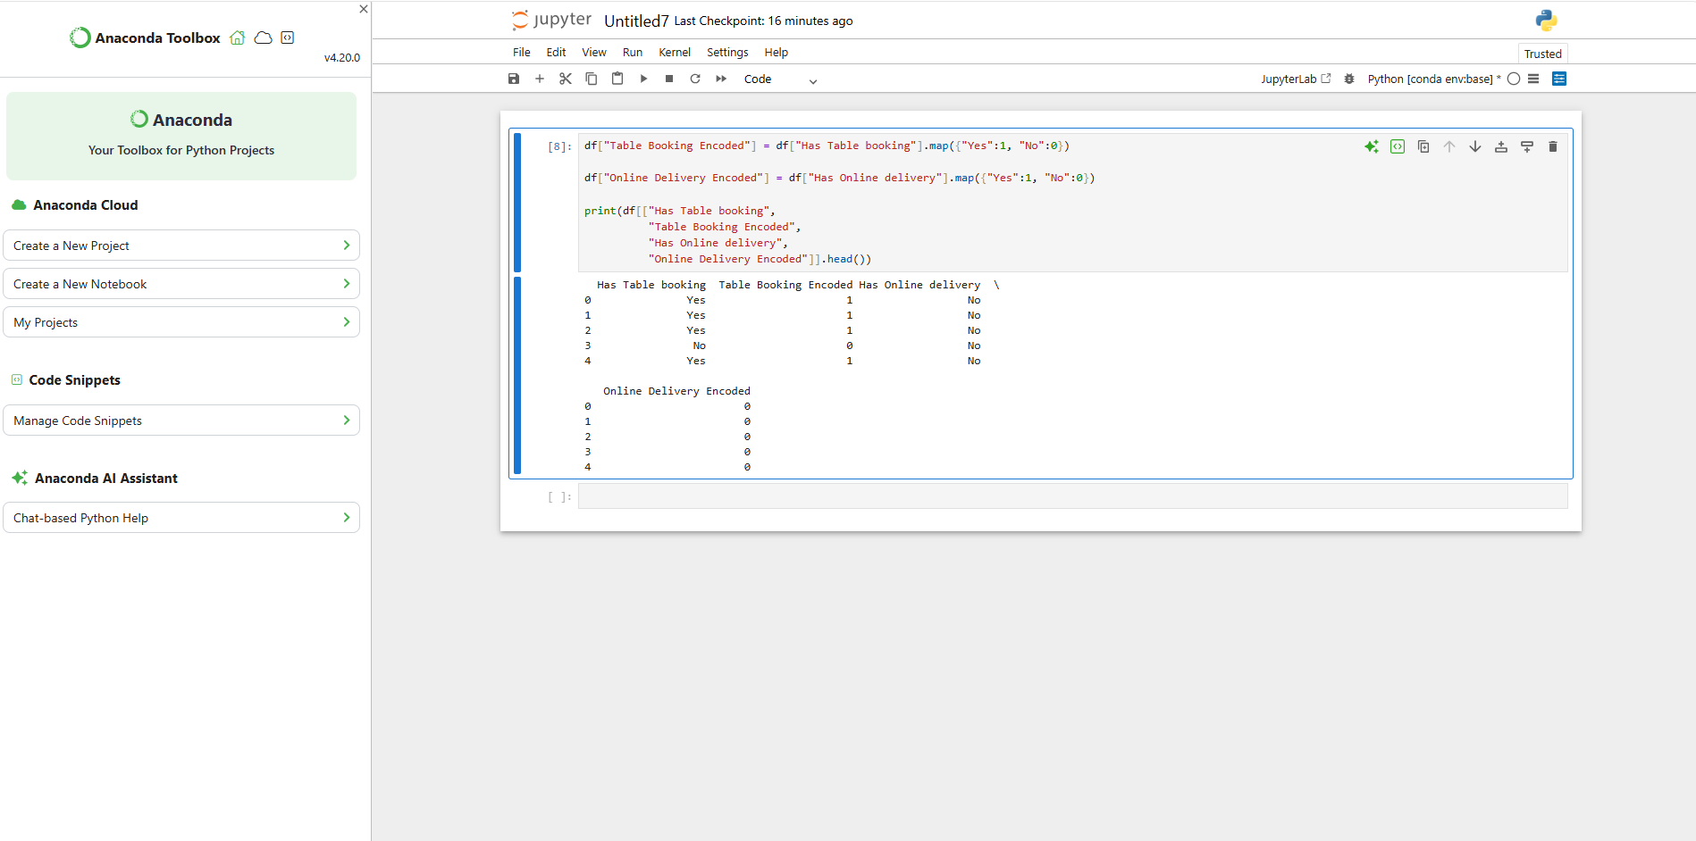

Encoding Method
Original Value | Encoded Value
Yes | 1
No | 0
Observation
The categorical variables were successfully transformed into numerical format. This process is known as Label Encoding and is useful for machine learning algorithms, which require numerical inputs instead of text values.

Level 2 – Task 3 Conclusion
Feature engineering techniques were applied to create new useful variables. Restaurant name length and address length were generated as additional features. Furthermore, categorical variables such as table booking and online delivery status were encoded into numerical values, making the dataset suitable for advanced analysis and machine learning applications.

Level 2 Final ConclusionLevel 2 analysis focused on restaurant services, pricing patterns, and feature engineering.
Key Findings
- Only 12.12% of restaurants provide table booking facilities.
- Around 25.66% of restaurants offer online delivery services.
- Restaurants with table booking have higher average ratings (3.44) than those without (2.56).
- Price Range 1 is the most common category.
- Higher-priced restaurants generally receive better ratings.
- Dark Green rating color has the highest average rating (4.66).
- New features and encoded variables were successfully created for future predictive analysis.

CONCLUSION
The Data Science Internship at Cognifyz Technologies provided valuable hands-on experience in data analysis and visualization using Python. During this internship, Level 1 and Level 2 tasks were successfully completed by applying various data science techniques to a real-world restaurant dataset.
The project involved data exploration, preprocessing, descriptive analysis, geospatial analysis, table booking and online delivery analysis, price range analysis, and feature engineering. These tasks helped in understanding customer preferences, restaurant trends, and the impact of different business factors on restaurant performance.
Through this internship, practical skills in Python, Pandas, NumPy, Matplotlib, and data analysis were enhanced. The internship also improved problem-solving abilities, analytical thinking, and understanding of real-world data science workflows.
Overall, this internship was a rewarding learning experience that strengthened technical knowledge and provided practical exposure to industry-oriented Data Science concepts and applications.
I would like to express my sincere gratitude to Cognifyz Technologies for providing this valuable opportunity to learn, explore, and enhance my skills in the field of Data Science.
Submitted By: Vaheeda
B.Sc (Computer Science)
Akkineni Nageswara Rao College
Academic Year: 2020–2023

