
WHITE PAPER TEMPLATE
[White paper title]
[State the scientific conclusion or question in one clear sentence]
Prepared by [author or team]
[Month Year] | Version [x.x]

Contents
Template note: after editing headings, press Ctrl+A, then F9 in Word to refresh the contents and page numbers.
Executive summary 2
At a glance 2
Introduction 3
Background 3
Scope and definitions 3
Approach 3
Evidence and findings 4
Finding 1: [Conclusion-led heading] 4
Finding 2: [Conclusion-led heading] 4
Interpretation and recommendations 5
What the evidence means 5
Recommended actions 5
Conclusion 5
References 6
Acknowledgments and disclosures 6
Appendix A. Methods and supporting detail 7
Method summary 7
Supplemental data 7

Executive summary
[Lead with the answer. In two or three sentences, state what was studied, what the evidence shows, and why it matters.]
Key takeaway [Write the single finding or implication a reader should remember after closing the paper.]

At a glance
- Problem — [Name the scientific or operational limitation.]
- Evidence — [Name the dataset, method, and strongest observed result.]
- Implication — [Explain the decision, workflow, or research consequence.]
- Validation status — [Measured, inferred, preliminary, replicated, or validated.]

Evidence checklist
- [State the sample size, specimen type, and exclusions.]
- [Name the assay, analysis workflow, software, and version.]
- [Report units, uncertainty, controls, and acceptance criteria.]
- [Separate measured, inferred, preliminary, and validated claims.]

Drafting rule
[Use the executive summary to make the result legible, not to repeat the full paper. Keep the strongest evidence and its qualification together.]
Evidence note Keep sample size, method, units, source, and validation status adjacent to every consequential claim.

Introduction

Background
[Introduce the biological or technical context. Define the unresolved problem before presenting the product, platform, or result. Use concrete biological nouns and measurable verbs.]
[Summarize the state of current evidence. Distinguish established knowledge from preliminary observations, and cite the primary source for each material claim.]

Scope and definitions
[State what the paper covers, what it does not cover, the intended audience, and any research-use-only or validation boundaries.]
- Population or samples — [Cohort, specimen type, inclusion criteria, exclusions.]
- Method — [Assay, workflow, platform, software, and version.]
- Endpoints — [Primary measurements and acceptance criteria.]
- Terminology — [Define each acronym at first use.]

Approach
[Describe the approach at the level needed to evaluate the evidence. Put detailed protocols, parameter lists, and supplemental analyses in the appendix.]

Suggested narrative sequence
- [Define the unresolved biological or technical problem.]
- [Explain the mechanism or method used to address it.]
- [Present evidence with the strongest result first.]
- [Interpret the result and state its validation boundary.]

Scientific voice
[Prefer direct, exact language. Define acronyms on first use, avoid unsupported superlatives, and state limitations where the claim appears.]

Evidence and findings
Figure 1. [Conclusion-led figure title]
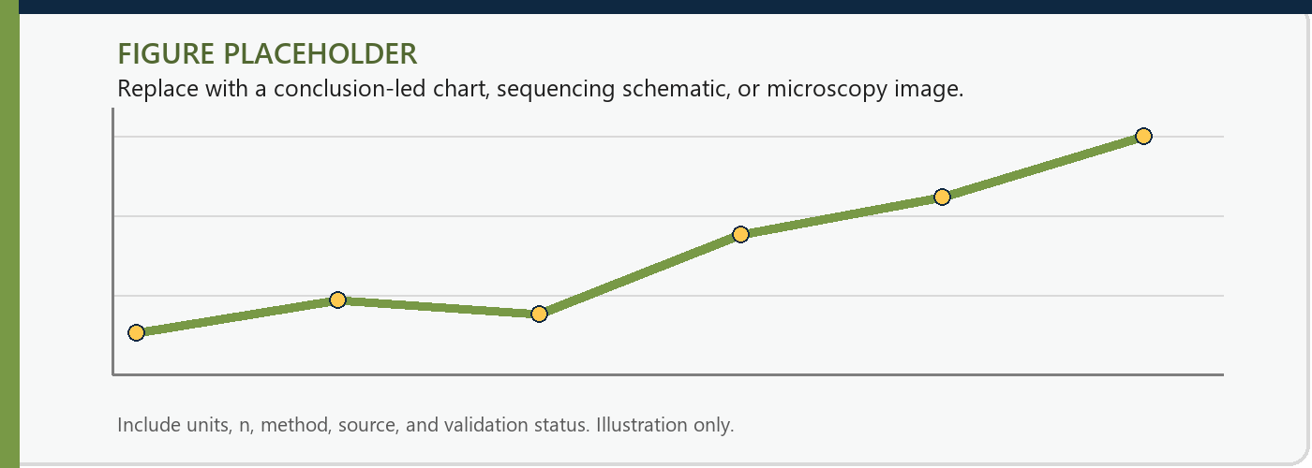
Source: [Dataset, method, sample size, units, version, and validation status].

Finding 1: [Conclusion-led heading]
[State the result first. Then explain the comparison, sample, uncertainty, and qualification that support it.]

Finding 2: [Conclusion-led heading]
[Use a short paragraph for the second result. If the comparison requires more than a few values, move it into the full-width evidence table below.]

Evidence question | Comparator or baseline | Observed result
[Metric or observation] | [Reference method or condition] | [Result with units and uncertainty]
[Biological interpretation] | [Current explanation] | [Supported interpretation and caveat]
Table 1 source: [Citation or internal dataset identifier].

Interpretation and recommendations

What the evidence means
[Explain the result without overstating it. Separate direct measurement from inference, and state which alternative explanations remain plausible.]
Scientific interpretation [Connect the measured result to the biological or workflow implication. Keep any limitation in the same paragraph.]

Recommended actions
- [Action 1: name the next decision, experiment, or workflow change.]
- [Action 2: name the owner, evidence threshold, or review point.]
- [Action 3: name the validation or commercialization boundary.]

Conclusion
[Restate the central result in plain language, explain its practical significance, and identify the next evidence needed. Do not introduce a new claim here.]

References
Use one citation style consistently. Prefer primary sources and include persistent identifiers when available.
- [Author(s). Title. Journal or publisher. Year; volume(issue):pages. DOI or URL.]
- [Author(s). Dataset or protocol title. Repository. Version. Year. DOI or accession.]
- [Phaeno internal study or technical note identifier. Version. Review date.]

Acknowledgments and disclosures
[List contributors, funding, conflicts of interest, data availability, code availability, and applicable research-use-only statements.]

Publication details
[Add the document identifier, version, review date, corresponding author, and a stable public URL. State whether the paper is research use only.]

Appendix A. Methods and supporting detail
[Place detail here that supports reproducibility or review but would interrupt the main argument.]

Method summary
Parameter | Required detail | Template prompt
Samples | Source, count, quality, exclusions | [Describe cohort or specimens]
Wet-lab workflow | Protocol, kit, lot, instruments | [Add versioned method details]
Analysis | Pipeline, parameters, references | [Add software and thresholds]
Statistics | Model, uncertainty, multiplicity | [Add analysis plan]
Table A1. Method details required for reproducibility and review.

Supplemental data
- [Supplemental figure, table, or sensitivity analysis.]
- [Data and code availability statement.]
- [Known limitation, edge case, or validation dependency.]
Appendix note Add Appendix B, C, and so on only when the supporting material has a distinct purpose. Keep each appendix in the contents.

