PHAENO OPERATIONS GUIDE
Order to Cash in POMS
How a PSeq laboratory order moves from commercial intake through controlled sample processing and result delivery, invoicing, cash allocation, and reconciliation
Audience | Phaeno Commercial, Laboratory, Result Release, Billing, Cash, and Reconciliation users
Scope | PSeq Lab Service; USD; native POMS accounts receivable
Guide date | September 2, 2026

Training note: Screens use POMS mock or synthetic records. No customer data was exposed and no transaction was created. Live availability depends on assigned roles, feature activation, and operational readiness.

The complete flow
POMS preserves the commercial, scientific, release, invoice, receipt, allocation, and reconciliation facts as separate audited states. A successful step never silently marks another step complete.
ORDER > QUOTE > SAMPLES > LAB > RESULTS > INVOICE > CASH > RECONCILE
Non-negotiable boundary: PSeq result release is governed by package completeness and scientific approval. Invoice balance, payment status, tax state, and customer credit never gate release.

Before an order can be committed
- The canonical CRM Company is active; its attached Customer operational scope is active and not manually blocked.
- A current Ready PSeq entitlement and canonical per-specimen offering exist; an active Customer administrator is required before quote issuance, not intake.
- Sample, shipping, result-destination, and submission-instruction configuration is complete.
- Billing contact, billing address, payment terms, and tax decision are recorded; Finance has approved the effective tax decision.

What POMS does automatically
- Keeps immutable request, quote, package, invoice, and closeout evidence.
- Creates the Lab authorization, work order, shipment, and tube slots when the accepted sample roster is finalized.
- Creates a governed result-release candidate after scientific approval.
- Issues one numbered invoice at job completion from the accepted quote, using the snapshotted billing, tax, currency, and payment terms.

What POMS deliberately does not do
- It does not approve a quote for the Customer or publish a result merely because Lab work is complete.
- It does not auto-apply suggested cash matches.
- It does not rewrite issued invoices, receipts, allocations, or reconciliations; corrections are additive and audited.
- It does not collect card or ACH details in this release, and raw/intermediate scientific files remain outside POMS.

Step 1 - Start the commercial order
Primary owner: Commercial Operator
Open Order operations > Order intake and choose New Customer order. Search eligible Customers by canonical CRM Company name. The attached Customer scope must be active, unblocked, and authorized for the current PSeq service and offering; an online Customer administrator is required later, before quote issuance. Then enter a unique job name, biological-source composition and sample count, and shared storage and safety facts. Do not enter patient identifiers, PHI, individual sample IDs, or tube barcodes in the pricing profile.
Start pricing stores the internal Customer scope on the order while displaying the canonical Company name, then creates the Customer-owned job in Quote in preparation with an immutable submitted-request revision. Customer notices begin only when a quote is issued.
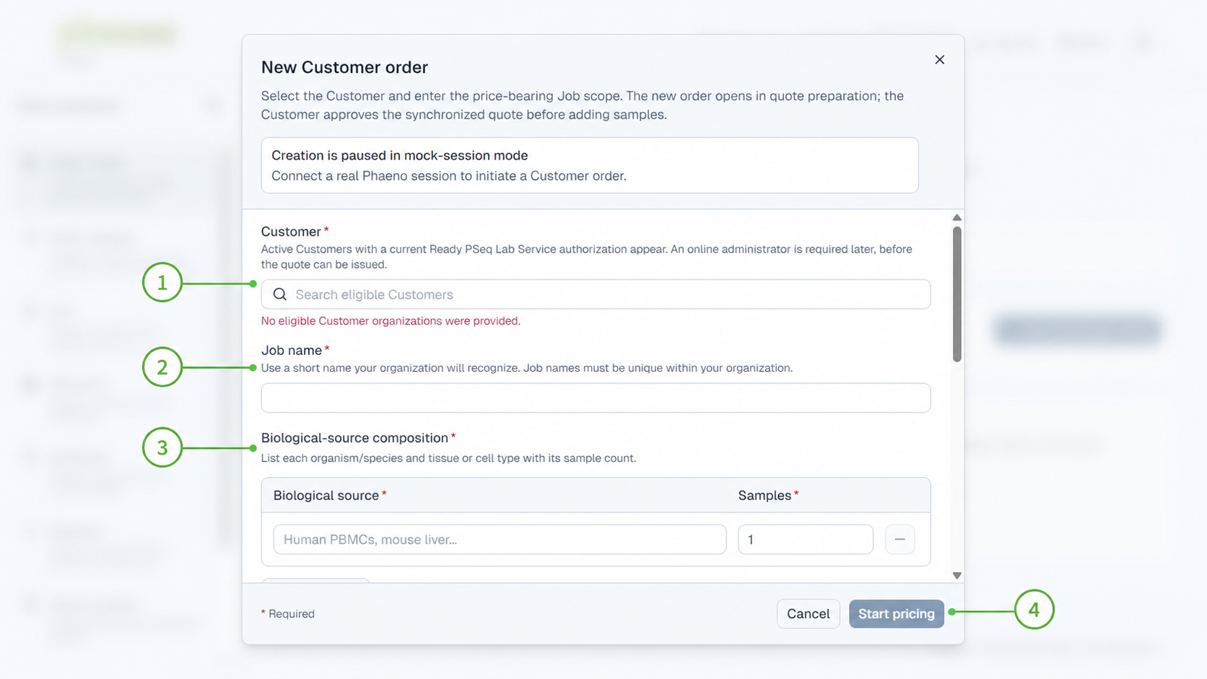
Figure 1. Enter the price-bearing job scope before sample-level work begins.
1 Search by canonical CRM Company name and select the eligible Customer.
2 Give the job a recognizable, unique name.
3 Record source groups and counts; the total becomes the committed quote quantity.
4 Start pricing after required safety/storage facts and the no-PHI confirmation are complete.

Step 2 - Resolve readiness and stage safely
Primary owner: Commercial Operator, Portal Access Administrator, Finance
Order staging keeps every Customer visible with its blockers. An authorized Commercial Operator may prepare internal PSeq work before online access or a Customer administrator is active when the minimum stage-eligibility rules are met. Quote issue and Customer commitment still require full readiness, including active Company access, an active Customer administrator, and complete operational and Finance configuration. Manage Company access, users, services, readiness, and retention in CRM > Companies; there is no separate Customer account directory.
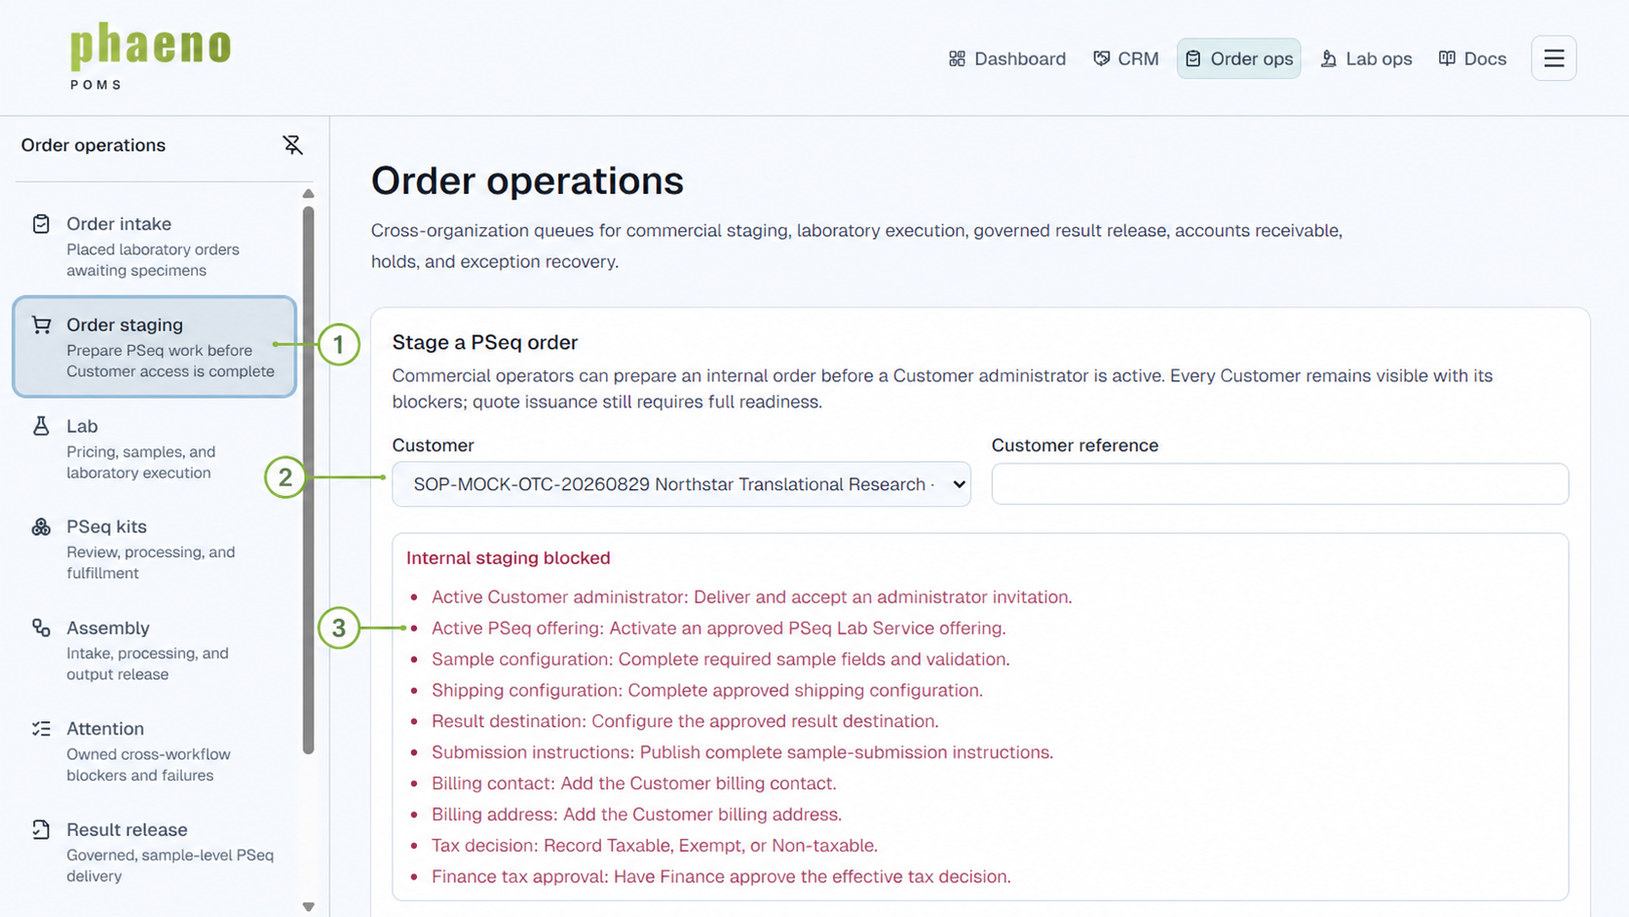
Figure 2. Readiness blockers are explicit and must be cleared before commitment.
1 Use Order staging for pre-commitment preparation.
2 Select the Customer; readiness is derived from current configuration.
3 Clear each blocker at its owning workspace; use CRM > Companies for Company access and readiness.

Step 3 - Issue and accept the quote
Primary owner: Commercial Operator, Finance, Customer Administrator
Issue quote from the Lab order only after full readiness is complete, an active Customer administrator can receive and approve it, and Finance has approved the effective tax decision. The required pseq-lab-service line uses the specimen sales unit and the committed sample count; server validation prevents its removal or a mismatched quantity.
- The issued quote freezes the service, quantity, pricing, currency, billing address, tax decision/rate, payment terms, expiration, and configuration version.
- Every active Customer administrator is notified and may approve. Phaeno cannot approve on the Customer's behalf.
- Acceptance records the immutable commercial commitment and opens exact sample-list preparation.
Control point: If a quote requires correction, issue a new revision. Never rewrite an issued or accepted revision.

Finalize samples and shipping
After acceptance, the Customer enters or imports the compliant sample roster. Finalization atomically creates the immutable Lab authorization, linked work order, shipment, and physical tube slots. The Customer assigns registered tube barcodes, confirms the crosswalk, prints the frozen shipment packet, and records carrier, tracking number, and shipment time.
- Use stable Customer sample identifiers that contain no direct patient identifiers.
- Do not manually create a Lab work order if finalization fails; correct the roster or shipping configuration and retry the durable operation.
- Quarantine and escalate an unexpected package that arrived before authorization; do not accession or process it.

Step 4 - Receive and accession specimens
Primary owner: Lab Receiving and Accession roles
Open Lab operations > Receipt & accession. Compare the shipment packet and every registered tube with the frozen crosswalk before recording custody. Packet lookup and tube comparison identify the expected work; they do not themselves record receipt or accession.
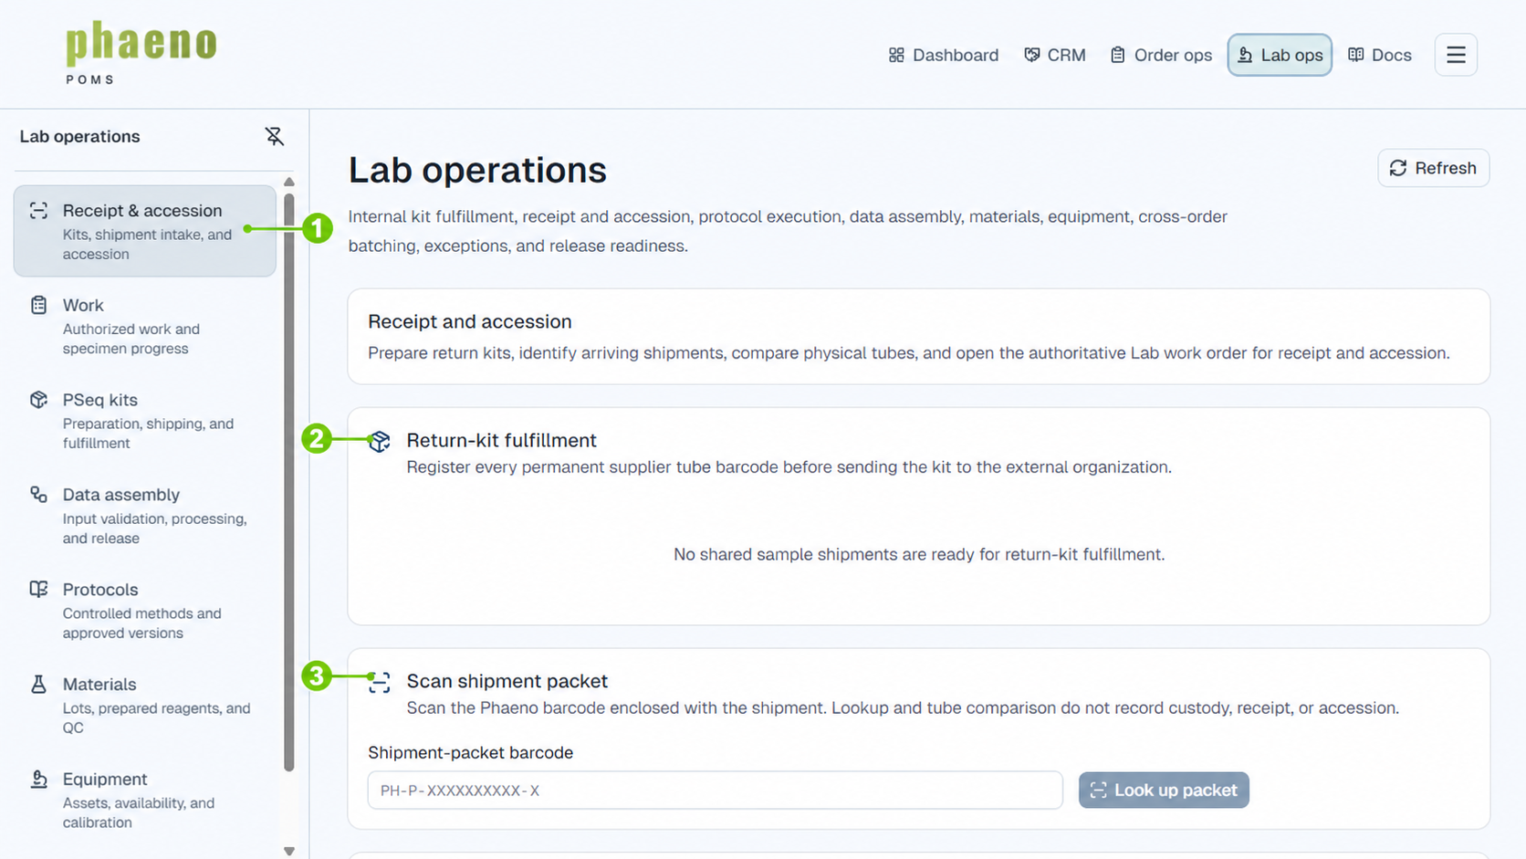
Figure 3. Link physical material to the authorized Lab work without guessing.
1 Use the Receipt & accession workspace.
2 Prepare and register return-kit tube barcodes before shipment.
3 Scan the packet and physical tubes, then open the authoritative work order to record receipt and accession.
Record receipt first, then accession number, location, quantity/unit, retention information, and container identity. Apply Accepted, On hold, or Rejected with approved reasons. Preserve lineage through child containers; never reuse a barcode or edit parentage to repair history.

Lab sample processing - entry and physical lineage
Primary owner: Lab Operator, Lab Supervisor
Sample processing begins only after Commercial authorization, physical receipt, accession, and an intake decision establish which material may proceed. POMS is the traceability record for the authorized work; the approved laboratory SOP remains the authority for bench technique, safety, timing, and acceptance limits.

Entry gate
- Open the linked Lab work order; do not create replacement work to bypass an authorization, receipt, or roster problem.
- Match the shipment packet and registered supplier tubes before recording custody. A comparison scan identifies expected material but does not record receipt or accession.
- Record receipt first, then the accession, location, tracked quantity/unit, retention information, and Accepted, On hold, or Rejected decision.
- Stop when identity, authorization, condition, or tube-slot association cannot be established safely. Record an exception instead of guessing.

Maintain the physical chain
- Use the adopted permanent supplier barcode for a qualified registered tube; otherwise use the POMS-assigned authoritative container barcode.
- Create a new child container for every aliquot, prepared reagent, library, or other derived material and link it to its immediate parent.
- Use Scan a container to verify the work order, accession, status, location, parent barcode, and associated library before acting.
- Never reuse a barcode, edit parentage, or delete a container to repair history. Use the supported correction, replacement, or rework path.
Proceed rule: The material may enter controlled execution only when the authorized work, accessioned identity, intake disposition, and required physical inputs are all clear. Holds and rejected material remain visible and cannot be silently treated as accepted.

Step 5 - Execute controlled laboratory work
Primary owner: Bench, Protocol, QC, Library, and Sequencing roles
Assign an approved, active protocol version that matches the authorized service and material state. Start the execution before recording step results, material consumption, or equipment use. The execution pins that version even after a newer version becomes active. Record required steps, captured values, materials, equipment, QC gates, deviations, repeats, holds, and abandoned work explicitly.
Create the physical library container before the library record, then link the submitted specimen, source container, library container, and completed preparation execution. Only QC-passed libraries may enter a sequencing batch. Cross-order batches are permitted because specimen and work-order lineage remains attached to every library.
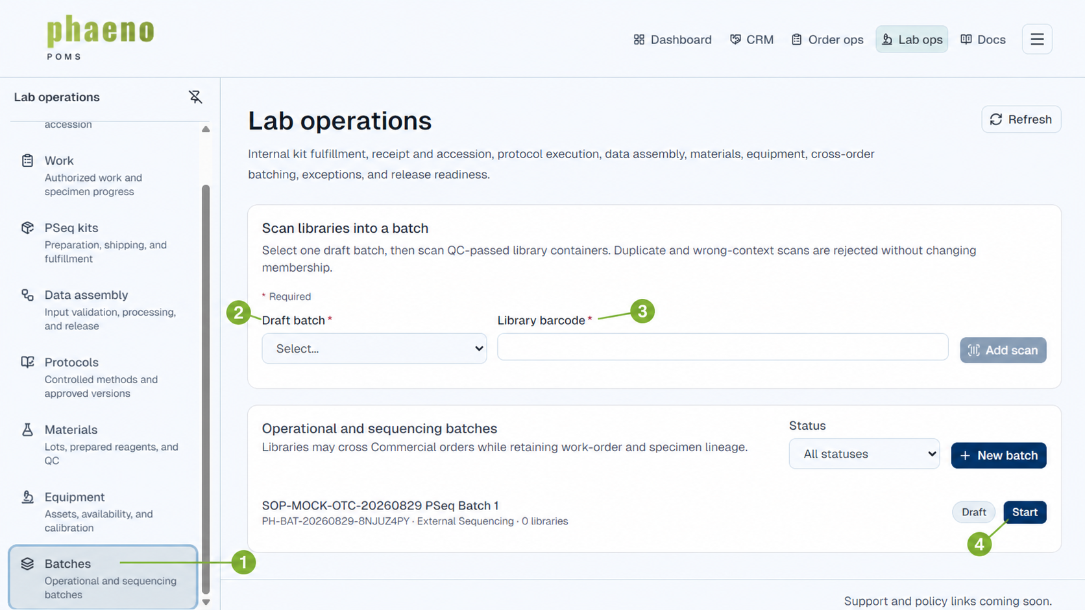
Figure 4. Scan QC-passed libraries into a controlled batch while preserving lineage.
1 Use the Batches workspace for operational and sequencing batches.
2 Select the intended draft batch.
3 Scan the physical library-container barcode; invalid or duplicate scans do not change membership.
4 Start only after the manifest and membership are confirmed.
For outsourced sequencing, advance the sendout through Shipped, Received by provider, Sequencing, and Complete only when each fact is known. Record custody events and provider references. The current sendout record does not ingest raw files or orchestrate scientific pipelines.

Lab sample processing - protocol execution, QC, and exceptions
Primary owner: Lab Operator, Lab Supervisor, Protocol Administrator
Assign only an approved, active protocol version that matches the authorized service and material state. Starting execution pins that exact version. Record every required step, typed capture, material lot, equipment use, QC decision, deviation, repeat, hold, or abandonment as a durable fact.
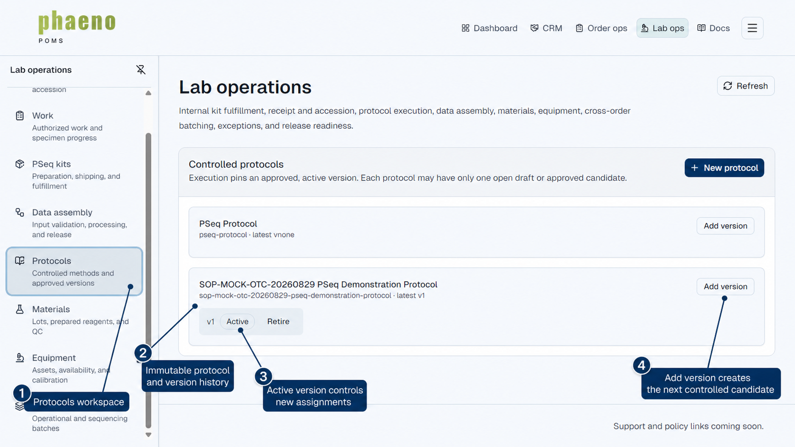
Figure 4A. Controlled versions make the governing method visible before work is assigned.
1 Open Protocols in Lab operations.
2 Use the immutable protocol key and version history to identify the method.
3 Only the active version is eligible for new assignments; an existing execution stays pinned.
4 Add version creates the next controlled candidate without rewriting prior execution history.
QC and exception gate: Complete execution only when required steps and QC gates are satisfied. Failed or held QC, unavailable or unqualified materials/equipment, identity concerns, and other blocking exceptions must remain recorded and resolved or reworked before scientific review.

Lab sample processing - library, sequencing, and output handoff
Primary owner: Lab Operator, Lab Supervisor, Scientific Reviewer
Processing remains traceable as material moves from an execution to a physical library, a batch or outsourced sendout, and the final output package. Each gate preserves the earlier record rather than replacing it.
Stage | POMS record | Proceed only when
Execution | Pinned protocol version; step captures; exact material lots and equipment; deviations and QC | The execution has started, required facts are present, materials/equipment were eligible, and required QC gates pass.
Library | Source container; physical library container/barcode; preparation execution; library QC | The physical library container exists first, lineage is complete, and status is QC passed.
Batch / sendout | Immutable batch number; membership; start/complete times; provider status and custody | The manifest is confirmed; scans are valid and not duplicate; each provider milestone is a known operational fact.
Output handoff | Exact final-package identifier/version and expected artifacts with checksums and scan status | The package is complete, checksummed, malware-clean, and all blocking exceptions are resolved for the release scope.

When work does not pass
- Preserve the failed execution, consumed material, QC result, rejected library, and original batch or custody facts.
- Record the blocking exception, safe Customer-action summary when required, supervisor resolution, and linked repeat or replacement work.
- Do not promote an internal scientific hypothesis or another Customer's information into Commercial or Customer-visible status.
Implementation boundary: POMS records sample lineage, controlled execution, QC, libraries, batches, sequencing sendout status/custody, exceptions, scientific approval, and the governed final package. Raw-file ingestion, pipeline orchestration, intermediate provenance, and long-term scientific storage remain outside the current Lab Ops implementation.

Step 6 - Approve and release results
Primary owner: Scientific Reviewer, Result Release Manager
Scientific review begins only after receipt, accession, required execution/QC, library/batch/sendout, exceptions, and the final output package are complete. The reviewer must be different from every person who recorded work in the release scope. Approval pins the exact package and moves Lab work to Ready for release.
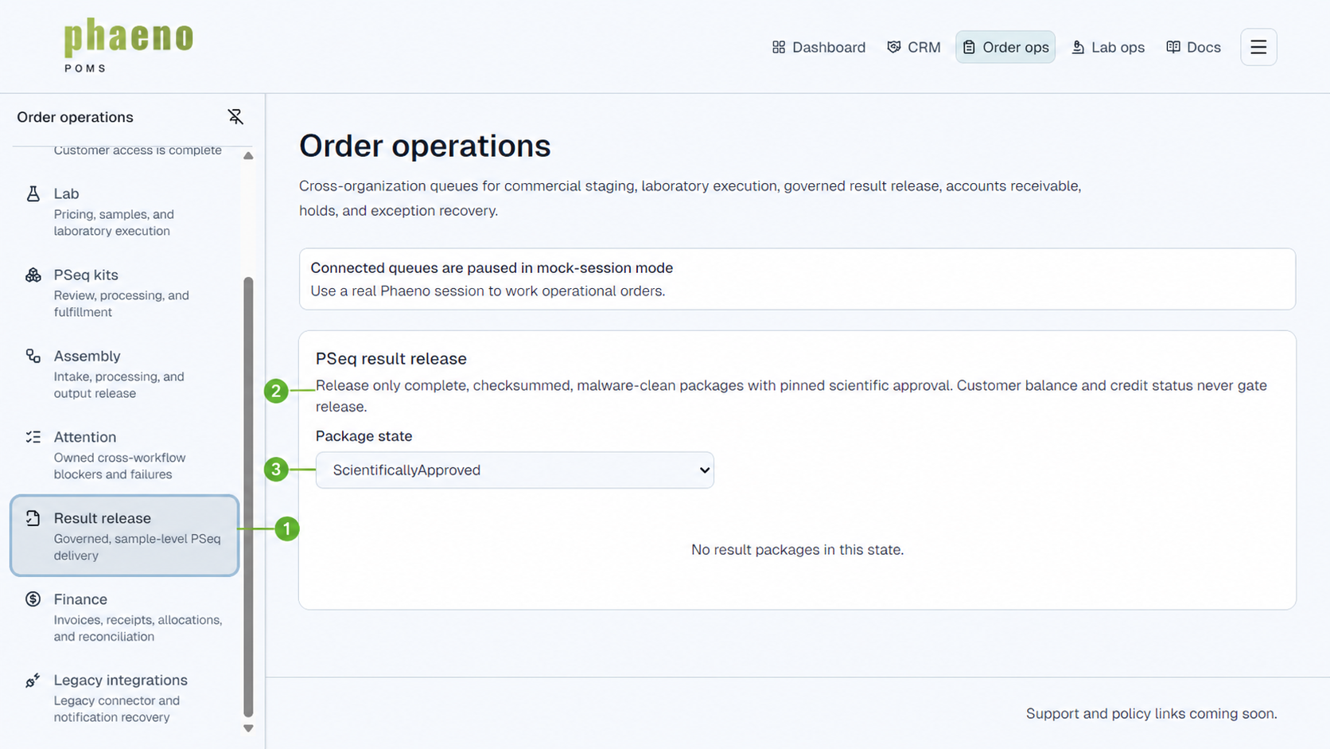
Figure 5. Result release is a governed sample-level decision, not a billing decision.
1 Use Result release after scientific approval creates the release candidate.
2 The package must be complete, checksummed, malware-clean, and pinned to approval; balance and credit are irrelevant.
3 Filter by package state and release or withdraw the correct version.
Release rule: A Result Release Manager may publish one approved sample while other samples remain in progress. Corrections create new package, approval, and release versions; withdrawal preserves history.

Step 7 - Issue and monitor the invoice
Primary owner: POMS automation, Billing Operator
At job completion, POMS idempotently issues one numbered invoice from the accepted quote. The due date is the completion date plus the snapshotted payment terms (Net 30 by default). The invoice PDF is immutable and available to Finance and the Customer.
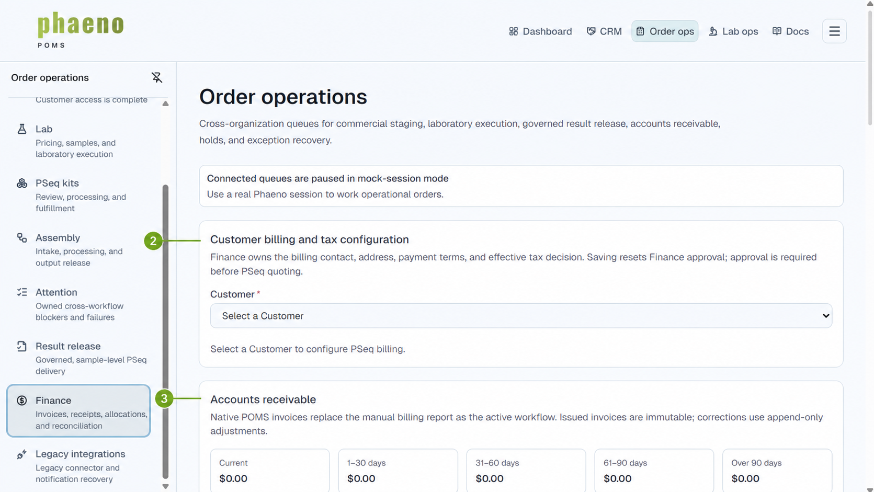
Figure 6. Finance configuration precedes quoting; AR aging begins after invoice issue.
1 Use the Finance workspace for PSeq billing and cash.
2 Maintain billing contact/address, terms, and Finance-approved tax configuration before quote issue.
3 Monitor current and overdue balances in Accounts receivable.
Never edit an issued invoice. Record append-only Credit, Debit, or Write-off adjustments with a reason. Historical manual billing rows remain legacy sources for Finance review and do not become native invoices.

Step 8 - Record and allocate cash
Primary owner: Cash Operator
Record each USD receipt with Customer, external identity, payer, amount, received date, method, bank reference, evidence, and memo. A CSV import is preview-only until explicit confirmation and creates unapplied receipts; it never applies cash.
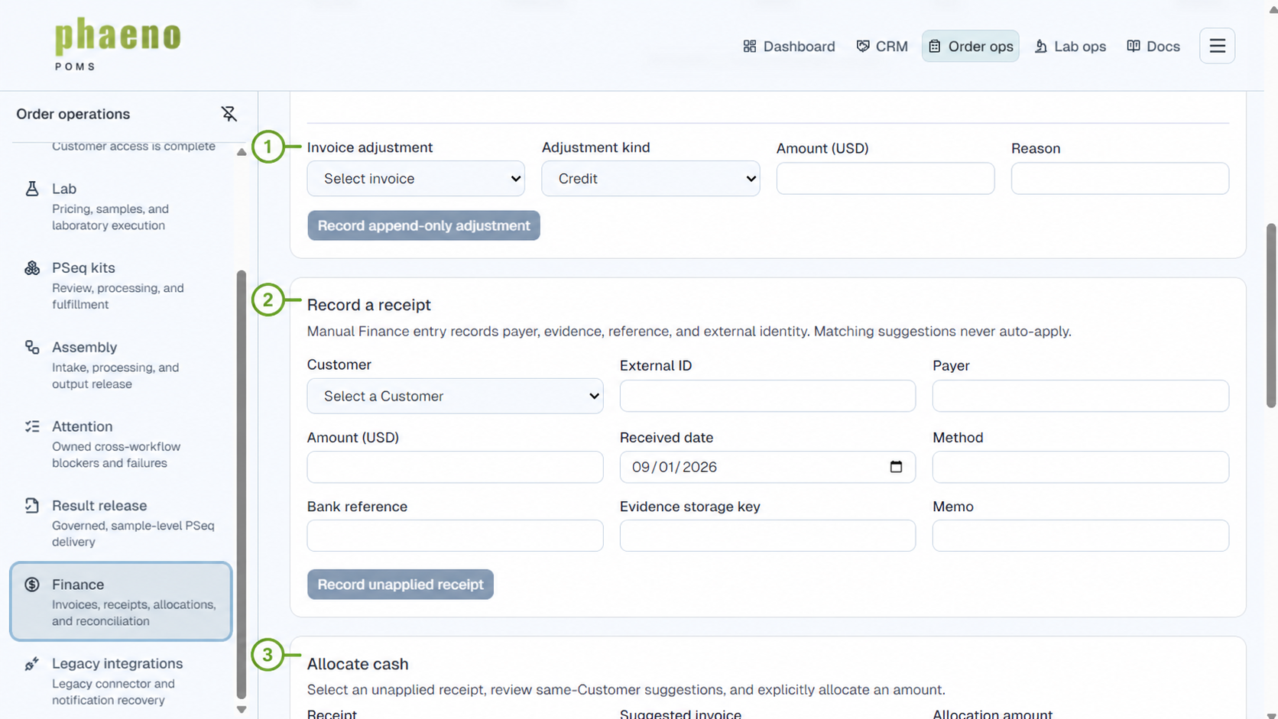
Figure 7. Receipt entry and allocation remain explicit, auditable actions.
1 Use an append-only adjustment to correct an invoice balance without rewriting it.
2 Record the receipt and its bank/evidence identity; it begins as unapplied cash.
3 Select the receipt, review same-Customer suggestions, and apply the chosen amount explicitly.
- Partial allocations, one receipt to many invoices, and many receipts to one invoice are supported.
- Overpayments remain unapplied until Finance allocates or resolves them.
- Matching suggestions never auto-apply, and reversals preserve the original receipt, actor, and reason.

Step 9 - Reconcile and close cash
Primary owner: Cash Operator, independent Cash Reconciler
The Cash Operator creates a batch for a period, selects the included receipts, enters the bank total, and submits only when the difference is zero. A different Cash Reconciler who contributed none of the batch activity approves the immutable closeout report.
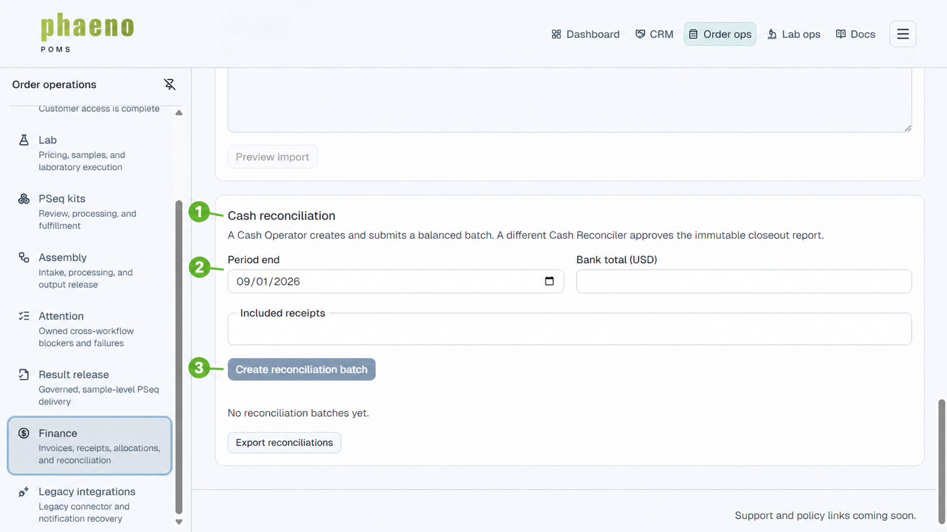
Figure 8. Balanced cash is independently reconciled and closed.
1 Use Cash reconciliation after receipt activity is complete for the period.
2 Set the period end and bank total, then include the exact receipts.
3 Create and submit the balanced batch; an independent reconciler performs final approval.
Order-to-cash completion: Cash is closed when the relevant invoice balance is resolved, receipt allocations are complete or intentionally remain unapplied, and an independent reconciler has approved the balanced batch. Result release may have occurred earlier and remains independent.

Roles and separation of duties
Role | Primary action | Key control
Customer administrator | Accept quote; finalize samples | Phaeno cannot approve for the Customer
Commercial Operator | Enter/stage orders; issue quote | Commitment waits for full readiness
Lab roles | Receipt, controlled processing, QC, libraries, and batching | Only assigned roles may record each fact
Scientific Reviewer | Approve exact package | Cannot have contributed work in scope
Result Release Manager | Release or withdraw version | Payment and credit are not gates
Billing Operator | Configure billing/tax; monitor invoice | Issued invoices are immutable
Cash Operator | Record, allocate, adjust, reconcile | Suggestions never auto-apply
Cash Reconciler | Approve closeout | Must be independent of batch activity

Attention and recovery
Attention queues own invitation failures, Company-access and readiness blockers, staged orders awaiting approval, projection or scanning failures, scientifically approved but unreleased packages, overdue invoices, unapplied cash, and reconciliation differences. Resolve Company-owned access, user, service, readiness, and retention issues in CRM > Companies.
- Refresh the record before retrying and identify whether the underlying operation already committed.
- Assign an owner and due date; assignment coordinates work but does not grant authorization.
- Perform the smallest valid next action and preserve the original record, attempts, and resolution.
- Never create a duplicate order, quote, Lab work order, shipment, package, release, invoice, receipt, or reconciliation to force recovery.

Quick status reference
Area | Important states and interpretation
Operational readiness | Needs setup, Ready, or Blocked; only a deliberate manual Blocked override is authoritative
Result package | Uploading, Scanning, Ready for review, Scientifically approved, Ready for release, Released, Failed, Withdrawn
Invoice | Issued, Partially paid, Paid, Voided, Written off
Receipt | Unapplied, Partially applied, Applied, Reversed
Reconciliation | Draft, Submitted, Approved; approval creates the immutable closeout report

Final operator checklist
- Commercial commitment: accepted quote revision and finalized sample roster are recorded.
- Laboratory completion: receipt, accession, container lineage, protocol execution, material/equipment use, library QC, batch/sendout, exceptions, final package, and scientific approval are complete for the intended scope.
- Customer delivery: the correct package version has an explicit release or withdrawal decision.
- Invoice: one numbered invoice exists from the accepted quote; any correction is an append-only adjustment.
- Cash: receipts are recorded and allocated explicitly; remaining unapplied cash is intentional and owned.
- Reconciliation: the balanced batch is approved by an independent Cash Reconciler.
Support handoff: When escalation is required, include safe order, job, package, invoice, receipt, and reconciliation identifiers plus the visible state and last valid action. Do not include credentials, payment data, PHI, or customer-confidential scientific detail.

