WEB-ACTIVITY-BASED-LEARNING
1. LearnHub Online Learning Platform
LearnHub is an online learning platform webpage designed to provide information about online courses, learning opportunities, and educational resources. It presents course details in an organized and attractive layout.

**Main File:** `index.html`
**Styling File:** `style.css`
**Key Features:**
- Course categories and descriptions.
- Attractive course cards.
- Information about online learning.
- Simple and user-friendly webpage design.

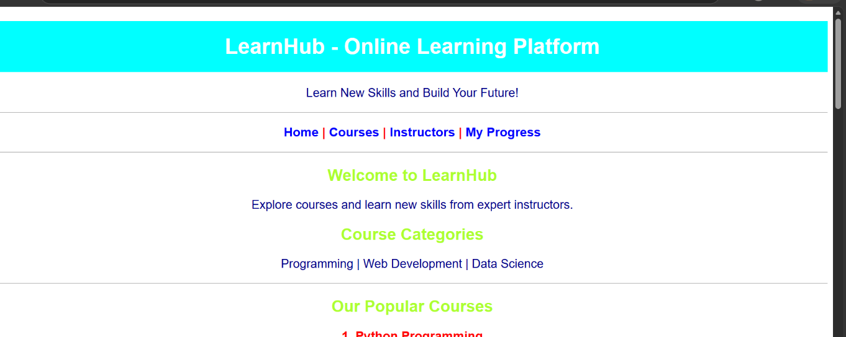
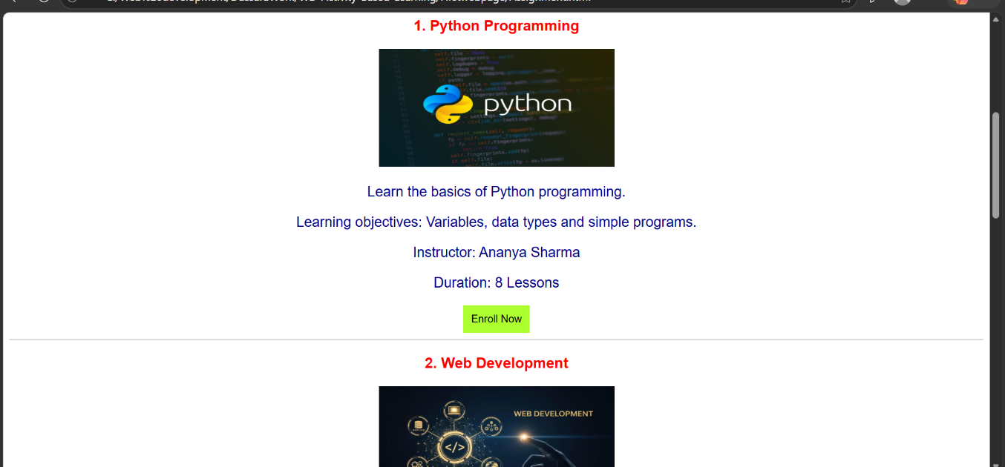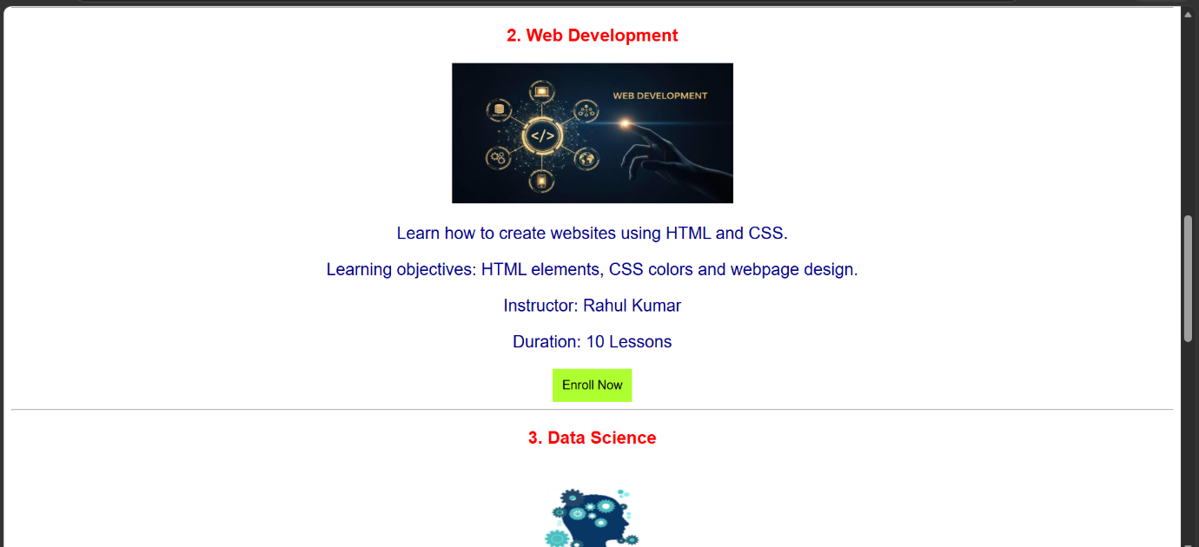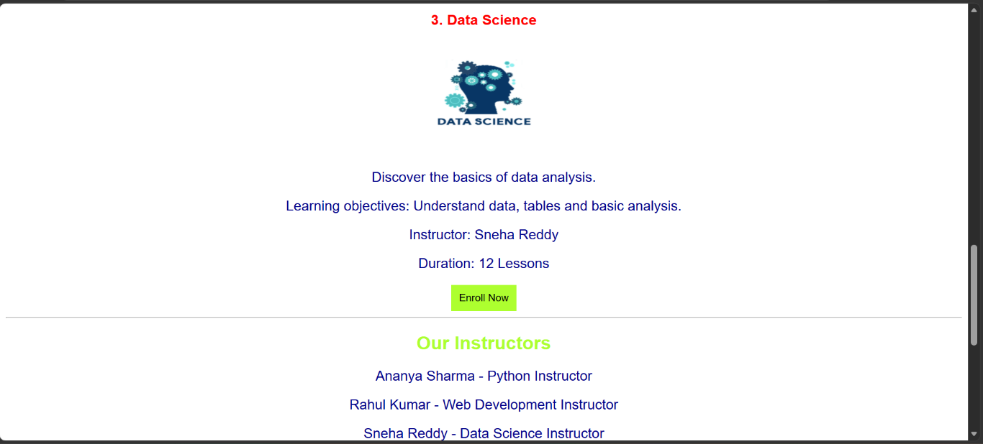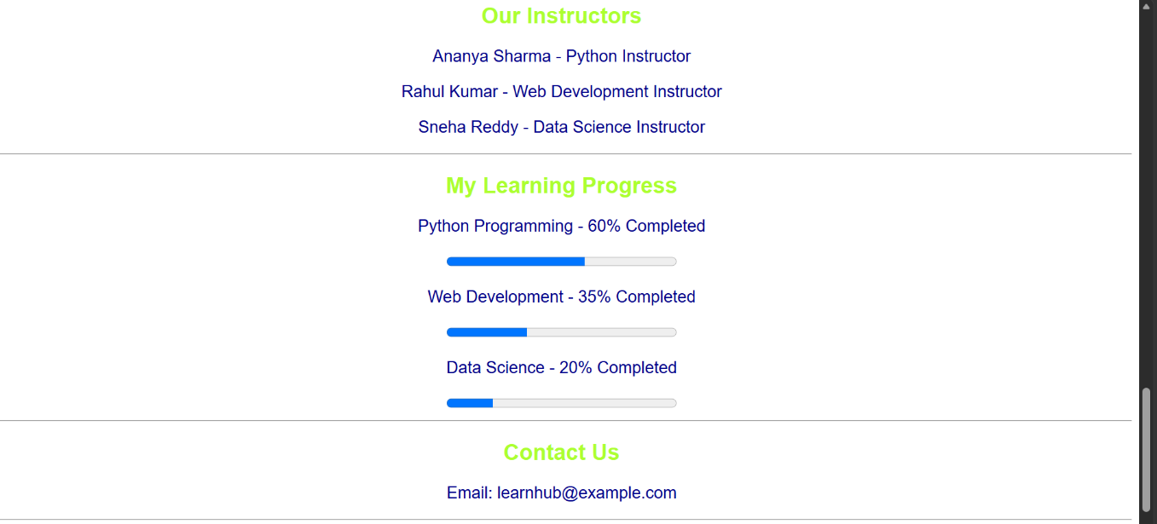
2. Fitness Center and Gym Website
This project is a fitness and gym website designed to showcase workout programs, fitness facilities, and membership options. It uses a bold and attractive design to create an engaging experience for visitors.

**Main File:** `index.html`
**Styling File:** `style.css` **Key Features:**
- Workout programs and fitness activities.
- Gym facilities and services.
- Membership plans.
- Attractive layouts and styling.
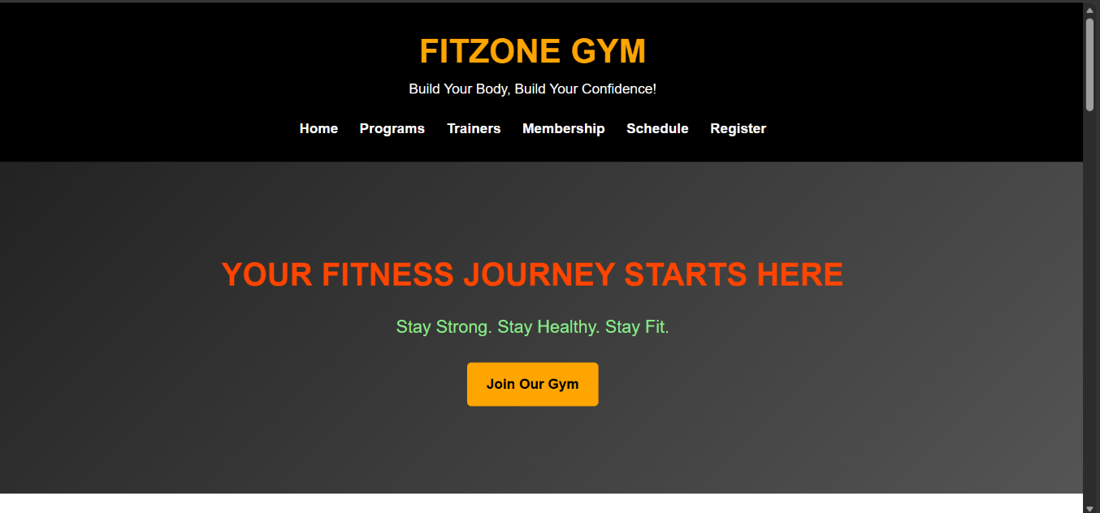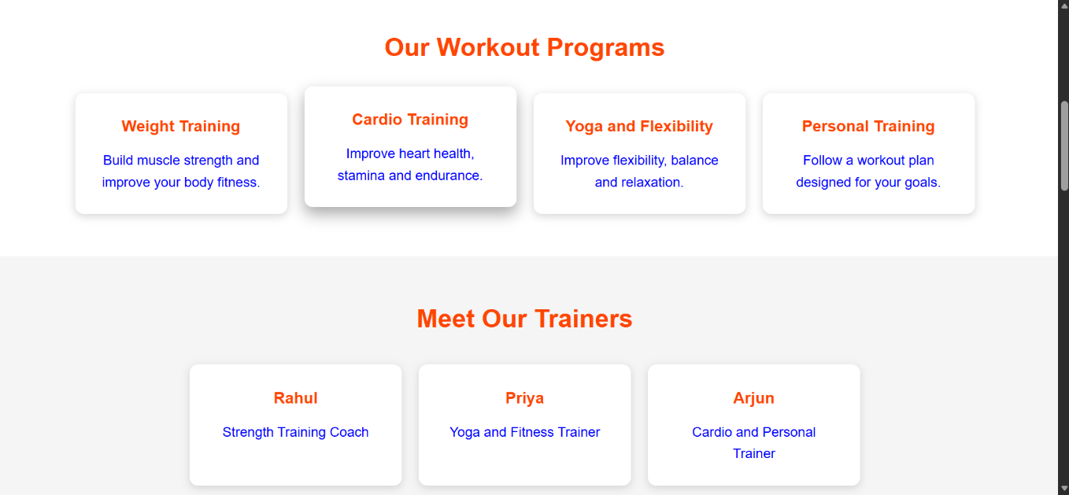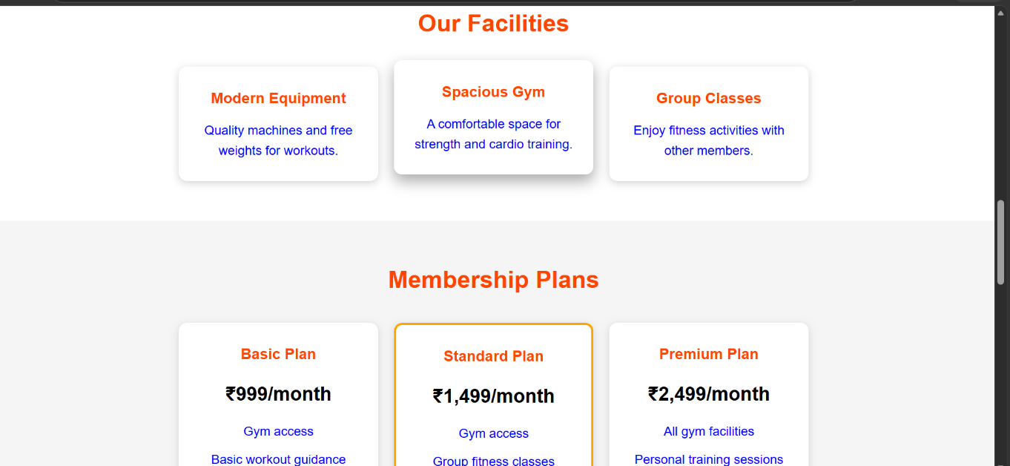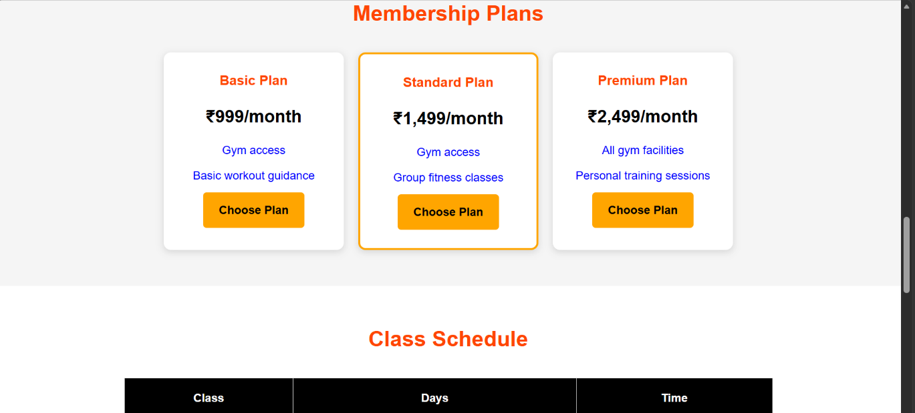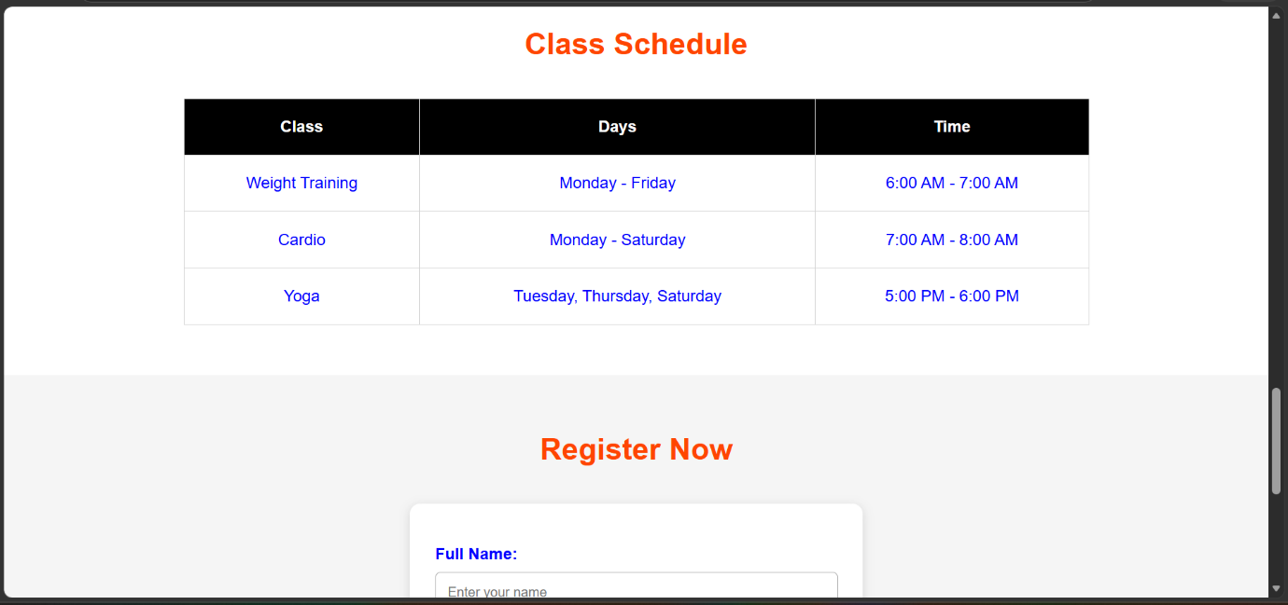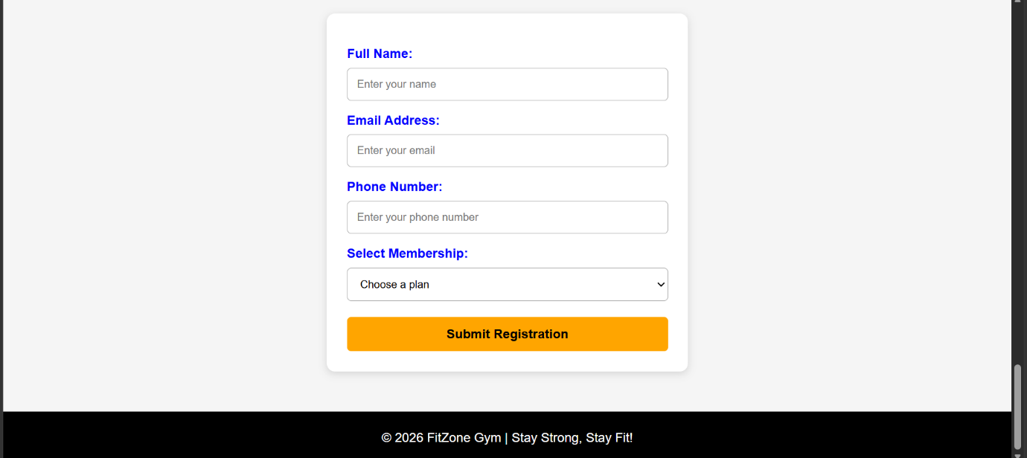

3. Yoga and Meditation Website
This project is a yoga and meditation website designed to introduce yoga practices, meditation techniques, and wellness activities. It uses a calming design and readable text to create a peaceful browsing experience.

**Main File:** `index.html`
**Styling File:** `style.css`
**Key Features:**
- Yoga poses and meditation techniques.
- Information about health and wellness.
- Yoga classes and membership details.
- Calming colors and an organized layout.
