**CusVarDB Manual**

CusVarDB is a windows based tool for creating a variant protein database from Next-generation sequencing datasets. The programs supports variant calling for Genome, RNA-Seq and exome datasets. The program performs mainly 4 modules

1. Align the datasets with reference database
2. Perform the variant calling using Genome Analysis Toolkit (GATK)
3. Annotate the variant using ANOOVAR
4. Create the variant protein database

Apart from the main modules, the program also supports additional function such as I) download the SRA II) Convert the SRA file to fastq file format III) Download the annotation (ANNOVAR) database and Dry-run concept to customize the commands.

**Prerequisites**

The tool works on Windows 10 and higher version of operating systems. Tool requires Ubuntu 18.04 LTS to be installed.

Please follow the below steps to install Ubuntu 18.04 LTS on Windows OS

Settings->Update & Security->For Developers

Enable the Developer mode. This will install the packages requires to Run the Linux environment

Below step will enable the Ubuntu on System

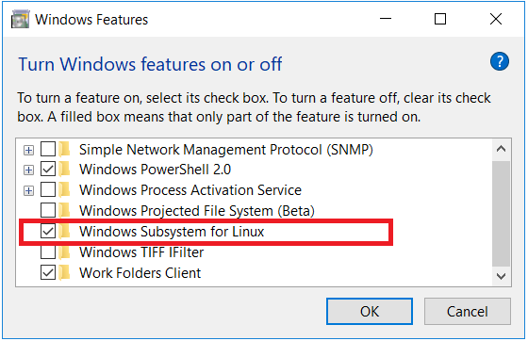Control panel->Uninstall programs->Turn windows feature on or off-> click on Windows Subsystems for Linux as shown in below image (Red rectangle box highlighted)

Restart the Operating System to take the effect.

**Installing the Ubuntu 18.04 LTS**

Go to Microsoft stores->Search->

Type “Ubuntu 18.04 LTS” and download the Ubuntu 18.04 LTS.

(If problem in installing, please follow the YouTube or the web link <https://www.youtube.com/watch?v=Cvrqmq9A3tA> or <https://www.windowscentral.com/how-install-bash-shell-command-line-windows-10> )

After the installation of Ubuntu, necessary packages has to be installed such as

* Java 8
* BWA
* SAMTools
* Unzip

These tools and packages can be downloaded by the CusVarDB tool. Below image will provide the brief of downloading the Linux dependencies and packages.

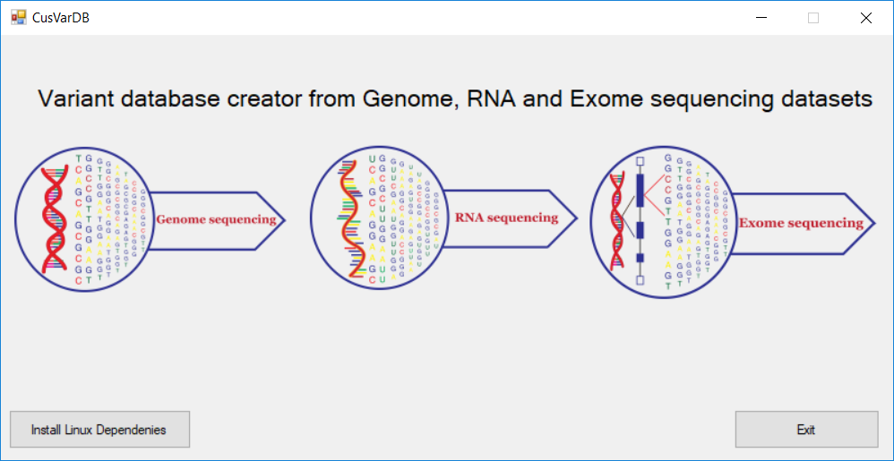

Install Linux dependencies option will download the tools and packages. After the each tool / package installation the terminal will asks for user to press any key to continue and download the next tool / packages.

In case, if user will find any problem in installing the Linux dependencies, below command will help in installing the packages / tools manually.

sudo add-apt-repository ppa:webupd8team/java

sudo apt-get update

sudo apt-get install openjdk-8-jre

sudo apt-get install bwa

sudo apt-get install samtools

sudo apt install unzip

(**Note**: Make sure that you have followed the order of downloading the tools / packages. In case any error occurred during the alignment process then make sure that you have installed the samtools version 1.7 (using htslib 1.7-2) and BWA version (0.7.17-r1188)

NGS tools used in our pipeline are mentioned below. These are the mandate tools which need to be downloaded by the users.

**GATK, PICARD, FASTQC, ANNOVAR and fastq-dump** download link

1. GATK 3.8 can be downloaded at: <https://software.broadinstitute.org/gatk/download/archive>
2. PICARD can be downloaded at: <https://broadinstitute.github.io/picard/>
3. FastQC can be downloaded at: <https://www.bioinformatics.babraham.ac.uk/projects/fastqc/fastqc_v0.11.8.zip>
4. Fastq-dump can be downloaded at

<https://ftp-trace.ncbi.nlm.nih.gov/sra/sdk/current/sratoolkit.current-win64.zip>

5. ANNOVAR can be downloaded at:

<http://annovar.openbioinformatics.org/en/latest/user-guide/download/>

All the downloaded files are kept in a folder named “tools” as mentioned in the below image.

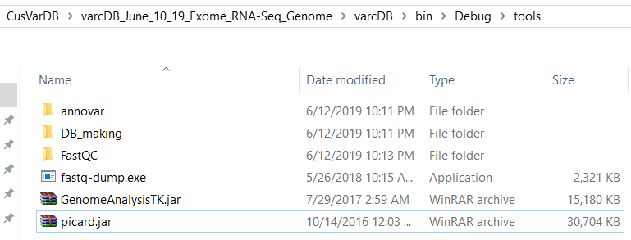

**(Note:** Make sure that the Folder and the file names of downloaded tool are same as above mentioned. Otherwise the tool will end up giving error message “No such file or directory”)

**Additional features**

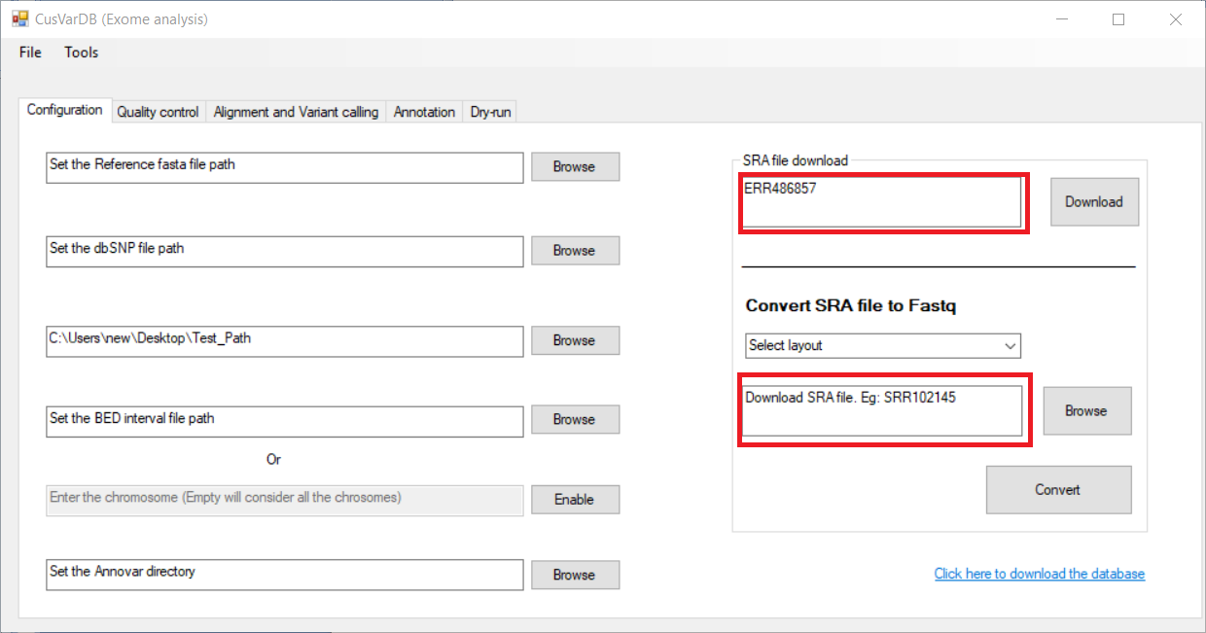User can download the SRA files from the SRR, ERR or DRR ids. The configuration panel provides the download option for downloading the SRA dataset using the wget command and fastq-dump command will converts them into single or paired end datasets.

The variant annotation is performed using ANNOVAR tool. The “download database” option will allow the user to download the annotation database provided by ANNOVAR. The user can select the database by clicking the individual “check box” or by clicking the “select all” button to download the listed database.

(**Note**: During the variant annotation step, the user needs to select the downloaded database. In other case “database not exist” error will occur)

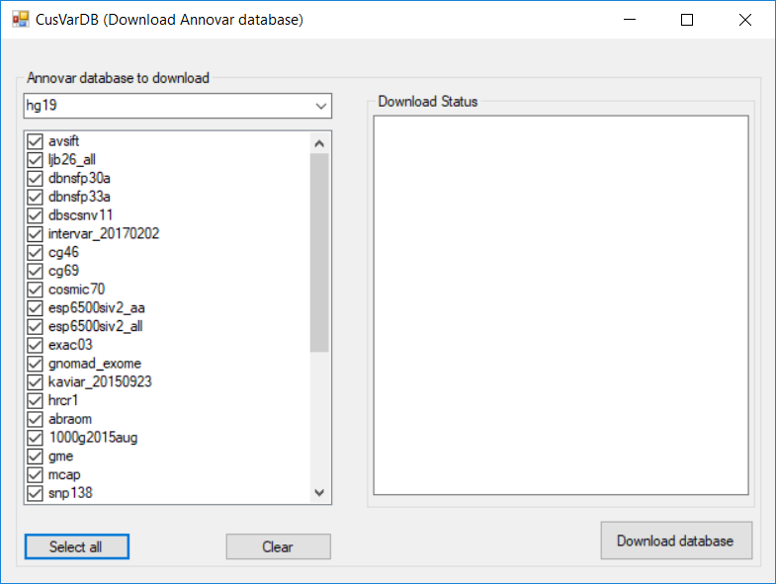

**Dry-run**

The dry run option helps the advanced or professional user to customize the command. This panel generates the command ready to run as bash script. The bash scripts generates raw VCF file. Further, the annotation and variant protein database can be generated from the “**Annotation tab**”.

Dry run generated commands are stored in a dry_run.sh file. This file can be executed in terminal by typing below command

>bash dry_run.sh

(**Note**: The bash script needs to be run on Linux Environment.)

**Running the GUI**

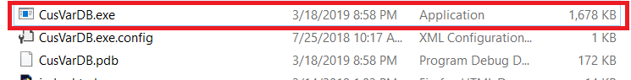To run the application, extract the CusVarDB.rar file and navigate to the folder CusVarDB. You will find the executable called CusVarDB.exe or CusVarDB Refer the below figure.

**Working with test datasets**

The test data set a sub set from the large whole exome data, where we have extracted the chromosome 22 reads and made the dataset (read1.fastq and read2.fastq). The reads were extracted from the samtools view command. From whole exome data we extracted the chr22 bam file and converted the BAM file to fastq file using the picard samtofastq command. Apart from the Fastq datasets, you will find dbSNP and the reference genome database used for the analysis.

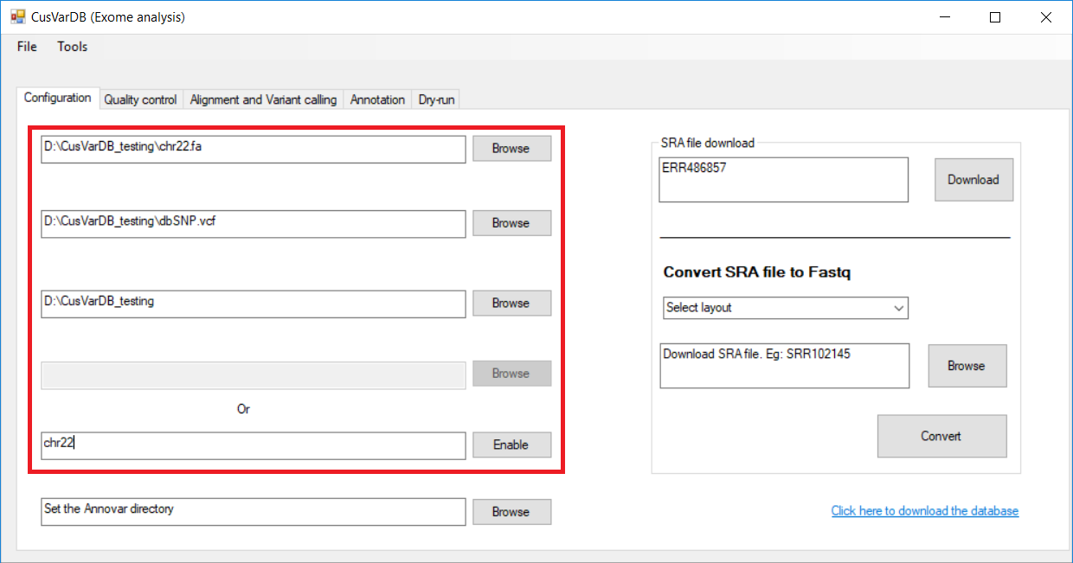Make sure that before starting any task **set the working directory**. Keep all the datasets and required perquisites in the working directory. It is good to have different directories for different studies to avoid conflicts. All the analysis files and the results files are stored in the working directory. User always has the option to go back to the necessary files to get to know whether the analysis is completely performed or not. Below figure shows uploading the required files for the analysis.

**Quality control (QC)**

Before we proceed to analysis, it is good to know about the quality of data. Generally the variant calling required high quality data which gives the true positive variants. We have used FastQC tool to run the quality for raw reads. This operation will provide the basic statistics and per base sequence quality in the main panel. The detailed summary option will be provided by the “Show full summary” option.

**Alignment and variant calling**

Alignment and variant calling is performed with multiple steps, we have used tools such as BWA, SAMtools, picard and GATK to perform these steps. The current panel provides the user to select the GATK algorithms (UnifiedGenotyper or HaplotypeCaller) and the data layout (Single or Paired-end). User can customize the threads and the memory, default thread is calculated based on total number of threads / 2 and the memory is calculated by dividing the total memory (in GB) by 2 (total memory / 2) . Read group ID, Platform unit, sample and platform are the labels, detailed information is provided by the GATK (https://gatkforums.broadinstitute.org/gatk/discussion/6472/read-groups)

In addition, break after each command will pause the execution of command. The next command will be resumed only if the user enters any key. This option is helpful in understanding the backend process.

**Annotation and variant database generation**

This panel performs the variant annotation using ANNOVAR tool. Make sure that the database which has been selected for the annotation is already been downloaded. After the annotation step, variant protein database is generated from the raw variants generated by the GATK tool.

The variant protein database is generated from the RefSeq version 81. User has the option to update the database to new version, the RefSeq database will be found at directory “DB-making\ homo_sapiens_RS81.fasta”.

(Note: The latest version of RefSeq database can be downloaded at NCBI. Make sure that the header of the database must be in specific format (as mentioned below).

>gi|53828740|ref|NP_001005484.1| NP_001005484.1#OR4F5#79501#olfactory receptor 4F5 [Homo sapiens]

(**Note**: Any change in the header will lead to index error.)