**Test assignment for frontend position for  
Big Data Federation, Moldova**

**Task description:**For this assignment you will need to use tools mentioned in “List of required tools” section at the bottom of this document. You will need to create an app containing 2 pages.  
  
**1. First page, list of companies.**Should display a sortable table of companies:

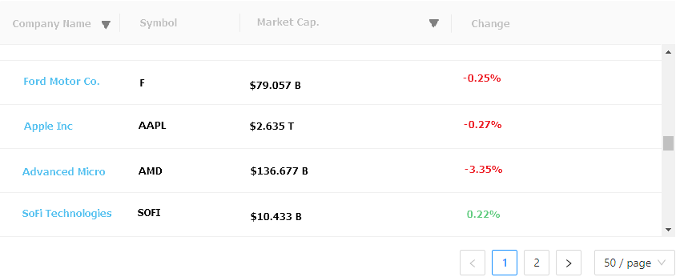

Use following API endpoint to acquire data for this page: <https://iexcloud.io/docs/api/#list>   
  
Please use ***mostactive*** param to get data market list. Take only first 100 items and create simple pagination. Use only following fields to display in a table:  
***companyName, marketCap, change, symbol***. Make companies sortable by ***companyName*** and ***marketCap***.   
  
Each company should be a link. After clicking a company, user should see second page containing chart of corresponding company (page description below).

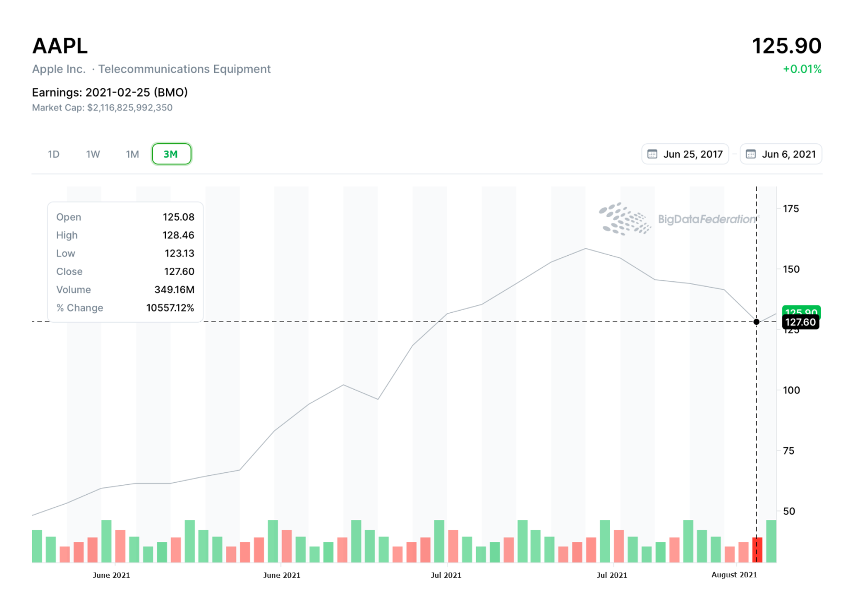**2. Second page, company chart**Should contain a chart having two series of data.  
Chart should contain 2 elements:  
1. Line chart  
2. Green & red bars at the bottom  
(as well as corresponding X, Y axes as seen on the image above)  
  
Please use following API to get data for this chart: <https://iexcloud.io/docs/api/#historical-prices>   
  
Use ***close*** property to display line chart and ***volume*** property to display bars at the bottom (you may ignore the colors).

**List of required tools:**

• <https://create-react-app.dev/> and <https://redux.js.org/introduction/installation>

• <https://www.highcharts.com/>

• <https://www.npmjs.com/package/highcharts-react-official>

• <https://iexcloud.io/> (for data, you’ll need to create a free account)

You can use any UI library for styling the table and SCSS or LESS [preprocessor](https://en.wikipedia.org/wiki/Preprocessor) [scripting language](https://en.wikipedia.org/wiki/Scripting_language).

*We wish you success!*