CLIMATE VARIABILITY AND CROP YIELD
IN MAHARASHTRA, 2000–2017
Dataset audit, literature review and proposed empirical design
WORKING RESEARCH REPORT
Prepared 18 October 2026
Study period: 2000–2017 | Geography: Maharashtra, India | Crops: soybean and cotton
Purpose
This report evaluates the four CSV files supplied for the project, summarises relevant peer-reviewed evidence, and sets out a reproducible district-panel design. It distinguishes usable observations from data that still need to be obtained or reconciled.
Data status at preparation
Preliminary only. The supplied agricultural panel is usable for descriptive summaries, but the climate files do not yet provide the requested district-by-year weather panel. No causal or regression result is claimed in this report.

Executive summary
The project asks whether weather variability—especially temperature and monsoon rainfall—is associated with district-level soybean and cotton yields in Maharashtra from 2000 to 2017. The research question is well suited to a district-year panel, but the four supplied files are not yet a complete analysis-ready panel.
The ICRISAT-labelled CSV contains 464 district-year rows across 2000–2017 and provides soybean and cotton area, production and yield. The ERA5-Land-labelled file contains hourly 2 m temperature from a single coordinate (19.0°N, 73.3°E), not the requested monthly spatial grid; it contains no precipitation variable and misses 1 January 2000. The remaining files provide district rainfall normals and subdivision-level historical rainfall, rather than daily 0.25° rainfall grids or district-year rainfall for all 18 study years.
A descriptive aggregation of the agricultural file shows substantial year-to-year variation. State-level weighted soybean yield, calculated as total production divided by total area, ranges from approximately 485 kg/ha in 2015 to 1,581 kg/ha in 2010. The corresponding cotton series ranges from approximately 100 kg/ha in 2000 to 460 kg/ha in 2016. These are descriptive figures from the supplied file, not estimates of weather effects.
The recommended next step is to obtain the complete ERA5-Land monthly grid with both temperature and precipitation, the IMD daily 0.25° rainfall data, and a boundary layer aligned to the historical district units in the ICRISAT panel. Irrigation, fertiliser use and total cropped area must also be extracted from the full ICRISAT District-Level Database if available. Only after these alignments should the project estimate crop-specific fixed-effects models.

Decisions required before estimation
- Treat the supplied ERA5 CSV as a single-point temperature extract, not as statewide monthly climate data.
- Use the rainfall normal file for spatial context only; do not use static normals as year-to-year rainfall observations.
- Choose one district geography and reconcile split districts before joining climate and agricultural records.
- Do not interpret all zero yields as missing or as valid zero productivity until crop-coverage metadata are checked.

1. Introduction
Agricultural yields depend on weather during crop development as well as on irrigation, soil conditions, crop varieties, input use and management. In monsoon-dependent regions, both insufficient rainfall and intense or poorly timed rainfall can affect crop performance. Temperature effects can also be nonlinear: a moderate rise may support growth in some conditions, while heat beyond a crop’s tolerance can reduce yields (Schlenker & Roberts, 2009; Auffhammer et al., 2012).
Maharashtra is an appropriate setting for investigating these relationships because the state contains sharply different rainfall environments, including the wetter Konkan belt and the comparatively dry interiors of Marathwada and parts of western Maharashtra, alongside Vidarbha. Soybean and cotton are important monsoon-season crops in the district-level data supplied for this project. Studying the two crops separately is preferable to assuming that they respond to weather in the same way: their growing characteristics, water requirements and observed productivity differ.
The proposed study will examine district-level variation in soybean and cotton yields between 2000 and 2017 and ask how that variation covaries with growing-season temperature, seasonal rainfall totals and rainfall extremes. The emphasis is on separating changes within a district over time from persistent differences between districts. The intended analysis will therefore combine crop outcomes with spatially matched climate indicators and, where the data permit, controls for irrigation, fertiliser use and agricultural area.
Three questions guide the work. First, how are district-level soybean and cotton yields associated with growing-season temperature and rainfall? Second, do rainfall deficits and excesses, or the intensity and timing of rainfall, explain variation beyond seasonal totals? Third, are the patterns robust after accounting for district-specific characteristics, common year shocks and observable agricultural inputs? Prior work motivates nonlinear temperature terms and separate measures of rainfall amount and intensity rather than a single annual climate average (Lobell & Field, 2007; Maiti et al., 2026).
The current files support an initial audit and descriptive summaries, but not yet a defensible regression. The temperature file is limited to one grid point; the historical rainfall series is organised by meteorological subdivision and ends in 2015; the rainfall-normal table has no annual variation; and the provided crop dataset omits the requested irrigation and fertiliser controls. These limitations are treated as data requirements, not filled by assumptions. The report therefore distinguishes preliminary description from the proposed empirical analysis.

2. Literature and background
The literature points to three design choices for this project. First, climate-yield relationships can be nonlinear, so linear-only temperature terms may be insufficient. Second, seasonal rainfall totals do not capture the distinction between drought, moderate rain and extreme events. Third, the appropriate spatial scale matters: national or state-level results are useful context, but the project requires weather and yields aligned to a consistent district geography.

2.1 Selected studies

Lobell, Schlenker & Costa-Roberts (2011) — Climate trends and global crop production since 1980
Model / approach Empirical crop–weather models used to compare observed climate trends with a counterfactual in which those trends did not occur.
Data Global crop-yield series and growing-season temperature trends for 1980–2008, focusing on maize, wheat, soybean and rice.
Relevant finding Climate trends were associated with global production reductions of about 3.8% for maize and 5.5% for wheat; soybean and rice outcomes varied across regions. This supports crop-specific rather than one-size-fits-all modelling.

Schlenker & Roberts (2009) — Nonlinear temperature effects indicate severe damages to U.S. crop yields under climate change
Model / approach County-panel crop-yield models using nonlinear exposure to temperature, including the distribution of temperatures across the growing season.
Data U.S. county-level maize, soybean and cotton yields paired with fine-scale weather data.
Relevant finding Yields rise only up to crop-specific temperature thresholds and fall sharply above them; estimated thresholds were approximately 30°C for soybeans and 32°C for cotton. This motivates nonlinear heat-exposure measures, while U.S. thresholds should not be transferred mechanically to Maharashtra.

Lobell & Field (2007) — Global scale climate–crop yield relationships and the impacts of recent warming
Model / approach Global empirical relationships between crop yields and spatially averaged growing-season temperature and precipitation.
Data Annual yield records for six major global crops paired with crop-location climate summaries.
Relevant finding Simple temperature and precipitation measures explained roughly 30% or more of year-to-year global yield variation for the crops studied; warming effects differed by crop. It supports a parsimonious weather baseline before adding more detailed indices.

Auffhammer, Ramanathan & Vincent (2012) — Climate change, the monsoon, and rice yield in India
Model / approach Statistical analysis of state-level rice yields and monsoon characteristics, with counterfactual simulations of changes in climate indicators.
Data Indian state-level data for 1966–2002, including rice yields, drought, extreme rainfall, night-time temperature and late-season rainfall.
Relevant finding Drought and extreme rainfall reduced rice yields in predominantly rainfed states, with drought more damaging in their estimates. This supports distinguishing rainfall deficits from high-rainfall events.

Goswami et al. (2006) — Increasing trend of extreme rain events over India in a warming environment
Model / approach Trend analysis of the frequency and magnitude of daily rainfall extremes and moderate events.
Data Daily Indian rainfall data for monsoon seasons over 1951–2000, with emphasis on central India.
Relevant finding Extreme events became more frequent/intense while moderate events declined; seasonal mean rainfall did not show a significant trend. A seasonal total alone can therefore conceal agriculturally relevant rainfall-distribution changes.

Pai et al. (2014) — Development of a new high spatial resolution (0.25° × 0.25°) long period (1901–2010) daily gridded rainfall data set over India
Model / approach Construction and comparison of a quality-controlled gridded daily rainfall product; no crop-yield regression is the paper’s main purpose.
Data Daily records from 6,955 rain gauges, gridded at 0.25° over mainland India for 1901–2010 and compared with other gridded products.
Relevant finding The product better represented high-rainfall west-coast/orographic areas and the drier lee side of the Western Ghats. It is an appropriate methodological reference for the requested IMD daily rainfall source.

Muñoz-Sabater et al. (2021) — ERA5-Land: a state-of-the-art global reanalysis dataset for land applications
Model / approach Description and evaluation of a high-resolution land reanalysis driven by ERA5 meteorological forcing.
Data Global hourly and monthly ERA5-Land fields, evaluated against relevant observations and other products for land-surface applications.
Relevant finding ERA5-Land provides a consistent, comparatively high-resolution set of land variables for hydrological and environmental analysis. The dataset is a climate input, not a crop-yield model, and should be aggregated to the agricultural unit with care.

Patil & Shende (2024) — Impact of climate change on productivity of soybean in Akola district of Maharashtra
Model / approach Correlation tests, multiple linear regression, Shapiro–Wilk normality tests, and Mann–Kendall/Sen’s-slope trend analysis.
Data Soybean area, production and yield series for Akola (1901–2020), paired with local weather factors including rainfall and temperature-related indicators.
Relevant finding The paper reports a positive, statistically significant relationship between soybean productivity and rainfall and attributes 33% of productivity variation to the climate factors included in its regression. It is geographically relevant, though its long historical period and specification must be considered when comparing results.

Maiti et al. (2026) — Excess rainfall threatens monsoon crop yield stability under climate change
Model / approach Nonlinear analysis based on optimum rainfall thresholds, crop-specific responses and rainfall-frequency/intensity indices, followed by climate-scenario projections.
Data District-level yield observations for eight Indian monsoon crops over 1990–2017, including soybean and cotton, combined with rainfall indices.
Relevant finding Rainfall above an optimum threshold can harm yields as well as rainfall deficits; rainy-day intensity was more informative than event frequency in the reported analysis. This directly motivates testing both deficits and surpluses in the Maharashtra panel.

Wooldridge (2010) — Econometric Analysis of Cross Section and Panel Data (2nd ed.)
Model / approach Econometric methods reference covering fixed effects, panel estimators and inference with dependent observations.
Data Methods text rather than one empirical dataset; relevant chapters develop panel-data assumptions and estimators.
Relevant finding District and year fixed effects provide a standard way to absorb time-invariant district differences and common year shocks. Inference should account for repeated observations within district; with about 26 historical units, small-cluster sensitivity checks are warranted.

2.2 Implications for this study
The most defensible starting point is a crop-specific panel model with district fixed effects and year fixed effects. Temperature should be represented with a flexible term or heat-exposure measure, while rainfall should include seasonal totals and at least one indicator of unusually heavy rainfall or rainfall deficits. A nonlinear term is justified by the crop-climate literature, but the functional form must remain parsimonious with only 18 years of observations. Irrigation and input-use controls are desirable, because weather is not the only time-varying determinant of yield.
The cited papers do not establish that a particular coefficient or threshold will hold in Maharashtra. Most provide methodological precedent or findings from another spatial scale. The proposed estimates must therefore be treated as local empirical results, with robustness checks and transparent limitations, rather than as a direct transfer of published effects.

3. Data sources and file audit
Four CSV files were supplied for inspection on 18 October 2026. Their original download dates and, for two files, exact originating URLs are not embedded in the files. The official/recommended source pages below were checked on 18 October 2026; this date is a source-verification date and should not be mistaken for the date on which the CSVs were originally downloaded.
File supplied | Observed coverage | Variables and apparent units | Readiness / limitation
ERA5-Land-labelled temperature CSV | 157,776 hourly records; 2000–2017; one point at 19.0°N, 73.3°E. | valid_time, t2m, latitude, longitude. t2m is consistent with ERA5 2 m temperature in kelvin; a temperature-in-Celsius series is derived by subtracting 273.15. | Not the requested monthly spatial grid. No total precipitation field. The first available timestamp is 2000-01-02 00:00, leaving 24 missing hourly observations for 1 January 2000.
ICRISAT-labelled district-level CSV | 464 rows; 2000–2017; 25–26 historical district units per year. | Soybean and cotton area (1,000 ha), production (1,000 tonnes), yield (kg/ha), plus district/state identifiers. | Useful crop outcomes, but not the requested irrigated area, fertiliser use or total cropped area. The exact source version is not encoded; Bombay has no row in 2013, 2014, 2015 or 2017.
District-wise rainfall normal CSV | 35 Maharashtra district entries plus other Indian states; static monthly and seasonal normals. | JAN–DEC, annual and seasonal rainfall totals; values appear to be in mm. | No year dimension and no documented normal period in the file. Useful for spatial/climatological context only, not for estimating weather-yield associations over time.
Rainfall in India, 1901–2015 CSV | 4,116 records; 36 meteorological subdivisions; 1901–2015. | Monthly, annual, and seasonal rainfall totals; Maharashtra-related subdivisions include Madhya Maharashtra, “MATATHWADA” and Vidarbha. | Subdivision-level, not district or 0.25° grid-level; ends in 2015, so it does not cover 2016–2017. The exact originating URL is not embedded in the file.

3.1 Preliminary agricultural summary
State-level annual yield in the table below is calculated from the supplied area and production fields as (total production ÷ total area) × 1,000. This produces kg/ha because both area and production are expressed in thousands. It is a weighted aggregate derived from the input file and may differ from a simple average of district yield values.
Crop | Mean area (000 ha) | Mean production (000 t) | Mean annual weighted yield (kg/ha) | Minimum yield (year) | Maximum yield (year)
Soybean | 2,667.1 | 2,834.9 | 1,101 | 485 (2015) | 1,581 (2010)
Cotton | 3,539.6 | 887.7 | 244 | 100 (2000) | 460 (2016)

Soybean weighted yield averaged approximately 1,101 kg/ha across the 18 annual aggregates, with a low near 485 kg/ha in 2015 and a high near 1,581 kg/ha in 2010. Cotton averaged approximately 244 kg/ha, with a low near 100 kg/ha in 2000 and a high near 460 kg/ha in 2016. These movements show meaningful outcome variation for investigation; they do not, on their own, identify weather as the cause.
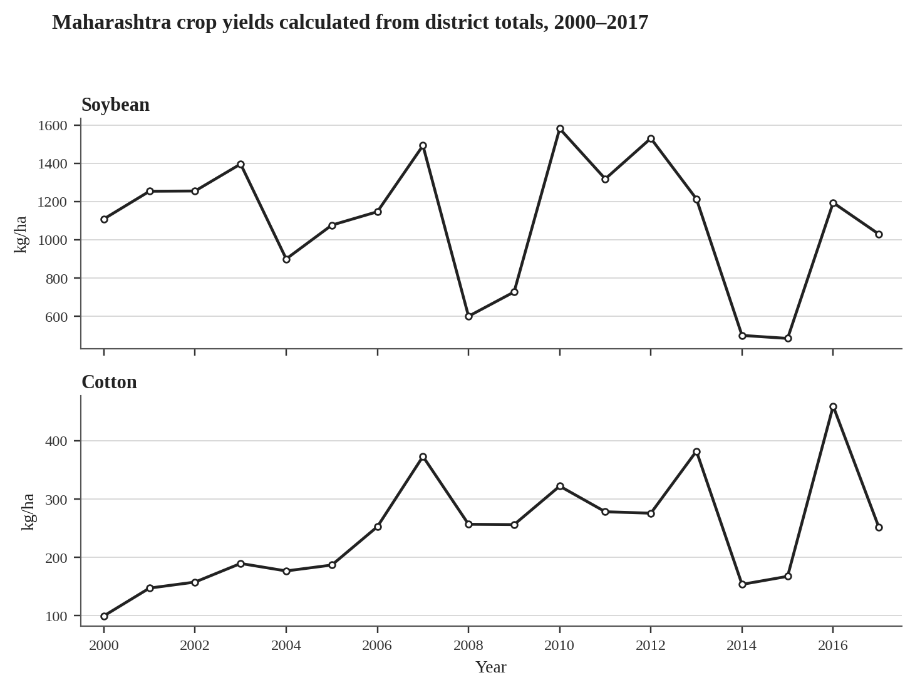
Figure 1. Annual area-weighted yields calculated from the supplied ICRISAT-labelled district file. State aggregates are constructed from summed district production and area; no causal interpretation is implied.

3.2 Rainfall description and coverage
The supplied district-normal file records 35 Maharashtra district entries. Annual normal rainfall ranges from 573.2 mm for Ahmednagar to 3,470.6 mm for Ratnagiri; the June–September normal ranges from 437.6 mm to 3,261.5 mm across the included entries. The breadth of this spatial range supports district-level weather matching rather than assigning one statewide rainfall number to every district. The file does not identify the climatological normal period, so that metadata must be recovered before formal citation or interpretation.
The historic subdivision file provides an annual series for three Maharashtra-related meteorological subdivisions through 2015. For 2000–2015, average June–September rainfall is approximately 801 mm in Madhya Maharashtra, 622 mm in Marathwada (spelled “MATATHWADA” in the file) and 961 mm in Vidarbha. The series helps describe regional rainfall variability, but it is too coarse to substitute for daily gridded rainfall assigned to each historical district.
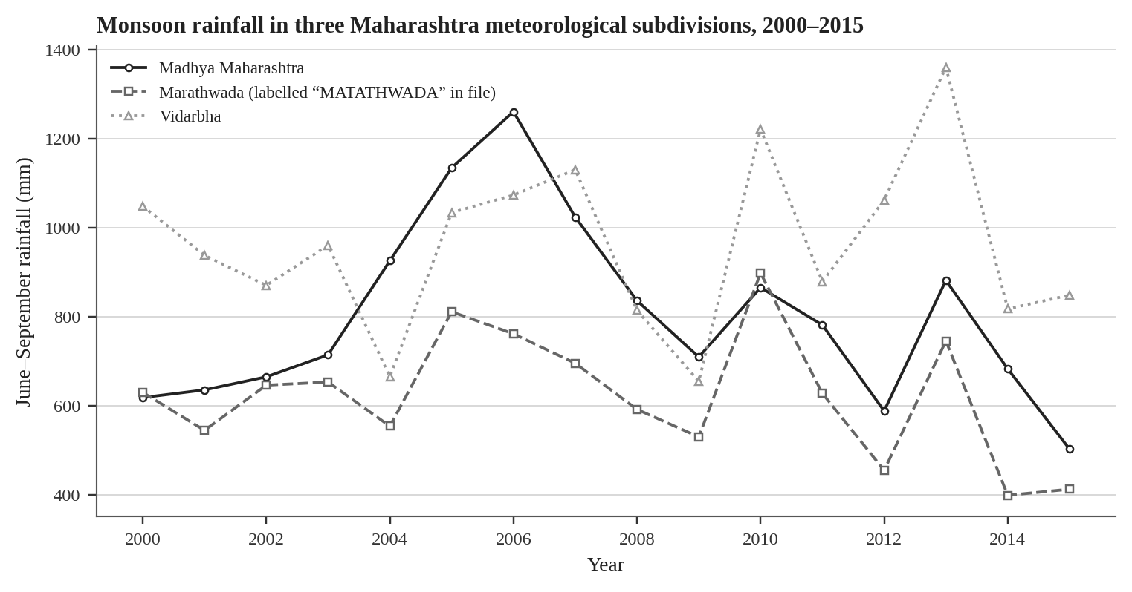
Figure 2. June–September rainfall totals for three meteorological subdivisions, 2000–2015, as recorded in the supplied historical rainfall file. These are subdivision aggregates, not district-level or gridded observations.

4. Outstanding data requirements
Outstanding item | Required action
ERA5-Land monthly temperature and precipitation | Submit the CDS request for 2000–2017 across N 22.5, W 72.5, S 15.5, E 81. Obtain both 2m_temperature and total_precipitation on the spatial grid. Check whether the returned product is monthly means or monthly accumulated/averaged values and convert precipitation using the exact CDS metadata.
IMD 0.25° daily gridded rainfall | Download the raw daily files for 2000–2017, retain source files unchanged, and record units, grid coordinate conventions and source page. Use daily data to calculate monsoon totals, heavy-rain-day frequency/intensity and dry-spell measures.
District boundary file and stable geography | Obtain a boundary shapefile/GeoJSON with an explicit vintage and source licence. Because the crop file uses historical district units, either use matching historical boundaries or aggregate current boundaries/climate to the older geography. Do not perform a name-only join across district vintages.
Full ICRISAT district database and metadata | Extract soybean and cotton yield/area/production and, where available, irrigated area, fertiliser use and total cropped area for 2000–2017. Confirm whether missing fields are unavailable or merely absent from the supplied crop-only extract.
Source/access log and report format | Record the exact download URL and actual retrieval date for each raw file. Confirm the professor/course-sheet format, citation style, expected figures/tables and submission deadline before final submission.

4.1 Data preparation order
- Preserve each downloaded file unchanged and record a checksum, source URL, access date, format, units and licence/terms.
- Convert ERA5-Land temperature from kelvin to °C; convert precipitation only after confirming the exact accumulation/averaging semantics of the CDS product.
- Derive district-by-month or district-by-season weather from grid cells using a consistent spatial overlay and area-weighted aggregation where appropriate.
- Create crop-specific district-year outcomes from ICRISAT and document whether zero-valued observations mean no cultivation, a structural zero or missing data.
- Resolve old/new district splits before merging outcomes, boundaries and climate. Keep a mapping table that records each historical district and its present-day successor units.
- Check missingness, outliers, crop-area and production arithmetic, and duplicate district-year keys before estimation.

5. District-boundary reconciliation
Boundary reconciliation is essential because the provided crop series refers to an older set of Maharashtra district units, while the rainfall-normal file contains 35 district entries and a current administrative layer may contain a different set. A name match is not enough: a new district’s crop yield cannot be copied from its former parent district without a defensible apportionment rule or district-level source data.
New / changed district | Parent geography | Formation date | Verification note
Jalna | Aurangabad (now Chhatrapati Sambhajinagar) and part of Parbhani | 1 May 1981 | Official GSDA district history; formation drew talukas from two older districts.
Latur | Osmanabad (now Dharashiv) | 15 August 1982 | Official district history confirms the split date.
Gadchiroli | Chandrapur | 26 August 1982 | Official GSDA district history confirms the parent district and date.
Nandurbar | Dhule | 1 July 1998 | Official Nashik Divisional Commissioner / district pages confirm the date.
Washim | Formed in 1998; parent territory requires tehsil-level confirmation | 1 July 1998 | Official GSDA page confirms formation date; it also describes an earlier historical Washim district split between Akola and Yavatmal, so a simplistic one-parent crosswalk should be avoided.
Hingoli | Parbhani | 1 May 1999 | Official GSDA district history confirms the split.
Gondia | Bhandara | 1 May 1999 | Official GSDA district history confirms the split.
Palghar | Thane | 1 August 2014 | Official Thane district page states Palghar became Maharashtra’s 36th district after Thane was divided.

The named examples were checked against Maharashtra government district-history pages on 18 October 2026. The Washim entry needs more careful tehsil-level mapping than “from Akola” alone. Jalna also includes territory from Parbhani, not only Aurangabad. For modelling, the safest route is to preserve the older ICRISAT geography until the yield series itself can be split reliably.

6. Proposed empirical design
Once the missing weather grids, controls and boundary crosswalk are resolved, estimate separate models for soybean and cotton. A baseline specification is:
Yieldᵢₜ = αᵢ + λₜ + β₁ Tempᵢₜ + β₂ Temp²ᵢₜ + γ₁ Rainᵢₜ + γ₂ Rain²ᵢₜ + δ′Xᵢₜ + εᵢₜ
Here, i indexes historical districts and t indexes years. αᵢ represents district fixed effects; λₜ represents year fixed effects; Temp is a growing-season or crop-stage temperature measure; Rain is seasonal rainfall; and X contains time-varying agricultural controls where available. The specification should be adapted to the data and should not include variables that are unavailable or incorrectly measured.
A second specification should replace or augment total rainfall with measures that capture the distribution of daily rainfall, such as rainfall below a deficit threshold, the number of heavy-rain days, rainfall intensity on wet days or the longest dry spell during the crop season. These variables require daily IMD rainfall and should be pre-specified to avoid testing many indicators without a clear rationale.

6.1 Estimation and diagnostics
- Use log yield only for positive observed yield values; report how zero-yield observations are handled and run a sensitivity analysis.
- Cluster standard errors by district because repeated observations from the same district are not independent. With roughly 25–26 clusters, consider a small-cluster correction or wild-cluster bootstrap as a robustness check.
- Compare linear and nonlinear weather terms, inspect collinearity between temperature and rainfall measures, and report effect sizes with uncertainty rather than significance stars alone.
- Include irrigation, fertiliser and total cropped area only after confirming definitions, units, coverage and whether these are contemporaneous inputs or potentially endogenous responses.
- Use sensitivity checks across crop seasons, alternative rainfall indices, and consistent boundary vintages. Results should be described as associations unless the design identifies a credible causal effect.

7. Source register and limitations
Online source pages below were checked on 18 October 2026. For the four uploaded CSV files, the upload/inspection date is known, but the original download/access date is not. The exact originating URL cannot be independently reconstructed from a CSV filename alone; the original download record should be retained if available.
Item | Source / purpose | Source URL | Access note
ERA5-Land monthly means (requested source) | Copernicus Climate Data Store; variables and grid request must be submitted by an authenticated user. | https://cds.climate.copernicus.eu/datasets/reanalysis-era5-land-monthly-means?tab=download | Checked 18 Oct 2026; request not verified as submitted/queued.
Supplied ERA5-Land-labelled temperature extract | User-supplied CSV; exact export URL/creation date absent from file metadata. | https://cds.climate.copernicus.eu/datasets/reanalysis-era5-land-monthly-means?tab=download | Inspected 18 Oct 2026; only one grid point and temperature variable present.
IMD daily 0.25° rainfall paper / data context | Pai et al. (2014), MAUSAM original publication page. | https://mausamjournal.imd.gov.in/index.php/MAUSAM/article/view/851 | Checked 18 Oct 2026; source article verified; raw 2000–2017 rainfall grid not supplied.
IMD rainfall information portal | India Meteorological Department rainfall information. | https://mausam.imd.gov.in/responsive/rainfallinformation_state.php | Checked 18 Oct 2026; not proof that the requested historical daily grid was downloaded.
ICRISAT district-level database | Official ICRISAT District Level Data page. | https://www.icrisat.org/public/resources/data/district-level-data | Checked 18 Oct 2026; supplied CSV appears to be a crop-variable subset; source version and exact extract date unconfirmed.
District boundaries — DataMeet maps | Community repository for Indian spatial data; validate district vintage and licence for the exact layer. | https://github.com/datameet/maps | Checked 18 Oct 2026; no shapefile/GeoJSON was supplied in this upload.
Alternative administrative boundaries — GADM | GADM data download page; check version, licensing and use restrictions before use. | https://gadm.org/download.html | Checked 18 Oct 2026; no boundary file was supplied.
Supplied district rainfall normals CSV | File supplied by user; exact download URL, normal period and licence not embedded. IMD portal is a relevant official point of reference. | https://mausam.imd.gov.in/responsive/rainfallinformation_state.php | Inspected 18 Oct 2026; metadata and normal period still need confirmation.
Supplied rainfall in India 1901–2015 CSV | File supplied by user; exact originating URL/version not embedded. | https://mausamjournal.imd.gov.in/index.php/MAUSAM/article/view/851 | Inspected 18 Oct 2026; appears to be a subdivision-level annual/monthly series, not the daily 0.25° product.
ERA5-Land paper | Muñoz-Sabater et al. (2021), Earth System Science Data. | https://doi.org/10.5194/essd-13-4349-2021 | Checked 18 Oct 2026; original journal page verified.

7.1 Limitations at the current stage
- The current weather files do not match the requested temporal and spatial resolution for a district-year model.
- The crop CSV is labelled ICRISAT but its exact version and extract method are not recorded in the file; metadata should be attached to the final data package.
- The rainfall-normal period is unknown; normal values are not observations for individual study years.
- The supplied boundaries are absent; geographic joins and district-split adjustments have not been performed.
- The observed yield swings have not been statistically attributed to weather. No inferential model has been run in this report.

References
Auffhammer, M., Ramanathan, V., & Vincent, J. R. (2012). Climate change, the monsoon, and rice yield in India. Climatic Change, 111(2), 411–424. https://doi.org/10.1007/s10584-011-0208-4
Goswami, B. N., Venugopal, V., Sengupta, D., Madhusoodanan, M. S., & Xavier, P. K. (2006). Increasing trend of extreme rain events over India in a warming environment. Science, 314(5804), 1442–1445. https://doi.org/10.1126/science.1132027
Lobell, D. B., & Field, C. B. (2007). Global scale climate–crop yield relationships and the impacts of recent warming. Environmental Research Letters, 2(1), 014002. https://doi.org/10.1088/1748-9326/2/1/014002
Lobell, D. B., Schlenker, W., & Costa-Roberts, J. (2011). Climate trends and global crop production since 1980. Science, 333(6042), 616–620. https://doi.org/10.1126/science.1204531
Maiti, A., Tiwari, A. D., Pokhrel, Y., Rosa, L., McDonald, A., Singh, G., et al. (2026). Excess rainfall threatens monsoon crop yield stability under climate change. Earth’s Future, 14, e2025EF007801. https://doi.org/10.1029/2025EF007801
Muñoz-Sabater, J., Dutra, E., Agustí-Panareda, A., Albergel, C., Arduini, G., Balsamo, G., et al. (2021). ERA5-Land: a state-of-the-art global reanalysis dataset for land applications. Earth System Science Data, 13, 4349–4383. https://doi.org/10.5194/essd-13-4349-2021
Pai, D. S., Rajeevan, M., Sreejith, O. P., Mukhopadhyay, B., & Satbha, N. S. (2014). Development of a new high spatial resolution (0.25° × 0.25°) long period (1901–2010) daily gridded rainfall data set over India and its comparison with existing data sets over the region. MAUSAM, 65(1), 1–18. https://doi.org/10.54302/mausam.v65i1.851
Patil, A., & Shende, N. (2024). Impact of climate change on productivity of soybean in Akola district of Maharashtra. Journal of Food Legumes, 35(4), 267–273. https://doi.org/10.59797/journaloffoodlegumes.v35i4.315
Schlenker, W., & Roberts, M. J. (2009). Nonlinear temperature effects indicate severe damages to U.S. crop yields under climate change. Proceedings of the National Academy of Sciences, 106(37), 15594–15598. https://doi.org/10.1073/pnas.0906865106
Wooldridge, J. M. (2010). Econometric Analysis of Cross Section and Panel Data (2nd ed.). MIT Press. https://mitpress.ublish.com/book/econometric-analysis-cross-section-and-panel-data

Appendix A. Variable dictionary and audit notes
Variable | File | Units / format | Audit note
valid_time | ERA5 CSV | Timestamp | Hourly timestamp; first record is 2000-01-02 00:00. No explicit timezone field in the CSV.
t2m | ERA5 CSV | Kelvin (expected ERA5 convention) | For °C, subtract 273.15. Verify the exported variable metadata when downloading the full field.
latitude / longitude | ERA5 CSV | Degrees | Only one unique point: latitude approximately 19.0, longitude approximately 73.3.
SOYABEAN AREA | ICRISAT-labelled CSV | 1,000 ha | District-level crop area; 68 records have zero area, production and yield together.
SOYABEAN PRODUCTION | ICRISAT-labelled CSV | 1,000 tonnes | Use with area to calculate an area-weighted yield.
SOYABEAN YIELD | ICRISAT-labelled CSV | kg/ha | Provided field; derived yield should be cross-checked against production/area ratio.
COTTON AREA | ICRISAT-labelled CSV | 1,000 ha | District-level crop area; 99 records have zero area, production and yield together.
COTTON PRODUCTION | ICRISAT-labelled CSV | 1,000 tonnes | Five low-area records in 2016–2017 differ from the production/area yield quotient by more than 10 kg/ha, likely due to rounded inputs or source conventions; audit before final estimation.
COTTON YIELD | ICRISAT-labelled CSV | kg/ha | Provided field; check arithmetic and data dictionary.
JAN–DEC, ANNUAL, Jun-Sep | Rainfall normals CSV | mm (apparent; metadata to confirm) | Climatological totals; normal reference period missing from file.
ANNUAL, Jun-Sep etc. | Historic rainfall CSV | mm (apparent) | Sub-division level; some missing values occur in the national file.

Appendix B. Official district-history pages checked
Jalna district history — Creation date 1 May 1981; included talukas from Aurangabad and Partur from Parbhani.
Latur administrative history — Latur separated from Osmanabad on 15 August 1982.
Gadchiroli district history — Gadchiroli carved out of Chandrapur on 26 August 1982.
Nandurbar district history — Nandurbar formed from Dhule on 1 July 1998.
Washim district history — Formation date 1 July 1998; exact parent-area crosswalk should be checked at taluka level.
Hingoli district history — Hingoli formed by division of Parbhani on 1 May 1999.
Gondia district history — Gondia formed by division of Bhandara on 1 May 1999.
Palghar district information — Palghar became the state’s 36th district on 1 August 2014 after Thane was divided.

Appendix C. Immediate action list
1. Submit the ERA5-Land monthly means request through CDS for 2000–2017, variables 2m_temperature and total_precipitation, area N 22.5 / W 72.5 / S 15.5 / E 81; save the submitted request ID and downloaded raw file.
2. Download IMD daily 0.25° gridded rainfall for 2000–2017 and preserve the raw files.
3. Download and inspect a boundary layer; choose the historical district geography matching the crop panel and document a validated crosswalk.
4. Retrieve the full ICRISAT district-level data and metadata for irrigation, fertiliser use and total cropped area if available.
5. Keep the Lobell et al. (2011) PDF already held by the team with the remaining papers; record which PDFs are open access and which require institutional access.
6. Request the professor’s/course sheet instructions and revise formatting, citations and submission packaging accordingly.

