[insert NMIMS logo]
A Compartmental SEIR-Vector Model for Malaria Transmission Dynamics under Climate Variability in Urban Environments
Design Experience [I / II / III] Project Report
submitted in partial fulfilment of the requirements of
[Name of the Programme]
in
[Name of the Stream / Department]
Vertical: VIP
by
[Name 1 (Roll No. / SAP ID)]
[Name 2 (Roll No. / SAP ID)]
[Name N (Roll No. / SAP ID) — one line per student; team size N to be confirmed]
Under the supervision of
[Name of Faculty Mentor]
[Designation, Department, MPSTME]
MPSTME, SVKM’s NMIMS (Deemed-to-be University), Mumbai
[2026–27 — confirm academic year]
SVKM’s NMIMS University
(Deemed-to-be University)
[insert NMIMS logo]
MUKESH PATEL SCHOOL OF TECHNOLOGY MANAGEMENT & ENGINEERING (MPSTME)
Vile Parle (W), Mumbai-56
[2026–27 — confirm academic year]
CERTIFICATE
This is to certify that the Design Experience [I / II / III] project entitled “A Compartmental SEIR-Vector Model for Malaria Transmission Dynamics under Climate Variability in Urban Environments” has been carried out by [Names with Roll No.] under my guidance and supervision, and has been submitted in partial fulfilment of the requirements of [Name of the Programme] in [Name of the Stream] of MPSTME, SVKM’s NMIMS (Deemed-to-be University), Mumbai, India.
____________________  Project mentor  (name and signature)  (Internal Guide) | ____________________  Vertical SPOC  (name and signature) | ____________________  HoD  (name and signature)

Date:
Place: Mumbai

ACKNOWLEDGEMENT
[Thank the faculty mentor, vertical SPOC, industry / community / competition partners, funding or resource providers and peers. Mention the specific help received.]
Name | Roll No. | SAP ID
[Student 1] | [ ] | [ ]
[Student 2] | [ ] | [ ]
[Student N — one row per student] | [ ] | [ ]

DECLARATION
We declare that this report is our original work and reflects our own contribution in the semester of registration. We have acknowledged all contributors and cited all sources. The use of AI tools, if any, is disclosed in Section 5.5 and Appendix VII, and AI-generated content has been verified by us.
Signatures of students: ____________ ____________ ____________ [one line per student] Date: ____________

Abstract
Malaria transmission depends on mosquitoes, and mosquito numbers depend on climate and on the water available for breeding. In cities, blocked or sparse drains leave standing water after rain, but most transmission models describe climate and ignore the condition of urban drainage. This project asks whether the build quality and maintenance of urban drainage change modelled malaria outcomes in a city ward, and how much maintenance is “enough” for a given drainage network.
During this semester the team scoped the problem, organised a literature search into six keyword clusters and logged eight papers in a structured Literature Matrix. The team also identified data sources for each paper: the World Bank Climate Change Knowledge Portal is the primary candidate for climate data, while ward-level malaria case data must be requested from a municipal health department. The team then built a conceptual model and implemented the professor-approved mathematical specification in Python. It is an eight-compartment ordinary differential equation model that couples a human SEIR system to a mosquito system with an aquatic stage. Temperature enters through the biting rate, the parasite incubation rate and mosquito mortality. Rainfall enters through the larval carrying capacity and larval flushing. A Clogging Index Ω, built from drainage density and maintenance efficiency, links drainage condition to breeding habitat.
The main technical contribution is a tested, documented simulation tool with two variants. The “spec” variant implements the approved equations exactly. The “extended” variant adds rainfall memory and imported infections. The tool also includes a 9 × 9 drainage-scenario sweep, threshold analysis of Ω and sensitivity analysis, 42 passing automated tests, and a logged record of every departure from the specification.
With synthetic climate, mostly placeholder parameters and an uncalibrated habitat scale, worse drainage gave more malaria in every run. Only the worst illustrative ward sustained local transmission, above Ω ≈ 8.7. The Ω at which the reproduction number never exceeds 1 was about 100 to 200 times smaller. These results describe model behaviour, not any real city. The next steps are to lock the target city, obtain real climate and case data, source the placeholder parameters and calibrate the model.

Table of Contents
Right-click here and choose Update Field to build the table of contents.

List of Figures
Right-click here and choose Update Field to build the list of figures.

List of Tables
Right-click here and choose Update Field to build the list of tables.

Abbreviations
Abbreviation | Full form
AMC | Ahmedabad Municipal Corporation
API | Annual parasite incidence
CCKP | Climate Change Knowledge Portal (World Bank)
DFE | Disease-free equilibrium
EIP | Extrinsic incubation period
EIR | Entomological inoculation rate
ELP | Egg, larva, pupa (mosquito aquatic stages)
GLM / GLMM | Generalised linear (mixed) model
HoD | Head of Department
IEEE | Institute of Electrical and Electronics Engineers
IER | [full form of IER as used by the Design Experience office]
MPSTME | Mukesh Patel School of Technology Management & Engineering
ODE | Ordinary differential equation
R0 | Basic reproduction number
SEI | Susceptible–Exposed–Infectious
SEIR | Susceptible–Exposed–Infectious–Recovered
SPOC | Single point of contact
VIP | Vertically Integrated Projects [confirm full form used by MPSTME]

Chapter 1
Introduction
This chapter introduces the project topic: how climate and the condition of urban drainage together shape malaria transmission in a city. It explains why the topic was chosen and what this report covers. It then states the problem, names the stakeholders, and lists the objectives and expected outcomes. It also separates the work done this semester from any earlier background. The chapter ends with an outline of the rest of the report.

1.1 Background of the project topic

1.1.1 Malaria as a vector-borne disease
Malaria is caused by Plasmodium parasites and is spread between people by the bites of infected female Anopheles mosquitoes. The parasite has to develop inside the mosquito before the mosquito can infect a person, and inside a person before that person can infect a mosquito. Transmission therefore depends on three groups of factors: how many mosquitoes there are, how often they bite, and how long they survive compared with the time the parasite needs to develop. Compartmental models describe this cycle by dividing the human and mosquito populations into states such as susceptible, exposed, infectious and recovered. Ordinary differential equations (ODEs) then track how individuals move between the states over time [1], [2].

1.1.2 Climate and malaria
Temperature affects almost every step of the mosquito and parasite life cycle. Laboratory work shows that parasite development inside the mosquito speeds up with temperature, while mosquito survival and vector competence can fall at warmer temperatures. Transmission therefore does not simply rise with temperature [3]. At the cool end, parasite development has been observed to be faster than the classic degree-day formula predicts [4]. Rainfall mainly controls the amount of water available for mosquito larvae. A recent comparison found that three different ways of linking temperature and rainfall to a malaria model gave substantially different predictions [5]. How climate is put into a model is therefore itself a design decision.

1.1.3 Urban malaria and drainage
Malaria is not only a rural problem. In the Indian city of Ahmedabad, ward-level malaria risk was shown to be structured jointly by population density, climate variables and poverty [6]. In a city, much of the standing water in which mosquitoes breed is linked to the drainage network. When drains are sparse, or are present but blocked, water remains after rain and creates breeding habitat. When drains are clear, heavy rain can flush larvae away. [supporting reference needed for the drainage–standing water–breeding link; not yet in the Lit Matrix] This project expresses the drainage condition of a ward as a single Clogging Index, Ω, built from drainage density and maintenance efficiency, and feeds it into the mosquito part of a malaria transmission model (Chapter 3).

1.2 Motivation and scope of the report
The motivation is practical. If drainage condition measurably changes malaria risk, then drain construction and drain maintenance become malaria-control tools as well as civic services. The model can then ask how much maintenance is “enough” for a given drainage network.
This report covers the work done in the semester of registration ([confirm semester and dates]):
- scoping of the project title
- a structured literature review and data identification
- the conceptual model
- implementation of the professor-approved mathematical specification as a tested Python model
- simulation experiments on illustrative wards and drainage scenarios
The report does not present findings about any real city, for four reasons:
- The climate inputs used so far are synthetic.
- Most parameter values are placeholders awaiting literature sources.
- The habitat scale K₀ is uncalibrated.
- No malaria case data has yet been obtained.
The results therefore show how the model behaves. They are not predictions.

1.3 Problem statement / need, and stakeholders or users
Problem statement. Existing compartmental malaria models include climate through temperature and rainfall, but none of the models reviewed in this project represents the condition of urban drainage as a driver of mosquito breeding habitat (Section 2.3). Planners and health departments therefore have no mechanistic way to compare drainage scenarios, such as building more drains or maintaining existing ones better, in terms of malaria risk.
Need. A transparent, reproducible model is needed. It should couple human and mosquito infection dynamics to temperature, rainfall and a drainage index. It should be able to rank drainage scenarios and find threshold drainage conditions. It should also state clearly which of its inputs are measured and which are assumed.
Stakeholders and potential users. The following groups are identified from the project records as potential users of the model or providers of its data. No interaction with them has taken place yet.
- Municipal or state health departments and vector-control units. They hold ward-level malaria surveillance data. In the closest comparable study, the Ahmedabad Municipal Corporation provided such data through institutional collaboration [6].
- Urban planners and municipal drainage and maintenance departments. They decide on drain construction and cleaning.
- Researchers in climate–health modelling.
- The faculty mentor and the VIP vertical as academic stakeholders.
[record any stakeholder or partner interactions that took place; none are documented]

1.4 Objectives and expected outcomes
The objectives, derived from the project title and the research question in the model report, are:
1. To build a compartmental SEIR (human) – SEI with aquatic stage (mosquito) model of malaria transmission, with temperature- and rainfall-dependent parameters.
2. To represent urban drainage condition through a Clogging Index Ω and link it to larval carrying capacity and larval flushing.
3. To implement the model reproducibly in Python. Every parameter is recorded with its source or flagged as a placeholder, every departure from the approved specification is logged, and automated tests check the implementation.
4. To simulate illustrative wards and a grid of drainage scenarios, and to find threshold values of Ω and the minimum maintenance level needed for a given drainage density.
5. To identify the real climate, demographic and malaria data needed to apply the model to a target Indian city.
Expected outcomes for this semester:
- a structured literature and data review
- an approved model specification
- a working, tested simulation tool with documented results on synthetic inputs
- a clear list of the data and parameter sources needed before the model can be applied to a real city

1.5 Project context and continuity
Vertical and partner. The project is carried out under the VIP vertical. No industry or community partner is recorded [confirm: no partner].
Work of this semester. Based on the project records, the following work was carried out this semester [confirm that the scoping, Lit Matrix and Data Identification work belongs to this semester]:
1. Scoping and framing. The title was broken into its components: compartmental modelling, a human SEIR system coupled to a mosquito SEI system, climate-dependent parameters, and the urban setting. A research workflow was set out for the literature review and data acquisition phases.
2. Literature review infrastructure. A Literature Matrix was set up; a Data Provenance Log is planned but has not yet been created. Search terms were organised into six clusters, and eight papers were logged (Chapter 2).
3. Data identification. Each logged paper was mapped to its datasets, data characteristics, format and availability (Section 2.2.3).
4. Conceptual model. A three-part model diagram was finalised: human compartments, vector compartments, and host–vector coupling through the biting rate.
5. Mathematical specification. The equations were written up and approved by the professor in a specification document (docs/SPEC.md).
6. Implementation and experiments. The project skeleton was created on 13 October 2026, and the model went through versions v1 to v1.3 on 14 October 2026 (git history). The work produced a written model report for a supervisor meeting.
Earlier work. [describe any work done before this semester (earlier team or semester), or state “None — the project started this semester”]
Continuity. Chapter 6 lists the items that remain open and hand-over notes so that the project can continue in the next semester.

1.6 Organization of the report
- Chapter 2 reviews the domain and the eight logged papers, summarises the data identification findings and states the research gap.
- Chapter 3 sets out the requirements, the design alternatives and decisions, the selected model design with its equations, the relevant standards and ethical considerations, and the project plan.
- Chapter 4 describes the implementation, testing, results and their analysis, the iterations made and the limitations.
- Chapter 5 documents team structure, individual contributions, teamwork, reflection and the AI-use disclosure.
- Chapter 6 gives the conclusions and future scope.
- The references and Appendices I–VII follow.
In summary, this chapter introduced malaria as a climate-sensitive, vector-borne disease. It explained why the condition of urban drainage may matter for mosquito breeding and stated the problem: models do not yet link drainage condition to malaria transmission. The chapter set five objectives, listed the work done this semester, and noted that all results in this report come from synthetic inputs and placeholder parameters.

Chapter 2
Background Study
This chapter reviews the background needed to design the model. It first gives an overview of compartmental malaria modelling and of how climate is put into such models. It then describes the literature search strategy and reviews the eight papers logged in the team's Literature Matrix (Lit Matrix), with a comparison table. It also summarises the data identification work, which asked which papers use real data and where real data for this project could come from. The chapter ends with the research gap that defines the problem. Every paper detail in this chapter is taken from the Lit Matrix and the Data Identification Table. These entries have not yet been re-checked against the original papers ([verified against paper: yes/no, to be completed per paper in Table 2.1]).

2.1 Overview of the domain and its context

2.1.1 Compartmental host–vector models
The standard mathematical description of malaria transmission couples two populations:
- Humans, usually divided into susceptible (S_{h}), exposed (E_{h}), infectious (I_{h}) and recovered (R_{h}) classes, an SEIR structure.
- Adult mosquitoes, divided into susceptible (S_{v}), exposed (E_{v}) and infectious (I_{v}) classes, an SEI structure. Infected mosquitoes are usually assumed to stay infectious until they die.
The two populations are linked by biting. A susceptible human can be infected by the bite of an infectious mosquito, and a susceptible mosquito can be infected by biting an infectious human. The basic reproduction number R0 summarises whether an infection introduced into a fully susceptible population will spread (R0 > 1) or die out (R0 < 1) [1], [2].
Some models also represent the mosquito's aquatic life stages (eggs, larvae, pupae). This is the natural place where breeding habitat, and therefore rainfall and drainage, enters the model [7], [8].

2.1.2 Climate forcing
Temperature affects three key quantities:
- the mosquito biting rate
- the parasite's extrinsic incubation period (EIP) inside the mosquito
- mosquito survival
Rainfall affects the aquatic stages, mainly through the carrying capacity of breeding sites, and very heavy rain can flush larvae away. Models put these effects in either as mechanistic thermal-response functions or as statistical relationships fitted to case data. The choice between the two has a large effect on the predicted seasonal pattern [5].

2.1.3 Urban context
Urban malaria differs from rural malaria in its breeding sites, population density and socio-economic structure. The single Indian urban study in the Lit Matrix (Ahmedabad) found that population density, climate and poverty together structure ward-level risk [6].

2.2 Review of relevant sources

2.2.1 Search strategy
Search terms were organised into six keyword clusters:
1. model structure
2. vector biology
3. climate coupling
4. urban context
5. parameter estimation
6. regional grounding
[list the actual search keywords used in each cluster and the databases searched; only the cluster names are recorded]
Candidate papers were sourced across the clusters. Eight have been read and logged in the Lit Matrix, which records for each paper:
- the model type and the human and vector compartments
- the climate variables, study region and data sources
- the key parameter values and the R0 or key result
- the limitations, a relevance score from 1 to 5, and notes
Eight papers is a small base for a literature review. The target is 15–25 papers after triage, and expanding the matrix is part of the future work (Chapter 6).

2.2.2 Review of the logged papers
Baseline SEIR–SEI models.
- Shah and Gupta [2] present a deterministic SEIR–SEI model for malaria with parameters interpreted in an Indian context, simulated in MATLAB. They derive an R0 threshold: the disease-free equilibrium is stable for R0 < 1 and unstable for R0 > 1. Their sensitivity analysis identifies the mosquito biting rate and mosquito death rate as the most influential parameters. The model has no temperature, rainfall or other environmental forcing.
- Osman, Adu and Yang [1] give a similar human SEIR + mosquito SEI model with an analytically derived R0 and the same stability result. It has no climate dependence and no mosquito life stages, and many parameters are assumed.
Together, these two papers give the basic structure and the analysis tools (R0, sensitivity) on which this project builds. They also record the transmission and recovery values used as placeholders in this project (Section 3.3.4).
Models with mosquito life stages.
- Turner et al. [7] combine a human SEIR model, a mosquito SEI model and a four-stage mosquito life cycle (egg, larva, pupa, adult), with climate effects and competition among mosquitoes. The population is hypothetical (560 humans, 2,500 mosquitoes) and is not calibrated to any location. The model is available as an open BioModels record, which makes it useful for checking an implementation, though not for calibration.
- Padder et al. [8] extend the SEIR–SEI structure with immature and adult mosquito stages and control functions for a generic vector-borne disease. With their parameter set R0 ≈ 0.742, and controls reduce infected humans and adult mosquitoes. Temperature and rainfall are discussed but not coupled into the equations.
Climate–parasite and climate–vector experiments.
- Paaijmans et al. [3] infected An. stephensi with the rodent parasite P. yoelii at 20–26 °C. Higher temperature sped up parasite development but reduced the fraction of mosquitoes surviving to become infectious, so transmission is not monotonic in temperature.
- Waite et al. [4] measured P. falciparum development at 17–20 °C and found it faster than the conventional degree-day model predicts, especially under realistic daily temperature fluctuation.
Both are laboratory studies. They are sources of temperature-response parameters, not field data.
Climate-forced malaria model. Madito, Brooke and Silal [5] compare three formulations of temperature and rainfall effects in one vector–host compartmental model across African climatic regions. The formulations include temperature-dependent biting, mortality and EIP, and a rainfall-dependent carrying capacity. The three give substantially different predictions: stable seasonal transmission, extended peaks, or irregular rainfall-driven peaks. The model is driven by World Bank Climate Change Knowledge Portal data. It is the closest methodological reference for the climate coupling in this project.
Urban India. Santos-Vega et al. [6] model monthly ward-level P. vivax and P. falciparum cases in Ahmedabad (2002–2014) with phenomenological and statistical models (Markov-chain and negative-binomial GLM/GLMM). Their best models combine seasonality, temperature, two socio-economic risk regions and neighbouring wards. The study is the closest match to this project's setting, but it is not a mechanistic SEIR–SEI model.
Table 2.1: Comparison of the eight papers logged in the Literature Matrix
Ref. | Model type | Compartments (human / vector) | Climate variables | Key parameters (abridged) | Limitations noted | Verified against paper
[4] | Lab study of parasite development; not a transmission model | — / An. stephensi, An. gambiae (experimental) | Temperature; daily fluctuation | EIP measured at 17–20 °C | Narrow temperature range; lab only; no rainfall or human epidemiology | [yes/no]
[7] | SEIR–SEI + egg/larva/pupa life cycle | S_{h}, E_{h}, I_{h}, R_{h} / S_{v}, E_{v}, I_{v} + egg, larva, pupa | Rainfall / geo-climate effects | Carrying capacity 2×10⁴; transmission probabilities 0.02 and 0.8333; mosquito mortality 0.1429 | Generic parameters; hypothetical population; not calibrated | [yes/no]
[1] | Human SEIR + mosquito SEI ODE | S_{h}, E_{h}, I_{h}, R_{h} / S_{v}, E_{v}, I_{v} | None | Recovery 0.0035; mosquito→human probability 0.022; immunity loss 0.00017 | No climate forcing; many assumed parameters; no life stages | [yes/no]
[3] | Lab vectorial-capacity study + simple model | — / An. stephensi with P. yoelii | Temperature (humidity fixed 90 ± 5%) | 4 temperatures (20–26 °C); 25 mosquitoes per sample | Rodent parasite; lab only; narrow range | [yes/no]
[5] | Vector–host compartmental model, 3 climate formulations | S, E, A, I_{u}, I_{s}, T_{u}, T_{s}, R / E_{a}, L_{a}, P_{a}, S_{m}, E_{m}, I_{m} | Temperature + rainfall | a(T), μ(T), development rates (T), K_{m}(R), γ_{m}(T); control coverage 25–90% | Formulations disagree; no mobility or socio-economic factors; no local case calibration | [yes/no]
[6] | Phenomenological model + Markov chain + GLM/GLMM | Not compartmental / vector implicit | Temperature, rainfall, relative humidity | Temperature lag 1 month, RH lag 2 months; up to 78 parameters | Ahmedabad-specific; statistical, not mechanistic | [yes/no]
[2] | SEIR–SEI deterministic ODE | S_{h}, E_{h}, I_{h}, R_{h} / S_{v}, E_{v}, I_{v} | None | p_{h} = 0.022, γ_{h} = 0.0035, μ_{v} = 0.0165 | No environmental forcing; homogeneous population | [yes/no]
[8] | Extended SEIR–SEI + immature/adult mosquitoes + controls | S_{h}, E_{h}, I_{h}, R_{h} / S_{v}, E_{v}, I_{v}, L, A | None in equations | R0 ≈ 0.742; controls u₁ = 0.46, u₂ = u₃ = 0.99 | No climate forcing; generic disease; larva and pupa combined | [yes/no]

2.2.3 Data identification
A separate Data Identification Table maps each logged paper to the datasets it used, their characteristics, format and availability. A Data Provenance Log to track candidate data sources is planned but has not yet been created [Data Provenance Log: not yet created / attach if created]. The main findings are listed below and summarised in Table 2.2.
- Only 2 of the 8 papers use real, named datasets (Madito et al. and Santos-Vega et al.). Two are laboratory studies that supply parameter values (Waite et al., Paaijmans et al.). The other four are theoretical models with literature-derived or assumed parameters.
- Climate data. The World Bank Climate Change Knowledge Portal (CCKP) [9] is recorded as public and open. It provides monthly temperature and precipitation for 1950–2022 on a grid of about 0.5°, downloadable through the web interface, an API or a public cloud bucket. It is the primary candidate source of climate data for any Indian target city.
- Malaria case data is the bottleneck. The closest comparable study obtained ward-level case data for Ahmedabad through direct collaboration with the municipal corporation's malaria division [6]. Such data is not openly downloadable. A formal request to the relevant municipal or state health department will be needed.
- Demographic data. Census of India data [10] is public and can supply the population layer.
- Laboratory papers as a parameter bank. The temperature-response results of the two laboratory studies are best kept as a “literature parameter bank” that feeds the model directly, separate from the data-cleaning pipeline.
Table 2.2: Summary of the data identification findings
Ref. | Dataset(s) named in the paper | Data type | Availability
[4] | None (original laboratory experiment) | Experimental counts | Not published as a dataset; parameter source
[7] | BioModels record MODEL1805220001 (model file) | Simulation model (SBML) | Public (model, not field data)
[1] | None | — | Not applicable (theoretical)
[3] | None (original laboratory experiment) | Experimental | Not published as a dataset; parameter source
[5] | World Bank CCKP monthly temperature and precipitation, 1950–2022 | Gridded climate | Public, open access
[6] | AMC malaria surveillance; meteorological station data (IIT Gandhinagar); Census of India; ward maps | Case counts, time series, census tables, GIS | AMC and station data: on request only. Census: public
[2] | None | — | Not applicable (theoretical)
[8] | None | — | Not applicable (theoretical)

2.3 Gap or need identified
Across the eight papers reviewed, three patterns stand out:
- Little coupling of climate into SEIR–SEI models. The mechanistic models either have no climate forcing [1], [2], [8] or have climate forcing that is generic and uncalibrated [7]. Only one paper couples temperature and rainfall into the equations in several alternative ways [5].
- No mechanistic model of the urban setting. The only urban Indian study is statistical, not mechanistic [6].
- No drainage variable. None of the eight papers represents the condition of urban drainage, meaning the density of drains and how well they are maintained, as a variable that controls mosquito breeding habitat.
Gap statement. Within the literature reviewed so far, there is no mechanistic, climate-forced SEIR–SEI malaria model in which urban drainage condition controls larval carrying capacity and larval flushing. There is also no tool that can compare drainage-maintenance scenarios in terms of malaria risk. The project's proposed contribution, the Clogging Index Ω coupled to the aquatic stage of the mosquito model, addresses this gap. [confirm with literature — the novelty claim rests on 8 papers only and must be re-checked after the Lit Matrix is expanded to 15–25 papers]
Data need. The data identification shows a second gap, a practical one. Climate data for an Indian city is openly available, but ward-level malaria case data is not. The model must therefore be built and tested on synthetic inputs first, with a data request to the health department running in parallel. This sequence shapes the design in Chapter 3.
In summary, this chapter reviewed compartmental host–vector modelling, climate forcing and the urban context. It compared the eight logged papers in Table 2.1, and the data identification showed that only two of them use real, named datasets. It identified the World Bank CCKP as the climate-data source and municipal malaria case data as the main bottleneck. It stated the gap: no reviewed model links urban drainage condition to mosquito breeding habitat. This claim is to be confirmed once the literature base is expanded.

Chapter 3
Design and Development Process
This chapter explains how the model was designed. It turns the problem from Chapter 2 into requirements and sets out the design alternatives found in the project records, with the decisions taken and their reasons. It then presents the selected design: the system architecture, the Clogging Index, the climate functions, the eight-compartment ODE system, the inputs and the two model variants. It also covers standards, constraints and ethical considerations, and ends with the project plan. All equations are copied from the professor-approved specification (docs/SPEC.md), which is the source of truth for the mathematics.

3.1 Stakeholder / user needs and specifications
No stakeholder has yet been consulted directly ([record any stakeholder input]). The requirements in Table 3.1 come from three sources:
- the problem statement (Section 1.3)
- the approved specification
- the project's working rules, which were set at the start of implementation
Table 3.1: Requirements for the model and software
ID | Requirement | Type | Source
R1 | Represent humans (S_{h}, E_{h}, I_{h}, R_{h}) and mosquitoes (A_{v}, S_{v}, E_{v}, I_{v}) in 8 compartments | Functional | Specification §4
R2 | Biting rate, parasite incubation and mosquito mortality depend on temperature T (°C) | Functional | Specification §3
R3 | Larval carrying capacity and flushing depend on rainfall R (mm/day) and on the Clogging Index Ω | Functional | Specification §1–2
R4 | Compare wards with different drainage density D_{d} and maintenance M_{i}, and sweep a grid of drainage scenarios | Functional | Research question
R5 | Report peak infectious humans (max over t of I_{h}) as the heatmap metric unless the professor specifies otherwise | Functional | Specification §6 note 8
R6 | Solve with scipy.integrate.odeint; time in days, rates per day | Implementation | Project rules
R7 | Every parameter value in one file, each with its literature source or the label “PLACEHOLDER – needs literature value” | Traceability | Specification §6 note 5; project rules
R8 | No change to any approved equation without approval; every approved departure marked in code and logged | Traceability | Project rules
R9 | Automated tests run after every change | Verification | Project rules
R10 | Modular code with type hints and documented units; no hard-coded numbers inside equations | Maintainability | Project rules
R11 | Reproducible results (fixed random seed, pinned package versions) | Reproducibility | Model report §7

3.2 Design alternatives considered and the decision

3.2.1 Model structure
The literature review (Chapter 2) offered four types of model structure. Table 3.2 compares them against criteria that follow from the requirements. The scores and weights are not recorded in the project files and must be filled in by the team.
Table 3.2: Decision matrix for the model structure (scores 1–5; weights and scores to be confirmed by the team)
Criterion (weight) | A. Simple SEIR–SEI [1], [2] | B. SEIR–SEI + egg/larva/pupa stages [7] | C. SEIR–SEI + one aquatic stage (selected) | D. Statistical / phenomenological [6]
Has an entry point for breeding habitat and drainage (R3) ([w]) | [ ] | [ ] | [ ] | [ ]
Mechanistic climate coupling (R2) ([w]) | [ ] | [ ] | [ ] | [ ]
Parameters obtainable without local field data ([w]) | [ ] | [ ] | [ ] | [ ]
Analytical tools available (R0, sensitivity) ([w]) | [ ] | [ ] | [ ] | [ ]
Implementation and testing effort ([w]) | [ ] | [ ] | [ ] | [ ]
Weighted total | [ ] | [ ] | [ ] | [ ]

Reasons recorded for the choice.
- Option A has no place for breeding water, so drainage cannot enter.
- Option D needs ward-level case data, which is not yet available, and it does not describe mechanisms.
- Option B represents the aquatic stages in more detail than the available parameters support.
- Option C keeps the well-studied SEIR–SEI core of A and adds one aquatic compartment A_{v}. That compartment is the point where rainfall and Ω enter. This is the structure in the professor-approved specification. [confirm the reasons and who made the decision, and when]

3.2.2 Other design decisions
Table 3.3 lists the other alternatives that appear in the project records, the option taken and the reason recorded at the time. Sources are the specification, the deviation log (DEVIATIONS.md) and the decision log (PROGRESS.md).
Table 3.3: Further design decisions recorded during development
Decision | Alternatives in the records | Chosen | Reason recorded
Programming environment | MATLAB or Python | Python with scipy.integrate.odeint | Required by the project rules [add the team’s reason for choosing Python over MATLAB]
Climate input | Real CCKP data or synthetic series | Synthetic for now | Lets the model be built and tested before the target city and real data are chosen
Climate formulation | Several approaches exist [5] | Thermal-response functions for T and a rainfall-proportional carrying capacity, as in the specification | Specification §2–3
Model variant | Specification only, or specification plus realism changes | Both kept: “spec” and “extended” | Extended adds rainfall memory (breeding water persists after rain) and imported infections (urban wards receive travel-related cases). Which to use in the thesis is an open question for the professor.
Start-up of simulations | Report year 1; fixed 3-year spin-up; spin-up until convergence | Spin-up until local infections change by < 1% per year (maximum 20 years) | In the first run the peak equalled the arbitrary day-0 seed; 3 years did not reach a steady pattern
Heatmap metric | Peak I_{h} (specification) or attack rate per 1,000 | Peak I_{h} primary, attack rate supplementary | Specification §6 note 8; open question for the professor
“Safe” threshold | Peak R0(t) < 1 or local growth < 1 (persistence) | Both reported | They differ by about 100–200×; open question
Initial infectious mosquitoes | Seed infectious mosquitoes or not | Not seeded (option rejected) | Made no difference in a diagnostic run
Recovery rate γ_{h} | Original 0.01/day (unsourced) or 0.0035/day | 0.0035/day | Replaced the unsourced value with a literature-anchored one. Not tuned to obtain a result.
Calibration | Calibrate several parameters or only K₀ | K₀ only, to total annual parasite incidence | Built and tested but not run: no calibration target yet
Water retention grows with Ω | Include or not | Implemented, switched OFF | Plausible mechanism, not part of the specification; current results do not use it

3.3 Selected design

3.3.1 Architecture and workflow
Fig. 3.1 shows the software architecture. The architecture follows the chain from inputs to model to outputs:
1. Parameters and climate inputs are read.
2. The Clogging Index Ω is computed for each ward.
3. The ODE system is solved over repeated years until the spin-up converges.
4. Metrics are computed on the final year.
5. The same chain is run for three illustrative wards, an 81-cell drainage grid, a threshold analysis and sensitivity runs.
6. Figures are produced.
The Python modules that implement each step are listed in Chapter 4.
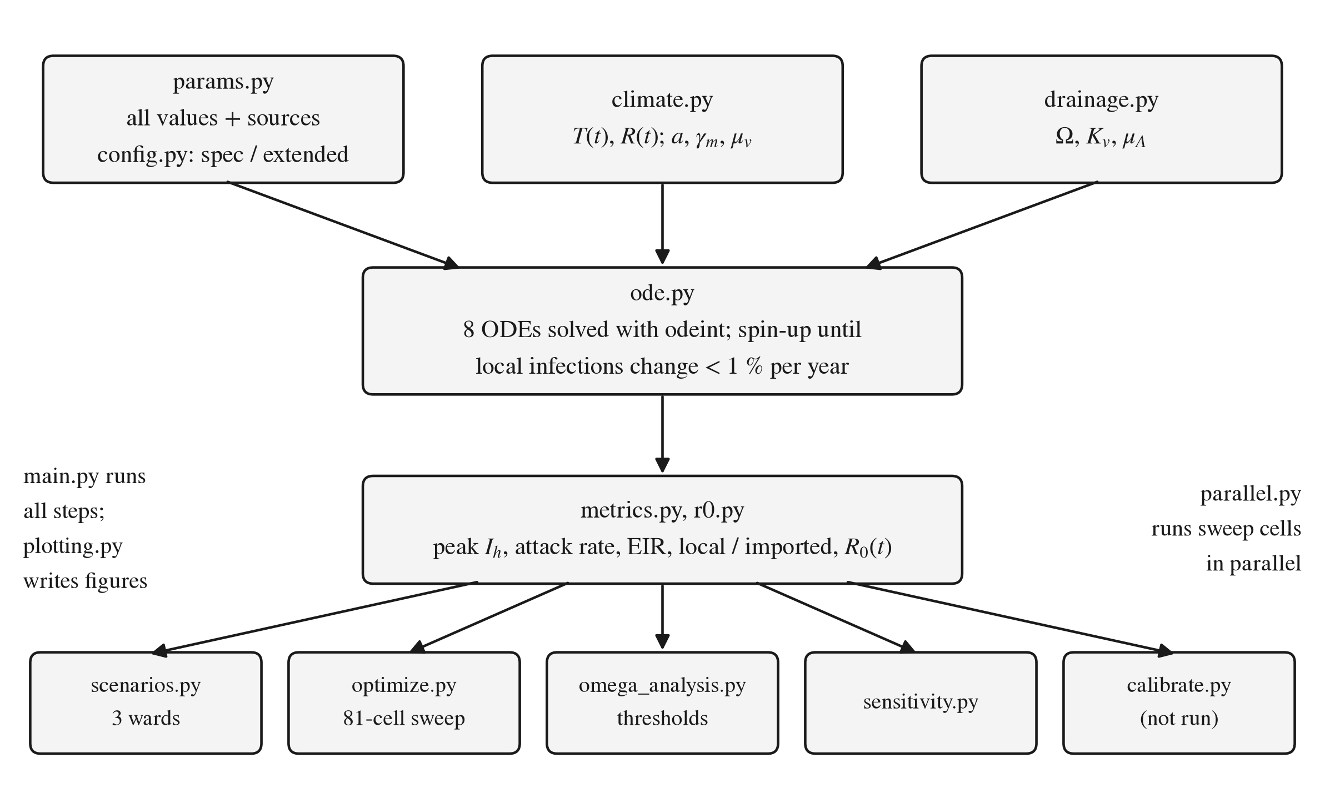
Fig. 3.1: System workflow of the simulation tool, from inputs to figures
Fig. 3.2 shows the conceptual model. The human compartments follow S_{h} → E_{h} → I_{h} → R_{h}, with births, waning immunity, natural death and death from malaria. The mosquito compartments follow A_{v} → S_{v} → E_{v} → I_{v}, with egg-laying limited by the carrying capacity. The two populations are coupled through biting. Temperature and rainfall enter at the points marked.
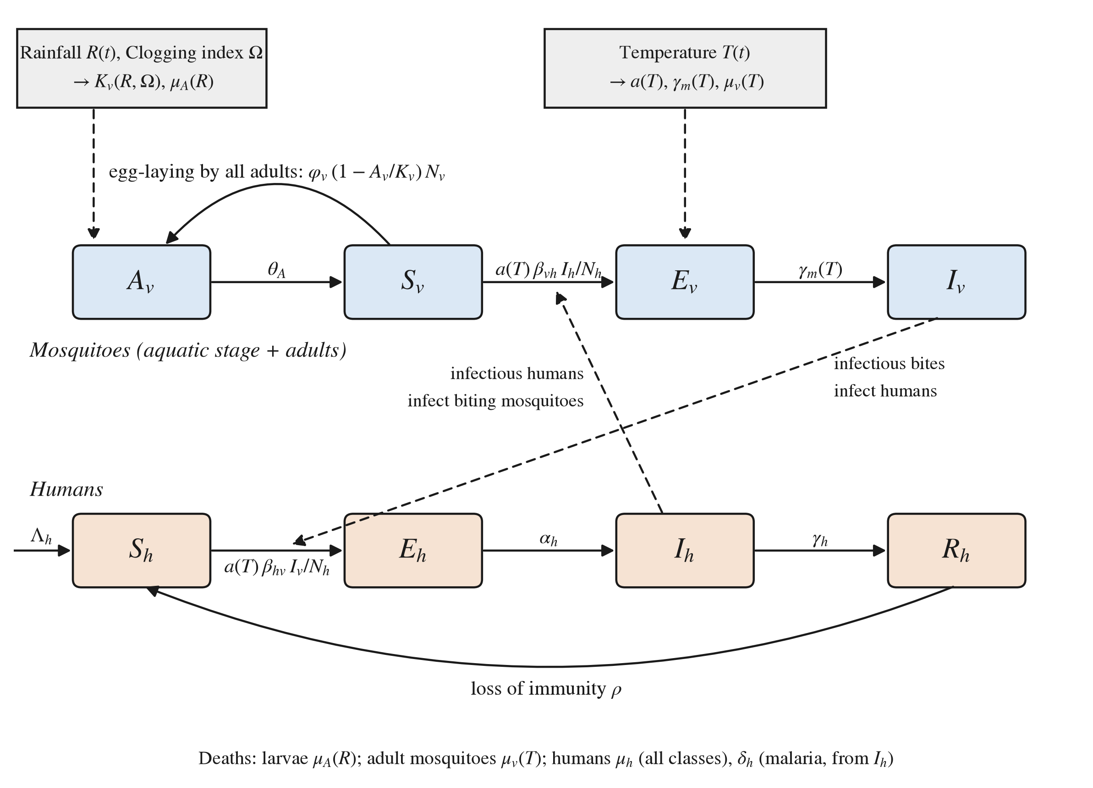
Fig. 3.2: Eight-compartment SEIR–vector model with climate and drainage entry points

3.3.2 Urban drainage and the Clogging Index Ω
A ward is described by two numbers between 0 and 1:
- D_{d}, drainage density: how much drainage infrastructure exists.
- M_{i}, maintenance efficiency: how clear the drains are kept, where 0 is fully blocked and 1 is perfectly clear.
The specification combines them into the Clogging Index Ω (also written D_{m}), where ε = 0.001 is a smoothing constant that prevents division by zero:
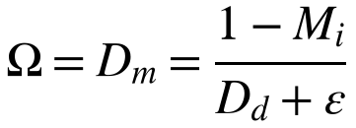 (3.1)
Ω is large when drains are both blocked and sparse, and falls when either improves. Ω enters the mosquito model in two ways that reinforce each other. First, it raises the aquatic carrying capacity, which is proportional to daily rainfall R(t) in mm/day:
(3.2)
Second, it weakens the flushing of larvae by heavy rain:
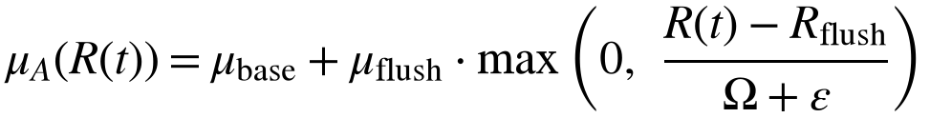 (3.3)
So a clogged ward has more breeding habitat for the same rain and loses fewer larvae on heavy-rain days. Table 3.4 gives the three illustrative ward profiles used in the experiments. The profiles were chosen by the team and do not describe real wards.
Table 3.4: Illustrative ward profiles and their Clogging Index
Ward profile | D_{d} | M_{i} | Ω | Habitat multiplier 1 + ηΩ (η = 0.5)
High infrastructure / high maintenance | 0.8 | 0.9 | 0.1248 | 1.062
Medium infrastructure / low maintenance | 0.5 | 0.3 | 1.3972 | 1.699
Poor infrastructure / neglected | 0.1 | 0.1 | 8.9109 | 5.455

The 9 × 9 grid of D_{d} and M_{i} values from 0.1 to 0.9 covers Ω from 0.1110 to 8.9109.

3.3.3 Climate-dependent thermal response functions
Temperature T (°C) sets three mosquito and parasite rates. The biting rate follows a Brière function:
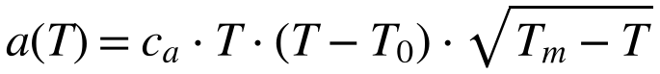 (3.4)
The parasite incubation rate in the mosquito follows a degree-day model:
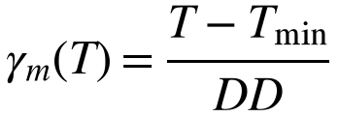 (3.5)
Adult mosquito mortality follows a quadratic curve:
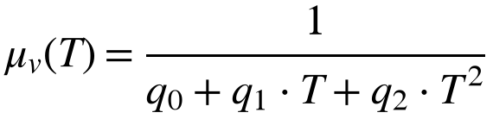 (3.6)
The parameter values come from the sources named in the parameter file, all marked for verification:
- Brière constants c_{a}, T₀, T_{m}: Mordecai et al. [11] [verify].
- Degree-day constants T_{min} = 16 °C and DD = 111 °C·day: the classic Detinova/Macdonald P. falciparum model [verify source; no reference number assigned until the source is confirmed].
- Mortality coefficients q₀, q₁, q₂: Martens [12] [verify].
Waite et al. found that the degree-day model underestimates development at cool temperatures [4]. This matters less for the 24–32 °C synthetic climate used here, but should be revisited for real data.

3.3.4 State variables and the ODE system
The human population is N_{h}, and the adult mosquito population is N_{v}. The aquatic stage A_{v} is not part of N_{v}.
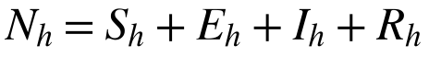 (3.7)
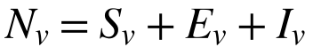 (3.8)
The vector equations are:
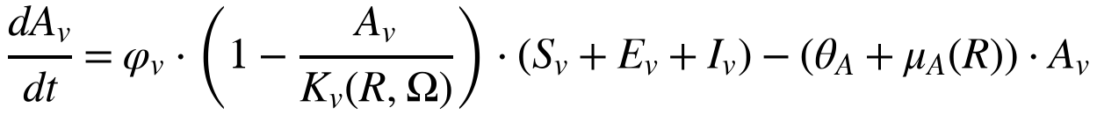 (3.9)
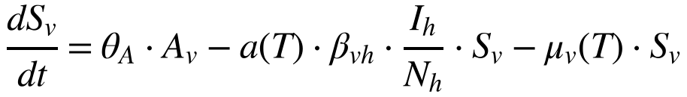 (3.10)
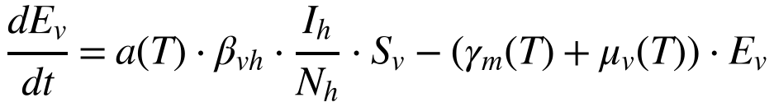 (3.11)
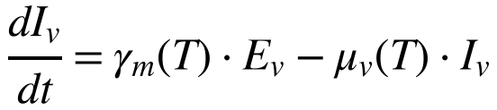 (3.12)
The human equations are:
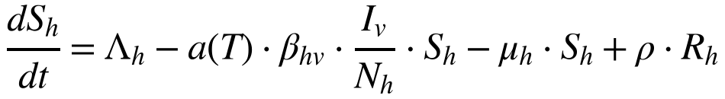 (3.13)
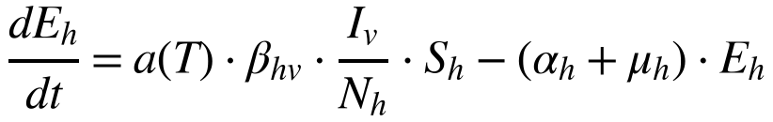 (3.14)
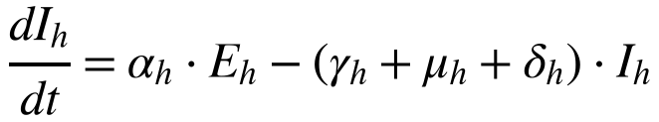 (3.15)
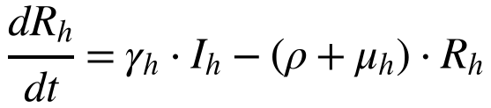 (3.16)
How to read the coupling terms. The infection of mosquitoes in (3.10)–(3.11) depends on three factors:
- the biting rate a(T)
- the probability β_{vh} that a bite on an infectious human infects the mosquito
- the fraction of humans who are infectious, I_{h}/N_{h}
The infection of humans in (3.13)–(3.14) depends on the same biting rate, the probability β_{hv} that an infectious bite infects a human, and the number of infectious mosquitoes per human, I_{v}/N_{h}. These two terms are the forces of infection. Through a(T) they are where temperature enters the host–vector coupling.
Parameters. Appendix II gives the full parameter table with values, units and sources. In summary:
- Sourced, to verify against the papers:
- the Brière, degree-day and mortality constants above
- β_{vh} = 0.48, attributed in the parameter file to Chitnis et al. [13] [verify]
- β_{hv} = 0.022 and γ_{h} = 0.0035/day. These exact values are recorded in the Lit Matrix for Shah and Gupta [2] (p_{h} = 0.022, γ_{h} = 0.0035) and for Osman et al. [1] (mosquito-to-human probability 0.022, recovery 0.0035). The parameter file attributes both to Chitnis et al. [13] [verify the attribution, and the meaning of p_{h} in Shah and Gupta]. The value β_{hv} = 0.022 is at the low end of quoted values and is an open question for the professor.
- Placeholders awaiting literature values: K₀ (500, uncalibrated), η, μ_{base}, μ_{flush}, R_{flush}, φ_{v}, θ_{A}, μ_{h}, α_{h}, δ_{h} and ρ.
- Derived: Λ_{h} = μ_{h} × N_{h}(0), so that the disease-free population stays constant.

3.3.5 Inputs, initial conditions and outputs
Synthetic climate. Real climate data has not yet been loaded, so the model uses a synthetic year designed to resemble a monsoon city (day 0 = 1 January). It is not data from any real place.
- Temperature: a smooth cosine between 24 and 32 °C (mean 28 °C), hottest on day 135.
- Rainfall:
- a dry-season background of 0.2 mm/day plus a bell-shaped monsoon centred on day 212 (mean peak 15 mm/day, width 30 days)
- multiplied by log-normal day-to-day noise with a fixed seed (42)
- about 1,357 mm per year, 92% of it from June to September
- rainfall is above zero on every day
Initial conditions. The specification does not give initial conditions. The following were chosen and documented:
- Humans: N_{h} = 10,000, with 10 infectious people; all other infected classes start at 0.
- Larvae start at the day-0 carrying capacity.
- Adults start at the level that larval maturation supports.
- No mosquito starts infected.
Outputs.
- peak I_{h} and its day (the specification's metric)
- attack rate: new infections per 1,000 people per year
- local and imported infections
- entomological inoculation rate (EIR)
- the time-varying reproduction number R0(t), from the next-generation matrix as R0 = √(K_{hv}·K_{vh})
- two Ω thresholds:
- Ω*, where the yearly peak of R0(t) equals 1
- the persistence threshold, where local infections neither grow nor shrink from year to year

3.3.6 Model variants, spin-up and logged deviations
The tool has two variants:
- “spec” implements the equations above exactly, plus four numerical guards against impossible values. The guards are never active with the synthetic climate.
- “extended” adds rainfall memory and imported infections.
Both variants simulate repeated years of the same climate until the result settles (spin-up) and report only the final year.
Every departure from the specification follows the same process:
1. It is proposed and explained before any code is written.
2. It is implemented only after approval.
3. It is marked in the code with a # DEVIATION: comment.
4. It is entered in a permanent deviation log.
All nine deviations were approved by the student team during development. Mentor review is [pending — confirm whether and when the professor reviewed deviations #1–#9]. Table 3.5 summarises them.
Table 3.5: Logged deviations from the approved specification
# | Change | Reason | Variant | Active in current results
1 | K_{v} floored at 1 mosquito | Avoid division by zero in A_{v}/K_{v} on rain-free days | Both | No (rain > 0 every day)
2 | a(T) = 0 outside T₀ < T < T_{m} | Formula gives an undefined or negative value outside the range | Both | No (24–32 °C)
3 | γ_{m}(T) floored at 0 below T_{min} | Negative development is not physical | Both | No
4 | Denominator of μ_{v}(T) floored at 1 day | Denominator ≤ 0 below about 3.7 °C and above about 40 °C | Both | No
5 | Fixed 3-year spin-up, report year 3 | Remove dependence on the arbitrary day-0 seed | Both | Kept for the regression test and threshold calculations
6 | K_{v} driven by rainfall with memory (retention time τ = 10 days) | Breeding water persists after rain | Extended | Yes
7 | Retention time grows with Ω | Clogged drains may hold water longer | Extended | No (switched off)
8 | Imported infections, 1 per 1,000 people per year (S_{h} → E_{h}) | Urban wards receive travel-related infections | Extended | Yes
9 | Spin-up until local infections change by < 1% per year (maximum 20 years) | 3 years did not reach a steady pattern | Both | Yes

3.4 Standards, constraints, safety, ethical, societal and environmental considerations
Standards.
- References follow the IEEE numbered style required by the report format.
- No formal engineering or software standard has been adopted for the model [list any standard followed, or confirm “none”].
- The software follows documented good practice:
- version control with git
- pinned package versions
- automated tests
- a fixed random seed
- units documented in every function
- a single parameter file with a source for every value
Constraints.
- Data: the target city is not yet confirmed (Ahmedabad is the strongest candidate), and malaria case data has not been obtained.
- Parameters: most parameter values are still placeholders.
- Calibration: none is possible until a calibration target is chosen.
- Model structure:
- The model is deterministic, so infections can shrink towards zero but never reach it.
- Its parameters are generic P. falciparum / Anopheles values. Urban India often involves P. vivax and An. stephensi, which are not represented.
- Computing: a full run takes about two minutes on the development machine.
Ethical considerations.
- Confidentiality of health data. Ward-level surveillance data is held by municipal health departments and is released only on request [6]. Any data obtained must be used only for the agreed purpose, stored securely, and reported only at the agreed level of aggregation. It must not be published without the data owner's permission. [confirm whether institutional ethics approval or a data-use agreement is required before the data request]
- Honest reporting. The synthetic climate, placeholder parameters and uncalibrated K₀ are stated wherever results appear. Model behaviour is not presented as evidence about a real city.
- Integrity of the specification. The approved equations are not changed silently. Every departure is logged and traceable.
- AI use is disclosed in Section 5.5 and Appendix VII.
- Intellectual property. Under the IPR Policy of SVKM's NMIMS, approval is needed before any public disclosure of potentially patentable work.
Societal and environmental considerations. If confirmed with real data, results of this kind could support decisions on drain construction and maintenance as part of vector control. Because current results depend on placeholder parameters, no policy recommendation is made (Section 4.5).

3.5 Project plan
Work breakdown.
1. Scoping and framing
2. Literature review and Lit Matrix
3. Data identification (a Data Provenance Log is planned)
4. Conceptual model
5. Mathematical specification and professor approval
6. Implementation and testing
7. Simulation experiments and analysis
8. Model report for the supervisor meeting
9. Project report and portfolio
Table 3.6 gives the milestones. Dates are filled in only where the git history records them. All other dates are placeholders.
Table 3.6: Project milestones
# | Milestone | Planned date | Completed | Evidence
M1 | Project scoping and research workflow | [date] | [date] | Executive summary
M2 | Lit Matrix (8 papers) set up; Data Provenance Log [not yet created] | [date] | [date] | Lit Matrix workbook
M3 | Data Identification Table | [date] | [date] | Data Identification workbook
M4 | Conceptual model diagram finalised | [date] | [date] | Executive summary
M5 | Project skeleton and specification committed | [date] | 13 Oct 2026 | git history
M6 | First complete model build and subsequent versions v1–v1.3 | [date] | 14 Oct 2026 | git history; progress log
M7 | Model report for the supervisor meeting | [date] | 14 Oct 2026 (progress log) [confirm; file last updated 16 Oct 2026] | docs/MODEL_REPORT.md
M8 | Supervisor meeting and feedback | [date] | [date] | [minutes]
M9 | Project report draft | [date] | [in progress] | This report
M10 | Portfolio Review (Week 13) | [date] | — | —
M11 | Final Evaluation / TEE (Week 15) | [date] | — | —

Gantt chart. [insert Gantt chart once the planned dates for M1–M11 are confirmed]
Task allocation. [task allocation per student — not recorded in the project files; see also Section 5.1]
In summary, this chapter set eleven requirements and compared four model structures in a decision matrix whose scores are to be confirmed. It recorded the further design decisions with their reasons. It presented the selected design: an eight-compartment SEIR–vector ODE model with temperature-dependent rates and a Clogging Index Ω that raises breeding habitat and weakens larval flushing, run in a “spec” and an “extended” variant with spin-up and nine logged deviations. It also covered the constraints and ethical considerations and the project plan.

Chapter 4
Implementation, Results and Analysis
This chapter describes how the design of Chapter 3 was implemented and tested, and what the simulations show. It covers the software structure and how to run it, the testing and verification process, the results for three illustrative wards and an 81-cell drainage grid, two threshold analyses and the sensitivity runs. It also describes the iterations made after the first run and closes with the advantages, limitations and possible applications of the model. Three conditions apply to every result in this chapter:
- The climate is synthetic: invented temperature and rainfall series, not observations.
- Most parameter values are placeholders without a confirmed literature source.
- The habitat scale K₀ is uncalibrated.
The results therefore show how the model behaves. They are not findings about any real city. All result numbers are taken from the project's model report (docs/MODEL_REPORT.md), which was produced from a full run of the model with all 42 tests passing.

4.1 Implementation

4.1.1 Software structure
The model is implemented in Python as a package, src/malaria_model/, with one module per responsibility (Table 4.1). A single entry script, main.py, runs all experiments and writes the figures. The ODE system is solved with scipy.integrate.odeint:
- time step at most 1 day
- relative and absolute tolerance 10⁻⁶
- daily temperature and rainfall linearly interpolated between days
Table 4.1: Module map of the simulation package
Module | Role
params.py | Every parameter value, each with its source or a PLACEHOLDER label
config.py | Chooses the variant (spec / extended) and the spin-up mode
climate.py | Thermal functions a(T), γ_{m}(T), μ_{v}(T); synthetic T(t) and R(t); rainfall with memory
drainage.py | Clogging Index Ω, carrying capacity K_{v}, larval mortality μ_{A}
ode.py | The 8 equations; simulation; spin-up
metrics.py | Peak I_{h}, attack rate, local vs imported infections, EIR
r0.py | R0(t) from the next-generation matrix
scenarios.py | Runs the three wards and builds the summary table
optimize.py | The 81-cell D_{d} × M_{i} sweep (run in parallel)
omega_analysis.py | R0 vs Ω, Ω*, persistence threshold, minimum M_{i}
sensitivity.py | γ_{h} × β_{hv} and importation sensitivity runs
calibrate.py | K₀ calibration (built and tested; not run, no target yet)
plotting.py | All figures
parallel.py | Runs grid cells in parallel processes

4.1.2 Environment and how to run
The project runs in a Python 3.14 virtual environment with package versions pinned in requirements.txt. The random seed for the synthetic rainfall is fixed (42), so every run is identical. From the project folder:
- .venv/bin/python -m pytest runs the 42 automated tests.
- .venv/bin/python main.py runs all experiments and writes the figures to results/figures/. The recorded run took 127 s.
- .venv/bin/python main.py --calibrate X calibrates K₀ to a target of X infections per 1,000 per year. This has not been run.
The model was developed in versions recorded in git: v1 to v1.3 on 14 October 2026, after the project skeleton and specification were committed on 13 October 2026. Section 4.4 describes the development steps.
[name the student(s) who implemented each module — not recorded in the project files]

4.2 Testing, validation and verification

4.2.1 Test plan
Verification is by automated tests, written with pytest and run after every change. The suite has 42 tests in six files (Table 4.2). The number of tests per file was confirmed by test collection (pytest --collect-only, which lists the tests without running them). The descriptions are taken from the test function names.
Table 4.2: Automated test suite
Test file | Tests | What is checked
test_drainage.py | 6 | Ω, K_{v} and μ_{A} against hand-calculated values; Ω rises when maintenance or drainage falls; K_{v} floor on a dry day; flushing only above R_{flush}
test_thermal.py | 8 | a(T), γ_{m}(T) and μ_{v}(T) against hand-calculated values; guards outside the valid range; synthetic climate ranges; interpolation between days
test_ode.py | 6 | No NaN or infinite values; no negative compartments; a disease-free start stays disease-free; human population balance
test_metrics.py | 6 | Climate repetition and spin-up; attack rate, peak and day of peak against hand values; R0 from the next-generation matrix against a hand value
test_extended.py | 12 | Regression of the spec variant; spec unaffected by extended-only parameters; no NaN or negative values; importation keeps the population total unchanged; local/imported split; rainfall-memory properties; retention-time switch; spin-up convergence and cap; calibration round-trip
test_omega.py | 4 | Minimum maintenance against hand values; Ω* and the persistence threshold are roots and correctly ordered
Total | 42 | All passing in the recorded run

Two tests protect the approved specification:
- Regression test. The spec variant with the fixed 3-year spin-up reproduces the numbers of the earlier run exactly.
- Spec-isolation test. Changing extended-only parameters does not change the spec output.

4.2.2 Specification compliance
Section 3.3.6 describes the process for departures from the specification. The project rules require that, before any task is finished, every # DEVIATION: marker in the source code is checked against the deviation log. When this report was drafted there were nine markers in the code and nine log entries (#1 to #9) [confirm the marker-to-entry match by reviewing each marker].

4.2.3 Validation
The model has not been validated against real data. No malaria case data or real climate data has been used yet, and K₀ has not been calibrated. The checks above verify that the code implements the specification correctly. They do not show that the model describes a real city.

4.3 Results and analysis
How to read the numbers:
- Attack rate: new infections per 1,000 people during the reported year.
- EIR: infectious bites per person per year.
- Peak I_{h}: the largest number of people infectious at the same time, out of 10,000.
- Local growth: locally acquired infections this year divided by last year. Below 1 means dying out; above 1 means growing.
- R0(t): how many new infections one case would cause at day t's temperature and mosquito density.

4.3.1 Ward summaries
[name the student(s) who produced this analysis]
Table 4.3 and Table 4.4 summarise the final reported year for each illustrative ward in the spec and extended variants.
Table 4.3: Per-ward summary, spec variant (final reported year; uncalibrated K₀ = 500; placeholder parameters)
Ward (Ω) | Mosquitoes per human (mean / peak) | EIR per year | Attack per 1,000 | Peak I_{h} (day) | Local growth | R0 max / mean | Spin-up | Converged
High infra (0.125) | 0.157 / 0.783 | 2.6×10⁻¹¹ | 5.74×10⁻¹⁰ | 3.76×10⁻⁸ (day 0) | 0.36 | 1.08 / 0.357 | 20 yr | No
Medium (1.4) | 0.257 / 1.35 | 1.4×10⁻⁹ | 3.09×10⁻⁸ | 1.17×10⁻⁶ (day 0) | 0.432 | 1.42 / 0.455 | 20 yr | No
Poor (8.91) | 0.826 / 4.39 | 0.0826 | 1.81 | 18.5 (day 301) | 1.02 | 2.56 / 0.817 | 20 yr | No

Table 4.4: Per-ward summary, extended variant (final reported year; uncalibrated K₀ = 500; placeholder parameters; 1 imported infection per 1,000 per year)
Ward (Ω) | Mosquitoes per human (mean / peak) | EIR per year | Attack per 1,000 (local + imported) | Peak I_{h} (day) | Local growth | R0 max / mean | Spin-up | Converged
High infra (0.125) | 0.166 / 0.715 | 0.0127 | 1.27 (0.28 + 0.995) | 10.4 (day 304) | 1 | 1.02 / 0.364 | 3 yr | Yes
Medium (1.4) | 0.268 / 1.16 | 0.0242 | 1.52 (0.531 + 0.995) | 12.9 (day 305) | 1.01 | 1.3 / 0.461 | 5 yr | Yes
Poor (8.91) | 0.866 / 3.77 | 0.961 | 21.3 (20.4 + 0.962) | 212 (day 310) | 1.03 | 2.34 / 0.829 | 20 yr | No

What the tables show.
- In both variants, every column rises with Ω.
- In the spec variant the two better wards are effectively extinct, with about 10⁻⁸ and 10⁻⁶ infectious people, and are shrinking each year (growth 0.36 and 0.432).
- In the extended variant, imported infections keep the better wards at a low, steady level, and most of their infections are imported: about 78% in the best ward and 65% in the medium ward. In the poor ward only about 4.5% is imported.
What not to conclude.
- The absolute numbers are not predictions, because K₀ and most parameters are placeholders.
- The peak in late October to early November (days 301–310) reflects the timing of the synthetic monsoon, not any real season.
- The poor ward did not converge within the 20-year spin-up in either variant, so its values are not a steady state.

4.3.2 Ward time series (extended variant)
[name the student(s) who produced this analysis]
Fig. 4.1, Fig. 4.2 and Fig. 4.3 follow the three wards through the reported year in the extended variant.
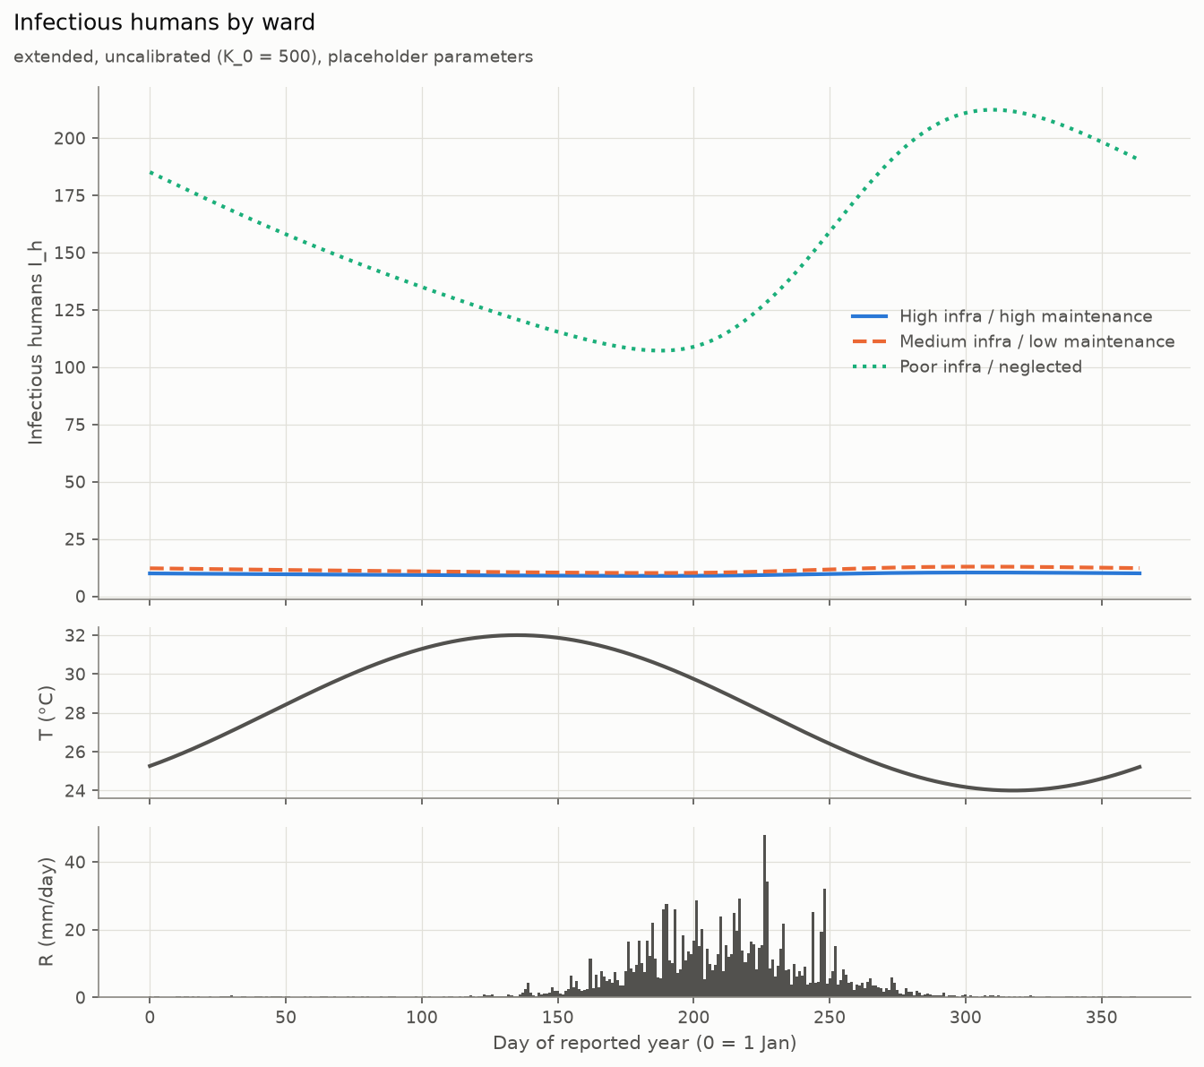
Fig. 4.1: Infectious humans I_{h} by ward through the reported year, with temperature and rainfall (extended variant)
- What it shows: infectious humans through the reported year in each ward, with T(t) and R(t) in the lower panels.
- Key observation: the poor ward's I_{h} rises after the monsoon and peaks around day 310, while the other two wards stay low and flat.
- What not to conclude: that the seasonal timing matches any real city. The climate is synthetic.
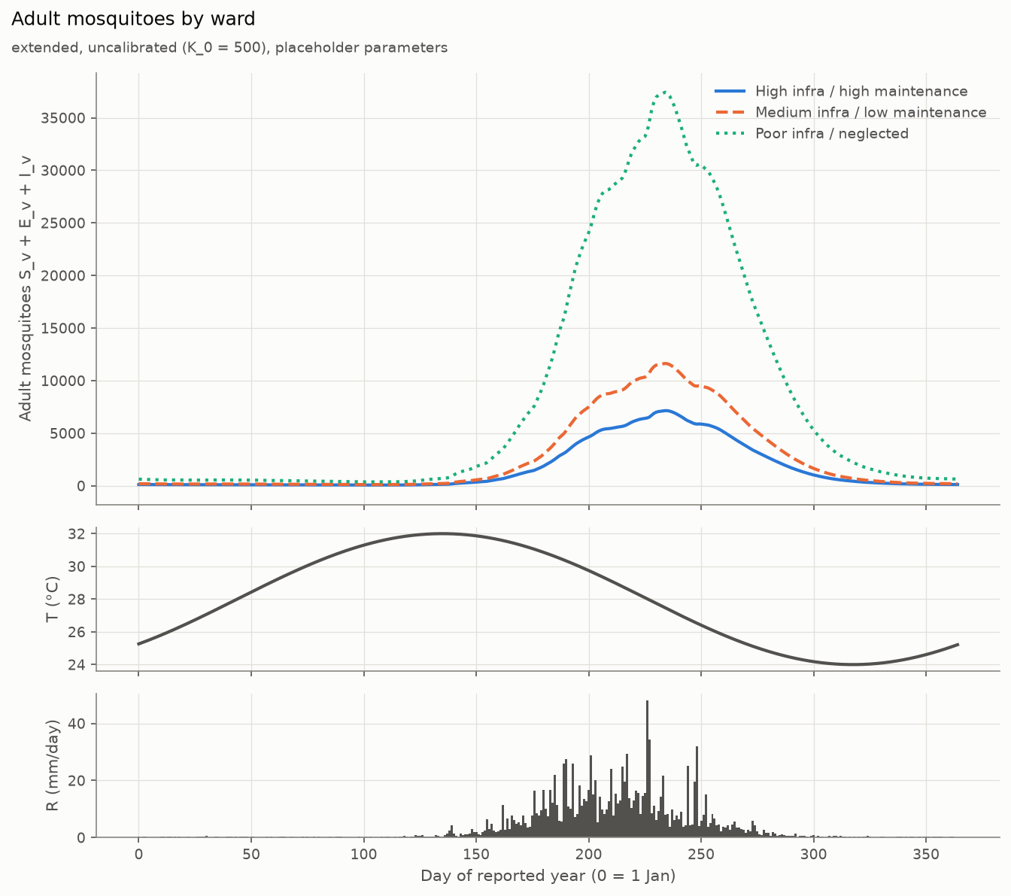
Fig. 4.2: Adult mosquitoes S_{v} + E_{v} + I_{v} by ward (absolute numbers, N_{h} = 10,000), with temperature and rainfall (extended variant)
- What it shows: absolute adult mosquito numbers through the year. They follow the monsoon.
- Key observation: the poor ward's peak is about 5 times the best ward's (3.77 vs 0.715 peak mosquitoes per human; Table 4.4), which is the direct effect of Ω on the carrying capacity.
- What not to conclude: real mosquito densities. They scale directly with the uncalibrated K₀.
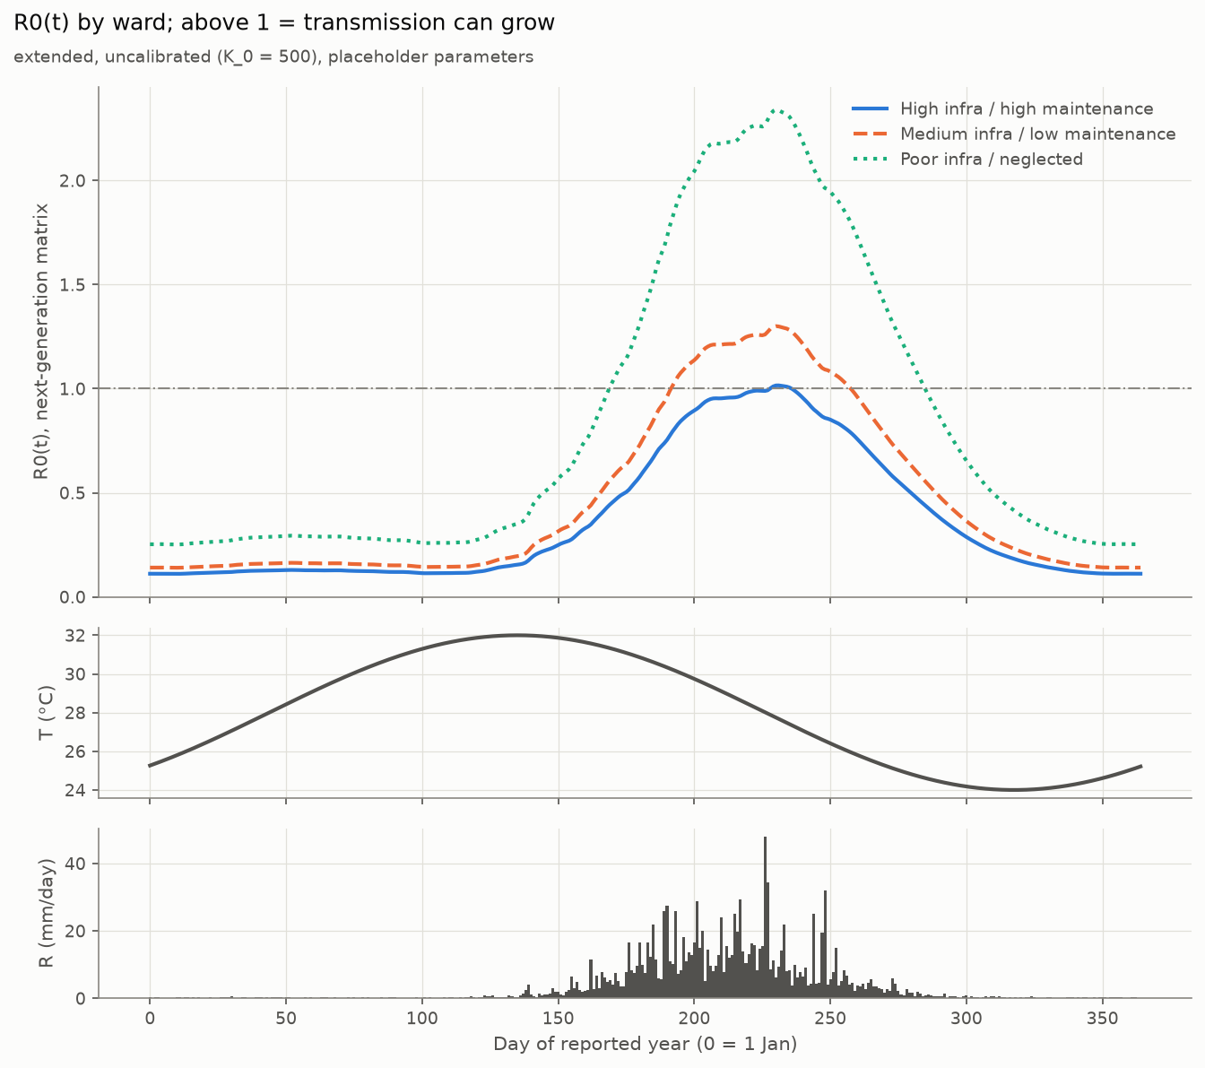
Fig. 4.3: Time-varying reproduction number R0(t) by ward, with the line R0 = 1, temperature and rainfall (extended variant)
- What it shows: R0(t), computed from the next-generation matrix as R0 = √(K_{hv}·K_{vh}). K_{hv} is the number of humans infected per infectious mosquito, and K_{vh} the number of mosquitoes infected per infectious human.
- Key observation: R0(t) exceeds 1 only during the monsoon. The peaks are 1.02 (best), 1.3 (medium) and 2.34 (poor), while the year-round means are all below 1 (0.364, 0.461 and 0.829).
- What not to conclude: that R0(t) > 1 means an outbreak. The best ward briefly exceeds 1, yet its local infections do not grow (Section 4.3.4).

4.3.3 Drainage-scenario heatmaps
[name the student(s) who produced this analysis]
Fig. 4.4 and Fig. 4.5 show the 81-cell drainage grid for the spec variant, and Fig. 4.6 and Fig. 4.7 for the extended variant.
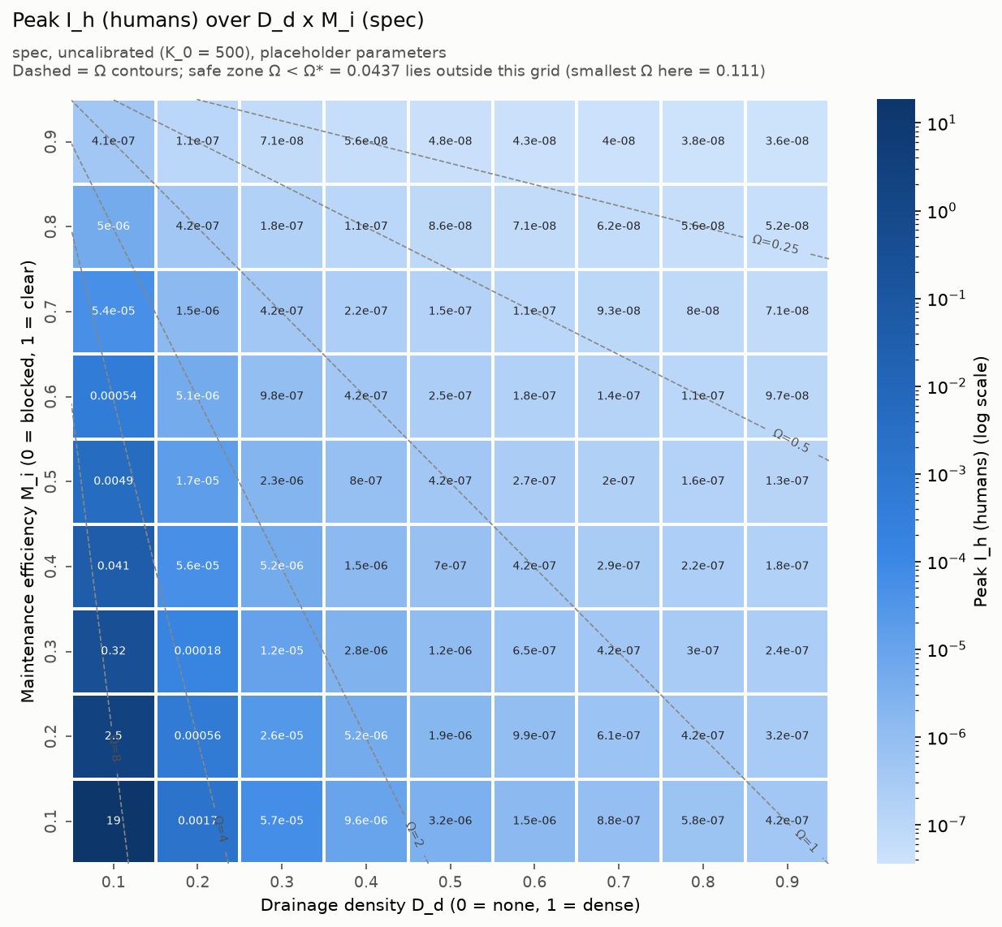
Fig. 4.4: Peak I_{h} over drainage density D_{d} × maintenance M_{i}, spec variant (log colour scale; dashed lines are contours of equal Ω)
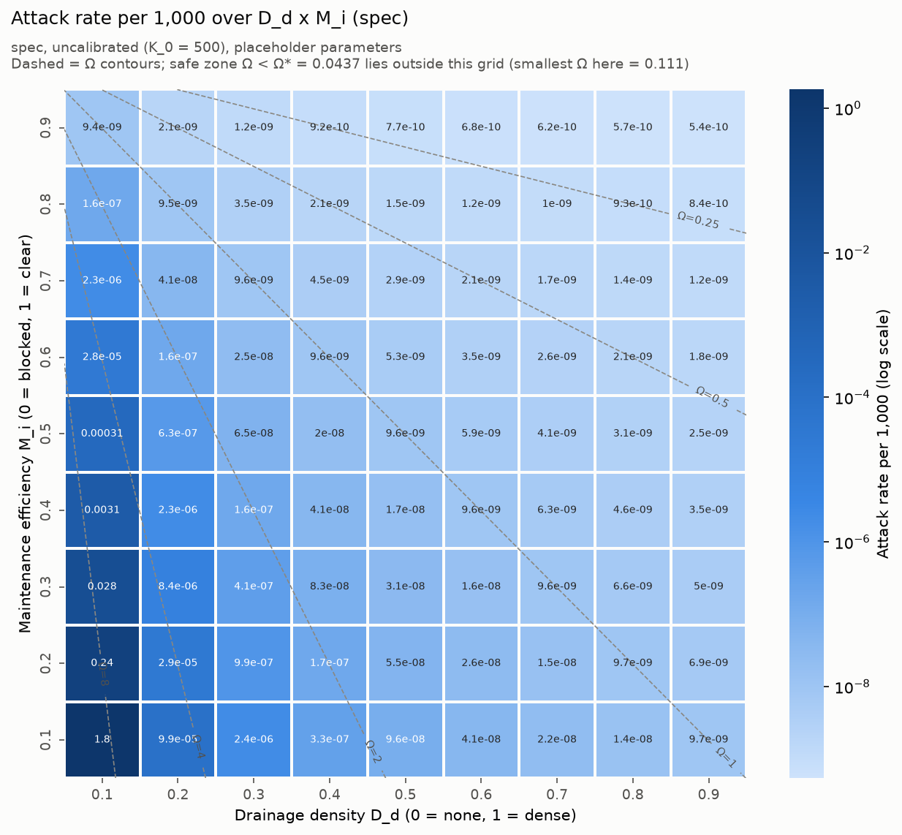
Fig. 4.5: Attack rate per 1,000 over D_{d} × M_{i}, spec variant
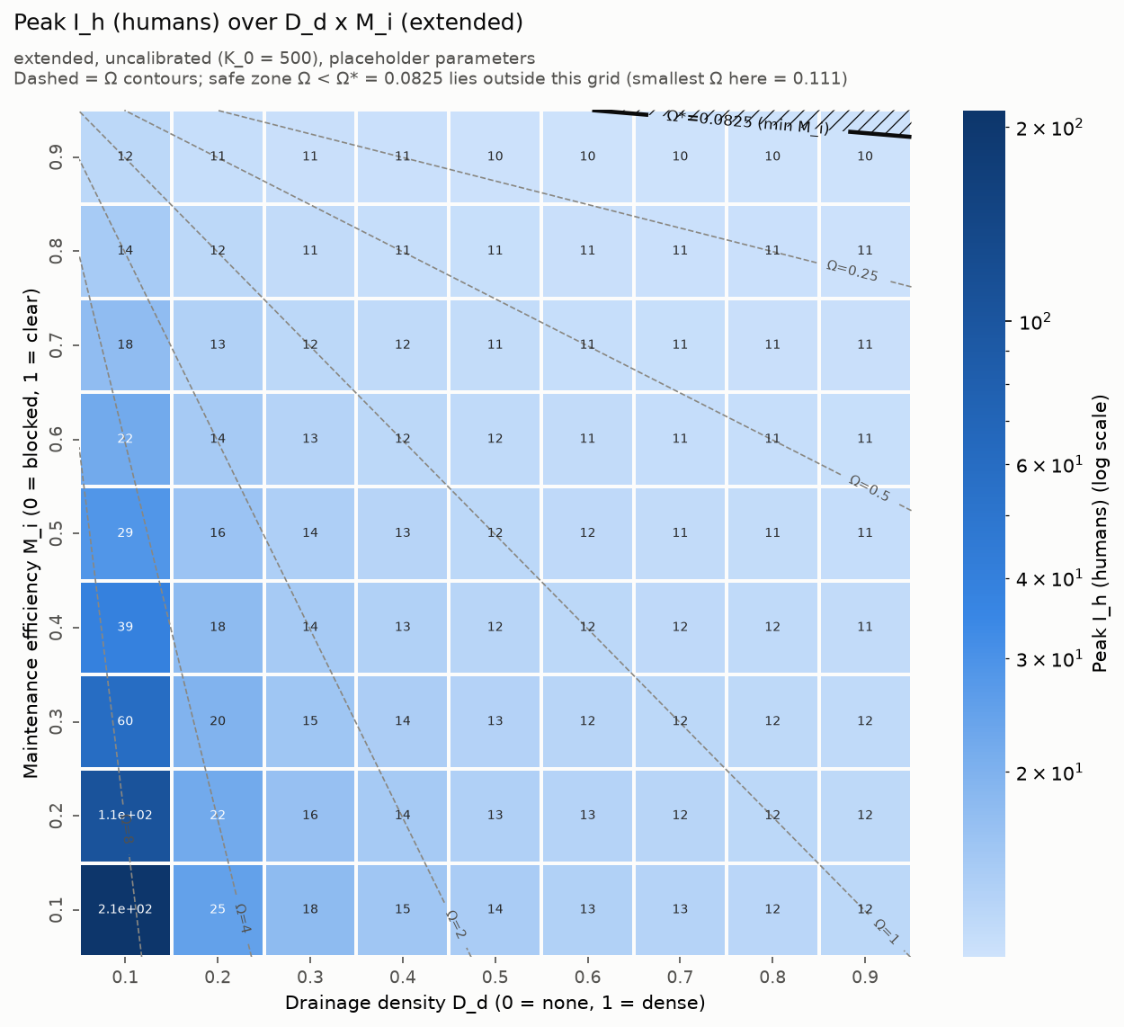
Fig. 4.6: Peak I_{h} over D_{d} × M_{i}, extended variant (the solid line at top right marks the minimum M_{i} for Ω* = 0.0825)
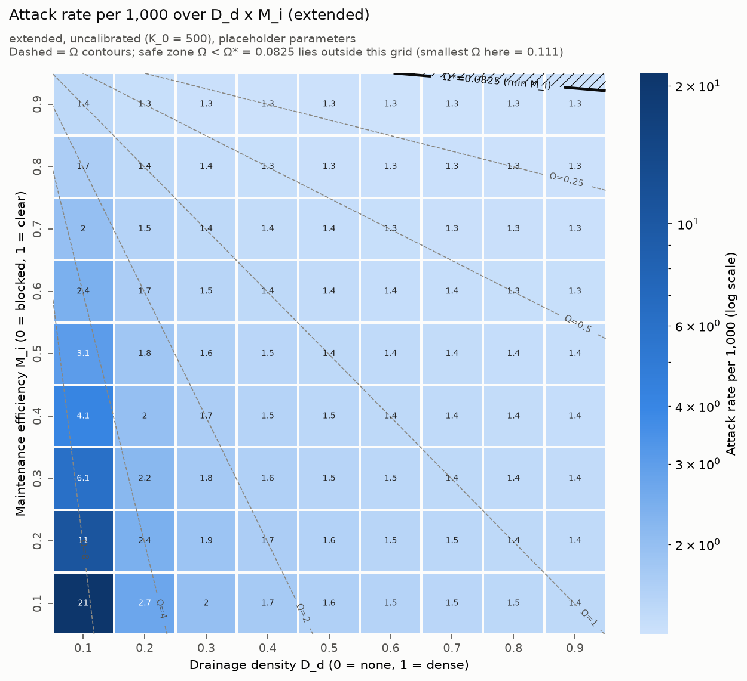
Fig. 4.7: Attack rate per 1,000 over D_{d} × M_{i}, extended variant (the solid line at top right marks the minimum M_{i} for Ω* = 0.0825)
- What they show: each of the 81 cells is one (D_{d}, M_{i}) combination, coloured by the outcome in the reported year. The colour scale is logarithmic because values span many orders of magnitude. In the spec variant the attack rate runs from 5.4×10⁻¹⁰ in the smallest cell (read from the figure) up to 1.8 per 1,000.
- Key observations:
- The worst cell is always bottom-left (D_{d} = 0.1, M_{i} = 0.1).
- Outcomes change along the contours of equal Ω, not along rows or columns separately.
- In the extended variant most cells sit near 1.3–1.5 per 1,000, close to the importation level.
- What not to conclude: that the cells are independent evidence. They are 81 points on one curve (Section 4.3.5). The “safe” region below Ω* lies outside this grid for both variants.

4.3.4 Two thresholds: peak R0 = 1 vs persistence
[name the student(s) who produced this analysis]
Fig. 4.8 plots the yearly peak and mean of R0(t) against Ω for both variants, with Ω* and the persistence thresholds marked; Table 4.5 lists the threshold values.
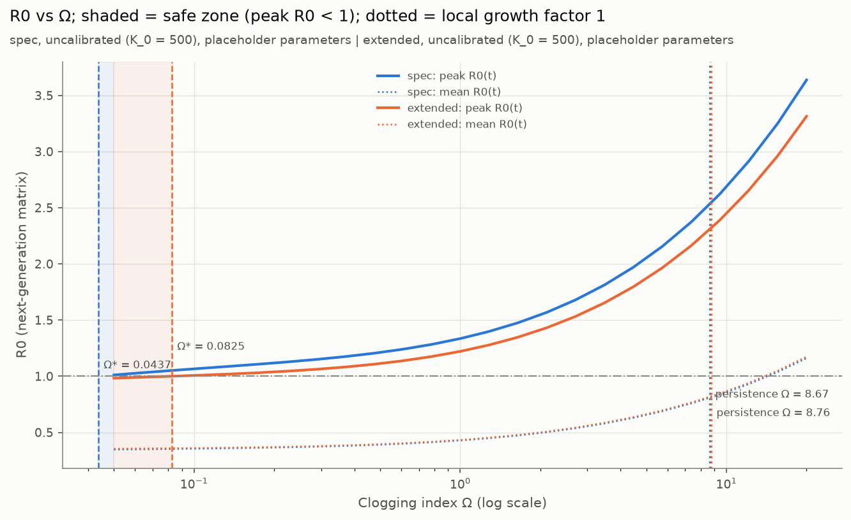
Fig. 4.8: Peak and mean R0(t) against Ω for both variants, with Ω* (shaded safe zone) and the persistence thresholds marked
Table 4.5: Threshold values of the Clogging Index Ω
Threshold | Meaning | Spec | Extended
Ω* (peak R0(t) = 1) | Below this, R0 never exceeds 1 at any time of year | 0.04367 | 0.08253
Persistence Ω (local growth = 1, imports off) | Below this, local infections shrink year to year | 8.673 | 8.761
Ratio |  | ≈ 199× | ≈ 106×

From Ω ≤ threshold, the minimum maintenance needed at each drainage density is M_{i} ≥ 1 − threshold × (D_{d} + ε) (Table 4.6).
Table 4.6: Minimum maintenance M_{i} needed at each drainage density D_{d}
D_{d} | 0.1 | 0.2 | 0.3 | 0.4 | 0.5 | 0.6 | 0.7 | 0.8 | 0.9
Min M_{i} for peak R0 < 1 (spec) | 0.996 | 0.991 | 0.987 | 0.982 | 0.978 | 0.974 | 0.969 | 0.965 | 0.961
Min M_{i} for peak R0 < 1 (extended) | 0.992 | 0.983 | 0.975 | 0.967 | 0.959 | 0.95 | 0.942 | 0.934 | 0.926
Min M_{i} for no growth (spec) | 0.124 | 0 | 0 | 0 | 0 | 0 | 0 | 0 | 0
Min M_{i} for no growth (extended) | 0.115 | 0 | 0 | 0 | 0 | 0 | 0 | 0 | 0

- What it shows: two different definitions of a “safe” drainage condition. R0(t) is a snapshot. Exceeding 1 briefly during the monsoon peak lets infections grow for a few weeks, but they shrink for the rest of the year, when R0(t) is well below 1 (yearly means 0.36–0.83). Persistence depends on the balance over the whole year. The peak criterion is therefore very cautious, and the persistence criterion much less so.
- Key observation: only drainage density D_{d} = 0.1 needs any maintenance (about M_{i} ≥ 0.12) to stop local persistence. Keeping peak R0 below 1 all year needs M_{i} between 0.93 and 0.996.
- What not to conclude: a policy recommendation. Both thresholds depend on placeholder parameters, and which threshold counts as “safe” is an open question for the professor.

4.3.5 Dependence on Ω only
[name the student(s) who produced this analysis]
Fig. 4.9 plots the outcome of every grid cell against its value of Ω.
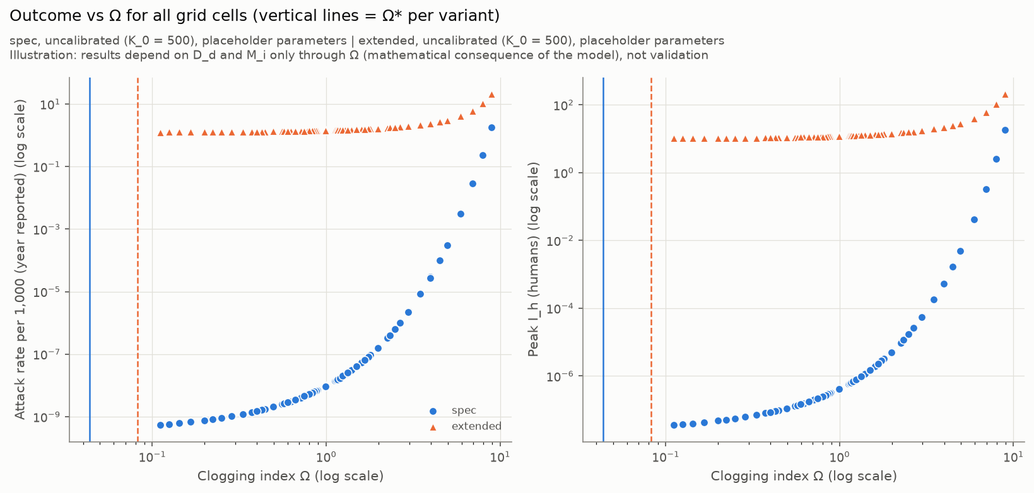
Fig. 4.9: Attack rate (left) and peak I_{h} (right) of all 81 grid cells against Ω for both variants; vertical lines mark Ω* of each variant
- What it shows: all 81 cells fall on a single curve per variant when plotted against Ω.
- Why: in the equations, D_{d} and M_{i} appear only inside Ω, in K_{v} and μ_{A}. Two wards with the same Ω therefore have identical simulations.
- What not to conclude: that this validates the model. It is a mathematical consequence of the model structure. It also means the model cannot separate “build more drains” from “maintain existing drains better” except through their combined effect on Ω.

4.3.6 Spec vs extended variant
[name the student(s) who produced this analysis]
Fig. 4.10 compares the two variants ward by ward.
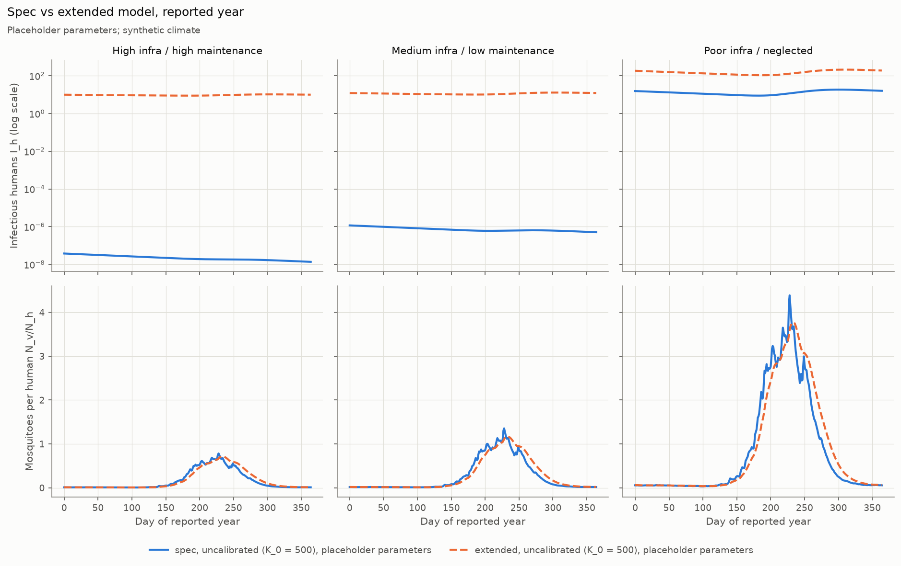
Fig. 4.10: Spec vs extended variant by ward: I_{h} on a log scale (top) and mosquitoes per human (bottom)
- What it shows: the mosquito curves of the two variants are almost identical. Rainfall memory only smooths and slightly delays them: the peaks are 0.715 vs 0.783 mosquitoes per human for the best ward and 3.77 vs 4.39 for the poor ward.
- Key observation: the large difference in I_{h} comes from importation, not from rainfall memory. With imports set to 0, the extended best ward falls to an attack rate of 5.68×10⁻¹⁰ per 1,000, the same order as the spec variant (5.74×10⁻¹⁰).
- What not to conclude: that rainfall memory is unimportant in general. Its retention time (10 days) is a placeholder, and the synthetic rainfall is positive every day.

4.3.7 Sensitivity analyses
[name the student(s) who produced this analysis]
Fig. 4.11 shows how the attack rate responds to the two most uncertain transmission parameters.
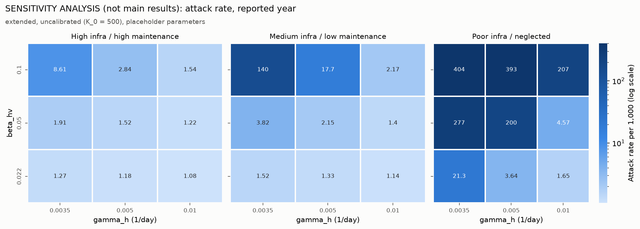
Fig. 4.11: Attack rate per 1,000 for three values each of the recovery rate γ_{h} and the vector-to-human transmission probability β_{hv}, by ward (extended variant; sensitivity analysis, not main results)
Recovery rate × transmission probability. Each of γ_{h} ∈ {0.0035, 0.005, 0.01} per day and β_{hv} ∈ {0.022, 0.05, 0.1} was tested in all 9 combinations.
- What it shows: the ward ranking (higher Ω gives a higher attack rate) held in all 9 combinations.
- Key observation: the magnitudes vary enormously. The poor ward's attack rate ranges from 1.65 per 1,000 (γ_{h} = 0.01, β_{hv} = 0.022) to 404 per 1,000 (γ_{h} = 0.0035, β_{hv} = 0.1), and the best ward's from 1.08 to 8.61.
- What not to conclude: any particular attack rate. The direction of the effect is robust to these two parameters; its size is not.
Importation rate (Table 4.7).
Table 4.7: Attack rate per 1,000 for different importation rates, extended variant: total (local)
Imports per 1,000 per year | Best ward | Medium ward | Poor ward | Ranking holds (total / local)
0 | 5.68×10⁻¹⁰ (5.65×10⁻¹⁰) | 2.69×10⁻⁸ (2.68×10⁻⁸) | 1.47 (1.47) | Yes / yes
0.1 | 0.128 (0.0283) | 0.154 (0.054) | 4.3 (4.21) | Yes / yes
1 | 1.27 (0.28) | 1.52 (0.531) | 21.3 (20.4) | Yes / yes
10 | 12.4 (2.65) | 14.6 (4.93) | 68.4 (59.7) | Yes / yes

- For the better wards the total attack rate is roughly proportional to the import rate, so their outcome is set mainly by importation, which is a placeholder.
- For the poor ward, imports seed local transmission: local cases rise from 1.47 to 59.7 per 1,000 as imports rise from 0 to 10.

4.3.8 Overall analysis
Four findings hold across both variants, all 9 sensitivity combinations and all 4 importation rates:
1. Worse drainage (higher Ω) gives more mosquitoes and more infections in every run.
2. With imports switched off, only the worst illustrative ward (Ω = 8.911) sustains local transmission. The persistence threshold is about Ω = 8.7.
3. The two “safe” thresholds differ by about 100–200 times, so the choice of threshold changes the message completely.
4. In the extended variant, imported infections dominate the better wards.
Why the absolute numbers are small. The model sits in a low-transmission regime because of its placeholder values. With β_{hv} = 0.022 at 28 °C, a = 0.350 and μ_{v} = 0.1142 per day, so one infectious mosquito infects about a·β_{hv}/μ_{v} ≈ 0.067 people in its lifetime. Only comparisons between wards are meaningful.

4.4 Feedback received and iterations made

4.4.1 Feedback received
[professor / mentor feedback from the supervisor meeting — date, attendees and feedback to be added. Do not fill in until the minutes are available.]
[peer feedback, if any]
The model report prepared for the supervisor meeting listed the decisions requested from the professor:
- a calibration target and its source
- whether rainfall memory and importation are acceptable additions to the specification
- which threshold to treat as “safe”
- literature values for β_{hv} and γ_{h}
- whether to model treatment
- which heatmap metric to use
- whether it is acceptable that D_{d} and M_{i} act only through Ω
- a review of deviations #1–#9
- whether to adapt the model to P. vivax and An. stephensi
[record the professor’s answers to these questions]

4.4.2 Iterations
The model went through four documented iterations, all on 14 October 2026 according to the progress log. The numbers in this subsection come from earlier runs recorded in the progress log (docs/PROGRESS.md). They are not the final results of Section 4.3. The match between iterations and the git versions v1–v1.3 is [confirm; inferred from the files changed in each commit].
Iteration 1: first complete build (earlier run).
- The spec equations, synthetic climate, three wards and the 81-cell sweep were implemented, with 20 tests passing.
- The first heatmap was degenerate: peak I_{h} was 10.0 on day 0 for all three wards and all 81 cells. The peak was simply the arbitrary seed of 10 infectious people at the start of the simulation, so the heatmap showed the initial conditions, not the effect of drainage.
- Mosquito numbers did differ by ward (peak adult mosquitoes 7,831 / 13,549 / 43,836 for low / medium / high Ω). [insert the original first heatmap image if a copy exists; it was overwritten by later runs]
Diagnosis (read-only investigation).
- The main cause was weak transmission: the annual-mean R0 was below 1 in every ward, and the weakest link was K_{hv} = 0.068 humans infected per infectious mosquito.
- Starting the simulation in the dry season played a minor part.
- Seeding infectious mosquitoes made no difference, so that option was rejected.
Iteration 2: spin-up and new metrics (earlier run).
- A fixed 3-year spin-up was added (deviation #5), reporting year 3.
- The attack rate and R0(t) metrics and the first sensitivity analysis were added.
- The unsourced recovery rate γ_{h} = 0.01 was replaced with the literature-anchored 0.0035 per day. The aim was to source the value, not to obtain a result.
- Results for low / medium / high Ω:
- peak I_{h}: 1.30 / 1.86 / 12.4
- attack rate per 1,000: 0.0198 / 0.0491 / 1.21
- days with R0 > 1: 15 / 65 / 113
- Both metrics now rose with Ω. However, in the low and medium wards the peak was still on day 0, because infection was still declining from the year before. Tests: 26 passing.
Iteration 3: two variants and spin-up until convergence.
- 3 years did not reach a steady pattern, so spin-up until local infections change by less than 1% per year was added (deviation #9).
- The extended variant was added: rainfall memory (#6) and importation (#8), with the Ω-dependent retention time (#7) switched off.
- The Ω threshold analysis and calibration code were also added.
- Tests: 42 passing, including the regression test that reproduces iteration 2.
- This iteration produced the results in Section 4.3.
Iteration 4: documentation. The model report for the supervisor meeting was written from a fresh full run, with every number cross-checked against the output.
[name the student(s) responsible for each iteration]

4.5 Advantages, limitations and applications
Advantages.
- Traceable to the approved specification. The spec variant implements the equations exactly, and every departure is logged, marked in the code and covered by tests.
- Transparent about uncertainty. Every parameter has a source or a PLACEHOLDER label in one file.
- Verified. 42 automated tests cover hand-calculated formulas, conservation, regression and the thresholds.
- Fast and reproducible. A full run takes about two minutes, with a fixed seed and pinned packages.
- Ready for the next step. Calibration of K₀ and the threshold tools are already built.
Limitations (from the model report).
1. Synthetic climate: T(t) and R(t) are invented shapes, not observations.
2. Placeholder parameters: most drainage, larval and human rates are unsourced, and the sourced ones still need checking against the papers. β_{hv} = 0.022 is at the low end of literature values.
3. Uncalibrated K₀: absolute mosquito numbers, EIR and case numbers are arbitrary in scale.
4. Importation dominates the better wards in the extended variant, and its rate is a placeholder.
5. The poor ward is near the threshold and has not converged: it is still growing after the 20-year spin-up cap (growth 1.02 and 1.03 per year).
6. The two “safe” thresholds differ by about 100–200 times.
7. The model is deterministic: populations shrink towards zero but never reach it, so values such as 3.76×10⁻⁸ infectious people mean “effectively extinct”.
8. The species parameters do not fit an Indian city: they are generic P. falciparum / Anopheles values. Indian urban malaria often involves P. vivax, which can relapse, and An. stephensi, which also breeds in containers and tanks.
9. The ward profiles are illustrative, chosen by the team.
10. Ω is the only drainage pathway, so infrastructure and maintenance cannot be separated.
Applications and possible impact. Once real climate data, sourced parameters and a calibration target are in place, the tool could:
- rank wards of a target city by drainage-related malaria risk
- estimate how much drain maintenance is needed at a given drainage density
- test climate scenarios
It can also serve as a documented, tested starting point for later teams. No policy use is proposed at this stage.
In summary, this chapter described a modular Python implementation of the approved model, verified by 42 passing tests and a strict deviation-logging process. With synthetic climate, placeholder parameters and uncalibrated K₀, worse drainage gave more malaria in every run. Only the worst illustrative ward sustained local transmission (persistence threshold Ω ≈ 8.7), and the peak-R0 threshold was about 100–200 times smaller. The chapter traced how the first degenerate heatmap led to spin-up, new metrics and the extended variant, and it listed the limitations that keep these results at the level of model behaviour.

Chapter 5
Individual Contribution, Teamwork and Reflection
This chapter documents how the team worked: its structure and roles, each student's individual contribution, teamwork and leadership, each student's reflection, and the project management and AI-use disclosure. Assessment in Design Experience is individual, so each student completes their own Sections 5.2 and 5.4. This draft gives the structure and the documented facts only. All individual content is to be written by the students themselves.

5.1 Team structure, roles and responsibilities
The team has [N] students under the supervision of [faculty mentor], in the VIP vertical. Roles and responsibilities are not recorded in the project files; Table 5.1 is to be completed by the team.
Table 5.1: Team structure and roles
Student | Role(s) | Main responsibilities
[Student 1] | [role] | [responsibilities]
[Student 2] | [role] | [responsibilities]
[Student N — one row per student] | [role] | [responsibilities]

The work packages that had to be covered are listed in Section 3.5:
1. scoping
2. literature review
3. data identification
4. conceptual model
5. specification
6. implementation and testing
7. simulation and analysis
8. model report
9. project report
[map each work package to the student(s) responsible]

5.2 Individual contribution statement
Each student writes their own statement, and the team completes the contribution matrix in Table 5.2. No contribution has been written for any student in this draft.
Table 5.2: Contribution matrix (work package × student; Evidence IDs from the IER)
Work package | [Student 1] | [Student 2] | [Student N] | Evidence IDs
Scoping and framing | [ ] | [ ] | [ ] | [ ]
Literature review / Lit Matrix | [ ] | [ ] | [ ] | [ ]
Data identification | [ ] | [ ] | [ ] | [ ]
Conceptual model and specification | [ ] | [ ] | [ ] | [ ]
Implementation and testing | [ ] | [ ] | [ ] | [ ]
Simulation experiments and analysis | [ ] | [ ] | [ ] | [ ]
Model report and project report | [ ] | [ ] | [ ] | [ ]

5.2.1 [Student 1 name]
[To be written by the student. Prompts: Which tasks did you own? What outputs did you produce (files, tables, figures, code modules, sections of this report)? Which Evidence IDs in the IER support each output? What did you do that would not have been done without you?]

5.2.2 [Student 2 name]
[To be written by the student. Same prompts as 5.2.1.]

5.2.3 [Student N name — one subsection per student]
[To be written by the student. Same prompts as 5.2.1.]

5.3 Teamwork and leadership
The project records document the following teamwork activities. Everything else is to be added by the team.
- Recovery plan. A one-day, two-person roadmap was drawn up to turn the scoping, literature and data work into a visible progress update for the professor (executive summary). [date, who took part, outcome]
- Supervisor meeting preparation. A written model report was prepared for a supervisor meeting. It set out the model, the results, the limitations and a list of decisions requested from the professor (Section 4.4.1). [meeting date, attendees, outcome]
- Professor approval of the specification. The mathematical specification is recorded as professor-approved. [date and form of approval]
[meetings held (dates, attendance; minutes in Appendix IV)]
[how work was coordinated (communication channels, shared repository, task tracking)]
[conflicts or disagreements and how they were handled, or “none”]
[stakeholder / partner interactions, or “none this semester”]
[summary of peer feedback and mentor feedback]

5.4 Reflection by each student
Each student writes their own reflection. No reflection has been written for any student in this draft.

5.4.1 [Student 1 name]
[To be written by the student. Prompts: Which key decisions did you take or influence, and why? What was the hardest challenge and how did you deal with it? What did you learn, technically and about teamwork? What would you do differently, and what is your plan for improvement next semester?]

5.4.2 [Student 2 name]
[To be written by the student. Same prompts as 5.4.1.]

5.4.3 [Student N name — one subsection per student]
[To be written by the student. Same prompts as 5.4.1.]

5.5 Project management, professional conduct and AI-use disclosure

5.5.1 Project management
The project records show the following management practices.
- Version control. The code and documents are kept in a git repository. The recorded history is:
- 13 October 2026: project skeleton and specification
- 14 October 2026: versions v1 to v1.3
- 16 October 2026: model report and figures
- 1 November 2026: report inputs
- Progress log. docs/PROGRESS.md records, for each task, the files changed, the reasons, the test results, unfinished items and the next step. It also keeps a list of decisions with their reasons and a list of open questions for the professor.
- Deviation log. docs/DEVIATIONS.md is a permanent, append-only record of every approved departure from the specification (Section 3.3.6).
- Single source of truth. The professor-approved specification (docs/SPEC.md) governs the mathematics. All parameter values live in one file, each with its source.

5.5.2 Professional conduct
- The approved equations were not changed without approval.
- Placeholder parameters and synthetic data are labelled wherever they are used.
- One parameter change (γ_{h}) is recorded with its reason, and the record states that it was not tuned to obtain a result.
- Results are reported as model behaviour, not as findings about a real city.
[add any other conduct points the team wishes to state]

5.5.3 AI-use disclosure
[CONFIRM THIS SECTION — draft compiled from the git history, PROGRESS.md and the project files; the team must check every row]
AI tools were used in this project as described below and in the log in Appendix VII. AI output was checked by the students before it was accepted [confirm].
- Tool. [confirm] Claude, used through Claude Code, an AI coding assistant. The repository contains a CLAUDE.md file: the working rules given to the assistant, first committed on 16 October 2026.
- Purposes. [confirm each]
- drafting and debugging the Python model code and tests
- diagnosing the degenerate first run (Section 4.4.2). Deviation #5 (fixed 3-year spin-up) followed from this diagnosis. Deviation #9 (spin-up until convergence) followed when the 3-year spin-up did not settle. Deviations #6–#8 (rainfall memory, Ω-dependent retention time, importation) were realism changes decided by the student team.
- drafting documentation: progress log, deviation log, model report
- reviewing figures
- drafting this project report from the team's records
- Literature and data work. [Were AI tools used to compile the Lit Matrix or the Data Identification Table? If yes, which tool, for what, and how was the output verified? To be completed by the team.]
- Verification.
- automated tests (42 passing), including hand-calculated values for every formula
- a regression test of the spec variant
- a rule that the AI tool may not change any equation from the approved specification without the team's approval, with every approved departure logged in DEVIATIONS.md and marked in the code
- cross-checking every number in the model report against the model output
- review by the faculty mentor [confirm whether and when the mentor reviewed the AI-assisted work]
In summary, this chapter set out the structure for documenting team roles, individual contributions with Evidence IDs, teamwork, and each student's reflection; the individual sections are to be completed by the students. It also recorded the documented project-management practices: version control, the progress and deviation logs, and the single specification. It gave a draft AI-use disclosure, which the team must confirm.

Chapter 6
Conclusion and Future Scope
This chapter brings the report together. It summarises the work carried out this semester and the conclusions that can be drawn from the analysis in Chapter 4, within the limits set by synthetic climate, placeholder parameters and an uncalibrated K₀. It then sets out the future scope and hand-over notes so that the project can continue in the next semester.

6.1 Work carried out and conclusions
Work carried out. This semester the team carried out six pieces of work:
1. Scoped the project.
2. Reviewed and logged eight papers in a structured Literature Matrix.
3. Identified data sources for each paper and for the project.
4. Developed a conceptual model.
5. Implemented the professor-approved eight-compartment SEIR–vector specification in Python, with a Clogging Index Ω linking urban drainage condition to mosquito breeding habitat and larval flushing. The implementation has two variants (spec and extended), a 42-test suite and a logged record of nine approved deviations.
6. Ran simulations for three illustrative wards, an 81-cell drainage grid, two threshold analyses and sensitivity analyses.
Conclusions. These follow from Chapter 4 and describe the behaviour of the model under synthetic climate, mostly placeholder parameters and an uncalibrated K₀. They are not findings about any real city.
1. The specification can be implemented faithfully and verifiably. The spec variant reproduces the approved equations. Its numerical guards are inactive for the inputs used, and all 42 tests pass, including a regression test.
2. In the model, worse drainage always means more malaria. Higher Ω gave more mosquitoes and more infections in every run. This held in both variants, all 9 combinations of γ_{h} and β_{hv}, and all 4 importation rates. The direction of the effect is robust, but its size is not: the poor ward's attack rate ranged from 1.65 to 404 per 1,000 across the sensitivity runs.
3. Only the most neglected illustrative ward sustains local transmission. With imports off, local infection grows from year to year only above Ω ≈ 8.7 (8.673 spec, 8.761 extended). Only the poor ward (Ω = 8.911) is above this threshold, and it had not reached a steady state within 20 years.
4. The definition of “safe” drainage matters more than any single number. The Ω below which R0(t) never exceeds 1 (0.044 spec, 0.083 extended) is about 100–200 times smaller than the persistence threshold. Keeping R0 below 1 all year would need maintenance of 0.93–0.996 at every drainage density, whereas preventing persistence needs maintenance only at the lowest density (M_{i} ≥ about 0.12 at D_{d} = 0.1).
5. In the extended variant, importation dominates the better wards. At the placeholder rate of 1 per 1,000 per year, about 78% and 65% of their infections are imported, so the importation rate is a key unknown.
6. D_{d} and M_{i} act only through Ω. This follows from the structure of the specification. As a result, the model cannot separate building drains from maintaining them.
Regarding the gap identified in Chapter 2: the project has produced a working mechanistic model in which drainage condition controls breeding habitat. Within the eight papers reviewed, no such model was found. This statement must be re-checked against a larger literature base [confirm with literature].
[professor / mentor feedback on these conclusions, to be added after the supervisor meeting]

6.2 Future scope and hand-over notes

6.2.1 Future work, in order of priority
1. Lock the target city. Ahmedabad is the strongest candidate but is not confirmed.
2. Request malaria case data. Draft and send a formal request to the relevant municipal or state health department for ward-level case data. Agree the terms of use and confidentiality (Section 3.4).
3. Calibration target and calibration. Choose a target for annual parasite incidence per 1,000 people for a reference ward, and its source. Then run main.py --calibrate TARGET and check whether K₀ is well identified; the tool reports this.
4. Real climate data. Download temperature and rainfall for the target city from the World Bank CCKP and replace the synthetic series. The CCKP data is monthly, so the method for getting daily values must be decided and documented.
5. Climate scenarios. Once real data is in place, test how the drainage thresholds shift under warmer or wetter conditions.
6. Source the placeholder parameters.
- Find literature values for β_{hv} and γ_{h} and verify their attribution (Section 3.3.4).
- Verify the Brière, degree-day and mortality constants against the papers.
- Replace the remaining placeholders: K₀, η, μ_{base}, μ_{flush}, R_{flush}, φ_{v}, θ_{A}, μ_{h}, α_{h}, δ_{h}, ρ, the rainfall retention time and the importation rate.
7. Species for Indian cities. Consider adapting the model to P. vivax (including relapse) and An. stephensi (including container breeding).
8. Treatment. Decide whether to model treatment. Treated infections recover in weeks rather than months, which would change the results substantially (Section 4.3.7).
9. Expand the Lit Matrix from 8 to 15–25 papers. Record the search keywords for each cluster, and create the Data Provenance Log.
10. Model questions for the professor:
- the preferred threshold
- the preferred heatmap metric
- whether the extended changes are accepted
- whether D_{d} and M_{i} should act only through Ω
- a longer spin-up for wards near the threshold
11. Validation against local surveillance data once it is obtained.

6.2.2 Hand-over notes
- Where things are.
- docs/SPEC.md: the approved mathematics, the source of truth
- docs/DEVIATIONS.md: every approved departure, append-only
- docs/PROGRESS.md: status, decisions, open questions and next step
- docs/MODEL_REPORT.md: full results and explanations
- src/malaria_model/params.py: all parameter values with their sources
- results/figures/: the figures
- Rules to keep.
- Do not change any equation without approval.
- Log every deviation in the code and in DEVIATIONS.md.
- Label every parameter with its source or as a PLACEHOLDER.
- Run the tests after every change.
- Open questions. These are listed in PROGRESS.md and in Section 4.4.1. [update with the professor’s answers]

6.2.3 How to run the project
From the project folder, with the virtual environment .venv set up from requirements.txt (Python 3.14):
- .venv/bin/python -m pytest runs the 42 automated tests.
- .venv/bin/python main.py runs all experiments and writes the figures to results/figures/. This takes about two minutes.
- .venv/bin/python main.py --calibrate X calibrates K₀ to a target of X infections per 1,000 per year (not yet run).
In summary, the project has turned a professor-approved specification into a tested and documented simulation tool. Under synthetic inputs, the tool shows that worse urban drainage consistently increases modelled malaria, and that the choice of “safe” threshold changes the answer by two orders of magnitude. The next semester should obtain real climate and case data, source the placeholder parameters and calibrate the model, so that these behaviours can be tested against a real city.

References
[1] M. A.-R. E.-N. Osman, I. K. Adu and C. Yang, “A simple SEIR mathematical model of malaria transmission,” Asian Research Journal of Mathematics, vol. 7, no. 3, pp. 1–22, [verify month] 2017, doi: 10.9734/ARJOM/2017/37471. [verify author-name format; recorded as “Mojeeb Al-Rahman El-Nor Osman”]
[2] N. H. Shah and J. Gupta, “SEIR model and simulation for vector borne diseases,” Applied Mathematics, vol. 4, no. 8A, pp. 13–17, [verify month] 2013, doi: 10.4236/am.2013.48A003.
[3] K. P. Paaijmans et al., “Warmer temperatures reduce the vectorial capacity of malaria mosquitoes,” Biology Letters, vol. 8, no. 3, pp. 465–468, [verify month] 2012, doi: 10.1098/rsbl.2011.1075.
[4] J. L. Waite et al., “Exploring the lower thermal limits for development of the human malaria parasite, Plasmodium falciparum,” Biology Letters, [verify vol., no., pp., month] 2019, doi: 10.1098/rsbl.2019.0275.
[5] G. T. Madito, B. D. Brooke and S. P. Silal, “Comparing three approaches to modelling the effects of temperature and rainfall on malaria incidence in different climatic regions,” BMC Public Health, vol. 26, Art. no. 674, [verify month] 2026, doi: 10.1186/s12889-026-26280-0.
[6] M. Santos-Vega, M. J. Bouma, V. Kohli and M. Pascual, “Population density, climate variables and poverty synergistically structure spatial risk in urban malaria in India,” PLOS Neglected Tropical Diseases, vol. 10, no. 12, Art. no. e0005155, [verify month] 2016, doi: 10.1371/journal.pntd.0005155.
[7] A. Turner, C. Jung, P. Tan, S. Gotika and V. Mago, “A comprehensive model of spread of malaria in humans and mosquitos,” in Proc. IEEE SECON 2015, [verify full conference name, pp., month] 2015, doi: 10.1109/SECON.2015.7132968.
[8] A. Padder, S. Qureshi, A. E. Matouk and K. Dehingia, “Dynamical analysis of a vector-borne disease model with control function strategies,” Discover Applied Sciences, vol. 7, Art. no. 1031, [verify month] 2025, doi: 10.1007/s42452-025-07644-4.
[9] World Bank, “Climate Change Knowledge Portal,” climateknowledgeportal.worldbank.org, [date accessed].
[10] [verify issuing body], “Census of India,” censusindia.gov.in, [date accessed].
[11] [verify initials] Mordecai et al., “[verify title],” Ecology Letters, [verify vol., no., pp., month] 2013.
[12] [verify initials] Martens, “[verify title and source],” 1997.
[13] [verify initials] Chitnis, [verify initials] Hyman and [verify initials] Cushing, “[verify title],” Bull. Math. Biol., [verify vol., no., pp., month] 2008.

Appendix I
Summary of the IER and Evidence Register
[Insert the summary of the IER / Design Experience Portfolio and the Evidence Register. Evidence IDs are not recorded in the project files.] Table I.1 gives the layout.
Table I.1: Evidence Register summary
Evidence ID | Description | Location | Student(s)
[ ] | [e.g. Lit Matrix workbook] | [e.g. docs/report/inputs/] | [ ]
[ ] | [e.g. Data Identification Table] | [ ] | [ ]
[ ] | [e.g. approved specification (docs/SPEC.md)] | [ ] | [ ]
[ ] | [e.g. model code and tests (git versions v1–v1.3)] | [ ] | [ ]
[ ] | [e.g. model report for the supervisor meeting] | [ ] | [ ]

Appendix II
Model Specifications

II.1 Parameter table
All rates are per day. “Lit.” means a value with a named source that has not yet been verified against the paper. PLACEHOLDER means that no literature value has yet been sourced. Table II.1 lists every parameter. Source: params.py and the model report.
Table II.1: Model parameters, values and sources
Symbol | Meaning | Value | Units | Source / status
ε | Smoothing constant | 0.001 | – | Specification §1
K₀ | Carrying-capacity scale | 500 | mosquitoes per (mm/day) | PLACEHOLDER, uncalibrated
η | Sensitivity of K_{v} to Ω | 0.5 | – | PLACEHOLDER
μ_{base} | Baseline larval mortality | 0.1 | 1/day | PLACEHOLDER
μ_{flush} | Flushing coefficient | 0.005 | (1/day)/(mm/day) | PLACEHOLDER
R_{flush} | Rain threshold for flushing | 15 | mm/day | PLACEHOLDER
c_{a}, T₀, T_{m} | Brière biting-rate constants | 2.03×10⁻⁴, 11.7, 42.3 | –, °C, °C | Lit.: Mordecai et al. [11] [verify]
T_{min}, DD | Degree-day parasite development | 16, 111 | °C, °C·day | Lit.: classic Detinova/Macdonald P. falciparum model [verify source]
q₀, q₁, q₂ | Mosquito mortality quadratic | −4.4, 1.31, −0.03 | day, day/°C, day/°C² | Lit.: Martens [12] [verify]
φ_{v} | Egg-laying (oviposition) rate | 10 | female eggs/adult/day | PLACEHOLDER
θ_{A} | Aquatic → adult maturation | 0.1 | 1/day | PLACEHOLDER
β_{vh} | Human → mosquito transmission probability per bite | 0.48 | – | Attributed in params.py to Chitnis et al. [13] [verify]
β_{hv} | Mosquito → human transmission probability per bite | 0.022 | – | Value recorded in [2], [1]; attributed in params.py to Chitnis et al. [13] [verify]; low end of quoted range, open question
Λ_{h} | Human births/immigration | 0.4566 | humans/day | Derived: μ_{h} × 10,000
μ_{h} | Human natural death rate | 4.566×10⁻⁵ (= 1/(60·365)) | 1/day | PLACEHOLDER (60-year life expectancy)
α_{h} | Human incubation rate E_{h} → I_{h} | 0.0833 (= 1/12) | 1/day | PLACEHOLDER
γ_{h} | Human recovery rate | 0.0035 | 1/day | Value recorded in [2], [1]; attributed in params.py to Chitnis et al. [13] [verify]; changed from an unsourced 0.01
δ_{h} | Malaria death rate | 1×10⁻⁴ | 1/day | PLACEHOLDER
ρ | Loss of immunity R_{h} → S_{h} | 0.00274 (= 1/365) | 1/day | PLACEHOLDER

Numerical settings.
- K_V_MIN = 1 mosquito and Q_DEN_MIN = 1 day (guards #1 and #4).
- odeint maximum step 1 day; relative and absolute tolerance 10⁻⁶.
- Spin-up tolerance 1% per year, maximum 20 years.
Extended variant only (all PLACEHOLDER).
- Rainfall retention time τ = 10 days, with a numerical floor R_EFF_MIN = 0.01 mm/day.
- Imported infections: 1 per 1,000 people per year.
- Ω-dependent retention time: switched off (slope 0.1 if switched on).

II.2 Equations
The approved equations are given in Section 3.3 as Equations (3.1) to (3.16), copied from docs/SPEC.md. The deviations add the following formulas (docs/DEVIATIONS.md). They are not part of the approved specification:
- #1: K_{v} = max(K₀ (1 + η Ω) R(t), K_V_MIN).
- #2: a(T) = 0 outside T₀ < T < T_{m}.
- #3: γ_{m}(T) = max(0, (T − T_{min})/DD).
- #4: μ_{v}(T) = 1 / max(q₀ + q₁ T + q₂ T², Q_DEN_MIN).
- #6 (extended): K_{v} = K₀ (1 + η Ω) max(R_{eff}(t), R_EFF_MIN), where
- R_{eff}[d] = (1 − w) R_{eff}[d−1] + w R[d]
- w = 1 − exp(−1/τ)
- #7 (extended, off): τ(Ω) = τ (1 + slope × Ω).
- #8 (extended): a transfer ι S_{h} from S_{h} to E_{h}, with ι = imports per 1,000 per year / 1000 / 365 per day.

II.3 Module and function map
Table II.2 shows where each deviation is implemented in the code.
Table II.2: Location of the deviations in the code
Deviation | File | Function
#1 | drainage.py | carrying_capacity()
#2 | climate.py | biting_rate()
#3 | climate.py | incubation_rate()
#4 | climate.py | vector_mortality()
#5 | ode.py | simulate_with_spinup()
#6 | ode.py; climate.py | build_forcing(); effective_rainfall()
#7 | config.py | ModelConfig.tau()
#8 | ode.py | human_rhs()
#9 | ode.py | simulate_converged()

The module map is given in Table 4.1 and the system workflow in Fig. 3.1.

Appendix III
Source Code and Result Tables

III.1 Key source code
The listings below are copied unchanged from the repository at the time of the build. The full code is in src/malaria_model/.

III.1.1 params.py
"""All parameter values for the SEIR-Vector malaria model.
This is the ONLY place where numbers live. Equations in the other modules
refer to these names. Units: time in days, temperature in °C, rainfall in
mm/day, populations in individuals. All rates are per day.
Each value carries a comment with its source, or the label
"PLACEHOLDER - needs literature value".
"""
from __future__ import annotations
# ---------------------------------------------------------------------------
# Section 1: Urban Drainage and Clogging Index (SPEC §1)
# ---------------------------------------------------------------------------
EPSILON: float = 0.001 # smoothing constant [-]; source: docs/SPEC.md §1
# ---------------------------------------------------------------------------
# Section 2: Aquatic carrying capacity and larval mortality (SPEC §2)
# ---------------------------------------------------------------------------
K_0: float = 500.0 # mosquitoes per (mm/day); PLACEHOLDER - needs literature value
# (chosen so the monsoon adult-mosquito:human ratio is ~1-5)
ETA: float = 0.5 # sensitivity of K_v to clogging Omega [-]; PLACEHOLDER - needs literature value
MU_BASE: float = 0.1 # baseline larval mortality [1/day]; PLACEHOLDER - needs literature value
# (commonly quoted range 0.05-0.3 /day)
MU_FLUSH: float = 0.005 # flushing coefficient [(1/day)/(mm/day)]; PLACEHOLDER - needs literature value
R_FLUSH: float = 15.0 # rainfall threshold for flushing [mm/day]; PLACEHOLDER - needs literature value
# ---------------------------------------------------------------------------
# Section 3: Thermal response functions (SPEC §3)
# ---------------------------------------------------------------------------
# Brière biting rate. Source: Mordecai et al. 2013, Ecology Letters
# (Brière fit for Anopheles biting rate) - verify exact values against the paper.
C_A: float = 2.03e-4 # Brière scale constant [1/(day·°C²·√°C)]
T_0: float = 11.7 # lower thermal limit for biting [°C]
T_M: float = 42.3 # upper thermal limit for biting [°C]
# Degree-day parasite development. Source: classic Detinova / Macdonald
# P. falciparum degree-day model (EIP = 111 / (T - 16) days).
T_MIN: float = 16.0 # minimum temperature for parasite development [°C]
DD: float = 111.0 # degree-days needed to complete the EIP [°C·day]
# Adult mosquito mortality, quadratic denominator. Source: Martens (1997),
# Anopheles daily survival p(T) = exp(-1/(-4.4 + 1.31 T - 0.03 T^2)).
Q_0: float = -4.4 # [day]
Q_1: float = 1.31 # [day/°C]
Q_2: float = -0.03 # [day/°C²]
# ---------------------------------------------------------------------------
# Section 5: Vector and human parameters (SPEC §5 glossary)
# ---------------------------------------------------------------------------
PHI_V: float = 10.0 # oviposition rate [female eggs/(adult·day)]; PLACEHOLDER - needs literature value
# (order of magnitude: ~100 eggs per 3-4 day gonotrophic cycle, half female)
THETA_A: float = 0.1 # aquatic-to-adult maturation [1/day]; PLACEHOLDER - needs literature value
# (~10 days egg->adult; general range 7-14 days)
BETA_VH: float = 0.48 # human->vector transmission prob. per bite [-];
# approx. Chitnis, Hyman & Cushing 2008 (Bull. Math. Biol.) - verify exact value
BETA_HV: float = 0.022 # vector->human transmission prob. per bite [-];
# approx. Chitnis, Hyman & Cushing 2008 baseline - verify exact value.
# Low end of quoted values (~0.01-0.5): OPEN QUESTION FOR PROFESSOR.
N_H0: float = 10_000.0 # initial human population of a ward [humans]; PLACEHOLDER - needs ward census
MU_H: float = 1.0 / (60.0 * 365.0) # human natural mortality [1/day]; PLACEHOLDER - needs literature value
# (60-year life expectancy, country-specific)
LAMBDA_H: float = MU_H * N_H0 # human recruitment [humans/day]; derived so the
# disease-free population stays at N_H0
ALPHA_H: float = 1.0 / 12.0 # human incubation rate E_h->I_h [1/day]; PLACEHOLDER - needs literature value
# (intrinsic incubation ~10-14 days)
GAMMA_H: float = 0.0035 # human recovery rate [1/day] (~285-day untreated infection);
# approx. Chitnis, Hyman & Cushing 2008 baseline; NEEDS VERIFICATION.
# Changed 2026-10-14 from unsourced 0.01, see PROGRESS.md Decisions.
DELTA_H: float = 1e-4 # disease-induced human mortality [1/day]; PLACEHOLDER - needs literature value
RHO: float = 1.0 / 365.0 # loss of immunity R_h->S_h [1/day]; PLACEHOLDER - needs literature value
# ---------------------------------------------------------------------------
# Numerical guards (approved deviations, see docs/DEVIATIONS.md)
# ---------------------------------------------------------------------------
K_V_MIN: float = 1.0 # floor on carrying capacity [mosquitoes]; DEVIATION #1
Q_DEN_MIN: float = 1.0 # floor on mu_v denominator [day] => mu_v <= 1/day; DEVIATION #4
# ---------------------------------------------------------------------------
# Synthetic climate (SPEC §6 note 6) - all synthetic, not real data
# ---------------------------------------------------------------------------
N_DAYS: int = 365 # simulation length [days]; day 0 = 1 January
DAYS_PER_YEAR: float = 365.0 # period of the seasonal cycle [days]
T_MEAN: float = 28.0 # mean temperature [°C]; synthetic
T_AMP: float = 4.0 # temperature amplitude [°C] -> range 24-32 °C; synthetic
T_PEAK_DAY: float = 135.0 # hottest day (mid-May, pre-monsoon) [day]; synthetic
R_DRY: float = 0.2 # background rainfall [mm/day]; synthetic
R_PEAK: float = 15.0 # monsoon peak mean rainfall [mm/day]; synthetic
R_PEAK_DAY: float = 212.0 # monsoon peak (late July) [day]; synthetic
R_WIDTH: float = 30.0 # monsoon width (std. dev.) [days]; synthetic
R_NOISE_SD: float = 0.5 # log-normal daily noise std. dev. (log scale) [-]; synthetic
RANDOM_SEED: int = 42 # fixed seed so the synthetic rainfall is reproducible
# ---------------------------------------------------------------------------
# Initial conditions (SPEC §6 note 7) - see PROGRESS.md "Decisions"
# ---------------------------------------------------------------------------
I_H0: float = 10.0 # seed infectious humans [humans]
E_H0: float = 0.0 # initial exposed humans [humans]
R_H0: float = 0.0 # initial recovered humans [humans]
E_V0: float = 0.0 # initial exposed mosquitoes [mosquitoes]
I_V0: float = 0.0 # initial infectious mosquitoes [mosquitoes]
# A_v(0) and S_v(0) are computed from the dry-season equilibrium in ode.initial_state().
# ---------------------------------------------------------------------------
# Ward profiles (D_d, M_i) - illustrative, not real wards
# ---------------------------------------------------------------------------
WARDS: dict[str, tuple[float, float]] = {
"High infra / high maintenance": (0.8, 0.9),
"Medium infra / low maintenance": (0.5, 0.3),
"Poor infra / neglected": (0.1, 0.1),
}
# ---------------------------------------------------------------------------
# Heatmap sweep and solver settings
# ---------------------------------------------------------------------------
GRID_MIN: float = 0.1 # lowest D_d and M_i in the sweep [-]
GRID_MAX: float = 0.9 # highest D_d and M_i in the sweep [-]
GRID_RESOLUTION: int = 9 # number of points per axis (9 x 9 = 81 runs)
ODE_HMAX: float = 1.0 # max solver step [day] so no rainy day is skipped
ODE_RTOL: float = 1e-6 # relative tolerance for odeint
ODE_ATOL: float = 1e-6 # absolute tolerance for odeint [individuals]
# ---------------------------------------------------------------------------
# Spin-up (approved 2026-10-14, DEVIATION #5)
# ---------------------------------------------------------------------------
N_YEARS_TOTAL: int = 3 # years simulated with the climate repeated each year
# (years 1-2 = burn-in, discarded; year 3 is reported)
# ---------------------------------------------------------------------------
# Metrics and plotting
# ---------------------------------------------------------------------------
PER_POPULATION: float = 1000.0 # attack rate is reported per this many people
R0_THRESHOLD: float = 1.0 # epidemic threshold drawn on the R0(t) figure [-]
LOG_SCALE_RATIO: float = 10.0 # heatmaps use a log colour scale if max/min >= this
# ---------------------------------------------------------------------------
# Sensitivity analysis (SEPARATE from the main results)
# ---------------------------------------------------------------------------
SENS_GAMMA_H: list[float] = [0.0035, 0.005, 0.01] # recovery rates tested [1/day]
SENS_BETA_HV: list[float] = [0.022, 0.05, 0.1] # vector->human probabilities tested [-]
# ===========================================================================
# EXTENDED VARIANT ONLY (approved 2026-10-14; not used by the "spec" variant)
# ===========================================================================
MODEL_VARIANT: str = "extended" # headline variant in main.py: "spec" or "extended"
# Rainfall memory (DEVIATION #6, #7)
TAU_RAIN: float = 10.0 # breeding-water retention time [days]; PLACEHOLDER - needs literature value
# (order of magnitude for puddles/drains; no specific source known)
R_EFF_MIN: float = 0.01 # numerical floor on R_eff [mm/day]; PLACEHOLDER - needs literature value
# (deliberately tiny: a guard, not a "permanent water" parameter)
OMEGA_LENGTHENS_TAU: bool = False # switch: clogged drains retain water longer (OFF by default)
TAU_OMEGA_SLOPE: float = 0.1 # tau(Ω) = TAU_RAIN * (1 + slope * Ω) [1/unit Ω];
# PLACEHOLDER - needs literature value
# Importation of infections (DEVIATION #8)
IMPORT_PER_1000_PER_YEAR: float = 1.0 # imported infections [per 1,000 people per year];
# PLACEHOLDER - needs literature value
# Carrying capacity scale for the extended variant
K_0_CALIBRATED: float | None = None # calibrated K_0 [mosquitoes/(mm/day)]; None = not yet
# calibrated (extended then uses K_0 above)
# Spin-up until convergence (DEVIATION #9)
SPINUP_TOL: float = 0.01 # stop when local attack rate changes < 1% year over year [-]
SPINUP_MAX_YEARS: int = 20 # cap on spin-up years
# K_0 calibration search (medium ward reference; target supplied by the user)
CALIBRATION_WARD: str = "Medium infra / low maintenance"
CAL_K0_MIN: float = 10.0 # lowest K_0 scanned [mosquitoes/(mm/day)]
CAL_K0_MAX: float = 1.0e6 # highest K_0 scanned [mosquitoes/(mm/day)]
CAL_SCAN_POINTS: int = 9 # log-spaced scan points
CAL_RTOL: float = 1e-3 # relative tolerance on calibrated K_0 [-]
CAL_MIN_ELASTICITY: float = 0.1 # d ln(API)/d ln(K_0) below this => "poorly identified" [-]
CAL_MAX_IMPORT_FRACTION: float = 0.5 # imported share above this => "poorly identified" [-]
# Ω analysis
OMEGA_SEARCH_MIN: float = 0.0 # lower bound for critical-Ω search [-]
OMEGA_SEARCH_MAX: float = 20.0 # upper bound for critical-Ω search [-]
OMEGA_CURVE_POINTS: int = 25 # Ω values on the R0-vs-Ω curve
OMEGA_CURVE_MIN: float = 0.05 # smallest Ω on the R0-vs-Ω curve (log-spaced) [-]
VECTOR_SPINUP_YEARS: int = 2 # years to settle vector dynamics before reading R0(t)
OMEGA_CONTOUR_LEVELS: list[float] = [0.25, 0.5, 1.0, 2.0, 4.0, 8.0] # Ω contours on heatmaps
# Importation sensitivity (separate from main results)
SENS_IMPORT: list[float] = [0.0, 0.1, 1.0, 10.0] # imported infections per 1,000 per year
# Parallel runs
N_WORKERS: int = 8 # processes for grid sweeps

III.1.2 climate.py
"""Climate inputs: thermal response functions and synthetic T(t), R(t).
Temperature T in °C, rainfall R in mm/day, time t in days (day 0 = 1 Jan).
Formulas for a(T), gamma_m(T), mu_v(T) follow docs/SPEC.md §3.
"""
from __future__ import annotations
from dataclasses import dataclass
import numpy as np
from malaria_model import params as p
# ---------------------------------------------------------------------------
# Thermal response functions (SPEC §3)
# ---------------------------------------------------------------------------
def biting_rate(T: float) -> float:
"""Brière biting rate a(T) [bites per mosquito per day].
a(T) = c_a * T * (T - T_0) * sqrt(T_m - T), with T in °C.
"""
# DEVIATION: a(T) = 0 outside (T_0, T_m) to avoid NaN/negative, see DEVIATIONS.md #2
if T <= p.T_0 or T >= p.T_M:
return 0.0
return p.C_A * T * (T - p.T_0) * np.sqrt(p.T_M - T)
def incubation_rate(T: float) -> float:
"""Parasite (sporogonic) development rate gamma_m(T) [1/day].
gamma_m(T) = (T - T_min) / DD, with T in °C and DD in °C·day.
"""
# DEVIATION: gamma_m floored at 0 below T_min, see DEVIATIONS.md #3
return max(0.0, (T - p.T_MIN) / p.DD)
def vector_mortality(T: float) -> float:
"""Adult mosquito mortality mu_v(T) [1/day].
mu_v(T) = 1 / (q_0 + q_1*T + q_2*T^2), with T in °C.
"""
denominator = p.Q_0 + p.Q_1 * T + p.Q_2 * T**2 # [day]
# DEVIATION: denominator floored at Q_DEN_MIN so mu_v <= 1/day, see DEVIATIONS.md #4
return 1.0 / max(denominator, p.Q_DEN_MIN)
# ---------------------------------------------------------------------------
# Synthetic climate (SPEC §6 note 6)
# ---------------------------------------------------------------------------
def synthetic_temperature(n_days: int = p.N_DAYS) -> np.ndarray:
"""Daily temperature [°C] for days 0..n_days-1 (smooth seasonal cosine).
T(t) = T_mean + T_amp * cos(2*pi*(t - T_peak_day) / 365).
"""
t = np.arange(n_days, dtype=float)
return p.T_MEAN + p.T_AMP * np.cos(2 * np.pi * (t - p.T_PEAK_DAY) / p.DAYS_PER_YEAR)
def synthetic_rainfall(n_days: int = p.N_DAYS, seed: int = p.RANDOM_SEED) -> np.ndarray:
"""Daily monsoonal rainfall [mm/day] for days 0..n_days-1.
A dry-season background plus a Gaussian monsoon bump centred on
R_peak_day, multiplied by log-normal daily noise (always > 0).
"""
t = np.arange(n_days, dtype=float)
mean_rain = p.R_DRY + p.R_PEAK * np.exp(-0.5 * ((t - p.R_PEAK_DAY) / p.R_WIDTH) ** 2)
rng = np.random.default_rng(seed)
noise = rng.lognormal(mean=0.0, sigma=p.R_NOISE_SD, size=n_days)
return mean_rain * noise
def effective_rainfall(rain: np.ndarray, tau: float) -> np.ndarray:
"""Rainfall with memory, R_eff [mm/day], for a repeating daily series R [mm/day].
Exponentially weighted average with retention time tau [days]:
w = 1 - exp(-1/tau), R_eff[d] = (1 - w) * R_eff[d-1] + w * R[d].
Computed over two back-to-back copies of the series and the second copy is
returned, so R_eff is periodic like the repeating climate. Being a weighted
average of non-negative rainfall, R_eff >= 0 and has the same long-run mean as R.
"""
w = 1.0 - np.exp(-1.0 / tau)
doubled = np.tile(rain, 2)
r_eff = np.empty_like(doubled)
r_eff[0] = doubled[0]
for d in range(1, len(doubled)):
r_eff[d] = (1.0 - w) * r_eff[d - 1] + w * doubled[d]
return r_eff[len(rain):]
@dataclass(frozen=True)
class Climate:
"""Daily climate series with lookup at any (fractional) day.
Attributes:
temperature: daily temperature [°C], index = day.
rainfall: daily rainfall [mm/day], index = day.
"""
temperature: np.ndarray
rainfall: np.ndarray
@property
def days(self) -> np.ndarray:
"""Day index array [days]."""
return np.arange(len(self.temperature), dtype=float)
def repeat(self, n_years: int) -> "Climate":
"""Return a Climate with the daily series repeated n_years times [days = n_years * len]."""
return Climate(np.tile(self.temperature, n_years), np.tile(self.rainfall, n_years))
def T_at(self, t: float) -> float:
"""Temperature [°C] at time t [days], linearly interpolated between days."""
return float(np.interp(t, self.days, self.temperature))
def R_at(self, t: float) -> float:
"""Rainfall [mm/day] at time t [days], linearly interpolated between days."""
return float(np.interp(t, self.days, self.rainfall))
def make_synthetic_climate(n_days: int = p.N_DAYS, seed: int = p.RANDOM_SEED) -> Climate:
"""Build the synthetic 365-day Climate (T in °C, R in mm/day)."""
return Climate(synthetic_temperature(n_days), synthetic_rainfall(n_days, seed))

III.1.3 drainage.py
"""Urban drainage: clogging index, carrying capacity, larval mortality.
Formulas follow docs/SPEC.md §1-2. Rainfall R in mm/day.
"""
from __future__ import annotations
from malaria_model import params as p
def clogging_index(D_d: float, M_i: float) -> float:
"""Clogging index Omega [-] from drainage density D_d [-] and maintenance M_i [-].
Omega = (1 - M_i) / (D_d + epsilon).
"""
return (1.0 - M_i) / (D_d + p.EPSILON)
def carrying_capacity(R: float, omega: float, k0: float | None = None) -> float:
"""Aquatic carrying capacity K_v [mosquito larvae] for rainfall R [mm/day].
K_v = K_0 * (1 + eta * Omega) * R. k0 overrides params.K_0
[mosquitoes/(mm/day)] (used by the extended variant and calibration).
"""
K_0 = p.K_0 if k0 is None else k0
K_v = K_0 * (1.0 + p.ETA * omega) * R
# DEVIATION: K_v floored at K_V_MIN to avoid division by zero on dry days, see DEVIATIONS.md #1
return max(K_v, p.K_V_MIN)
def larval_mortality(R: float, omega: float) -> float:
"""Larval mortality mu_A [1/day] including rainfall flushing.
mu_A = mu_base + mu_flush * max(0, (R - R_flush) / (Omega + epsilon)).
"""
return p.MU_BASE + p.MU_FLUSH * max(0.0, (R - p.R_FLUSH) / (omega + p.EPSILON))

III.1.4 ode.py
"""The 8-compartment SEIR-Vector ODE system (docs/SPEC.md §5).
State order: [A_v, S_v, E_v, I_v, S_h, E_h, I_h, R_h], all in individuals.
Time t in days. The right-hand side returns derivatives in individuals/day.
Two variants (see config.py):
spec - equations exactly as in SPEC (plus the approved guards #1-#4);
extended - K_v driven by rainfall with memory R_eff (#6), and imported
infections S_h -> E_h (#8).
"""
from __future__ import annotations
from dataclasses import dataclass
import numpy as np
import pandas as pd
from scipy.integrate import odeint
from malaria_model import params as p
from malaria_model.climate import (
Climate, biting_rate, effective_rainfall, incubation_rate, vector_mortality,
)
from malaria_model.config import ModelConfig, spec_config
from malaria_model.drainage import carrying_capacity, larval_mortality
from malaria_model.metrics import local_infections
STATE_NAMES: list[str] = ["A_v", "S_v", "E_v", "I_v", "S_h", "E_h", "I_h", "R_h"]
# ---------------------------------------------------------------------------
# Climate forcing seen by the equations
# ---------------------------------------------------------------------------
@dataclass(frozen=True)
class Forcing:
"""Daily inputs to the ODE, repeating with period len(temperature) [days].
temperature [°C]; rain_for_K [mm/day] drives K_v; rain_for_flush [mm/day]
drives larval flushing. In the spec variant both rain series are R(t).
"""
temperature: np.ndarray
rain_for_K: np.ndarray
rain_for_flush: np.ndarray
def at(self, t: float) -> tuple[float, float, float]:
"""(T [°C], R for K_v [mm/day], R for flushing [mm/day]) at time t [days].
Linear interpolation between days; after the last day the series wraps
to day 0, so the climate repeats every period.
"""
n = len(self.temperature)
tm = t % n
i = int(tm)
j = (i + 1) % n
f = tm - i
return (
self.temperature[i] + f * (self.temperature[j] - self.temperature[i]),
self.rain_for_K[i] + f * (self.rain_for_K[j] - self.rain_for_K[i]),
self.rain_for_flush[i] + f * (self.rain_for_flush[j] - self.rain_for_flush[i]),
)
def build_forcing(climate: Climate, omega: float, config: ModelConfig) -> Forcing:
"""Daily forcing for a ward with clogging index omega [-] under `config`."""
rain = climate.rainfall
if not config.is_extended:
return Forcing(climate.temperature, rain, rain)
# DEVIATION: K_v uses rainfall with memory R_eff (floored at R_EFF_MIN), see DEVIATIONS.md #6
r_eff = np.maximum(effective_rainfall(rain, config.tau(omega)), p.R_EFF_MIN)
return Forcing(climate.temperature, r_eff, rain)
# ---------------------------------------------------------------------------
# Right-hand side
# ---------------------------------------------------------------------------
def vector_rhs(
A_v: float, S_v: float, E_v: float, I_v: float, I_h: float, N_h: float,
T: float, R_K: float, R_flush: float, omega: float, k0: float | None = None,
) -> tuple[float, float, float, float]:
"""Derivatives of the vector compartments [mosquitoes/day].
Inputs: populations [individuals], T [°C], R_K = rain driving K_v [mm/day],
R_flush = rain driving flushing [mm/day], omega [-], k0 = K_0 [mosquitoes/(mm/day)].
Returns (dA_v/dt, dS_v/dt, dE_v/dt, dI_v/dt).
"""
a = biting_rate(T)
mu_v = vector_mortality(T)
gamma_m = incubation_rate(T)
K_v = carrying_capacity(R_K, omega, k0)
mu_A = larval_mortality(R_flush, omega)
N_v = S_v + E_v + I_v
infection = a * p.BETA_VH * (I_h / N_h) * S_v # new vector infections [mosquitoes/day]
dA_v = p.PHI_V * (1.0 - A_v / K_v) * N_v - (p.THETA_A + mu_A) * A_v
dS_v = p.THETA_A * A_v - infection - mu_v * S_v
dE_v = infection - (gamma_m + mu_v) * E_v
dI_v = gamma_m * E_v - mu_v * I_v
return dA_v, dS_v, dE_v, dI_v
def human_rhs(
S_h: float, E_h: float, I_h: float, R_h: float, I_v: float, T: float,
import_rate: float = 0.0,
) -> tuple[float, float, float, float]:
"""Derivatives of the human compartments [humans/day].
Inputs: populations [individuals], T [°C], import_rate [1/day] (0 in spec).
Returns (dS_h/dt, dE_h/dt, dI_h/dt, dR_h/dt).
"""
N_h = S_h + E_h + I_h + R_h
infection = biting_rate(T) * p.BETA_HV * (I_v / N_h) * S_h # new human infections [humans/day]
# DEVIATION: imported infections move S_h -> E_h (0 in spec), see DEVIATIONS.md #8
imported = import_rate * S_h # [humans/day]
dS_h = p.LAMBDA_H - infection - imported - p.MU_H * S_h + p.RHO * R_h
dE_h = infection + imported - (p.ALPHA_H + p.MU_H) * E_h
dI_h = p.ALPHA_H * E_h - (p.GAMMA_H + p.MU_H + p.DELTA_H) * I_h
dR_h = p.GAMMA_H * I_h - (p.RHO + p.MU_H) * R_h
return dS_h, dE_h, dI_h, dR_h
def rhs(y: np.ndarray, t: float, omega: float, forcing: Forcing,
k0: float, import_rate: float) -> list[float]:
"""Full right-hand side for scipy.integrate.odeint.
y: state [individuals] in STATE_NAMES order; t: time [days]; omega [-];
forcing: daily T [°C] and rain [mm/day]; k0 [mosquitoes/(mm/day)];
import_rate [1/day]. Returns the 8 derivatives [individuals/day].
"""
A_v, S_v, E_v, I_v, S_h, E_h, I_h, R_h = y
T, R_K, R_flush = forcing.at(t)
N_h = S_h + E_h + I_h + R_h
vector = vector_rhs(A_v, S_v, E_v, I_v, I_h, N_h, T, R_K, R_flush, omega, k0)
human = human_rhs(S_h, E_h, I_h, R_h, I_v, T, import_rate)
return [*vector, *human]
# ---------------------------------------------------------------------------
# Simulation
# ---------------------------------------------------------------------------
def initial_state(omega: float, climate: Climate, config: ModelConfig | None = None) -> np.ndarray:
"""Initial state [individuals] for a ward with clogging index omega [-].
Larvae start at the day-0 carrying capacity; adults start at the level
that larval maturation alone would sustain (theta_A * A_v / mu_v).
"""
config = config or spec_config()
forcing = build_forcing(climate, omega, config)
A_v0 = carrying_capacity(forcing.rain_for_K[0], omega, config.k0)
S_v0 = p.THETA_A * A_v0 / vector_mortality(forcing.temperature[0])
S_h0 = p.N_H0 - p.E_H0 - p.I_H0 - p.R_H0
return np.array([A_v0, S_v0, p.E_V0, p.I_V0, S_h0, p.E_H0, p.I_H0, p.R_H0])
def simulate(omega: float, climate: Climate, y0: np.ndarray | None = None,
config: ModelConfig | None = None, include_end: bool = False) -> pd.DataFrame:
"""Integrate the model over the climate's length with odeint.
omega: clogging index [-]; climate: daily T [°C] and R [mm/day];
y0: optional initial state [individuals]; config: variant (default spec);
include_end: also output day len(climate) (the first day of the next period).
Returns a DataFrame indexed by day [days] with one column per compartment,
plus N_v (adult mosquitoes) and N_h (humans).
"""
config = config or spec_config()
if y0 is None:
y0 = initial_state(omega, climate, config)
n = len(climate.temperature)
t = np.arange(n + 1 if include_end else n, dtype=float)
forcing = build_forcing(climate, omega, config)
sol = odeint(
rhs, y0, t, args=(omega, forcing, config.k0, config.import_rate),
hmax=p.ODE_HMAX, rtol=p.ODE_RTOL, atol=p.ODE_ATOL,
)
df = pd.DataFrame(sol, columns=STATE_NAMES, index=pd.Index(t, name="day"))
df["N_v"] = df["S_v"] + df["E_v"] + df["I_v"]
df["N_h"] = df["S_h"] + df["E_h"] + df["I_h"] + df["R_h"]
return df
def simulate_with_spinup(omega: float, climate: Climate, n_years: int = p.N_YEARS_TOTAL,
config: ModelConfig | None = None) -> pd.DataFrame:
"""Simulate n_years with the one-year climate repeated; return only the last year.
omega: clogging index [-]; climate: one year of daily T [°C] and R [mm/day].
The returned DataFrame is re-indexed to days 0..len(climate)-1 of the reported year,
so it has the same shape as simulate(omega, climate).
"""
# DEVIATION: burn-in years run and discarded before the reported 365 days, see DEVIATIONS.md #5
return _split_years(_simulate_tiled(omega, climate, n_years, config), climate)[-1]
def _simulate_tiled(omega: float, climate: Climate, n_years: int,
config: ModelConfig | None) -> pd.DataFrame:
"""One continuous odeint run over n_years of repeated climate [days 0..n_years*365-1]."""
return simulate(omega, climate.repeat(n_years), initial_state(omega, climate, config), config)
def _split_years(full: pd.DataFrame, climate: Climate) -> list[pd.DataFrame]:
"""Cut a multi-year run into per-year DataFrames re-indexed to days 0..364."""
n = len(climate.temperature)
years = []
for k in range(len(full) // n):
year = full.iloc[k * n:(k + 1) * n].copy()
year.index = pd.Index(climate.days, name="day")
years.append(year)
return years
@dataclass
class SpinupResult:
"""Reported year plus spin-up diagnostics.
df: reported year, days 0..364; years_run: total years simulated;
converged: local attack rate changed < SPINUP_TOL in the last year;
growth_factor: local new infections, reported year / previous year [-].
"""
df: pd.DataFrame
years_run: int
converged: bool
growth_factor: float
def _growth(current: float, previous: float) -> float:
"""Year-over-year ratio of local infections [-]; 1.0 if both are zero."""
if previous <= 0.0:
return 1.0 if current <= 0.0 else float("inf")
return current / previous
def simulate_converged(omega: float, climate: Climate, config: ModelConfig) -> SpinupResult:
"""Simulate year by year until LOCAL infections change < SPINUP_TOL (cap SPINUP_MAX_YEARS).
Each year starts from the previous year's end state; the climate repeats.
"""
# DEVIATION: spin-up repeated until local incidence converges (cap 20 yr), see DEVIATIONS.md #9
y = initial_state(omega, climate, config)
previous_local = None
growth = float("nan")
for year in range(1, p.SPINUP_MAX_YEARS + 1):
full = simulate(omega, climate, y, config, include_end=True)
y = full[STATE_NAMES].iloc[-1].to_numpy()
df = full.iloc[:-1]
local = local_infections(df, climate)
if previous_local is not None:
growth = _growth(local, previous_local)
if abs(growth - 1.0) < p.SPINUP_TOL:
return SpinupResult(df, year, True, growth)
previous_local = local
return SpinupResult(df, p.SPINUP_MAX_YEARS, False, growth)
def simulate_reported_year(omega: float, climate: Climate, config: ModelConfig) -> SpinupResult:
"""Run the spin-up chosen in config ("fixed" #5 or "converge" #9); return the reported year."""
if config.spinup == "converge":
return simulate_converged(omega, climate, config)
years = _split_years(_simulate_tiled(omega, climate, p.N_YEARS_TOTAL, config), climate)
growth = _growth(local_infections(years[-1], climate), local_infections(years[-2], climate))
return SpinupResult(years[-1], p.N_YEARS_TOTAL, abs(growth - 1.0) < p.SPINUP_TOL, growth)

III.2 Result tables
Table III.1 summarises the synthetic climate, and Table III.2 gives the derived drainage quantities for the three wards.
Table III.1: Statistics of the synthetic climate (not real weather data)
Quantity | Value
Temperature | T(t) = 28 + 4·cos(2π(t − 135)/365); range 24.00–32.00 °C; mean 28.00 °C
Hottest / coolest day | Day 135 (mid-May) / day 317
Annual rainfall | 1,357 mm, of which 1,246 mm (92%) falls in June–September (days 151–272)
Daily rainfall range | 0.064 to 48.07 mm/day (maximum on day 226)
Days above the flushing threshold (15 mm/day) | 27
Rainfall with memory (extended, τ = 10 days) | Mean 3.72 mm/day; range 0.174–19.57 mm/day

Table III.2: Derived drainage quantities for the three illustrative wards
Ward profile | Ω | Habitat multiplier 1 + ηΩ | Flushing divisor Ω + ε
High infrastructure / high maintenance | 0.1248 | 1.062 | 0.1258
Medium infrastructure / low maintenance | 1.3972 | 1.699 | 1.3982
Poor infrastructure / neglected | 8.9109 | 5.455 | 8.9119

The ward summaries, thresholds, minimum-maintenance table and importation sensitivity table are given in Section 4.3.

Appendix IV
Meeting Minutes, Peer Feedback and Mentor Feedback
[Insert minutes of team meetings and supervisor meetings (date, attendees, points discussed, decisions, actions). No minutes are recorded in the project files.]
[Insert peer feedback forms.]
[Insert mentor feedback, including the outcome of the supervisor meeting for which the model report was prepared.]

Appendix V
VIP Evidence

V.1 Literature Matrix summary
The Lit Matrix has 8 logged papers, against a target of 15–25 after triage. All eight are marked “Read”. Table V.1 lists them. The relevance scores are the team's own ratings (1–5).
Table V.1: Literature Matrix: status and relevance of the logged papers
ID | Reference | Study region | Relevance (1–5) | Status
1 | Waite et al. 2019 [4] | Laboratory | 4 | Read
2 | Turner et al. 2015 [7] | Generic / hypothetical | 5 | Read
3 | Osman, Adu and Yang 2017 [1] | Generic parameters | 4 | Read
4 | Paaijmans et al. 2012 [3] | Laboratory | 5 | Read
5 | Madito, Brooke and Silal 2026 [5] | Semi-arid, tropical and sub-tropical Africa | 5 | Read
6 | Santos-Vega et al. 2016 [6] | Ahmedabad, Gujarat, India | 5 | Read
7 | Shah and Gupta 2013 [2] | India (parameters interpreted in an Indian context) | 5 | Read
8 | Padder et al. 2025 [8] | Generic vector-borne disease | 4 | Read

V.2 Data Provenance Log
[Data Provenance Log: not yet created / attach if created]

V.3 Data Identification Table
The full Data Identification Table is summarised in Table 2.2. The table's own summary sheet makes six recommendations:
1. Only 2 of the 8 papers reference a real, named, acquirable dataset (papers 5 and 6).
2. The World Bank CCKP is public and directly usable, and is the likely primary climate-data source for any Indian target city.
3. The Ahmedabad case data used in paper 6 is not openly downloadable. An equivalent request must be made to the target city's municipal health or vector-borne-disease-control department.
4. Census of India data is public and can supply the demographic layer.
5. The Data Provenance Log should record CCKP as an “Obtained / In use” candidate, and the municipal surveillance data as “To verify” or “Requested”.
6. The laboratory papers (1 and 4) should be kept as a literature parameter bank, separate from the data pipeline.

V.4 Draft paper status
[status of any draft research paper (none / in preparation / submitted), target venue]

Appendix VI
Publications, Certificates and IP
[list papers presented or published, competition certificates and patent / IP filings, or state “None this semester”]

Appendix VII
AI-Tool Use Disclosure Log
[CONFIRM THIS LOG — draft compiled from the git history, PROGRESS.md and the project files; every row must be checked by the team]
Table VII.1 lists each use of an AI tool, its purpose and how the output was verified.
Table VII.1: AI-tool use log
# | Date / period | Tool | Purpose | How the output was verified
1 | [dates] | [tool, if any] | [Was an AI tool used to compile the Lit Matrix and/or the Data Identification Table? To be completed by the team.] | [ ]
2 | 13–14 Oct 2026 (git history) [confirm] | Claude (Claude Code) [confirm] | Drafting and debugging the model code and tests from the approved specification | 42 automated tests with hand-calculated values; regression test; no equation changed without approval; deviations logged in DEVIATIONS.md and marked in the code [confirm]
3 | 14 Oct 2026 (progress log) [confirm] | Claude (Claude Code) [confirm] | Diagnosing the degenerate first run and proposing fixes (spin-up, new metrics) | Read-only diagnosis. Deviation #5 (fixed 3-year spin-up) followed from it; #9 (spin-up until convergence) followed when the 3-year spin-up did not settle; #6–#8 were realism changes decided by the student team. Each was implemented only after approval and logged in DEVIATIONS.md [confirm]
4 | 14–16 Oct 2026 [confirm] | Claude (Claude Code) [confirm] | Drafting documentation: progress log, deviation log, model report; reviewing figures | Every number cross-checked against the model output and params.py (model report §13) [confirm]
5 | From 1 Nov 2026 | Claude (Claude Code) | Drafting this project report from the team's records (chapters, figures, Word build) | Review and editing by the team; placeholders for every unrecorded fact; mentor review [confirm]
6 | [ ] | [ ] | [any other AI use (grammar, brainstorming, visualisation, literature search)] | [ ]

