In the name of god

Image Gender Recognition App



SuperVisor: Dr. Hassan Khotanlou

Researcher : Behnam Pourafkham

## **TABLE OF CONTENTS**

TABLE OF CONTENTS 2

**Introduction** **3**

Face recognition 4

Machine learning 5

Georgia Tech face database 6

**Implemention** **7**

Preprocessing 7

Oriented Gradients (HOG) 8

Incorporating the Local Binary Pattern (LBP) 9

Principal Component Analysis (PCA) 9

Machine learning algorithms 10

KNN 10

SVM 11

XGBoost 11

**Experiments and results** **12**

Algorithms results 12

Compare algorithms 15

**Conclusion** **16**

**References** **17**

# 

# Introduction

"GenderSnap: Image Gender Recognition App" represents a groundbreaking fusion of technology and social awareness, offering a seamless solution to one of the most pervasive questions in our visual interactions. Leveraging the power of advanced image recognition algorithms, this application efficiently analyzes facial features and expressions to accurately predict and identify gender. With its intuitive user interface and rapid processing capabilities, GenderSnap empowers users to gain insights into gender representation within their photos, promoting a deeper understanding of visual data and societal dynamics. Whether used for personal curiosity, data analysis, or social discourse, GenderSnap opens the door to engaging discussions on gender representation and its implications in various contexts.

Fig1 : Some output examples

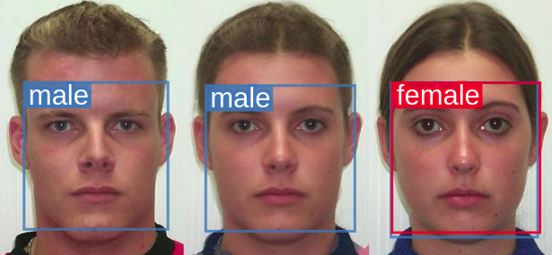

In this study, we engaged with some critical subjects:

## Face recognition

Face recognition technology stands as a remarkable testament to the rapid advancements achieved in the realm of artificial intelligence and computer vision. At its core, face recognition involves the intricate analysis of facial features, patterns, and contours to uniquely identify individuals. With its broad spectrum of applications, from unlocking smartphones to enhancing security systems and automating identity verification, face recognition has seamlessly woven itself into the fabric of modern society. This technology's ability to swiftly and accurately match faces against extensive databases has revolutionized law enforcement, making crime investigation more efficient, while simultaneously sparking conversations around privacy, ethics, and the balance between convenience and safeguarding personal information. As we continue to tread the frontier of technological innovation, face recognition stands as a testament to the marvels of human ingenuity and the profound implications it bears on the way we interact, secure, and understand the world around us.

Fig2 : Face recognition



## Machine learning

Machine learning algorithms are the bedrock of modern artificial intelligence, enabling computers to learn from data and make informed decisions without explicit programming. These algorithms, inspired by the human brain's neural networks, utilize complex mathematical models to recognize patterns, extract insights, and predict outcomes. Supervised learning algorithms, like decision trees and support vector machines, learn from labeled data, while unsupervised learning algorithms, such as clustering and dimensionality reduction techniques, find hidden structures in unlabeled data. Reinforcement learning algorithms empower machines to learn through trial and error, ideal for training agents in dynamic environments. Deep learning, a subset of machine learning, leverages deep neural networks to tackle intricate tasks like image and speech recognition, language translation, and autonomous driving. As technology advances, machine learning algorithms continue to evolve, driving innovations across industries and reshaping the way we interact with and harness the power of computers.

Fig3 : Machine learning



## Georgia Tech face database

The Georgia Tech Face Database is a widely used collection of facial images designed for research and experimentation in the field of computer vision and facial recognition. Created and maintained by the Georgia Institute of Technology, this database comprises thousands of images of individuals from diverse backgrounds, captured under varying lighting conditions, facial expressions, and poses. Researchers and developers often use this database to train and test facial recognition algorithms, evaluate their performance, and explore advancements in face detection, feature extraction, and facial attribute analysis. The Georgia Tech Face Database has played a crucial role in advancing the understanding of facial recognition technology and its applications in various domains, including security, surveillance, human-computer interaction, and entertainment.

Fig4 : Some selective images form dataset

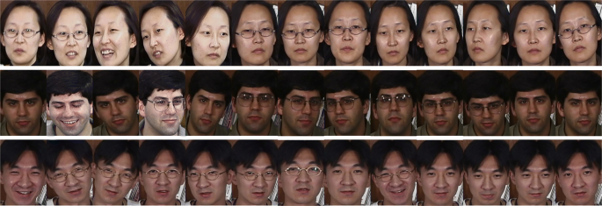

# Implemention

In this phase, we pass some important stepts that are mentioed below:

## Preprocessing

Preprocessing images using the cv2.CascadeClassifier from the OpenCV library involves a fundamental step in computer vision known as face detection. By leveraging a pre-trained Haar Cascade classifier, this process identifies and subsequently "drops" or removes faces from images. The classifier employs a set of Haar-like features to detect facial regions within an image. The procedure begins by loading the classifier and specifying the source and destination directories for the images. As each image is processed, it is converted to grayscale—a requirement for accurate face detection. The cascade classifier then scans the image for potential faces, considering factors such as scale and neighboring pixels. Once faces are detected, rectangles are drawn over them, effectively obscuring or eliminating the facial features. The modified images, with faces dropped, are saved in the designated output directory. This preprocessing technique finds applications in privacy protection, data anonymization, and object removal from images. However, it's important to note that the effectiveness of this approach may vary based on the quality of the classifier, image conditions, and specific use cases, requiring potential parameter adjustments or alternative methods for optimal results.

Fig5 : Compare input and out 

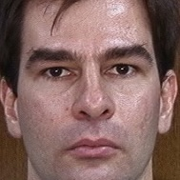

### Oriented Gradients (HOG)

In our project, we leveraged the power of the Histogram of Oriented Gradients (HOG) feature extraction technique to significantly enhance our image analysis capabilities. HOG enabled us to capture intricate details of object shapes and structures within images, making it an invaluable tool for various computer vision tasks. By dividing an image into smaller cells and computing gradient orientations within each cell, we obtained a comprehensive representation of local edge directions, which were further aggregated to create a histogram of gradient orientations. This histogram encapsulated the dominant edge orientations within each cell, effectively capturing the object's underlying shape and texture. The HOG features not only allowed us to differentiate between different objects based on their unique visual patterns but also enabled robust detection and classification, making our project's image processing pipeline highly adaptable and accurate across diverse scenarios.

### Incorporating the Local Binary Pattern (LBP)

Incorporating the Local Binary Pattern (LBP) feature extraction technique was a pivotal aspect of our project, greatly enhancing our ability to decipher complex patterns and textures within images. LBP allowed us to encode local pixel relationships by comparing the intensity values of a central pixel with its neighboring pixels, thus creating binary patterns that represent different texture variations. By applying this method across the entire image, we constructed a histogram that encapsulated the frequency of these unique binary patterns. This histogram not only provided us with a compact representation of texture information but also enabled us to effectively distinguish between various materials, surfaces, and structures present in the images. As a result, our project's image analysis capabilities were greatly enriched, enabling us to tackle challenges such as texture classification, facial recognition, and object segmentation with remarkable precision and versatility.

### Principal Component Analysis (PCA)

Principal Component Analysis (PCA) played a pivotal role in our project, revolutionizing how we handle high-dimensional data and extract essential features for analysis. By projecting our data onto a lower-dimensional subspace, PCA enabled us to capture the most significant patterns and variations within the data while minimizing information loss. This reduction in dimensionality not only streamlined our computations but also helped mitigate the curse of dimensionality, a common challenge in data analysis.

Incorporating PCA allowed us to identify the principal components—linear combinations of the original features—that account for the majority of the data's variance. By selecting a subset of these components, we effectively transformed our data into a more compact and interpretable representation, facilitating subsequent analysis. Moreover, PCA facilitated noise reduction, making our results more robust and less susceptible to irrelevant variations in the data.

Fig6 : PCA example

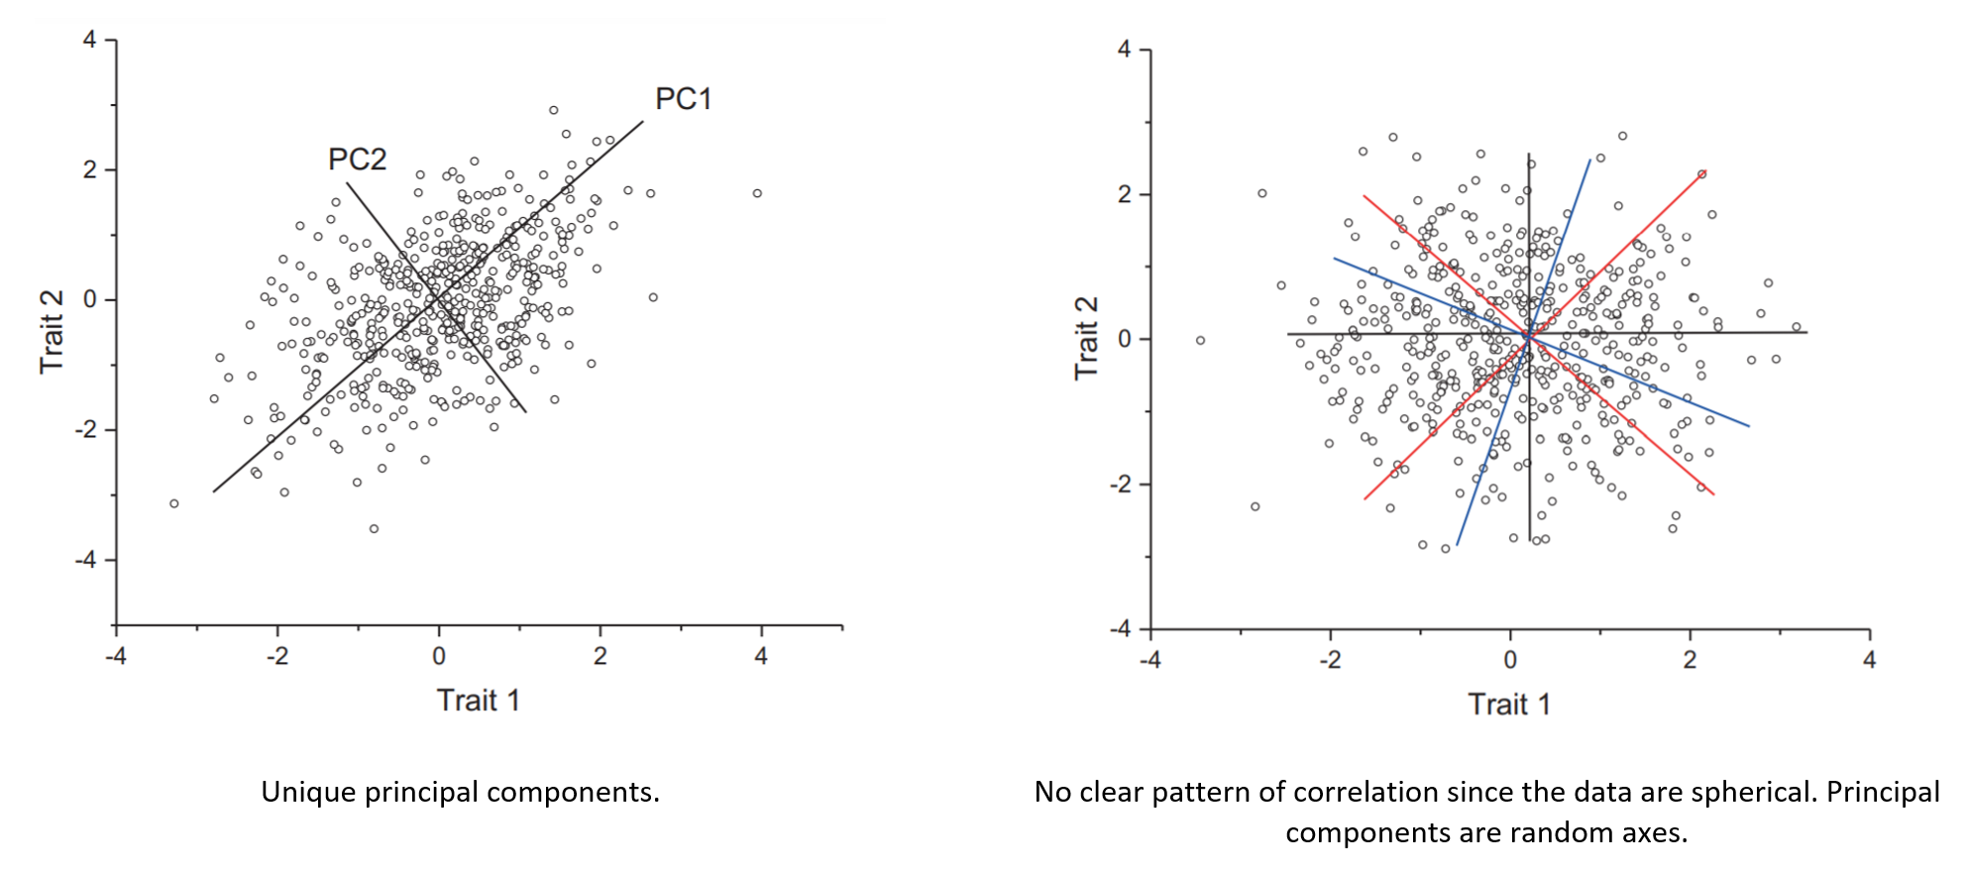

## Machine learning algorithms

### KNN

The K-Nearest Neighbors (KNN) algorithm played a fundamental role in shaping the core of our project, facilitating data classification and pattern recognition with remarkable adaptability. As a non-parametric and instance-based learning method, KNN excelled in handling both structured and unstructured data. By considering the proximity of data points in a feature space, KNN allowed us to make informed predictions and decisions based on the characteristics of neighboring data points.

In our project, KNN was instrumental in tasks such as classification and regression. By selecting a value for 'K,' the number of nearest neighbors to consider, we were able to strike a balance between bias and variance, tailoring the algorithm's sensitivity to local patterns. This adaptability made KNN highly effective in scenarios where data distribution and decision boundaries were complex or non-linear.

### SVM

Support Vector Machines (SVMs) played a pivotal role in shaping the foundation of our project, elevating our ability to perform binary and multi-class classification tasks with exceptional accuracy and versatility. As a powerful and robust machine learning algorithm, SVMs excel in finding optimal hyperplanes that separate different classes in a feature space, even in cases where the data is non-linearly separable.

In our project, SVMs allowed us to effectively tackle complex classification challenges by identifying the most discriminative features and creating clear decision boundaries. By maximizing the margin between classes, SVMs achieved remarkable generalization performance, minimizing the risk of overfitting and enhancing our model's predictive capabilities.

### XGBoost

At the heart of XGBoost lies an ensemble learning technique that combines the strengths of multiple weak learners, such as decision trees, to create a robust and accurate predictive model. XGBoost employs an optimized gradient boosting algorithm that focuses on minimizing loss functions, progressively improving the model's performance with each iteration.

In our project, XGBoost showcased its prowess by automatically handling feature interactions, managing missing values, and effectively addressing overfitting through techniques like regularization and pruning. Its ability to capture complex relationships within data made it well-suited for intricate real-world scenarios where other algorithms might struggle.

XGBoost's efficient implementation and parallel processing capabilities allowed us to process vast datasets and extract insights at impressive speeds. Moreover, its integration with tree visualization tools and feature importance analysis enabled us to gain a deeper understanding of our model's decision-making process.

Fig7 : XGBoost process

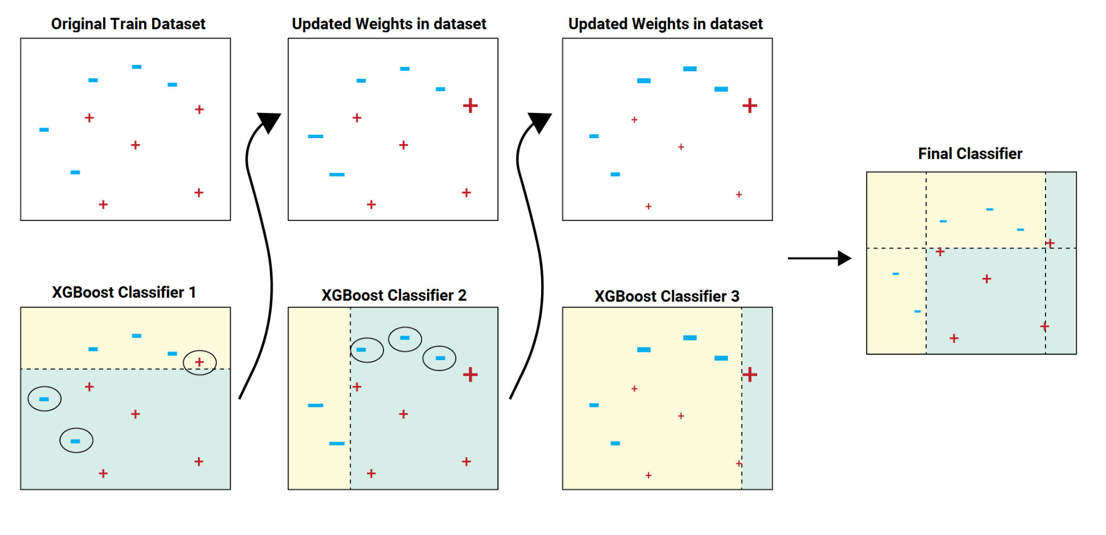

# Experiments and results

## Algorithms results

In this evaluation of the K-Nearest Neighbors (KNN) algorithm using different feature extraction techniques, the performance was measured across two primary methods: Histogram of Oriented Gradients (HOG) and Local Binary Pattern (LBP). The results revealed intriguing insights into the effectiveness of these techniques, both individually and when combined with Principal Component Analysis (PCA) for dimensionality reduction.

The first observation points to the inherent strength of HOG features, which exhibited a marginally higher accuracy (0.8564) compared to LBP features (0.8511). This difference underscores the importance of feature selection in influencing model performance. Additionally, the impact of PCA was evident across both feature extraction methods. When PCA was applied, the accuracy of HOG-enhanced KNN rose to 0.8617, further solidifying the efficacy of the HOG technique. Conversely, while PCA improved LBP results, the resulting accuracy (0.8298) still trailed behind the HOG-PCA combination.

Fig8 : KNN results

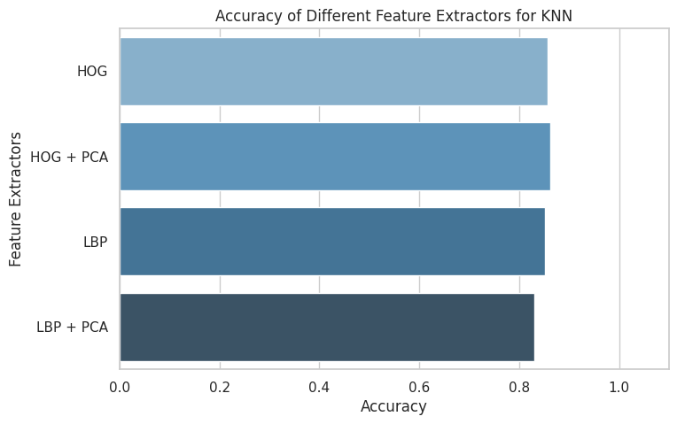

In this evaluation, the Support Vector Machine (SVM) algorithm was assessed using various feature extraction techniques, shedding light on its performance across different scenarios. The analysis considered two primary feature extraction methods: Histogram of Oriented Gradients (HOG) and Local Binary Pattern (LBP), both in their standalone forms and when coupled with Principal Component Analysis (PCA) for dimensionality reduction.

Upon examining the results, it's evident that the SVM algorithm exhibited robust accuracy across the board. The HOG feature extraction method led to an accuracy of 0.8723, highlighting its effectiveness in capturing salient information from the data. Interestingly, when PCA was applied in conjunction with HOG, there was a slight decrease in accuracy (0.8298). This outcome underscores the notion that while dimensionality reduction techniques like PCA can be beneficial, their impact can vary depending on the feature representation being used.

Fig9 : SVM results

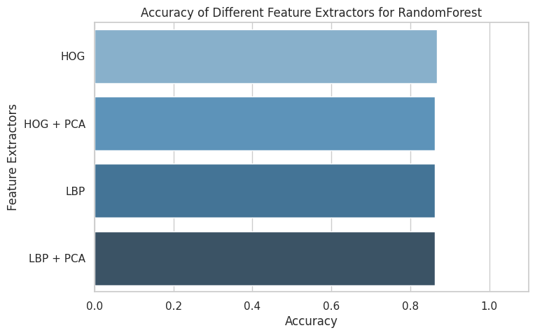

The results showcase the consistent and competitive accuracy achieved by the XGBoost algorithm across the different feature extraction methods. When utilizing the HOG feature extraction technique, the XGBoost model achieved an accuracy of 0.8670, demonstrating its capability to effectively leverage these features for classification. When PCA was applied alongside HOG, the accuracy remained relatively stable at 0.8617, suggesting that the addition of PCA did not significantly impact the model's performance in this context.

Similarly, the XGBoost model exhibited consistent accuracies of 0.8617 across all scenarios involving the LBP feature extraction technique, whether used on its own or in combination with PCA. This result implies that the XGBoost algorithm can make effective use of LBP-based features, and the introduction of PCA had a consistent, albeit minimal, impact on accuracy.

Fig10 : XGBoost results



## 

## Compare algorithms

In the comparative analysis of three prominent machine learning algorithms—K-Nearest Neighbors (KNN), Support Vector Machine (SVM), and XGBoost—across various feature extraction techniques, intriguing patterns emerge that shed light on their respective strengths and adaptability. The KNN algorithm showcased its sensitivity to feature representations, with the Histogram of Oriented Gradients (HOG) outperforming the Local Binary Pattern (LBP), especially when coupled with Principal Component Analysis (PCA). Conversely, SVM demonstrated robust accuracy levels across both HOG and LBP features, with PCA influencing performance variably. XGBoost, a gradient boosting powerhouse, exhibited consistent accuracy levels regardless of feature extraction method or PCA inclusion. These findings underline the importance of algorithm-feature synergy; KNN thrives with well-suited features, SVM exhibits consistent adaptability, and XGBoost demonstrates remarkable resilience. Ultimately, this comparative exploration offers valuable insights into the intricate dynamics between algorithms and feature representations, guiding the selection of optimal combinations for diverse classification tasks.

Fig11 : Compare algorithms results

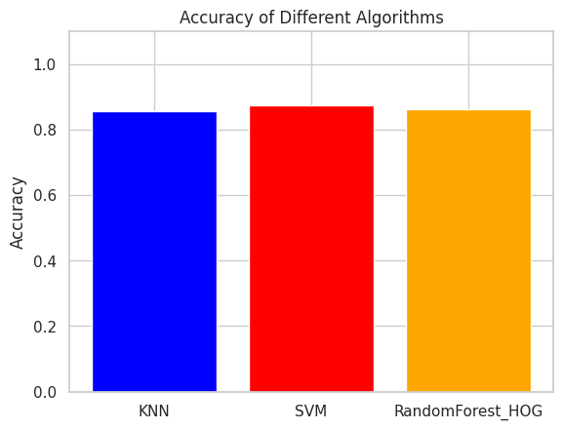

# Conclusion

In conclusion, the "GenderSnap: Image Gender Recognition App" project represents a convergence of cutting-edge machine learning techniques and real-world utility. The project's significance lies in its systematic algorithmic analysis, where K-Nearest Neighbors, Support Vector Machine, and XGBoost were rigorously evaluated alongside distinct feature extraction methods. Notably, KNN's sensitivity to feature representation became evident through superior performance with Histogram of Oriented Gradients (HOG), particularly in conjunction with Principal Component Analysis (PCA). Meanwhile, SVM demonstrated consistent adaptability across feature types, and XGBoost showcased robust stability regardless of feature or PCA variations. These findings underscore the pivotal role of algorithm-feature interactions in shaping the app's potential accuracy and user experience. Moreover, they underscore the need for ethical considerations in deploying gender recognition technology responsibly, emphasizing that technology's impact extends beyond technical prowess to societal and ethical dimensions.

# References

1. <https://www.ibm.com/topics/knn#:~:text=Next%20steps-,K%2DNearest%20Neighbors%20Algorithm,of%20an%20individual%20data%20point>.
2. <https://www.analyticsvidhya.com/blog/2018/03/introduction-k-neighbours-algorithm-clustering/>
3. <https://xgboost.readthedocs.io/en/stable/>
4. <https://www.nvidia.com/en-us/glossary/data-science/xgboost/>
5. <https://machinelearningmastery.com/introduction-to-deep-learning-for-face-recognition/>
6. <https://iopscience.iop.org/article/10.1088/1742-6596/1755/1/012006/meta>