**Crypto Convertor**

A simple, not so ambiguous application to convert Cryptocurrency to currency, which is made as an technical assignment.

**Tech Stack**

* Dotnet Core 2.2
* Angular
* MS Test, Moq
* Rabbitmq
* Docker
* Docker-Compose
* Redis

**Solution Design**

A simple solution design with using Microservice and Dockerise concepts. I tried to keep

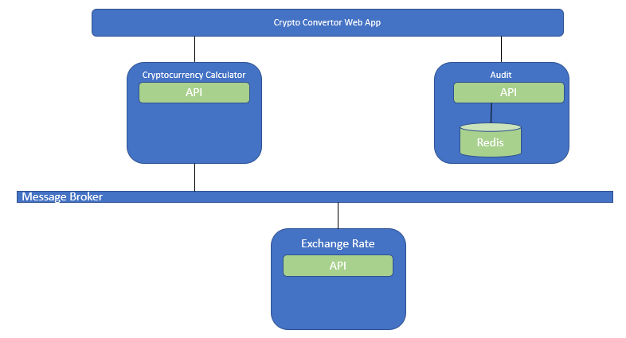

Web App: is a simple UI which triggers the cryptocurrency calculations.

Crypto Calculator: An Api which receives the Exchange Rates from other service and calculate crypto against the currency list.

Exchange Rate: An Api which load and distribute the list of exchange rates against USD, per request from the Message Broker.

Audit Service: Simple service to save logs.