**Physics Laboratory - Report #2**

Experiment: 48

**Determination of the Planck constant using electroluminescent diodes**

Instructor: Dr. Robert Oliva Vidal

**Prepared By:**

Student 1: Behram ÇELEN - 245930

Student 2: Muhammed Asil KARAKULAK- 245872

Date: 20.03.2018

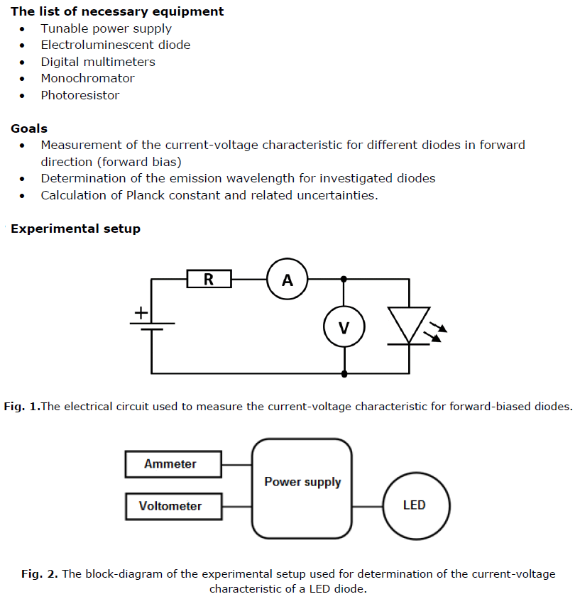

**Determining of the Planck constant from the I-V characteristic of LED**

When we connect the LED to an external voltage in the forward bias direction, the height of potential barrier across the p-n junction is reduced (see Fig. 8a). At a particular voltage the height of the potential barrier becomes very low and the LED starts glowing, i.e. in the forward biased condition electrons crossing the junction recombine with the holes moving in the opposite direction and the excess energy is emitted as photons. The light energy emitted during forward biasing of LED is given by the equation:



The relationship between the light energy emitted from LED and the applied voltage is the following:



where e = 1.602 × 10−19 C is the magnitude of the electron charge, Ub – a voltage referring to the potential barrier of a diode, determined from the I-V curve (cf. Fig. 8b).

The experimental determination of Planck’s constant is then easily obtained by measuring the wavelength of the emitted radiation from an LED and applied voltage over the LED concurrently, by combining the equations to get h:



Rearranging Eq. 4 we get:



**REFERENCE**

Laboratorium Podstaw Fizyki, Politechnika Wroclawska, “http://lpf.wppt.pwr.edu.pl/opisy.php”

**Measurements**

Twenty potential-current instances are measured for 4 different colors of LEDs. For each color, wavelengths are measured. Resulting data sets are plotted and analyzed.

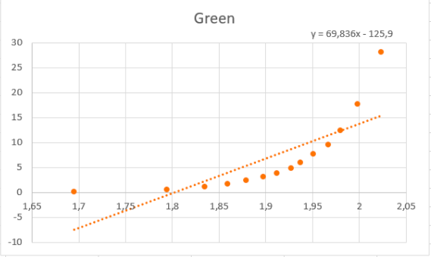



|  |  |  |  |  |  |  |  |  |  |  |
| --- | --- | --- | --- | --- | --- | --- | --- | --- | --- | --- |
| Green | U[V] | I[mA] | 𝜆[nm] |  | ( | | h | | (h) | |
| Resolution | 0,001 | 0,1 | 1 | 1,91 | 0,55 | | 4.31e-34 | | 1.05e-24 | |
| 1 | 0.022 | 0 | 560 |  | |  | |  | |
| 2 | 0.48 | 0 |  |
| 3 | 0.727 | 0 |  |
| 4 | 0.976 | 0 |  |
| 5 | 1.224 | 0 |  |
| 6 | 1.475 | 0 |  |
| 7 | 1.695 | 0.04 |  |
| 8 | 1.794 | 0.48 |  |
| 9 | 1.835 | 1.07 |  |
| 10 | 1.859 | 1.66 |  |
| 11 | 1.879 | 2.37 |  |
| 12 | 1.897 | 3.07 |  |
| 13 | 1.912 | 3.84 |  |
| 14 | 1.927 | 4.88 |  |
| 15 | 1.937 | 5.97 |  |
| 16 | 1.951 | 7.63 |  |
| 17 | 1.967 | 9.59 |  |
| 18 | 1.98 | 12.43 |  |
| 19 | 1.998 | 17.67 |  |
| 20 | 2.023 | 28.09 |  |

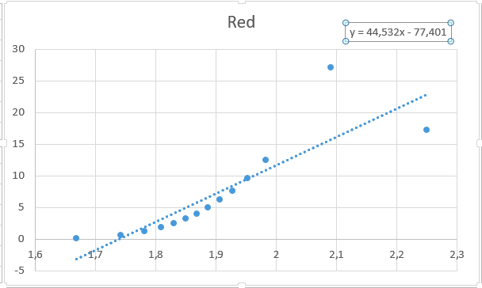

|  |  |  |  |  |  |  |  |  |  |
| --- | --- | --- | --- | --- | --- | --- | --- | --- | --- |
| Red | U[V] | I[mA] | 𝜆[nm] |  | ( | | h | | (h) |
| Resolution | 0,001 | 0,1 | 1 | 3,56 | 0,37 | | 3.45e-34 | | 5.85e-35 |
| 1 | 0.021 | 0 | 616 |  | |  | |  |
| 2 | 0.483 | 0 |  |
| 3 | 0.726 | 0 |  |
| 4 | 0.97 | 0 |  |
| 5 | 1.22 | 0 |  |
| 6 | 1.467 | 0 |  |
| 7 | 1.668 | 0.12 |  |
| 8 | 1.742 | 0.58 |  |
| 9 | 1.782 | 1.2 |  |
| 10 | 1.809 | 1.82 |  |
| 11 | 1.83 | 2.47 |  |
| 12 | 1.85 | 3.21 |  |
| 13 | 1.868 | 3.99 |  |
| 14 | 1.887 | 4.96 |  |
| 15 | 1.906 | 6.16 |  |
| 16 | 1.927 | 7.61 |  |
| 17 | 1.953 | 9.61 |  |
| 18 | 1.983 | 12.46 |  |
| 19 | 2.25 | 17.26 |  |
| 20 | 2.09 | 27.04 |  |

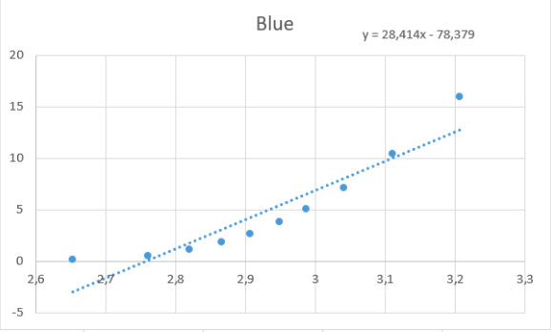



|  |  |  |  |  |  |  |  |
| --- | --- | --- | --- | --- | --- | --- | --- |
| Blue | U[V] | I[mA] | 𝜆[nm] |  | ( | h | (h) |
| Resolution | 0,001 | 0,1 | 1 | 1,61 | 0,40 | 4,03e-34 | 2.03e-35 |
| 1 | 0.0234 | 0 | 447 |  |  |  |
| 2 | 0.491 | 0 |  |
| 3 | 0.729 | 0 |  |
| 4 | 0.971 | 0 |  |
| 5 | 1.226 | 0 |  |
| 6 | 1.489 | 0 |  |
| 7 | 1.724 | 0 |  |
| 8 | 1.972 | 0 |  |
| 9 | 2.207 | 0 |  |
| 10 | 2.46 | 0 |  |
| 11 | 2.653 | 0.12 |  |
| 12 | 2.761 | 0.54 |  |
| 13 | 2.82 | 1.14 |  |
| 14 | 2.866 | 1.85 |  |
| 15 | 2.906 | 2.67 |  |
| 16 | 2.949 | 3.83 |  |
| 17 | 2.987 | 5.04 |  |
| 18 | 3.041 | 7.12 |  |
| 19 | 3.111 | 10.46 |  |
| 20 | 3.206 | 15.96 |  |

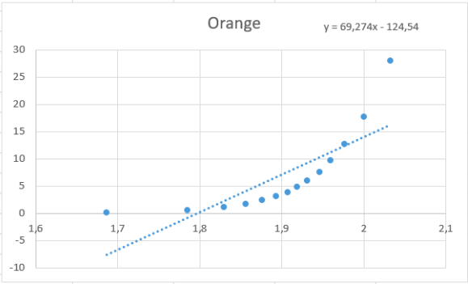



|  |  |  |  |  |  |  |  |  |
| --- | --- | --- | --- | --- | --- | --- | --- | --- |
| Orange | U[V] | I[mA] | 𝜆[nm] |  | ( | h | | (h) |
| Resolution | 0,001 | 0,1 | 1 | 1,92 | 0,21 | 4.34e-34 | | 3.36e-35 |
| 1 | 0.023 | 0 | 574 |  |  | |  |
| 2 | 0.476 | 0 |  |
| 3 | 0.733 | 0 |  |
| 4 | 0.996 | 0 |  |
| 5 | 1.224 | 0 |  |
| 6 | 1.472 | 0 |  |
| 7 | 1.687 | 0.07 |  |
| 8 | 1.785 | 0.51 |  |
| 9 | 1.83 | 1.1 |  |
| 10 | 1.856 | 1.68 |  |
| 11 | 1.876 | 2.35 |  |
| 12 | 1.893 | 3.11 |  |
| 13 | 1.907 | 3.88 |  |
| 14 | 1.919 | 4.87 |  |
| 15 | 1.931 | 5.95 |  |
| 16 | 1.946 | 7.6 |  |
| 17 | 1.96 | 9.67 |  |
| 18 | 1.977 | 12.65 |  |
| 19 | 2 | 17.73 |  |
| 20 | 2.033 | 27.95 |  |

**Calculations:**

**Deriving Planck’s Constant**

Planck’s Constant is calculated for each data set by the equation:

where potential barrier is calculated by:

Variables from 𝑦=𝑎𝑥+𝑏 line fit. (U vs I)

|  |  |  |  |  |
| --- | --- | --- | --- | --- |
|  | Green | Red | Blue | Orange |
| a | 69.83622174 | 44.53210712 | 20.32014952 | 69.27397902 |
| b | -125.901761 | -77.40105596 | -54.23981351 | -124.5405601 |
|  | 16.21 | 7.53 | 4.056 | 14.95 |
|  | 30.90 | 14.3 | 11.74 | 28.43 |

**Uncertanities**

Uncertanity of potential barrier calculated by:

= =

Uncertanity of Planck’s Constant calculated by:

=