**Physics Laboratory - Report #3**

Experiment: 33C

**MEASUREMENT OF SURFACE TENSION: STALAGMOMETRIC METHOD**

Instructor: Dr. Robert Oliva Vidal

**Prepared By:**

Student 1: Behram ÇELEN - 245930

Student 2: Muhammed Asil KARAKULAK- 245872

Date: 27.03.2018

**Measurement procedure**

**1. List of equipment**

* Stalagmometer
* Tested liquids
* Weighing vessel
* Calliper
* Thermometer

**2. Goal**

Determination of surface tension of several different liquids.

**3. Measurement setup**

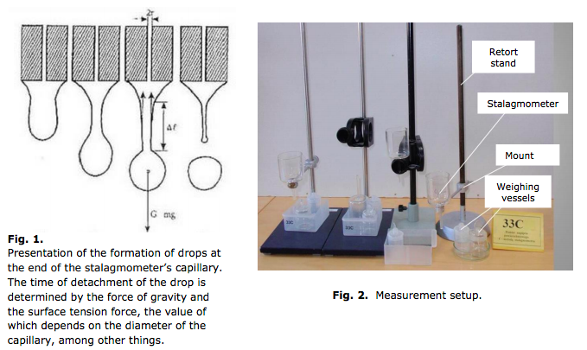

**Calculations Rules:**

a) Calculate the value of the expression

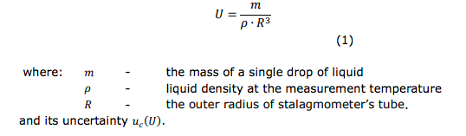

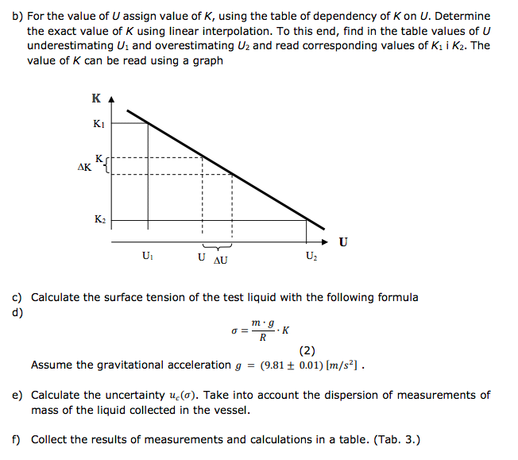

Measurements;

|  |  |  |  |  |  |  |  |
| --- | --- | --- | --- | --- | --- | --- | --- |
|  |  |  | pure | 50 drop |  |  |  |
|  | water | vessel | 4.6 | 8.23 | stalagmometer |  | 0.5 |
|  |  |  |  | 8.25 |  |  |  |
|  |  |  |  | 8.25 |  |  |  |
|  | alcohol | vessel |  | 5.72 |  |  |  |
|  |  |  |  | 5.77 |  |  |  |
|  |  |  |  | 5.72 |  |  |  |