Exercise 1. Building a Simple 2D Model

**Exercise Description**

Groundwater Vistas is a powerful pre- and post-processor for several of the commonly used modeling programs, such as MODFLOW and MT3DMS. The purpose of this exercise is to introduce some of the basics for using the Groundwater Vistas software. Vistas will be used for this course to develop input datasets for MODFLOW, MODPATH, and MT3DMS, and to post-process model results.

**Part I. Getting Started**

1. Start Groundwater Vistas
2. Click **File>New>GWVistas Document** and then and you should see the following window 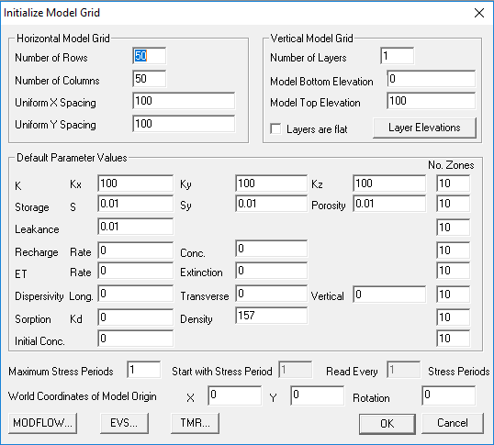 Model development will be much easier if you enter correct information for these parameters, particularly the model grid information.
3. For this simple exercise, create a model that has **100 columns** and **100 rows**. Use **uniform x** and **y** spacing of **50** meters.
4. For the **vertical grid** information, leave the **number of layers** as **1** and assign a **bottom elevation** of **–100** and a **top elevation** of **10**.
5. Assign a **hydraulic conductivity** value of **1000 m/day** for **Kx, Ky,** and **Kz**.
6. Assign values of **1e-5, 0.2,** and **0.2** for **S, Sy**, and **porosity,** respectively.
7. Assign a **recharge rate** of **0.002 m/d.**
8. After you have entered these values, your window should look like the following: 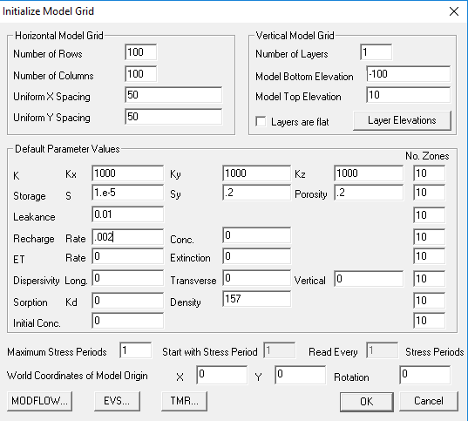
9. Click **Ok** to generate the model template. You should now see the following 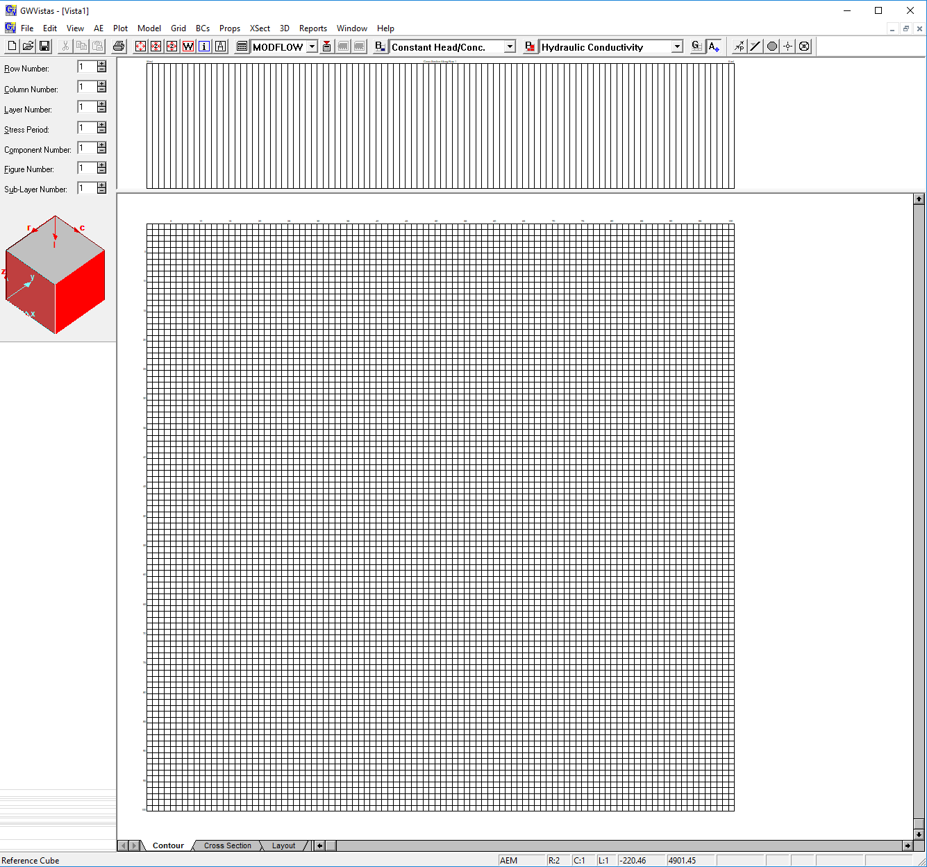
10. There are four areas of the Groundwater Vistas main window: **(1) the menus and toolbar across the top, (2) the locator box on the left, (3) the cross section window beneath the toolbar, and (4) the model grid window.**
11. As with any software, it’s always a good idea to save the current file. Click **File>Save as**, and save the Groundwater Vista file to the working subdirectory ex01 in your “exercises” folder for this workshop. In this case, you might want to call the file ***Ex01.gwv*.**

**Part II. Working with Boundaries**

1. Beneath the main menu, there are four buttons labeled **B P G A**. These buttons represent **Boundaries, Properties, Grid**, and **Analytic element.** Whichever one of these buttons is pressed indicates the current editing mode in Vistas. So if we want to work with boundaries, we would press the **B** button.
2. For the sake of this example, lets assume there is a lake on the east side of this model with an irregularly shaped coastline, and we want to use constant head cells to represent the lake. Constant head cells can be added by clicking **BCs>Constant head/conc**. Only one boundary type can be edited at a time. The boundary type shown in the drop down box is the current boundary type.
3. To enter a single constant-head boundary, right click on one of the model cells. A window will come up and ask for information about the boundary. To delete this same boundary, right-click again on the same cell.
4. To enter many constant-head boundaries within an irregularly shaped polygon, click on the **polygon tool**, which is located to the left of the **Op** button on the toolbar. With the polygon tool pressed, you can trace a polygon. Double-click when you get to the end of the polygon. Make sure that you do not click outside of the model grid. Once again a window will come up and ask for information about the boundary. In this case, you can accept the default values as shown below 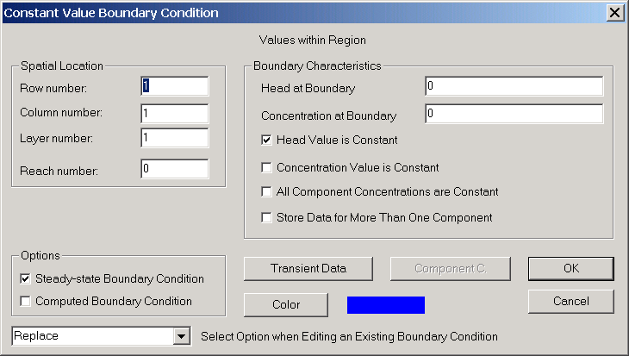
5. Trace out an irregular pattern for the ocean using the polygon tool. Create something that looks like the following: 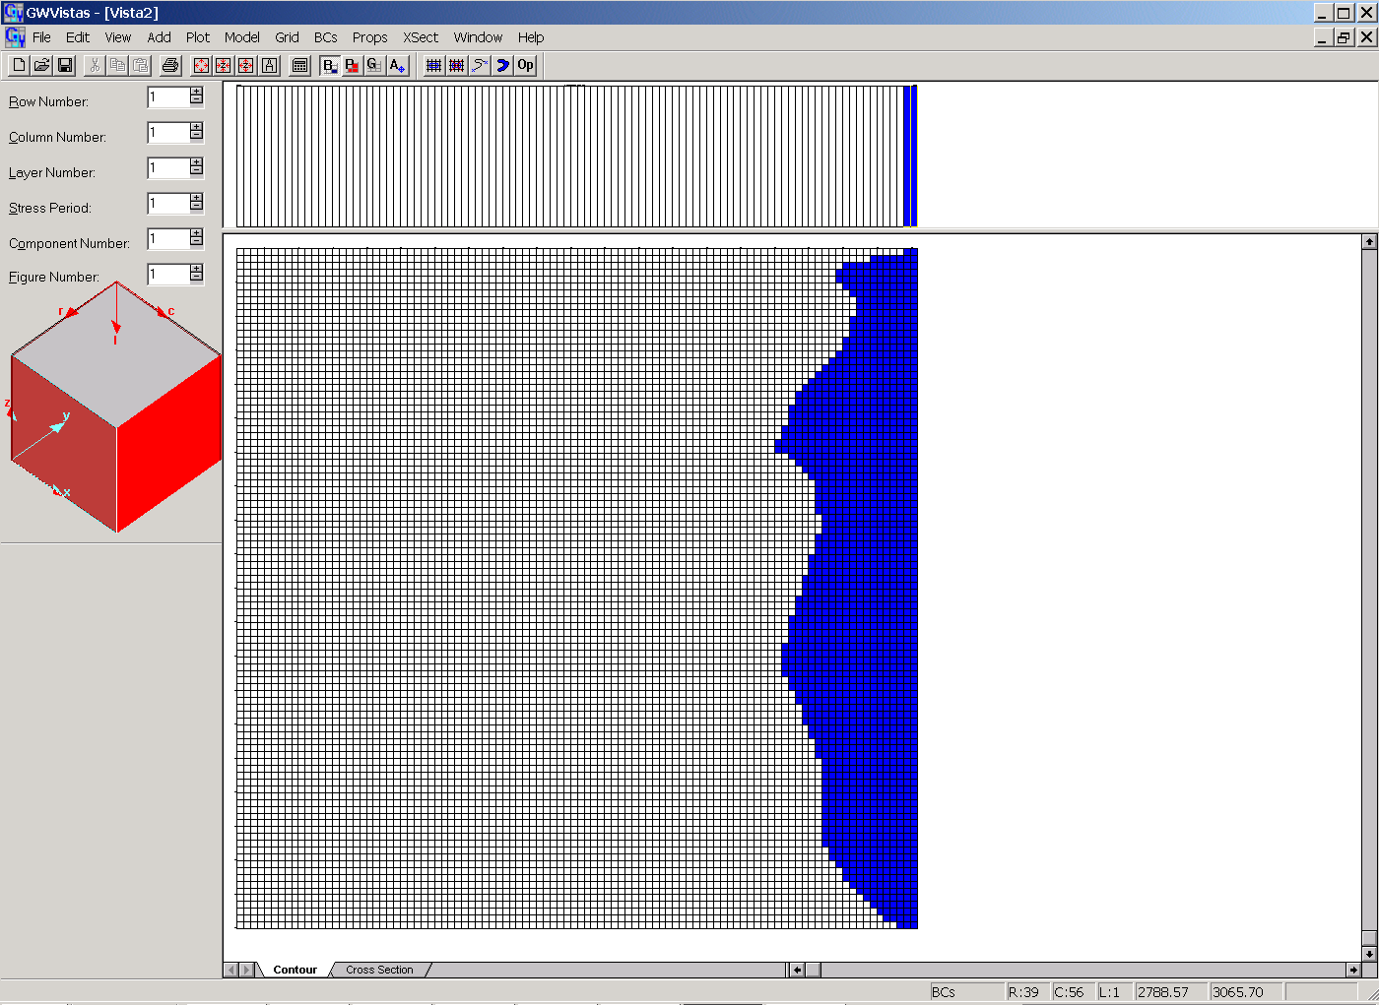

**Part III. Working with Properties**

1. Now lets say that we want to add a zone of lower hydraulic conductivity somewhere in the middle of our model grid. Hydraulic conductivity referred to as a **property** in Vista terminology. To work with properties, click the **P** button. Also click on the **Props** menu and make sure there is a check next to **Hydraulic Conductivity.**
2. Groundwater Vistas uses the zone concept for the different property types. To see the zones available for hydraulic conductivity, click on the **Db** button (which means database) on the toolbar. Currently, there are 10 possible zones, but only zone 1 has non-zero hydraulic conductivity values. Enter a value of **50** for **Kx, Ky**, and **Kz** in zone **2**. If you want, you can also change the color of this zone by double-clicking in the color box next to **Kz**. Your database might look like the following 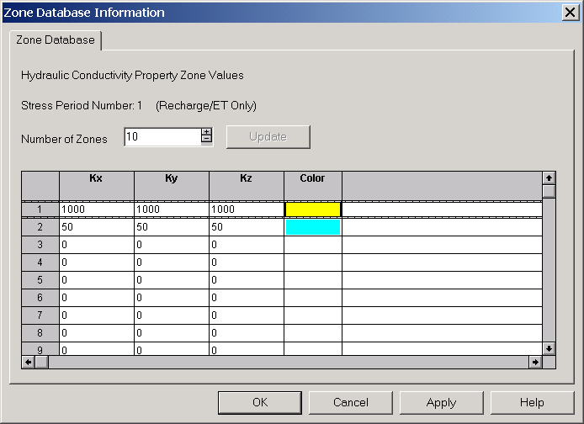
3. When you move the mouse over the model grid, the zone number and zone value are displayed in the lower left corner of the Vista window. To add a new zone to the model grid, use the polygon tool again to trace an irregular shape in the middle of the model area. When asked for the **zone number**, enter **2**. You now have a heterogeneous distribution for hydraulic conductivity.

**Part IV. Running MODFLOW2005**

1. At this point, we are ready to run MODFLOW. In this example, we will use the version of MODFLOW that comes with Groundwater Vistas.
2. One of the first things you should always do when using Vistas is verify that the working directory is set properly. To set the working directory, click on **Model>Paths to Models** and at the bottom of the box where it says “Working Directory”, browse for the correct working directory (***ex01***). Groundwater Vistas will create model datasets in the working directory and will also read model output from files in the working directory. Some of the errors that you will encounter while using Vistas are the result of an inaccurate working directory.
3. Information regarding a MODFLOW2005 simulation can be found in two places—under the **Model>MODFLOW** menu and under the **Model>MODFLOW2005** menu. Normally, you should browse through each one of the options under these menus to make sure the parameters are set properly.
4. Go to the **Model>MODFLOW>Packages** menu. Set the MODFLOW Version to **MODFLOW2005**.
5. After you have looked through each of the menus and are satisfied that the parameters are set properly, you need to create the MODFLOW2005 datasets. Go to **Model>MODFLOW2005>Create Datasets**. If you look in your working subdirectory, you will see that the MODFLOW2005 datasets have been created.
6. Use a text editor to inspect each of the files created in the working subdirectory. If you are new to MODFLOW2005 you will notice changes in the input files. For example, all information regarding the model grid is now stored in the ***discretization file*** (with suffix .dis). Also look at the name file. The name file controls the overall simulation options.
7. Next, run MODFLOW2005 by going to **Model>MODFLOW2005>Run MODFLOW2005.**
8. When MODFLOW2000 finishes, you will be asked if you want to process the results. Click **yes**.

**Part V. Importing and Plotting Results**

1. When you import model results you should see the following window 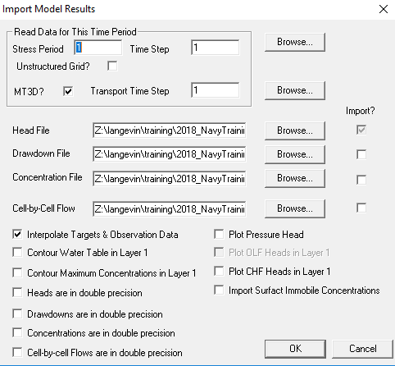
2. Normally you want to import the head file and also the cell-by-cell flow file. If you import the cell-by-cell flow file you will able to view the water budget and draw velocity vectors. Later, when we use, we will also import concentrations.
3. After you have imported results, there are several ways to make useful plots. Most of the plotting options are listed under the Plot menu. Look at the **Plot>What to Display** window. This is the main window for turning on or off display options. 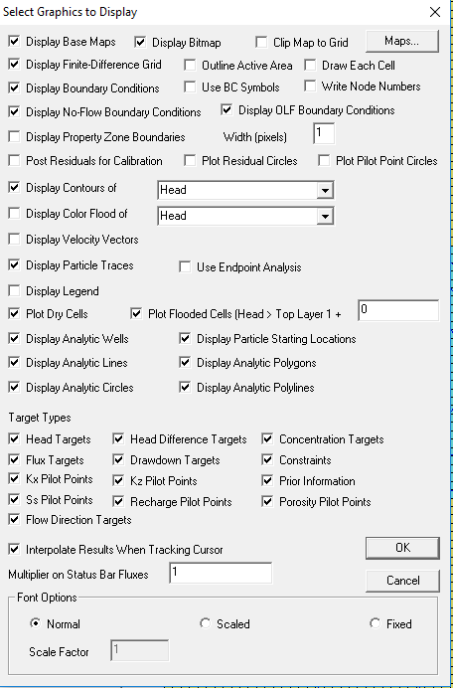 Toward the bottom right corner of the main Vista window, there is a number that changes as you move the cursor over the model grid. This number reflects the value of whatever option is selected next to the **Display Contours** of box. So for in this case, Head has been selected. So when you move the cursor over the model grid, you will see the head value for each location.
4. If you are unhappy with the way your contours look, you can change the contour interval, label font, etc. under **Plot>Contour>Parameters (Plan)**…
5. Vistas has several options for showing water budget information. If the **B** button is pushed, then as you move the mouse over the different boundaries, in the bottom left-hand corner of the main Vista window, you can see discharge information for each boundary cell (F=xxx.xxE-xx). This discharge value has units of **L3/T**, which for this case is **m3/day**.
6. You can also view detailed water budget information for the entire model or a subset of the model by going to **Plot>Mass Balance**, and then selecting an option. According to this model, how much groundwater is discharging into the lake?

**Part VI. Using ModelViewer**

1. The USGS ModelViewer program is a nice way to look at a model in three dimensions. Let’s take a look at the model that you just created with ModelViewer. The model should load using the New option and then selecting the MODFLOW-2005 name file.
2. Once the model is loaded, you can then turn things on and off with the Show menu. Additional controls can be found under Toolbox. These should be self-explanatory. Experiment with these options to create three-dimensiona plots of the model. Ask for help if you run into trouble.