Exercise 2. Working with an Existing Model

**Exercise Description**

Djibouti is a small country located in the Horn of Africa and home to the US Navy base Camp Lemonier. Camp Lemonier is located on the Gulf of Aden next to the capital city of Djibouti City. The Djibouti Model is a very simple two-layer groundwater model that was developed to simulate the impact of single and multiple-well pumping scenarios on the water table at Camp Lemonnier.

In this exercise, your job is to reproduce and verify the drawdown analysis that was conducted for Comp Lemonnier, Djibouti. The following table was produced as part of that analysis.

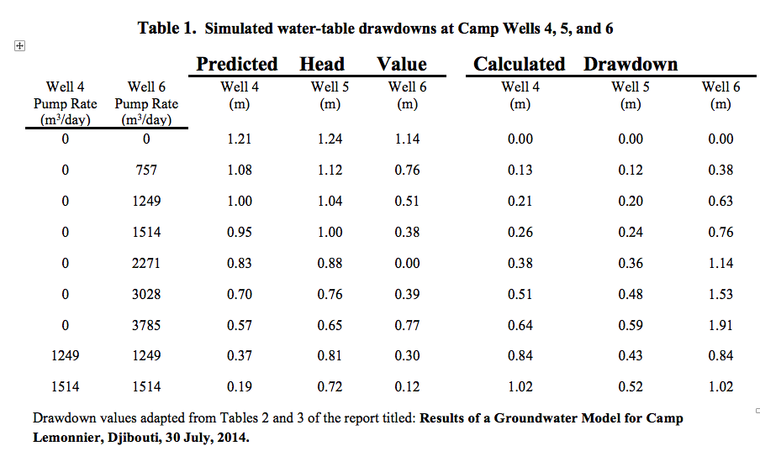

**Part I. Importing the Existing Model**

1. Start Groundwater Vistas and import a MODFLOW Dataset… Select GW Vistas Document in the next screen. 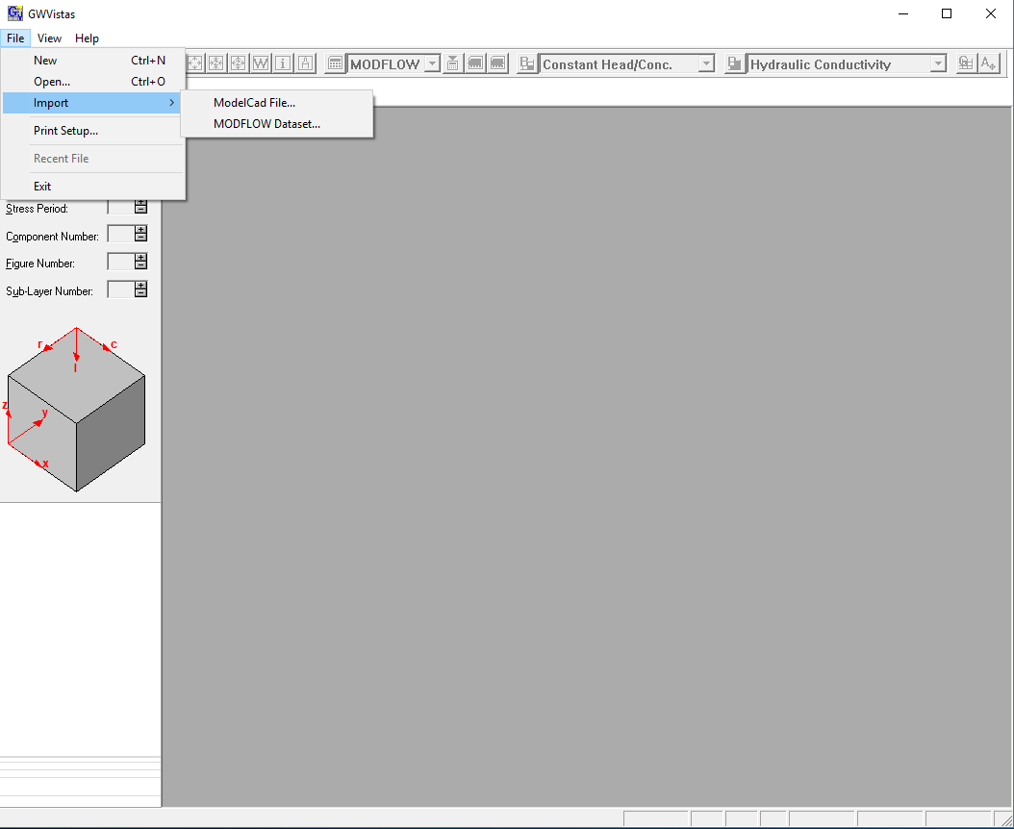
2. In the following window click on the MODFLOW… button. 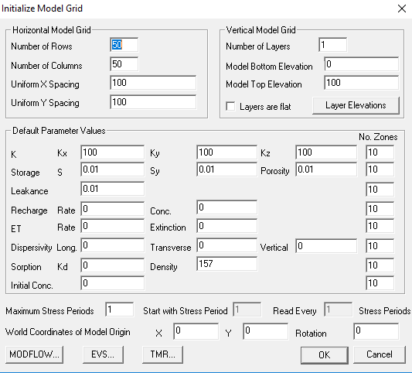
3. Here you specify the location of the existing model. For this class the model is located in the exercises\data\djibouti folder. You will be providing selecting the name file. If specified correctly, you should see something like the following: 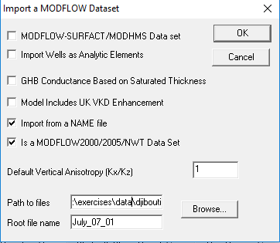
4. After clicking okay one or more times, you should see the following. This means that the model was imported correctly. 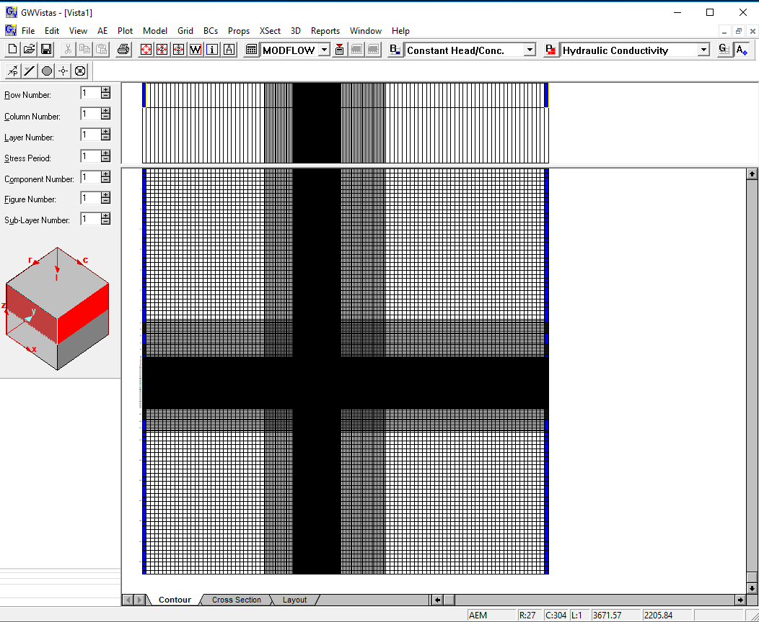
5. We want to know where our MODFLOW files will be created. The first thing we should always do is check our paths to models. Here we want to specify that the working directory is at: exercises\ex02. If this folder does not exist, you may need to create it first.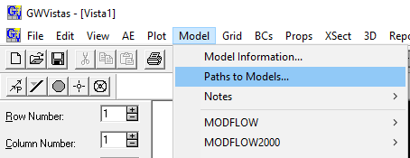
6. Let’s go ahead and run this model. This is normally a two-step process with Groundwater Vistas. First you need to create the MODFLOW datasets, and then you need to run the model. So we do Model>MODFLOW>Create datasets… And then we do Model>MODFLOW>Run MODFLOW. When MODFLOW finishes running, Vistas will ask if you want to process the results. You should generally say yes, and you will see a window like the following. 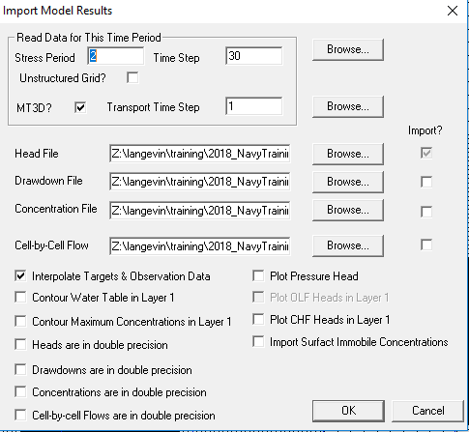
7. If you just hit OK here, you should see a plot of head contours for the last stress period and time step of the model. 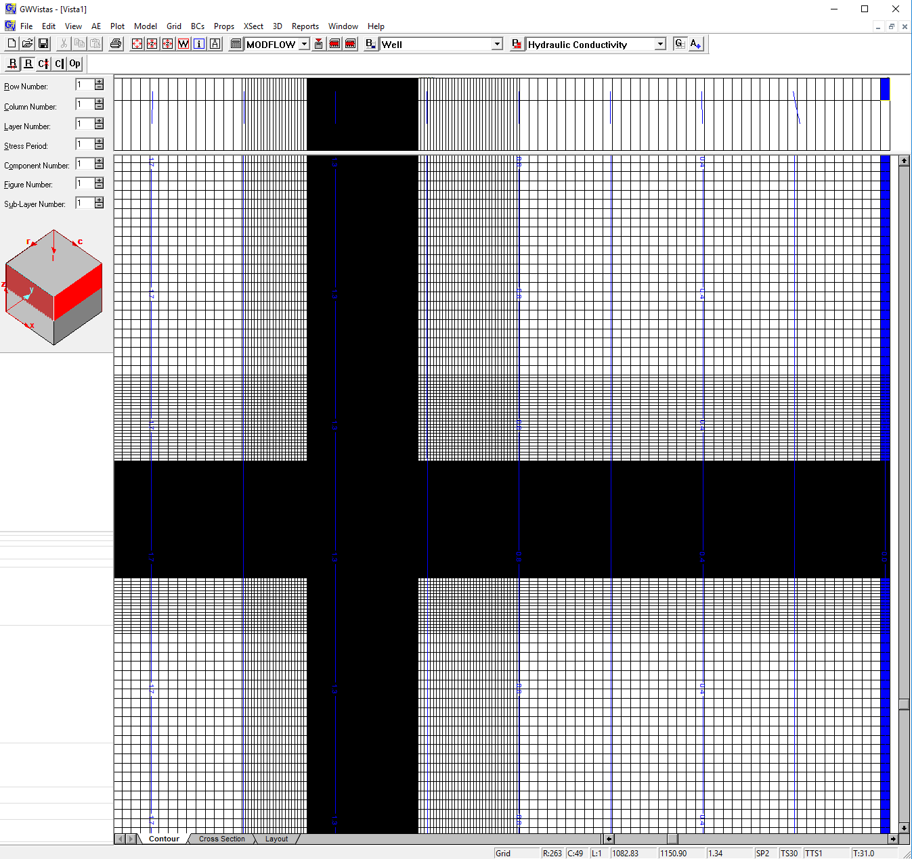
8. These model results should correspond to Figure 6 in the modeling report, which is the baseline hydraulic head values without any groundwater pumping. 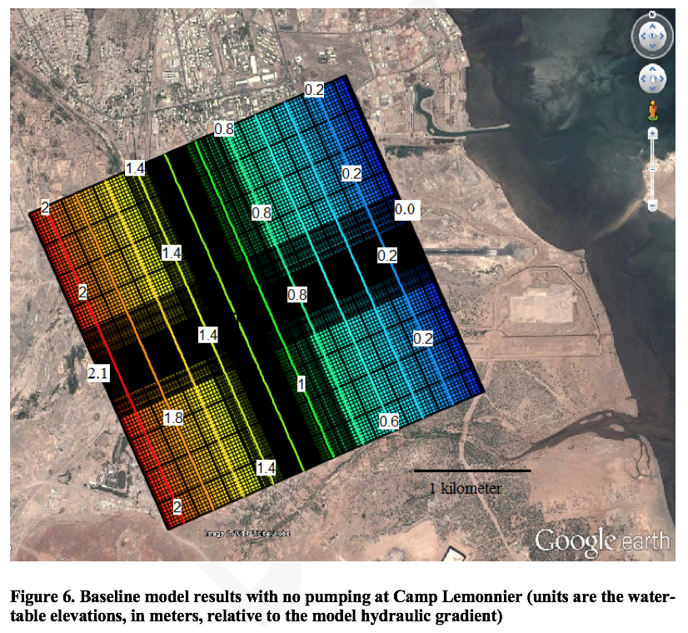
9. You should pay attention to the information shown on the bottom of the Vistas window. The first item is the editing mode that you are in. In this case, you are in the Grid editing mode. You may also see BCs here or Properties, which means you are editing boundary conditions or hydrogeologic properties. Next are the x and y positions of the cursor. These values will change as you move your cursor around in the grid. The next value is the head value (or whatever you are contouring) wherever the cursor is located. The last values are the stress period, time step, transport time step, and simulation time. We will talk about these things more later in the class.
10. As with any software, it’s always a good idea to save the current file. Click **File>Save as**, and save the Groundwater Vista file to the working subdirectory ex01 in your “exercises” folder for this workshop. In this case, you might want to call the file ***ex01.gwv*.**

**Part II. Simulating the Effect of Groundwater Pumping**

1. The modeling report shows the following figure of three pumping wells, Well 4, Well 5, and Well 6. These are the wells shown in the table in the introduction of this exercise. 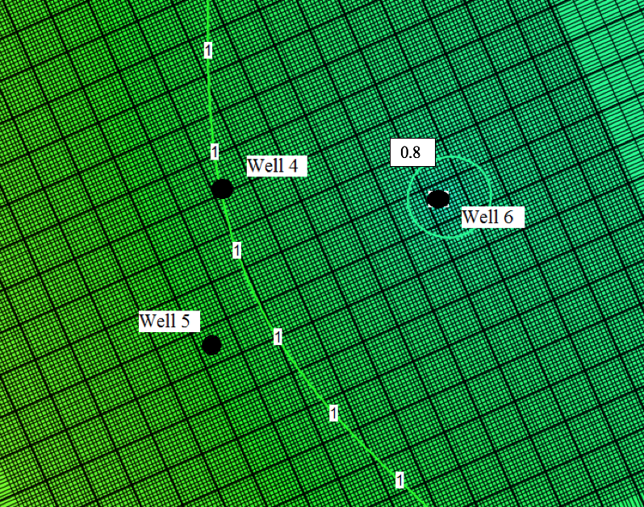
2. You can’t see these wells in the present model view, because the grid is so fine in this area. We can zoom into this area using Control-W or the View>Window menu. You should see something like the following, where the red squares represent the three pumping wells. Groundwater Vistas cannot show a rotated grid, but we can clearly see how these wells are wells 4, 5, and 6 in the previous figure. 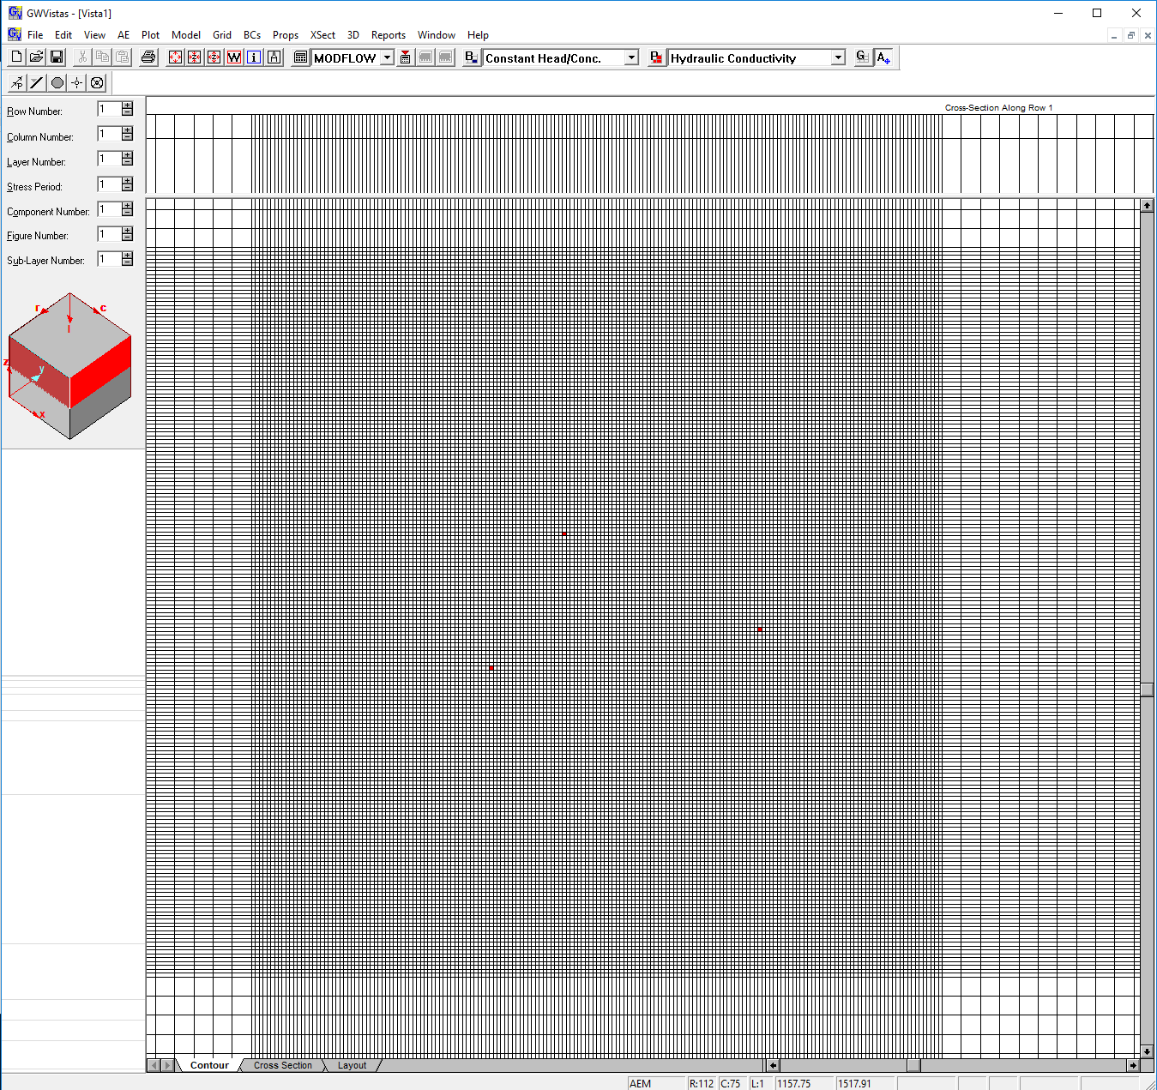
3. Hover your mouse over each of the three wells. What are the simulated head values? Note that these are the simulated head values without any pumping.
   1. Well 4: ___________
   2. Well 5: ___________
   3. Well 6: ___________
4. In this next part, we are going to add the effect of pumping from Well 6, which is the well furthest to the right. According to the drawdown table shown on the first page of this exercise, we are going to enter a pumping rate of 757 m3/day. We are going to add this pumping to stress period 2, which means that stress period 1 will represent the baseline case without pumping and stress period 2 will represent the pumping case. We can enter the pumping rate for Well 6 by double-clicking on the well, which will bring up this Window: 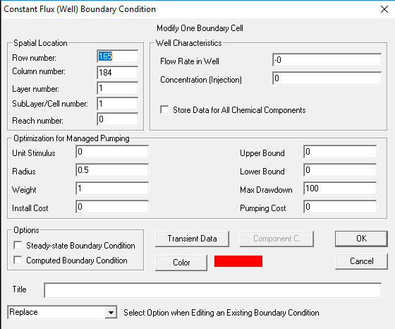
5. Next we click on the button that says Transient Data, which will bring up this window: 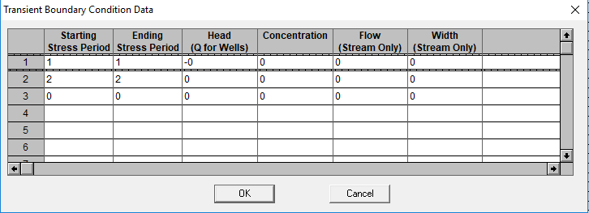
6. Here we enter the pumping rate for stress period 2, so that the window looks like the following. Note that we used a negative value, which means that water is pumped out of the aquifer. 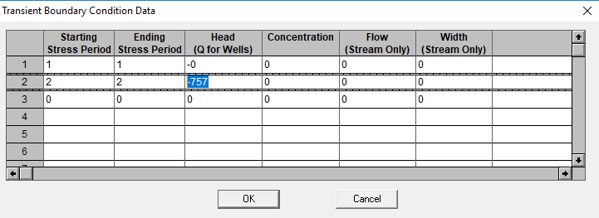
7. Now that we have made this change, there are two things we need to do to run the model. Go ahead and do those things. Now let’s calculate the drawdown for these three wells. Drawdown is equal to the head at the well without pumping minus head at the well with pumping. Calculate drawdown for the three wells.
   1. Well 4: ___________ - ___________ = ___________
   2. Well 5: ___________ - ___________ = ___________
   3. Well 6: ___________ - ___________ = ___________
8. How do your results compare to the table on the first page?

**Part III. Repeat the Drawdown Analysis and Verify the Table**

1. Use the model to fill in the following table.

