Exercise 2. PARTICLEFLOW—Understanding Advection and Dispersion

**Exercise Description**

The purpose of this exercise is to demonstrate the concepts of advection and dispersion, and to demonstrate the role of aquifer heterogeneity on solute transport. The PARTICLEFLOW software used for this exercise was developed by Paul Hsieh of the USGS. Documentation for the software is included in the ***Ex02-ParticleFlow*** subdirectory (***ofr01-286.pdf***). Note that you will need to extract the ***topodrive_particleflow.zip*** file.

**Part I. Advection in a Uniform Flow Field**

1. Go to the subdirectory ***ex02\topodrive_particleflow*** and double-click on the file ***pflow.exe***.
2. A new window should come up with the title Particle Transport and Dispersion.
3. First click Start and then enter the following data
   * 1. Grid spacing (meters): 10
     2. Number of columns: 50
     3. Number of rows: 25
     4. Average hydraulic gradient: 0.001
4. Then click ok, and you should see a model grid as shown below. 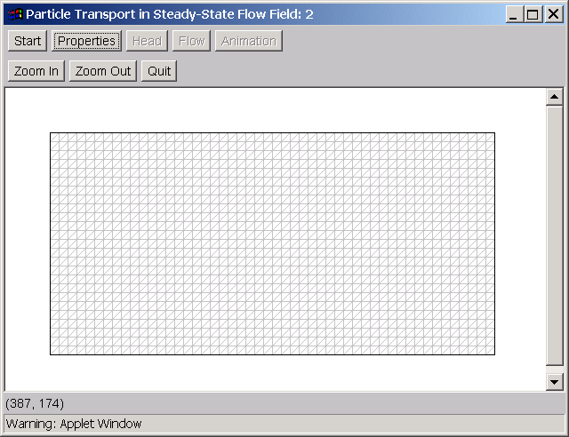
5. Next click on the Properties button to assign hydraulic properties (hydraulic conductivity and porosity). You should see the following window 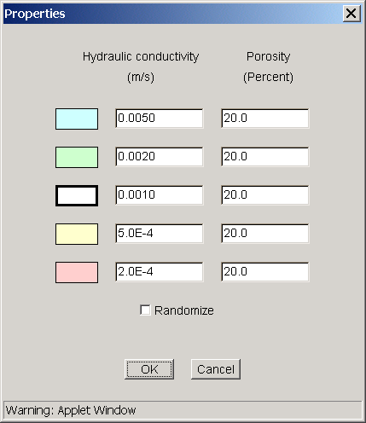
6. Do not change the default setting, which assigns a uniform hydraulic conductivity of 0.001 m/s and porosity of 0.2 [zone 3] to the entire model domain. Click OK to proceed.
7. In the main window, click the Head button. When inside the Head window, click Compute and you will see a uniform head distribution as shown below 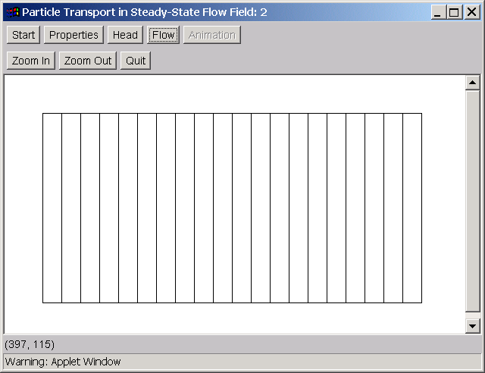
8. Next, click on the Flow button. Under the Options, select Particle Movement. Also, set Initial particle (placement) spacing to 1 meter, and activate the option Keep previous particles. Click OK to proceed.
9. In the main window, move the mouse to an area near the left boundary where you would like to define a source area. Double-click the left mouse button when you want to enclose the source area.
10. Click the Animation button and assign the input as shown 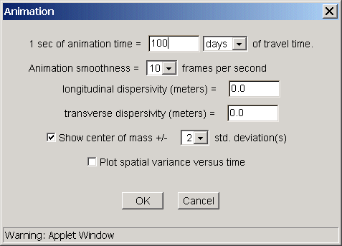
11. Finally, click OK and you will return to the main window. Click the mouse anywhere within the main window and you should see the particles move downgradient. Click the mouse again to stop particle movement. Note the two arrow bars on the side, which mark the center of the particle plume as it travels downgradient. The shape of the plume remains the same in this uniform flow field as there is nothing to cause the plume to spread.

**Part II. Advection and Dispersion in a Uniform Flow Field**

1. In the main window, click on the Animation button. Assign the following dispersivity values

Longitudinal dispersivity (meters): 1.0

Transverse dispersivity (meters): 0.1

1. Click anywhere in the main window and watch how the particles move downgradient. Note how the addition of dispersion has led to the spreading of the particle plume in both the longitudinal and transverse directions. Much more spreading occurs in the longitudinal direction because we have specified the longitudinal dispersivity to be 10 times greater than the transverse dispersivity. Also note that the center of the plume remains the same as in the previous case with advection only, when the two cases are compared at the same observation time. 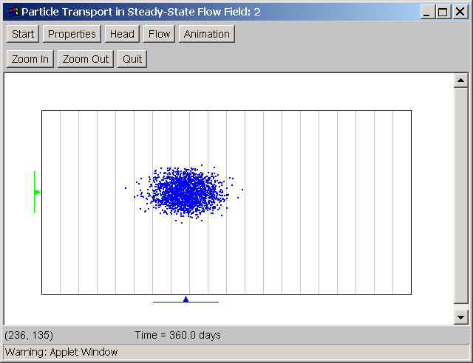
2. Go back to the Animation window and assign different values of longitudinal and transverse dispersivity to see how they affect solute transport. A key point to pay attention to is how some particles travel a lot faster than the average while some other particles lag significantly behind, due to the dispersion imposed. This phenomenon becomes more profound when the dispersivities are increased.

**Part III. Advection in a Heterogeneous Flow Field**

1. In the main window, click on the properties button. Do not change the default values of hydraulic conductivity and porosity. However, click on the checkbox next to the Randomize option, which generates a random K distribution 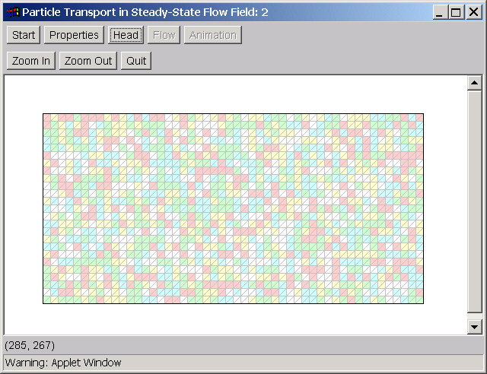
2. Next, repeat the steps as described previously to compute the head distribution and start the particle animation. **Make sure to change the longitudinal and transverse dispersivities back to zero.** Then watch the advection of particles in the heterogeneous flow field, like the snapshot shown below 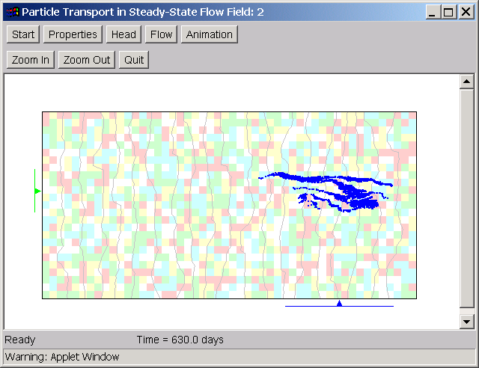
3. Note how the aquifer heterogeneity has led to the spreading of particles even though the dispersivities are set to zero.

**Part IV. Advection and Dispersion in a Heterogeneous Flow Field**

1. In the main window, again click on the Animation button. Assign

Longitudinal dispersivity (meters): 1.0

Transverse dispersivity (meters): 0.1

1. Watch how the particles move in the heterogeneous flow field with both advection and dispersion. Compared with the previous case, the addition of dispersion enhances the spreading of the particle plume. 