**Introduction**

The flow system is in a narrow 100 ft wide valley which runs east-west for 5,000 ft. The valley has a surface elevation of 500 ft and contains a 30 ft thick unconfined upper aquifer of mostly sand and gravel. Beneath the upper aquifer is 20 ft of clay that acts as a confining layer for the 50 ft thick lower aquifer of find sands. There is impermeable bedrock below the lower aquifer and in the hills bordering the valley to the east and west. At the eastern and western boundaries of the valley are north-south flowing rivers cutting through the valley’s northern and southern hills and running along the base of impermeable mountains.

The horizontal conductivity of the upper aquifer in the horizontal direction is 100 ft/d, the vertical conductivity is 5 ft/d and the specific yield is 0.20. The clay confining layer has horizontal conductivity of 0.001 ft/day, a vertical conductivity of 0.0001 ft/d, and a specific storage of 0.000001 ft-1. The lower aquifer has a horizontal conductivity of 20 ft/d, and vertical conductivity of 10 ft/d, and a specific storage of 0.000001 ft-1.

Simulate groundwater flow in the valley as a steady-state flow system. Use 3 layers, 1 row, and 50 columns with a uniform horizontal grid spacing of 1,000 feet in each direction. Use layer 1 to represent the upper aquifer, layer 2 to represent the clay confining layer, and layer 3 to represent the lower aquifer. The eastern and western boundaries will be constant head representing the two rivers. The northern and southern boundaries will be no-flow representing the bedrock. The river to the east has a stage of 490 ft and the river to the west has a stage of 480 ft.

**Part I. Model Setup**

1. Start Groundwater Vistas
2. Click File>New>GWVistas Document
3. Create a model that has 1 row, 3 layers, and 50 columns. Set uniform X and Y spacing to 100 ft. Set model bottom elevation to 400 ft and model top elevation to 500 ft. Set vertical conductivity (Kz) to 5 ft/d, specific storage (S) to 0.000001 and specific yield (Sy) to 0.2. Click on the “Layer Elevations” button and set the layer bottoms for layers 1-3 to 470 ft, 450 ft, and 400 ft. Click Ok.

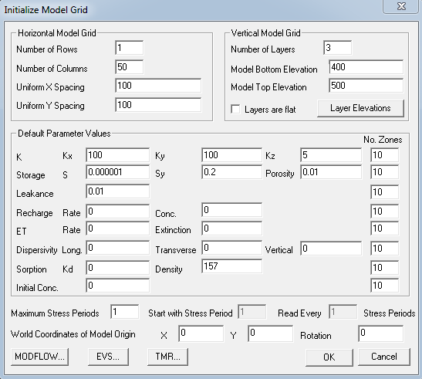

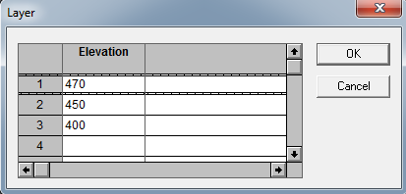

1. Click on **Model>Paths to Models** and browse to the correct working directory folder (ex03).
2. Click on the “Edit Property Zones” button in the top toolbar and then click on the “Zone Database” (Db) button.

 🡪 

1. In the Zone Database Information window set up three zones. For the first zone set Kx and Ky to 100 ft/day and Kz to 5 ft/day. The second zone set Kx and Ky to 0.001 ft/day and Kz to 0.0001 ft/day. For the third zone set Kx and Ky to 20 ft/day and Kz to 10 ft/day. Set different colors for each zone. Click OK.

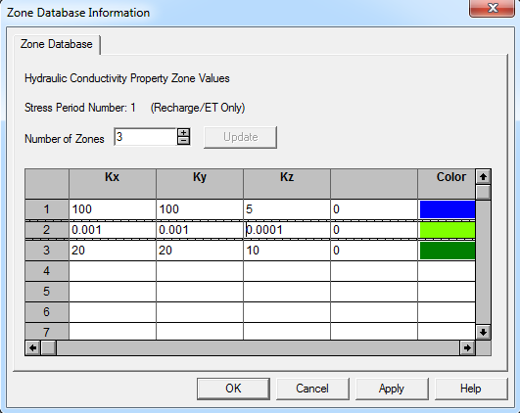

1. Now set all cells in layer 2 to zone 2, and all cells in layer 3 to zone 3 (all cells are currently set to zone 1, so you do not need to set anything for layer 1). To do this click the + button next to the layer number in the upper left part of the screen so that layer number 2 is selected. Now click on the Polygon tool in the toolbar and draw a polygon around all the cells that appear you the lower view. In the “Set Zone Number in Polygon” dialog set the zone number to 2 and click okay. Set layer 3 to zone 3 following similar steps.

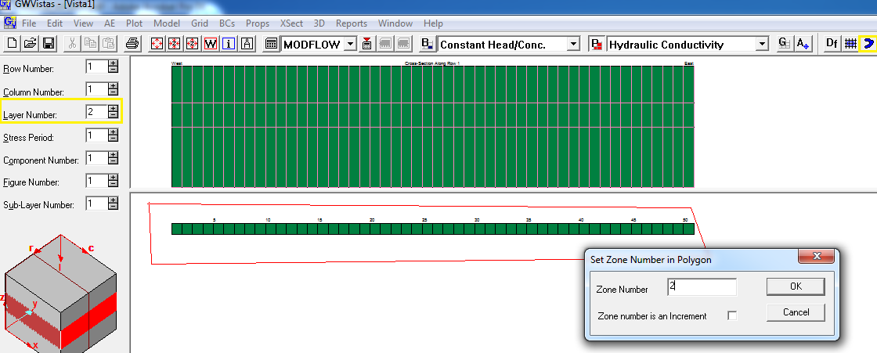

1. Click on the “Edit Boundary Conditions” button in the toolbar and select “River” from the drop down to the right of the button. Click on the polyline button in the toolbar and draw a line through the left-most cell. In the “River Boundary Condition” window set the layer number to 1, river stage to 480 ft, the river bottom to 460 ft, and the hydraulic conductivity to 10 ft/day.



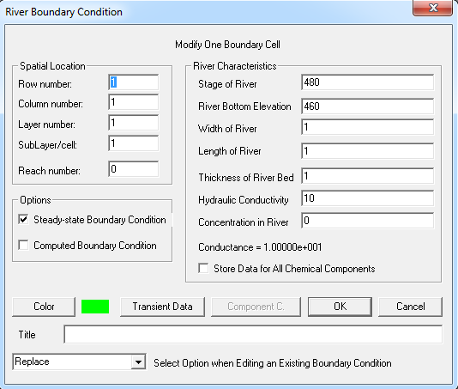

1. Click on the “Edit Boundary Conditions” button in the toolbar and select “River” from the drop down to the right of the button. Click on the polyline button in the toolbar and draw a line through the right-most cell. In the “River Boundary Condition” window set the layer number to 1, the river stage to 490 ft, the river bottom to 470 ft, and the hydraulic conductivity to 10 ft/day.
2. Save your work. Select **File>Save as…** and save it to your ex03 folder as “ex03.gwf”.
3. Select **Model>Modflow2005>Create Datasets**
4. Select **Model>Modflow2005>Run MODFLOW2005**. Click “Yes” to process the results. Import the head and cell by cell flow files. Only check “Interpolate Targets & Observation Data” from the list of checkboxes at the bottom.

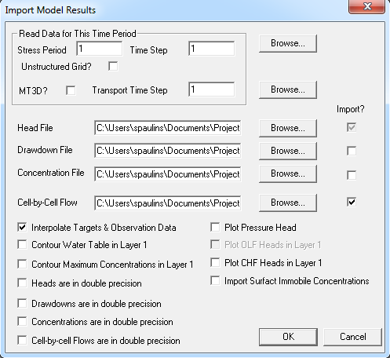

**Part II Working with Model Output**

Exercise 1:

Adjust the cross-section plot at the top of the screen so that you can see the contoured head lines. What can you tell about the direction of flow? (remember that flow occurs perpendicular to the head lines). Which side of the model has downward flow? Which side of the model has upward flow? Does flow generally go from east to west or west to east?

Exercise 2:

Select **Plot>Mass Balance>Layer Summary…**

Change the layer on the left-hand side of the screen and try this again.

At what rate is water flowing from the eastern river out to the western river? At what rate is water flowing down into the bottom layer and then back up again into the top layer? What layer is most of the water flowing through?

Exercise 3:

Select **Plot>Profiles>Head**

Does the head vs distance plot of layer 1 follow a straight line? Can you think of the reason why it does this?

Switch to the “Layer 3” tab. This shows the head in layer 3 based on distance. Use this information and Darcy’s Law to estimate the amount of flow expected through layer 3. Is the amount you calculated more or less than the amount of flow you can infer from the mass balance from Exercise 2? Why?

**Part III Additional Runs**

Each additional run is a modification of the base case. Do as many modifications as time permits. For each additional run use the “SaveAs” option to create a modified dataset from the base run dataset (ex03.gwf). To get back to the base dataset select **File>…ex03.gwv.**

Exercise 4:

Increase the stage and river bottom of the eastern river by 5 ft and decrease the stage and river bottom of the western river by 10 ft. How much additional water is flowing in and out of the rivers? How much additional water is flowing up/down to the lower aquifer?

Exercise 5:

Change the river hydraulic conductivity from 10 ft/day to 1000 ft/day. How did head profiles change? How much did the river inflows and outflows change? Why did it only change by this amount?

Exercise 6:

After construction of your model a study is conducted of the eastern and western riverbeds. It is determined that there are river sediments deposited under both river beds down to an elevation of 450 ft. (through the 20 ft. clay layer). The river deposits have an estimated horizontal conductivity of 100 ft/day and a vertical conductivity of 20 ft/day. Update your model with a new zone for the river deposits. What effect does this have on the head distribution? What effect does this have on the amount of flow in/out of the rivers and vertical flow to layer 3?

Exercise 7:

A well is drilled in the cell next to the eastern river and is screened in the lower aquifer (column 49 layer 3). The well extracts water at a rate of 60 ft3/day. Switch the view to layer 3. Click on the “Edit Boundary Conditions” button on the toolbar and just “Well” from the dropdown menu to the right, and select **BCs>Insert>Single Cell** then click on the cell at column 49. In the “Constant Flux (Well) Boundary Condition” window enter a flow rate of -60.

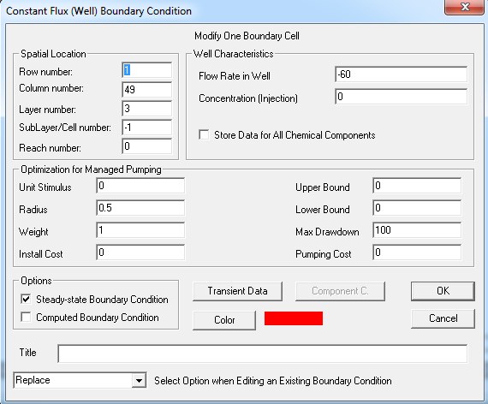

Look at the head profiles for the three layers. What is the horizontal flow direction of the lower layer? Is it the same as the upper layer? Bring up the MODFLOW mass balance and look at the total inflows and outflows. Do they match up? Why not? Is this a problem?

Exercise 8:

A concealed fault is discovered running through the center of the valley cutting the bottom model layer. Switch the view to layer 3. Click on the “Edit Boundary Conditions” button on the toolbar and just “Wall (HFB)” from the dropdown menu to the right, and select **BCs>Insert>Single Cell** then click on the cell at column 24. Set the hydraulic conductivity to 0.00001. Next to “Location of Wall Within Finite-Difference Cell” click the right check-box.

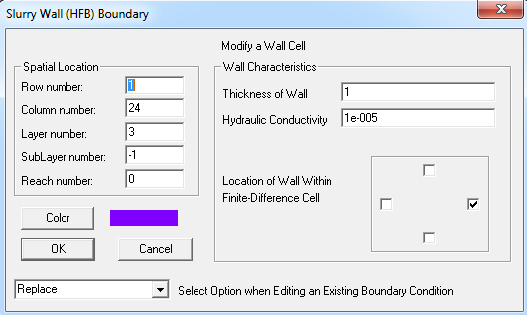

How did your head profiles change? What effect does this have on the amount of flow into and out of the bottom layer?