Exercise 4. Class Project Model—Freyberg Model

**Exercise Description**

The purpose of this exercise is build a simple two-dimensional groundwater model using Groundwater Vistas (GWVistas). The model is based on Freyberg (1988) and will also be used in the model calibration exercise.

**Part I. Build a base model using Groundwater Vistas**

1. Open GWVistas and create a new GWVistas document.  
   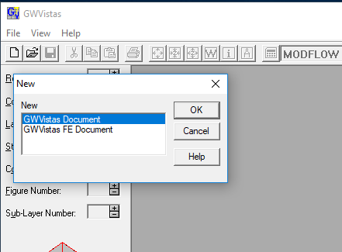
2. Initialize the model grid.  
   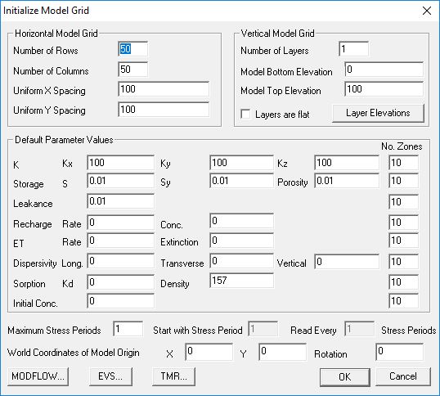   
   Set the Number of Rows and Columns to be 40 and 20, respectively. Use a Uniform X and Y Spacing of 250 m. Set the Model Top Elevation to 35 m (we will define the Model Bottom Elevation later using an external data file). Set Kx, Ky, and Kz to 7.811284e-5 m/s. Set the groundwater Recharge rate to 1.6e-9 m/s. Set the Maximum Stress Periods to 2.
3. Add no-flow cells to the model. Select the No-Flow menu item under the BCs item on the menu bar.  
   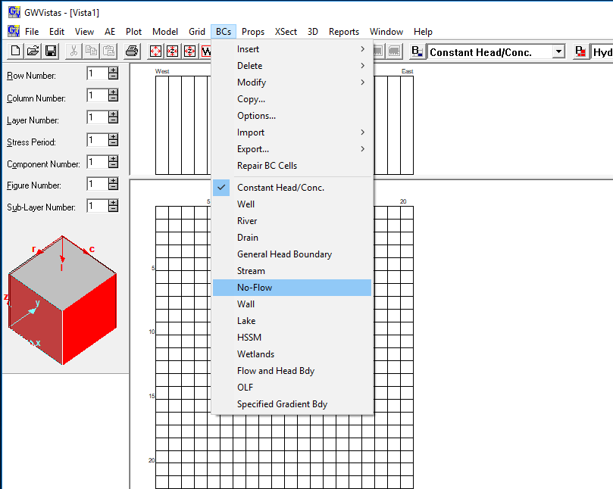
4. Add no-flow cells to the model (continued). Import the NoFlow data as a NoFlow Matrix File. The no flow data are in the exercises\data\freyberg\active.dat file.  
   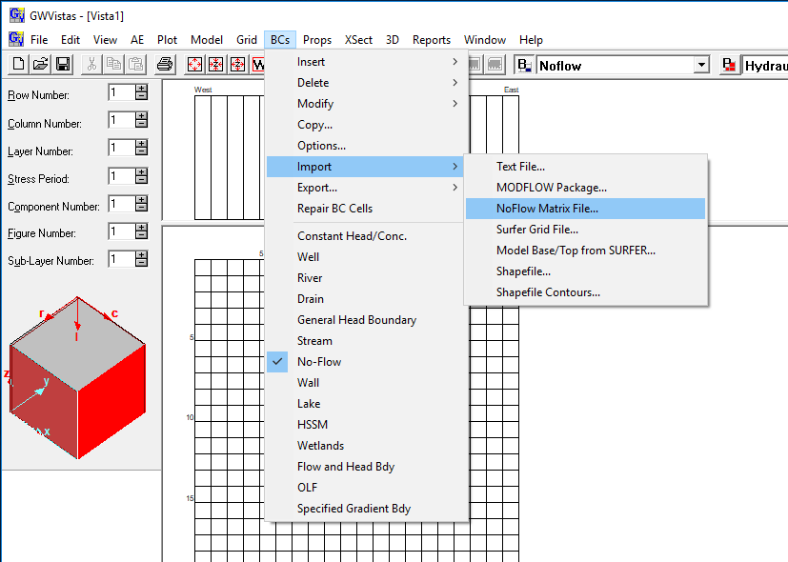
5. Add Constant Head/Conc. BCs to all of the active cells in the last row of the model as Single Cells.  
   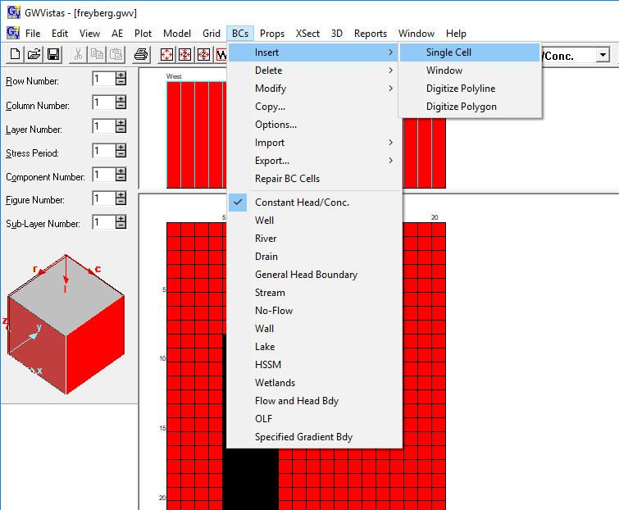  
     
   The specified heads for the 10 cells in row 40 are listed below.

|  |  |  |  |  |  |  |  |  |
| --- | --- | --- | --- | --- | --- | --- | --- | --- |
| **Layer** | **Row** | **Column** | **Head** |  | **Layer** | **Row** | **Column** | **Head** |
| 1 | 40 | 6 | 16.9 |  | 1 | 40 | 11 | 14.0 |
| 1 | 40 | 7 | 16.4 |  | 1 | 40 | 12 | 13.0 |
| 1 | 40 | 8 | 16.1 |  | 1 | 40 | 13 | 12.5 |
| 1 | 40 | 9 | 15.6 |  | 1 | 40 | 14 | 12.0 |
| 1 | 40 | 10 | 15.1 |  | 1 | 40 | 15 | 11.4 |

1. Import the bottom elevation of the model. Select the Bottom Elevation menu item under the Props item on the menu bar. Import the bottom elevation as a Matrix file. The bottom elevation data are in the exercises\data\freyberg\bottom.dat file.  
     
   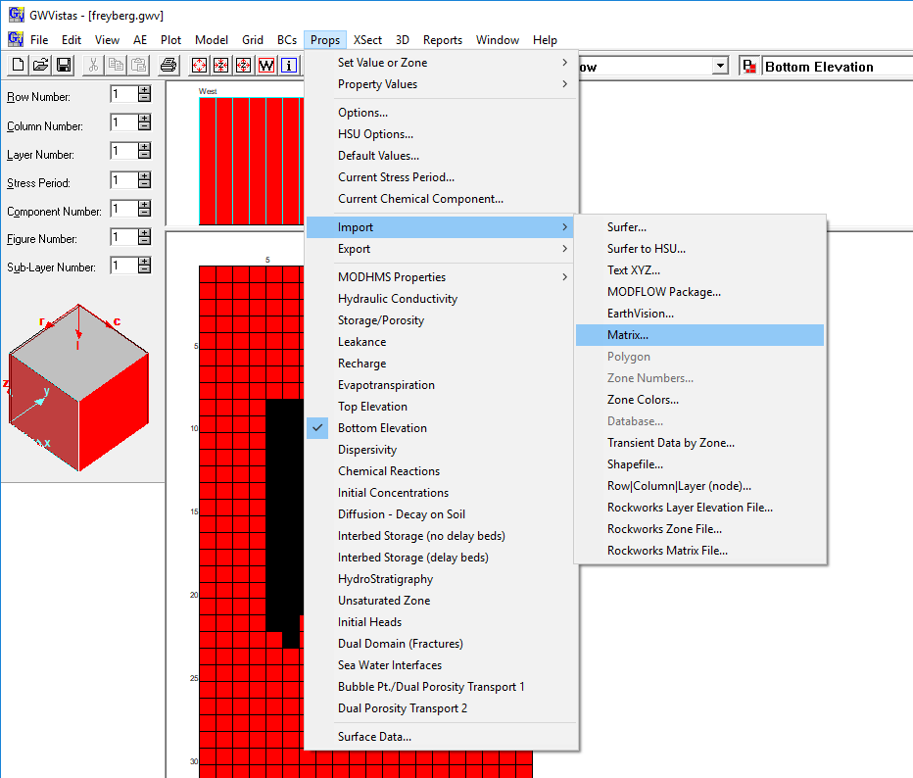
2. Add the river boundary to the model. Select River from the BCs menu item. Add the river boundary using Insert→Digitize Polyline. Start the polyline in column 15 as close to the top of the model domain as possible. Terminate the polyline in column 15 as close to the model domain as possible.  
     
   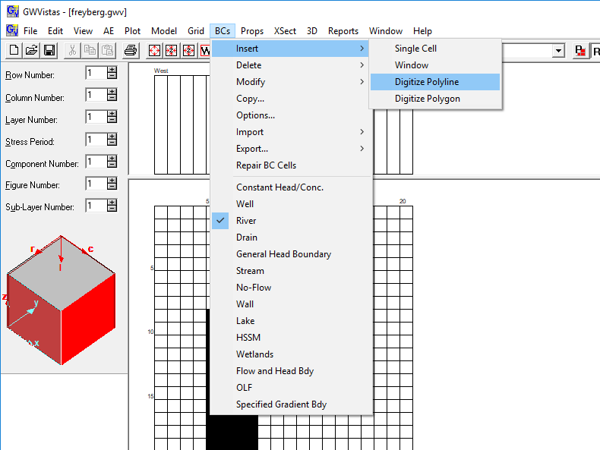
3. Add the river boundary to the model (continued). In the first dialog box that appears (River Values at Start of Line) enter Stage of River=20.215 m, River Bottom Elevation=20.125 m, Length of River=250 m, and Hydraulic Conductivity=0.0002 m/s. Press OK.  
     
   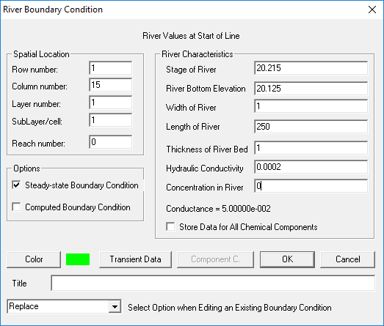
4. Add the river boundary to the model (continued). In the second dialog box that appears (River Values at End of Line) enter Stage of River=11.135 m, River Bottom Elevation=10.125 m, Length of River=250 m, and Hydraulic Conductivity=0.0002 m/s. Press OK.  
     
   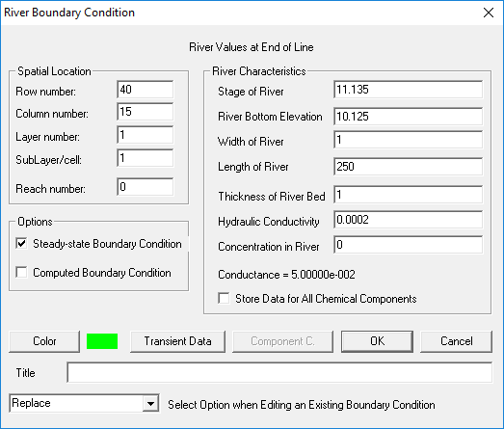
5. Add the pumping wells in stress period 2. Use the Analytical Element Well button on the Menu bar.  The specified pumping rates in stress period 2 are listed below.

|  |  |  |  |  |  |  |  |  |
| --- | --- | --- | --- | --- | --- | --- | --- | --- |
| **Layer** | **Row** | **Column** | **Rate** |  | **Layer** | **Row** | **Column** | **Rate** |
| 1 | 9 | 16 | -8.2e-3 |  | 1 | 26 | 10 | -0.83e-3 |
| 1 | 11 | 13 | -4.1e-3 |  | 1 | 29 | 6 | -0.72e-3 |
| 1 | 20 | 14 | -3.9e-3 |  | 1 | 34 | 12 | -4.3e-3 |

1. Add the pumping wells in stress period 2 (continued). Insert an analytical element well in the appropriate row and column location for the first well. Deselect Pumping Rate is Steady State and press the Transient Data…button.  
     
   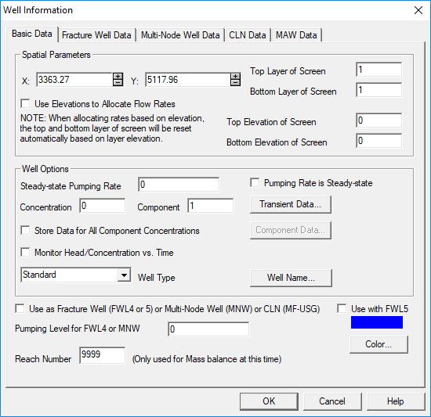  
     
   Enter the pumping rate for the well in stress period 1 and 2 as shown below and press OK.  
   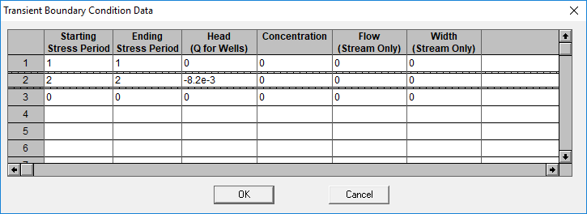
2. Add the pumping wells in stress period 2 (continued). Repeat these steps for all 6 of the pumping wells.
3. Add observation wells. Use the Analytical Element Target button on the Menu bar.  Target locations and pre-development heads at the observation wells are listed below. Specification of observation data

|  |  |  |  |  |  |  |  |  |
| --- | --- | --- | --- | --- | --- | --- | --- | --- |
| **Layer** | **Row** | **Column** | **Head** |  | **Layer** | **Row** | **Column** | **Head** |
| 1 | 4 | 11 | 22.4614 |  | 1 | 26 | 6 | 24.4067 |
| 1 | 4 | 17 | 19.9037 |  | 1 | 28 | 8 | 22.9664 |
| 1 | 5 | 10 | 22.9966 |  | 1 | 31 | 17 | 15.1956 |
| 1 | 11 | 3 | 29.1572 |  | 1 | 35 | 9 | 20.4257 |
| 1 | 15 | 12 | 18.9131 |  | 1 | 36 | 12 | 16.5496 |
| 1 | 17 | 18 | 17.6646 |  | 1 | 40 | 9 | 15.6000 |
| 1 | 23 | 12 | 18.9259 |  | 1 | 40 | 12 | 13.0000 |
| 1 | 24 | 17 | 16.1062 |  | 1 | 40 | 14 | 12.0000 |

1. Add observation wells (continued). Insert an analytical element target in the appropriate row and column location for the first well. Deselect Target is Steady State and press the Transient Data…button. Enter the observed head for the well in stress period 1 as shown below and press OK.  
    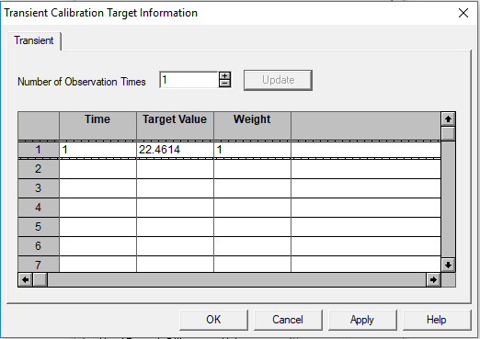
2. Add observation wells (continued). Repeat these steps for all 16 of the observation wells.

**Part II. Run the Model**

1. All of the hydraulic data and boundary conditions have been specified at this point. Confirm that all of the required packages have been specified by navigating to Model→MODFLOW→Packages. You should confirm that the Basic, Output Control, Solver, Well, River, Recharge, and CHD packages are checked as shown below.  
   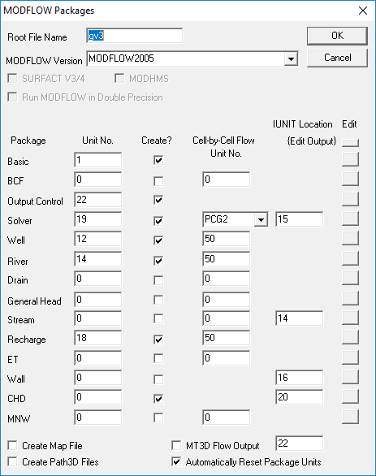
2. Create the MODFLOW-2005 model datasets by navigating to Model→MODFLOW2005→Create Datasets. Confirm that no errors occur when creating the datasets.
3. Run the model by navigating to Model→MODFLOW2005→Run MODFLOW2005. If the model runs successfully the following dialog box should appear. Press Yes if you get this dialog. Otherwise, find an instructor to troubleshoot the issue.  
   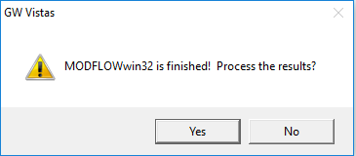
4. After successfully running them model the results can be loaded in GWVistas. Let’s look at the results for the first stress period. Change Stress Period from 2 to 1 in the Read Data for This Time Period box and unselect Interpolate Targets & Observation Data.  
   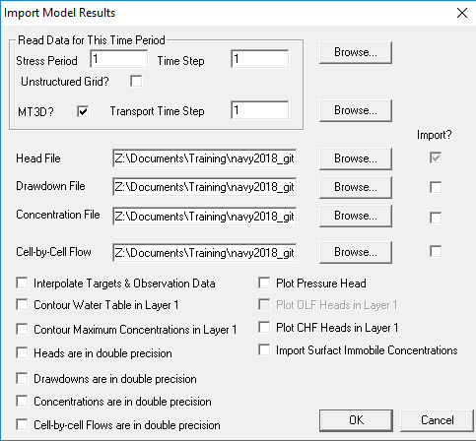  
   You should see something like the following in GWVistas.  
     
   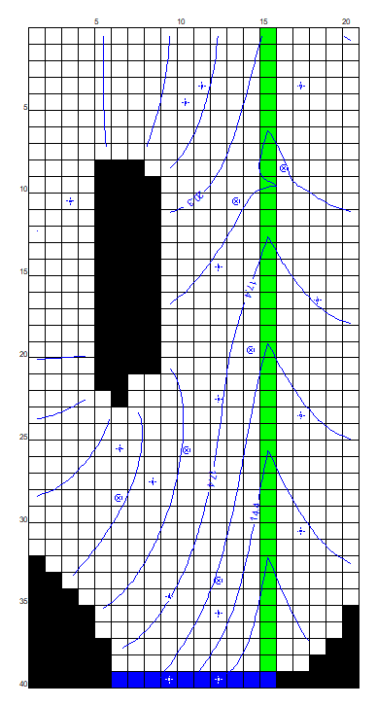
5. If you have time, explore the plot options available in GWVistas (Plot→What to Display…).

**Part III. Evaluate uncalibrated model performance**

1. Evaluate how well the uncalibrated model matches the observations that were defined as analytical head targets by navigating to Plot→Calibration→Statistics/Plots…
2. A plot showing observed and simulated on the same graph can be created by pressing the Plot Observed vs. Simulated button.  
     
   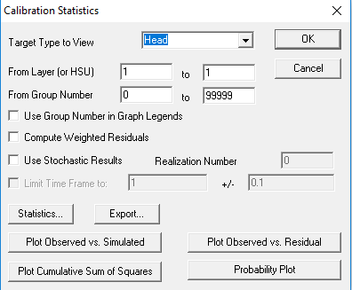  
     
   You should see something similar to the plot shown below.  
   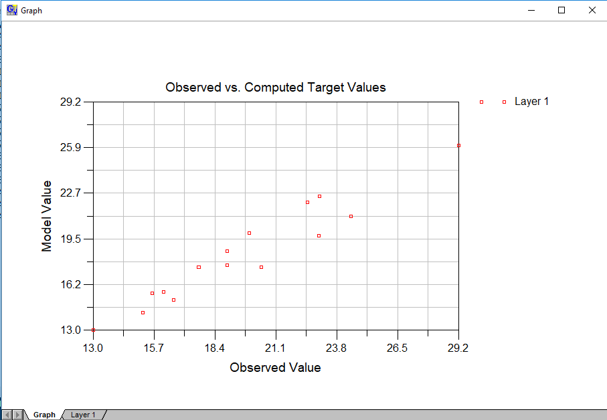  
   The simulated and observed values can be viewed on the Layer 1 tab. You should be able to determine that the uncalibrated model is under-simulating observed heads.
3. If you have time, you can plot observed values versus the residual.
4. You can create a calibration report by navigating to Reports→Calibration→Target Residuals… This will create a report that includes observed and simulated values, residuals, and summary statistics (residual mean, etc.). These reports can be useful to guide the model calibration process.
5. The spatial distribution of errors can be evaluating by navigating to Plot→Calibration→Post Residuals and/or Plot→Calibration→Plot Residuals Circles. These plots can be useful for determining if there is spatial bias in the residuals and can be useful to guide parameter zonation. You may need to adjust the view options (Plot→Calibration→Options) to correctly size the residual circles or residual text to your liking.