Exercise 5. Class Project Model Calibration—Freyberg Model

**Exercise Description**

The purpose of this exercise is calibrate the two-dimensional groundwater model created using Groundwater Vistas (GWVistas) in the previous exercise. We will use a zoned approach to calibrate hydraulic conductivity for the first stress period.

**Part I. Use the Groundwater Vistas file from the previous exercise to create a new Groundwater Vistas file for calibration**

1. Open the GWVistas file created in the last exercise.
2. Save the file as a new GWVistas file (File→Save As…) in the exercises\Ex05 directory.
3. Change the Root File Name (Model→MODFLOW→Packages…) to ex05.
4. Recreate the model datasets (Model→MODFLOW2005→Create Datasets) and rerun the model (Model→MODFLOW2005→Run MODFLOW2005).
5. Load the model results for stress period 1 and post the residuals on the plot (Plot→Calibration→Post Residuals). You may need to adjust the view options (Plot→Calibration→Options) to make the residual text easier to read. You should see something like the figure below.  
   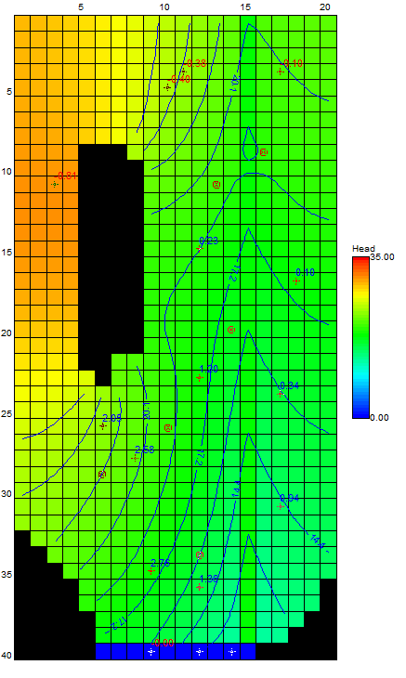

**Part II. Develop a zonation strategy**

1. One approach to model calibration is to subdivide parameter arrays into zones of constant values. Zones can be defined based on soil parameters, hydrogeologic properties, model residuals, etc. or a combination of these attributes.  
     
   Inactive areas of the models represent bedrock outcrop areas. Bedrock outcrops also exist on the eastern, northern, and western edges of the model domain. In general, the river corridor transitions from coarser materials at the upstream end of the model domain (north) to finer grained materials at the downstream end of the model domain (south).  
     
   Develop a proposed zonation for the hydraulic conductivity and proposed values for each zone. Increasing the hydraulic conductivity in areas where the simulated head is above the observed head will generally decrease simulated heads. Conversely, decreasing the hydraulic conductivity will generally increase the simulated heads.  
     
   Discuss your proposed zonation with the instructors.  
     
   Question 1: What effect will changing the hydraulic conductivity in constant head cells have on heads in these cells? ____________________
2. After developing a proposed zonation for the hydraulic conductivity in the model use GWVistas to set parameter values in your zones. To start modifying the hydraulic conductivity zonation activate the hydraulic conductivity property data (Props→Hydraulic Conductivity). Additional zones can be added using Props→Set Value or Zone. Property values can be set as single cells, in a window, along a polyline, or within a polygon (see figure below).   
     
   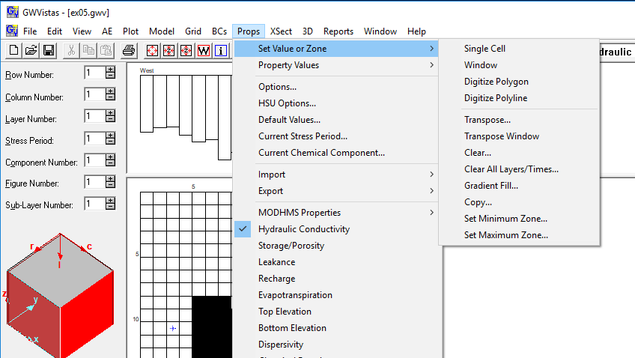  
     
   For example, defining a zone using a polygon is shown below. The area in the polygon will be defined as zone 2.  
     
   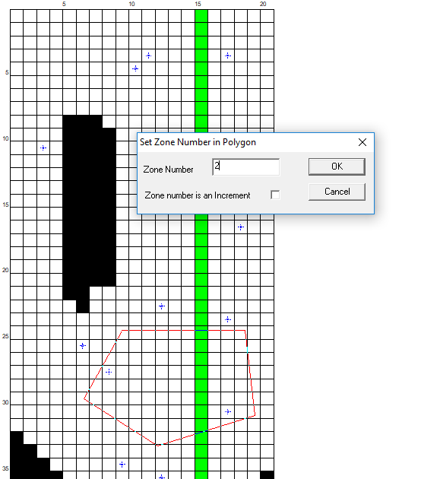  
   Next the value in zone 2 can be changed by modifying the value in the hydraulic conductivity property database (Props→Property Values→Database). In this case, the hydraulic conductivity in zone 2 will be set to 5 m/day.  
     
   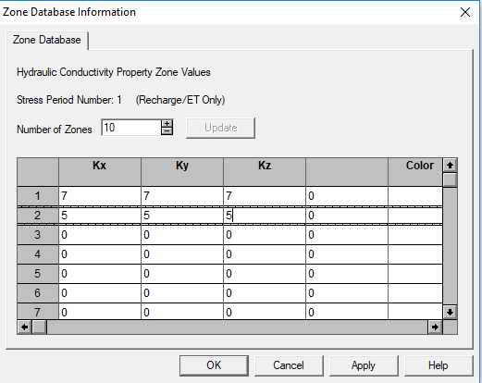  
     
   After resetting zone colors (Props→Property Values→Reset Zone Colors), the new zonation of hydraulic conductivity can be seen (shown below).  
   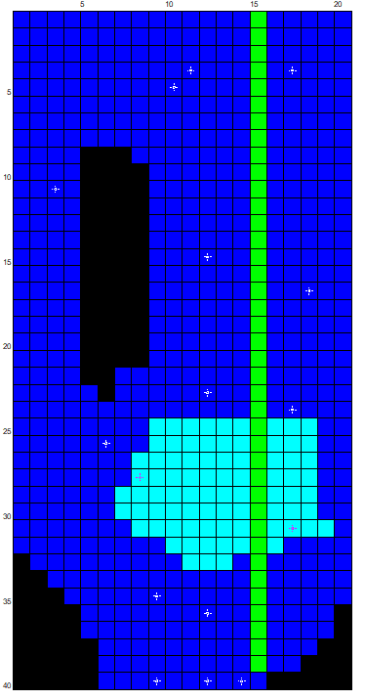  
   Continue to follow this procedure to define to set the properties in all of your proposed zones
3. After defining all of your zones and setting the parameters, rerun the model, load the results, and evaluate improvements to the model calibration. You should generate a calibration report during each calibration trial (Reports→Calibration→Target Residuals…) to gage improvements.
4. After rerunning the model and evaluating the model calibration develop a plan for additional changes. Additional changes would include modification of the zone hydraulic conductivity values and possibly modification to the zonation.
5. Continue this process and develop the best calibrated model you can in an allotted 2.5 hour period. The target root mean square error for the observation wells you should try to achieve for your calibration is ≈0.2 m. Please keep track of the number of calibration trials it takes for you to achieve “calibration”.

**Part II. Summarize Model Calibration**

1. Provide your final calibrated hydraulic conductivity field to your instructors. Activate the hydraulic conductivity property data (Props→Hydraulic Conductivity) and export the data as a matrix file (Props→Export→Property Values (Matrix)…). Name the file GroupNo_HK.dat, where GroupNo is your group number.
2. Provide the binary heads file (*.hds) for your final calibrated model. Prepend your group number (for example, GroupA) to your binary heads file.
3. Provide the total simulated river and constant head flow values for your final calibrated model to your instructors.

**Part III. Develop and Run the Prediction Model**

1. Save the current GWVistas file as a new GWVistas file (File→Save As…) in the exercises\Ex05 directory.
2. Change the Root File Name (Model→MODFLOW→Packages…) to ex05_prediction.
3. Add the pumping wells. Use the Analytical Element Well button on the Menu bar.  The specified pumping rates are listed below.

|  |  |  |  |  |  |  |  |  |
| --- | --- | --- | --- | --- | --- | --- | --- | --- |
| **Layer** | **Row** | **Column** | **Rate** |  | **Layer** | **Row** | **Column** | **Rate** |
| 1 | 9 | 16 | -708.48 |  | 1 | 26 | 10 | -71.712 |
| 1 | 11 | 13 | -354.24 |  | 1 | 29 | 6 | -62.208 |
| 1 | 20 | 14 | -336.96 |  | 1 | 34 | 12 | -371.520 |

1. Add the pumping wells (continued). Insert an analytical element well in the appropriate row and column location for the first well. Enter the pumping rate for the well as shown below and press OK.  
   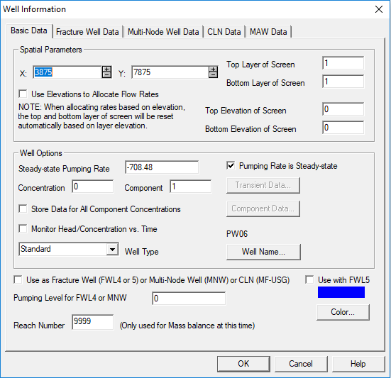
2. Add the pumping wells (continued). Repeat these steps for all 6 of the pumping wells.
3. Create the MODFLOW-2005 model datasets (Model→MODFLOW2005→Create Datasets) and run the model (Model→MODFLOW2005→Run MODFLOW2005). Load the model results.
4. Provide the binary heads file (*.hds) for your prediction model. Prepend your group number (for example, GroupA) to your binary heads file.
5. Provide the total simulated river and constant head flow values for your prediction model to your instructors.