Exercise 7. Class Project Model Particle Tracking—Freyberg Model

**Exercise Description**

The purpose of this exercise is to perform a particle tracking analysis on the calibrated prediction model created using Groundwater Vistas (GWVistas) in the previous exercise.

**Part I. Add particle tracks to the calibrated prediction Groundwater Vistas file**

1. Open the GWVistas file created in the last GWVistas exercise (ex05).
2. Change the MODPATH Root File Name (Model→MODPATH→Packages…) to ex05_mp.
3. Add a particle in each cell (AE→Particle→Window) by dragging the window box over the entire model domain. Add the particle in the middle of the cell as shown below.  
   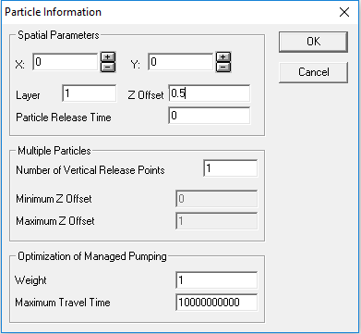  
   And add 4 particles per cell as shown below.  
   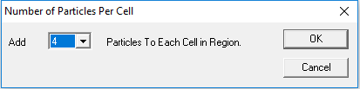
4. Set the particle tracking options (Model→MODPATH→Particle Options) to Forward tracking and calculate particle tracking for a Max. Travel Time=3650 days and Stop at weak sinks as shown below.  
   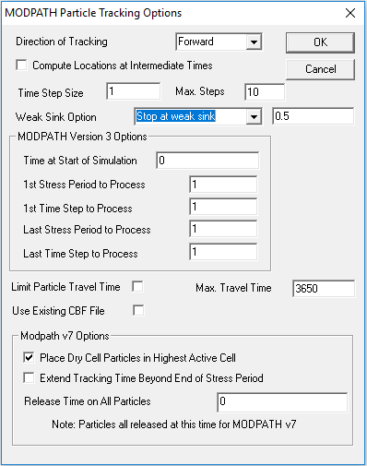
5. Create the MODPATH model datasets (Model→MODPATH→Create Datasets) and run the model (Model→MODPATH→Run MODPATH).
6. Load the model results. You may need to adjust the view options (Plot→What to Display…) to make the particle tracks easier to see. You should see something like the figure below.  
     
   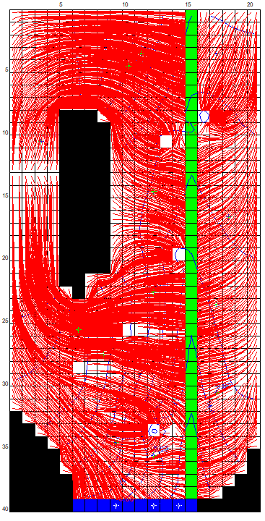

**Part II. Perform backward tracking**

1. Remove all of the existing particles in the model by first selecting all of the particles (Edit→Select All→Particle) and then pressing the delete key.
2. Add a circle of particles around each pumping well. First zoom into the location of a pumping well and add a circle particle (AE→Particle→Circle). Add 20 particles around the perimeter of the circle (Number=20) and start the particles in the middle of the cell (Z Offset=0.5) as shown below.  
   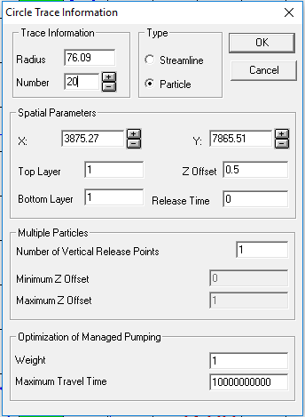  
     
   You should see something like shown below.  
     
   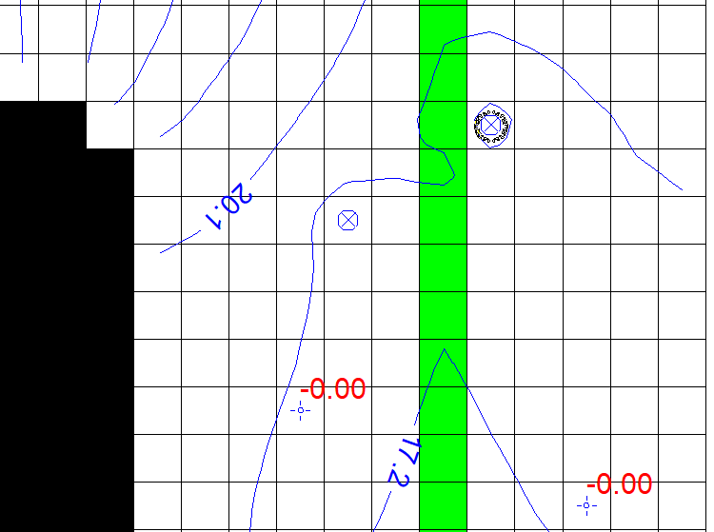  
     
   Do the same for all 6 pumping wells.
3. Set the particle tracking options (Model→MODPATH→Particle Options) to Reverse.
4. Create the MODPATH model datasets (Model→MODPATH→Create Datasets), run the model (Model→MODPATH→Run MODPATH) and load the model results. You should see something like the figure shown below.  
   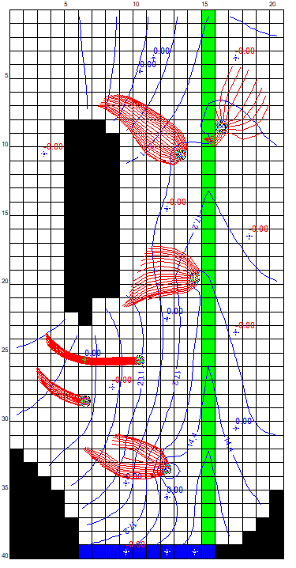
5. Endpoint analyses can be useful for determining the contributing area for a well. Endpoint analyses can be displayed using after MODPATH has been run. The endpoint analysis can be evaluated using Plot→Particles→Endpoint Analysis… and the following settings.  
   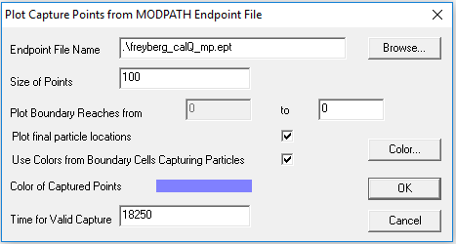  
     
   You should see something similar to the figure below.  
   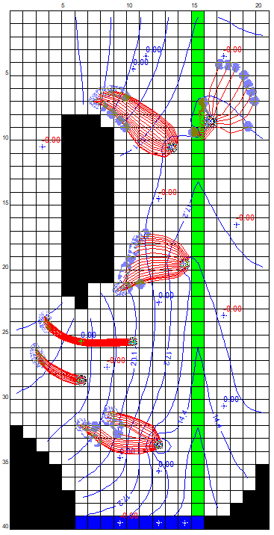

**Part III. Particle Tracking of a Contaminant**

1. Remove all of the existing particles in the model by first selecting all of the particles (Edit→Select All→Particle) and then pressing the delete key.
2. Add a window of particles in cells in row 13 and column 3. Use 4 Vertical Release Points and add 16 Particles To Each Cell in Region.
3. Set the particle tracking options (Model→MODPATH→Particle Options) to Forward.
4. Create the MODPATH model datasets (Model→MODPATH→Create Datasets), run the model (Model→MODPATH→Run MODPATH) and load the model results.
5. Provide your particle track file (ex05_mp.ptl) to your instructors. Name the file GroupNo_ex05_mp.ptl, where GroupNo is your group number.
6. Time permitting, add another window of particles in cells in row 14 and column 3 and evaluate the results.