Exercise 8. Simulating advective and dispersive movement of a contaminant plume

**Exercise Description**

The purpose of this exercise is to use MT3D to simulate the transport of a solute.

**Part I. Simulate Advective Transport using MT3D**

1. Copy the Groundwater Vista file that you created in Exercise 05 into the ex08 folder. Open up this file, and make sure to change the paths to models to the ex08 folder.
2. We are going to simulate solute transport for a 10-year period. Change the period length of stress period one to 10 years. This is set in the Model>MODFLOW>Stress Period Setup box.
3. In order to use MT3D, we need MODFLOW to save all of the flows in a special file that can be read by MT3D. For MODFLOW to create this file, you turn on the MT3D Flow Output, which can be found under the Model>Modflow>Packages menu.
4. Run the flow model.
5. Next, we are going to simulate a solute contaminant source as a constant-concentration condition in row 13 and column 2. Put your mouse over that cell and right-click. Here you will enter a concentration value of 1.0; you will uncheck the box that says the head value is constant, and you will check the box that says the concentration value is constant. 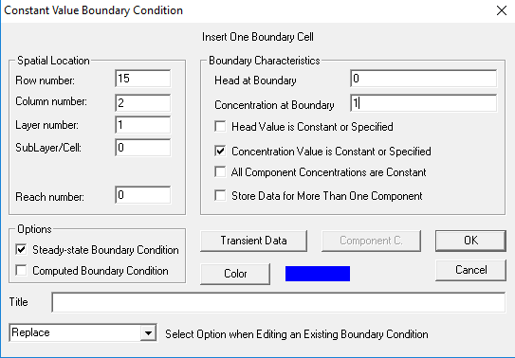
6. At this point you should be ready to run MT3D and simulate solute transport. The procedure is similar to running MODFLOW. First you create the datasets and then you run MT3D.
7. When MT3D is finished, you should be able to post-process the results. A color flood is a way to look at the solute concentrations. See if you can make a plot that looks like this: 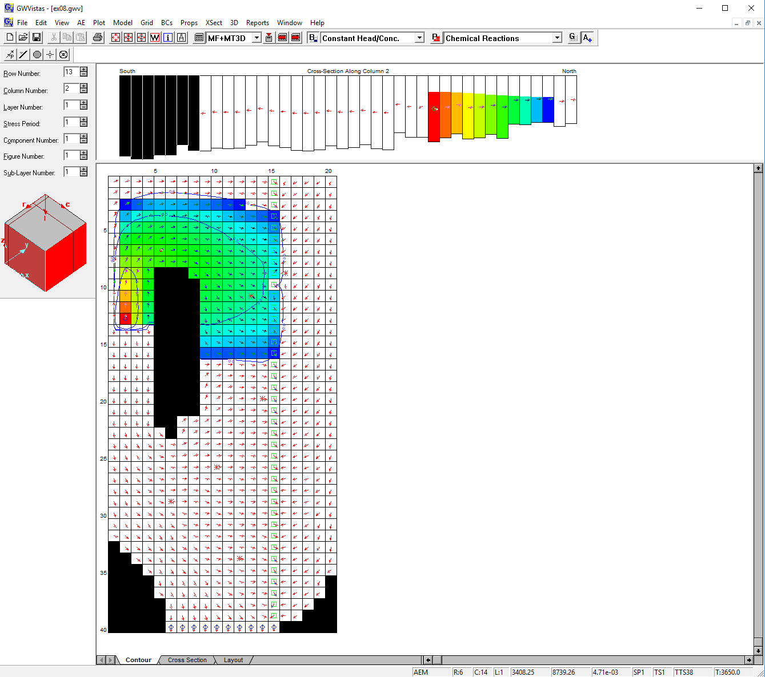
8. It is also possible to plot solute concentration breakthrough curves. This is done by adding an analytical element well somewhere along the flow path from the constant concentration boundary. When you add an analytic element well, make sure you check the box that says Monitor Head/Concentration vs. Time. 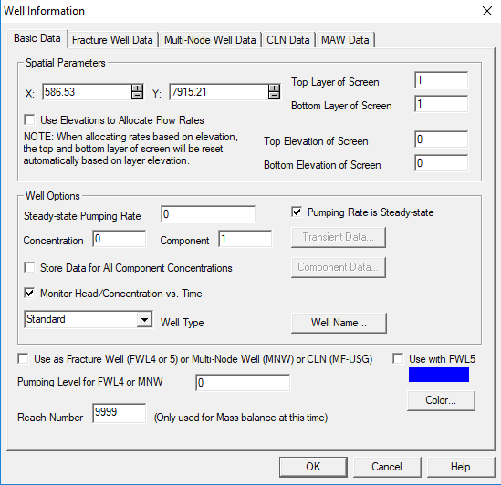
9. In order to see a breakthrough curve, you will first rerun MT3D and load the results. Then goto Plot>Hydrograph>Monitoring Well and change the Plot from Head to Concentration and click OK. You should hopefully see a plot that looks like this: 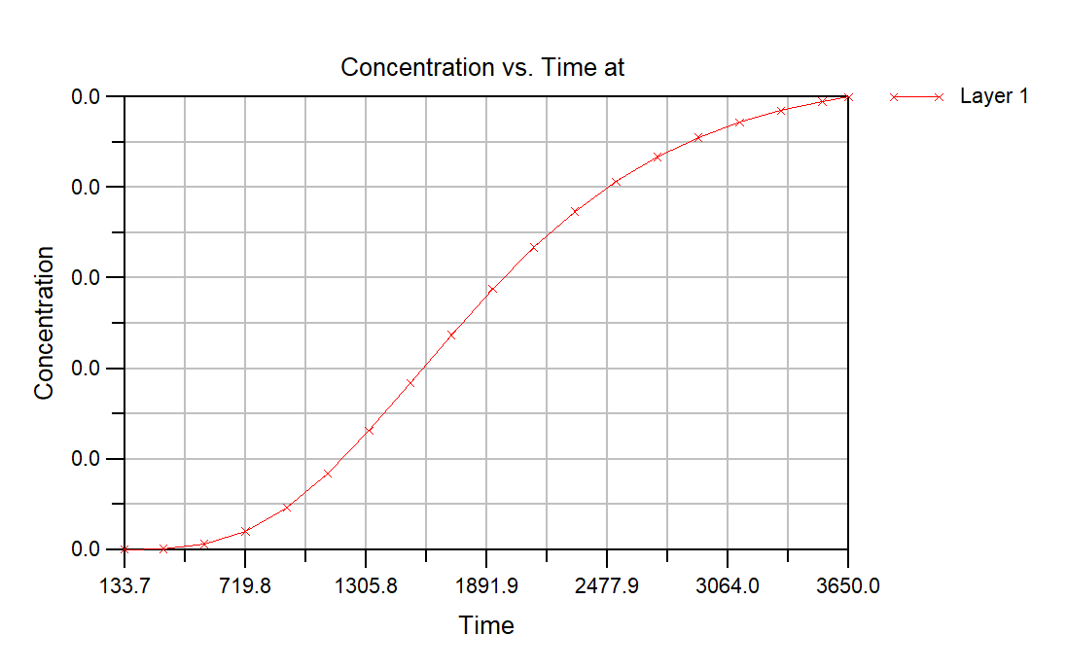
10. It’s possible that the y-axis does not have enough precision. If this is the case, then double-click on the y-axis and increase the precision of the y-axis so you see something like this: 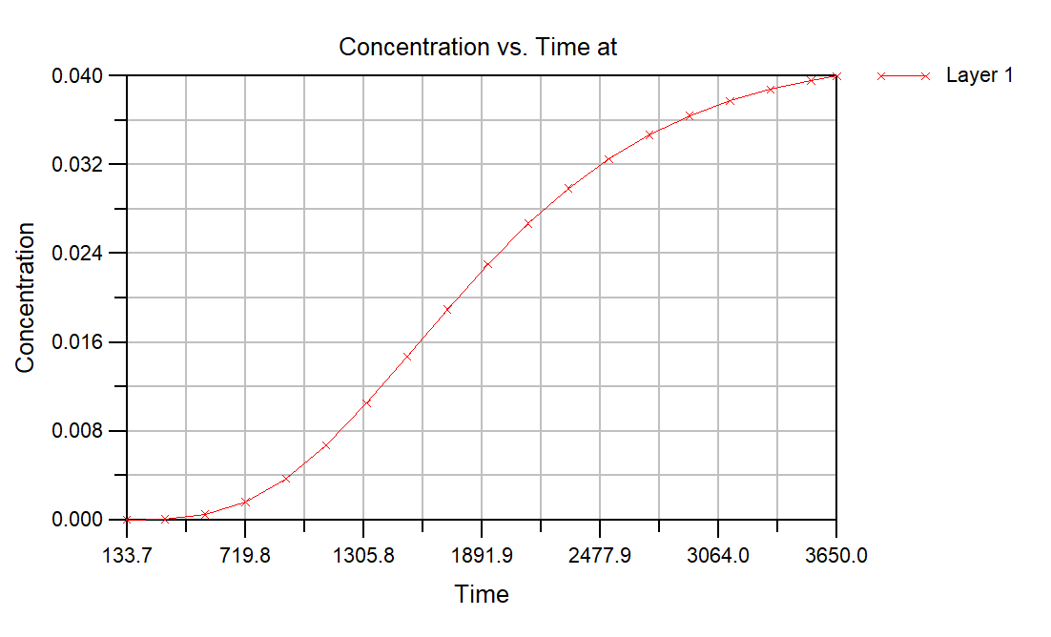
11. In order to do comparisons between simulations, you may want to export these concentrations to another file. This can be done by clicking on the Layer 1 tab on the bottom of the chart, and then right-clicking anywhere in the spreadsheet to find an Export… option, which allows you to export to a file (Note that this data is also written to an MT3D observations file, which should be in your paths to models with an obs extension). 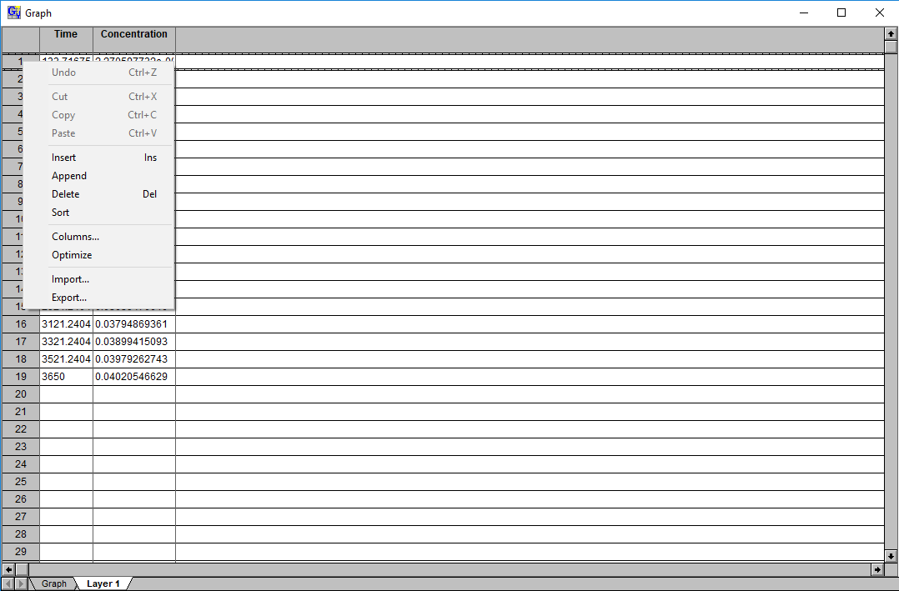
12. Visualize and animate movement of the solute plume using ModelViewer.

**Part II. Compare the different solute transport schemes**



**Part III. Run the solute transport model using the true Freyberg parameters**