Exercise 9. Simulating remediation of a TCE plume

**Exercise Description**

The purpose of this exercise is to use MT3D to simulate the movement and remediation of a TCE plume. The exercise is partially patterned after a paper by Matthieu et al (2014) that describes a TCE plume at the Tucson International Airport. We will simulate an area that is 1000 m in the east-west direction by 600 m in the north-south direction and 19 m deep. We will assign constant-head boundary conditions to generate flow from east to west, and use no-flow conditions for the north and south boundaries. The model will represent two different time periods. For the first time period (a three-year period), a well will be used to inject TCE into the aquifer. This well will turn off after the three-year period. The second period will represent 10 years of plume movement with and without various remediation strategies.

Matthieu, D. E., Brusseau, M. L., Guo, Z. , Plaschke, M. , Carroll, K. C. and Brinker, F. (2014), Persistence of a Groundwater Contaminant Plume after Hydraulic Source Containment at a Chlorinated‐Solvent Contaminated Site. Groundwater Monit R, 34: 23-32. doi:10.1111/gwmr.12077

**Part I. Simulate movement of the TCE plume**

1. For this model we will work in the ex09 folder. Set up a new model with dimensions of 1000 x 600 x 19 m. Use 3 layers, 60 rows, 100 columns. This will result in a cell size of 10 x 10 m.
2. Set the model top to 0, and set layer 1 to be 7 m thick, layer 2 to be 5 m thick, and layer 3 to be 7 m thick.
3. Assign hydraulic conductivity to be isotropic with the middle layer assigned a value of 6.6 m/d. The K for layers 1 and 3 should be set to 0.26 m/d.
4. Longitudinal, transverse, and vertical dispersivities should be set to 5, .5, and 0.075 m.
5. Assign the molecular diffusion coefficient to be 7.6 x 10-5 m2/d.
6. Assign a porosity value of 0.25 for the middle layer; assign a value of 0.37 for layers 1 and 3.
7. We will represent sorption using a linear isotherm. We will assign a distribution coefficient of 0.04 cm3/g and a bulk density equal to 1.587 g/cm3.
8. We want 2 stress periods. First period length is 1095 days (3 years) to allow the plume to form. Set the second stress period to be 10 years.
9. Set constant heads on the left and right sides so that there is a hydraulic gradient equal to 0.004 that causes flow from east to west. These constant heads should be assigned to all three layers.
10. Insert an injection well into layer 2, row 30 and column 80. Use an injection rate of 1 m3/d and assign a TCE concentration of 50,000 micrograms per liter. This injection well should only apply to stress period 1, so make sure that the “steady state” button is not checked. 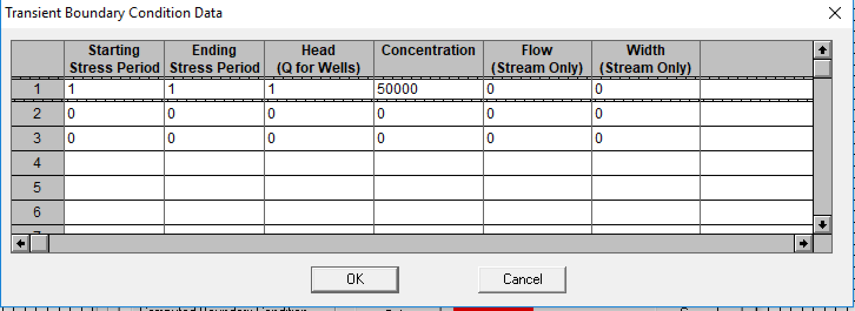
11. Run the model and simulate the formation and movement of the plume without any remediation. The following images show the plume after 3 years and after 13 years.

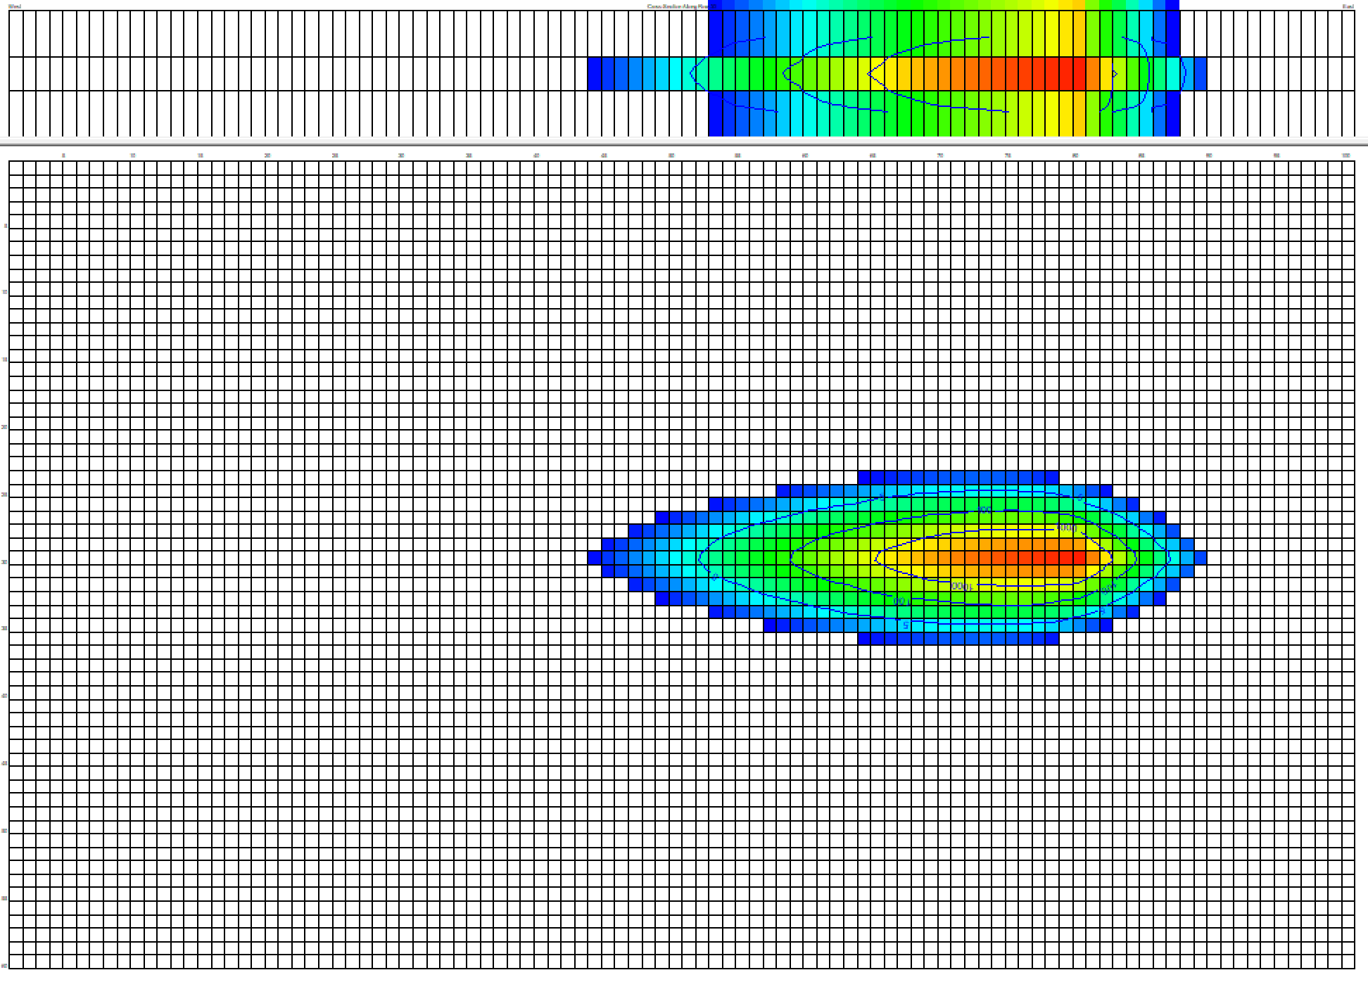 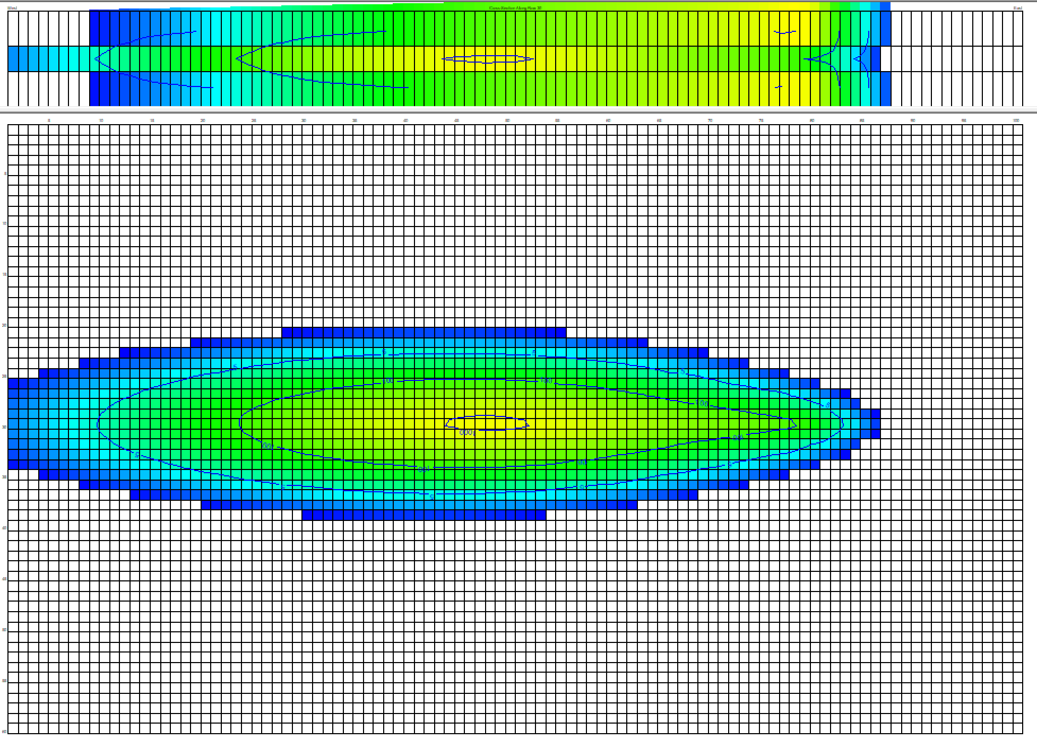

1. What is the retardation factor for this plume?
2. What is the total mass of TCE that was injected?
3. At the end of the first stress period, how much TCE has been adsorbed and how much TCE remains in solution?

**Part II. Remediation strategies**

1. For this problem we would like to evaluate the most effective pump-and-treat strategies. We can pump a total of 300 m3/d from three wells that you can place anywhere that you want. Our goal is to maximize the amount of TCE that we extract.
2. Install the three pumping wells in the model, and assign them each a pumping rate so that the total does not exceed 300 m3/d. The pumping wells should be installed in layer 2 and should only be active for the second stress period.