ESWMP — Demand Intake Service
Database Model — Diagram, Schema & Recommendations

Service: Eswmp.Work · Port 6004 · Database: eswmp_work · Schema: demand
Scope note: the diagram and tables describe the logical model from the source specification, with the design recommendations folded in and marked. Items shown as REC are proposed, not as-built; confirm against the EF migrations and WorkDbContext.cs before treating them as fact.

1. Entity-relationship diagram
Three tables in the demand schema, with the recommended foreign keys, indexes, check constraint, and tenant-isolation additions applied. Each column note carries its provenance.
■ spec as stated in the source specification
■ REC added per the recommendations in section 3

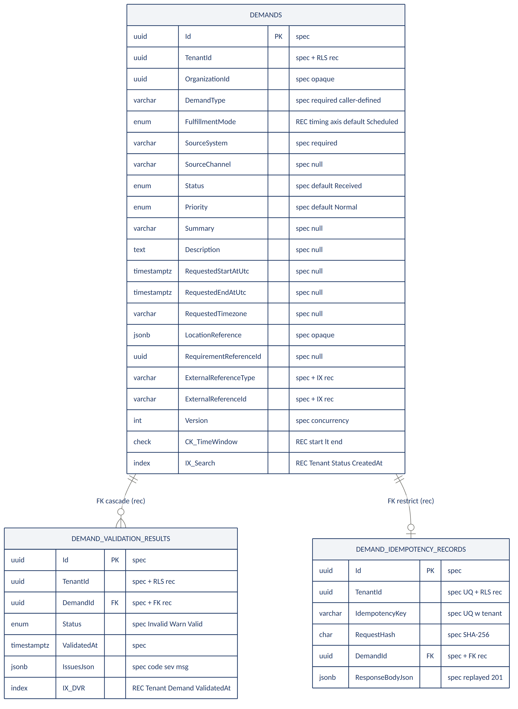
Cardinality: one Demand has many validation results (one row per validate call) and at most one idempotency record (one per create key). Delete rules differ by intent — cascade for validation results, restrict for idempotency records.

2. Schema reference
Columns as stated in the specification. Rows highlighted in purple are additions from the recommendations.

2.1 demand.Demands — aggregate root
Column | Type | Notes
Id | uuid (PK) | TenantScopedEntity
TenantId | uuid | Query-filtered · RLS (rec)
OrganizationId | uuid, null | Opaque — no Organization service
DemandType | varchar, required | Caller-defined — nature of work
FulfillmentMode | enum (rec) | Timing axis — OnDemand/Scheduled/Recurring/Standby
SourceSystem | varchar, required | Submitting caller system
SourceChannel | varchar, null | e.g. MobileApp, CallCenter
Status | enum, def. Received | Lifecycle state
Priority | enum, def. Normal | Low → Critical
Summary | varchar, null | Optional text
Description | text, null | Optional text
RequestedStartAtUtc | timestamptz, null | Window start
RequestedEndAtUtc | timestamptz, null | Window end
RequestedTimezone | varchar, null | Timezone id
LocationReference | jsonb, null | Opaque
RequirementReferenceId | uuid, null | Set once matched
ExternalReferenceType | varchar, required | Opaque pointer · indexed (rec)
ExternalReferenceId | varchar, required | Opaque pointer · indexed (rec)
Version | int, def. 1 | Optimistic concurrency
CK_TimeWindow | check (rec) | start < end — mirrors validate rule
IX_Search | index (rec) | TenantId, Status, CreatedAt
Status: Received · Validating · Ready · Accepted · Rejected · Cancelled · Expired. Priority: Low · Normal · High · Urgent · Critical.

2.2 demand.DemandValidationResults
Column | Type | Notes
Id | uuid (PK) | TenantScopedEntity
TenantId | uuid | RLS (rec) — see R1
DemandId | uuid, FK (rec) | → Demands, ON DELETE CASCADE
Status | enum | Invalid · ValidWithWarnings · Valid
ValidatedAt | timestamptz | Timestamp
IssuesJson | jsonb | [{code, severity, message}]
IX_DVR | index (rec) | TenantId, DemandId, ValidatedAt

2.3 demand.DemandIdempotencyRecords
Column | Type | Notes
Id | uuid (PK) | TenantScopedEntity
TenantId | uuid | Unique with key · RLS (rec)
IdempotencyKey | varchar, required | From Idempotency-Key header
RequestHash | char(64) | SHA-256 of request JSON
DemandId | uuid, FK (rec) | → Demands, ON DELETE RESTRICT
ResponseBodyJson | jsonb | Original 201, replayed verbatim
Unique index: (TenantId, IdempotencyKey) — the only constraint the source spec states explicitly.

3. Reference values
Suggested value sets for the five categorical columns. DemandType, SourceSystem, and SourceChannel hold the caller's own vocabulary — the platform stores them as opaque strings and must never branch on them; the values shown are an illustrative PetZiv starter set, configuration owned by the caller. FulfillmentMode and Status are platform-owned closed sets that downstream logic depends on. Note the deliberate split of DemandType (nature of work) from FulfillmentMode (timing) — see 3.1–3.2.
■ spec value set fixed by the specification — closed, not tenant-extensible
■ REC illustrative PetZiv starter set — confirm the real list before enforcing

3.1 Demands.DemandType caller-defined
DemandType carries one axis only: the nature of the work, in the caller's own terms. It deliberately does NOT encode timing (on-demand vs scheduled) — that is a separate, platform-owned axis, FulfillmentMode (section 3.2). Splitting them is what keeps the type set extensible: a new service adds one DemandType with no platform change, and a new fulfillment model never forks every type into an on-demand and a scheduled variant.
Grounding: ServiceNow Field Service Management classifies work orders by nature (reactive, preventive, inspection, installation); appointment and on-demand platforms classify by timing (one-time, recurring, immediate). On-demand marketplace guidance is explicit that instant-vs-scheduled is a structural property driving matching, payment, and notification logic — building one model on the other's stack is cited as a leading cause of costly rebuilds. Hence timing lives in its own column, not in DemandType.
Value | Meaning
GroomingVisit | A grooming service (bath, cut, style) for a pet.
VetConsult | A veterinary consultation or advisory interaction.
DogWalk | A walking service, often the recurring or on-demand case.
PetTransport | A pickup / drop-off or movement request.
Boarding | An overnight or multi-day stay.
Training | A behaviour or obedience training session.
NailTrim | A short grooming add-on; shown to illustrate cheap extensibility.
Assessment | An evaluation to determine what work, if any, is required.
These are illustrative PetZiv values on the nature-of-work axis. Recommended handling: a per-tenant lookup owned by caller configuration, not a platform enum — the platform stores the string and never branches on it.

3.2 Demands.FulfillmentMode platform-owned, closed set (rec)
The timing axis — how a demand is fulfilled in time. Unlike DemandType this is platform-owned and closed, because downstream matching, booking, and notification logic branches on it. A dedicated column (rather than inferring from the requested window or overloading Priority) makes the distinction explicit and queryable at the scheduling handoff. Recommended NOT NULL default: Scheduled.
Value | Meaning
OnDemand | Immediate / near-immediate; routes to real-time matching and dispatch.
Scheduled | Booked for a specific future time or window; routes to availability + booking.
Recurring | One instance of a repeating arrangement; cadence lives in recurrence fields, not here.
Standby | Flexible / as-capacity-allows — the drop-in pattern from scheduling platforms.
Closed set, like Status. Any DemandType can pair with any FulfillmentMode — the two axes are orthogonal, so a Demand row is effectively one cell in a type-by-mode grid (e.g. GroomingVisit + OnDemand, or DogWalk + Recurring).

3.3 Demands.SourceSystem caller-defined
Which caller system submitted the request — provenance, effectively. Values should be stable machine identifiers, not display names. A slug convention (lowercase, hyphenated) keeps them clean.
Value | Meaning
PetZivApp | The PetZiv consumer mobile application.
PetZivWeb | The PetZiv customer web experience.
PetZivAdmin | Internal staff/admin tooling creating demands on a customer's behalf.
PartnerAPI | A third-party partner submitting through the public API.
CallCenterCRM | The CRM used by call-centre agents.
Migration | Records loaded in bulk during data migration — distinguishes backfill from live intake.
SystemScheduler | An automated internal process (e.g. generating recurring instances).
Recommended handling: reserve one value (Migration or backfill) for bulk-loaded rows so they stay separable from live traffic later.

3.4 Demands.SourceChannel caller-defined, nullable
How the request reached the caller — the human or interaction channel, distinct from the software system in SourceSystem. Nullable, so decide what null means: unknown versus not-applicable.
Value | Meaning
MobileApp | Submitted by the customer through a mobile app.
WebPortal | Submitted through a browser-based portal.
CallCenter | Taken by a human agent over the phone.
Email | Originated from an inbound email.
Chat | Originated from a chat or messaging interaction.
WalkIn | Captured in person at a physical location.
PartnerIntegration | Arrived via a partner's integration rather than a direct customer action.
AutomatedRecurrence | Generated by the system with no human channel — an explicit value in place of null.
Recommended handling: use an explicit System/Automated value rather than overloading null, if 'no human channel' and 'channel unknown' both need to be distinguishable in reporting.

3.5 Demands.Status platform-owned, fixed by spec
ESWMP's own lifecycle state. Unlike the three columns above, this set is closed — the lifecycle and mutability rules depend on the exact values, so it is not tenant-extensible.
Value | Meaning
Received | Initial state on creation. Broadly mutable via PATCH.
Validating | Present in the mutability rules; a Demand may not rest here if validate is synchronous.
Ready | Passed validation (Valid or ValidWithWarnings). Only Priority is mutable. Can be accepted.
Accepted | Terminal. Publishes DemandAcceptedEvent. Fully immutable.
Rejected | Terminal. Requires a reasonCode. Publishes DemandRejectedEvent.
Cancelled | Terminal. Publishes DemandCancelledEvent.
Expired | Terminal and defined, but unreachable today — no expiry job sets it.
Reachable transitions: Received → Ready → Accepted; and Received/Validating/Ready → Rejected or Cancelled. Nothing transitions into Expired yet.

4. Recommendations applied
Each item below is realized in the accompanying DDL and marked in the diagram and tables above.
R1 Confirm the tenant query filter on DemandValidationResults [ High ]
The spec confirms HasQueryFilter on Demand and DemandIdempotencyRecord but not on DemandValidationResult. If the filter is absent there, validation results — including IssuesJson, which may echo caller-supplied content — are reachable across tenants unless every read joins through a filtered Demand. The DDL adds optional row-level-security policies on all three tables as database-level defence in depth.
Action: grep -n "HasQueryFilter" src/Eswmp.Work/Data/WorkDbContext.cs
R2 Enforce the parent links with explicit delete rules [ Medium ]
Both child tables now carry an explicit foreign key. Delete rules differ by intent: CASCADE on validation results (a removed Demand should not leave orphans) and RESTRICT on idempotency records (the create receipt should outlive casual deletes so replays stay correct). A time-window CHECK constraint mirrors the INVALID_TIME_WINDOW validation rule at the database level.
Action: Confirm no code path hard-deletes a Demand in a way RESTRICT would block; revisit alongside any purge policy.
R3 Add a covering index for the search endpoint [ Medium ]
POST /search filters on status, priority, demandType and a created-date range, all tenant-scoped. IX_Search on (TenantId, Status, CreatedAt) with Priority and DemandType included keeps that query flat as intake volume grows — the exact scenario the spec names as the extraction trigger.
Action: Validate with EXPLAIN once representative data exists.
R4 Confirm the enum storage strategy [ Low ]
Status and Priority are modelled as native enum types for legibility and safe reordering. If the code maps them as int via HasConversion, switch the columns to smallint to match. Status drives the immutability rules, so a silent remap would be a correctness bug.
Action: grep -rn "HasConversion" src/Eswmp.Work/Data/
R5 Keep the Version check atomic [ Low ]
Version is application-managed: PATCH supplies expectedVersion, a mismatch returns 412. The read-check-increment must run in one statement (UPDATE … WHERE Id = @id AND Version = @expected) so two concurrent PATCHes cannot both write n+1.
Action: Verify the update path is a single guarded statement, not read-then-write.
R6 Keep deferred entities on the backlog, not in the schema [ Informational ]
Two documented simplifications should stay visible rather than becoming dead affordances: no history/audit table (GET /history returns []), and Expired is a defined status with nothing that sets it. Both are fine as staged delivery.
Action: Track the audit trail and expiry sweep as backlog items.

Confirmed from the source specification: the three tables and their fields, the (TenantId, IdempotencyKey) unique index, query filters on Demand and DemandIdempotencyRecord, and the validate-writes-on-every-call behaviour. Everything marked REC — foreign keys, indexes, the check constraint, RLS, enum storage — is a recommendation to verify against the codebase before it is stated as fact.

