ESWMP — Work Requirement Service
Database Model — Diagram, Schema & Domain Boundary

Domain: Demand & Intake Service: Eswmp.Work Database: eswmp_work Schema: requirement
This service is the sibling of Demand Intake within the Demand & Intake domain. Both live in the same deployable unit and the same database, in separate schemas: Demand Intake owns demand, Work Requirement owns requirement. Neither may touch the other's tables; the only coupling is the source reference and the event contract.
Provenance: the entities, fields, enums, statuses, and boundary rules are drawn from the Work Requirement Service Specification (Document 06). Physical types, lengths, indexes, and constraints are specified here. Where this contract adopts a convention from the shipped Demand Intake service rather than the spec's own wording, it is noted in §7.

1. Purpose and boundary
The Work Requirement Service is the authoritative owner of what must be true for a unit of work to be performed. It answers one question: what is operationally required? It deliberately does not answer who performs the work, when it is scheduled, whether a resource is available, whether capacity exists, or which candidate is best.
A customer request is not a Work Requirement. “Dog grooming, tomorrow afternoon, at my home” is demand. The Work Requirement it resolves to is operational: work type Mobile Dog Grooming, 90 minutes, one Groomer plus one Mobile Grooming Vehicle, capabilities DOG_GROOMING and MOBILE_SERVICE, certification ANIMAL_FIRST_AID, capacity PET_COUNT = 1. That translation is this service's entire job.

1.1 Owns
Work Requirement, Requirement Template, Template Version, Resource Role Requirement, Capability Requirement, Certification Requirement, Capacity Requirement, Time Requirement, Duration Requirement, Location Requirement, Execution Requirement, Travel Requirement, Buffer Requirement, Dependency Requirement, Constraint, Preference, Requirement Version, Requirement Resolution.

1.2 References but does not own
Source Demand, Product, Service Offering, Resource Type, Capability Definition, Certification Type, Capacity Dimension, Location, Organization. All are held as opaque codes or reference ids — never copied into this schema.

1.3 Must never own
Resource Availability, Resource Capacity State, Candidate Eligibility, Candidate Score, Schedule, Reservation, Appointment, Assignment, Task Status. These belong to the Scheduling & Availability and Workforce & Execution domains. The service must not become the scheduling engine, the product engine, or the assignment engine.
The distinction that matters most: a Capacity Requirement says the work consumes PET_COUNT = 2. It does not know how much capacity remains — that is the Capacity Service. A Capability Requirement says DOG_GROOMING is needed. It does not know who has it — that is Eligibility.

2. Core aggregate
Templates generate Work Requirements. A Work Requirement carries its template provenance (TemplateId + TemplateVersion) so work created under version 1 never silently becomes version 2. Capability, certification, and capacity requirements attach to a Resource Role — not to the work as a whole — which is what makes multi-resource work expressible.
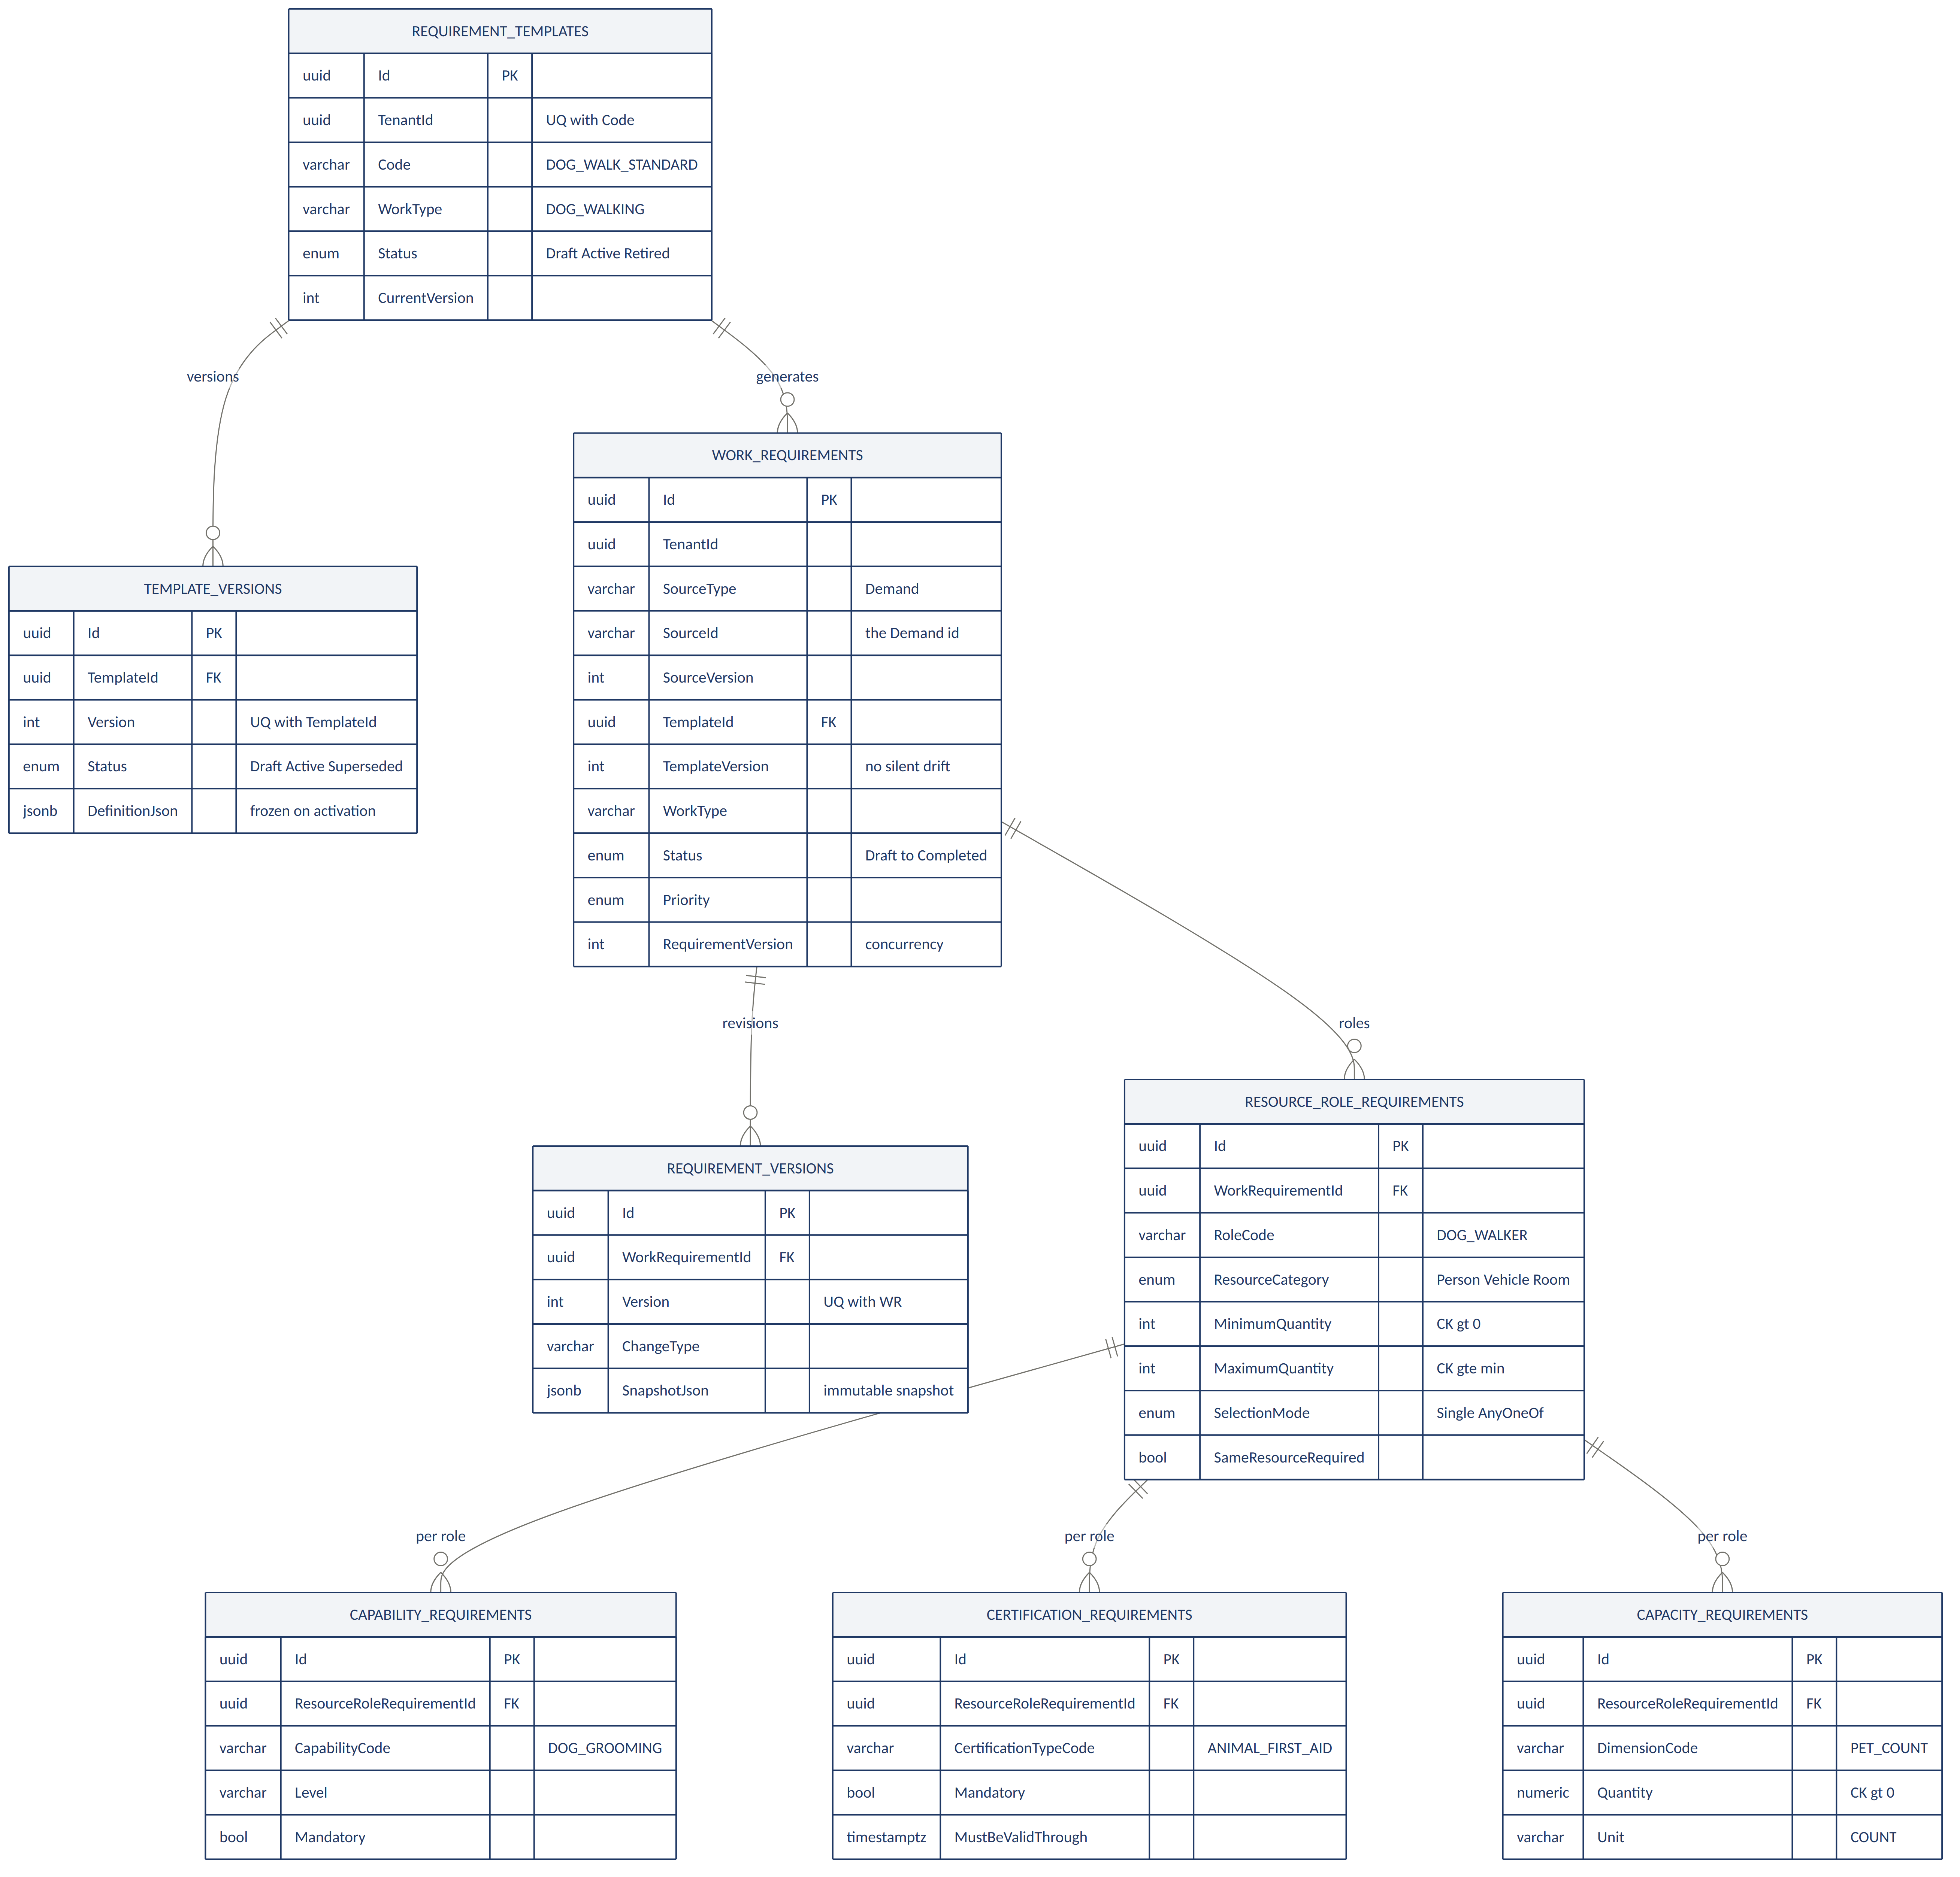
Role-scoping is the structural key: a Mobile Grooming requirement has two roles (Groomer, Vehicle), and DOG_GROOMING attaches to the Groomer while a driving licence attaches to the Vehicle operator. A flat capability list on the work could not express that.

3. Requirement detail

3.1 Single-cardinality requirements
Duration, Time, Location, Execution, and Travel are one-per-Work-Requirement, each enforced by a unique constraint on WorkRequirementId.
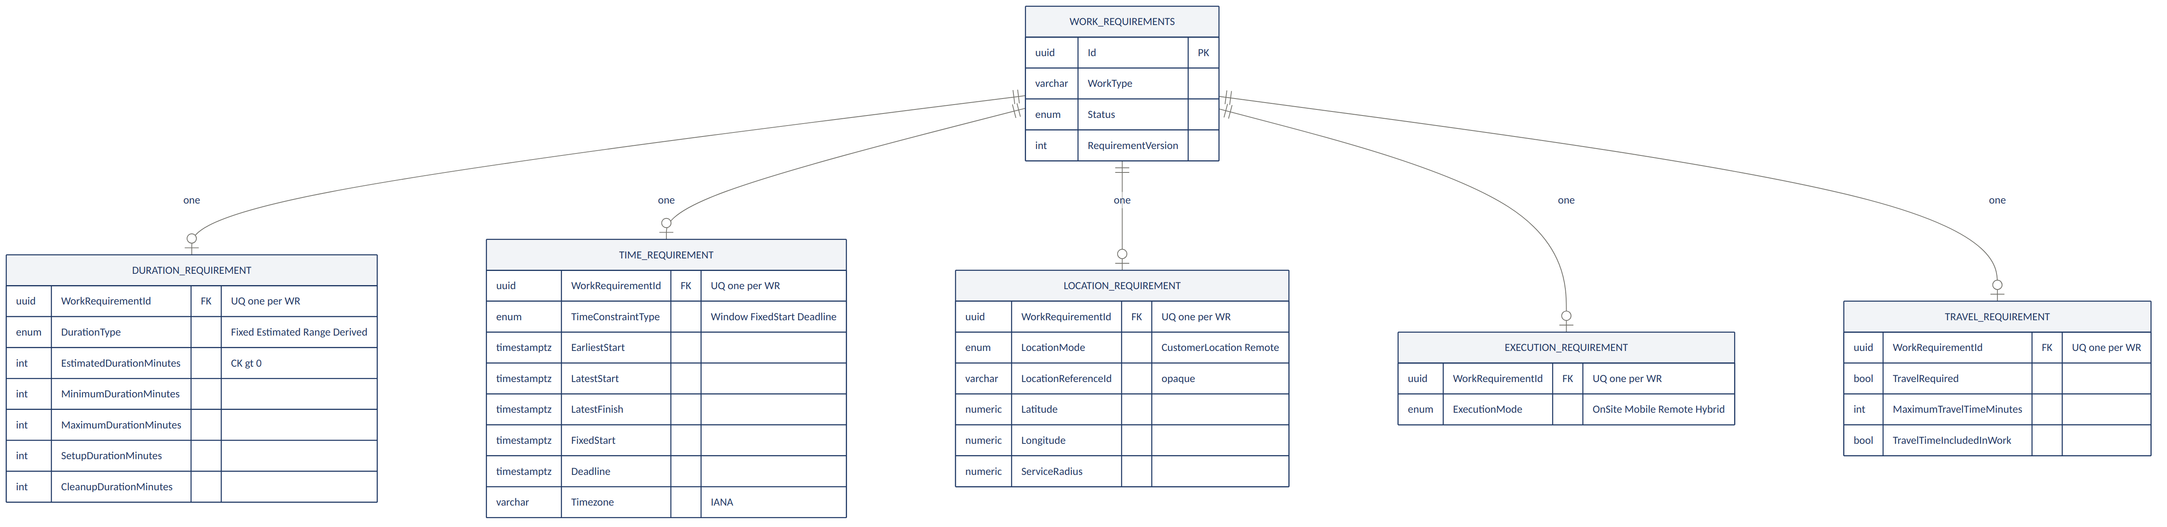

3.2 Multi-cardinality requirements
Buffers, dependencies, constraints, and preferences are many-per-Work-Requirement. Constraints gate (hard) or influence (soft); Preferences only weight — they are never a gate.
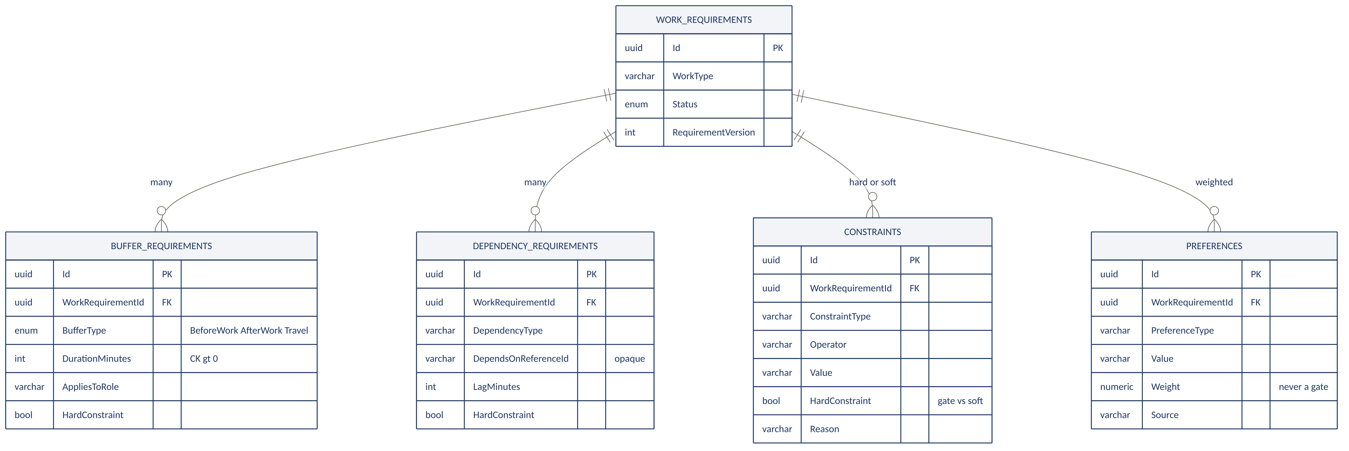

4. Schema reference

4.1 requirement.WorkRequirements — aggregate root
Column | Type | Notes
Id | uuid (PK)
TenantId | uuid | Query filter + RLS
SourceType | varchar, required | Origin kind — 'Demand' today
SourceId | varchar, required | The Demand's id; source object never copied
SourceVersion | int, null | Demand.Version at resolution time
TemplateId | uuid, null | FK → RequirementTemplates
TemplateVersion | int, null | Frozen; prevents silent drift
WorkType | varchar, required | e.g. DOG_WALKING
WorkCategory | varchar, null | Classification
ServiceMode | varchar, null | e.g. MOBILE
ComplexityLevel | varchar, null
Status | enum, def. Draft | Draft → Completed (§5)
Priority | enum, def. Normal | Low … Critical
EffectiveFrom / To | timestamptz, null | Validity window
RequirementVersion | int, def. 1 | Optimistic concurrency
IX_WR_Source | index | TenantId, SourceType, SourceId — the domain join
IX_WR_Search | index | TenantId, Status, CreatedAt

4.2 requirement.RequirementTemplates / TemplateVersions
Templates hold reusable operational defaults per tenant; versions freeze them. Cross-tenant template use is prohibited, enforced by UQ (TenantId, Code).
Column | Type | Notes
Code | varchar, required | e.g. DOG_WALK_STANDARD; UQ per tenant
WorkType | varchar, required | e.g. DOG_WALKING
Status | enum | Draft | Active | Retired
CurrentVersion | int | Pointer to the live version
— versions —
Version | int | UQ with TemplateId
Status | enum | Draft | Active | Superseded | Retired
DefinitionJson | jsonb | Requirement definitions, immutable after activation
EffectiveFrom / To | timestamptz | Version validity
ChangeReason | varchar | Why this version exists

4.3 requirement.ResourceRoleRequirements
The pivot of the model. Capability, certification, and capacity requirements all hang off a role.
Column | Type | Notes
RoleCode | varchar, required | e.g. DOG_WALKER, GROOMER, VEHICLE
ResourceCategory | enum, required | Person | Team | Vehicle | Facility | Room | Equipment | VirtualResource | ResourcePool
MinimumQuantity | int, def. 1 | CHECK > 0
MaximumQuantity | int, null | CHECK ≥ minimum
Required | bool, def. true
SelectionMode | enum, def. Single | Single | Multiple | AnyOneOf | AllRequired | Optional
SameResourceRequired | bool, def. false | Same physical resource across the work
Sequence | int, def. 0 | Ordering hint
AnyOneOf is what allows “one of: Standard Van or Large Van” without demanding two vehicles.

4.4 Role-scoped requirements
Table | Key fields | Notes
CapabilityRequirements | CapabilityCode, Level, MinimumExperience, Mandatory | e.g. DOG_GROOMING
CertificationRequirements | CertificationTypeCode, Mandatory, MustBeValidThrough | e.g. ANIMAL_FIRST_AID; validity must cover the work period
CapacityRequirements | DimensionCode, Quantity, Unit, AggregationScope | e.g. PET_COUNT = 2, COUNT. CHECK Quantity > 0

4.5 Single-cardinality requirements
Table | Key fields | Notes
DurationRequirements | DurationType, Estimated/Min/Max, Setup, Cleanup | Fixed | Estimated | Range | Derived. CHECK positive, min ≤ max
TimeRequirements | TimeConstraintType, EarliestStart, LatestStart, LatestFinish, FixedStart/End, Deadline, Timezone | Flexible | Window | FixedStart | FixedInterval | Deadline. CHECK temporal ordering
LocationRequirements | LocationMode, LocationReferenceType/Id, Lat, Lng, ServiceRadius | CustomerLocation | ProviderLocation | FacilityLocation | SpecificLocation | Remote
ExecutionRequirements | ExecutionMode | OnSite | Mobile | Remote | FacilityBased | Hybrid
TravelRequirements | TravelRequired, Origin/DestinationMode, MaxTravelTime, MaxDistance | Describes travel constraints; does not calculate routes

4.6 Multi-cardinality requirements
Table | Key fields | Notes
BufferRequirements | BufferType, DurationMinutes, AppliesToRole, HardConstraint | BeforeWork | AfterWork | Travel | Cleanup | Setup
DependencyRequirements | DependencyType, DependsOnReferenceType/Id, LagMinutes | Opaque pointer — no cross-service FK
Constraints | ConstraintType, Operator, Value, HardConstraint, Reason | Hard = must hold (gate). Soft = should hold
Preferences | PreferenceType, Value, Weight, Source | Weighted desirability. Never a gate

4.7 Versioning, idempotency, outbox
Table | Purpose | Notes
RequirementVersions | One row per revision | SnapshotJson holds the immutable resolved snapshot; UQ (WorkRequirementId, Version)
IdempotencyRecords | Replay protection | UQ (TenantId, IdempotencyKey) + SHA-256 request hash — mirrors the demand schema exactly
OutboxMessages | Transactional event publish | State change + outbox row commit together; partial index on unprocessed

5. Work Requirement status
Status | Meaning
Draft | Created, not yet validated.
Validating | Validation in progress.
Valid | Passed validation; usable by Eligibility, Capacity, and Scheduling.
Invalid | Failed validation; must not be consumed downstream.
Superseded | Replaced by a newer requirement version.
Cancelled | Withdrawn.
Completed | Work finished. Set from a downstream lifecycle event — this service never infers completion itself.

6. Validation categories
Validation runs across seven categories. Structural, semantic, and temporal rules are additionally enforced as database CHECK constraints, so an invalid requirement cannot be persisted even by a code path that skips the validator.
Category | Examples
Structural | Work type required; at least one resource role; duration required; source reference required
Reference | Capability code exists; certification type exists; capacity dimension exists; location exists
Semantic | Quantity positive; duration positive; minimum quantity ≤ maximum
Temporal | Latest start not before earliest start; deadline not before earliest start; certification validity covers the work period
Composition | Mobile execution implies a vehicle role — warning or error by policy
Cross-requirement | A PET_COUNT capacity requirement must reference a role able to consume PET_COUNT
Policy | Tenant or organization policy gates

7. Alignment with Demand Intake
Both services sit in the Demand & Intake domain and share a deployable unit and database. Four points where this contract adopts the shipped Demand Intake convention rather than the specification's own wording, so the domain presents one coherent surface:
Point | Specification says | This contract
Base path | /v1/work-requirements | /api/v1/work-requirements — matches /api/v1/demands
Error model | RFC-7807 problem+json | The shipped hybrid: error + code + traceId + issues[]
Upstream event | ServiceRequestCreated | DemandAcceptedEvent, via an adapter (§8)
Source fields | sourceType / sourceId / sourceVersion | Retained as-is; SourceId holds the Demand id

7.1 Open question — “Service Request”
The specification repeatedly names a Service Request as the upstream, and its recommended deployment unit lists three modules: Demand Intake, Service Request, and Work Requirement. The architecture diagram shows only two — Demand Intake feeding Work Requirement. The specification also states plainly that this service “references: Source Demand.”
Two readings are possible, and the source material does not settle it:
- Service Request is this specification's name for what the platform calls a Demand — in which case no third service exists and the naming is simply inconsistent between documents.
- Service Request is a genuine third service sitting between Demand Intake and Work Requirement, not yet built and not yet drawn.
This contract does not resolve the question. It is designed so that either reading works without schema change: SourceType is open text, and the adapter layer (§8) absorbs whichever upstream event arrives. The decision should be taken at workshop before Work Requirement is implemented, because it determines whether a Service Request service needs specifying at all.

8. Upstream adapter
The specification requires that this service never couple to a caller's business vocabulary, and mandates an adapter between the upstream demand and the resolution contract. That adapter is what makes the open question above harmless.
DemandAcceptedEvent → Demand Adapter → Resolution Contract → Work Requirement Service
ServiceRequestCreated → Service Request Adapter → Resolution Contract → Work Requirement Service
Today only the first path exists: the adapter consumes DemandAcceptedEvent, reads the Demand's opaque externalReference and its demandType, and normalizes them into a resolution request naming a template code and inputs. If a Service Request service ever appears, a second adapter is added and the core service is untouched — it never learns which upstream produced the work. SourceType records which one did.
Note on the domain join: Demand Intake already carries a requirementReferenceId field, set once a demand is matched to a Work Requirement. This schema's SourceType / SourceId is the reverse pointer. The two together form the only coupling between the schemas — there is no foreign key across them, and neither service reads the other's tables.

Established by the Work Requirement Service Specification (Document 06): all entities, fields, enums, statuses, validation categories, permissions, and boundary rules. Specified by this contract: physical types and lengths, foreign keys and delete rules, indexes, CHECK constraints, the outbox and idempotency tables, and the four alignment decisions in §7. The “Service Request” question in §7.1 is unresolved in the source material and is flagged for workshop decision.

