**Part 1**

**Install postgressql**  
https://www.enterprisedb.com/downloads/postgres-postgresql-downloads  
<https://sbp.enterprisedb.com/getfile.jsp?fileid=1259563>  
  
Restore SQL data attached

1. Create database   
   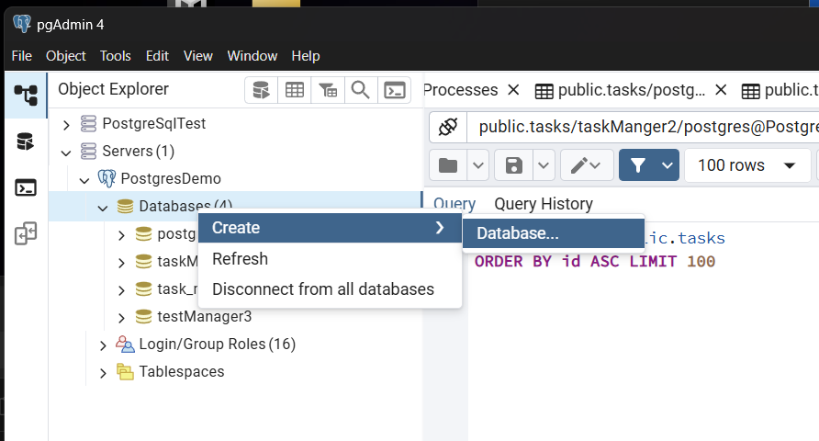

Fill in database name : task_manager_3  
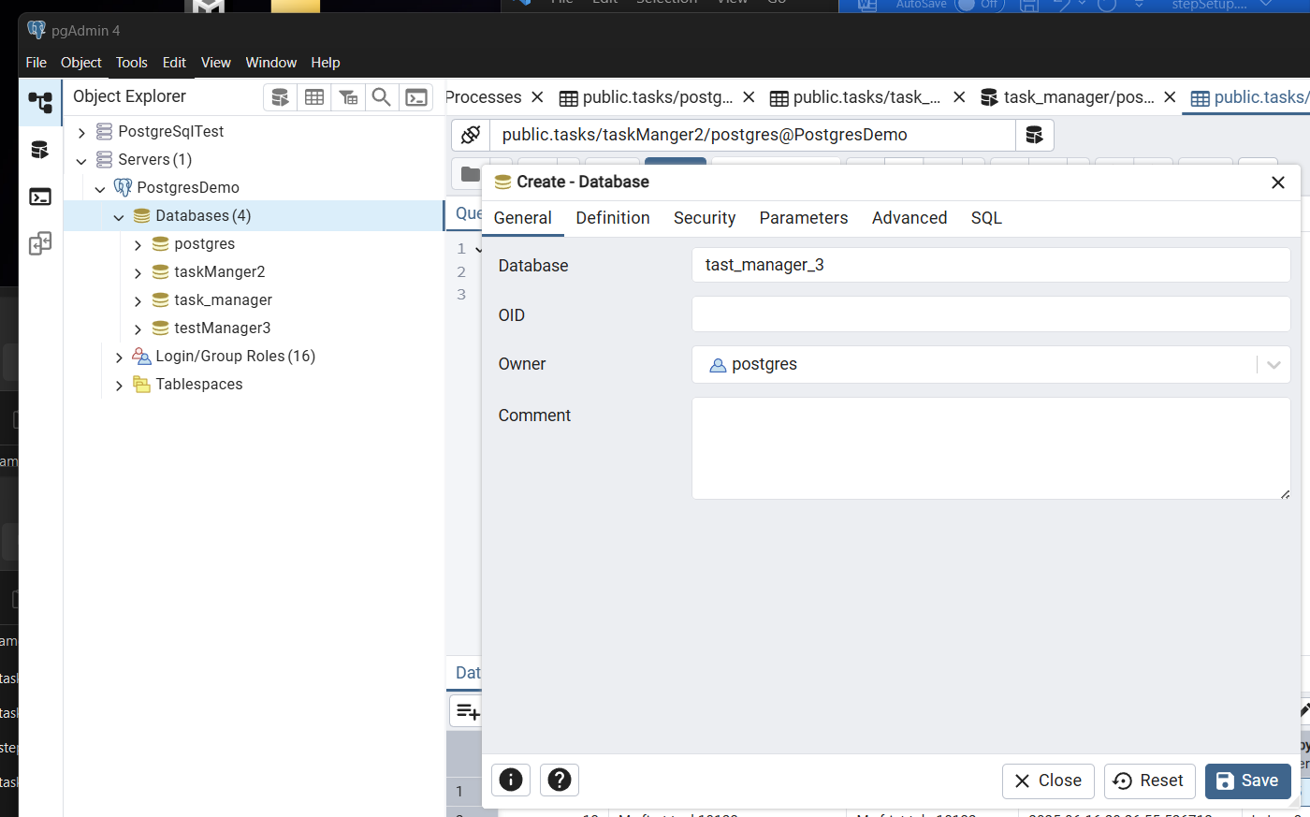

1. Database tast_manager_3 created as below

Select and choose to restore   
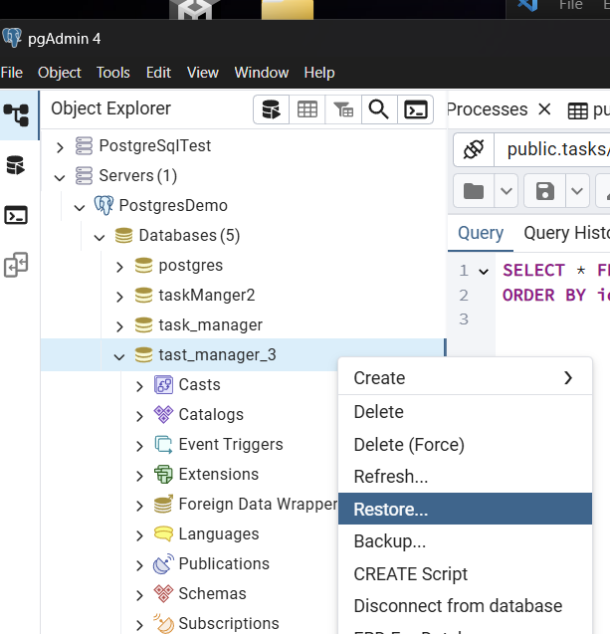

1. Select given database sql.  
   Choose custom or tar  
   select given database script sql : “taskManager.sql”

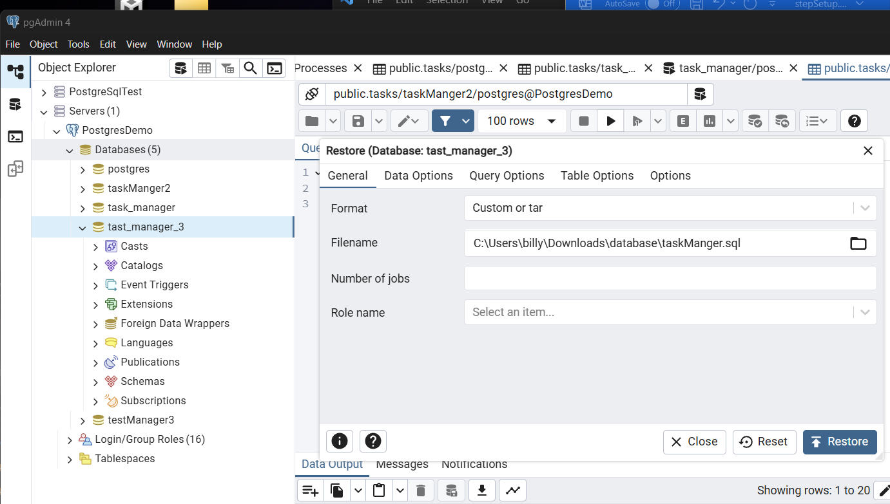

1. Successfully restore database – with table tasks and users

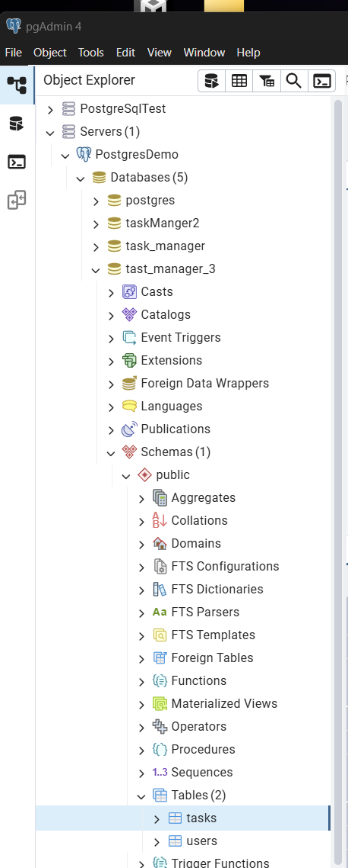

**Part 2 – install dependency**

1. There are 2 folder – to bring up as localhost

**npm install - both folder (frontend and backend)**  
**a) backend**

- Change database config accordingly (user/name/ database / password)  
  
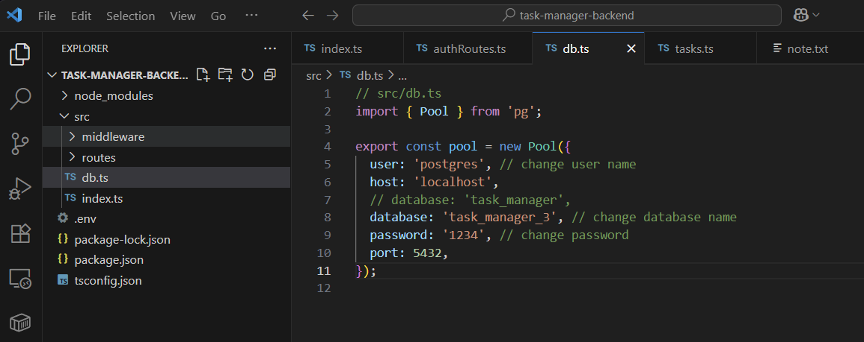  
  
**b) Bring up Frontend and backend**  
bring up both Frontend and Backend folder with bash/git bash/linux - “npm run start” at it own root directory

**Part 3: Encounter DB setup Error**

1. Choose your preferred server and database name to proceed
2. Example below tables is empty – (we need to create tasks and users tables)  
   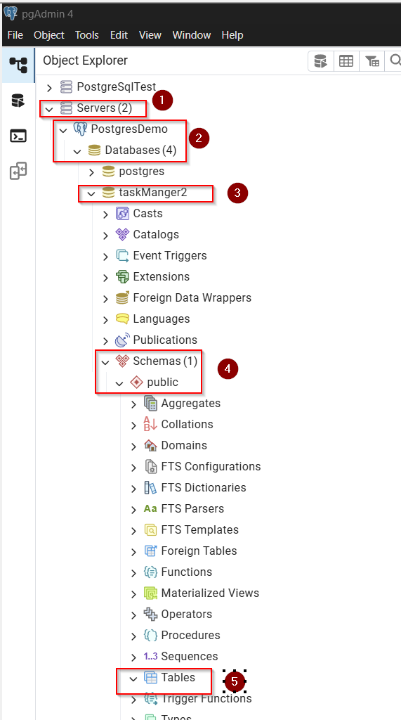

Right click the Tables >> Choose Query Tools   
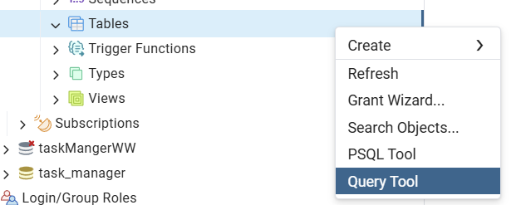

1. Paste the command attached file : init_db.sql provided, and click execution ,
2. Right Click >> Choose refresh table, the table will show “tasks and users” created.  
   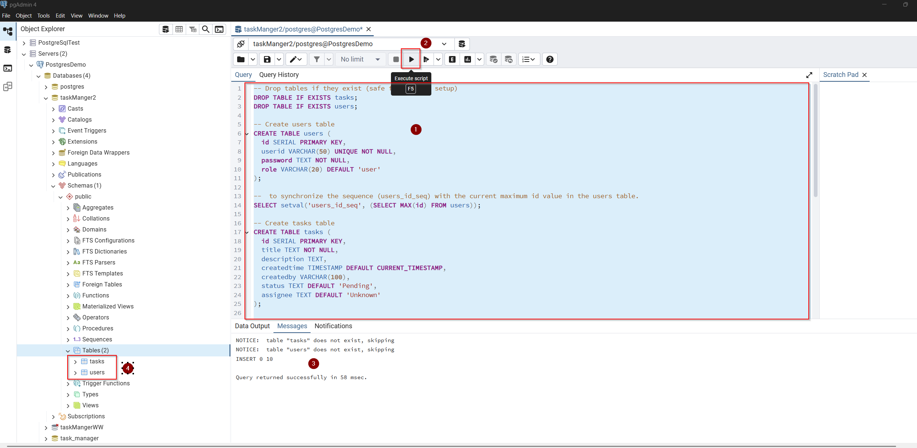  
     
   5. Check it the initial data seed is created  
   