Supplementary Table S1: The pre-registration of the literature comparison (NA12) and its amendments, with the date of each and when it was made relative to the data, as the entries of docs/decisions.md state. Every entry was written before the comparison was run and before any out-of-fold prediction for these compounds was looked at; entries marked as made after a test run or after the digitising of a figure were made after the digitised values of that figure had been seen. A disclosure states what came into view that was not meant to be read (values of a source while it was inventoried, or the reason an amendment was prompted). The full rules are in docs/decisions.md.
No. | Date | Subject | Timing, as stated in the entry | Entry contains a disclosure
pre-registration | 2026-10-05 | Design: compounds, predictions compared (out-of-fold, exact and cluster level), per-value facts, error measure and band, values from the PDFs only | done before the values are read and before any prediction is looked at
1 | 2026-10-13 | how discrete measurements are read | Made before any NA12 value is written to `docs/na12_literature_values
2 | 2026-10-14 | aggregation and reporting | Made before the comparison has been run for any NA12 value and with no out-of-fold prediction for an NA12 compound looked at
3 | 2026-10-14 | Ohta 2005 and Ohtaki 1995 | made before any of their values is digitised
4 | 2026-10-14 | marker temperatures of figures with several series: column consensus | made before any comparison, with no out-of-fold prediction for an NA12 compound looked at
5 | 2026-10-16 | one temperature per measurement column across the figures of one run; one marker-centre method | made before any comparison, with no out-of-fold prediction for an NA12 compound looked at
6 | 2026-10-16 | edge-flag tolerance 2u | made before any comparison, with no out-of-fold prediction for an NA12 compound looked at
7 | 2026-10-16 | Ohta et al. Fig. 3, thermal conductivity: only legible markers | made before any comparison, with no out-of-fold prediction looked at
8 | 2026-10-17 | approximate zT consistency check for Ohta et al. | made before any comparison, with no out-of-fold prediction looked at
9 | 2026-10-17 | Ohtaki et al. 1995: legible markers only, extending amendment 7 | made before any Ohtaki marker is digitised, with no out-of-fold prediction looked at
10 | 2026-10-17 | Ohtaki et al. Fig. 7: column-grouping gate 6 deg C | made after the Fig. 7 digitising, before any comparison, with no out-of-fold prediction looked at
11 | 2026-10-17 | Ohtaki et al. Fig. 4: unplaceable clicks, columns of the not-legible list, estimator settings | made after a test run of the Fig. 4 files, before the official run and any comparison, with no out-of-fold prediction looked at
12 | 2026-10-17 | Ohtaki et al. Fig. 1: the 1000/T axis, tilt, units, room temperature | made after a test run of the Fig. 1 files, before the official run and any comparison, with no out-of-fold prediction looked at
13 | 2026-10-17 | the legibility gates of amendment 12 apply to every digitised scanned figure | made before the comparison, with no out-of-fold prediction looked at
14 | 2026-10-19 | Shibasaki et al. 2009 and Rajasekaran et al. 2020: which values are rows | made before any value of the two papers is read into the values file and before the comparison, with no out-of-fold prediction looked at | yes
15 | 2026-10-19 | a value the stated-temperature figure cannot resolve is taken from the figure that does | made before the comparison, with no out-of-fold prediction looked at
16 | 2026-10-19 | Rajasekaran et al. Fig. 10: values from the printed ticks, marker opening radius, the abstract as a check | made after the test run of the digitised files, before the official run and the comparison, with no out-of-fold prediction looked at | yes
17 | 2026-10-19 | the symmetry cross-check on the opened body, and a window centred on the click; every scanned figure | made before the comparison, with no out-of-fold prediction looked at | yes
Generated from docs/decisions.md (SHA256 c961c9c5d8f0cd4cd7502ea556c2c7b306a7b7c7d161bcdd76d0b69cbf4067be) at commit 6dc4ba44bd71a5f2393925cf8bd49c02985acb32.
Supplementary Table S2: Hyperparameters of the comparison models of Section 3.1.2. Part A: LightGBM, tuned once per target on all rows of the target by a 20-trial Optuna search scored with 3-fold chemistry-cluster cross-validation (the XGBoost protocol), then frozen; the search ranges are those of the code. Part B: the random forest, which is not tuned: one setting, fixed in advance, is used for all four targets (Section 2.3). The target scale is log₁₀ for σ and κ and linear for S and zT.
Part A: LightGBM (tuned, frozen).
Parameter | S | σ | κ | zT | Search range
n_estimators | 400 | 550 | 400 | 500 | 100 to 600 (step 50)
max_depth | 10 | 9 | 7 | 12 | 3 to 12
num_leaves | 82 | 126 | 241 | 75 | 15 to 255 (log scale)
learning_rate | 0.0638 | 0.0568 | 0.0877 | 0.0447 | 0.01 to 0.3 (log scale)
subsample | 0.712 | 0.592 | 0.552 | 0.51 | 0.5 to 1
colsample_bytree | 0.823 | 0.638 | 0.677 | 0.626 | 0.5 to 1
min_child_samples | 25 | 35 | 38 | 40 | 5 to 50
reg_lambda | 3.69 | 3.27 | 0.0269 | 2.34 | 0.001 to 10 (log scale)
reg_alpha | 7.16 | 9.84 | 1.24 | 3.9 | 0.001 to 10 (log scale)
inner-CV R² of the chosen set | 0.735 | 0.685 | 0.794 | 0.739
rows of the target | 185,064 | 182,755 | 121,110 | 129,419
Part B: random forest (fixed setting, not tuned; the same for S, σ, κ and zT).
Parameter | Value
n_estimators | 500
max_features | 0.333
min_samples_leaf | 5
max_depth | none (no limit)
min_samples_split | 2
bootstrap | yes
Generated by scripts/make_supplement_hyperparameters.py from the frozen files of results/na2_lightgbm and results/na2_rf_* and from src/nested_cv.py (the SHA256 of every input is in reports/supplement_hyperparameters/run_config.json).

Supplement

Supplementary Note S1: Extended background (supplement to Section 1)

Thermoelectric fundamentals
The Seebeck effect, named after Thomas Johann Seebeck, is the creation of an electric voltage by a temperature difference across a junction of two dissimilar conductors. The magnitude of this voltage per unit temperature difference is the Seebeck coefficient (S, µV K⁻¹). A thermoelectric generator directly converts a temperature gradient into electrical power, without moving parts, using an array of p-type and n-type semiconductor legs connected electrically in series and thermally in parallel (Supplementary Figure S1)¹. The reverse phenomenon, the Peltier effect, uses an electric current to transfer heat across a junction, enabling solid-state cooling, and the Thomson effect is the heating or cooling of a current-carrying conductor in a temperature gradient. Together, these three effects form the basis of thermoelectric energy conversion².
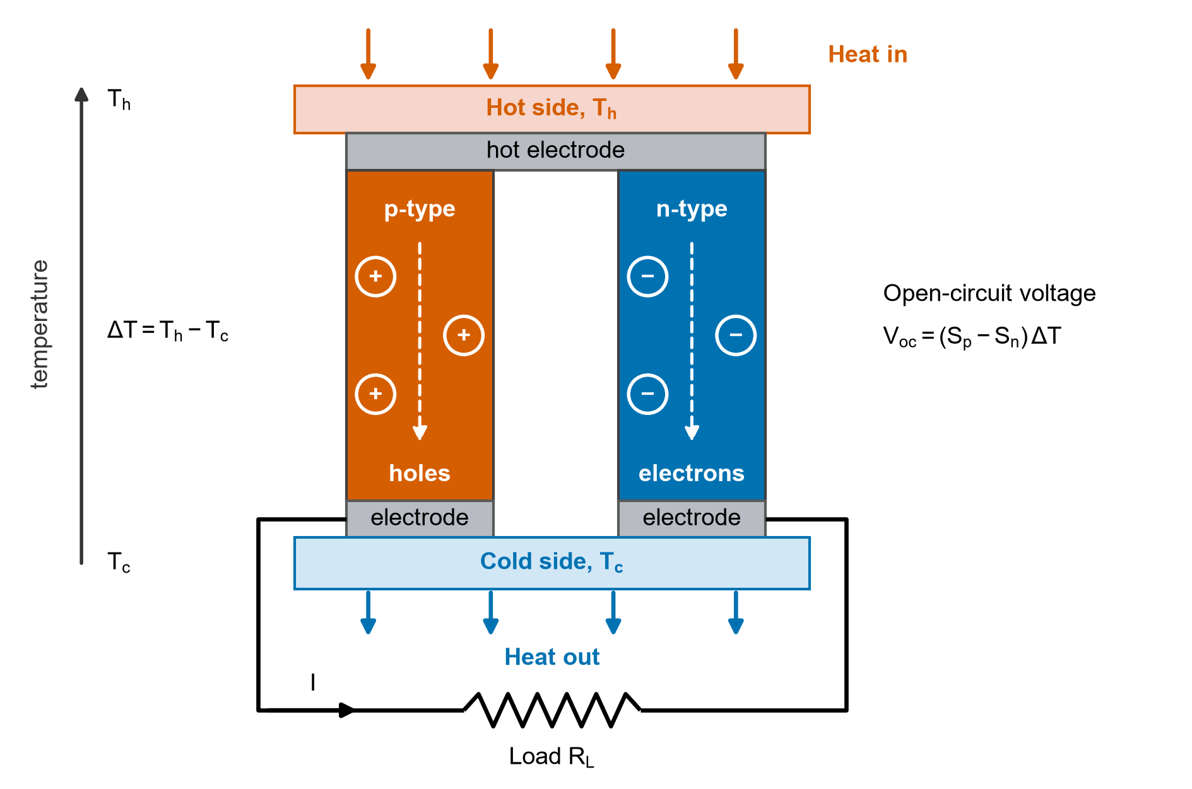
Supplementary Figure S1
Supplementary Figure S1: Schematic (drawn by the authors, not to scale) of a thermoelectric p–n couple. Heat flows from the hot to the cold side; the majority carriers of each leg (holes in the p-type leg, electrons in the n-type leg) diffuse from the hot to the cold end, which gives rise to an open-circuit Seebeck voltage V_{oc}. The two legs are joined in series by electrodes and drive a current I (conventional direction) through the load R_{L}.
In Eq. (1), the numerator S²σ is the power factor (PF), a measure of electrical power output, whereas κ comprises an electronic part (κ_{e}) controlled by charge carriers and a lattice part (κ_{l}) controlled by phonons. High zT requires S²σ to be maximized and κ minimized simultaneously, which is inherently difficult because these quantities are interrelated through the carrier concentration (Supplementary Figure S2)³. As carrier concentration increases, σ increases while S decreases, because the average entropy per carrier decreases. In addition, the Wiedemann–Franz law links κ_{e} to σ:
$κ_{e}=LσT$ (S1)
where L is the Lorenz number. The only transport parameter that can be reduced relatively independently is κ_{l}, which has driven research toward materials with complex crystal structures, heavy atoms and large unit cells that scatter phonons efficiently.
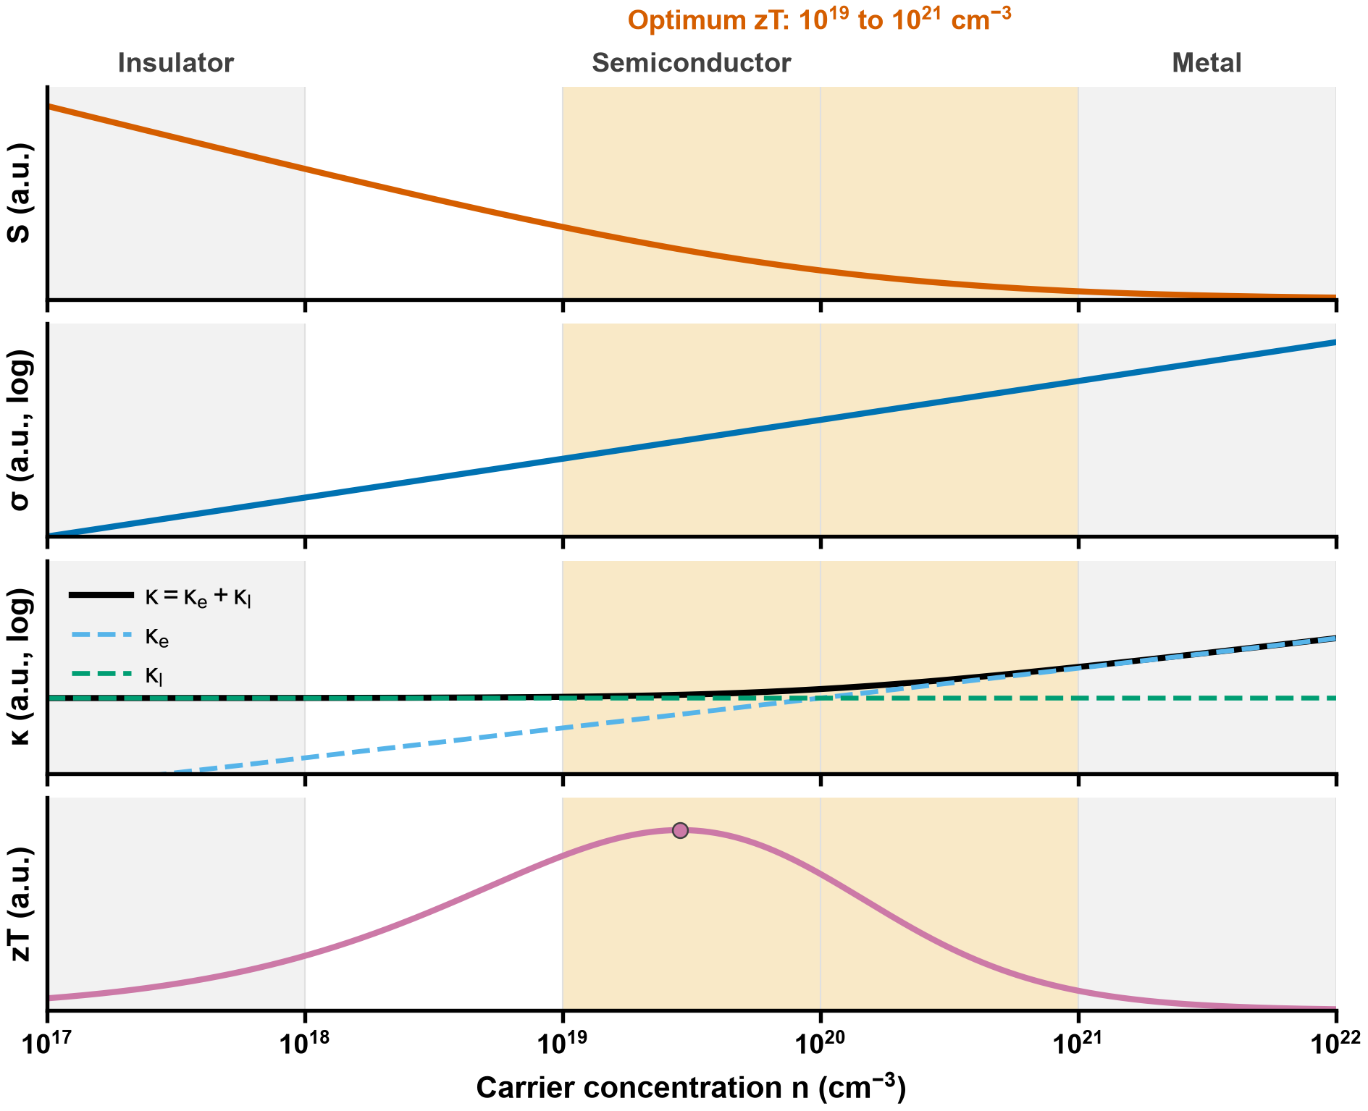
Supplementary Figure S2
Supplementary Figure S2: Schematic (drawn by the authors, arbitrary units) of the dependence of the Seebeck coefficient S, the electrical conductivity σ, the thermal conductivity κ (electronic κ_{e} and lattice κ_{l}) and the figure of merit zT on the carrier concentration n (logarithmic axis), drawn from a simple model of the dependence described by Snyder and Toberer³ (S falls with n, σ is proportional to n, κ_{e} follows σ by the Wiedemann–Franz law, κ_{l} is constant), not from data. The optimum range, 10¹⁹ to 10²¹ cm⁻³, is taken from that paper (page 105); the boundaries between insulator, semiconductor and metal are schematic.
Several strategies approach the PGEC ideal⁴. Band convergence aligns multiple band extrema to enhance the density-of-states effective mass and hence S without reducing mobility⁵. Nanostructuring introduces grain boundaries that scatter long-wavelength phonons more effectively than charge carriers, reducing κ_{l} while preserving σ⁶. Doping or alloying introduces mass and strain fluctuations that scatter phonons over a range of frequencies. Interest has also grown in materials with intrinsic bond anharmonicity: lone-pair electrons (SnSe, BiCuSeO), rattling cations in oversized cages (skutterudites, clathrates) and soft lattice modes (halide perovskites) produce strong anharmonic phonon–phonon interactions and intrinsically low κ_{l} without complex processing⁷.

Perovskite thermoelectric materials
In ABX₃ perovskites, A is a larger cation (e.g. Sr, Ca, Ba, Cs), B a smaller cation (e.g. Ti, Mn, Co, Sn) and X an anion (O, Cl, Br, I, S, Se, Te). The ideal cubic structure (space group Pm3̄m) consists of corner-sharing BX₆ octahedra with the A cation in the cuboctahedral void (Fig. 1). Structural stability is conventionally assessed by the Goldschmidt tolerance factor t and the octahedral factor µ⁸:
$t=\frac{r_{A}+r_{X}}{\sqrt{2}\left(r_{B}+r_{X}\right)}, µ=\frac{r_{B}}{r_{X}}$ (S2)
where r_{A}, r_{B} and r_{X} are the ionic radii of the A-, B- and X-site ions. The tolerance factor is an imperfect classifier of perovskite formation: Bartel et al.⁹ proposed a revised tolerance factor τ that accounts for oxidation state and classifies both oxides and halides more accurately than t. While tolerance factors provide useful first-pass estimates, the Materials Project already provides DFT-computed formation energies and energies above the convex hull, which are more reliable stability indicators; this study therefore uses Materials Project stability data directly rather than geometric criteria.
Oxide perovskites. Oxide perovskites have been studied as thermoelectrics owing to their chemical stability at high temperature and the abundance of their constituent elements. Heavily La- or Nb-doped SrTiO₃ single crystals are n-type, with Seebeck coefficients of −420 to −150 µV K⁻¹ and a thermal conductivity of 9.1 to 12 W m⁻¹ K⁻¹ at room temperature, similar to that of undoped SrTiO₃ and falling as T⁻¹ (phonon conduction); their zT is 0.02 to 0.08 at room temperature and reaches 0.27 at 1073 K¹⁰. CaMnO₃ has a Seebeck coefficient of about −350 µV K⁻¹ but its resistivity is too high; substituting Yb for part of the Ca (Ca_{0.95}Yb_{0.05}MnO₃) raised zT at 1000 K by a factor of 4 to 0.2¹¹. LaCoO₃ and its Sr-doped derivatives are p-type, with large Seebeck coefficients but modest zT¹².
Halide perovskites. Following their success in photovoltaics, halide perovskites have entered the thermoelectric field. CsSnI₃ and related all-inorganic halides exhibit lattice thermal conductivity below 0.5 W m⁻¹ K⁻¹ arising from soft, anharmonic vibrations and cation rattling in the halide cage^{13,14}, but experimental validation of high zT has been limited by the instability of tin-based compounds under ambient conditions¹⁵. In hybrid organic–inorganic perovskites such as MASnI₃, the rotational freedom of the organic cation further complicates transport and is difficult to encode in compositional feature vectors.
Chalcogenides. Chalcogenide perovskites (e.g. BaZrS₃, BaZrSe₃) and related ternary chalcogenides are attractive lead-free targets because they combine earth-abundant elements with heavy anions and low thermal conductivity¹⁶.

Computational methods and materials databases
The conventional computational route to thermoelectric properties begins with a DFT band structure from codes such as VASP¹⁷ or Quantum ESPRESSO¹⁸. Electronic transport coefficients (S, σ/τ, κ_{e}/τ) are then obtained by solving the BTE within the constant relaxation-time approximation, commonly with BoltzTraP¹⁹; because τ is assumed constant, absolute σ and κ_{e} require additional experimental input or separate calculations. Lattice thermal conductivity requires interatomic force constants from supercell calculations and solution of the phonon BTE, e.g. with ShengBTE²⁰. A complete characterization (S, σ, κ_{e}, κ_{l} at several temperatures) of one compound can take days to weeks, motivating ML surrogate models.
Starrydata2 is the largest publicly available database of experimental thermoelectric measurements, assembled by systematic digitization of published figures; each data point is linked to a paper DOI and sample ID^{21,22}. Known limitations include digitization uncertainty (a precision of 0.3% of the graph width for semi-automatic extraction, with occasional errors above 10% of the original value for points near zero on linear axes²²), inter-laboratory variability for the same nominal composition and occasional unlabeled computational data. The Materials Project provides DFT-computed crystal structures, formation energies, energies above the convex hull and band gaps for inorganic compounds via a REST API²³, but transport coefficients are not available for most entries. The ESTM (Experimentally Synthesized Thermoelectric Materials) database curated at the Korea Research Institute of Chemical Technology contains 5,205 experimental observations for 880 unique materials²⁴. ESTM was curated independently of Starrydata2, making it a valuable external validation resource. JARVIS, maintained by NIST, contains BoltzTraP-computed transport properties for thousands of compounds²⁵; these differ systematically from experiment because of the constant relaxation-time approximation and ideal-crystal assumptions.

Machine learning for thermoelectric property prediction
ML approaches are divided by input representation. Structure-based approaches use atomic coordinates, lattice vectors and site symmetry, e.g. crystal graph neural networks (CGCNN)²⁶. Composition-based methods use only the chemical formula, from which statistical summaries of elemental properties are computed; they are more broadly applicable because they do not require the crystal structure, which is often unknown for hypothetical materials. Tree ensembles (XGBoost, LightGBM, gradient-boosted decision trees) dominate composition-based thermoelectric prediction because they handle tabular features, are robust to missing values and are compatible with SHAP; deep neural networks and transformer-based models (TabPFN) have been used with mixed results. Table 1 summarizes recent studies.
Parse et al.²⁷ trained XGBoost on 18,126 cleaned Starrydata2 instances covering 2,761 compounds, split compound by compound into 80% training and 20% test data (R² = 0.815 on the test set); a 5-fold cross-validation over the whole dataset was added. Jia et al.²⁸ introduced composition-based cross-validation, excluding individual compositions rather than random rows, and obtained R² of 0.89 under 10-fold composition-based CV and 0.90 on a test set, for zT on 92,291 data points from 7,295 compositions; this is stricter than standard K-fold but less strict than system-level grouping, because members of the same chemical family (e.g. different doping levels of Bi₂Te₃) can still appear in both sets. Sun et al.²⁹ combined MAGPIE and CBFV features, selected with Pearson correlation and LassoCV, in deep neural networks (R² = 0.95 on the training set and 0.90 on the test set), the dual-featurizer approach used here. Ma and Poon³⁰ added pair-interaction descriptors (Miedema mixing enthalpy) and dopant properties, reporting modest improvements. Barua et al.³¹ trained XGBoost on ≈160,000 data points and reported R² between 0.67 and 0.80 on three test sets. Stacking ensembles on small, domain-restricted datasets^{32,33} reported R² of 0.92–0.99. Wang et al. used 10-fold cross-validation over the whole dataset, a row-level protocol of the kind whose inflation relative to chemistry-aware splitting this study quantifies; the split of Elavunkel and Padhan is not stated in its abstract and was not checked.
MAGPIE³⁴ computes six statistics (minimum, maximum, range, mean, average deviation, mode) of 22 elemental properties, yielding 132 features per composition. CBFV extends this with the Oliynyk elemental property set³⁵, including polarizability, Gordy and Mulliken electronegativities, Miracle radius, metallic valence and heat of atomization. Physics-informed descriptors such as mass variance (phonon scattering by mass disorder)³⁶, tolerance factors^{8,9} and Miedema mixing enthalpy³⁰ have also been explored.

Validation strategies and data leakage
Random train–test splitting and K-fold cross-validation assume independent and identically distributed (i.i.d.) samples; when this holds, K-fold CV provides a nearly unbiased estimate of generalization error³⁷. Data leakage from improper validation is now recognized as a widespread cause of over-optimistic results across ML-based science³⁸. Thermoelectric datasets violate the i.i.d. assumption because a material such as Bi_{0.5}Sb_{1.5}Te₃ may appear at 21 temperatures (300, 325, . . . , 800 K); under random splitting the test prediction becomes interpolation along a known temperature curve rather than extrapolation to new chemistry. Roberts et al.³⁹ showed that grouped or blocked CV, which withholds entire groups of correlated observations, is needed for unbiased estimates with structured data. In materials informatics, Meredig et al.⁴⁰ introduced leave-one-cluster-out CV, Xiong et al.⁴¹ showed that standard K-fold overstates the ability to extrapolate, and Li et al.⁴² demonstrated systematic degradation of materials ML models under distribution shift. chemistry-cluster CV assigns all measurements of one group exclusively to training or test. The grouping can be defined at the level of compositions (as in²⁸), element sets (e.g. Bi–Sb–Te), chemistry clusters (Section 2.4) or broader families; stricter grouping gives more conservative but more realistic estimates for genuinely new chemistry.

Model interpretability
SHAP (SHapley Additive exPlanations) attributes each prediction to features using Shapley values from cooperative game theory, and TreeExplainer computes exact values in polynomial time for tree ensembles⁴³. SHAP provides consistent global (mean |SHAP|) and local explanations, unlike gain-based importance. LIME fits local linear surrogates around individual predictions⁴⁴ but does not provide global patterns. In thermoelectrics, interpretability is a tool for scientific validation: if melting temperature dominates predictions of κ, this is consistent with known physics (bond strength governs phonon velocity), whereas a dominant but physically irrelevant feature would indicate a spurious correlation.

Supplementary Note S2: The eleven cleaning steps in detail (supplement to Section 2.1)
Data preparation (steps 1–5). Step 1 extracted the four target properties, converted resistivity to conductivity and applied physical-range bounds: −1000 ≤ S ≤ 1000 µV K⁻¹, 10 ≤ σ ≤ 10⁷ S m⁻¹, 0.05 ≤ κ ≤ 25 W m⁻¹ K⁻¹ and 0 ≤ zT ≤ 4, giving 1,996,047 observations. The Seebeck bound is an empirical cap that excludes gross digitization errors rather than imposing a tight physical limit; the σ and κ limits correspond approximately to the semiconductor–insulator boundary and to a permissive value below amorphous (Cahill–Pohl) limits⁴⁵, respectively (the Cahill–Pohl limit is material-specific, so the κ bound is not itself that minimum); and the zT bound of 4 is a choice of this study, set above the zT of 2.6 ± 0.3 reported at 923 K for SnSe single crystals along the b axis⁷; it is not a physical limit. Step 2 merged curve data with sample metadata. Step 3 restricted temperatures to 300–800 K and binned them into 25 K intervals so that slightly different reported temperatures (e.g. 300, 310 and 320 K) fall in the same bin, leaving 1,096,324 observations. Step 4 pivoted the data from long format (one row per measurement) to wide format (one row per sample per temperature bin), giving 398,763 rows, and Step 5 removed formulas that could not be parsed by the pymatgen Composition class⁴⁶ (5,382 rows, 1.3%).
Quality filtering (steps 6–8). Step 6 compared the reported zT with the value recomputed from Eq. (1) for all rows containing the four properties and removed rows whose relative discrepancy exceeded 50%:
$\frac{|{zT}_{rep}−S^{2}σT/κ|}{{zT}_{rep}}>0.5$ (S3)
This removed 4,712 rows (1.2%); it changed the mean zT from 0.383 to 0.387. This is conservative (some valid individual property measurements may be lost), but guarantees internal consistency of the retained rows. Step 7 removed DFT-computed entries identified by searching paper metadata for keywords such as “DFT”, “first principles”, “ab initio” and “VASP”, because such values differ systematically from experiment owing to the constant relaxation-time assumption; only 986 rows (0.3%) were flagged, confirming that Starrydata2 is predominantly experimental. Step 8, the largest single step, removed 78,685 rows (20.3%): for each (formula, temperature) group with multiple measurements, the coefficient of variation (CV) was computed and groups exceeding property-specific thresholds were removed (0.5 for S, κ and zT; 0.8 for σ, set higher a priori because conductivity varies more between samples); these are starting values fixed before any model was trained, not values tuned on model performance.
Statistical filtering (steps 9–11). Step 9 applied a median absolute deviation (MAD) filter, removing values with
$|x−median(x)|>3.5 MAD(x)$ (S4)
a robust alternative to a rule based on the mean and standard deviation⁴⁷, where x is S, log₁₀ σ or log₁₀ κ, and the median and the MAD, MAD(x) = median(|x − median(x)|), are taken over all rows that have a value of that property. The MAD is unscaled (no 1.4826 consistency factor), so the multiplier of 3.5 MADs corresponds to about 2.4 standard deviations for normally distributed data; it is a choice of this study (see below), not the multiplier recommended in the cited work. The MAD filter was applied to S, σ and κ but not to zT, a derived quantity whose plausibility is better judged against the physical bounds of Step 1; it removed 19,361 rows (6.3%). Rows with zT > 3.0 lie above the zT of 2.6 ± 0.3 reported at 923 K for SnSe single crystals along the b axis⁷; 15 of the 129,419 zT rows (0.012%) are affected; they are retained as statistically immaterial. Step 10 removed formulas with fewer than 3 distinct temperatures, for which consistency cannot be verified (4,650 rows). Step 11 applied a rolling-median smoothness filter (window = 3) to each temperature curve of each sample and property: a point is a spike if it deviates from the centred rolling median by more than 3.5 times the median of those absolute deviations along that curve (the same unscaled multiplier as Step 9, applied to the local deviations), setting 25,166 spike values to NaN and removing rows in which all properties became NaN (4,323 rows, 1.5%).

Supplementary Note S3: Reading the literature values: rules of the comparison (supplement to Section 2.6)
Reading the literature. Values are read from the PDFs only, with page and figure or table, and marked as table, text or digitised. A value read from a figure carries the tool (vector extraction from the PDF where the figure is vector, WebPlotDigitizer, version 5, clicks on the scan otherwise⁴⁸) and the axis calibration; no uncertainty is attached to a digitised marker, and an uncertainty is recorded only where the paper prints one. Discrete markers are read at their own measurement temperature and assigned to the 25 K floor bins of the cleaning pipeline (a bin is labelled by its lower edge, so the lowest bin is labelled 300 K); curves, and only curves, are read on a 100 K grid (300 to 700 K). Values below 300 K (room temperature, 298.15 K) or at or above 800 K are recorded and not compared. Derived curves are not read (Wiedemann-Franz electronic conductivity, fitted lines, DFT and Boltzmann-transport results). Units are converted to those of the pipeline (S: µV K⁻¹, σ: S m⁻¹, κ: W m⁻¹ K⁻¹; zT as stated, or Z multiplied by the temperature). Where S, σ (or resistivity), κ and zT are all read at one temperature, zT is recomputed from the other three and the ratio is reported against the printed value; where the temperatures differ (κ of the SrTiO₃ crystals) an interpolated, labelled approximate check is made. These checks are reported, never used to exclude or change a value. A value takes the temperature the paper states for it (Shibasaki et al., Fig. 5: 300 K), not the drawn position of its marker. Where the clicked value axis of a digitising project did not match the printed ticks (Rajasekaran et al., Fig. 10), the value is read at the click’s pixel row on the printed ticks and the clicked values are not used; the abstract’s printed value is then a check. A table value with no stated temperature (Rajasekaran et al., Table 2) is not read.
Marker temperatures in figures with several series. In a figure whose series were measured at common temperatures, the temperature of a marker is the consensus of its column: the mean of the marker-centre temperatures of the series, read on a straight line through the printed ticks of the axis (the calibration uncertainty u is the largest residual of that line); where several figures report one measurement run, a column has one temperature, the mean of the figures’ consensus weighted by $1/u^{2}$. The marker centre is the centroid of the enclosed white interior of an open symbol or of the opened body of a filled one; a symmetry fit is used only for symbols with no enclosed interior (hatched, dotted, plus). Where the series do not share temperatures (Ohtaki et al., Figs. 4 and 6), every marker has its own temperature. For an axis of $1000/T$ (Ohtaki et al., Fig. 1), $T=1000/x$, $u(T)=T^{2}/1000 u(x)$, and x is interpolated between the bottom and the top tick lines because the scan is tilted; for Rajasekaran et al., Fig. 10, the small tilt of the frame is corrected from the frame’s own edges.
Edge sensitivity. A value whose temperature lies within 2 u of a bin edge is compared in its floor bin (the headline) and also in the neighbouring bin; both are reported, together with the overall summary under the neighbouring-bin assignment and the values whose result changes.
Legibility. Only markers whose centre can be placed are read. The enclosed interior of an open symbol, or the opened body of a filled one, is searched in two passes (a window centred on the click, then on what the first pass found) so that a marker is not clipped when the click is off-centre. A marker overlapped by another symbol is recorded as not legible, with its series and column, in a list derived from the digitised files and not typed; the count is reported with the results. A click whose centre the estimator cannot place is skipped. Three image-derived gates apply, with the same thresholds, to every digitised scanned figure (Ohta et al., Figs. 1, 2, 3 and 4; Ohtaki et al., Figs. 1, 4, 6 and 7; Rajasekaran et al., Fig. 10): a marker is removed if its enclosed interior is smaller than 0.8 of the median of its series (interior partly covered), if a left-right symmetry fit computed on its opened body (which a joining line does not bias) and its interior centre are more than 10 px apart, or if its image temperature is more than 15 K from the temperature of its click. The columns of a figure for the not-legible list are derived from a reference series (and a 20 K gap) where the series share columns, and from the clustering of all markers where they do not.
Paper-specific rules. For Shibasaki et al., only undoped LaRhO₃ is compared (the pre-registered compound is the undoped member); the Ni- and Mg-substituted members are recorded and not compared. The rows come from Fig. 5, which states 300 K; the end markers of Figs. 2 and 4 are a cross-check. Where a Fig. 5 value lies within 1% of its axis range it cannot be read, and the same sample’s value at that temperature is taken from the figure that resolves it: this applies to the conductivity of undoped LaRhO₃, taken from the end markers of the unsubstituted series of Figs. 2 and 4. For Rajasekaran et al., the rows come from Fig. 10, panels (a) and (b) (BaSnO₃ with La at the Ba site; the undoped sample has no conductivity or Seebeck coefficient in the paper), each row compared at the cluster level.

Supplementary Note S4: The five validation methods (supplement to Section 3.1.1)
Supplementary Table S3 and Supplementary Figure S3 compare the five validation methods. Random split, 5-fold and 10-fold CV give practically identical R² (maximum difference 0.002 per target), showing that all three leak the same temperature-series information and that increasing the number of folds does not address the leakage.
Supplementary Table S3: R² obtained with five validation methods (same model, frozen hyperparameters and 397 features). Random 80/20 pools 20 independent draws; 5-fold and 10-fold are single partitions; composition and chemistry cluster are the mean ± SD across 5 repeats. ∆R² is random 80/20 minus chemistry cluster.
Target | Random 80/20 | 5-fold | 10-fold | Composition | Chemistry cluster | ∆R²
S | 0.958 | 0.958 | 0.960 | 0.832 ± 0.004 | 0.753 ± 0.005 | +0.205
σ | 0.915 | 0.915 | 0.917 | 0.776 ± 0.002 | 0.702 ± 0.002 | +0.213
κ | 0.943 | 0.944 | 0.946 | 0.857 ± 0.001 | 0.809 ± 0.002 | +0.134
zT | 0.918 | 0.918 | 0.919 | 0.818 ± 0.001 | 0.746 ± 0.005 | +0.172
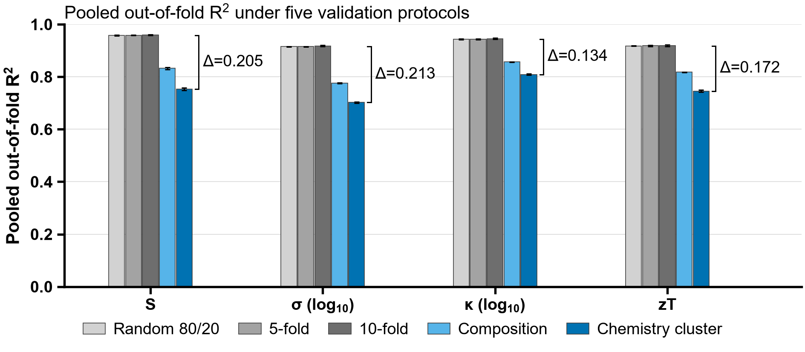
Supplementary Figure S3
Supplementary Figure S3: Pooled R² across the five validation methods. Chemistry-cluster CV is the lowest for every target; ∆ is random 80/20 minus chemistry cluster. Error bars are the standard deviations defined in Supplementary Table S3.

Supplementary Note S5: Weights of the stacking ensemble (supplement to Section 3.1.2)
The fitted weights are not interpreted: the three models’ predictions are near-collinear (the correlation of any pair within any fold is at least 0.976), the weights range from 0.01 to 0.70 over the 100 fits, and the largest spread of one model’s weight across the 25 folds of a target is 0.35 to 0.60 (depending on the target).

Supplementary Note S6: The carrier-type classifier in detail (supplement to Section 3.1.3)
For the p class precision is 0.955 (0.940–0.966) and recall 0.951 (0.938–0.962), for the n class 0.940 (0.930–0.948) and 0.944 (0.934–0.954), and the area under the ROC curve is 0.987 (0.985–0.990, first repeat only). Summed over the five repeats the confusion matrix is 388,028 n-type rows correct and 22,832 predicted p; 24,978 p-type rows predicted n and 489,442 correct. Accuracy is lower for the 59 rows of single-row clusters (0.78) and for clusters of two to nine rows (0.92) than for larger ones.

Supplementary Note S7: Feature selection: protocol, convergence, device and a post hoc check (supplement to Section 3.1.4)
Inside every outer training fold (5 repeats of 5 folds, the folds of Section 3.1.1) three steps were applied to the training rows only: a Pearson filter that drops one of each pair of features with |r| above 0.95, a LassoCV (20 penalties, inner chemistry-cluster folds) that keeps the features with non-zero coefficients, and a ranking of those by mutual information with the target on a subsample of 20,000 rows, from which the top k of the earlier work were kept. The target’s frozen XGBoost was then fitted twice on the same training rows, on the selected features and on all 397, and scored on the same test rows, on one machine and one device. The earlier work names the three steps and the number of features it kept per target, but not the settings of the steps. The number kept, k, is the earlier work’s, used to reproduce what it compared and not as a recommended choice. The remaining settings were fixed before any result of the comparison was seen and none was tuned: the Pearson threshold, a common near-duplicate cut; the penalty grid and the three inner chemistry-cluster folds of the LassoCV, with scikit-learn’s defaults for the range of the grid and for the tolerance; and the size of the mutual-information subsample, chosen for run time. The one setting changed in the course of this work is the Lasso’s iteration limit (below). Because the earlier work did not state the settings, the comparison tests the procedure as instantiated here; other settings could change the numbers.
Convergence. At the first setting tried, 2000 iterations, every one of the 20 folds diagnosed (the first repeat of each target) raised a convergence warning (258 warnings); at 20,000 iterations none did, and that setting is used throughout. The selected sets nevertheless depend on the setting: the Jaccard similarity between the sets chosen at the two settings has a median of 0.93 and a minimum of 0.56, and the fold R² changed by more than 0.005 in 6 of the 20 folds (mean absolute change 0.003), so a selection made at the lower setting depends on the number of iterations. The change in R² is not interpreted on its own: a per-fold change of 0.005 is comparable to the variation caused by running the same fit with the same selected set on a different machine, 0.0062 in the one fold compared (the first fold of the first repeat for κ, a Windows PC and a Linux server, both on the CPU). Of the 100 selection fits at the adopted setting, 1 raised a convergence warning (S, repeat 2, fold 0, in an inner path of the penalty search; its final refit converged).
Device. The XGBoost fits were run with the CUDA device requested (a Tesla V100S is listed in the run record). The scripts record the device requested, not the device the booster used; the paired comparison does not depend on it, because both fits of a fold ran on the same machine and device. The all-397 fits reproduce the committed chemistry-cluster values of Section 3.1.1, which were fitted on a different machine, to within 1.2 × 10⁻¹⁶ in every fold.
Post hoc check (exploratory; added after the result above was seen, and it does not change it). The feature temperature_bin is one of the 397 features and was selected in none of the 100 folds. Refitting the frozen model on the selected features plus temperature_bin, on the same folds and device, gives R² of 0.720 (S), 0.687 (σ), 0.795 (κ) and 0.736 (zT), which recovers 34%, 61%, 70% and 97% of the gap between the selected set and all 397 (pooled per-repeat means). The combined set still stays below all 397 in 25, 24, 24 and 20 of the 25 folds. These figures are descriptive: no threshold, interval or test was set for them, and the grouped comparison above remains the result.
Supplementary Table S4: Chemistry-cluster CV R² (mean ± SD over 5 repeats of 5 grouped folds) of each target’s frozen XGBoost on all 397 features and on the features kept by the selection of the earlier work, applied inside every outer training fold (Pearson filter at |r| = 0.95, a LassoCV over 20 penalties, then the top k by mutual information on a 20,000-row subsample; k = 25, 44, 39, 32 for S, σ, κ, zT). Both fits of a fold use the same rows, machine and device. The paired difference is the comparison fixed before the run (difference of the pooled R², chemistry-cluster bootstrap interval in brackets). The last three rows are post hoc and exploratory: the same selected features plus temperature_bin, added after the result above was seen; no interval or test is attached to them.
Quantity | S | σ | κ | zT
All 397 features | 0.753 ± 0.005 | 0.702 ± 0.002 | 0.809 ± 0.002 | 0.746 ± 0.005
Selected features (k imposed) | 0.702 ± 0.008 | 0.664 ± 0.003 | 0.762 ± 0.003 | 0.451 ± 0.006
Selected minus all 397 (paired, fixed before the run) | −0.050 [−0.060, −0.042] | −0.038 [−0.045, −0.032] | −0.047 [−0.057, −0.038] | −0.295 [−0.328, −0.262]
Features kept by the Lasso, mean (range over 25 folds) | 182 (129–206) | 156 (119–184) | 184 (176–195) | 161 (138–183)
k (earlier work) | 25 | 44 | 39 | 32
Post hoc: selected + temperature_bin | 0.720 ± 0.010 | 0.687 ± 0.003 | 0.795 ± 0.003 | 0.736 ± 0.005
Post hoc: (selected + temperature_bin) minus all 397 | −0.033 | −0.015 | −0.014 | −0.009
Post hoc: share of the selected-to-all-397 gap recovered (%) | 34 | 61 | 70 | 97
Post hoc: folds of 25 with selected + temperature_bin below all 397 | 25 | 24 | 24 | 20

Supplementary Note S8: Feature importance in detail (supplement to Section 3.1.5)
SHAP values are in the units of each target (µV K⁻¹ for S; log₁₀ units for σ and κ). Feature labels read “Elemental , (MAGPIE or CBFV)”: the property is one of the elements, the statistic is taken over the elements of the formula (mean = atomic-fraction-weighted mean, mean abs. deviation = the weighted mean absolute deviation about that mean, range, minimum and maximum over the elements, mode = the value of the most abundant element). For S the top feature, for instance, is the spread of the elemental thermal conductivities of the formula, not the thermal conductivity of the sample.
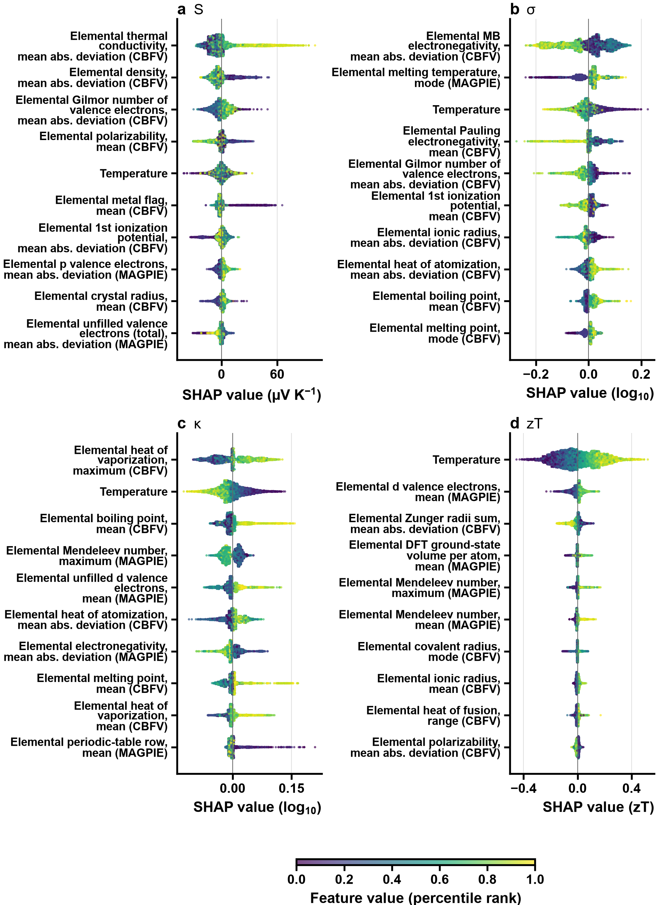
Supplementary Figure S4
Supplementary Figure S4: SHAP beeswarm plots for (a) S, (b) σ, (c) κ and (d) zT: one point per test row (5,000 per model, first repeat of the chemistry-cluster folds), coloured by the percentile rank of the row’s value of the feature; the features are the ones with the largest mean |SHAP| among these rows, so their order can differ from Fig. 6, which averages all folds of all repeats. Every feature other than temperature is a statistic of an ELEMENTAL property of the elements in the formula, not a measured property of the material (for S, the top feature is the spread of the elemental thermal conductivities, not the sample’s thermal conductivity).
The two featurization schemes contribute differently to the targets (Supplementary Figure S5). In the zT model, temperature accounts for 20% of the mean |SHAP|, CBFV features for 53% and MAGPIE features for 28% (shares over all 397 features, chemistry-cluster folds). In the other models temperature accounts for 2% (S), 4% (σ) and 5% (κ), CBFV features for 69%, 68% and 60%, and MAGPIE features for 29%, 28% and 35%. CBFV features carry the largest share of every model (53 to 69%), but they are also the more numerous (264 against 132 MAGPIE features): per feature, the mean share of a CBFV feature is 0.85 to 1.22 times that of a MAGPIE feature, so neither scheme is more informative per feature. Both carry a substantial share of every model; this attribution does not show whether either could be dropped.
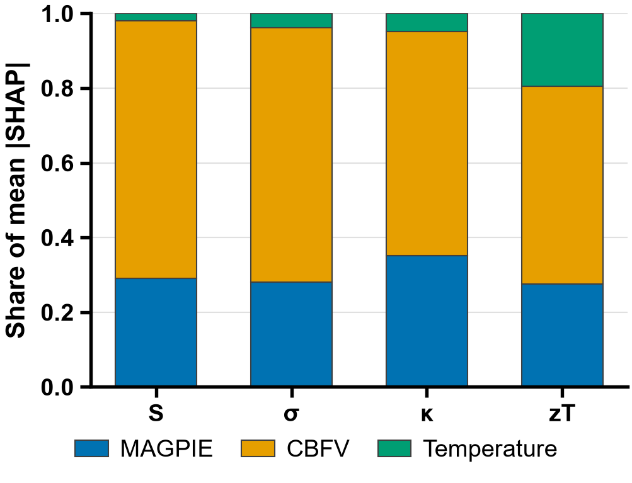
Supplementary Figure S5
Supplementary Figure S5: Relative contribution of MAGPIE, CBFV and temperature features (share of mean |SHAP| over all features) to each model.

Supplementary Note S9: Direct versus component-wise zT prediction in detail (supplement to Section 3.1.6)
Direct zT prediction was compared with the component-wise derivation S²σT/κ under chemistry-cluster CV (Supplementary Table S5). Direct prediction is more accurate (R² = 0.727 vs 0.540), with each model using its own target’s frozen hyperparameters. The derived pathway suffers from error propagation; to first order, the relative error of the derived zT is
$\frac{δzT}{zT}≈\sqrt{{\left(2\frac{δS}{S}\right)}^{2}+{\left(\frac{δσ}{σ}\right)}^{2}+{\left(\frac{δκ}{κ}\right)}^{2}}$ (S5)
so the quadratic dependence on S doubles its relative error, and the weakest component model (σ, R² = 0.692, against 0.820 for S and 0.821 for κ) adds a large further term. Back-transforming the log-space predictions of σ and κ with a smearing correction changes the derived R² by −0.005, too little to alter the comparison. The individual component models remain useful diagnostically: a material predicted to have high S but low σ, for example, may benefit from carrier-concentration optimization through doping. The comparison was repeated under random row-level validation (shuffled 5-fold, five repeats, the same 56,088 rows and the same frozen hyperparameters; Supplementary Table S5). Direct prediction is again more accurate (R² = 0.917 vs 0.880), so the ordering does not depend on grouped validation. The size of the advantage does: the gap between the two pathways is 0.036 under random validation and 0.186 under chemistry-cluster validation (differences of unrounded R²), a factor of 5.1. Random validation therefore understates how much the derived route loses when it has to generalize to unseen chemistry.
Supplementary Table S5: Direct versus component-wise zT prediction on the 56,088 rows with all four properties present (4,139 chemistry clusters); each model uses its own target’s frozen hyperparameters. Chemistry-cluster CV is 5 repeats x 5 folds of grouped folds; random CV is 5 repeats x 5 folds of shuffled row-level folds; both pool the out-of-fold predictions (n = 280,440).
Pathway | R² (chemistry-cluster) | MAE (chemistry-cluster) | R² (random) | MAE (random)
Direct (features → zT) | 0.727 | 0.132 | 0.917 | 0.072
Derived (S²σT/κ) | 0.540 | 0.166 | 0.880 | 0.083

Supplementary Note S10: The literature comparison per paper (supplement to Section 3.4)
Supplementary Table S6: Comparison of out-of-fold predictions with published measurements, per paper. n: values compared; inside: values whose absolute relative error is within the relative uncertainty of the measurement (S 0.06, σ 0.08, κ 0.11, zT 0.19), with the fraction; median abs. rel. error: median absolute relative error (linear units); log₁₀ ratio: median absolute and signed median of log₁₀(prediction) − log₁₀(literature) for σ and κ. Exact level: the same composition at the same temperature bin; cluster level: the mean of the held-out predictions of the sample’s chemistry cluster at that bin (a family average). Part A: the independent papers; Part B: the papers whose DOI is among the DOIs of the training data (training sources), not pooled with part A.
Part A: independent papers.
Paper | Level | Property | n | Inside (fraction) | Median abs. rel. error | Median abs. log₁₀ ratio | Signed median log₁₀ ratio
Ohtaki et al.⁴⁹ | exact | S | 10 | 3 (0.300) | 0.086 | – | –
Ohtaki et al.⁴⁹ | exact | σ | 22 | 0 (0.000) | 0.416 | 0.206 | −0.185
Ohtaki et al.⁴⁹ | exact | κ | 2 | 0 (0.000) | 0.362 | 0.195 | −0.195
Ohtaki et al.⁴⁹ | exact | zT | 3 | 0 (0.000) | 1.139 | – | –
Sebastia-Luna et al.⁵⁰ | exact | S | 3 | 0 (0.000) | 0.449 | – | –
Sebastia-Luna et al.⁵⁰ | exact | σ | 3 | 0 (0.000) | 4.896 | 0.768 | +0.768
Sebastia-Luna et al.⁵⁰ | exact | κ | 3 | 0 (0.000) | 0.160 | 0.062 | +0.062
Sebastia-Luna et al.⁵⁰ | exact | zT | 3 | 0 (0.000) | 5.194 | – | –
Singh and Pandey⁵¹ | exact | S | 3 | 1 (0.333) | 0.145 | – | –
Ohtaki et al.⁴⁹ | cluster | S | 40 | 0 (0.000) | 0.596 | – | –
Ohtaki et al.⁴⁹ | cluster | σ | 66 | 7 (0.106) | 6.105 | 0.851 | +0.851
Ohtaki et al.⁴⁹ | cluster | κ | 5 | 1 (0.200) | 0.248 | 0.124 | −0.124
Ohtaki et al.⁴⁹ | cluster | zT | 5 | 0 (0.000) | 0.917 | – | –
Sebastia-Luna et al.⁵⁰ | cluster | S | 3 | 0 (0.000) | 0.504 | – | –
Sebastia-Luna et al.⁵⁰ | cluster | σ | 3 | 0 (0.000) | 5.230 | 0.793 | +0.793
Sebastia-Luna et al.⁵⁰ | cluster | κ | 3 | 0 (0.000) | 0.137 | 0.054 | +0.054
Sebastia-Luna et al.⁵⁰ | cluster | zT | 3 | 0 (0.000) | 4.485 | – | –
Singh and Pandey⁵¹ | cluster | S | 13 | 0 (0.000) | 0.354 | – | –
Overall, independent papers: papers weigh equally (the mean over papers of the fraction inside the band; the median over papers of each paper’s median).
Level | Property | Papers | Mean fraction inside | Median of median abs. rel. error | Median of median abs. log₁₀ ratio | Median of signed median log₁₀ ratio
exact | S | 3 | 0.211 | 0.145 | – | –
exact | σ | 2 | 0.000 | 2.656 | 0.487 | +0.291
exact | κ | 2 | 0.000 | 0.261 | 0.128 | −0.067
exact | zT | 2 | 0.000 | 3.166 | – | –
cluster | S | 3 | 0.000 | 0.504 | – | –
cluster | σ | 2 | 0.053 | 5.668 | 0.822 | +0.822
cluster | κ | 2 | 0.100 | 0.193 | 0.089 | −0.035
cluster | zT | 2 | 0.000 | 2.701 | – | –
Part B: training-source papers (not pooled with part A).
Paper | Level | Property | n | Inside (fraction) | Median abs. rel. error | Median abs. log₁₀ ratio | Signed median log₁₀ ratio
Flahaut et al.¹¹ | exact | σ | 4 | 0 (0.000) | 0.550 | 0.348 | −0.348
Shibasaki et al.⁵² | exact | S | 1 | 0 (0.000) | 0.601 | – | –
Flahaut et al.¹¹ | cluster | S | 6 | 0 (0.000) | 0.846 | – | –
Flahaut et al.¹¹ | cluster | σ | 13 | 1 (0.077) | 0.331 | 0.175 | −0.175
Flahaut et al.¹¹ | cluster | κ | 15 | 2 (0.133) | 0.271 | 0.104 | +0.104
Flahaut et al.¹¹ | cluster | zT | 12 | 4 (0.333) | 0.629 | – | –
Ohta et al.¹⁰ | cluster | S | 35 | 0 (0.000) | 0.544 | – | –
Ohta et al.¹⁰ | cluster | σ | 34 | 0 (0.000) | 0.874 | 0.388 | +0.269
Ohta et al.¹⁰ | cluster | κ | 16 | 10 (0.625) | 0.091 | 0.039 | −0.020
Ohta et al.¹⁰ | cluster | zT | 19 | 2 (0.105) | 0.473 | – | –
Rajasekaran et al.⁵³ | cluster | S | 5 | 0 (0.000) | 0.433 | – | –
Rajasekaran et al.⁵³ | cluster | σ | 2 | 0 (0.000) | 16.319 | 1.173 | +1.173
Shibasaki et al.⁵² | cluster | S | 1 | 0 (0.000) | 0.601 | – | –
Supplementary Table S7: Edge sensitivity: the overall summary of the independent papers (papers weigh equally) with every value that lies within twice the calibration uncertainty of a temperature-bin edge evaluated in its floor bin (headline) and in the neighbouring bin.
Level | Property | Fraction inside, headline | Fraction inside, neighbouring bin | Median abs. rel. error, headline | Median abs. rel. error, neighbouring bin | Median abs. log₁₀ ratio, headline | Median abs. log₁₀ ratio, neighbouring bin
exact | S | 0.211 | 0.111 | 0.145 | 0.313 | – | –
exact | σ | 0.000 | 0.000 | 2.656 | 2.659 | 0.487 | 0.488
exact | κ | 0.000 | 0.000 | 0.261 | 0.265 | 0.128 | 0.131
exact | zT | 0.000 | 0.000 | 3.166 | 3.098 | – | –
cluster | S | 0.000 | 0.000 | 0.504 | 0.504 | – | –
cluster | σ | 0.053 | 0.045 | 5.668 | 5.700 | 0.822 | 0.824
cluster | κ | 0.100 | 0.125 | 0.193 | 0.189 | 0.089 | 0.088
cluster | zT | 0.000 | 0.000 | 2.701 | 2.701 | – | –

Supplementary Note S11: Nomenclature and abbreviations
The symbols and abbreviations used in the manuscript are listed in Supplementary Table S8.
Supplementary Table S8: Symbols and abbreviations used in the manuscript.
Symbol / abbreviation | Meaning
AI | Artificial intelligence
ML | Machine learning
DL | Deep learning
TE | Thermoelectric
DFT | Density functional theory
BTE | Boltzmann transport equation
PGEC | Phonon-glass electron-crystal
XGBoost | Extreme gradient boosting
LightGBM | Light gradient boosting machine
GBDT | Gradient-boosted decision trees
RF | Random forest
DNN | Deep neural network
CGCNN | Crystal graph convolutional neural network
TabPFN | Tabular prior-data fitted network
CV | Cross-validation (also coefficient of variation in Step 8)
MAGPIE | Materials-Agnostic Platform for Informatics and Exploration
CBFV | Composition-based feature vector
SHAP | SHapley Additive exPlanations
LIME | Local interpretable model-agnostic explanations
MAE | Mean absolute error
MAD | Median absolute deviation
MP | Materials Project
ESTM | Experimentally Synthesized Thermoelectric Materials (database)
JARVIS | Joint Automated Repository for Various Integrated Simulations
VASP | Vienna Ab initio Simulation Package
KRICT | Korea Research Institute of Chemical Technology
API | Application programming interface
REST | Representational state transfer
zT | Dimensionless figure of merit
S | Seebeck coefficient
σ | Electrical conductivity
κ, κ_{e}, κ_{l} | Total, electronic and lattice thermal conductivity
PF | Power factor (S²σ)
L | Lorenz number
R² | Coefficient of determination
T | Absolute temperature
E_{hull} | Energy above the convex hull
E_{g} | Band gap
ABX₃ | General perovskite stoichiometry
1. Rowe, D. M. Thermoelectrics Handbook: Macro to Nano. (CRC Press, 2005). doi:10.1201/9781420038903.
2. Goldsmid, H. J. Introduction to Thermoelectricity. (Springer Berlin Heidelberg, 2010). doi:10.1007/978-3-642-00716-3.
3. Snyder, G. J. & Toberer, E. S. Complex thermoelectric materials. Nature Materials 7, 105–114 (2008).
4. Slack, G. New materials and performance limits for thermoelectric cooling. in CRC handbook of thermoelectrics (CRC Press, 1995). doi:10.1201/9781420049718.ch34.
5. Pei, Y. et al. Convergence of electronic bands for high performance bulk thermoelectrics. Nature 473, 66–69 (2011).
6. Biswas, K. et al. High-performance bulk thermoelectrics with all-scale hierarchical architectures. Nature 489, 414–418 (2012).
7. Zhao, L.-D. et al. Ultralow thermal conductivity and high thermoelectric figure of merit in SnSe crystals. Nature 508, 373–377 (2014).
8. Goldschmidt, V. M. Die gesetze der krystallochemie. Die Naturwissenschaften 14, 477–485 (1926).
9. Bartel, C. J. et al. New tolerance factor to predict the stability of perovskite oxides and halides. Science Advances 5, eaav0693 (2019).
10. Ohta, S., Nomura, T., Ohta, H. & Koumoto, K. High-temperature carrier transport and thermoelectric properties of heavily la- or nb-doped SrTiO3 single crystals. Journal of Applied Physics 97, 034106 (2005).
11. Flahaut, D., Funahashi, R., Lee, K., Ohta, H. & Koumoto, K. Effect of the yb substitutions on the thermoelectric properties of CaMnO3. in 2006 25th international conference on thermoelectrics 103–106 (IEEE, 2006). doi:10.1109/ict.2006.331291.
12. Androulakis, J., Migiakis, P. & Giapintzakis, J. La 0.95 sr 0.05 CoO 3 : An efficient room-temperature thermoelectric oxide. Applied Physics Letters 84, 1099–1101 (2004).
13. Lee, W. et al. Ultralow thermal conductivity in all-inorganic halide perovskites. Proceedings of the National Academy of Sciences 114, 8693–8697 (2017).
14. Xie, H. et al. All-inorganic halide perovskites as potential thermoelectric materials: Dynamic cation off-centering induces ultralow thermal conductivity. Journal of the American Chemical Society 142, 9553–9563 (2020).
15. Stoumpos, C. C., Malliakas, C. D. & Kanatzidis, M. G. Semiconducting tin and lead iodide perovskites with organic cations: Phase transitions, high mobilities, and near-infrared photoluminescent properties. Inorganic Chemistry 52, 9019–9038 (2013).
16. Sopiha, K. V., Comparotto, C., Márquez, J. A. & Scragg, J. J. S. Chalcogenide perovskites: Tantalizing prospects, challenging materials. Advanced Optical Materials 10, 2101704 (2021).
17. Kresse, G. & Furthmüller, J. Efficient iterative schemes for ab initio total-energy calculations using a plane-wave basis set. Physical Review B 54, 11169–11186 (1996).
18. Giannozzi, P. et al. QUANTUM ESPRESSO: A modular and open-source software project for quantum simulations of materials. Journal of Physics: Condensed Matter 21, 395502 (2009).
19. Madsen, G. K. H. & Singh, D. J. BoltzTraP. A code for calculating band-structure dependent quantities. Computer Physics Communications 175, 67–71 (2006).
20. Li, W., Carrete, J., A. Katcho, N. & Mingo, N. ShengBTE: A solver of the boltzmann transport equation for phonons. Computer Physics Communications 185, 1747–1758 (2014).
21. Katsura, Y. et al. Data-driven analysis of electron relaxation times in PbTe-type thermoelectric materials. Science and Technology of Advanced Materials 20, 511–520 (2019).
22. Katsura, Y. et al. Starrydata: From published plots to shared materials data. Science and Technology of Advanced Materials: Methods 5, 2506976 (2025).
23. Jain, A. et al. Commentary: The materials project: A materials genome approach to accelerating materials innovation. APL Materials 1, 011002 (2013).
24. Na, G. S. & Chang, H. A public database of thermoelectric materials and system-identified material representation for data-driven discovery. npj Computational Materials 8, (2022).
25. Choudhary, K. et al. The joint automated repository for various integrated simulations (JARVIS) for data-driven materials design. npj Computational Materials 6, 173 (2020).
26. Xie, T. & Grossman, J. C. Crystal graph convolutional neural networks for an accurate and interpretable prediction of material properties. Physical Review Letters 120, 145301 (2018).
27. Parse, N. et al. Predicting high-performance thermoelectric materials with StarryData2. Advanced Theory and Simulations 7, (2024).
28. Jia, X., Aziz, A., Hashimoto, Y. & Li, H. Dealing with the big data challenges in AI for thermoelectric materials. Science China Materials 67, 1173–1182 (2024).
29. Sun, Y., Chen, X., Gao, J., Zhu, W. & Pan, M. Rationally design thermoelectric materials based on ingenious machine learning methods. Advanced Electronic Materials 11, 2500210 (2025).
30. Ma, C. T. & Poon, S. J. Reexamining machine learning models on predicting thermoelectric properties. (2025).
31. Barua, N. K., Lee, S., Oliynyk, A. O. & Kleinke, H. Thermoelectric material performance (zT) predictions with machine learning. ACS Applied Materials & Interfaces 17, 1662–1673 (2025).
32. Wang, Y. et al. High-performance stacking ensemble learning for thermoelectric figure-of-merit prediction. Materials & Design 249, 113552 (2025).
33. Elavunkel, V. K. & Padhan, P. Unlocking thermoelectric potential: A machine learning stacking approach for half-heusler alloys. ACS Applied Energy Materials 8, 15241–15257 (2025).
34. Ward, L., Agrawal, A., Choudhary, A. & Wolverton, C. A general-purpose machine learning framework for predicting properties of inorganic materials. npj Computational Materials 2, (2016).
35. Oliynyk, A. O. et al. High-throughput machine-learning-driven synthesis of full-Heusler compounds. Chemistry of Materials 28, 7324–7331 (2016).
36. Tamura, S. Isotope scattering of dispersive phonons in ge. Physical Review B 27, 858–866 (1983).
37. Hastie, T., Tibshirani, R. & Friedman, J. The Elements of Statistical Learning. (Springer New York, 2009). doi:10.1007/978-0-387-84858-7.
38. Kapoor, S. & Narayanan, A. Leakage and the reproducibility crisis in machine-learning-based science. Patterns 4, 100804 (2023).
39. Roberts, D. R. et al. Cross‐validation strategies for data with temporal, spatial, hierarchical, or phylogenetic structure. Ecography 40, 913–929 (2017).
40. Meredig, B. et al. Can machine learning identify the next high-temperature superconductor? Examining extrapolation performance for materials discovery. Molecular Systems Design & Engineering 3, 819–825 (2018).
41. Xiong, Z. et al. Evaluating explorative prediction power of machine learning algorithms for materials discovery using k -fold forward cross-validation. Computational Materials Science 171, 109203 (2020).
42. Li, K., DeCost, B., Choudhary, K., Greenwood, M. & Hattrick-Simpers, J. A critical examination of robustness and generalizability of machine learning prediction of materials properties. npj Computational Materials 9, 55 (2023).
43. Lundberg, S. M. & Lee, S.-I. A unified approach to interpreting model predictions. in Advances in neural information processing systems 30 (NIPS 2017) 4765–4774 (2017). doi:10.48550/arXiv.1705.07874.
44. Ribeiro, M. T., Singh, S. & Guestrin, C. "Why should i trust you?". in Proceedings of the 22nd ACM SIGKDD international conference on knowledge discovery and data mining 1135–1144 (ACM, 2016). doi:10.1145/2939672.2939778.
45. Cahill, D. G., Watson, S. K. & Pohl, R. O. Lower limit to the thermal conductivity of disordered crystals. Physical Review B 46, 6131–6140 (1992).
46. Ong, S. P. et al. Python materials genomics (pymatgen): A robust, open-source python library for materials analysis. Computational Materials Science 68, 314–319 (2013).
47. Leys, C., Ley, C., Klein, O., Bernard, P. & Licata, L. Detecting outliers: Do not use standard deviation around the mean, use absolute deviation around the median. Journal of Experimental Social Psychology 49, 764–766 (2013).
48. Rohatgi, A. WebPlotDigitizer. (2026).
49. Ohtaki, M., Koga, H., Tokunaga, T., Eguchi, K. & Arai, H. Electrical transport properties and high-temperature thermoelectric performance of (Ca0.9M0.1)MnO3 (m = y, la, ce, sm, in, sn, sb, pb, bi). Journal of Solid State Chemistry 120, 105–111 (1995).
50. Sebastia-Luna, P. et al. Vacuum-deposited cesium tin iodide thin films with tunable thermoelectric properties. ACS Applied Energy Materials 5, 10216–10223 (2022).
51. Singh, S. & Pandey, S. K. Understanding the thermoelectric properties of LaCoO3 compound. Philosophical Magazine 97, 451–463 (2016).
52. Shibasaki, S., Takahashi, Y. & Terasaki, I. Thermoelectric properties of b-site substituted LaRhO3. Journal of Electronic Materials 38, 1013–1016 (2009).
53. Rajasekaran, P. et al. Facile synthesis of morphology-controlled la:BaSnO3 for the enhancement of thermoelectric power factor. CrystEngComm 22, 5363–5374 (2020).

