Machine learning-assisted materials screening and prediction of thermoelectric properties of lead-free perovskite materials
Muhammad Behzad Gullª, Kamran Javedª, Muhammad Ejaz Khan^{∗a}
ªSchool of Computing Sciences, Pak-Austria Fachhochschule: Institute of Applied Sciences and Technology, Haripur, Khyber Pakhtunkhwa, 22620, Pakistan
Abstract
Lead-free thermoelectric materials are needed, and screening candidates with machine learning (ML) is useful only if the predictions can be trusted. Here, gradient-boosted (XGBoost) models trained on a pinned snapshot of Starrydata2 (280,664 cleaned rows; 185,064, 182,755, 121,110 and 129,419 rows with a Seebeck coefficient, electrical conductivity, thermal conductivity and figure of merit), described by 397 composition-based features (MAGPIE, CBFV and temperature), predict the Seebeck coefficient (S), electrical conductivity (σ), thermal conductivity (κ) and figure of merit (zT) and are applied, as hypothesis generation, to lead-free, perovskite-type compounds of the Materials Project. The screening gives 30 candidates, 9 of them in chemistry clusters present in the training data and 21 in clusters that are not. Under a rule fixed before the predictions were seen, the shortlist is the 4 candidates that are on the convex hull and in chemistry clusters present in the training data (CsSnI₃, BaSnO₃, LaRhO₃ and LaCoO₃, in the order of their predicted zT); all 4 have a published thermoelectric measurement and a chemistry cluster present in the training data, so they are not blind recoveries. The ranked list is a set of hypotheses to test, not a set of predictions to rely on, and how far each predicted property can be trusted was measured. Chemistry-cluster grouped cross-validation lowered R² by 0.134–0.213 relative to random splits, giving composition-only R² values of 0.753, 0.702, 0.809 and 0.746 for S, σ, κ and zT, respectively. External validation on the independent ESTM database lowered R² further: for zT it was 0.513 on rows whose chemistry cluster is absent from training and 0.666 on rows sharing no source publication with training. Against DFT-computed Seebeck coefficients (JARVIS) the Seebeck model shows at most marginal sign transfer (agreement 0.52) and a negative rank correlation for semiconductors (-0.08). In the pre-registered comparison of out-of-fold predictions with published measurements (Section 3.4), 4 of 16 Seebeck values and 0 of 36 σ, κ and zT values from 3 independent papers lie inside the measurement band at the exact level (the inter-laboratory measurement uncertainty, 6–19 %). Direct zT regression outperformed the component-wise route S²σT/κ (R² = 0.727 vs 0.540) because component errors compound, and SHAP analysis ranked temperature first for the zT model and a CBFV statistic first for the S, σ and κ models. No predicted zT of any other candidate is presented as a finding. Composition-based models are useful for triage, but chemistry-aware validation is essential to avoid overstating their accuracy.
Keywords: Thermoelectric materials ; Machine learning ; Lead-free perovskites ; Validation bias ; Data leakage ; Figure of merit ; XGBoost ; SHAP
∗Corresponding author. E-mail address: muhammad.ejaz@paf-iast.edu.pk

1 Introduction
The world’s energy situation is challenged both by the rapidly rising demand for energy and the need to reduce carbon emissions for environmental reasons. Waste heat is a crucial, but underutilized, resource in this equation. It has been estimated that approximately 72% of global primary energy consumption is lost after conversion, largely as low-grade heat from combustion engines, industrial furnaces and power plants¹. Thermoelectric generators are solid-state devices that need no maintenance. They exploit the Seebeck effect to directly convert temperature gradients into an electrical voltage, thus recovering this lost energy as electricity².
The efficiency of thermoelectric conversion is determined by the dimensionless figure of merit (Eq. (1)), where S is the Seebeck coefficient (µV K⁻¹), σ is the electrical conductivity (S m⁻¹), T is the absolute temperature (K), and κ is the thermal conductivity (W m⁻¹ K⁻¹), the sum of electronic (κ_{e}) and lattice (κ_{l}) contributions (Eq. (2)):
$zT=\frac{S^{2}σT}{κ}$ (1)
$κ=κ_{e}+κ_{l}$ (2)
The fundamental physical challenge is to maximize zT. The problem stems from the coupling of S, σ and κ_{e} through the carrier concentration and the Wiedemann–Franz law. A material with a high zT should be designed according to the “phonon-glass electron-crystal” (PGEC) concept, which conducts electricity as a crystal but scatters heat like a glass^{3,4}.
The best thermoelectric materials available today contain toxic lead. Lead telluride (PbTe) and its alloys exhibit zT values as high as ≈2.2 at 915 K (p-type PbTe–SrTe)⁵, but their use is increasingly constrained by environmental and regulatory concerns. Bismuth telluride-based alloys (Bi₂Te₃) dominate near-room-temperature applications, with zT of about 1 historically and a peak of 1.4 at 100 °C in nanocrystalline Bi–Sb–Te bulk alloys⁶, while silicon–germanium alloys serve high-temperature applications. The push to eliminate Pb has led to research on other material families; lead-free halide perovskites have attracted attention as candidates, partly because of their ultralow lattice thermal conductivity^{7,8}.
Perovskites with general formula ABX₃ consist of corner-sharing BX₆ octahedra with A cations in the interstitial voids, and offer considerable octahedral-tilting and chemical flexibility. Many perovskites possess intrinsically low lattice thermal conductivity due to soft, anharmonic lattice vibrations^{7,9}, a desirable property for thermoelectric applications.
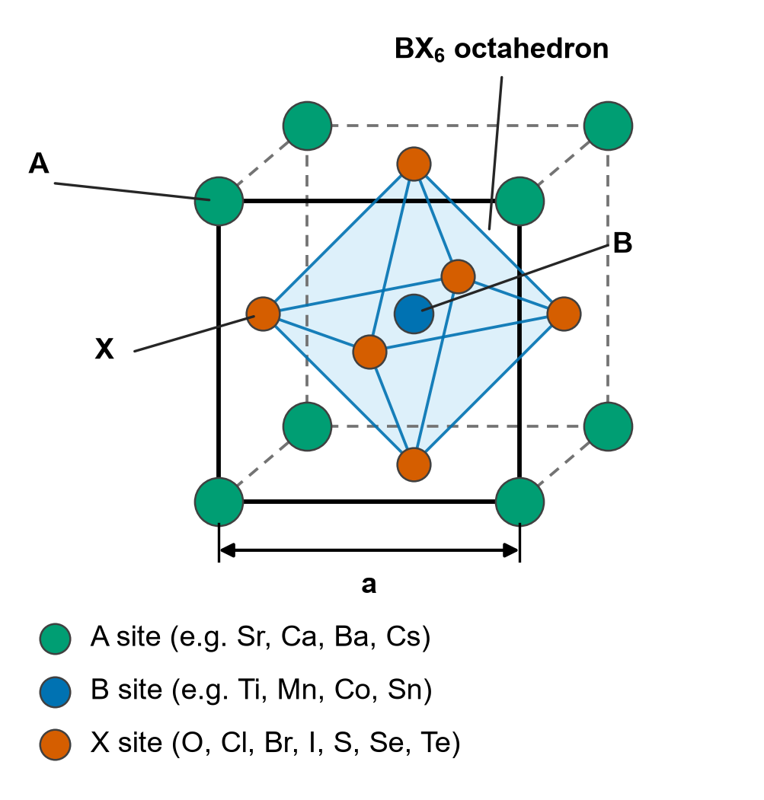
Figure 1
Figure 1: Schematic of the ideal cubic perovskite structure (ABX₃), drawn by the authors from the fractional coordinates of the Pm3̄m cell in an oblique projection: A-site cations (green) at the corners, the B-site cation (blue) at the body centre and X-site anions (orange-red) at the face centres, forming the BX₆ octahedron; a is the lattice parameter.
Lead-based halide perovskites such as CsPbI₃ show ultralow thermal conductivity owing to their soft lattices⁷, but lead toxicity remains a critical bottleneck. Research has thus moved to lead-free alternatives using Sn, Ge or Bi. Sn-based perovskites are unstable due to the facile oxidation of Sn²⁺ to Sn⁴⁺¹⁰, and other alternatives show lower intrinsic efficiencies. Oxide perovskites including SrTiO₃, CaMnO₃ and LaCoO₃ have been investigated for high-temperature applications, with doped compositions reaching zT of ≈0.2 (Yb-doped CaMnO₃ at 1000 K¹¹) and 0.18 at room temperature (La_{0.95}Sr_{0.05}CoO₃¹²). The chemical space of possible lead-free perovskites is enormous, and pinpointing which compositions are both stable and efficient is still non-trivial.
Density functional theory (DFT) coupled with the Boltzmann transport equation (BTE) provides a rigorous framework to predict thermoelectric properties. However, a full transport calculation for a single complex crystal may require weeks of supercomputer time¹³, rendering high-throughput screening of thousands of candidates impractical. Machine learning models can learn nonlinear structure–property relationships from existing data and screen thousands of candidates in seconds. Parse et al.¹⁴ predicted zT with R² = 0.815, Jia et al.¹⁵ achieved R² ≈ 0.90, and Sun et al.¹⁶ reported R² = 0.90 on a test set using deep neural networks.
However, existing ML implementations have two major weaknesses. The first is a ‘black-box’ limitation: models predict zT as a single output but do not disclose the underlying trade-offs among S, σ and κ, and can yield physically inconsistent property combinations. The second is data leakage: random train–test splits can place temperature-series data from the same material in both training and test sets, producing inflated accuracies that overestimate true generalization^{17,18}. Grouped validation has been studied in general materials informatics^{18–20}, and a comparison of random, composition-wise and family-wise splits exists for a small thermoelectric subset²¹; to our knowledge, no study has quantified, on a full database snapshot and with one model and one set of hyperparameters, how much leakage inflates reported performance across five validation strategies.
Table 1 lists the metric and the validation protocol that each published thermoelectric ML study reports. The studies differ in dataset, target, preprocessing and validation protocol, so their values are not comparable with one another or with the R² values of this work, and no ranking is made. What Table 1 shows is the protocol: k-fold CV over rows²² (and the added five-fold CV of¹⁴) on one side, compound- or composition-level splits^{14–16} and external test sets²³ on the other. In this work, the same model, features and frozen hyperparameters give R² values that differ by 0.134 to 0.213 between random and chemistry-cluster validation (Section 3.1.1), and chemistry-cluster values are higher than the external values (Section 3.2); a metric reported without its protocol therefore cannot be read as a measure of model quality. A fuller account of the thermoelectric fundamentals, the perovskite families, the computational methods and databases and the machine-learning approaches is in Supplementary Note S1.
Table 1: Recent ML studies of thermoelectric property prediction: the metric and the validation protocol each reports, as the authors report them. The studies differ in dataset, target, preprocessing and protocol, so the values are not comparable with one another or with the R² of this work.
Study | Model | Source | Rows | Reported metric | Validation protocol
Parse et al.¹⁴ | XGBoost | Starrydata2 | 18.1K | R² (zT) 0.815 (test) | Compound-wise 80/20 split; 5-fold CV also reported
Jia et al.¹⁵ | GBDT | Starrydata2 | 92.3K | R² (zT) 0.89 (CV); 0.90 (test) | Composition-level 10-fold CV and a test set
Ma & Poon²⁴ | LightGBM | Compiled TE | 14.1K | R² (zT) 0.86; R² (|S|) 0.8 | Not stated
Sun et al.¹⁶ | DNN | Starrydata2 | 231.1K | R² (zT) 0.90 (test); 0.95 (training) | Compound-disjoint train/test split
Barua et al.²³ | XGBoost | Starrydata2 | ∼160K | R² (zT) 0.67–0.80 | Three external test sets
Wang et al.²² | Stacking | UCSB dataset and literature | 5.2K | R² (zT) 0.970 | 10-fold CV
Elavunkel & Padhan²⁵ | Stacking | Half-Heusler | Not stated in the abstract | R² (S) 0.99; (σ) 0.96; (κ) 0.93; (zT) 0.92 | Not stated in the abstract
Five gaps motivate this study. (1) Validation bias is unquantified at scale: the only thermoelectric comparison of several splitting strategies we know of uses a small subset²¹, and none uses one model across five strategies on a full database snapshot. (2) Component properties are rarely reported: σ and κ are seldom predicted as independent targets, although knowing what is and is not predictable from composition is essential for reliable screening. (3) Feature-selection effects are not examined: correlation filtering, Lasso or mutual-information selection is often applied without checking whether it helps tree models with built-in feature subsampling. (4) Lead-free perovskite screening with experimentally trained, chemistry-aware-validated models is limited: existing screens rely on DFT-trained models or random-split validation. (5) Model architecture is overemphasized: gains from complex architectures are usually reported on small datasets with random splits. The present study addresses all five gaps.
This study develops a composition-based machine learning framework to screen lead-free, perovskite-type compounds of the Materials Project (energy above the convex hull of at most 0.05 eV atom⁻¹) and to measure how far each predicted property can be trusted. Its aim is a ranked list of candidates, reported as hypotheses and separated by whether their chemistry cluster occurs in the training data, with a shortlist fixed by a rule set before the predictions were seen. Alongside direct regression of zT, the framework predicts S, σ and κ individually, so that the two routes can be compared and the property limiting a candidate’s performance can be identified. How far the predictions can be trusted is addressed by three research questions: (RQ1) what R² composition-only descriptors (MAGPIE and CBFV) realistically reach under chemistry-aware validation, and how far that is from the label-noise ceiling; (RQ2) by how much does the validation methodology inflate reported accuracy; and (RQ3) how does component-wise prediction compare with direct regression of zT. The main contributions are a structure-aware screening of the Materials Project, in which perovskite-type structure is decided by an explicit connectivity test rather than by space group, and candidates are reported as hypotheses, separated by whether their chemistry cluster occurs in the training data; a reproducible eleven-step curation of Starrydata2 into 280,664 rows (17,977 unique formulas, 8,908 chemistry clusters, 3,909 parent chemical systems); a five-way comparison of validation strategies showing that row-level splits inflate R² by +0.134 to +0.213; composition-only R² under chemistry-cluster CV for S, σ, κ and zT, set against the label-noise ceiling, tested against the independent ESTM database and shown to depend little on the learner: a stack of XGBoost, LightGBM and a random forest, with weights fitted without the test rows, is not distinguishable from their unweighted mean (the paired difference is at most 0.0004 and its interval contains zero on every target), the mean is above XGBoost by at most 0.005, and the three models agree within 0.007 in R² on every target; and a demonstration that direct zT regression outperforms the component-wise route under both random and chemistry-cluster validation, with a gap 5.1 times larger under chemistry-cluster validation (0.186 against 0.036 in R²).
The remainder of the paper is organised as follows. Section 2 describes the data, descriptors, models, validation design, Materials Project screening and literature comparison; Section 3 presents and discusses the results, with the screening in Section 3.3; Section 4 concludes. Extended background, detailed procedures and further results are in the Supplement and are cited where they are needed; symbols and abbreviations are in Supplementary Note S11.

2 Methods

2.1 Data and cleaning
The research follows a four-phase pipeline (Fig. 2): (1) data acquisition and curation from Starrydata2; (2) feature engineering with two complementary compositional featurization schemes; (3) model development with chemistry-aware validation; and (4) virtual screening of lead-free perovskite candidates from the Materials Project. Each phase addresses a particular challenge: noise and inconsistency in experimental databases, translation of formulas into physically meaningful numerical representations, avoidance of temperature-series leakage, and the listing of lead-free candidates for experimental testing.
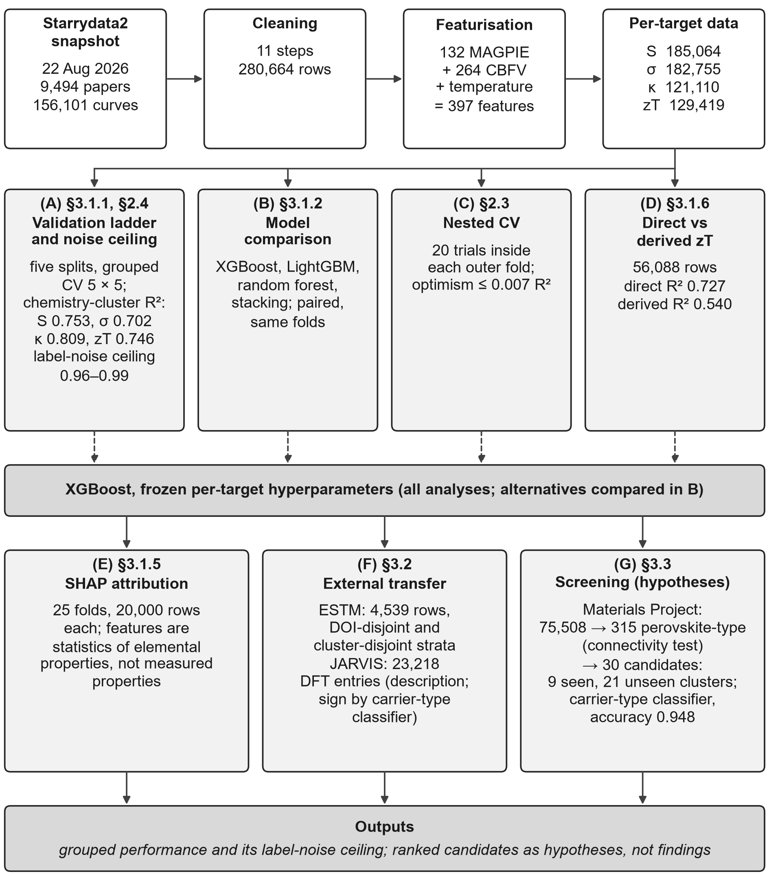
Figure 2
Figure 2: Study workflow, from data acquisition to the outputs. Every count is read from a committed artifact and every section number from the headings of this manuscript; the screening yields hypotheses, not findings.
The main data source is Starrydata2^{26,27}, which covers bismuth tellurides, lead chalcogenides, skutterudites, half-Heuslers, oxides and silicides, among others. The study uses a single pinned pull of the Starrydata2 export taken on 22 August 2026 (the export is regenerated daily, so an unpinned pull is not reproducible): 9,494 publications, 55,261 samples and 156,101 digitised property curves, held in three files (papers, samples and curves). The raw curves hold 2,679,279 digitised points in total, of which 2,068,554 are points of the four target properties against temperature (1,996,047 remain after range filtering). Each data point is a single property reading of one sample at one temperature, so counts of data points reflect measurement volume rather than the number of distinct compositions. Four targets were extracted: S, σ, κ and zT; where resistivity ρ was reported instead of conductivity, it was converted using σ = 1/ρ. Each formula is also assigned a parent chemical system (the sorted set of its constituent elements, e.g. Bi–Sb–Te for all bismuth antimony telluride variants irrespective of stoichiometry or doping), kept for reference; the grouping used for validation is the chemistry cluster defined in Section 2.4.
An eleven-step cleaning pipeline converted the raw data into a reliable training set (Fig. 3): data preparation (steps 1–5), quality filtering (steps 6–8) and statistical filtering (steps 9–11). Each step, the number of rows it removed and the criterion it applied are described in Supplementary Note S2.
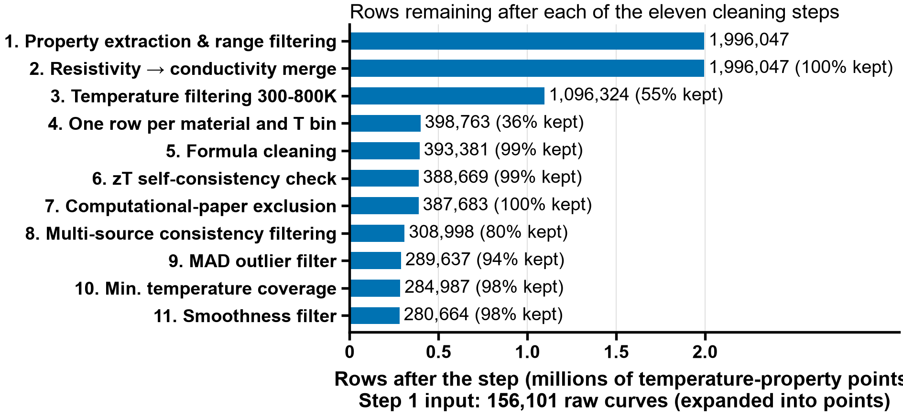
Figure 3
Figure 3: Row count through the eleven-step cleaning pipeline, from 1,996,047 property observations after range filtering to 280,664 rows in the final cleaned dataset.
Analysis choices. The following settings of the cleaning pipeline are choices of this study, fixed before any model was trained; none was tuned on model performance and none was tested by a sensitivity analysis, so the results are conditional on them. (i) The temperature window of 300–800 K restricts the study to near-room-temperature and mid-temperature readings; readings outside it are outside the scope of the prediction and are not used. (ii) The 25 K bin width groups readings of one sample that were reported at slightly different temperatures into one bin while keeping the shape of the curve; it was not varied. (iii) The 50% tolerance of the zT consistency check is deliberately loose: it removes gross inconsistencies between a reported zT and the value recomputed from the same sample’s S, σ and κ, without discarding rows over the ordinary digitization and measurement uncertainty of the three properties. (iv) Formulas with fewer than 3 distinct temperatures are removed because the smoothness filter, whose window is 3, cannot judge a curve with fewer points. (v) A window of 3 is the smallest odd window that defines a local median; a wider window would also flatten genuine extrema of zT(T). The multiplier 3.5 of the two MAD filters (Steps 9 and 11) is likewise a choice.
The final cleaned dataset contains 280,664 rows; featurisation (formulas that fail either featuriser are excluded and logged) leaves 280,173 rows covering 17,977 unique chemical formulas in 8,908 chemistry clusters and 3,909 parent chemical systems. The four per-target datasets contain 185,064 rows with S, 182,755 with σ, 121,110 with κ and 129,419 with zT (66.1%, 65.2%, 43.2% and 46.2% of the featurised rows); they overlap and are not a partition. The mean zT of the retained rows is 0.427 (0.426 over the 280,664 cleaned rows, against 0.387 after Step 6). The S distribution (Fig. 4a) mixes p-type samples (55.6% of the S rows) and n-type samples, and the negative values of the latter pull the mean (19.1 µV K⁻¹) below the median (50.0 µV K⁻¹) (Table 2).
Table 2: Final dataset statistics: the 280,173 featurised rows, per property (coverage is the share of those rows with a value; SD is the sample standard deviation).
Property | Rows | Coverage | Mean | Median | SD | Range
S (µV K⁻¹) | 185,064 | 66.1% | 19.1 | 50.0 | 176.9 | −461 to 562.5
σ (S m⁻¹) | 182,755 | 65.2% | 83,498 | 45,262 | 129,514 | 959 to 1.66 × 10⁶
κ (W m⁻¹ K⁻¹) | 121,110 | 43.2% | 2.54 | 2.00 | 1.98 | 0.28 to 13.78
zT | 129,419 | 46.2% | 0.427 | 0.316 | 0.388 | 0.000 to 3.899
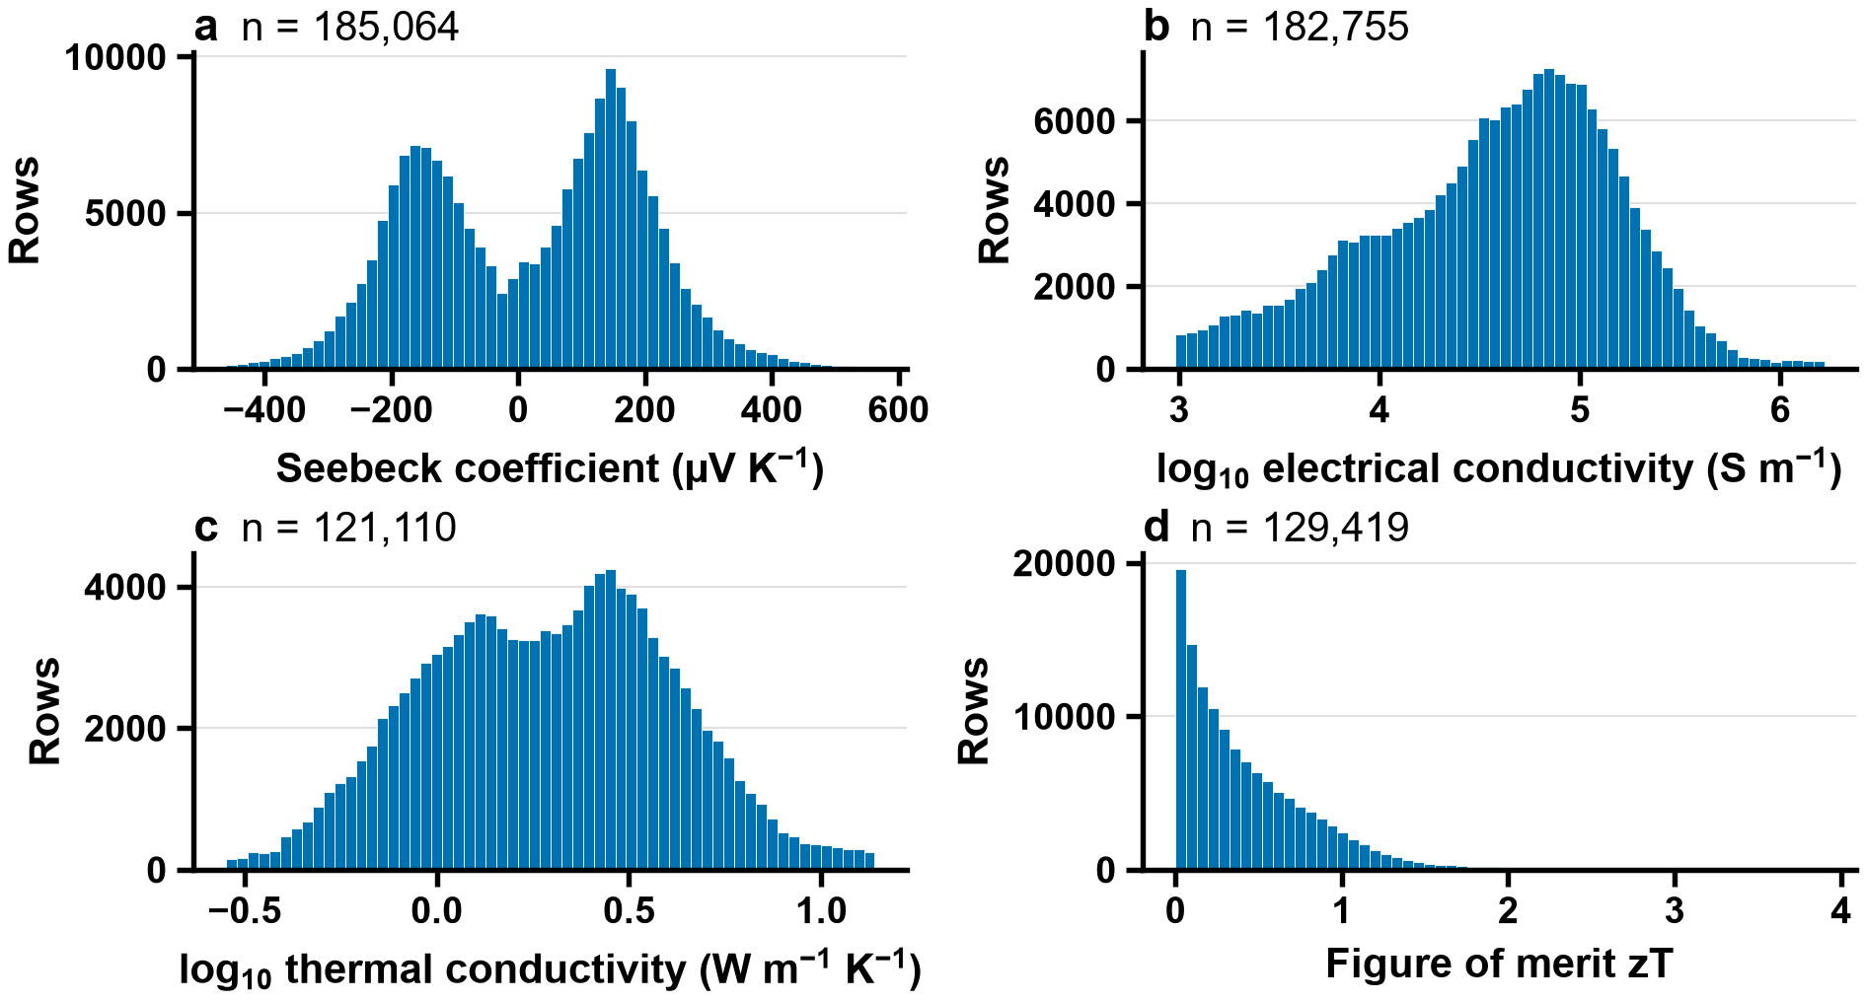
Figure 4
Figure 4: Distribution of thermoelectric properties in the final dataset (280,173 featurised rows): (a) Seebeck coefficient, (b) electrical conductivity, (c) thermal conductivity and (d) figure of merit.

2.2 Descriptors
The first feature set was generated with the MAGPIE preset of the matminer library^{28,29}: six statistics for each of 22 elemental properties, i.e. 132 features computed from the chemical formula alone. The second set was generated with CBFV using the Oliynyk element property set³⁰, which includes properties not available in MAGPIE (polarizability, Gordy and Mulliken electronegativity, heat of atomization); all 264 CBFV features were retained, without a correlation filter. Temperature (T, K) was added as a direct input feature, giving 132 + 264 + 1 = 397 descriptors in total.
All results use the full 397-feature set; no explicit feature selection is applied, because XGBoost subsamples columns at every tree; the explicit selection of the earlier work was tested as a paired comparison and lowers R² on every target (Section 3.1.4). A descriptor ablation with the hyperparameters frozen at their full-feature values (so that only the descriptor set changes) shows how little each block adds: restricting the descriptors to MAGPIE and temperature (133 features) lowers the chemistry-cluster R² by only 0.006 for S, 0.010 for σ, 0.006 for κ and 0.005 for zT, and the CBFV block alone reaches 0.744 for zT against 0.746 for the full set.

2.3 Models
XGBoost³¹ was selected after comparison with LightGBM³², random forest³³ and a stacking ensemble (Section 3.1.2): under chemistry-cluster CV XGBoost scored highest of the single models on 3 of the four targets (on S the forest was nominally higher by +0.000, a tie within the interval), and no single model differed from it by more than 0.007 in R²; the nested stack was not distinguishable from the unweighted mean of the three, which was above XGBoost by at most 0.005 (Section 3.1.2). XGBoost was preferred for its robustness to missing features (κ is present in 43.2% of the featurised rows), feature subsampling, computational efficiency and compatibility with SHAP. The models are scikit-learn³⁴-compatible XGBRegressor objects fitted directly on the features: no imputation or standardisation is applied, since XGBoost handles missing values natively and tree splits are invariant to feature scaling. Four models were trained for S (µV K⁻¹), log₁₀σ, log₁₀κ and zT; the logarithmic transformation was applied to σ and κ because they span several orders of magnitude, and every R² is computed in the space the target was trained in.
Hyperparameters were tuned once per target on all rows of that target, by an Optuna search of 20 trials scored by R² under 3-fold chemistry-cluster cross-validation, then frozen and reused unchanged across every validation protocol and experiment, so that differences between conditions reflect the condition and not the tuning (Table 3); the frozen values differ between targets. Because the evaluation folds draw on rows that were also used for tuning, the grouped R² values may be optimistic^{35,36}; its size was measured by re-tuning inside every outer training fold (a fresh 20-trial search on the outer training rows only, same folds, five repeats of five folds: nested CV). The committed value minus the nested one is +0.006 for S (chemistry-cluster bootstrap interval +0.004 to +0.009), +0.006 for σ (+0.004 to +0.008), +0.002 for κ (+0.000 to +0.004) and −0.001 for zT (−0.004 to +0.002, no measurable optimism): the grouped values reported here are optimistic by at most about 0.007 R², an order of magnitude below the gap between random and grouped validation.
Comparison models (Section 3.1.2). LightGBM³² is tuned exactly as XGBoost (20 Optuna trials, 3-fold chemistry-cluster CV on all rows of the target, then frozen; the tuned values are in Supplementary Table S2). The random forest³³ is not tuned: all four targets use one setting fixed in advance from the software defaults for regression reviewed by Probst et al.³⁷ (500 trees, a third of the features per split, a minimum node size of 5, no depth limit, bootstrap sampling; Supplementary Table S2), because a tuned search was too slow for the available compute: the first session ran 10.7 h and completed 15 trials for S, 12 scored and 3 pruned, before it was stopped, and the design was changed before any random-forest test-fold result existed. The inner-CV R² of the scored S trials ranged from 0.306 to 0.739 (no trial excluded); the one trial with trees of depth 3 was clearly worse (0.306), and the 11 trials with trees of depth 15 or more, the region the fixed setting also occupies, ranged from 0.725 to 0.739, a spread of 0.014, against 0.797 for the frozen XGBoost model on the same objective. This asymmetry (XGBoost tuned, random forest fixed) favours XGBoost: a forest that tuning would improve is understated, so an XGBoost advantage over the fixed forest is an upper bound on its advantage over a tuned one, and a forest that matches or beats XGBoost stands despite it. The tuning evidence is for S only, and the average tuning gains that Probst et al. report are for classification, so neither shows that regression on composition features is insensitive to tuning.
Table 3: XGBoost hyperparameters: the four frozen sets (each tuned once on all rows of its target, by a 20-trial Optuna search scored with 3-fold chemistry-cluster cross-validation) and the search space.
Parameter | S | σ | κ | zT | Search range
n_estimators | 500 | 550 | 350 | 500 | 100–600
max_depth | 10 | 10 | 9 | 9 | 3–10
learning_rate | 0.03183 | 0.02669 | 0.05742 | 0.02188 | 0.01–0.3
subsample | 0.8969 | 0.8676 | 0.9052 | 0.6804 | 0.5–1.0
colsample_bytree | 0.5062 | 0.5167 | 0.7082 | 0.6984 | 0.5–1.0
min_child_weight | 4 | 4 | 6 | 4 | 1–10
reg_lambda | 0.6494 | 0.8074 | 0.05444 | 1.713 | 1e-3–10.0
reg_alpha | 8.793 | 6.548 | 3.351 | 0.05033 | 1e-3–10.0
The Seebeck regressor is trained on signed S and predicts the sign implicitly, but for compositions far from the training distribution the predicted sign may be unreliable. An XGBoost classifier was therefore trained on the same 397 features to predict carrier type (p vs n), with the frozen hyperparameters of the Seebeck regressor and the sign of the measured S as label (rows whose measured S is exactly zero are dropped; 185,056 rows, 55.6% p-type); its inputs are the same composition descriptors and the temperature bin, no measured property. Whether its sign should replace the regressor’s was decided before the screening: on the regressor’s own chemistry-cluster folds (the classifier refitted on them, so that both rules are scored on the same partition of the rows), the classifier’s sign accuracy is compared with that of the sign of the regressor’s out-of-fold prediction, and the classifier is used only if the cluster-bootstrap interval of the paired difference lies above zero. It does: sign accuracy 0.949 against 0.941, a difference of 0.008 (interval 0.004–0.012). The gain is small and comes mostly from rows whose measured |S| is below 20 µV K⁻¹ (7,307 rows, difference 0.058, against 0.006 for the others). During screening, when the classifier and regressor disagree on the sign, the classifier’s prediction is used.
SHAP TreeExplainer³⁸ is applied to each model on a fixed random subsample of 20,000 rows of each of the 25 chemistry-cluster test folds (five repeats of five folds), with the frozen hyperparameters of Paper A; the mean absolute SHAP value of each feature is averaged over the folds, and its SD across folds is shown. Global bar plots (mean |SHAP| per feature) are created for the top 15 features per target; the beeswarm plots use a second run that saved the SHAP values of individual rows for the first repeat (the same folds and frozen hyperparameters): 1,000 seeded test rows per fold, 5,000 per model, and show the 10 features with the largest mean |SHAP| among those rows. Agreement between the most important features and known thermoelectric physics provides an independent check that the models have learned meaningful relationships rather than spurious correlations.

2.4 Validation design
Chemistry-cluster grouped cross-validation prevents temperature-series and doping-series leakage. Each formula is assigned to a chemistry cluster: elements present below 5 atomic percent are treated as dopants and removed, remaining amounts within 5% of an integer are snapped to that integer, and the formula is reduced; a doped material therefore groups with its parent ((PbTe)_{0.97}(SrTe)_{0.02}(Na₂Te)_{0.01} and Pb_{0.97}Te both group with PbTe, while Bi₂Te_{2.7}Se_{0.3}, where selenium occupies 6.0 atomic percent and is an alloy component, does not group with Bi₂Te₃). The snapshot contains 8,908 chemistry clusters, against 3,909 parent chemical systems; the two groupings cross-cut each other, and the cluster is the stricter safeguard against near-duplicate dopant variants of one host lattice. Folds are generated by a custom assignment of whole clusters, with the placement of the largest clusters randomised between repeats: 5 repeats of 5-fold CV³⁹. To quantify inflation, five splitting strategies were applied with the same model, hyperparameters and features: (i) 20 independent random 80/20 draws, pooled; (ii) 5-fold and (iii) 10-fold CV, all partitioning data at row level; (iv) composition-level CV following Jia et al.¹⁵, where all temperature points of a given formula are kept in the same fold, preventing intra-formula leakage but allowing related compounds of the same family (e.g. Bi₂Te₃ and Bi_{0.5}Sb_{1.5}Te₃) on opposite sides of the split; and (v) chemistry-cluster CV, in which no member of a cluster appears in testing if any member appears in training. Performance was quantified by the coefficient of determination and the mean absolute error,
R2=1−i​yi−y​i2i​yi−y​2, MAE=1ni​|yi−y​i| (3)
and the validation inflation was defined as
$ΔR^{2}=R_{random}^{2}−R_{cluster}^{2}$ (4)
For external validation, the four final models, each fitted on all rows of its target with the frozen hyperparameters, were applied to ESTM⁴⁰. After restricting to 300–800 K, ESTM has 4,539 rows. ESTM and Starrydata2 are both digitised from the literature and share source papers: 69 ESTM source publications also appear in the training data. The rows are therefore partitioned in two ways that are never pooled: (a) the 1,416 rows sharing a source DOI with the training data are removed, leaving 3,123, which tests measurement transfer; (b) the 3,091 rows whose chemistry cluster appears in the training data are removed, leaving 1,448, which tests chemistry transfer. Because ESTM extends beyond the property ranges of the training data, results are also reported restricted to rows inside the training range of S, σ, κ and temperature (2,709 of 3,123 rows in (a), 1,196 of 1,448 in (b)). Back-transformation of the log-space predictions of σ and κ uses smearing factors computed from training-side out-of-fold residuals only, so that no external label is used for calibration. The 4,539 rows cover 853 distinct formulas, of which 343 also occur in the training data (300 of the 528 chemistry clusters occur in it). As a cross-domain description, the S model is also applied to DFT-computed Seebeck coefficients from the JARVIS dft_3d dataset⁴¹: 23,218 of its 93,902 entries carry a Seebeck coefficient for both n-type and p-type doping, each tabulated at 600 K and a doping of 10²⁰ cm⁻³, calculated from the DFT band structure with BoltzTraP in the constant-relaxation-time approximation (the relaxation time cancels in the Seebeck coefficient). All were featurised as the training data were, with the temperature input set to that temperature, and the Seebeck model was applied to them. The JARVIS values are computed for ideal crystals, so the comparison is not a validation. Because the two JARVIS values of a semiconductor have opposite signs by construction (the sign follows the imposed doping), a JARVIS sign exists only for the 13,123 entries whose n-type and p-type values have the same sign. The predicted sign is the sign of the predicted S; sign agreement is computed on these entries when the magnitude of the reference, the mean of the absolute n-type and p-type values, is at least 20 µV K⁻¹ (3,885 entries), and the rank correlation (Spearman) of the absolute predicted S with that reference is computed for every entry. Entries with an optb88vdw gap below 0.05 eV are treated as metals or semimetals and the others as semiconductors, and the entries are split by whether their chemistry cluster occurs in the training data. Intervals are chemistry-cluster bootstrap percentile intervals (clusters resampled with replacement). Electrical and thermal conductivity and zT are not compared: JARVIS gives conductivity only divided by an unknown relaxation time and no zT.
As a second external dataset, the teMatDb collection of digitised experimental thermoelectric curves^{42,43} was used at repository commit 86a9bf9 (its three data files are byte-identical to those of the Zenodo release v1.1.6): 272 samples with their source DOI and composition, of which 184 have a composition that the training canonicalisation can parse and are scored. Their curves, restricted to 300–800 K, are assigned to the 25 K temperature bins of the training data (one row per sample and bin) and featurised as ESTM was. The samples are grouped in three strata that are never pooled: a0, the sample’s source DOI is in the training data; a, it is not; b, its chemistry cluster (the fixed definition) is absent from the training data. The models, the smearing factors and the scoring are those of ESTM and nothing is refitted; R² is computed in the space of the target (log₁₀ for σ and κ), for zT against the declared value and against the value recomputed from the measured Seebeck coefficient, resistivity and thermal conductivity. Intervals are the 2.5th to 97.5th percentile of a bootstrap that resamples whole samples (2000 draws).

2.5 Screening of the Materials Project
The Materials Project API⁴⁴ is queried for compounds with energy above the convex hull E_{hull} ≤ 0.05 eV atom⁻¹ (lower values indicate greater thermodynamic stability) and a PBE band-gap window of 0.1 to 3 eV, then filtered for lead and for radioactive, unstable and toxic elements and reduced to ABX₃ candidates. Perovskite-type structure is decided by an explicit connectivity test (six-fold B–X coordination with corner-sharing BX₆ octahedra), not by space group alone, because the same space group is shared by perovskites and non-perovskite ABX₃ structures (for example the needle-like chain structure of α-SrZrS₃ and the GdFeO₃-type perovskite β-SrZrS₃ are both Pnma⁴⁵). Materials Project band gaps are PBE values, which underestimate experimental gaps⁴⁶; the band-gap criteria are therefore applied as stated, and sensitivity rows in which the gap criteria are widened by a factor of 1.5 and the stability limit is raised to 0.1 eV atom⁻¹ are reported alongside the counts. The filters are applied in the order stability, band-gap window, exclusion of lead and of radioactive elements, ABX₃ stoichiometry (anti-perovskites, with the anion on the A site, are set aside), the connectivity test, a final band-gap cap of 0.6 eV, and exclusion of Tl, Hg, Cd, As and Be; the counts after each filter are given in Section 3.3. The stability limit, the gap window and the cap are choices, not findings (the gap window has no literature justification, and PBE gaps underestimate measured ones), which is why the sensitivity lists are reported.
For each candidate, MAGPIE and CBFV features are computed and the four models predict S, σ, κ and zT from 300 to 800 K in 100 K steps; the carrier-type classifier assigns the sign of S (Section 2.3). Each candidate is flagged by whether its chemistry cluster occurs in the training data, and the candidates in seen and unseen clusters are reported separately, because the models are far less reliable outside the training chemistries (Sections 3.1 and 3.2). The screening is framed as hypothesis generation: the candidates are ordered by predicted zT, using the direct prediction because it was more accurate under chemistry-cluster CV than the derived S²σT/κ route (Section 3.1.6), but the ordering is a way of listing hypotheses, and no predicted zT is presented as a finding. Which candidates are highlighted was fixed before any prediction was seen: only the shortlist of compounds that are on the convex hull in every stability variant and whose chemistry cluster is in the training data (4 candidates), ordered by their maximum predicted zT over the grid, is named in the abstract and the conclusion; all other candidates appear only in the full ranked list with their cluster and stability labels. Every candidate is also labelled by a literature check, made independently of the predictions, for whether it has been studied as a thermoelectric. The four final models were fitted on all rows of their target with the frozen hyperparameters.

2.6 Literature comparison
Papers and compounds. The literature check was fixed before any value was read and before any prediction for these compounds was looked at (pre-registration B, docs/decisions.md). It uses 7 papers, each matched by DOI to its title, first author and journal through Crossref: CsSnI₃ (vacuum-deposited films)⁴⁷, LaCoO₃⁴⁸, LaRhO₃⁴⁹, La-doped BaSnO₃⁵⁰, La- and Nb-doped SrTiO₃ single crystals⁵¹, doped CaMnO₃^{11,52}. The compositions, dopants included, are those the papers state. BaSnO₃ and LaRhO₃ stay in only if their paper gives measured values. The test is not blind: the compounds were chosen because they have published measurements and, for the pre-registered shortlist, a chemistry cluster present in the training data.
What is compared. The predictions are the out-of-fold predictions of the chemistry-cluster cross-validation of Section 3.1.1 (frozen hyperparameters, five repeats of five folds), in which the chemistry cluster of the row was held out. They are not the predictions of the final models, and not those of the ranked list of Section 3.3, which are final-model predictions for Materials Project compounds. Nothing is refitted. Each literature value is compared at two levels that are reported separately: exact, the training rows with the same composition at the same 25 K temperature bin as the value (mean over those rows and over the five repeats), if the training data contain the composition; and cluster level, the mean over the training rows of the same chemistry cluster at that bin, so that a dopant level absent from the training data is still compared with held-out predictions of its cluster. Where a level has no row the value is reported as having no out-of-fold prediction. σ and κ are predicted in log₁₀ and compared in log₁₀ and in linear units (back-transformed without smearing).
Aggregation and error. Values of one paper, composition, sample and property in the same 25 K bin are averaged into one value before the comparison (n and the identifiers are kept). The doped SrTiO₃ crystals of Ohta et al. have dopant levels below 5 at% given only as carrier concentrations, so each is compared at the cluster level only, as SrTiO₃, and the four samples are never averaged together. The error is (prediction - literature)/|literature| and, for σ and κ, the log₁₀ ratio, set beside the relative standard uncertainty of the round-robin measurements of Alleno et al. (Section 3.1.1; S, σ, κ, zT), the only threshold used: a prediction is inside the band if its relative error does not exceed it.
Reporting. Results are reported per paper. Any overall summary weights papers equally: the fraction inside the band and the median absolute relative error are computed within each paper and then summarised by the median over papers. A paper whose DOI is among the DOIs of the training data is a training-source paper: it is reported separately, is never pooled with the independent papers, and for it the comparison partly restates the cross-validation error. By this rule 4 of the 7 papers are training sources, with this many rows of the training table whose DOI is theirs: Flahaut et al. 102, Ohta et al. 3, Rajasekaran et al. 2 and Shibasaki et al. 2; the other 3 (Ohtaki et al., Sebastia-Luna et al., Singh and Pandey) are independent. For every value the table states whether its DOI is among the training DOIs, whether its composition and cluster are in the training data, and whether the training data hold a row with the same DOI and composition (the value is then probably a training label, although its cluster was held out).
Pre-registration and its amendments. The comparison script was run only after the values file was filled and committed. The rules above are the pre-registration plus 17 dated amendments (docs/decisions.md; the full list is Supplementary Table S1), each written before the comparison and with no out-of-fold prediction for these compounds looked at. The thresholds of the legibility gates (amendments 12 and 13) were set after viewing the digitised figures, and amendment 13 applies them to every scanned figure. The symmetry cross-check of the gates was then corrected (amendment 17) after the end markers of Rajasekaran et al., Fig. 10, showed that a joining line biased it, and all scanned figures were extracted again, which restored markers that the biased check had removed. While the last two PDFs were inventoried, some values of their running text and tables came into view; this is disclosed in the amendments. No prediction was involved at any point. Every extraction was run from a committed script on a clean tree, with the SHA256 of each input recorded. The results are in Section 3.4.
The rules for reading values from the figures and tables of the papers, for assigning temperatures, for the legibility of digitised markers and for the paper-specific cases, and the edge-sensitivity rule, are given in Supplementary Note S3.

3 Results and discussion

3.1 Model performance

3.1.1 Chemistry-cluster cross-validation and validation inflation
Table 4 presents the chemistry-cluster results. R² was highest for κ (0.809), followed by S (0.753), zT (0.746) and σ (0.702). This ordering is consistent with the intrinsic predictability of each property from composition: κ depends on atomic mass, bond strength and structural complexity, all of which have strong compositional proxies, whereas σ depends strongly on carrier concentration, which is set by doping and synthesis conditions rather than by the nominal formula. Fig. 5 shows predicted versus measured values (first repeat): predictions follow the diagonal but are compressed towards the mean, with calibration slopes of 0.74 (S), 0.68 (σ), 0.80 (κ) and 0.73 (zT), and the top 5% of zT rows (mean measured zT 1.48) are predicted at 1.15 on average, consistent with high-performance compositions being rare in the training data.
The label-noise ceiling is the R² that a model without any error would reach given the noise of the labels: it combines the measurement noise of a round-robin test on one skutterudite⁵³ with the digitisation noise estimated from composition-matched entries of teMatDb and Starrydata2. It is 0.96–0.98 for S, 0.98–0.99 for σ, 0.96–0.97 for κ and 0.96–0.97 for zT (each range spans the lower value and the value corrected for both labels being noisy). Two qualifications apply. First, the digitisation term was measured on 96 composition-matched samples, 80 to 87 of which enter each property’s agreement figure, and two properties of that subset bias it in opposite directions: its target variance is narrower than that of the full database, which overstates the noise fraction and lowers the ceiling, while its simpler formulas are probably easier to digitise accurately, which understates the noise and raises the ceiling; the two effects cannot be netted. The term also differs by up to 0.024 in R² between this snapshot and an earlier pull of the same source database, so the ceiling is quoted to two decimals at most. Second, both components read the same printed curve, so neither captures synthesis-to-synthesis variation or processing differences between nominally identical specimens. For a composition-based model that variation is also label noise, so the true ceiling for such models lies below the one reported here, and the gap between it and the chemistry-cluster R², 0.15 to 0.29, is an upper bound on what a composition representation could recover.
Table 4: Chemistry-cluster grouped cross-validation results (5 repeats of 5-fold CV; R² is the mean ± standard deviation across repeats of the per-repeat pooled value, and MAE and RMSE are the means of the per-repeat pooled values; the fold-level SD is over all folds). MAE and RMSE are in µV K⁻¹ for S and in log₁₀ units for σ and κ.
Target | R² | Fold-level SD | MAE | RMSE | Rows | Features
S | 0.753 ± 0.005 | 0.032 | 51.5 | 87.9 | 185,064 | 397
log₁₀σ | 0.702 ± 0.002 | 0.029 | 0.230 | 0.334 | 182,755 | 397
log₁₀κ | 0.809 ± 0.002 | 0.017 | 0.097 | 0.140 | 121,110 | 397
zT | 0.746 ± 0.005 | 0.042 | 0.126 | 0.196 | 129,419 | 397
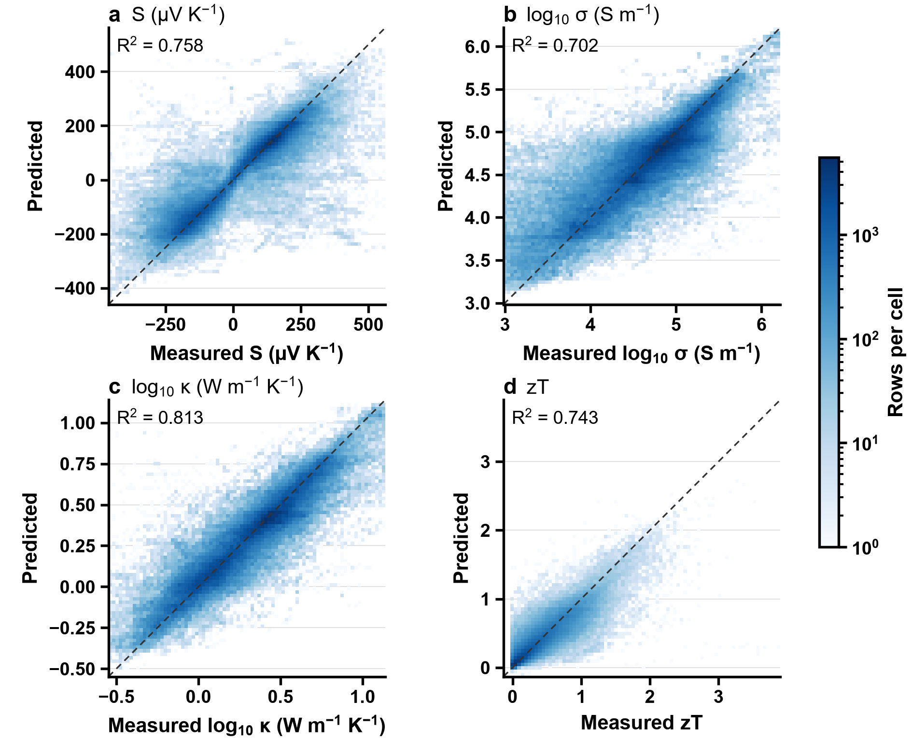
Figure 5
Figure 5: Predicted versus measured values under chemistry-cluster cross-validation (first repeat, all five folds pooled) for (a) S, (b) log σ, (c) log κ and (d) zT; colour is the number of rows per cell. The dashed line indicates perfect prediction.
The five validation methods of Section 2.4 are compared in Supplementary Note S4, with Supplementary Table S3 and Supplementary Figure S3. Random split, 5-fold and 10-fold CV give practically identical R² there. Composition-level CV gives intermediate values (e.g. zT R² = 0.818), and chemistry-cluster CV gives the lowest and most realistic values. This yields a clear hierarchy for zT: random/K-fold (0.918) > composition CV (0.818) > chemistry-cluster CV (0.746). The inflation ∆R² (Eq. (8)) ranges from +0.134 for κ to +0.213 for σ; we attribute the differences between properties to how strongly each depends on doping rather than on composition, which these data do not test directly. Chemistry-cluster CV is the relevant estimate for discovering entirely new chemical families, whereas composition-level CV is appropriate for the doping-optimization use case, i.e. predicting new variants within a known family.

3.1.2 Algorithm comparison
LightGBM, random forest and a stacking ensemble (XGBoost + LightGBM + random forest with a ridge meta-learner) are compared with XGBoost under chemistry-cluster CV (Table 5). Among the three single models XGBoost has the highest R² on 3 of the four targets, but the differences are small: LightGBM is lower by 0.002 to 0.007 on every target, and the random forest, run with one fixed setting and not tuned, is lower by 0.003 to 0.005 for σ, κ and zT and equal to XGBoost within the bootstrap interval for S (difference +0.000, interval −0.004 to +0.004, nominally above XGBoost); the chemistry-cluster bootstrap interval of the difference excludes zero for 4 of the 8 comparisons. The random forest was not tuned and the other two were, so part of its deficit may be the missing tuning; the unweighted mean of the three models, which has no fitted weights and so no leakage to guard against, is higher than XGBoost on every target, by 0.002 to 0.004 (the bootstrap interval excludes zero for all four), a small gain from averaging. The stack, a non-negative ridge meta-learner over the same three models whose weights are fitted on inner out-of-fold predictions within each outer training fold and applied to the outer test predictions, so that no test row enters a weight, is higher than XGBoost on all four targets, by 0.002 to 0.005, with a bootstrap interval that excludes zero for each (Table 5). It is also higher than the best single model of each target (the random forest for S, XGBoost for the others; chosen on the same folds, which favours the single model), with intervals that exclude zero. It is not distinguishable from the unweighted mean of the three: the paired difference is at most 0.0004 in absolute value and its interval contains zero on all four targets, so fitting the weights adds nothing measurable to averaging. The fitted weights are not interpreted; their range and the collinearity of the three models’ predictions are given in Supplementary Note S5. The three learners are tree ensembles on the same features, so their agreement shows that the choice among them does not change the picture, not that no learner could do better. A complementary check on the information content of the descriptors, independent of the learner, is the descriptor ablation of Section 2.2: moving from MAGPIE alone to the full set raises R² by only 0.006 (S), 0.010 (σ), 0.006 (κ) and 0.005 (zT).
Table 5: Chemistry-cluster CV R² (mean ± SD over 5 repeats of 5 grouped folds) of XGBoost, LightGBM, a random forest, the mean of the three and their stack on the same folds, with each model’s difference from XGBoost (same folds, paired) and the chemistry-cluster bootstrap interval of that difference in brackets. XGBoost and LightGBM are tuned with the same 20-trial search; the random forest uses one fixed, literature-based setting and is not tuned (Section 2.3), which favours XGBoost. The mean of the three models has no fitted weights. The stack is a non-negative ridge meta-learner over the three models whose weights are fitted on inner out-of-fold predictions inside each outer training fold, never on the outer test rows (Section 3.1.2). The last three rows are the paired comparisons fixed before the stack was run (difference of the pooled R² on the same folds, chemistry-cluster bootstrap interval in brackets); the best single model is chosen on the same folds, which favours the single model, and the last row is given to four decimals because it is below the third. The hyperparameters of LightGBM and the fixed setting of the random forest are in Supplementary Table S2.
Model | S | σ | κ | zT
XGBoost (tuned once, frozen) | 0.753 ± 0.005 | 0.702 ± 0.002 | 0.809 ± 0.002 | 0.746 ± 0.005
LightGBM (tuned, same protocol) | 0.746 ± 0.006 (−0.007 [−0.011, −0.002]) | 0.696 ± 0.004 (−0.006 [−0.008, −0.003]) | 0.803 ± 0.002 (−0.006 [−0.009, −0.004]) | 0.743 ± 0.004 (−0.002 [−0.008, +0.003])
Random forest (one fixed setting, not tuned) | 0.753 ± 0.004 (+0.000 [−0.004, +0.004]) | 0.697 ± 0.003 (−0.005 [−0.009, −0.001]) | 0.805 ± 0.002 (−0.004 [−0.008, +0.001]) | 0.742 ± 0.003 (−0.003 [−0.009, +0.002])
Mean of the three (no fitted weights) | 0.757 ± 0.004 (+0.004 [+0.002, +0.007]) | 0.705 ± 0.003 (+0.003 [+0.001, +0.004]) | 0.812 ± 0.001 (+0.002 [+0.001, +0.004]) | 0.750 ± 0.004 (+0.004 [+0.001, +0.007])
Stacking (XGBoost + LightGBM + random forest, ridge meta-learner, nested) | 0.758 ± 0.004 | 0.704 ± 0.003 | 0.812 ± 0.002 | 0.750 ± 0.004
Stack minus XGBoost | +0.005 [+0.002, +0.007] | +0.002 [+0.001, +0.004] | +0.003 [+0.001, +0.004] | +0.004 [+0.001, +0.007]
Stack minus the best single model (S: random forest; the other targets: XGBoost) | +0.004 [+0.002, +0.007] | +0.002 [+0.001, +0.004] | +0.003 [+0.001, +0.004] | +0.004 [+0.001, +0.007]
Stack minus the mean of the three | +0.0004 [−0.0010, +0.0016] | −0.0001 [−0.0011, +0.0009] | +0.0003 [−0.0008, +0.0014] | −0.0001 [−0.0022, +0.0019]

3.1.3 Carrier-type classification
Under chemistry-cluster CV the carrier-type classifier (185,056 rows, 7,810 clusters) reaches an accuracy of 0.948 (cluster-bootstrap interval 0.939–0.956) and a balanced accuracy of 0.948. Precision, recall, the confusion matrix and the accuracy by cluster size are in Supplementary Note S6. In the screening, the classifier changed the sign of the regressor’s S in 579 of the 2,454 candidate-temperature predictions (24%; 142 of the 409 candidates at one temperature or more) and in 16 of the 180 (9%; 3 candidates) of the main list, none of the shortlist.

3.1.4 Feature selection
Section 2.2 states that no explicit feature selection is applied. The earlier version of this work reports selecting features before fitting, keeping 25, 44, 39 and 32 features for S, σ, κ and zT. Whether that selection helps under chemistry-cluster CV was tested here as a paired comparison fixed before the run. The protocol, the convergence of the Lasso, the device and a post hoc check are in Supplementary Note S7.
The selection lowers R² on every target (Supplementary Table S4); the paired difference, selected minus all 397, is −0.050 for S (chemistry-cluster bootstrap interval −0.060 to −0.042), −0.038 for σ (−0.045 to −0.032), −0.047 for κ (−0.057 to −0.038) and −0.295 for zT (−0.328 to −0.262); every interval excludes zero, and in none of the 25 folds of any target is the selected set above the all-397 fit. The Lasso does not by itself reduce the set to k: it keeps on average 182 (S), 156 (σ), 184 (κ) and 161 (zT) of the 243 to 253 features that pass the Pearson filter, which is 3.6 to 7.3 times k, so it is the mutual-information step that imposes k, and the data-driven size is the Lasso’s count. The chosen Lasso penalty is the smallest of the grid in 36 of the 100 folds (24 of 25 for κ), so the Lasso counts are limited by the grid.

3.1.5 Feature importance
Table 6 lists the five features with the largest mean |SHAP| per target, each with the interval (2.5th to 97.5th percentile) of its per-fold mean across the 25 chemistry-cluster folds and the number of folds in which it is among the three most important features; the folds are five repeats of five grouped folds, so they are not independent, and for most features the intervals are wide. Only orderings that the folds support are interpreted. Temperature is the most important feature of the zT model in all 25 folds (mean |SHAP| 0.128, interval 0.120 to 0.136), consistent with the explicit T dependence in Eq. (1); the next two features by the mean, Elemental Zunger radii sum, mean abs. deviation (CBFV) and Elemental d valence electrons, mean (MAGPIE), are among the top three in 16 and 15 folds and their intervals overlap, so their order is not interpreted. All features other than temperature are statistics of ELEMENTAL properties of the elements in the formula, not measured properties of the material. For S, Elemental thermal conductivity, mean abs. deviation (CBFV) is among the top three in 24 of 25 folds and first in 17; for σ, Elemental MB electronegativity, mean abs. deviation (CBFV) is among the top three in 24 folds (first in 14) and temperature in 22; for κ, temperature is among the top three in 20 folds and among the top five in all 25, whereas the feature that leads on average, Elemental heat of vaporization, maximum (CBFV), is among the top three in only 14 folds and its interval reaches almost zero (0.001 to 0.056). In every model the intervals of the features ranked second to fifth by the mean overlap each other, so their order is not interpreted. Temperature is among the top five features in 15 of 25 folds for S and in all of them for σ, κ and zT. In the beeswarm plots (Supplementary Figure S4) the SHAP value of the temperature feature rises with temperature for zT (Spearman correlation of the feature value with its SHAP value 0.95) and falls with temperature for κ (−0.90) and σ (−0.79), and depends only weakly on it for S (0.19). These are attributions of the fitted models, not causal effects, and the physical reading of a descriptor is left to the reader: no mechanism is claimed here. Fig. 6 shows the bar plots with the SD across folds.
Table 6: The five features with the largest mean |SHAP| per target (mean over 25 chemistry-cluster test folds, each on 20,000 random test rows), each with the 2.5th to 97.5th percentile of the per-fold mean across the 25 folds and the number of folds in which it is among the three most important features. The folds are five repeats of five grouped folds, so they are not independent. Only orderings the folds support are interpreted: the intervals of ranks two to five overlap in every model, so those ranks are listed by their mean without a ranking claim. Units of the SHAP values are those of the target (µV K⁻¹ for S; log₁₀ units for σ and κ). Every feature is a statistic of an ELEMENTAL property of the elements in the formula (or the temperature), not a measured property of the material; the statistic is the atomic-fraction-weighted mean, the weighted mean absolute deviation about it (mean abs. deviation), the range, the minimum or the maximum over the elements, or the mode (the value of the most abundant element), from the MAGPIE or CBFV element tables. The labels come from docs/feature_labels.csv.
Rank | S | σ | κ | zT
1 | Elemental thermal conductivity, mean abs. deviation (CBFV) (12.9; 7.9–17.6; top 3 in 24 of 25 folds) | Elemental MB electronegativity, mean abs. deviation (CBFV) (0.069; 0.032–0.098; top 3 in 24 of 25 folds) | Elemental heat of vaporization, maximum (CBFV) (0.032; 0.001–0.056; top 3 in 14 of 25 folds) | Temperature (0.128; 0.120–0.136; top 3 in 25 of 25 folds)
2 | Elemental density, mean abs. deviation (CBFV) (7.4; 3.5–11.2; top 3 in 15 of 25 folds) | Elemental Pauling electronegativity, mean (CBFV) (0.039; 0.002–0.086; top 3 in 14 of 25 folds) | Temperature (0.028; 0.025–0.031; top 3 in 20 of 25 folds) | Elemental Zunger radii sum, mean abs. deviation (CBFV) (0.032; 0.004–0.062; top 3 in 16 of 25 folds)
3 | Elemental Gilmor number of valence electrons, mean abs. deviation (CBFV) (6.4; 2.0–13.8; top 3 in 10 of 25 folds) | Elemental melting temperature, mode (MAGPIE) (0.037; 0.011–0.096; top 3 in 9 of 25 folds) | Elemental melting point, mean (CBFV) (0.021; 0.001–0.060; top 3 in 8 of 25 folds) | Elemental d valence electrons, mean (MAGPIE) (0.027; 0.011–0.057; top 3 in 15 of 25 folds)
4 | Elemental polarizability, mean (CBFV) (5.4; 0.7–16.6; top 3 in 8 of 25 folds) | Temperature (0.035; 0.031–0.040; top 3 in 22 of 25 folds) | Elemental heat of atomization, mean abs. deviation (CBFV) (0.020; 0.003–0.046; top 3 in 12 of 25 folds) | Elemental Mendeleev number, maximum (MAGPIE) (0.012; 0.002–0.048; top 3 in 5 of 25 folds)
5 | Elemental metal flag, mean (CBFV) (5.4; 2.0–9.9; top 3 in 6 of 25 folds) | Elemental Gilmor number of valence electrons, mean abs. deviation (CBFV) (0.023; 0.016–0.032; top 3 in 0 of 25 folds) | Elemental Mendeleev number, maximum (MAGPIE) (0.018; 0.008–0.041; top 3 in 3 of 25 folds) | Elemental Mendeleev number, mean (MAGPIE) (0.011; 0.008–0.017; top 3 in 0 of 25 folds)
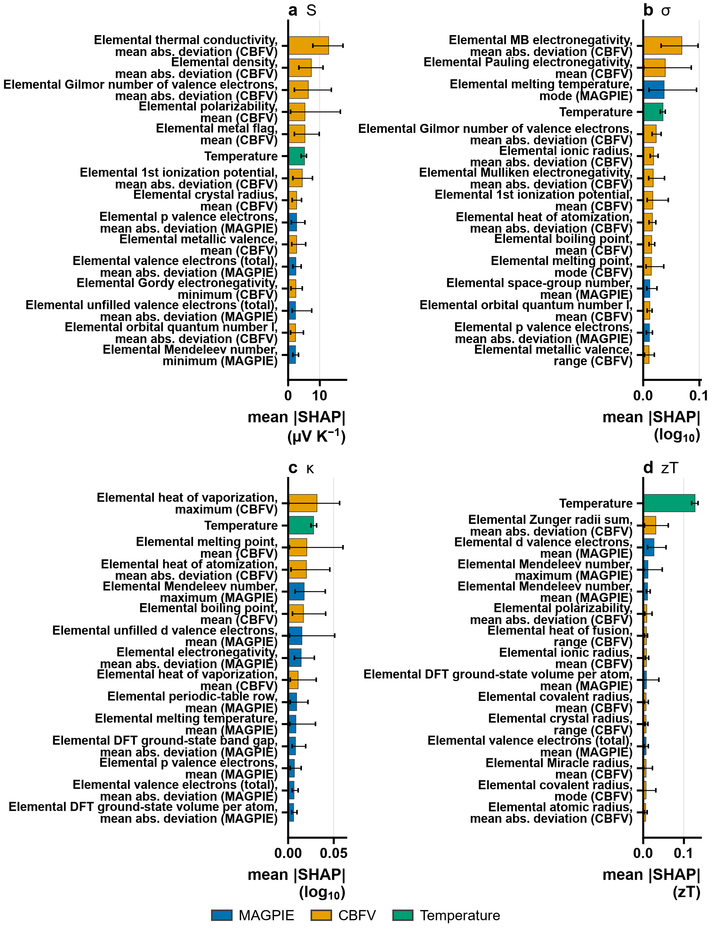
Figure 6
Figure 6: SHAP global feature importance (top 15 features, bars: mean over the 25 folds; error bars: 2.5th to 97.5th percentile of the per-fold mean across the 25 folds, which are five repeats of five grouped folds and not independent; orderings below the first few features are not supported where intervals overlap) for (a) S (µV K⁻¹), (b) σ (log₁₀ units), (c) κ (log₁₀ units) and (d) zT. Every feature other than temperature is a statistic of an ELEMENTAL property of the elements in the formula (the label names the property, the statistic and the element table, MAGPIE or CBFV), not a measured property of the material: the top feature of the S model, for example, is the spread of the elemental thermal conductivities, not the sample’s thermal conductivity.
Feature labels, the units of the SHAP values, the beeswarm plots and the shares of the two featurisation schemes are in Supplementary Note S8.

3.1.6 Direct versus component-wise zT prediction
Direct zT prediction was compared with the component-wise derivation S²σT/κ under chemistry-cluster CV (Supplementary Table S5). Direct prediction is more accurate (R² = 0.727 vs 0.540), with each model using its own target’s frozen hyperparameters. The size of the advantage does: the gap between the two pathways is 0.036 under random validation and 0.186 under chemistry-cluster validation (differences of unrounded R²), a factor of 5.1. Random validation therefore understates how much the derived route loses when it has to generalize to unseen chemistry. The error-propagation argument, the smearing check and the comparison under random validation are in Supplementary Note S9.

3.2 External validation
The most stringent test is evaluation on a completely independent dataset. ESTM data (4,539 rows within 300–800 K) were not used in model development. Results are summarized in Table 7 and Fig. 7. External scores are lower than the internal chemistry-cluster values for every property, and the loss is larger for chemistries absent from training (stratum b) than when only rows sharing a source publication with training are removed (stratum a). κ and zT transfer best. For κ the R² is 0.590 in stratum (b) (−0.219 from the internal value) and 0.672 in stratum (a) (−0.137); for zT it is 0.513 in stratum (b) (−0.232) and 0.666 in stratum (a) (−0.079). The two are tied in stratum (a), where their difference is smaller than the fit-to-fit difference given below, and in stratum (b) κ is clearly the highest. zT retains genuine predictive power for new chemistry, but well below its internal value. σ and S lose the most and κ and zT the least: in stratum (b) the change from the internal value is −0.419 for σ (R² = 0.283) and −0.416 for S (R² = 0.337), clearly more than κ and zT. For σ, ESTM extends beyond the conductivity range of the training data, and restricting stratum (b) to rows inside the training range of S, σ, κ and temperature (1,196 of 1,448 rows; 17% lie outside it) raises it to 0.400, reinforcing the limitation of composition-only models for carrier-concentration-dependent properties. An earlier scoring with an in-process refit of the same frozen hyperparameters (one pair of fits) differs from these values by up to 0.029 in R² (largest for κ in stratum (b)), an indication of fit-to-fit variation and not a variance estimate; the zT derived from the three predicted properties changed by 0.285 to 0.611 and is not offered as an external result. Orderings between targets are stated only where they exceed that difference; otherwise the targets are called tied.
Table 7: ESTM external validation (R²). The 4,539 ESTM rows within 300–800 K are scored in two strata that are never pooled: rows sharing no source DOI with the training data (a, n = 3,123) and rows whose chemistry cluster is absent from training (b, n = 1,448). The in-support column restricts (b) to rows inside the training range of S, σ, κ and temperature (n = 1,196). The drop is stratum (b) minus the internal chemistry-cluster value.
Target | Internal (chemistry cluster) | ESTM (a) DOI-disjoint | ESTM (b) cluster-disjoint | (b), in-support | Drop (b)
S | 0.753 | 0.560 | 0.337 | 0.506 | −0.416
σ | 0.702 | 0.404 | 0.283 | 0.400 | −0.419
κ | 0.809 | 0.672 | 0.590 | 0.636 | −0.219
zT (direct) | 0.746 | 0.666 | 0.513 | 0.552 | −0.232
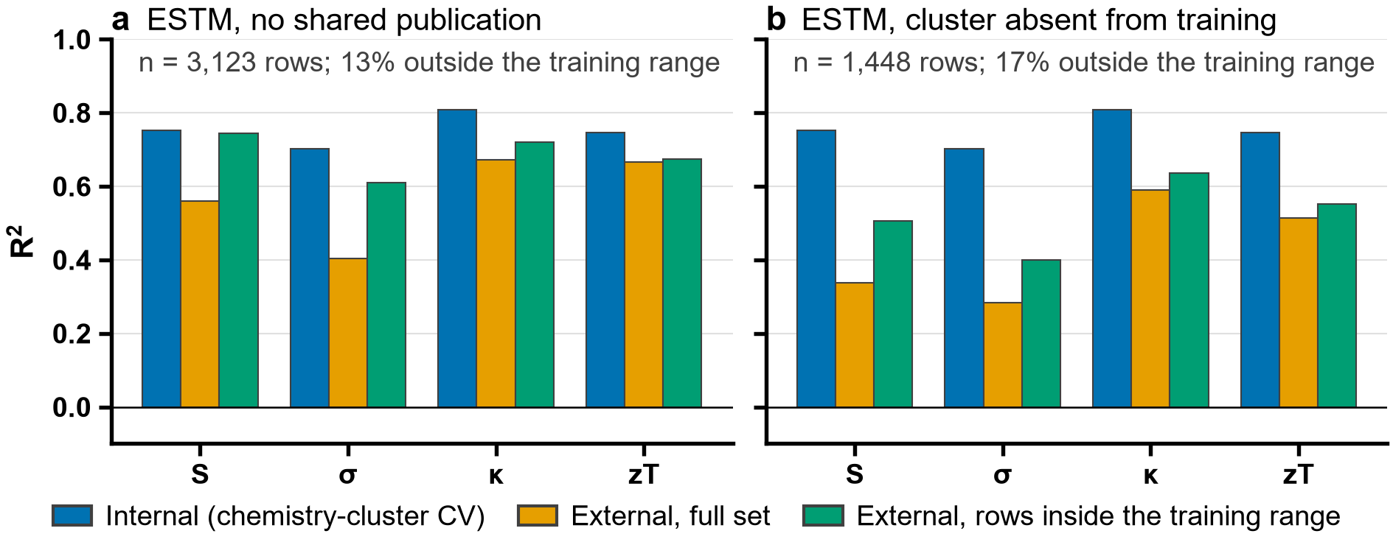
Figure 7
Figure 7: ESTM external validation: R² for the internal chemistry-cluster CV (blue), the external full set (orange) and the external rows inside the training range (green), for (a) rows sharing no source publication with the training data and (b) rows whose chemistry cluster is absent from training. The note in each panel gives the number of rows and the share of them outside the training range.
teMatDb. The same four final models were scored on teMatDb (Section 2.4; Table 8). An ordering between two targets or two strata is stated only where the difference exceeds the fit-to-fit difference given above and the sample-level intervals do not overlap; otherwise they are called tied. This is a conservative descriptive rule, not a test, and comparisons between targets within a stratum share their samples, which marginal intervals ignore. In stratum a0 (122 samples, 2,027 rows; not an external test, because the training data hold the same curves, so it serves as an upper reference) R² is 0.936 for S, 0.767 for σ, 0.913 for κ and 0.850 for zT; S and κ lie clearly above σ and no other pair of targets is distinguishable. In stratum a (61 samples, 903 rows) the scores for κ (0.661) and zT (0.488) are clearly lower than in a0, while the lower point values for S (0.712) and σ (0.172) cannot be told from a0, because their intervals overlap; no target is distinguishable from another in a, and the interval of σ (−0.807 to 0.675) includes zero. Stratum b has 27 samples (412 rows) and is described qualitatively: its point values for S, κ and zT are of the same order as in stratum a and are not distinguishable from them, the intervals of S, κ and zT are each at least 0.42 wide, and the interval of σ includes zero. Scoring against the zT recomputed from the measured Seebeck coefficient, resistivity and thermal conductivity instead of the declared zT changes R² by at most 0.012 in any stratum. The derived zT is not offered as an external result.
Table 8: teMatDb scoring with the same final models (R² with the 95% interval of a bootstrap over whole samples, 2000 draws, in brackets). Strata are never pooled: a0, the sample’s source DOI is in the training data (not an external test); a, the DOI is not in the training data; b, the chemistry cluster is absent from training. zT (direct) is scored against the declared zT; σ and κ in log₁₀ units. An ordering is stated only where the difference exceeds the fit-to-fit difference of the ESTM scoring (Section 3.2) and the intervals do not overlap; this is a descriptive rule, not a test.
Stratum | Rows | Samples | S | σ | κ | zT (direct)
a0, DOI in training | 2,027 | 122 | 0.936 [0.891, 0.969] | 0.767 [0.618, 0.865] | 0.913 [0.880, 0.941] | 0.850 [0.782, 0.897]
a, DOI not in training | 903 | 61 | 0.712 [0.375, 0.924] | 0.172 [−0.807, 0.675] | 0.661 [0.344, 0.840] | 0.488 [0.258, 0.685]
b, cluster absent from training | 412 | 27 | 0.696 [0.432, 0.857] | 0.430 [−0.121, 0.690] | 0.718 [0.387, 0.866] | 0.565 [0.262, 0.778]
The comparison with the DFT-computed Seebeck coefficients of JARVIS⁴¹ shows at most a marginal transfer of the sign and only a weak transfer of the magnitude. The sign test covers mostly metals: of the 13,123 entries with a JARVIS sign, 12,733 are metals or semimetals and 390 are semiconductors, and of the 3,885 entries that remain after the magnitude criterion 3,534 (91%) are metals or semimetals. Of the 9,762 semiconductors, 9,372 have opposite n-type and p-type signs and therefore no sign to compare. Sign agreement is at chance overall (0.50, interval 0.49–0.52, 3,885 entries), for metals and semimetals (0.50, 0.48–0.52) and for semiconductors (0.52, 0.47–0.58, only 351 entries). The model predicts p-type for 63% of these entries and JARVIS has 53% positive. With the carrier-type classifier’s sign, which the screening uses, the agreement is 0.52 (0.50–0.54) overall and 0.57 (0.51–0.62) for the semiconductors: marginally above chance, and clearly so only for metals in clusters seen in training (0.67, 0.59–0.74), against 0.51 for unseen clusters. The rank correlation of the absolute predicted S with the JARVIS magnitude is 0.23 (0.21–0.24) over all entries, 0.11 (0.09–0.13) for metals and semimetals and negative for semiconductors (-0.08, -0.11–-0.05); the overall value is carried by the metals and by chemistries the model has seen. For entries whose chemistry cluster occurs in the training data it is 0.38 (0.25–0.48, 1,150 entries) against 0.22 (0.20–0.24) for the others; among metals it is 0.31 for seen clusters (627 entries) and 0.10 for unseen ones, and the sign agreement of metals with seen clusters is 0.62 (0.53–0.69, 172 entries) against 0.50 for unseen ones. The models therefore carry essentially no sign information to DFT-computed values for chemistries outside the training data (agreement at chance with the regressor’s sign, marginally above it with the classifier’s), and a weak magnitude ranking that is largely confined to compositions they have seen. This is a statement about transfer to computed values for ideal crystals at one temperature and one doping level, which differ from measured values of real samples in several ways, not a measure of accuracy on perovskites.

3.3 Screening results

3.3.1 Candidate pool and ranked list
The screening starts from 75,508 Materials Project compounds with E_{hull} ≤ 0.05 eV atom⁻¹. 26,355 have a PBE gap in the window, 24,723 remain after the exclusion of lead and radioactive elements, and 806 have ABX₃ stoichiometry, of which 30 are anti-perovskites and are set aside. The connectivity test keeps 315 compounds as perovskite-type; a space-group rule alone would have kept 281, 62 of which fail the connectivity test, while 118 perovskite-type compounds lie outside the space groups of the rule. 32 have a gap of at most 0.6 eV, and 30 remain after the exclusion of Tl, Hg, Cd, As and Be. Of these 30 candidates, 9 (BaSnO₃, CaMnO₃, CsSnI₃ in two entries, LaCoO₃, LaNiO₃, LaRhO₃ and YCoO₃ in two entries) lie in chemistry clusters that occur in the training data and 21 do not; the two groups are reported separately because the models are validated only where the training data contain the chemistry. Of the 30 candidates, 12 remain at every tighter stability limit and are on the convex hull. Raising the stability limit to 0.1 eV atom⁻¹ keeps all of them and adds 14 (44 in total, all of the added ones in unseen clusters), widening the cap to 0.9 eV adds 19 (4 in seen clusters), both together give 73, and allowing Tl, As and Be adds 2. The list is therefore sensitive to the criteria, which are choices, and every candidate beyond the stable ones depends on them.
Table 9: Ranked list of the 30 lead-free, narrow-gap, perovskite-type candidates of the main list: hypotheses to test, not findings. Within each group (chemistry cluster present in the training data, or absent) the candidates are ordered by the maximum over 300–800 K of the predicted zT, reached at the temperature T; the other columns are the predictions at T (S with the sign of the carrier-type classifier). E_{hull} in eV atom⁻¹ (on hull: no energy above the convex hull), E_{g} the PBE gap in eV, σ in S m⁻¹, κ in W m⁻¹ K⁻¹. † the shortlist of the pre-registered rule (docs/decisions.md). ‡ the maximum lies above the melting point of the compound; see Table 10. Studied before: a paper whose title or abstract reports a thermoelectric measurement or calculation of the compound was found by a literature check made independently of the predictions (no evidence = none found, not none existing). The features are composition-only, so polymorphs of one compound (separate Materials Project entries) share their predictions.
Cluster | # | Compound (MP id) | E_{hull} | Stability | E_{g} | T (K) | S (µV K⁻¹) | σ | κ | zT | Studied before
seen | 1 | CsSnI₃ † ‡ (mp-614013) | 0.000 | on hull | 0.45 | 800 | 144 | 9.2 × 10³ | 0.62 | 0.58 | yes
seen | 2 | CsSnI₃ ‡ (mp-616378) | 0.012 | metastable | 0.54 | 800 | 144 | 9.2 × 10³ | 0.62 | 0.58 | yes
seen | 3 | BaSnO₃ † (mp-3163) | 0.000 | on hull | 0.37 | 800 | −74 | 3.0 × 10⁴ | 6.70 | 0.10 | yes
seen | 4 | CaMnO₃ (mp-19201) | 0.035 | metastable | 0.47 | 800 | −289 | 2.8 × 10³ | 3.77 | 0.08 | yes
seen | 5 | YCoO₃ (mp-1273178) | 0.012 | metastable | 0.31 | 800 | 208 | 1.1 × 10⁴ | 2.99 | 0.05 | yes
seen | 6 | YCoO₃ (mp-1288734) | 0.015 | metastable | 0.11 | 800 | 208 | 1.1 × 10⁴ | 2.99 | 0.05 | yes
seen | 7 | LaRhO₃ † (mp-5163) | 0.000 | on hull | 0.60 | 800 | 421 | 3.5 × 10³ | 1.81 | 0.05 | yes
seen | 8 | LaNiO₃ (mp-1284950) | 0.021 | metastable | 0.36 | 800 | −12 | 2.7 × 10⁴ | 2.86 | 0.04 | yes
seen | 9 | LaCoO₃ † (mp-1288145) | 0.000 | on hull | 0.28 | 800 | 35 | 3.8 × 10⁴ | 2.58 | 0.04 | yes
unseen | 1 | RbGeI₃ (mp-571458) | 0.013 | metastable | 0.52 | 800 | 100 | 1.8 × 10⁴ | 0.69 | 0.61 | yes
unseen | 2 | CsSnBr₃ (mp-27214) | 0.011 | metastable | 0.60 | 800 | 38 | 1.4 × 10⁴ | 0.67 | 0.57 | yes
unseen | 3 | AlSiP₃ (mp-5168) | 0.007 | metastable | 0.29 | 800 | 165 | 1.3 × 10⁴ | 4.64 | 0.37 | no evidence
unseen | 4 | RbEuCl₃ (mp-1206801) | 0.038 | metastable | 0.45 | 800 | 17 | 3.6 × 10⁴ | 1.33 | 0.35 | no evidence
unseen | 5 | SrBiO₃ (mp-29164) | 0.000 | on hull | 0.31 | 800 | −134 | 6.0 × 10³ | 2.19 | 0.21 | no evidence
unseen | 6 | KCrF₃ (mp-1180782) | 0.002 | metastable | 0.16 | 800 | 29 | 2.4 × 10⁴ | 2.19 | 0.21 | no evidence
unseen | 7 | EuHfS₃ (mp-1190059) | 0.000 | on hull | 0.13 | 800 | −68 | 3.1 × 10⁴ | 1.52 | 0.20 | no evidence
unseen | 8 | KBiO₃ (mp-29799) | 0.000 | on hull | 0.49 | 800 | −83 | 1.3 × 10⁴ | 2.02 | 0.17 | no evidence
unseen | 9 | EuZrS₃ (mp-1189927) | 0.000 | on hull | 0.15 | 800 | −136 | 2.4 × 10⁴ | 1.25 | 0.16 | no evidence
unseen | 10 | MnBO₃ (mp-1278986) | 0.032 | metastable | 0.60 | 800 | −55 | 9.5 × 10³ | 2.31 | 0.14 | no evidence
unseen | 11 | MnBO₃ (mp-1289597) | 0.020 | metastable | 0.15 | 800 | −55 | 9.5 × 10³ | 2.31 | 0.14 | no evidence
unseen | 12 | EuHfO₃ (mp-753781) | 0.000 | on hull | 0.60 | 800 | −131 | 5.1 × 10⁴ | 1.23 | 0.12 | no evidence
unseen | 13 | CaVO₃ (mp-22608) | 0.001 | metastable | 0.43 | 800 | −82 | 8.1 × 10⁴ | 3.11 | 0.11 | no evidence
unseen | 14 | CaVO₃ (mp-1435359) | 0.009 | metastable | 0.26 | 800 | −82 | 8.1 × 10⁴ | 3.11 | 0.11 | no evidence
unseen | 15 | LuVO₃ (mp-2767717) | 0.000 | on hull | 0.26 | 800 | 27 | 2.2 × 10⁴ | 1.23 | 0.08 | no evidence
unseen | 16 | EuZrO₃ (mp-1106293) | 0.000 | on hull | 0.51 | 800 | −169 | 4.6 × 10⁴ | 0.90 | 0.07 | no evidence
unseen | 17 | ErNiO₃ (mp-1189736) | 0.002 | metastable | 0.37 | 800 | −15 | 1.4 × 10⁴ | 1.12 | 0.07 | no evidence
unseen | 18 | NiBiO₃ (mp-25096) | 0.032 | metastable | 0.35 | 800 | 7 | 1.2 × 10⁴ | 1.95 | 0.06 | no evidence
unseen | 19 | MnVO₃ (mp-1106224) | 0.042 | metastable | 0.32 | 800 | −60 | 6.9 × 10³ | 3.63 | 0.06 | no evidence
unseen | 20 | ErCrO₃ (mp-19063) | 0.000 | on hull | 0.25 | 800 | 88 | 1.1 × 10⁴ | 2.10 | 0.06 | no evidence
unseen | 21 | MnSnO₃ (mp-691106) | 0.022 | metastable | 0.23 | 800 | −67 | 1.0 × 10⁴ | 3.19 | 0.04 | no evidence
Because PBE systematically underestimates band gaps⁴⁶, a band-gap criterion applied to PBE values admits compounds whose true gaps may be considerably larger; this should be considered when interpreting the narrow-gap filter. Predicted zT values order the candidates and are model outputs with the uncertainty given below; no predicted zT is presented as a finding of this paper. Perovskites are under-represented in the training data: rows labelled perovskite titanate by the composition-only family rules are 2.3% of the S rows, manganites 2.1% and cobaltites 4.6%. The chemistry-cluster MAE of zT is 0.126, so predicted zT should be read with an uncertainty of that order.

3.3.2 Shortlist and physical limits
Table 10: The 4 shortlist compounds with their thermal limits (sources in the text) and the predictions within them: the highest grid temperature reported, the maximum predicted zT up to it (at the temperature T), and the secondary view, the predicted zT at 600 K with the rank at 600 K next to the primary rank (maximum over the whole grid). Model outputs, not findings.
Compound | Thermal limit | Highest T reported (K) | Maximum zT within the limit | T (K) | zT at 600 K | Rank, primary | Rank, 600 K
CsSnI₃ | melts at 724 K | 700 | 0.53 | 700 | 0.42 | 1 | 1
BaSnO₃ | none found at or below 800 K | 800 | 0.10 | 800 | 0.07 | 2 | 2
LaRhO₃ | decomposes at 1728 K in air (none at or below 800 K) | 800 | 0.05 | 800 | 0.03 | 3 | 3
LaCoO₃ | none in air; reduced above 773 K in a reducing atmosphere | 800 | 0.04 | 800 | 0.03 | 4 | 4
Physics check of the shortlist (added after the predictions had been seen; the rule and its order are unchanged). A predicted value means something only at temperatures where the compound exists. CsSnI₃ melts at 451 °C (724 K)^{54,55}, so its predictions are reported only up to 700 K, where the maximum is 0.53 and not the 0.58 at 800 K, which lies above the melting point (Tables 9 and 10). The cubic structure of its Materials Project entry is, moreover, the high-temperature phase: the black phase is orthorhombic below 362 K, tetragonal up to 440 K and cubic above⁵⁶. For the other three compounds no melting or decomposition temperature at or below 800 K was found: doped BaSnO₃ films changed their conductivity by less than 2% in air at 530 °C⁵⁷; LaRhO₃ decomposes at a calculated 1728 K in air⁵⁸; LaCoO₃ is stable in air but is reduced in a reducing atmosphere from about 500 °C⁵⁹, so its predictions above 773 K apply to an oxidising atmosphere only. As a secondary view, because the primary maxima lie at the 800 K edge of the grid (406 of the 409 compounds), the shortlist ranked by the predicted zT at 600 K is CsSnI₃, BaSnO₃, LaRhO₃, LaCoO₃, the same order as the primary one (Table 10). The list is a set of hypotheses for experimental or higher-level computational follow-up, not a result of this paper. Two limits decide how far it can be read. First, the 21 candidates in chemistry clusters absent from the training data are the ones for which the chemistry-cluster and ESTM results of Sections 3.1 and 3.2 apply, and those results show a substantial loss of accuracy; the 9 in seen clusters are closer to the training data. Second, the only transfer test against computed values available here, the comparison with JARVIS (Section 3.2), shows at most marginal sign transfer and a negative rank correlation of the magnitude for semiconductors (-0.08, interval -0.11–-0.05), and the candidates are semiconductors by construction (0.1 eV or more in PBE). The ranking should therefore be read as an ordering produced by a composition-only model, not as an estimate of the performance of any compound. The literature comparison of Section 3.4 does not test the predictions of Table 9 directly, because it compares out-of-fold predictions for compositions of the training data with published measurements; it shows, however, that the cross-validated σ and zT for these perovskite families are far from the measurements (at the exact level 0 of 25 σ values and 0 of 6 zT values of the independent papers are inside the band, and the median absolute relative error of zT is 3.166), so the zT values of Table 9 should be read with that in mind. The PBE gap used for the narrow-gap criterion underestimates measured gaps, so the gap criterion is itself uncertain.

3.3.3 View by predicted S and κ
View by predicted S and κ (added after the literature comparison; not pre-registered). The literature comparison of Section 3.4 found the exact-level error of S and κ to be 0.7 and 1.9 times the typical cross-validation error of the rung, and that of σ and zT 3.2 and 11.8 times (a rough comparison, see there), so the main list is also shown by the two better-validated properties, at the grid temperature of the maximum predicted zT within each compound’s thermal limit (the limits of Table 10: CsSnI₃, 2 of the 30 entries, is limited to 700 K, the other 28 use 800 K, and limits were sought only for the shortlist; Fig. 8 and Table 11). In this view the zT order follows κ more than S: the rank correlation (Spearman) of predicted zT at that temperature with low κ is 0.45 and with |S| 0.06, and 2 of the 10 best by zT are in chemistry clusters present in the training data, against 5 of the 10 best by the rank sum of |S| and κ. σ was not validated (0 of 25 values of the independent papers inside the band at the exact level), so it is the property least known for these candidates and, as a quantity that doping can change, the one to optimise; this is a suggestion, not a result. Neither view predicts performance: Table 11 is an ordering of two predicted properties, not a score, and the pre-registered zT ranking of Table 9 remains the main result.
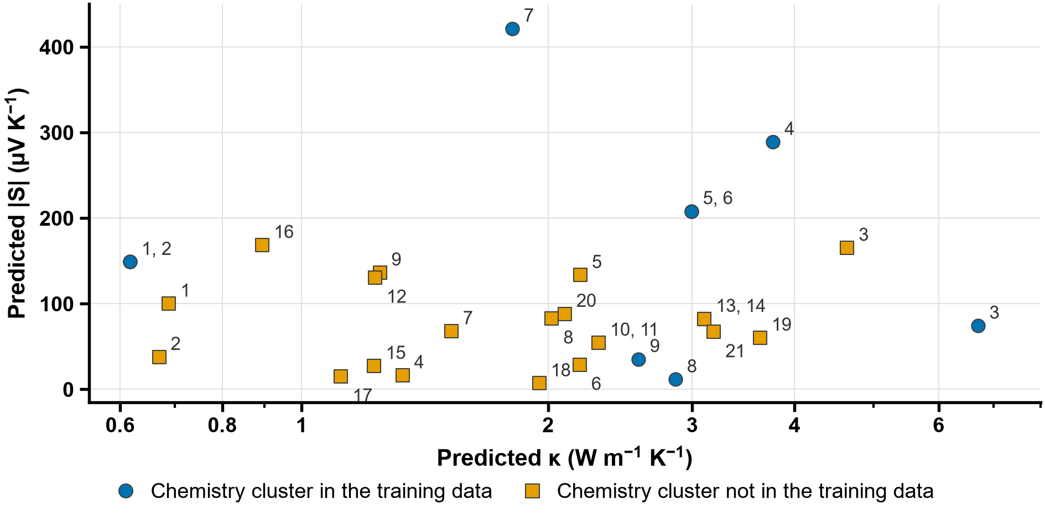
Figure 8
Figure 8: Predicted |S| against predicted κ at the maximum of the predicted zT within each compound’s thermal limit (Table 10) for the 30 candidates of the main list, whose chemistry cluster is present (circles) or absent (squares) in the training data; the number beside each point is its position # in Table 9 (the rank by predicted zT within its cluster group). Added after the literature comparison (NA12); not pre-registered. Model outputs, not findings; compounds with identical predictions are drawn once.
Table 11: The 30 candidates of Table 9 ordered by the sum of their rank by predicted |S| (largest first) and their rank by predicted κ (lowest first), both at the grid temperature T of the maximum predicted zT within the compound’s thermal limit (Table 10: only CsSnI₃ is limited, to 700 K; the other 28 entries have no limit applied and use 800 K; limits were sought only for the shortlist). Added after the literature comparison (NA12); not pre-registered. This is an ordering of two predicted properties only, not a performance score and not a prediction of zT. The best rank is the lowest; compounds with identical predictions (separate Materials Project entries of one composition) share a rank. zT rank: the position # of Table 9 (the rank within the cluster group by the pre-registered ranking, unchanged). † the shortlist of the pre-registered rule.
Position | Compound (MP id) | Cluster | zT rank (Table 9) | T (K) | |S| rank | κ rank | Rank sum
1 | CsSnI₃ † (mp-614013) | seen | 1 | 700 | 7 | 1 | 8
2 | CsSnI₃ (mp-616378) | seen | 2 | 700 | 7 | 1 | 8
3 | EuZrO₃ (mp-1106293) | unseen | 16 | 800 | 5 | 5 | 10
4 | LaRhO₃ † (mp-5163) | seen | 7 | 800 | 1 | 12 | 13
5 | RbGeI₃ (mp-571458) | unseen | 1 | 800 | 12 | 4 | 16
6 | EuZrS₃ (mp-1189927) | unseen | 9 | 800 | 9 | 9 | 18
7 | EuHfO₃ (mp-753781) | unseen | 12 | 800 | 11 | 8 | 19
8 | YCoO₃ (mp-1273178) | seen | 5 | 800 | 3 | 22 | 25
9 | YCoO₃ (mp-1288734) | seen | 6 | 800 | 3 | 22 | 25
10 | CsSnBr₃ (mp-27214) | unseen | 2 | 800 | 23 | 3 | 26
11 | SrBiO₃ (mp-29164) | unseen | 5 | 800 | 10 | 17 | 27
12 | KBiO₃ (mp-29799) | unseen | 8 | 800 | 14 | 14 | 28
13 | ErCrO₃ (mp-19063) | unseen | 20 | 800 | 13 | 15 | 28
14 | EuHfS₃ (mp-1190059) | unseen | 7 | 800 | 18 | 11 | 29
15 | CaMnO₃ (mp-19201) | seen | 4 | 800 | 2 | 28 | 30
16 | LuVO₃ (mp-2767717) | unseen | 15 | 800 | 26 | 7 | 33
17 | ErNiO₃ (mp-1189736) | unseen | 17 | 800 | 28 | 6 | 34
18 | AlSiP₃ (mp-5168) | unseen | 3 | 800 | 6 | 29 | 35
19 | RbEuCl₃ (mp-1206801) | unseen | 4 | 800 | 27 | 10 | 37
20 | MnBO₃ (mp-1278986) | unseen | 10 | 800 | 21 | 18 | 39
21 | MnBO₃ (mp-1289597) | unseen | 11 | 800 | 21 | 18 | 39
22 | CaVO₃ (mp-22608) | unseen | 13 | 800 | 15 | 24 | 39
23 | CaVO₃ (mp-1435359) | unseen | 14 | 800 | 15 | 24 | 39
24 | KCrF₃ (mp-1180782) | unseen | 6 | 800 | 25 | 16 | 41
25 | NiBiO₃ (mp-25096) | unseen | 18 | 800 | 30 | 13 | 43
26 | LaCoO₃ † (mp-1288145) | seen | 9 | 800 | 24 | 20 | 44
27 | MnSnO₃ (mp-691106) | unseen | 21 | 800 | 19 | 26 | 45
28 | BaSnO₃ † (mp-3163) | seen | 3 | 800 | 17 | 30 | 47
29 | MnVO₃ (mp-1106224) | unseen | 19 | 800 | 20 | 27 | 47
30 | LaNiO₃ (mp-1284950) | seen | 8 | 800 | 29 | 21 | 50

3.4 Literature comparison with published measurements
The shortlist compounds, and the doped families around them, were compared with published measurements under the pre-registered protocol of Section 2.6, which was amended 17 times before the comparison (Supplementary Table S1). The predictions compared are the out-of-fold predictions of the chemistry-cluster cross-validation of Section 3.1.1, not those of the final models and not those of Table 9. At the exact level the prediction is the mean held-out prediction for the same composition at the same 25 K temperature bin; at the cluster level it is the mean, over all training rows of the same chemistry cluster at that bin, of the held-out predictions, so that for a doped sample it is the average of the family the sample belongs to, not a prediction for that compound. The two levels are reported separately. A value is inside the band if its absolute relative error does not exceed the relative standard uncertainty of the round-robin measurements⁵³ (S 0.06, σ 0.08, κ 0.11, zT 0.19); for σ and κ, which the models predict as log₁₀, the log₁₀ ratio is also given. Results are reported per paper, an overall summary weighs the papers equally, and training-source papers are reported separately and never pooled with the independent papers.
What was compared. 485 literature values were read from the 7 papers; after averaging the values of one sample, property and bin, 423 remained, and 324 of these lie inside 300 K to 800 K and are compared (159 of the 423 values are compared at the cluster level only: those of Ohta et al. and Rajasekaran et al.). By DOI, 4 of the 7 papers are training sources (Flahaut et al., Ohta et al., Rajasekaran et al. and Shibasaki et al.) and 3 are independent (Ohtaki et al., Sebastia-Luna et al. and Singh and Pandey); 141 of the compared values are from independent papers and 183 from training-source papers, which are reported separately.
Independent papers, exact level (the main test). The exact level compares a literature value with the held-out prediction for the same composition at the same bin; the chemistry cluster of the composition is held out of the model that made it.
- S: 16 values from 3 papers, 4 inside the band (Ohtaki 3 of 10, Sebastia-Luna 0 of 3, Singh 1 of 3). Papers weighing equally, the mean fraction inside the band is 0.211 and the median of the papers’ median absolute relative errors is 0.145.
- σ: 25 values from 2 papers, 0 inside the band (Ohtaki 0 of 22, Sebastia-Luna 0 of 3). Papers weighing equally, the mean fraction inside the band is 0.000 and the median of the papers’ median absolute relative errors is 2.656; in log₁₀, the median over papers of the median absolute ratio is 0.487 and of the signed median +0.291 (prediction minus literature).
- κ: 5 values from 2 papers, 0 inside the band (Ohtaki 0 of 2, Sebastia-Luna 0 of 3). Papers weighing equally, the mean fraction inside the band is 0.000 and the median of the papers’ median absolute relative errors is 0.261; in log₁₀, the median over papers of the median absolute ratio is 0.128 and of the signed median −0.067 (prediction minus literature).
- zT: 6 values from 2 papers, 0 inside the band (Ohtaki 0 of 3, Sebastia-Luna 0 of 3). Papers weighing equally, the mean fraction inside the band is 0.000 and the median of the papers’ median absolute relative errors is 3.166.
Supplementary Table S6 gives every paper (Supplementary Note S10).
Independent papers, cluster level (a family-average comparison). At the cluster level the prediction is the average, over the training rows of the sample’s chemistry cluster at that bin, of the held-out predictions. It is compared with the literature value of one sample, so it asks how far the family average is from that sample, not how well the model predicts the compound. It is reported separately from the exact level.
- S: 56 values from 3 papers, 0 inside the band (Ohtaki 0 of 40, Sebastia-Luna 0 of 3, Singh 0 of 13). Papers weighing equally, the mean fraction inside the band is 0.000 and the median of the papers’ median absolute relative errors is 0.504.
- σ: 69 values from 2 papers, 7 inside the band (Ohtaki 7 of 66, Sebastia-Luna 0 of 3). Papers weighing equally, the mean fraction inside the band is 0.053 and the median of the papers’ median absolute relative errors is 5.668; in log₁₀, the median over papers of the median absolute ratio is 0.822 and of the signed median +0.822 (prediction minus literature).
- κ: 8 values from 2 papers, 1 inside the band (Ohtaki 1 of 5, Sebastia-Luna 0 of 3). Papers weighing equally, the mean fraction inside the band is 0.100 and the median of the papers’ median absolute relative errors is 0.193; in log₁₀, the median over papers of the median absolute ratio is 0.089 and of the signed median −0.035 (prediction minus literature).
- zT: 8 values from 2 papers, 0 inside the band (Ohtaki 0 of 5, Sebastia-Luna 0 of 3). Papers weighing equally, the mean fraction inside the band is 0.000 and the median of the papers’ median absolute relative errors is 2.701.
Training-source papers (reported separately, never pooled with the independent papers). A paper whose DOI is among the DOIs of the training data is a training source, and for it the comparison partly restates the cross-validation error. The rows of the training table with each paper’s DOI are: Flahaut et al.¹¹: 102 rows (6 compositions; 0 of its 75 values have a training row of the same DOI and composition); Ohta et al.⁵¹: 3 rows (1 composition; 0 of its 137 values have a training row of the same DOI and composition); Rajasekaran et al.⁵⁰: 2 rows (2 compositions; 0 of its 22 values have a training row of the same DOI and composition); Shibasaki et al.⁴⁹: 2 rows (2 compositions; 4 of its 26 values have a training row of the same DOI and composition). Their results per paper are in Supplementary Table S6 (part B). Comparisons by level: Flahaut et al. comparisons at the exact level 4, at the cluster level 46, of 55 values inside the window; Ohta et al. comparisons at the exact level 0, at the cluster level 104, of 104 values inside the window; Rajasekaran et al. comparisons at the exact level 0, at the cluster level 7, of 22 values inside the window; Shibasaki et al. comparisons at the exact level 1, at the cluster level 1, of 2 values inside the window.
Edge sensitivity. 86 of the compared values lie within twice the calibration uncertainty of a bin edge and were also evaluated in the neighbouring bin. Supplementary Table S7 gives the overall summary of the independent papers for the headline assignment and for the neighbouring-bin assignment. 16 value-level results change (a changed in-band status, or no prediction in the neighbouring bin): 15 of Ohtaki et al. and 1 of Ohta et al. Among the training-source papers, the neighbouring-bin run changes only the results of Ohta et al.: Ohta et al., S at the cluster level: 0 of 35 inside the band becomes 0 of 35, the median absolute relative error 0.544 becomes 0.541; Ohta et al., σ at the cluster level: 0 of 34 inside the band becomes 0 of 34, the median absolute relative error 0.874 becomes 0.889; Ohta et al., zT at the cluster level: 2 of 19 inside the band becomes 3 of 19, the median absolute relative error 0.473 becomes 0.524.
Markers not read. The digitised figures of Ohta et al. have 4 not-legible entries (0 markers removed by a gate, 0 unplaceable clicks, 4 empty derived columns), those of Ohtaki et al. 65 (13, 2 and 50) and those of Rajasekaran et al. 4 (0, 2 and 2); the vector figures have no such list.
Result. At the exact level, 4 of 16 Seebeck values and 0 of 36 σ, κ and zT values of the 3 independent papers lie inside the measurement band. The signed median log₁₀ ratio of σ is −0.185 for the 22 values of Ohtaki et al. and +0.768 for the 3 values of Sebastia-Luna et al., so the two papers differ in sign (+0.291 as the median over the two). The comparison rests on 3 independent papers and on few values for κ (5) and zT (6).
Context (not pre-registered; added after the result). For comparison with the errors above, the committed chemistry-cluster out-of-fold predictions of the rung (every prediction of the five repeats counted, not averaged per bin as the NA12 predictions are) have a median absolute relative error of 0.212 for S, 0.331 for σ, 0.151 for κ and 0.269 for zT, and a median absolute log₁₀ ratio of 0.153 for σ (signed median −0.026) and 0.066 for κ (signed median −0.005). At the exact level, the independent papers’ median absolute relative error of S (0.145) is 0.7 times the rung’s; the median absolute log₁₀ ratio of κ (0.128) is 1.9 times the rung’s, and that of σ (0.487) is 3.2 times the rung’s (the signed medians of the two papers differ in sign, as stated above); the median absolute relative error of zT (3.166) is 11.8 times the rung’s. The independent exact-level samples are small: S 16 values from 3 papers, σ 25 from 2, κ 5 from 2 and zT 6 from 2. The NA12 predictions are means over the training rows of a bin compared with one literature value, whereas the rung’s errors are per row, so the two are not like-for-like.

3.5 Limitations
Prediction of electrical conductivity is intrinsically limited (chemistry-cluster R² = 0.702; ESTM stratum (b) R² = 0.283) because carrier concentration depends on doping and synthesis conditions not reflected in the formula, a limitation common to all composition-only models. The carrier-type classifier is right for 0.948 of the held-out rows under chemistry-cluster CV, so about one row in twenty has a wrong sign even before the shift to a new family of compounds. MAGPIE and CBFV cannot encode the molecular properties of organic cations, so predictions for hybrid organic–inorganic perovskites should not be trusted. In the training data the sparsest temperature bin is the one at 775 K (3,173 zT rows) and the densest the one at 450 K (9,115 zT rows), so predictions near the top of the window are the least constrained. All 30 candidates of the main list, and 406 of the 409 featurised compounds, reach their maximum predicted zT at 800 K, the end of the grid and of the training window, so the maximum is a boundary value and not a located peak. The models provide point predictions without calibrated uncertainty; ensemble variance or conformal prediction⁶⁰ would make the screening more decision-ready.

4 Conclusions
A composition-only machine learning framework was developed to predict S, σ, κ and zT of thermoelectric materials and to screen lead-free perovskites, using 280,664 cleaned rows from Starrydata2 and 397 MAGPIE, CBFV and temperature descriptors. The main conclusions are:
- The screening of the Materials Project gives 315 perovskite-type compounds and 30 lead-free narrow-gap candidates, 9 in chemistry clusters seen in training and 21 unseen; it is hypothesis generation, and against DFT-computed Seebeck coefficients the models show at most marginal sign transfer. The pre-registered shortlist (CsSnI₃, BaSnO₃, LaRhO₃, LaCoO₃) consists of compounds that each have a published thermoelectric measurement and a chemistry cluster present in the training data, so it is not a blind test; in the pre-registered comparison with published measurements (Section 3.4), 4 of 16 Seebeck values and 0 of 36 σ, κ and zT values of the independent papers lie inside the measurement band at the exact level (for σ the signed median log₁₀ ratio is −0.185 for one paper and +0.768 for the other); the full ranked list (Table 9) is offered as hypotheses, and its zT values should be read with that comparison in mind.
- Validation methodology dominates reported accuracy. Random, 5-fold and 10-fold CV give nearly identical, inflated R² values; chemistry-cluster CV reduces R² by 0.134 (κ) to 0.213 (σ). (RQ2)
- Under chemistry-cluster CV, the composition-only R² values are 0.753 (S), 0.702 (σ), 0.809 (κ) and 0.746 (zT). Tripling the descriptor set adds at most 0.011 to R². A nested stack of XGBoost, LightGBM and a random forest is not distinguishable from their unweighted mean (at most 0.0004 apart, with intervals that contain zero on every target), and the mean is above XGBoost by at most 0.005; the three models agree within 0.007 in R² on every target, so among these tree ensembles on these features the R² does not depend on the learner; this is consistent with the information in composition-only features and the label noise setting the limit, but it does not exclude learners that use structure (RQ1)
- External validation on ESTM lowers R² further, most for chemistries absent from training (zT R² = 0.513, against 0.746 internally and 0.666 for rows sharing no source publication with training), while σ remains poorly predictable (R² = 0.283 in stratum b). Against DFT-computed Seebeck coefficients (JARVIS) the Seebeck model shows no sign transfer with the regressor’s sign (agreement 0.50, chance, on entries that are mostly metals) and a rank correlation of the magnitudes of 0.23 that is largely confined to chemistries seen in training.
- Direct zT regression (R² = 0.727) outperforms the component-wise route S²σT/κ (R² = 0.540) because component errors compound; component models remain diagnostically useful. (RQ3)
- SHAP analysis of the zT model ranks temperature first; for S, σ and κ the largest mean |SHAP| belongs to a statistic of an elemental property (CBFV; Table 6), not to a measured property of the material, and temperature is ranked second for κ.
Future work should (i) add structural information, e.g. by mapping doped compositions to parent-compound structures (Bi_{0.5}Sb_{1.5}Te₃ → Bi₂Te₃), or by using crystal graph networks such as CGCNN⁶¹ and MEGNet⁶²; (ii) quantify uncertainty with bootstrap ensembles or conformal prediction⁶⁰; (iii) combine DFT and experimental data through multi-fidelity or transfer learning; (iv) build doping-aware descriptors that separate dopant elements from the host formula²⁴; (v) close the loop with active learning; and (vi) measure the thermoelectric properties of the candidates of the ranked list for which the literature check found no study (19 of the 30 main-list candidates) to calibrate the framework in the under-represented perovskite region. Composition-based models are useful for triage, but only chemistry-aware validation prevents overstatement of their accuracy.

Data availability
The Starrydata2 export is regenerated daily, so this study uses one pinned snapshot (pulled 22 August 2026) archived with its SHA-256 hash; the Materials Project and ESTM data are public.

Code availability
[Code availability: to be supplied by the authors.]

Author contributions (CRediT)
Muhammad Behzad Gull: Methodology, Software, Data curation, Formal analysis, Investigation, Visualization, Writing – original draft. Kamran Javed: Supervision, Project, Resources, Writing – review & editing. Muhammad Ejaz Khan: Conceptualization, Supervision, Administration, Methodology, Validation, Writing – review & editing.

Funding
[Funding statement: to be supplied by the authors.]

Declaration of competing interest
The authors declare that they have no known competing financial interests or personal relationships that could have appeared to influence the work reported in this paper.

Declaration of generative AI and AI-assisted technologies in the writing process
[Declaration of generative AI use: to be written by the authors.]

Acknowledgements
The authors thank the developers and maintainers of Starrydata2, the Materials Project, ESTM (KRICT) and JARVIS (NIST) for making their data openly available, and the School of Computing Sciences, Pak-Austria Fachhochschule: Institute of Applied Sciences and Technology, for computational support.

References
1. Forman, C., Muritala, I. K., Pardemann, R. & Meyer, B. Estimating the global waste heat potential. Renewable and Sustainable Energy Reviews 57, 1568–1579 (2016).
2. Bell, L. E. Cooling, heating, generating power, and recovering waste heat with thermoelectric systems. Science 321, 1457–1461 (2008).
3. Slack, G. New materials and performance limits for thermoelectric cooling. in CRC handbook of thermoelectrics (CRC Press, 1995). doi:10.1201/9781420049718.ch34.
4. Snyder, G. J. & Toberer, E. S. Complex thermoelectric materials. Nature Materials 7, 105–114 (2008).
5. Biswas, K. et al. High-performance bulk thermoelectrics with all-scale hierarchical architectures. Nature 489, 414–418 (2012).
6. Poudel, B. et al. High-thermoelectric performance of nanostructured bismuth antimony telluride bulk alloys. Science 320, 634–638 (2008).
7. Lee, W. et al. Ultralow thermal conductivity in all-inorganic halide perovskites. Proceedings of the National Academy of Sciences 114, 8693–8697 (2017).
8. Xie, H. et al. All-inorganic halide perovskites as potential thermoelectric materials: Dynamic cation off-centering induces ultralow thermal conductivity. Journal of the American Chemical Society 142, 9553–9563 (2020).
9. Li, Y. et al. Phonon coherence in bismuth‐halide perovskite cs 3 bi 2 br 9 with ultralow thermal conductivity. Advanced Functional Materials 34, 2411152 (2024).
10. Stoumpos, C. C., Malliakas, C. D. & Kanatzidis, M. G. Semiconducting tin and lead iodide perovskites with organic cations: Phase transitions, high mobilities, and near-infrared photoluminescent properties. Inorganic Chemistry 52, 9019–9038 (2013).
11. Flahaut, D., Funahashi, R., Lee, K., Ohta, H. & Koumoto, K. Effect of the yb substitutions on the thermoelectric properties of CaMnO3. in 2006 25th international conference on thermoelectrics 103–106 (IEEE, 2006). doi:10.1109/ict.2006.331291.
12. Androulakis, J., Migiakis, P. & Giapintzakis, J. La 0.95 sr 0.05 CoO 3 : An efficient room-temperature thermoelectric oxide. Applied Physics Letters 84, 1099–1101 (2004).
13. Li, W., Carrete, J., A. Katcho, N. & Mingo, N. ShengBTE: A solver of the boltzmann transport equation for phonons. Computer Physics Communications 185, 1747–1758 (2014).
14. Parse, N. et al. Predicting high-performance thermoelectric materials with StarryData2. Advanced Theory and Simulations 7, (2024).
15. Jia, X., Aziz, A., Hashimoto, Y. & Li, H. Dealing with the big data challenges in AI for thermoelectric materials. Science China Materials 67, 1173–1182 (2024).
16. Sun, Y., Chen, X., Gao, J., Zhu, W. & Pan, M. Rationally design thermoelectric materials based on ingenious machine learning methods. Advanced Electronic Materials 11, 2500210 (2025).
17. Kapoor, S. & Narayanan, A. Leakage and the reproducibility crisis in machine-learning-based science. Patterns 4, 100804 (2023).
18. Meredig, B. et al. Can machine learning identify the next high-temperature superconductor? Examining extrapolation performance for materials discovery. Molecular Systems Design & Engineering 3, 819–825 (2018).
19. Xiong, Z. et al. Evaluating explorative prediction power of machine learning algorithms for materials discovery using k -fold forward cross-validation. Computational Materials Science 171, 109203 (2020).
20. Li, K., DeCost, B., Choudhary, K., Greenwood, M. & Hattrick-Simpers, J. A critical examination of robustness and generalizability of machine learning prediction of materials properties. npj Computational Materials 9, 55 (2023).
21. Ho, T. H., Hoang, N.-H. & Trinh, T. T. Physics-inspired feature engineering and interpretable machine learning for thermoelectric properties of multicomponent materials. Materials & Design 268, 116533 (2026).
22. Wang, Y. et al. High-performance stacking ensemble learning for thermoelectric figure-of-merit prediction. Materials & Design 249, 113552 (2025).
23. Barua, N. K., Lee, S., Oliynyk, A. O. & Kleinke, H. Thermoelectric material performance (zT) predictions with machine learning. ACS Applied Materials & Interfaces 17, 1662–1673 (2025).
24. Ma, C. T. & Poon, S. J. Reexamining machine learning models on predicting thermoelectric properties. (2025).
25. Elavunkel, V. K. & Padhan, P. Unlocking thermoelectric potential: A machine learning stacking approach for half-heusler alloys. ACS Applied Energy Materials 8, 15241–15257 (2025).
26. Katsura, Y. et al. Data-driven analysis of electron relaxation times in PbTe-type thermoelectric materials. Science and Technology of Advanced Materials 20, 511–520 (2019).
27. Katsura, Y. et al. Starrydata: From published plots to shared materials data. Science and Technology of Advanced Materials: Methods 5, 2506976 (2025).
28. Ward, L., Agrawal, A., Choudhary, A. & Wolverton, C. A general-purpose machine learning framework for predicting properties of inorganic materials. npj Computational Materials 2, (2016).
29. Ward, L. et al. Matminer: An open source toolkit for materials data mining. Computational Materials Science 152, 60–69 (2018).
30. Oliynyk, A. O. et al. High-throughput machine-learning-driven synthesis of full-Heusler compounds. Chemistry of Materials 28, 7324–7331 (2016).
31. Chen, T. & Guestrin, C. XGBoost: A scalable tree boosting system. in Proceedings of the 22nd ACM SIGKDD international conference on knowledge discovery and data mining 785–794 (ACM, 2016). doi:10.1145/2939672.2939785.
32. Ke, G. et al. LightGBM: A highly efficient gradient boosting decision tree. in Advances in neural information processing systems 30 (NIPS 2017) 3146–3154 (2017).
33. Breiman, L. Random forests. Machine Learning 45, 5–32 (2001).
34. Pedregosa, F. et al. Scikit-learn: Machine learning in python. Journal of Machine Learning Research 12, 2825–2830 (2011).
35. Cawley, G. C. & Talbot, N. L. C. On over-fitting in model selection and subsequent selection bias in performance evaluation. Journal of Machine Learning Research 11, 2079–2107 (2010).
36. Varma, S. & Simon, R. Bias in error estimation when using cross-validation for model selection. BMC Bioinformatics 7, 91 (2006).
37. Probst, P., Wright, M. N. & Boulesteix, A.-L. Hyperparameters and tuning strategies for random forest. WIREs Data Mining and Knowledge Discovery 9, e1301 (2019).
38. Lundberg, S. M. & Lee, S.-I. A unified approach to interpreting model predictions. in Advances in neural information processing systems 30 (NIPS 2017) 4765–4774 (2017). doi:10.48550/arXiv.1705.07874.
39. Roberts, D. R. et al. Cross‐validation strategies for data with temporal, spatial, hierarchical, or phylogenetic structure. Ecography 40, 913–929 (2017).
40. Na, G. S. & Chang, H. A public database of thermoelectric materials and system-identified material representation for data-driven discovery. npj Computational Materials 8, (2022).
41. Choudhary, K. et al. The joint automated repository for various integrated simulations (JARVIS) for data-driven materials design. npj Computational Materials 6, 173 (2020).
42. Ryu, B. et al. A high-quality thermoelectric material database with self-consistent ZT filtering. (2025) doi:10.48550/arXiv.2505.19150.
43. Ryu, B. TeMatDb v1.1.6: Thermoelectric material database. (2025) doi:10.5281/zenodo.15518036.
44. Jain, A. et al. Commentary: The materials project: A materials genome approach to accelerating materials innovation. APL Materials 1, 011002 (2013).
45. Sopiha, K. V., Comparotto, C., Márquez, J. A. & Scragg, J. J. S. Chalcogenide perovskites: Tantalizing prospects, challenging materials. Advanced Optical Materials 10, 2101704 (2021).
46. Borlido, P. et al. Large-scale benchmark of exchange–correlation functionals for the determination of electronic band gaps of solids. Journal of Chemical Theory and Computation 15, 5069–5079 (2019).
47. Sebastia-Luna, P. et al. Vacuum-deposited cesium tin iodide thin films with tunable thermoelectric properties. ACS Applied Energy Materials 5, 10216–10223 (2022).
48. Singh, S. & Pandey, S. K. Understanding the thermoelectric properties of LaCoO3 compound. Philosophical Magazine 97, 451–463 (2016).
49. Shibasaki, S., Takahashi, Y. & Terasaki, I. Thermoelectric properties of b-site substituted LaRhO3. Journal of Electronic Materials 38, 1013–1016 (2009).
50. Rajasekaran, P. et al. Facile synthesis of morphology-controlled la:BaSnO3 for the enhancement of thermoelectric power factor. CrystEngComm 22, 5363–5374 (2020).
51. Ohta, S., Nomura, T., Ohta, H. & Koumoto, K. High-temperature carrier transport and thermoelectric properties of heavily la- or nb-doped SrTiO3 single crystals. Journal of Applied Physics 97, 034106 (2005).
52. Ohtaki, M., Koga, H., Tokunaga, T., Eguchi, K. & Arai, H. Electrical transport properties and high-temperature thermoelectric performance of (Ca0.9M0.1)MnO3 (m = y, la, ce, sm, in, sn, sb, pb, bi). Journal of Solid State Chemistry 120, 105–111 (1995).
53. Alleno, E. et al. Invited article: A round robin test of the uncertainty on the measurement of the thermoelectric dimensionless figure of merit of Co0.97Ni0.03Sb3. Review of Scientific Instruments 86, 011301 (2015).
54. Gao, Z. et al. Defect passivation on lead-free CsSnI3 perovskite nanowires enables high-performance photodetectors with ultra-high stability. Nano-Micro Letters 14, 215 (2022).
55. Lin, S. et al. Inorganic lead-free b-$γ$-CsSnI3 perovskite solar cells using diverse electron-transporting materials: A simulation study. ACS Omega 6, 26689–26698 (2021).
56. Monacelli, L. & Marzari, N. First-principles thermodynamics of CsSnI3. Chemistry of Materials 35, 1702–1709 (2023).
57. Lee, W.-J. et al. Transparent perovskite barium stannate with high electron mobility and thermal stability. Annual Review of Materials Research 47, 391–423 (2017).
58. Jacob, K. T. & Waseda, Y. Phase relations in the system la-rh-o and thermodynamic properties of LaRhO3. Journal of the American Ceramic Society 78, 440–444 (1995).
59. Radovic, M. et al. Thermal, mechanical and phase stability of LaCoO3 in reducing and oxidizing environments. Journal of Power Sources 184, 77–83 (2008).
60. Shafer, G. & Vovk, V. A tutorial on conformal prediction. Journal of Machine Learning Research 9, 371–421 (2008).
61. Xie, T. & Grossman, J. C. Crystal graph convolutional neural networks for an accurate and interpretable prediction of material properties. Physical Review Letters 120, 145301 (2018).
62. Chen, C., Ye, W., Zuo, Y., Zheng, C. & Ong, S. P. Graph networks as a universal machine learning framework for molecules and crystals. Chemistry of Materials 31, 3564–3572 (2019).

