**CitiSIM**

**Business Inteligence Tool**

User Guide

<< To add description of APP >>

Recomended Browser: Mozilla Firefox

When accessing the platform, first page will be a LogIN form. Your personal credentials should be used here. For testing purposes we have a generic account that can be used. (emai: test@mail.ro, password: testing).

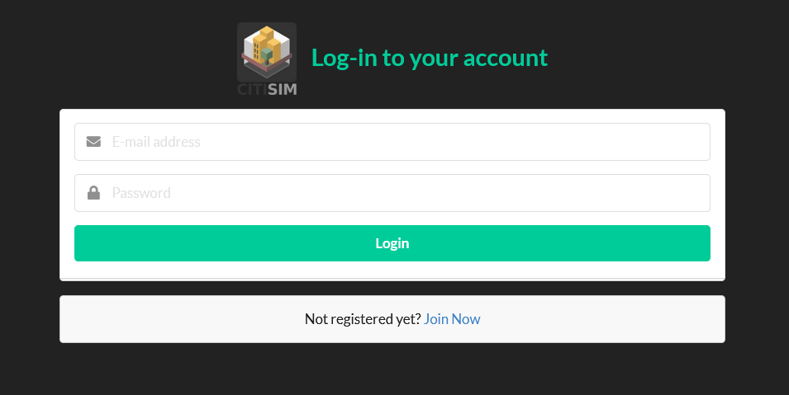

Fig. 1 LogIN form

A new account can be registered by clicking on the **Join Now** button at the bottom. It will redirect you to a registration form. With the new created account you can now LogIN.

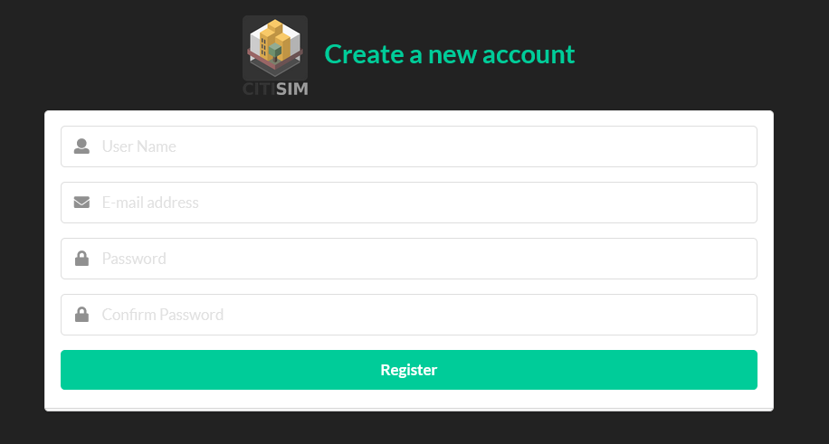

Fig. 2 Register form

The first page after authentication lists all your defined scenarios. Here you are able to create new ones or edit and remove the existing ones. Each scenario is defined by a name, investment value, duration, starting date, optionally a brief description and a set of rules. The rules define how the achieved savings from each month are shared between client and ESCO (Energy Service Company).

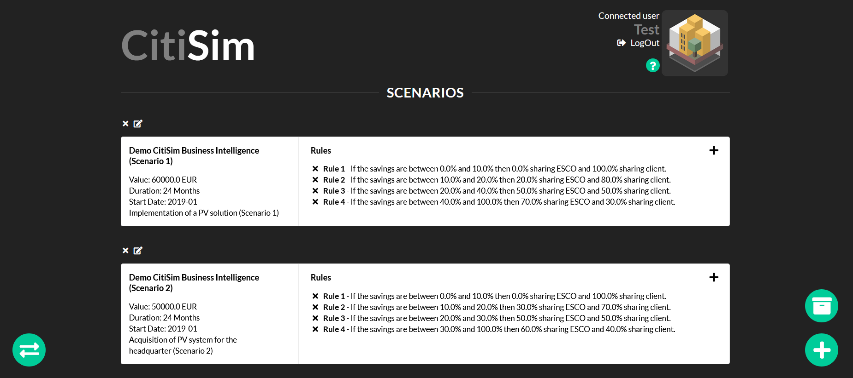

Fig. 3 Main page

To create a new scenario click on the green plus button on the bottom right corner and fill all the required fields. To remove or edit an existing scenario there are two buttons on top of each coresponding white box.

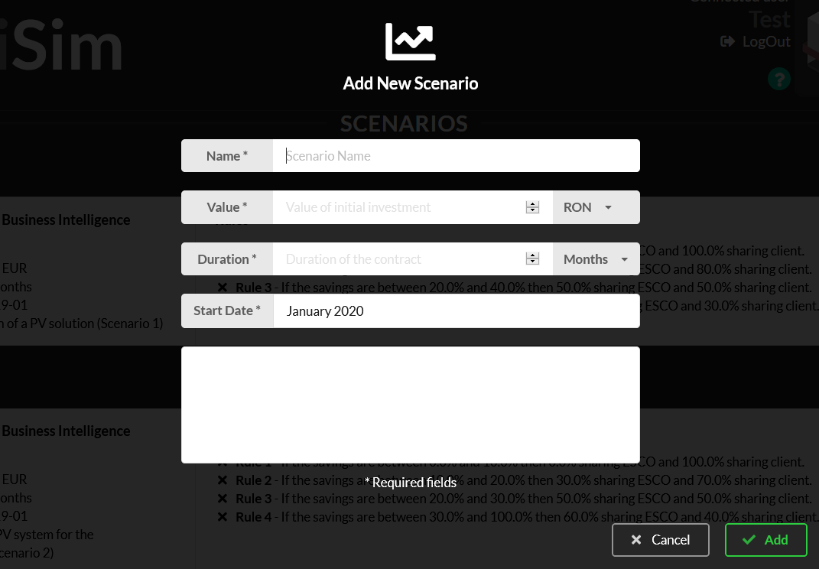

Fig. 4 New Scenario

To add a new rule you can find a plus sign on the right top corner of each scenario. To remove a rule there is an „X” button at the beginning of the line.

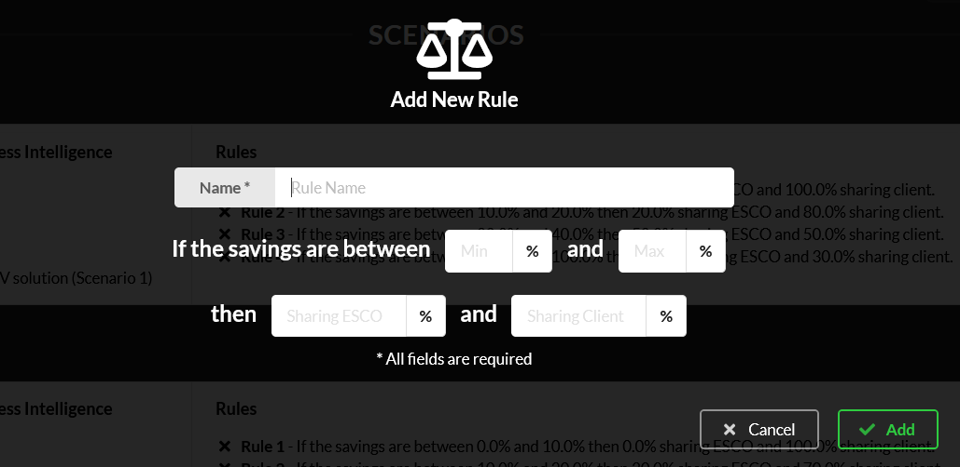

Fig. 5 New Rule

The Key Performance Indicators (KPI) can be accessed by clicking on the name of the scenario. The table in this page was created automatically with a number of rows equal to the number of months that coresponds to the duration of the project. At the beginning each energy consumpion data is equal to zero and the performance indicators will be computed each time you enter new values. Baseline Bill column coresponds to the energy consumption cost without the investment and Current Bill is the estimated cost for the same month after the energy investment.

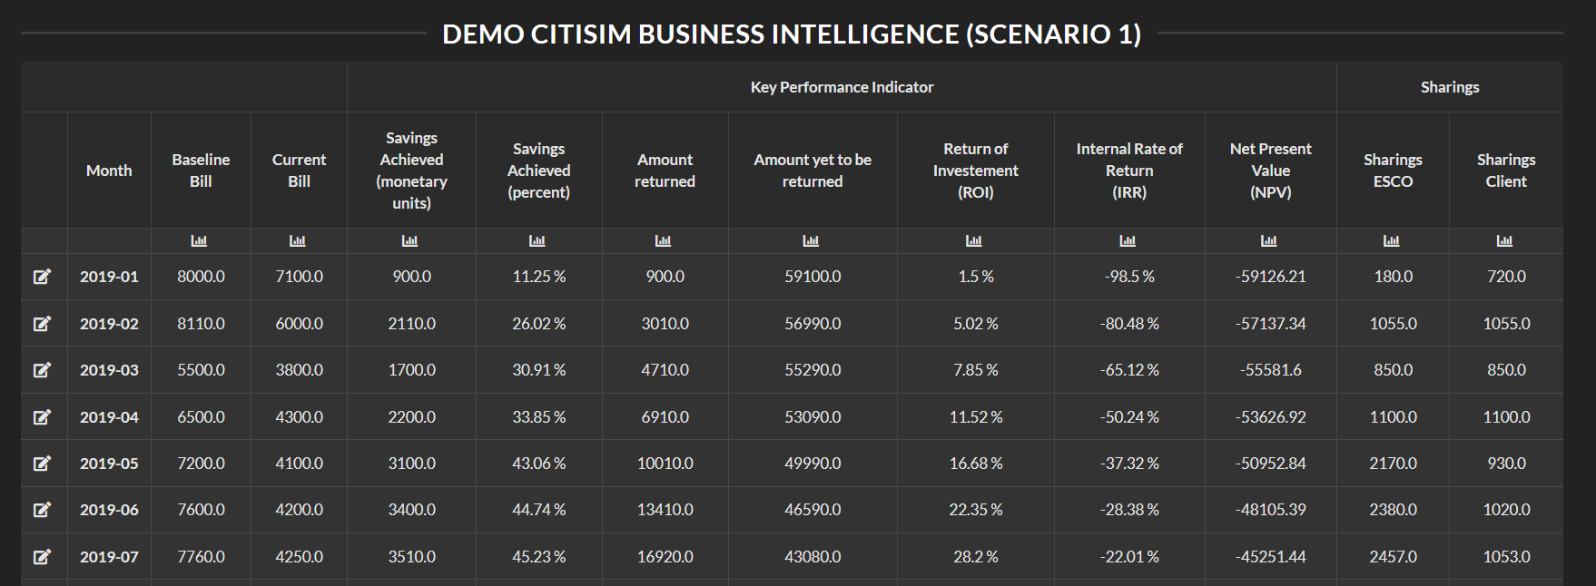

Fig. 6 Key Performance Indicators

The evolution of each performance indicator can be displayed in chart form by clicking on the chart icon under each column header.

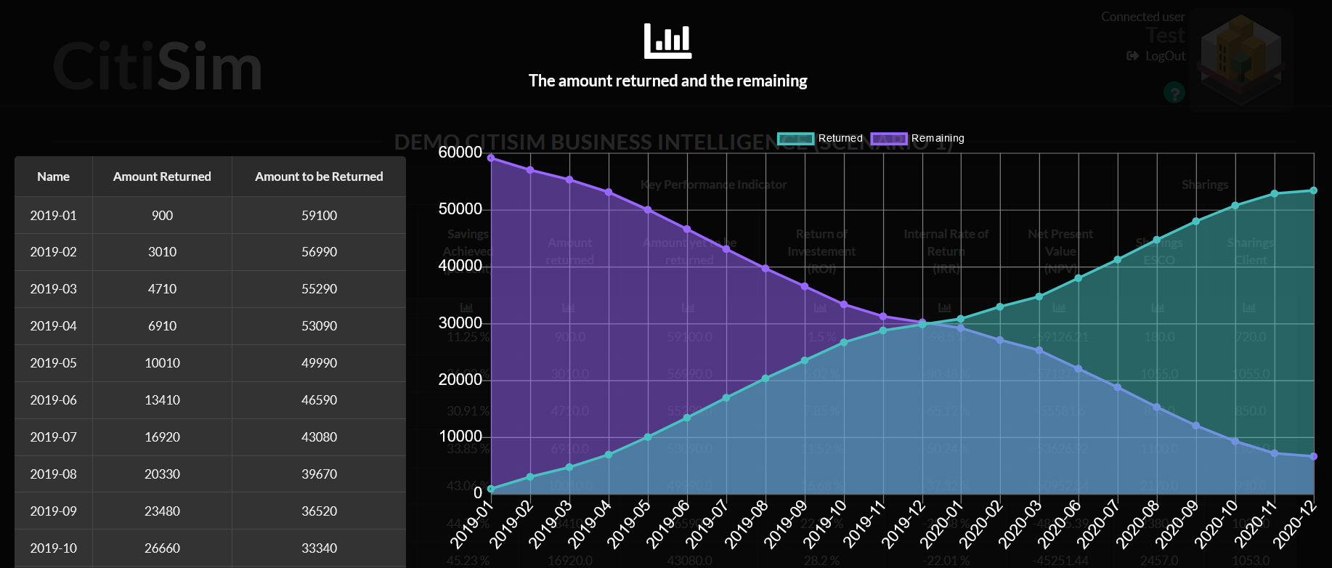

Fig. 7 KPI Chart

If you want to create multiple investment plans for the same project you have the posibility to compare two different scenarios. It is very easy to see the advantages and the disadvantages between two scenarios if they are displayed side by side in the same page. For that, on the main page, in the bottom left corner there is a green button with two white parralel arrows. It will redirect you to another page where you can select the two scenarios that you want to compare. The tables for both scenarios will be displayed at the top of the page, followed by different charts printed in parallel. There is a chart for each column in key performance indicators table.

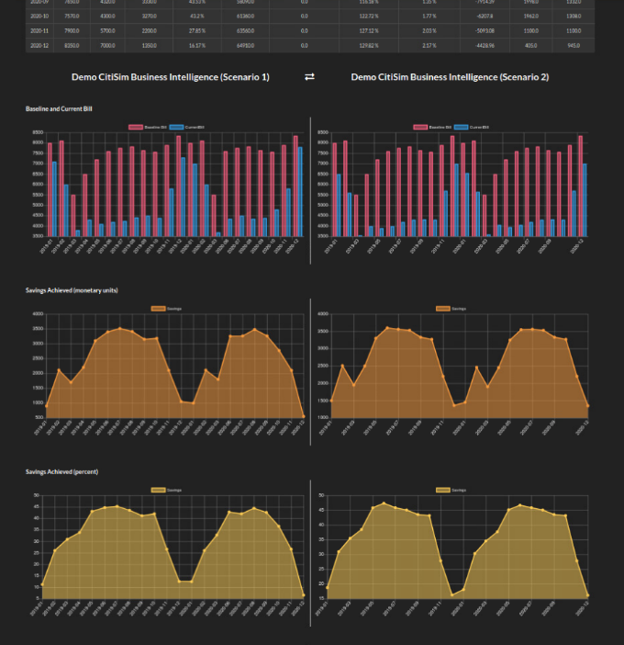

Fig. 8 Scenarios comparison

The platform also offers a tool that allows you to analise the energy consumption trend in order to accuratelly establish values for baseline and current bill. It allso offers you the posibility to predict future consumption values based on past energy indexes. To acces this tool, at the bottom right corner of the main page, there is a green button with a white box . It will redirect you to another page where you can define and manage your datasets.

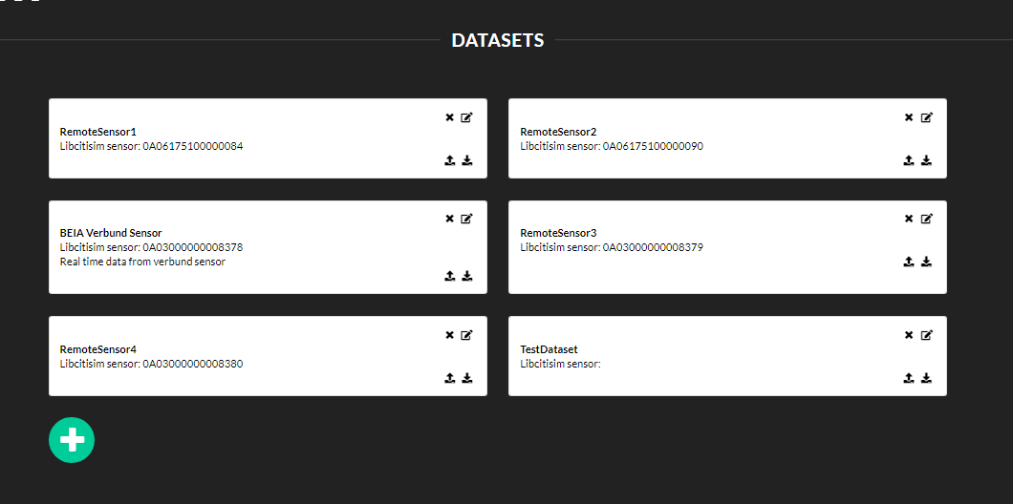

Fig. 9 Datasets

Each dataset is defined by a generic name, a Libcitisim sensor ID and a short description. The last two of them are optional. The Libcitisim sensor ID field must be used in correlation with a sensor that publishes data to Libcitisim Energy topic. On the server we have a service subscribed to the Libcitisim broker and whenever the sensor with your ID publishes new data it is automatically added to the dataset. The sensor must send the energy consumption index in kWh (an increasing value) and not the energy consumed from the last measurement.

You can export or import dataset data using the two icons in the bottom right corner of each dataset window. The export mechanism provide data in csv format. To import new data you must export the whole dataset, edit the CSV file and import it back. The import mechanism clears all the existing values in the database and inserts the new ones. Value and Timestamp are required when adding a new entry to the CSV file.

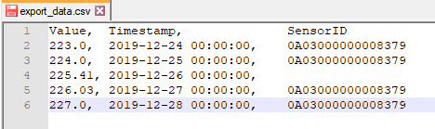

Fig. 10 CSV file

In the bottom right corner of the page you can find a chart like green button. It will redirect you to a page where you can interactively view the dataset. Here you can select a certain period of time to be displayed and you can set the granularity of the data from one day (where you can see the hourly consumption), one month (where you can see the daily consumption) to multiple months (where you can see the consumption specific to each month).

|  |  |
| --- | --- |
|  |  |

Fig. 11 Dataset display

The **Plot data as Delta values** option allows you to see the data as the amount of consumed energy for each interval and not as index evolution.

In the multiple months perspective you can predict the future consumption values. For this you must set the number of values to be predicted and press the **Forecast** botton. The mechanism need at least 24 past values in order to be able to predict. The computed values are added to the chart with a different color and a special table is crated at the bottom of the page.

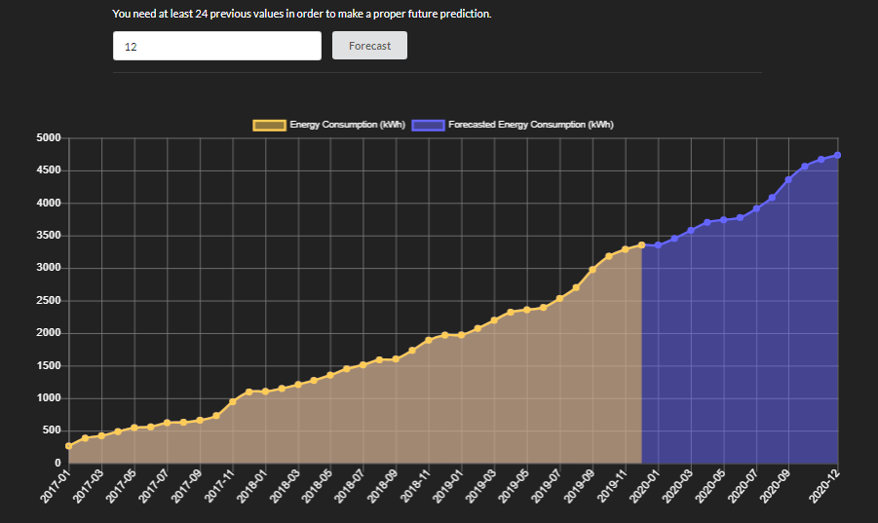

Fig. 12 Forcasted values

Also, for the same perspective there is available another mechanism that helps you to export consumption data from this interface to the key performance indicators table as Baseline Bills. At the bottom of the page you can find a section where you must select the Scenario for the data to be exported and the price for a kWh unit.

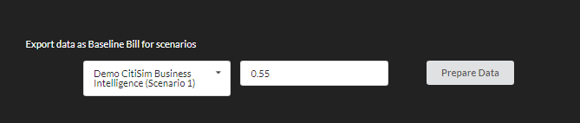

Fig. 13 Preparing the Baseline Bill export

The **Prepare Data** button launches a mechanism that automatically selects the months that are suited for the selected scenario and computes the Bill value using the unit price. The consumption values are selected from both the past and the predicted ones based on the period of the project.

The prepared data is displayed for final checks and after that you can press **Export.**  The exported data can be viewed in the Key Performance Indicators page of the selected scenario.

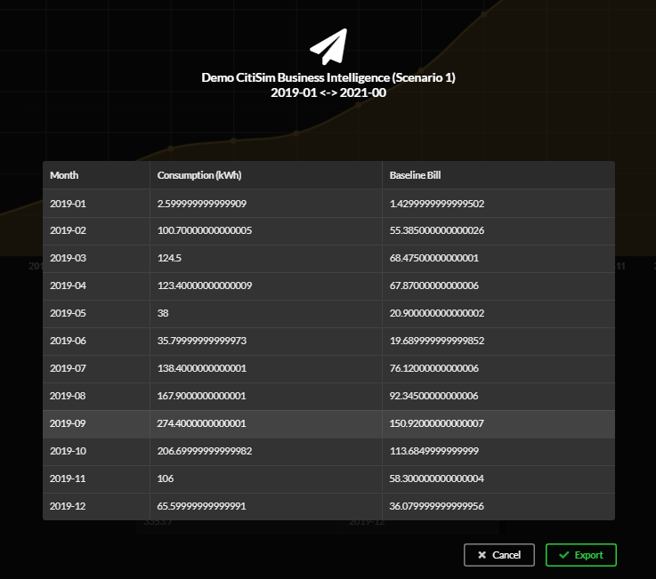

Fig. 14 Baseline Bill export