**Assignment 05**

12332288 胡蓓慧

1. **Modeling of carbon cycle**

In this problem, we will build a box model to understand the Earth’s carbon cycle based on the framework in Tomizuka 2009.

* 1. [15 points] Following equation 1-2 (without the buffer effect), build a two-box model to compute the atmospheric CO2 level in ppm (parts per million) from 1987 to 2004.

$$\begin{aligned}\frac{dN_{1}}{dt}=-k_{12}N_{1}+k_{21}N_{2}+γ \#\left(1\right)\end{aligned}$$

$$\begin{aligned}\frac{dN_{2}}{dt}=k_{12}N_{1}-k_{21}N_{2}\#\left(2\right)\end{aligned}$$

where $γ$ is the rate of production of ${CO}_{2}$ by fossil-fuel burning. where $N_{1}$ and $N_{2}$ denote the concentration of carbon in the atmosphere and the surface of the ocean, respectively, t is the time, and the transfer coefficient $k_{ij}$ is the ratio of carbon flux from reservoir i to j divided by the carbon content in reservoir i: $k_{12}$ =105/740 and $k_{21}$ =102/900 , $γ$ is the rate of production of ${CO}_{2}$ by fossil-fuel burning.

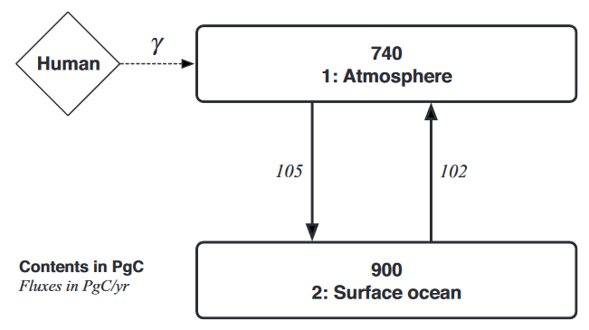

Figure 1 The simple two-box model for the global carbon cycle

The value of ${CO}_{2}$ concentration in ppm is found by dividing the carbon content in PgC by 2.13. In 1986, $N_{1}=347ppm$.

(1) and (2) can be transformed to formulas as belows:

$$\begin{aligned}dN_{1}=(-k_{12}N_{1}+k_{21}N_{2}+γ )dt\#\end{aligned}$$

$$\begin{aligned}dN_{2}=(k_{12}N_{1}-k_{21}N_{2})dt\#\end{aligned}$$

When $dt$ is smaller enough, $dt$ can be seen as $∆t$, $dN_{1}$ can be seen as ${∆N}_{1}$, so when $∆t=1$, $N_{1}^{i+1}=N_{1}^{i}+dN_{1}^{i}=N_{1}^{i}-k_{12}N_{1}+k_{21}N_{2}+γ$, $N_{2}^{i+1}=N_{2}^{i}+dN_{2}^{i}=N_{2}^{i}+k_{12}N_{1}-k_{21}N_{2}.$

So I use a for loop to compute the atmospheric CO2 level in ppm (parts per million) from 1987 to 2004. The fossil fuel rate $γ$ of each year are get from *global.1751_2008.csv*.

My result is saved in a list, which is shown as follows:

*[347.4178403755869, 348.7112676056338, 350.08079241213045, 351.4746641354907, 352.86629324151994, 354.2713413046096, 355.62111273289736, 356.95229141779373, 358.3247025086249, 359.74598833949364, 361.20632273118997, 362.6955078940884, 364.1474041707784, 365.5565833987238, 367.03436119185136, 368.57206201677303, 370.1158067146881, 371.8322999980965, 373.6850326650375]*

The first to the last item in this array denotes the atmospheric CO2 level in ppm from 1987 to 2004.

* 1. [20 points] Following equation 3-4 (with the buffer effect), build a two-box model to compute the atmospheric CO2 level in ppm from 1987 to 2004.

$$\begin{aligned}\frac{dN_{1}}{dt}=-k_{12}N_{1}+k_{21}(N_{2}^{0}+{ξ(N}_{2}-N_{2}^{0}))+γ \#\left(3\right)\end{aligned}$$

$$\begin{aligned}\frac{dN_{1}}{dt}=k_{12}N_{1}-k_{21}(N_{2}^{0}+{ξ(N}_{2}-N_{2}^{0}))\#\left(4\right)\end{aligned}$$

In 1986,we let $N_{2}^{0}=900-79= 821$, The buffer factor $ξ$ depends on the CO2 concentration in the atmosphere and is approximated as a quadratic function of the concentration. In this problem, $ξ$ can be calculate by function as follows:

$$ξ\left(z\right)≈3.69+1.86×{10}^{-2}z-1.80×{10}^{-6}z^{2}$$

where z is the atmospheric CO2 concentration of ppm unit.

Like problem 1.2, I use a for loop to calculate the atmospheric CO2 level in ppm. My result are as follows:

[347.4178403755869, 386.2678248192676, 379.07652231182266, 384.82042129901873, 386.44100423904933, 389.42203173163585, 391.9428548837997, 394.6092220225699, 397.281681136584, 400.0309463872509, 402.83107503883946, 405.6830665948721, 408.5203112074706, 411.33773620479604, 414.23711555982226, 417.206598695532, 420.20333376145396, 423.39618331711085, 426.7497421371073]

The first to the last item in this array denotes the atmospheric CO2 level in ppm with buffer effect from 1987 to 2004.

* 1. [5 points] Based on your results from 1.1 and 1.2, reproduce Figure 2 in Tomizuka (2009) as much as you can.

My result is shown in Figure 2.

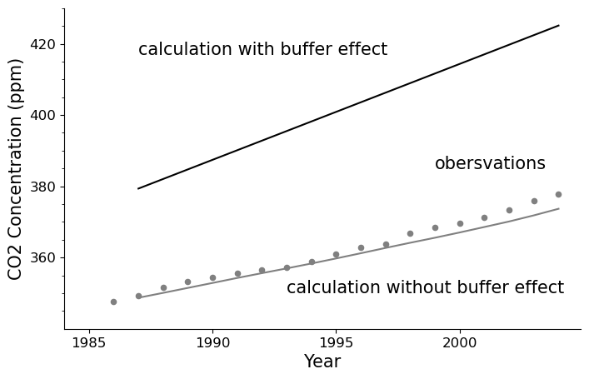

Figure 2 The CO2 trend predicted by the two-box model with the buffer effect !solid line". The observed values and the result without the buffer effect are shown by dots and a fine line, respectively.

[Bonus] [15 points] Following equation 5-13, compute the atmospheric CO2 level in ppm and reproduce Figure 4 in Tomizuka (2009).

$$\begin{aligned}f=f^{0}(1+β\ln\left(\frac{P}{P^{0}}\right))\#\left(5\right)\end{aligned}$$

where $f$ is the net primary productivity (the difference between the carbon uptake rate by photosynthesis and the carbon emission rate by respiration); $f^{0}$ corresponds to the preindustrial value of $f$. $P$ is the atmospheric CO2 concentration, and $P^{0}$ is the preindustrial value of $P$. The fertilization factor, or $β$ factor.

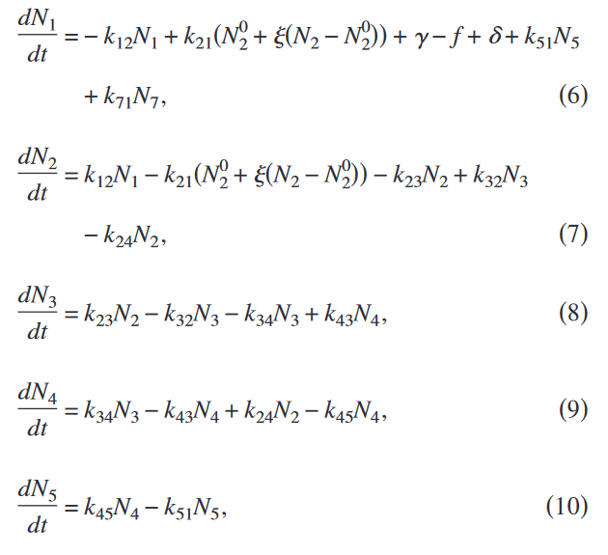

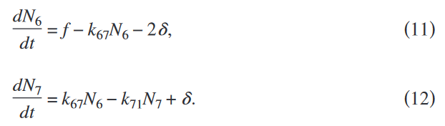

$δ$ is the emission rate to the atmosphere by changes in land use, we take $f^{0}$ =62 PgC/year .The atmospheric CO2 concentration before the industrial era is equivalent to 289 ppm.

The global land use flux from 1850 to 2000 can be obtained from file *'Global_land-use_flux-1850_2005.xls'*, and the data from 1750 to 1849 is calculated by linearly interpolated from 0.2 to 0.5.

I use $β=$ 0.38 and $β=0.50$ to calculate the atmospheric CO2 concentration. The method is same as former ones. My result are shown in Figure 3. The observations are obtained from files *'lawdome_observation.dat'* and *'Mauna_Loa_observation.csv'.*

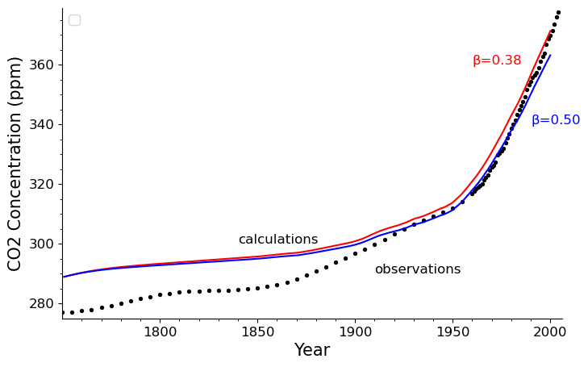

Figure 3 The CO2 trend calculated for 250 years by the seven-box model with $= 0.38 and 0.50. The observed values are shown for reference.