**Assignment 3**

胡蓓慧 12332288

1. **Niño 3.4 index**
   1. [10 points] Compute monthly climatology for SST from Niño 3.4 region, and subtract climatology from SST time series to obtain anomalies.

My result is Figure 1.

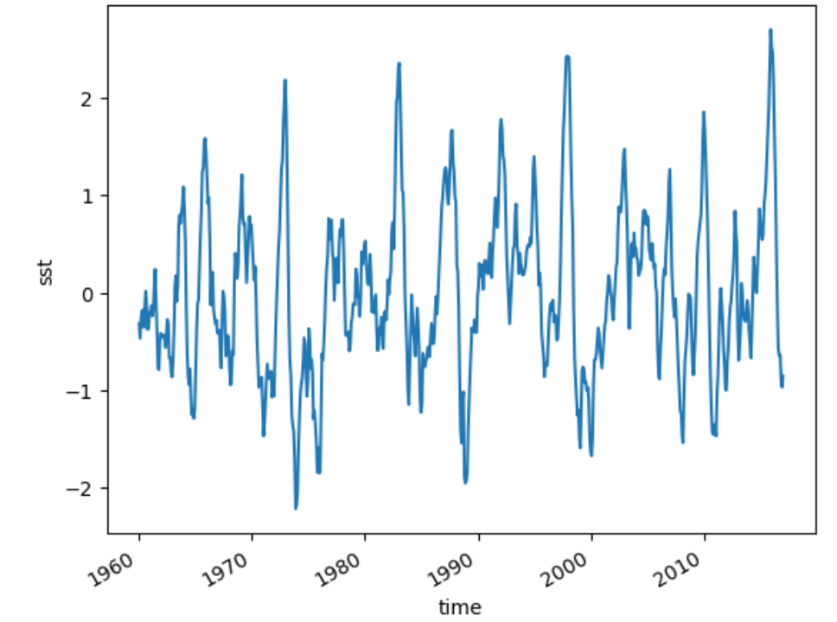

Figure 1 anomalies of SST time series

* 1. [10 points] Visualize the computed Niño 3.4.

My result is Figure 2.

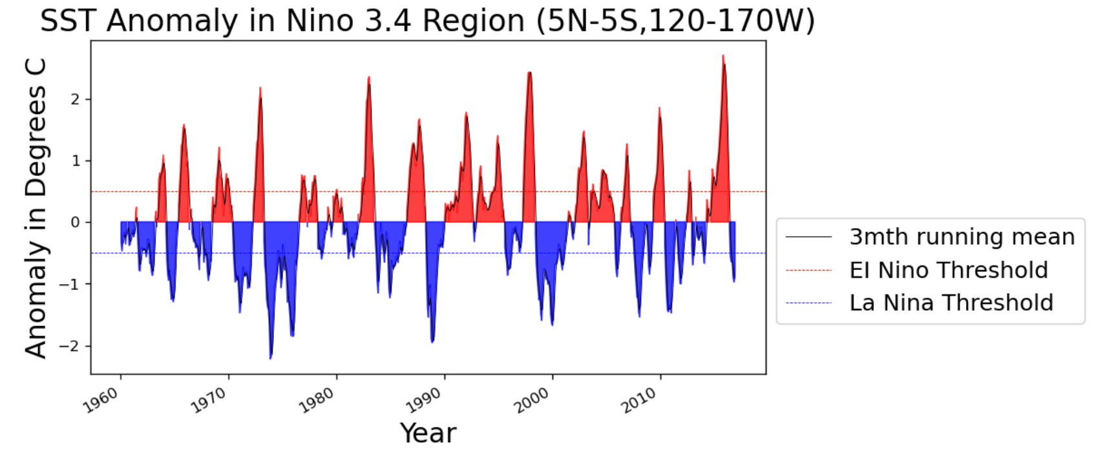

Figure 2

**2. Earth’s energy budget**

2.1 [5 points] Make a 2D plot of the time-mean TOA longwave, shortwave, and solar radiation for all-sky conditions. Add up the three variables above and verify (visually) that they are equivalent to the TOA net flux.

The 2D plot of the time-mean TOA longwave, shortwave, and solar radiation for all-sky conditions are Figue3-5.

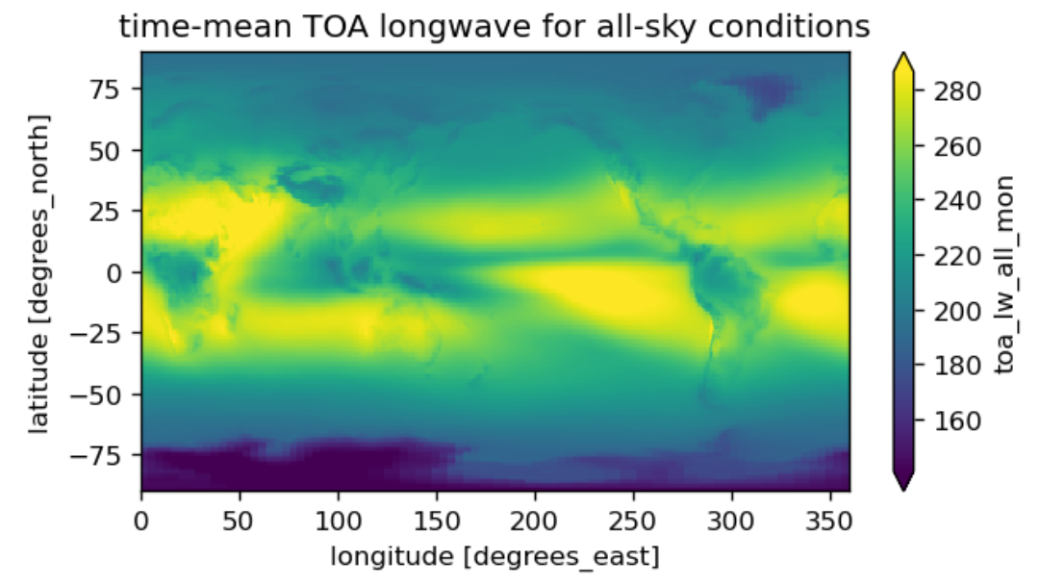

Figure 3

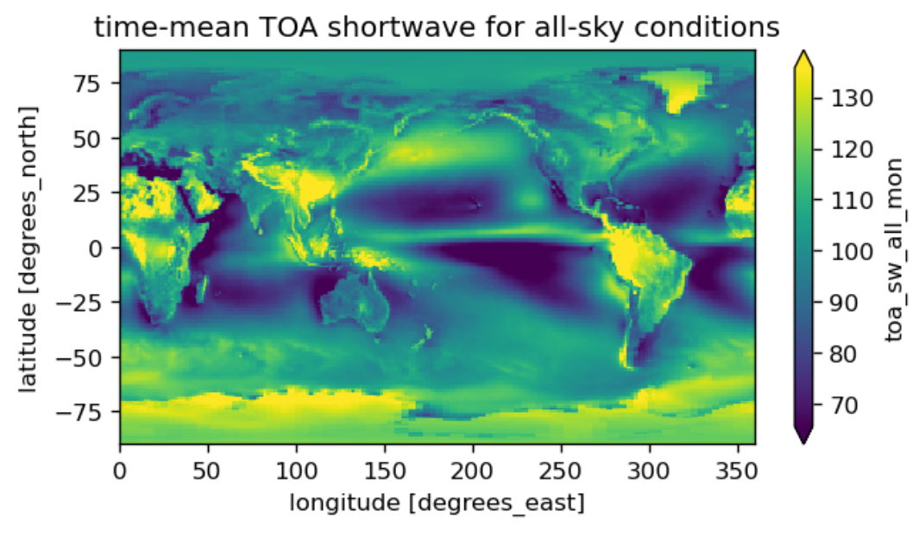

Figure 4

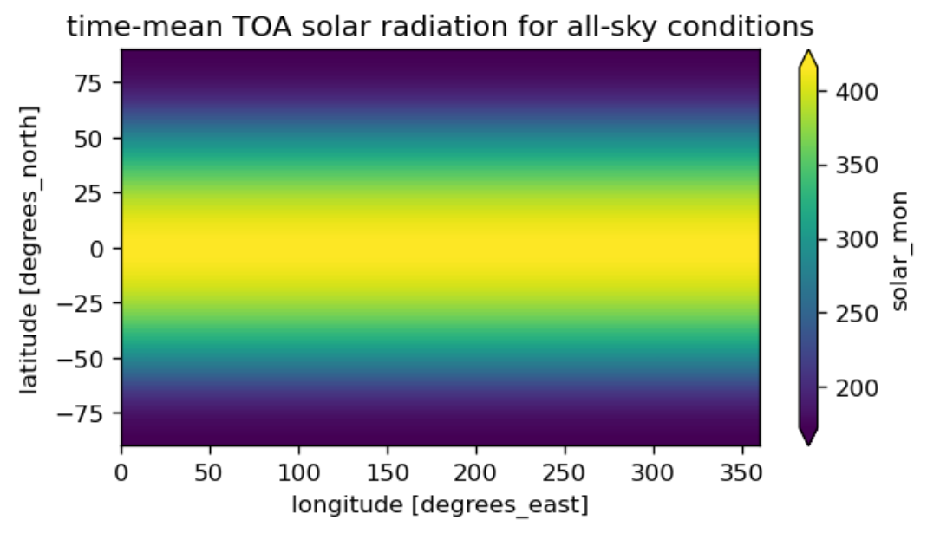

Figure 5

Then, I viually add up the three variables (shown as Figure 6) and compare the result with the TOA net flux (shown as Figure 7), found that they are equicalent.

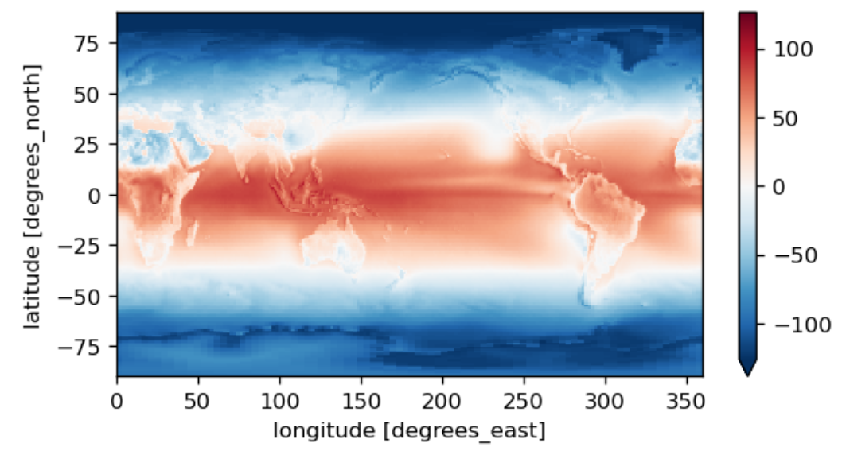

Figure 6

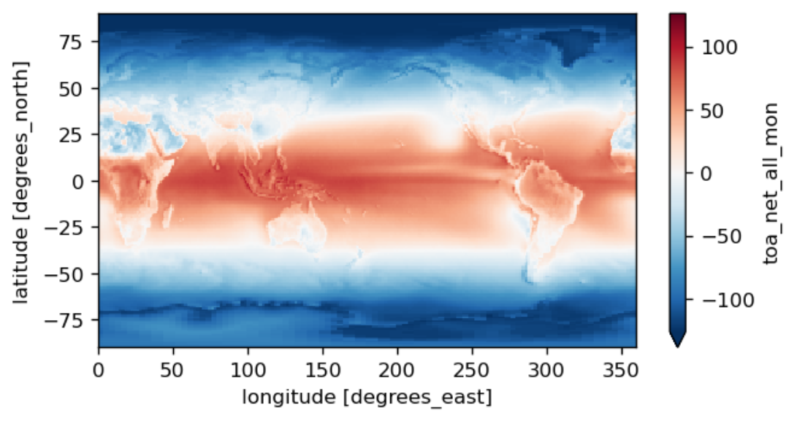

Figure 7

2.2 [10 points] Calculate and verify that the TOA incoming solar, outgoing longwave, and outgoing shortwave approximately match up with the cartoon above.

I get inspired by <https://blog.csdn.net/hydroclimate/article/details/122438081>.

To calculate the area of each grid, there has a function:

in this problem, abs(dLon1(j) - dLon2(j))=1,so I simplify the function.Finally, get the result as follows:

the TOA incoming solar: 340.28513

outgoing longwave: 99.13904

outgoing shortwave: 240.26797

my result approximately match up with the given cartoon.

2.3 [5 points] Calculate and plot the total amount of net radiation in each 1-degree latitude band. Label with correct units.

My result are shown in Figure 8.

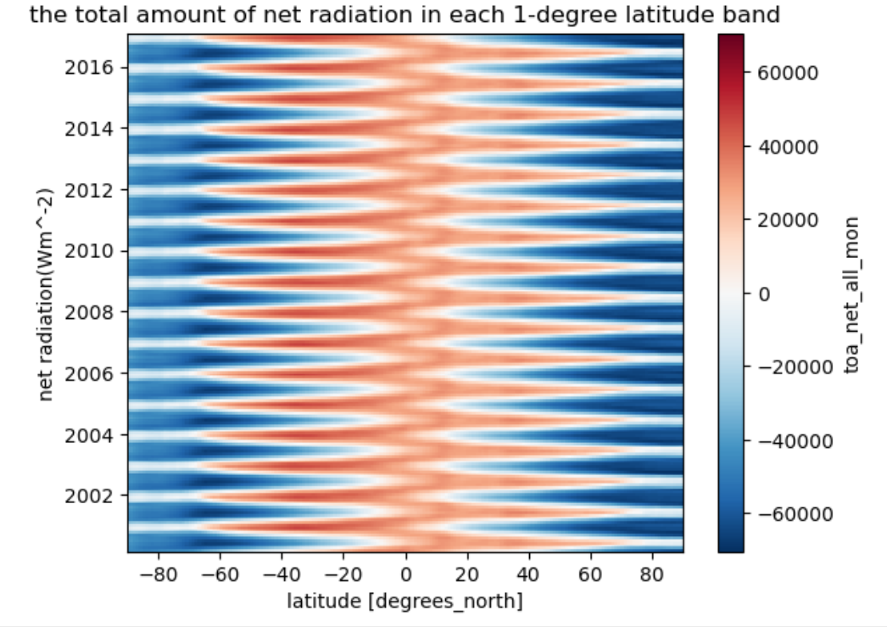

Figure 8

2.4 [5 points] Calculate and plot composites of time-mean outgoing shortwave and longwave radiation for low and high cloud area regions. Here we define low cloud area as ≤25% and high cloud area as ≥75%. Your results should be 2D maps.

My result are shown in Figure 9.

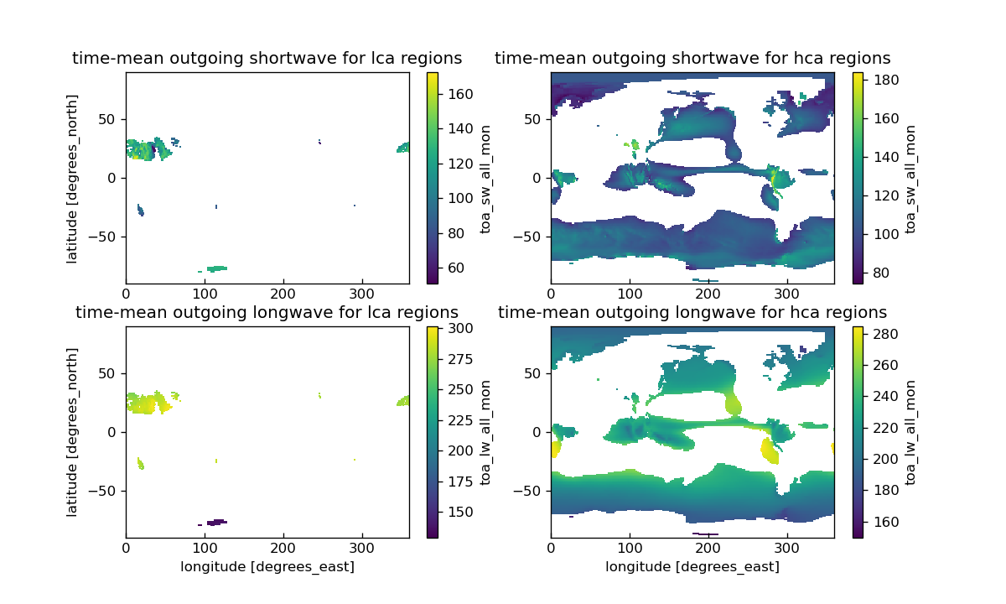

Figure 9

2.5 [5 points] Calculate the global mean values of shortwave and longwave radiation, composited in high and low cloud regions. What is the overall effect of clouds on shortwave and longwave radiation?

the global mean values of shortwave radiation is 99.1390380859375 while in low cloud area, it is 27.624053955078125;in high cloud area, it is 107.94964599609375.

the global mean values of longwave radiation is 240.26797485351562 while in low cloud area, it is 67.6646957397461;in high cloud area, it is 233.62255859375.

the overall effect of clouds on shortwave and longwave radiation is -45.805686950683594 and 28.010570526123047.

1. **Explore a netCDF dataset**

3.1 [5 points] Plot a time series of a certain variable with monthly seasonal cycle removed.

My result are as follows:

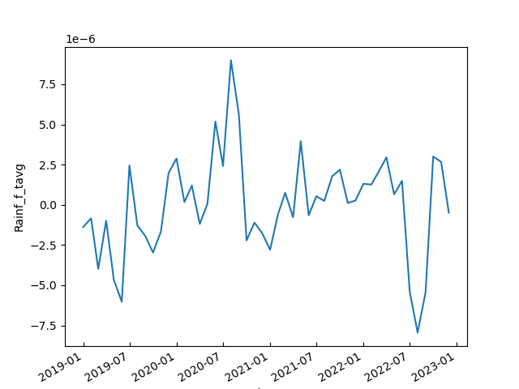

Figure 10

3.2 [5 points] Make at least 5 different plots using the dataset.

My result are Figure 11-15.

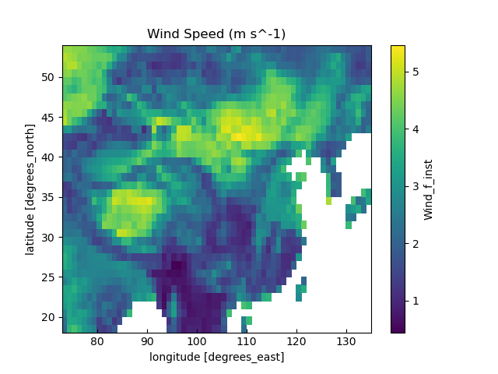

Figure 11

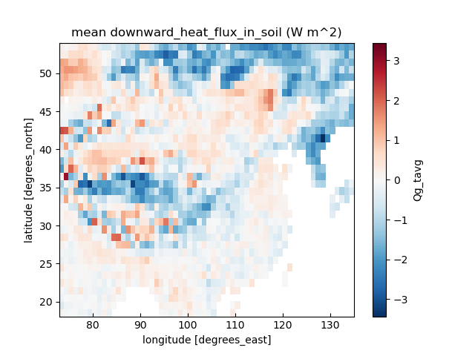

Figure 12

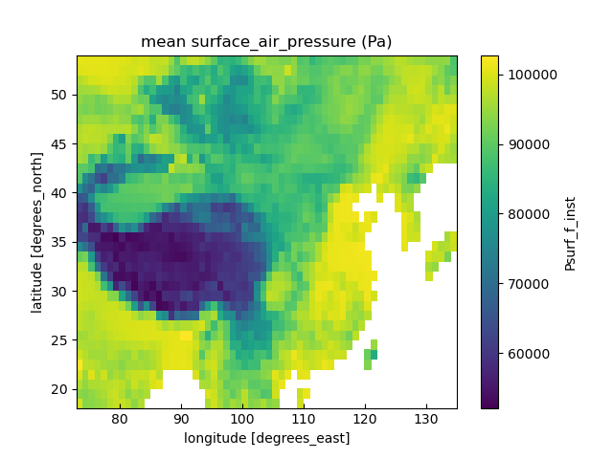

Figure 13

