**Assignment 04**

胡蓓慧

12332288

1. Global Earthquakes

In this problem set, we will use this file from the USGS Earthquakes Database. The dataset is similar to the one you use in Assignment 02. Use the file provided (usgs_earthquakes.csv) to recreate the following map. Use the mag column for magnitude. [10 points]

My result is as follows:

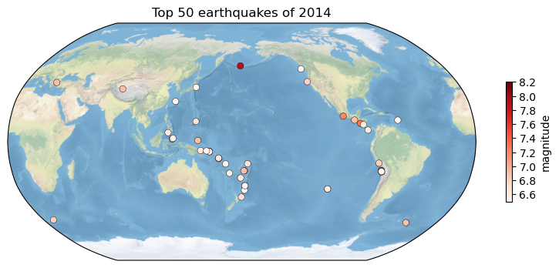

Figure

2. Explore a netCDF dataset

2.1 [10 points] Make a global map of a certain variable. Your figure should contain: a project, x label and ticks, y label and ticks, title, gridlines, legend, colorbar, masks or features, annotations, and text box (1 point each).

My data are download from[GES DISC Dataset: GLDAS Catchment Land Surface Model L4 daily 0.25 x 0.25 degree GRACE-DA1 V2.2 (GLDAS_CLSM025_DA1_D 2.2) (nasa.gov)](https://disc.gsfc.nasa.gov/datasets/GLDAS_CLSM025_DA1_D_2.2/summary?keywords=runoff), I use paramater ground water storage to to draw the plot and the result is shown in Figure 2.

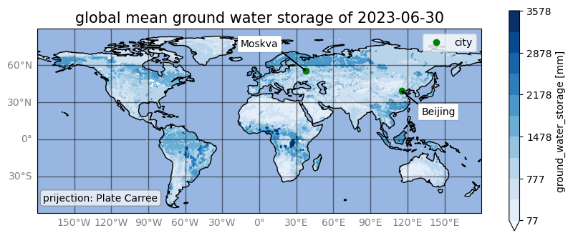

Figure

2.2 [10 points] Make a regional map of the same variable. Your figure should contain: a different project, x label and ticks, y label and ticks, title, gridlines, legend, colorbar, masks or features, annotations, and text box (1 point each).

I use a different project to draw the plot and the result is shown in Figure3.

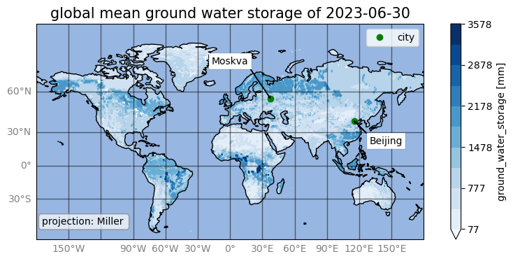

Figure