武汉纺织大学

Java应用开发课程设计

**采用MyBatis框架实现基于DAO设计模式的图书馆系统**

**学 院： 数学与计算机学院**

**班 级： 软件11802**

**姓 名： 孙凌锋**

**学 号： 1804240423**

**指导老师： 聂刚**

**成 绩：**

**完成日期： 2020年6月20日**

目 录

1 需求分析 1

1.1用户登陆 1

1.2主界面 1

1.3读者各项功能 1

1.3.1 图书查询和借阅归还 1

1.3.2 修改个人信息 1

1.3.3 修改密码 2

1.3.4 退出 2

1.4管理员功能 2

1.4.1 图书管理 2

1.4.2 读者管理 2

1.4.3 借还管理 2

1.4.4 修改密码 2

1.4.5 退出 2

2 系统设计 3

2.0数据库设计 3

2.1用户用例图 3

2.2 ER图 4

2.3 UML类图（Class Diagram） 4

2.4 UML时序图（Sequence Diagram） 6

2.4.1 借书模块 6

2.4.2还书模块 6

2.5 UML活动图（Activity Diagram） 6

2.5.1 登陆 6

2.5.2 借书模块 8

2.5.3 还书模块 8

3 系统实现 9

3.1 项目结构 9

3.2 配置文件 9

3.2.1 db.properties文件 9

3.2.2 log4j.properties文件 9

3.2.3 book-context.xml文件 10

3.3 VO类ReaderInfo.java 10

3.4 DAO接口类ReaderInfoDAO.java 11

3.5 接口映射文件ReaderInfo.xml 11

3.6 服务层LendService.java 13

3.8 用户界面 14

4 系统测试 14

5 系统总结 14

# 图书馆管理系统

# ####概述

# 基于Spring + Spring MVC + MyBatis的图书馆管理系统，使用Maven进行包管理。主要功能包括：图书查询、图书管理、图书编辑、读者管理、图书的借阅与归还以及借还日志记录等。

# ### 环境配置

# #### 开发环境：Windows 10，eclipse, Mysql5.5, Maven3.6.1

# #### 运行配置

# 1. 首先安装Mysql5.5，设置用户名为root，密码为root，默认端口号:3306,并保证其在运行状态，并执行library.sql文件导入数据。

# 2. 然后再配置Maven到环境变量中，在源代码目录下运行

# 使用tomcat插件运行

# 3. 使用浏览器访问http://localhost:8080即可进入系统。

# ### 概念设计

# 用户分为两类：读者、图书馆管理员。图书馆管理员可以修改读者信息，修改书目信息，查看所有借还日志等；读者仅可以修改个人信息、借阅或归还书籍和查看自己的借还日志。

# 1 需求分析

设计一个图书管理系统，实现读者角色：登陆，查询图书，借阅图书，归还图书，查询借阅记录，修改密码等功能

图书馆管理人员角色：登陆，图书增加，图书修改，图书删除，读者增加，读者修改，读者删除，借阅查询，借阅统计等功能。

## 1.1登陆

当程序运行时，显示“欢迎使用图书管理系统，请登陆”，提示用户依次输入用户名及其密码，当用户名及密码不正确时，显示提示信息“账号或密码错误!”账户密码正确时根据账户类别进入读者或管理员主界面。

## 1.2主界面

当用户名及密码正确时，进入系统主界面,网页图形化界面。

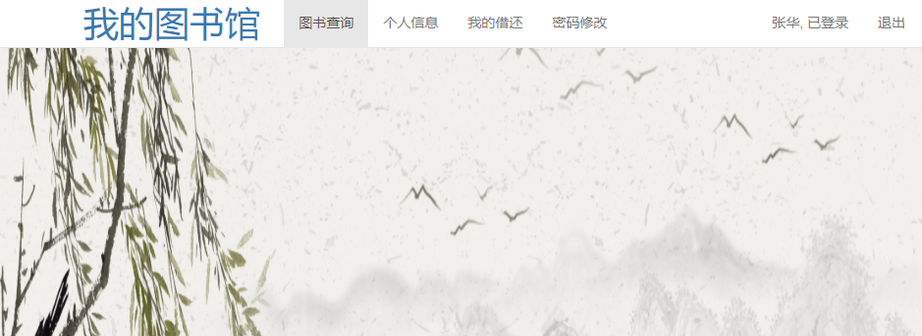

## 1.3读者的各项功能

### 1.3.1 图书查询

### 点击进入图书查询子界面

可查看所有图书的书名,作者,出版社,图书编号ISBN,价格,剩余数量,以及借还和查看详情按钮。

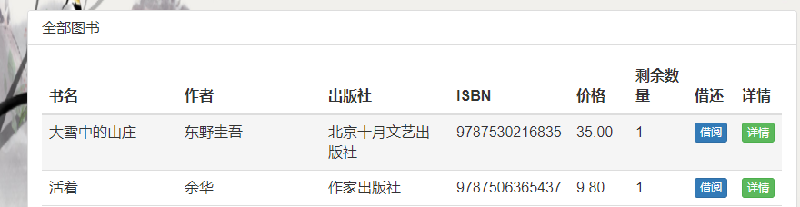

### 1.3.1.2 单本查询

图书查询的上部有按关键字查找书

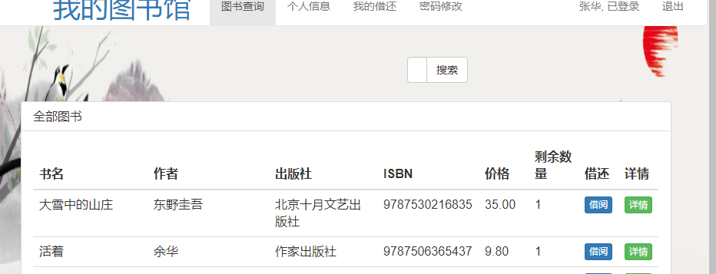

示例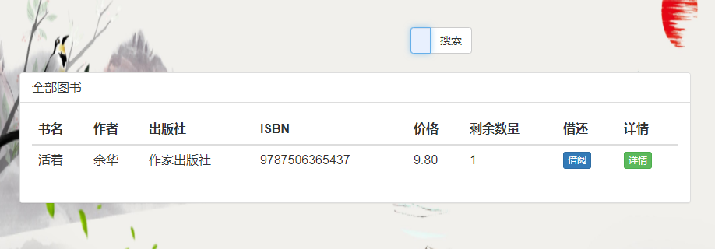

### 

### 1.3.2 查询修改个人信息

在个人信息页面可查看修改读者信息

可查看 读者证号码,姓名,性别,生日,地址,电话。

除读者证号不可修改以外均可修改且未设置字符限制.

### 1.3.3 修改密码

当选择密码修改时，显示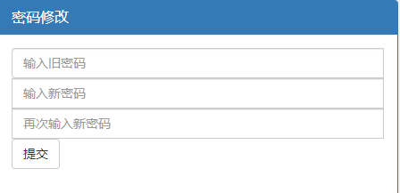

需填写完整后提交,若旧密码输入不正确，则提示“旧密码错误!”，若两次密码输入不一致，提示“两次输入的新密码不同,请检查”，输入成功后，修改数据库中的用户表，并提示“修改密码成功!”。

### 1.3.4 退出登录

右上角退出 回到登陆页面。



## 1.4 管理员账户的各项功能

###### 1.4.1图书管理

可查看全部图书的书名,作者,出版社,ISBN,价格,剩余数量,详情,可编辑和删除书籍。

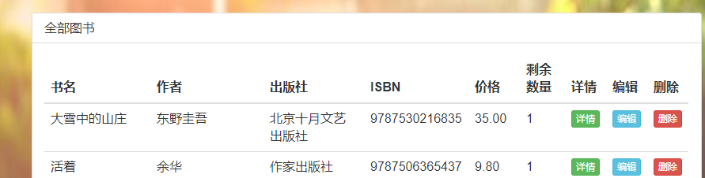

增加书籍

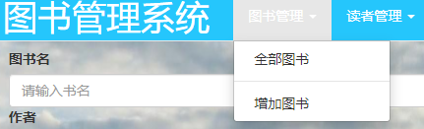

按提示填入图书名,作者,出版社,ISBN,简介,语言种类,价格,出版日期,分类号,数量进行添加.

1.4.2 读者管理

1.查看全部读者的所有信息:读者号,姓名,性别,生日,地址,电话.可编辑除读者号以外信息。也可以删除读者账户(删除读者证)。



2.增加读者 由管理员输入新读者的密码,姓名,性别,生日,地址,电话 读者号由系统自动顺序生成。

1.4.3借还管理

可查看读者借书还书日志,归还情况。

###### 1.4.4管理员密码修改



需填写完整后提交,若旧密码输入不正确，则提示“旧密码错误!”，若两次密码输入不一致，提示“两次输入的新密码不同,请检查”，输入成功后，修改数据库中的用户表，并提示“修改密码成功!”。管理员账户不可添加和删除。

###### 1.4.5 退出

右上角退出 回到登陆页面。



# **2 系统设计**

**2.0数据库设计**

## 

## 2.1用户用例图

系统分为读者，图书管理员两个角色，各角色的用户用例如下图2-1所示：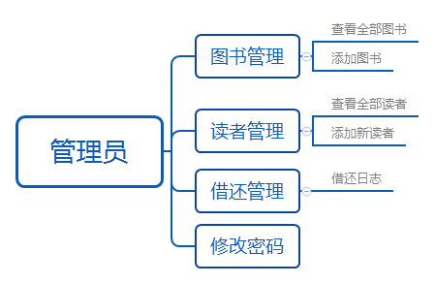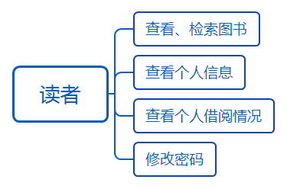

图2-1 用户用例图

## 2.2 ER图

数据库设计共有6个表用,对应的ER图如图3-1所示。

%3CmxGraphModel%3E%3Croot%3E%3CmxCell%20id%3D%220%22%2F%3E%3CmxCell%20id%3D%221%22%20parent%3D%220%22%2F%3E%3Cmysql.table%20entity.table.tableName%3D%22uses%22%20label%3D%22uses%22%20id%3D%222%22%3E%3CmxCell%20style%3D%22swimlane%3BfontStyle%3D0%3BchildLayout%3DstackLayout%3Bhorizontal%3D1%3Bhtml%3D1%3BstartSize%3D26%3BfillColor%3D%23b0e3e6%3BhorizontalStack%3D0%3BresizeParent%3D1%3BresizeParentMax%3D0%3BresizeLast%3D0%3Bcollapsible%3D1%3BmarginBottom%3D0%3BswimlaneFillColor%3D%23ffffff%3Balign%3Dcenter%3BfontSize%3D13%3BstrokeColor%3D%230e8088%3Brounded%3D0%3Bshadow%3D1%3Bcomic%3D0%3Bglass%3D0%3BgradientDirection%3Dsouth%3BgradientColor%3D%23ffffff%3B%22%20vertex%3D%221%22%20connectable%3D%220%22%20parent%3D%221%22%3E%3CmxGeometry%20x%3D%2260%22%20y%3D%2250%22%20width%3D%22310%22%20height%3D%22130%22%20as%3D%22geometry%22%2F%3E%3C%2FmxCell%3E%3C%2Fmysql.table%3E%3Cmysql.column%20entity.column.tableName%3D%22uses%22%20entity.column.name%3D%22userName%22%20entity.column.dataType%3D%22VARCHAR%22%20entity.column.PK%3D%22true%22%20label%3D%22%26lt%3Bimg%20title%3D%26quot%3BPrimary%20Key%26quot%3B%20src%3D%26quot%3Bimg%2Fdb%2Fkey1.png%26quot%3B%20width%3D%26quot%3B16%26quot%3B%20height%3D%26quot%3B16%26quot%3B%20align%3D%26quot%3Btop%26quot%3B%26gt%3B%26amp%3Bnbsp%3B%26lt%3Bfont%20size%3D%26quot%3B1%26quot%3B%20face%3D%26quot%3BTahoma%26quot%3B%26gt%3B%26lt%3Bspan%20style%3D%26quot%3Bfont-size%3A%2013px%26quot%3B%26gt%3B%26lt%3Bb%26gt%3Bid%20int%20primary%20key%26lt%3B%2Fb%26gt%3B%26lt%3B%2Fspan%26gt%3B%26lt%3B%2Ffont%26gt%3B%22%20entity.column.oldName%3D%22id%22%20entity.column.datalen%3D%2220%22%20entity.column.decimals%3D%22%22%20entity.column.autoIncreament%3D%22%22%20entity.column.unsigned%3D%22%22%20entity.column.bin%3D%22%22%20entity.column.ascii%3D%22%22%20entity.column.unicode%3D%22%22%20entity.column.unique%3D%22%22%20entity.column.isNotNull%3D%22NOT%20NULL%22%20entity.column.defaultValue%3D%22%22%20entity.column.comment%3D%22%22%20entity.column.enum%3D%22%22%20entity.column.set%3D%22%22%20entity.column.enumSetValue%3D%22%22%20id%3D%223%22%3E%3CmxCell%20style%3D%22text%3Bhtml%3D1%3BstrokeColor%3Dnone%3BfillColor%3Dnone%3BspacingLeft%3D4%3BspacingRight%3D4%3Boverflow%3Dhidden%3Brotatable%3D0%3BportConstraint%3Deastwest%3BfontSize%3D12%3BverticalAlign%3Dmiddle%3B%22%20vertex%3D%221%22%20parent%3D%222%22%3E%3CmxGeometry%20y%3D%2226%22%20width%3D%22310%22%20height%3D%2226%22%20as%3D%22geometry%22%2F%3E%3C%2FmxCell%3E%3C%2Fmysql.column%3E%3Cmysql.column%20entity.column.tableName%3D%22uses%22%20entity.column.name%3D%22chrName%22%20entity.column.datalen%3D%2220%22%20entity.column.dataType%3D%22VARCHAR%22%20label%3D%22%26lt%3Bimg%20title%3D%26quot%3BPrimary%20Key%26quot%3B%20src%3D%26quot%3Bimages%2Fspacer.gif%26quot%3B%20width%3D%26quot%3B16%26quot%3B%20height%3D%26quot%3B16%26quot%3B%20align%3D%26quot%3Btop%26quot%3B%26gt%3B%26amp%3Bnbsp%3B%26lt%3Bfont%20size%3D%26quot%3B1%26quot%3B%20face%3D%26quot%3BTahoma%26quot%3B%26gt%3B%26lt%3Bspan%20style%3D%26quot%3Bfont-size%3A%2013px%26quot%3B%26gt%3B%26lt%3Bb%26gt%3Bname%20varchar(10)%26lt%3B%2Fb%26gt%3B%26lt%3B%2Fspan%26gt%3B%26lt%3B%2Ffont%26gt%3B%22%20entity.column.oldName%3D%22name%22%20entity.column.decimals%3D%22%22%20entity.column.autoIncreament%3D%22%22%20entity.column.unsigned%3D%22%22%20entity.column.bin%3D%22%22%20entity.column.ascii%3D%22%22%20entity.column.unicode%3D%22%22%20entity.column.PK%3D%22false%22%20entity.column.unique%3D%22%22%20entity.column.isNotNull%3D%22%22%20entity.column.defaultValue%3D%22%22%20entity.column.comment%3D%22%22%20entity.column.enum%3D%22%22%20entity.column.set%3D%22%22%20entity.column.enumSetValue%3D%22%22%20id%3D%224%22%3E%3CmxCell%20style%3D%22text%3Bhtml%3D1%3BstrokeColor%3Dnone%3BfillColor%3Dnone%3BspacingLeft%3D4%3BspacingRight%3D4%3Boverflow%3Dhidden%3Brotatable%3D0%3BportConstraint%3Deastwest%3BfontSize%3D12%3BverticalAlign%3Dmiddle%3B%22%20vertex%3D%221%22%20parent%3D%222%22%3E%3CmxGeometry%20y%3D%2252%22%20width%3D%22310%22%20height%3D%2226%22%20as%3D%22geometry%22%2F%3E%3C%2FmxCell%3E%3C%2Fmysql.column%3E%3Cmysql.column%20entity.column.tableName%3D%22uses%22%20entity.column.name%3D%22password%22%20entity.column.datalen%3D%2250%22%20entity.column.dataType%3D%22VARCHAR%22%20label%3D%22%26lt%3Bimg%20title%3D%26quot%3BPrimary%20Key%26quot%3B%20src%3D%26quot%3Bimages%2Fspacer.gif%26quot%3B%20width%3D%26quot%3B16%26quot%3B%20height%3D%26quot%3B16%26quot%3B%20align%3D%26quot%3Btop%26quot%3B%26gt%3B%26amp%3Bnbsp%3B%26lt%3Bfont%20size%3D%26quot%3B1%26quot%3B%20face%3D%26quot%3BTahoma%26quot%3B%26gt%3B%26lt%3Bspan%20style%3D%26quot%3Bfont-size%3A%2013px%26quot%3B%26gt%3B%26lt%3Bb%26gt%3Bname%20varchar(10)%26lt%3B%2Fb%26gt%3B%26lt%3B%2Fspan%26gt%3B%26lt%3B%2Ffont%26gt%3B%22%20entity.column.oldName%3D%22chrName%22%20entity.column.decimals%3D%22%22%20entity.column.autoIncreament%3D%22%22%20entity.column.unsigned%3D%22%22%20entity.column.bin%3D%22%22%20entity.column.ascii%3D%22%22%20entity.column.unicode%3D%22%22%20entity.column.PK%3D%22false%22%20entity.column.unique%3D%22%22%20entity.column.isNotNull%3D%22%22%20entity.column.defaultValue%3D%22%22%20entity.column.comment%3D%22%E5%AF%86%E7%A0%81%22%20entity.column.enum%3D%22%22%20entity.column.set%3D%22%22%20entity.column.enumSetValue%3D%22%22%20id%3D%225%22%3E%3CmxCell%20style%3D%22text%3Bhtml%3D1%3BstrokeColor%3Dnone%3BfillColor%3Dnone%3BspacingLeft%3D4%3BspacingRight%3D4%3Boverflow%3Dhidden%3Brotatable%3D0%3BportConstraint%3Deastwest%3BfontSize%3D12%3BverticalAlign%3Dmiddle%3B%22%20vertex%3D%221%22%20parent%3D%222%22%3E%3CmxGeometry%20y%3D%2278%22%20width%3D%22310%22%20height%3D%2226%22%20as%3D%22geometry%22%2F%3E%3C%2FmxCell%3E%3C%2Fmysql.column%3E%3Cmysql.column%20entity.column.tableName%3D%22uses%22%20entity.column.name%3D%22role%22%20entity.column.datalen%3D%2220%22%20entity.column.dataType%3D%22VARCHAR%22%20label%3D%22%26lt%3Bimg%20title%3D%26quot%3BPrimary%20Key%26quot%3B%20src%3D%26quot%3Bimages%2Fspacer.gif%26quot%3B%20width%3D%26quot%3B16%26quot%3B%20height%3D%26quot%3B16%26quot%3B%20align%3D%26quot%3Btop%26quot%3B%26gt%3B%26amp%3Bnbsp%3B%26lt%3Bfont%20size%3D%26quot%3B1%26quot%3B%20face%3D%26quot%3BTahoma%26quot%3B%26gt%3B%26lt%3Bspan%20style%3D%26quot%3Bfont-size%3A%2013px%26quot%3B%26gt%3B%26lt%3Bb%26gt%3Bname%20varchar(10)%26lt%3B%2Fb%26gt%3B%26lt%3B%2Fspan%26gt%3B%26lt%3B%2Ffont%26gt%3B%22%20entity.column.oldName%3D%22chrName%22%20entity.column.decimals%3D%22%22%20entity.column.autoIncreament%3D%22%22%20entity.column.unsigned%3D%22%22%20entity.column.bin%3D%22%22%20entity.column.ascii%3D%22%22%20entity.column.unicode%3D%22%22%20entity.column.PK%3D%22false%22%20entity.column.unique%3D%22%22%20entity.column.isNotNull%3D%22%22%20entity.column.defaultValue%3D%22%22%20entity.column.comment%3D%22%E8%A7%92%E8%89%B2%22%20entity.column.enum%3D%22%22%20entity.column.set%3D%22%22%20entity.column.enumSetValue%3D%22%22%20id%3D%226%22%3E%3CmxCell%20style%3D%22text%3Bhtml%3D1%3BstrokeColor%3Dnone%3BfillColor%3Dnone%3BspacingLeft%3D4%3BspacingRight%3D4%3Boverflow%3Dhidden%3Brotatable%3D0%3BportConstraint%3Deastwest%3BfontSize%3D12%3BverticalAlign%3Dmiddle%3B%22%20vertex%3D%221%22%20parent%3D%222%22%3E%3CmxGeometry%20y%3D%22104%22%20width%3D%22310%22%20height%3D%2226%22%20as%3D%22geometry%22%2F%3E%3C%2FmxCell%3E%3C%2Fmysql.column%3E%3Cmysql.table%20entity.table.tableName%3D%22product%22%20label%3D%22product%22%20id%3D%227%22%3E%3CmxCell%20style%3D%22swimlane%3BfontStyle%3D0%3BchildLayout%3DstackLayout%3Bhorizontal%3D1%3Bhtml%3D1%3BstartSize%3D26%3BfillColor%3D%23b0e3e6%3BhorizontalStack%3D0%3BresizeParent%3D1%3BresizeParentMax%3D0%3BresizeLast%3D0%3Bcollapsible%3D1%3BmarginBottom%3D0%3BswimlaneFillColor%3D%23ffffff%3Balign%3Dcenter%3BfontSize%3D13%3BstrokeColor%3D%230e8088%3Brounded%3D0%3Bshadow%3D1%3Bcomic%3D0%3Bglass%3D0%3BgradientDirection%3Dsouth%3BgradientColor%3D%23ffffff%3B%22%20vertex%3D%221%22%20connectable%3D%220%22%20parent%3D%221%22%3E%3CmxGeometry%20x%3D%2260%22%20y%3D%22210%22%20width%3D%22310%22%20height%3D%22130%22%20as%3D%22geometry%22%2F%3E%3C%2FmxCell%3E%3C%2Fmysql.table%3E%3Cmysql.column%20entity.column.tableName%3D%22product%22%20entity.column.name%3D%22barcode%22%20entity.column.dataType%3D%22VARCHAR%22%20entity.column.PK%3D%22true%22%20label%3D%22%26lt%3Bimg%20title%3D%26quot%3BPrimary%20Key%26quot%3B%20src%3D%26quot%3Bimg%2Fdb%2Fkey1.png%26quot%3B%20width%3D%26quot%3B16%26quot%3B%20height%3D%26quot%3B16%26quot%3B%20align%3D%26quot%3Btop%26quot%3B%26gt%3B%26amp%3Bnbsp%3B%26lt%3Bfont%20size%3D%26quot%3B1%26quot%3B%20face%3D%26quot%3BTahoma%26quot%3B%26gt%3B%26lt%3Bspan%20style%3D%26quot%3Bfont-size%3A%2013px%26quot%3B%26gt%3B%26lt%3Bb%26gt%3Bid%20int%20primary%20key%26lt%3B%2Fb%26gt%3B%26lt%3B%2Fspan%26gt%3B%26lt%3B%2Ffont%26gt%3B%22%20entity.column.oldName%3D%22id%22%20entity.column.datalen%3D%2210%22%20entity.column.decimals%3D%22%22%20entity.column.autoIncreament%3D%22%22%20entity.column.unsigned%3D%22%22%20entity.column.bin%3D%22%22%20entity.column.ascii%3D%22%22%20entity.column.unicode%3D%22%22%20entity.column.unique%3D%22%22%20entity.column.isNotNull%3D%22NOT%20NULL%22%20entity.column.defaultValue%3D%22%22%20entity.column.comment%3D%22%22%20entity.column.enum%3D%22%22%20entity.column.set%3D%22%22%20entity.column.enumSetValue%3D%22%22%20id%3D%228%22%3E%3CmxCell%20style%3D%22text%3Bhtml%3D1%3BstrokeColor%3Dnone%3BfillColor%3Dnone%3BspacingLeft%3D4%3BspacingRight%3D4%3Boverflow%3Dhidden%3Brotatable%3D0%3BportConstraint%3Deastwest%3BfontSize%3D12%3BverticalAlign%3Dmiddle%3B%22%20vertex%3D%221%22%20parent%3D%227%22%3E%3CmxGeometry%20y%3D%2226%22%20width%3D%22310%22%20height%3D%2226%22%20as%3D%22geometry%22%2F%3E%3C%2FmxCell%3E%3C%2Fmysql.column%3E%3Cmysql.column%20entity.column.tableName%3D%22product%22%20entity.column.name%3D%22productName%22%20entity.column.datalen%3D%2250%22%20entity.column.dataType%3D%22VARCHAR%22%20label%3D%22%26lt%3Bimg%20title%3D%26quot%3BPrimary%20Key%26quot%3B%20src%3D%26quot%3Bimages%2Fspacer.gif%26quot%3B%20width%3D%26quot%3B16%26quot%3B%20height%3D%26quot%3B16%26quot%3B%20align%3D%26quot%3Btop%26quot%3B%26gt%3B%26amp%3Bnbsp%3B%26lt%3Bfont%20size%3D%26quot%3B1%26quot%3B%20face%3D%26quot%3BTahoma%26quot%3B%26gt%3B%26lt%3Bspan%20style%3D%26quot%3Bfont-size%3A%2013px%26quot%3B%26gt%3B%26lt%3Bb%26gt%3Bname%20varchar(10)%26lt%3B%2Fb%26gt%3B%26lt%3B%2Fspan%26gt%3B%26lt%3B%2Ffont%26gt%3B%22%20entity.column.oldName%3D%22name%22%20entity.column.decimals%3D%22%22%20entity.column.autoIncreament%3D%22%22%20entity.column.unsigned%3D%22%22%20entity.column.bin%3D%22%22%20entity.column.ascii%3D%22%22%20entity.column.unicode%3D%22%22%20entity.column.PK%3D%22false%22%20entity.column.unique%3D%22%22%20entity.column.isNotNull%3D%22%22%20entity.column.defaultValue%3D%22%22%20entity.column.comment%3D%22%22%20entity.column.enum%3D%22%22%20entity.column.set%3D%22%22%20entity.column.enumSetValue%3D%22%22%20id%3D%229%22%3E%3CmxCell%20style%3D%22text%3Bhtml%3D1%3BstrokeColor%3Dnone%3BfillColor%3Dnone%3BspacingLeft%3D4%3BspacingRight%3D4%3Boverflow%3Dhidden%3Brotatable%3D0%3BportConstraint%3Deastwest%3BfontSize%3D12%3BverticalAlign%3Dmiddle%3B%22%20vertex%3D%221%22%20parent%3D%227%22%3E%3CmxGeometry%20y%3D%2252%22%20width%3D%22310%22%20height%3D%2226%22%20as%3D%22geometry%22%2F%3E%3C%2FmxCell%3E%3C%2Fmysql.column%3E%3Cmysql.column%20entity.column.tableName%3D%22product%22%20entity.column.name%3D%22price%22%20entity.column.datalen%3D%229%22%20entity.column.dataType%3D%22DECIMAL%22%20label%3D%22%26lt%3Bimg%20title%3D%26quot%3BPrimary%20Key%26quot%3B%20src%3D%26quot%3Bimages%2Fspacer.gif%26quot%3B%20width%3D%26quot%3B16%26quot%3B%20height%3D%26quot%3B16%26quot%3B%20align%3D%26quot%3Btop%26quot%3B%26gt%3B%26amp%3Bnbsp%3B%26lt%3Bfont%20size%3D%26quot%3B1%26quot%3B%20face%3D%26quot%3BTahoma%26quot%3B%26gt%3B%26lt%3Bspan%20style%3D%26quot%3Bfont-size%3A%2013px%26quot%3B%26gt%3B%26lt%3Bb%26gt%3Bname%20varchar(10)%26lt%3B%2Fb%26gt%3B%26lt%3B%2Fspan%26gt%3B%26lt%3B%2Ffont%26gt%3B%22%20entity.column.oldName%3D%22price%22%20entity.column.decimals%3D%222%22%20entity.column.autoIncreament%3D%22%22%20entity.column.unsigned%3D%22%22%20entity.column.bin%3D%22%22%20entity.column.ascii%3D%22%22%20entity.column.unicode%3D%22%22%20entity.column.PK%3D%22false%22%20entity.column.unique%3D%22%22%20entity.column.isNotNull%3D%22%22%20entity.column.defaultValue%3D%22%22%20entity.column.comment%3D%22%22%20entity.column.enum%3D%22%22%20entity.column.set%3D%22%22%20entity.column.enumSetValue%3D%22%22%20id%3D%2210%22%3E%3CmxCell%20style%3D%22text%3Bhtml%3D1%3BstrokeColor%3Dnone%3BfillColor%3Dnone%3BspacingLeft%3D4%3BspacingRight%3D4%3Boverflow%3Dhidden%3Brotatable%3D0%3BportConstraint%3Deastwest%3BfontSize%3D12%3BverticalAlign%3Dmiddle%3B%22%20vertex%3D%221%22%20parent%3D%227%22%3E%3CmxGeometry%20y%3D%2278%22%20width%3D%22310%22%20height%3D%2226%22%20as%3D%22geometry%22%2F%3E%3C%2FmxCell%3E%3C%2Fmysql.column%3E%3Cmysql.column%20entity.column.tableName%3D%22product%22%20entity.column.name%3D%22supply%22%20entity.column.datalen%3D%2220%22%20entity.column.dataType%3D%22VARCHAR%22%20label%3D%22%26lt%3Bimg%20title%3D%26quot%3BPrimary%20Key%26quot%3B%20src%3D%26quot%3Bimages%2Fspacer.gif%26quot%3B%20width%3D%26quot%3B16%26quot%3B%20height%3D%26quot%3B16%26quot%3B%20align%3D%26quot%3Btop%26quot%3B%26gt%3B%26amp%3Bnbsp%3B%26lt%3Bfont%20size%3D%26quot%3B1%26quot%3B%20face%3D%26quot%3BTahoma%26quot%3B%26gt%3B%26lt%3Bspan%20style%3D%26quot%3Bfont-size%3A%2013px%26quot%3B%26gt%3B%26lt%3Bb%26gt%3Bname%20varchar(10)%26lt%3B%2Fb%26gt%3B%26lt%3B%2Fspan%26gt%3B%26lt%3B%2Ffont%26gt%3B%22%20entity.column.oldName%3D%22price%22%20entity.column.decimals%3D%22%22%20entity.column.autoIncreament%3D%22%22%20entity.column.unsigned%3D%22%22%20entity.column.bin%3D%22%22%20entity.column.ascii%3D%22%22%20entity.column.unicode%3D%22%22%20entity.column.PK%3D%22false%22%20entity.column.unique%3D%22%22%20entity.column.isNotNull%3D%22%22%20entity.column.defaultValue%3D%22%22%20entity.column.comment%3D%22%22%20entity.column.enum%3D%22%22%20entity.column.set%3D%22%22%20entity.column.enumSetValue%3D%22%22%20id%3D%2211%22%3E%3CmxCell%20style%3D%22text%3Bhtml%3D1%3BstrokeColor%3Dnone%3BfillColor%3Dnone%3BspacingLeft%3D4%3BspacingRight%3D4%3Boverflow%3Dhidden%3Brotatable%3D0%3BportConstraint%3Deastwest%3BfontSize%3D12%3BverticalAlign%3Dmiddle%3B%22%20vertex%3D%221%22%20parent%3D%227%22%3E%3CmxGeometry%20y%3D%22104%22%20width%3D%22310%22%20height%3D%2226%22%20as%3D%22geometry%22%2F%3E%3C%2FmxCell%3E%3C%2Fmysql.column%3E%3Cmysql.table%20entity.table.tableName%3D%22saleDetail%22%20label%3D%22saleDetail%22%20id%3D%2212%22%3E%3CmxCell%20style%3D%22swimlane%3BfontStyle%3D0%3BchildLayout%3DstackLayout%3Bhorizontal%3D1%3Bhtml%3D1%3BstartSize%3D26%3BfillColor%3D%23b0e3e6%3BhorizontalStack%3D0%3BresizeParent%3D1%3BresizeParentMax%3D0%3BresizeLast%3D0%3Bcollapsible%3D1%3BmarginBottom%3D0%3BswimlaneFillColor%3D%23ffffff%3Balign%3Dcenter%3BfontSize%3D13%3BstrokeColor%3D%230e8088%3Brounded%3D0%3Bshadow%3D1%3Bcomic%3D0%3Bglass%3D0%3BgradientDirection%3Dsouth%3BgradientColor%3D%23ffffff%3B%22%20vertex%3D%221%22%20connectable%3D%220%22%20parent%3D%221%22%3E%3CmxGeometry%20x%3D%22480%22%20y%3D%2280%22%20width%3D%22280%22%20height%3D%22208%22%20as%3D%22geometry%22%2F%3E%3C%2FmxCell%3E%3C%2Fmysql.table%3E%3Cmysql.column%20entity.column.tableName%3D%22saleDetail%22%20entity.column.name%3D%22lsh%22%20entity.column.dataType%3D%22VARCHAR%22%20entity.column.PK%3D%22true%22%20label%3D%22%26lt%3Bimg%20title%3D%26quot%3BPrimary%20Key%26quot%3B%20src%3D%26quot%3Bimg%2Fdb%2Fkey1.png%26quot%3B%20width%3D%26quot%3B16%26quot%3B%20height%3D%26quot%3B16%26quot%3B%20align%3D%26quot%3Btop%26quot%3B%26gt%3B%26amp%3Bnbsp%3B%26lt%3Bfont%20size%3D%26quot%3B1%26quot%3B%20face%3D%26quot%3BTahoma%26quot%3B%26gt%3B%26lt%3Bspan%20style%3D%26quot%3Bfont-size%3A%2013px%26quot%3B%26gt%3B%26lt%3Bb%26gt%3Bid%20int%20primary%20key%26lt%3B%2Fb%26gt%3B%26lt%3B%2Fspan%26gt%3B%26lt%3B%2Ffont%26gt%3B%22%20entity.column.oldName%3D%22id%22%20entity.column.datalen%3D%2220%22%20entity.column.decimals%3D%22%22%20entity.column.autoIncreament%3D%22%22%20entity.column.unsigned%3D%22%22%20entity.column.bin%3D%22%22%20entity.column.ascii%3D%22%22%20entity.column.unicode%3D%22%22%20entity.column.unique%3D%22%22%20entity.column.isNotNull%3D%22NOT%20NULL%22%20entity.column.defaultValue%3D%22%22%20entity.column.comment%3D%22%22%20entity.column.enum%3D%22%22%20entity.column.set%3D%22%22%20entity.column.enumSetValue%3D%22%22%20id%3D%2213%22%3E%3CmxCell%20style%3D%22text%3Bhtml%3D1%3BstrokeColor%3Dnone%3BfillColor%3Dnone%3BspacingLeft%3D4%3BspacingRight%3D4%3Boverflow%3Dhidden%3Brotatable%3D0%3BportConstraint%3Deastwest%3BfontSize%3D12%3BverticalAlign%3Dmiddle%3B%22%20vertex%3D%221%22%20parent%3D%2212%22%3E%3CmxGeometry%20y%3D%2226%22%20width%3D%22280%22%20height%3D%2226%22%20as%3D%22geometry%22%2F%3E%3C%2FmxCell%3E%3C%2Fmysql.column%3E%3Cmysql.column%20entity.column.tableName%3D%22saleDetail%22%20entity.column.name%3D%22barcode%22%20entity.column.datalen%3D%2210%22%20entity.column.dataType%3D%22VARCHAR%22%20label%3D%22%26lt%3Bimg%20title%3D%26quot%3BPrimary%20Key%26quot%3B%20src%3D%26quot%3Bimages%2Fspacer.gif%26quot%3B%20width%3D%26quot%3B16%26quot%3B%20height%3D%26quot%3B16%26quot%3B%20align%3D%26quot%3Btop%26quot%3B%26gt%3B%26amp%3Bnbsp%3B%26lt%3Bfont%20size%3D%26quot%3B1%26quot%3B%20face%3D%26quot%3BTahoma%26quot%3B%26gt%3B%26lt%3Bspan%20style%3D%26quot%3Bfont-size%3A%2013px%26quot%3B%26gt%3B%26lt%3Bb%26gt%3Bname%20varchar(10)%26lt%3B%2Fb%26gt%3B%26lt%3B%2Fspan%26gt%3B%26lt%3B%2Ffont%26gt%3B%22%20entity.column.oldName%3D%22barcode%22%20entity.column.decimals%3D%22%22%20entity.column.autoIncreament%3D%22%22%20entity.column.unsigned%3D%22%22%20entity.column.bin%3D%22%22%20entity.column.ascii%3D%22%22%20entity.column.unicode%3D%22%22%20entity.column.PK%3D%22false%22%20entity.column.unique%3D%22%22%20entity.column.isNotNull%3D%22%22%20entity.column.defaultValue%3D%22%22%20entity.column.comment%3D%22%22%20entity.column.enum%3D%22%22%20entity.column.set%3D%22%22%20entity.column.enumSetValue%3D%22%22%20id%3D%2214%22%3E%3CmxCell%20style%3D%22text%3Bhtml%3D1%3BstrokeColor%3Dnone%3BfillColor%3Dnone%3BspacingLeft%3D4%3BspacingRight%3D4%3Boverflow%3Dhidden%3Brotatable%3D0%3BportConstraint%3Deastwest%3BfontSize%3D12%3BverticalAlign%3Dmiddle%3B%22%20vertex%3D%221%22%20parent%3D%2212%22%3E%3CmxGeometry%20y%3D%2252%22%20width%3D%22280%22%20height%3D%2226%22%20as%3D%22geometry%22%2F%3E%3C%2FmxCell%3E%3C%2Fmysql.column%3E%3Cmysql.column%20entity.column.tableName%3D%22saleDetail%22%20entity.column.name%3D%22productName%22%20entity.column.datalen%3D%2250%22%20entity.column.dataType%3D%22VARCHAR%22%20label%3D%22%26lt%3Bimg%20title%3D%26quot%3BPrimary%20Key%26quot%3B%20src%3D%26quot%3Bimages%2Fspacer.gif%26quot%3B%20width%3D%26quot%3B16%26quot%3B%20height%3D%26quot%3B16%26quot%3B%20align%3D%26quot%3Btop%26quot%3B%26gt%3B%26amp%3Bnbsp%3B%26lt%3Bfont%20size%3D%26quot%3B1%26quot%3B%20face%3D%26quot%3BTahoma%26quot%3B%26gt%3B%26lt%3Bspan%20style%3D%26quot%3Bfont-size%3A%2013px%26quot%3B%26gt%3B%26lt%3Bb%26gt%3Bname%20varchar(10)%26lt%3B%2Fb%26gt%3B%26lt%3B%2Fspan%26gt%3B%26lt%3B%2Ffont%26gt%3B%22%20entity.column.oldName%3D%22productName%22%20entity.column.decimals%3D%22%22%20entity.column.autoIncreament%3D%22%22%20entity.column.unsigned%3D%22%22%20entity.column.bin%3D%22%22%20entity.column.ascii%3D%22%22%20entity.column.unicode%3D%22%22%20entity.column.PK%3D%22false%22%20entity.column.unique%3D%22%22%20entity.column.isNotNull%3D%22%22%20entity.column.defaultValue%3D%22%22%20entity.column.comment%3D%22%22%20entity.column.enum%3D%22%22%20entity.column.set%3D%22%22%20entity.column.enumSetValue%3D%22%22%20id%3D%2215%22%3E%3CmxCell%20style%3D%22text%3Bhtml%3D1%3BstrokeColor%3Dnone%3BfillColor%3Dnone%3BspacingLeft%3D4%3BspacingRight%3D4%3Boverflow%3Dhidden%3Brotatable%3D0%3BportConstraint%3Deastwest%3BfontSize%3D12%3BverticalAlign%3Dmiddle%3B%22%20vertex%3D%221%22%20parent%3D%2212%22%3E%3CmxGeometry%20y%3D%2278%22%20width%3D%22280%22%20height%3D%2226%22%20as%3D%22geometry%22%2F%3E%3C%2FmxCell%3E%3C%2Fmysql.column%3E%3Cmysql.column%20entity.column.tableName%3D%22saleDetail%22%20entity.column.name%3D%22price%22%20entity.column.datalen%3D%229%22%20entity.column.dataType%3D%22DECIMAL%22%20label%3D%22%26lt%3Bimg%20title%3D%26quot%3BPrimary%20Key%26quot%3B%20src%3D%26quot%3Bimages%2Fspacer.gif%26quot%3B%20width%3D%26quot%3B16%26quot%3B%20height%3D%26quot%3B16%26quot%3B%20align%3D%26quot%3Btop%26quot%3B%26gt%3B%26amp%3Bnbsp%3B%26lt%3Bfont%20size%3D%26quot%3B1%26quot%3B%20face%3D%26quot%3BTahoma%26quot%3B%26gt%3B%26lt%3Bspan%20style%3D%26quot%3Bfont-size%3A%2013px%26quot%3B%26gt%3B%26lt%3Bb%26gt%3Bname%20varchar(10)%26lt%3B%2Fb%26gt%3B%26lt%3B%2Fspan%26gt%3B%26lt%3B%2Ffont%26gt%3B%22%20entity.column.oldName%3D%22productName%22%20entity.column.decimals%3D%222%22%20entity.column.autoIncreament%3D%22%22%20entity.column.unsigned%3D%22%22%20entity.column.bin%3D%22%22%20entity.column.ascii%3D%22%22%20entity.column.unicode%3D%22%22%20entity.column.PK%3D%22false%22%20entity.column.unique%3D%22%22%20entity.column.isNotNull%3D%22%22%20entity.column.defaultValue%3D%22%22%20entity.column.comment%3D%22%22%20entity.column.enum%3D%22%22%20entity.column.set%3D%22%22%20entity.column.enumSetValue%3D%22%22%20id%3D%2216%22%3E%3CmxCell%20style%3D%22text%3Bhtml%3D1%3BstrokeColor%3Dnone%3BfillColor%3Dnone%3BspacingLeft%3D4%3BspacingRight%3D4%3Boverflow%3Dhidden%3Brotatable%3D0%3BportConstraint%3Deastwest%3BfontSize%3D12%3BverticalAlign%3Dmiddle%3B%22%20vertex%3D%221%22%20parent%3D%2212%22%3E%3CmxGeometry%20y%3D%22104%22%20width%3D%22280%22%20height%3D%2226%22%20as%3D%22geometry%22%2F%3E%3C%2FmxCell%3E%3C%2Fmysql.column%3E%3Cmysql.column%20entity.column.tableName%3D%22saleDetail%22%20entity.column.name%3D%22count%22%20entity.column.datalen%3D%229%22%20entity.column.dataType%3D%22INT%22%20label%3D%22%26lt%3Bimg%20title%3D%26quot%3BPrimary%20Key%26quot%3B%20src%3D%26quot%3Bimages%2Fspacer.gif%26quot%3B%20width%3D%26quot%3B16%26quot%3B%20height%3D%26quot%3B16%26quot%3B%20align%3D%26quot%3Btop%26quot%3B%26gt%3B%26amp%3Bnbsp%3B%26lt%3Bfont%20size%3D%26quot%3B1%26quot%3B%20face%3D%26quot%3BTahoma%26quot%3B%26gt%3B%26lt%3Bspan%20style%3D%26quot%3Bfont-size%3A%2013px%26quot%3B%26gt%3B%26lt%3Bb%26gt%3Bname%20varchar(10)%26lt%3B%2Fb%26gt%3B%26lt%3B%2Fspan%26gt%3B%26lt%3B%2Ffont%26gt%3B%22%20entity.column.oldName%3D%22price%22%20entity.column.decimals%3D%22%22%20entity.column.autoIncreament%3D%22%22%20entity.column.unsigned%3D%22%22%20entity.column.bin%3D%22%22%20entity.column.ascii%3D%22%22%20entity.column.unicode%3D%22%22%20entity.column.PK%3D%22false%22%20entity.column.unique%3D%22%22%20entity.column.isNotNull%3D%22%22%20entity.column.defaultValue%3D%22%22%20entity.column.comment%3D%22%22%20entity.column.enum%3D%22%22%20entity.column.set%3D%22%22%20entity.column.enumSetValue%3D%22%22%20id%3D%2217%22%3E%3CmxCell%20style%3D%22text%3Bhtml%3D1%3BstrokeColor%3Dnone%3BfillColor%3Dnone%3BspacingLeft%3D4%3BspacingRight%3D4%3Boverflow%3Dhidden%3Brotatable%3D0%3BportConstraint%3Deastwest%3BfontSize%3D12%3BverticalAlign%3Dmiddle%3B%22%20vertex%3D%221%22%20parent%3D%2212%22%3E%3CmxGeometry%20y%3D%22130%22%20width%3D%22280%22%20height%3D%2226%22%20as%3D%22geometry%22%2F%3E%3C%2FmxCell%3E%3C%2Fmysql.column%3E%3Cmysql.column%20entity.column.tableName%3D%22saleDetail%22%20entity.column.name%3D%22operator%22%20entity.column.datalen%3D%2220%22%20entity.column.dataType%3D%22VARCHAR%22%20label%3D%22%26lt%3Bimg%20title%3D%26quot%3BPrimary%20Key%26quot%3B%20src%3D%26quot%3Bimages%2Fspacer.gif%26quot%3B%20width%3D%26quot%3B16%26quot%3B%20height%3D%26quot%3B16%26quot%3B%20align%3D%26quot%3Btop%26quot%3B%26gt%3B%26amp%3Bnbsp%3B%26lt%3Bfont%20size%3D%26quot%3B1%26quot%3B%20face%3D%26quot%3BTahoma%26quot%3B%26gt%3B%26lt%3Bspan%20style%3D%26quot%3Bfont-size%3A%2013px%26quot%3B%26gt%3B%26lt%3Bb%26gt%3Bname%20varchar(10)%26lt%3B%2Fb%26gt%3B%26lt%3B%2Fspan%26gt%3B%26lt%3B%2Ffont%26gt%3B%22%20entity.column.oldName%3D%22count%22%20entity.column.decimals%3D%22%22%20entity.column.autoIncreament%3D%22%22%20entity.column.unsigned%3D%22%22%20entity.column.bin%3D%22%22%20entity.column.ascii%3D%22%22%20entity.column.unicode%3D%22%22%20entity.column.PK%3D%22false%22%20entity.column.unique%3D%22%22%20entity.column.isNotNull%3D%22%22%20entity.column.defaultValue%3D%22%22%20entity.column.comment%3D%22%22%20entity.column.enum%3D%22%22%20entity.column.set%3D%22%22%20entity.column.enumSetValue%3D%22%22%20id%3D%2218%22%3E%3CmxCell%20style%3D%22text%3Bhtml%3D1%3BstrokeColor%3Dnone%3BfillColor%3Dnone%3BspacingLeft%3D4%3BspacingRight%3D4%3Boverflow%3Dhidden%3Brotatable%3D0%3BportConstraint%3Deastwest%3BfontSize%3D12%3BverticalAlign%3Dmiddle%3B%22%20vertex%3D%221%22%20parent%3D%2212%22%3E%3CmxGeometry%20y%3D%22156%22%20width%3D%22280%22%20height%3D%2226%22%20as%3D%22geometry%22%2F%3E%3C%2FmxCell%3E%3C%2Fmysql.column%3E%3Cmysql.column%20entity.column.tableName%3D%22saleDetail%22%20entity.column.name%3D%22saleTime%22%20entity.column.datalen%3D%22%22%20entity.column.dataType%3D%22DATETIME%22%20label%3D%22%26lt%3Bimg%20title%3D%26quot%3BPrimary%20Key%26quot%3B%20src%3D%26quot%3Bimages%2Fspacer.gif%26quot%3B%20width%3D%26quot%3B16%26quot%3B%20height%3D%26quot%3B16%26quot%3B%20align%3D%26quot%3Btop%26quot%3B%26gt%3B%26amp%3Bnbsp%3B%26lt%3Bfont%20size%3D%26quot%3B1%26quot%3B%20face%3D%26quot%3BTahoma%26quot%3B%26gt%3B%26lt%3Bspan%20style%3D%26quot%3Bfont-size%3A%2013px%26quot%3B%26gt%3B%26lt%3Bb%26gt%3Bname%20varchar(10)%26lt%3B%2Fb%26gt%3B%26lt%3B%2Fspan%26gt%3B%26lt%3B%2Ffont%26gt%3B%22%20entity.column.oldName%3D%22count%22%20entity.column.decimals%3D%22%22%20entity.column.autoIncreament%3D%22%22%20entity.column.unsigned%3D%22%22%20entity.column.bin%3D%22%22%20entity.column.ascii%3D%22%22%20entity.column.unicode%3D%22%22%20entity.column.PK%3D%22false%22%20entity.column.unique%3D%22%22%20entity.column.isNotNull%3D%22%22%20entity.column.defaultValue%3D%22%22%20entity.column.comment%3D%22%22%20entity.column.enum%3D%22%22%20entity.column.set%3D%22%22%20entity.column.enumSetValue%3D%22%22%20id%3D%2219%22%3E%3CmxCell%20style%3D%22text%3Bhtml%3D1%3BstrokeColor%3Dnone%3BfillColor%3Dnone%3BspacingLeft%3D4%3BspacingRight%3D4%3Boverflow%3Dhidden%3Brotatable%3D0%3BportConstraint%3Deastwest%3BfontSize%3D12%3BverticalAlign%3Dmiddle%3B%22%20vertex%3D%221%22%20parent%3D%2212%22%3E%3CmxGeometry%20y%3D%22182%22%20width%3D%22280%22%20height%3D%2226%22%20as%3D%22geometry%22%2F%3E%3C%2FmxCell%3E%3C%2Fmysql.column%3E%3CmxCell%20id%3D%2220%22%20value%3D%221..n%22%20style%3D%22edgeStyle%3DentityRelationEdgeStyle%3BfontSize%3D12%3Bhtml%3D1%3BendArrow%3DERoneToMany%3BstrokeWidth%3D2%3BstrokeColor%3D%236c8ebf%3BexitX%3D1%3BexitY%3D0.25%3BentryX%3D0%3BentryY%3D0.5%3B%22%20edge%3D%221%22%20source%3D%224%22%20target%3D%2214%22%20parent%3D%221%22%3E%3CmxGeometry%20relative%3D%221%22%20as%3D%22geometry%22%2F%3E%3C%2FmxCell%3E%3CmxCell%20id%3D%2221%22%20value%3D%221..n%22%20style%3D%22edgeStyle%3DentityRelationEdgeStyle%3BfontSize%3D12%3Bhtml%3D1%3BendArrow%3DERoneToMany%3BstrokeWidth%3D2%3BstrokeColor%3D%236c8ebf%3BexitX%3D1%3BexitY%3D0.5%3BentryX%3D0%3BentryY%3D0.5%3B%22%20edge%3D%221%22%20source%3D%228%22%20target%3D%2216%22%20parent%3D%221%22%3E%3CmxGeometry%20relative%3D%221%22%20as%3D%22geometry%22%2F%3E%3C%2FmxCell%3E%3C%2Froot%3E%3C%2FmxGraphModel%3E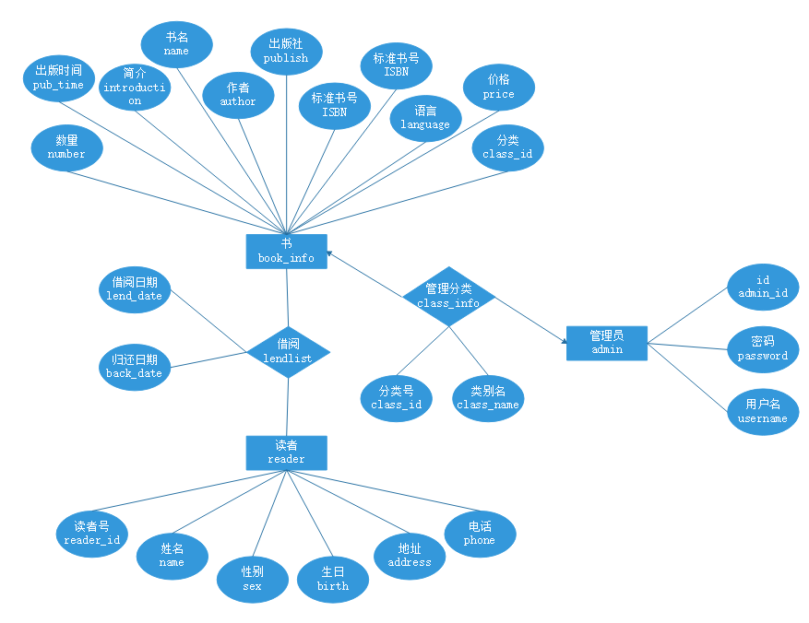

图3-1 数据库ER图

## 2.3 UML类图（Class Diagram）

各类的结构及类之间的关系如图2-5所示：

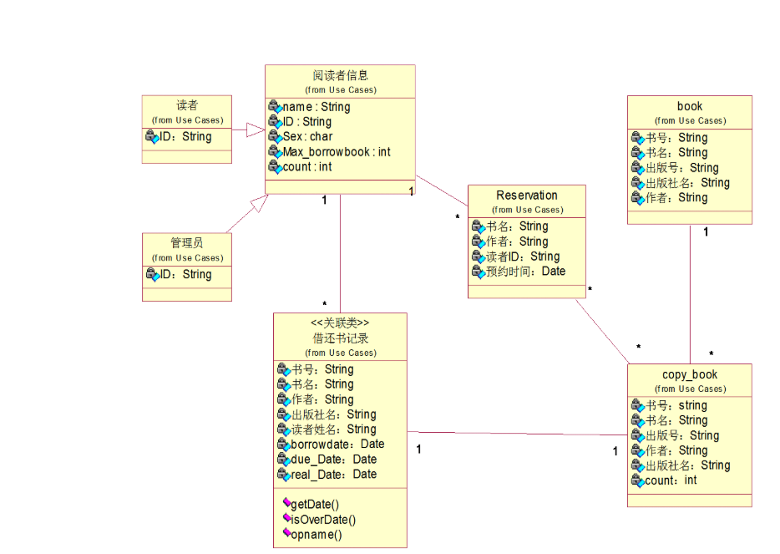

图2-5 用户功能类图

## 2.4 UML时序图（Sequence Diagram）

### 2.4.1 借书时序图

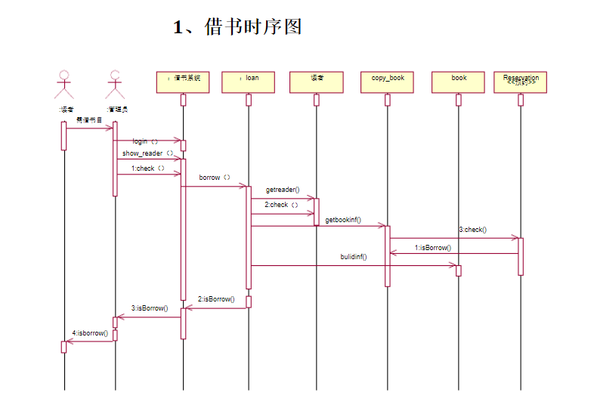

###### 2.4.2还书时序图

### 

## 2.5 UML活动图（Activity Diagram）

### 2.5.1 登陆

读者登陆和管理员登陆操作需要验证用户名，密码，只有当用户名和密码同时存在即用户存在的情况下才能成功登录系统，否则会提示错误信息，具体流程如图2-6所示。

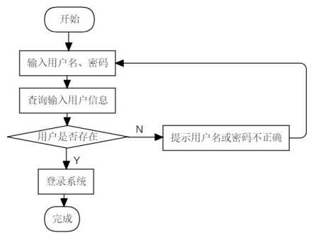

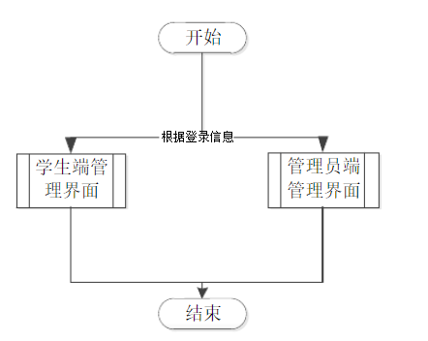

图2-2 登录流程图

### 2.5.2 借阅模块

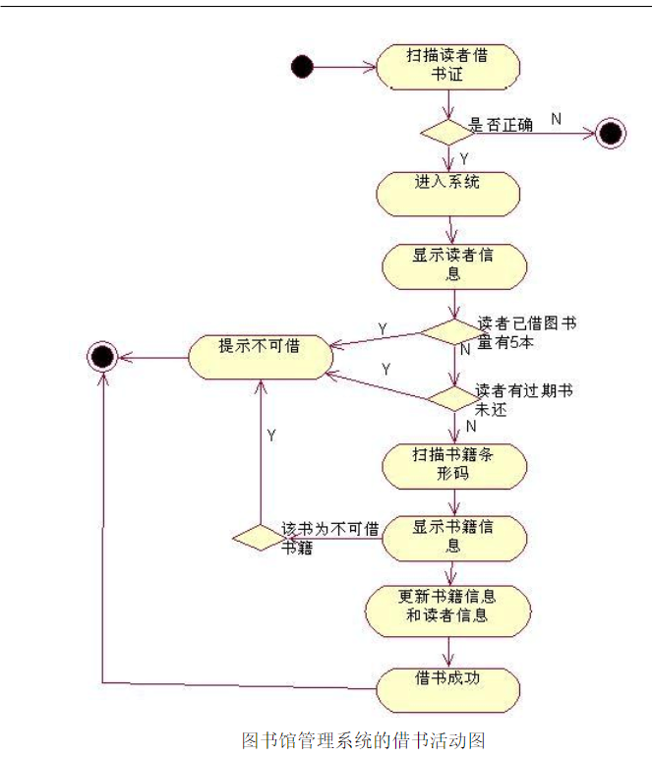

### 2.5.3 归还模块

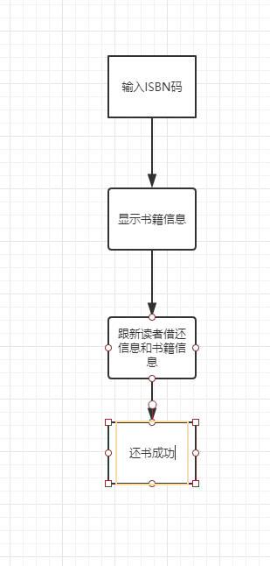

# **3 系统实现**

## 3.1 项目结构

## 

## 3.2 配置文件

### 3.2.1 db.properties文件

该配置文件主要是以文件形式保存数据库的驱动类名称，连接数据库的URL地址，访问数据库的用户名及对应的密码，程序运行时会读取该文件相关信息，避免硬编码，当相关信息发生变化时，只需修改配置文件而不用修改源代码，增加程序的可扩展型。

### 3.2.2 log4j.properties文件

 txt文件为解释文件作用和关键代码

### log4j.rootLogger = debug,stdout

### log4j.appender.stdout = org.apache.log4j.ConsoleAppender

### log4j.appender.stdout.Target = System.out

### log4j.appender.stdout.Threshold = debug

### log4j.appender.stdout.layout = org.apache.log4j.PatternLayout

### log4j.appender.stdout.layout.ConversionPattern = [%-5p] %d method:%l%n%m%n

### **3.2.3** book-context.xml文件

描述该文件作用，并对里面的配置进行解释

## 3.3 VO类ReaderInfo.java

描述该文件作用，并对里面的关键代码进行解释

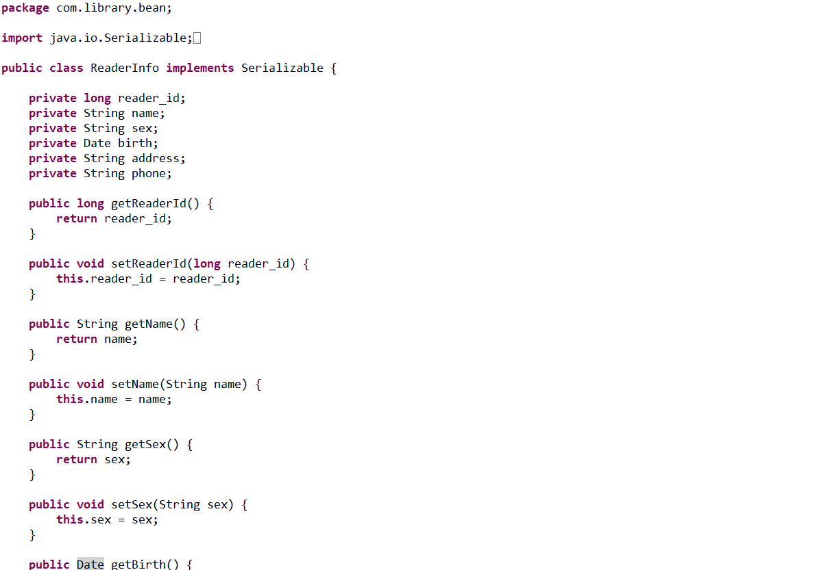

## 3.4 DAO接口类readerInfoDAO.java

描述该文件作用，并对里面的关键代码进行解释

## 

## 3.5 接口映射文件readerInfo.xml

描述该文件作用，并对里面的关键信息进行解释

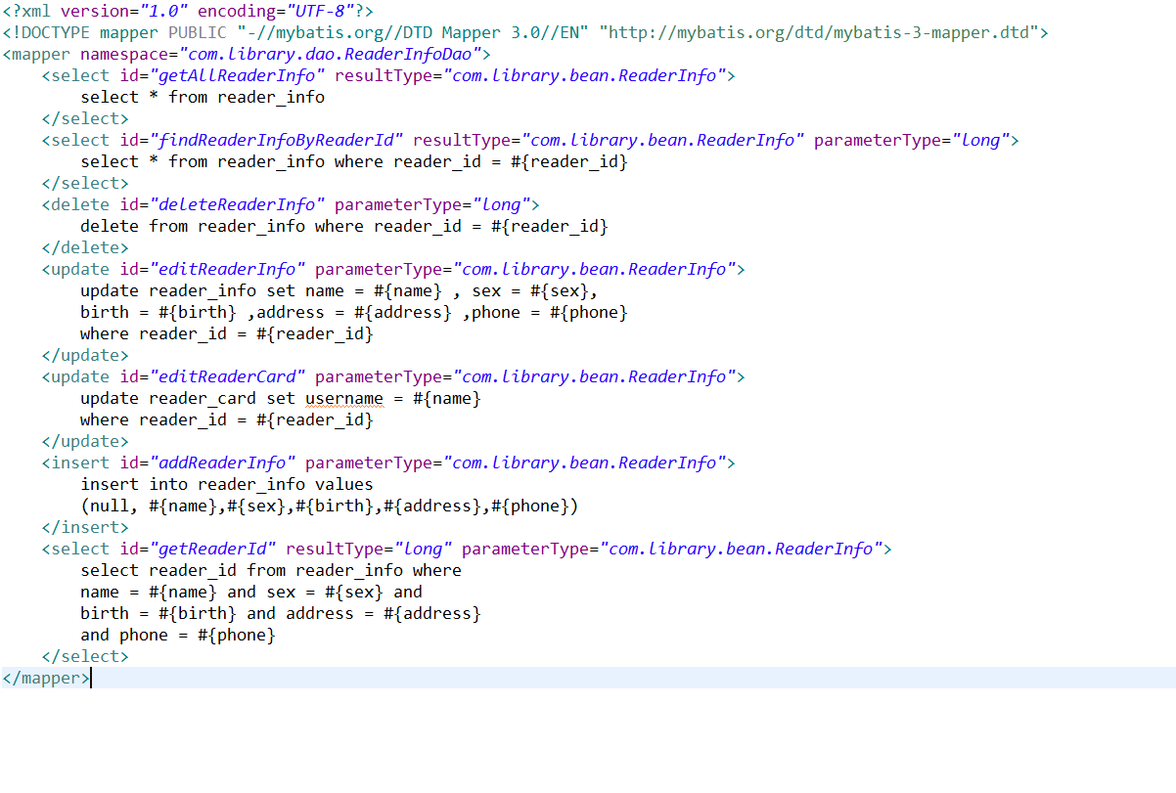

## 3.6 服务层Lendservice.java

描述该文件作用，并对里面的关键代码进行解释

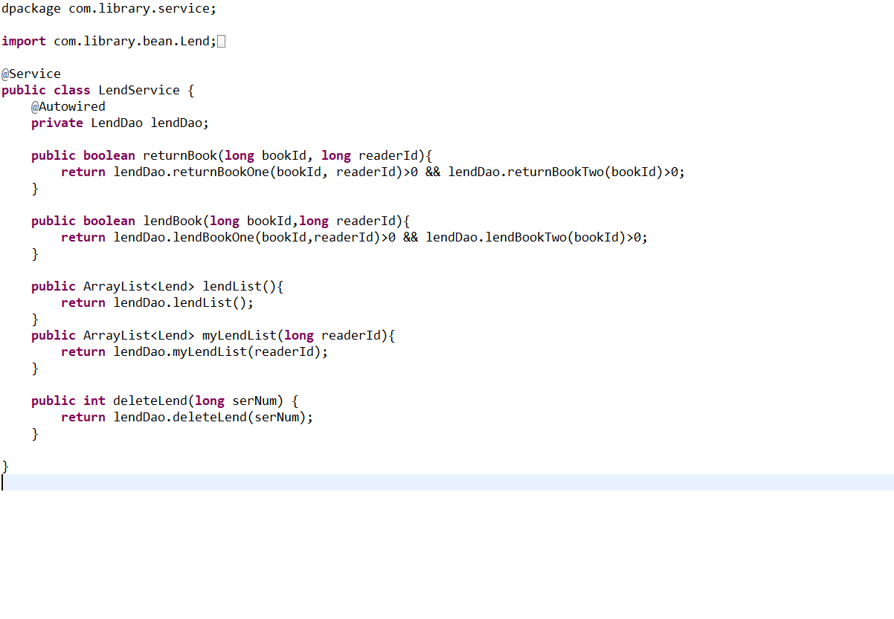

## 3.7 用户界面 前端

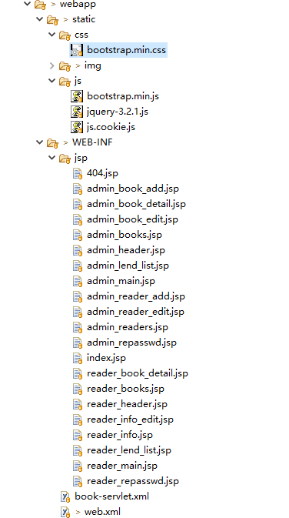

前端页面采用jsp+js+css 。js是脚本语言，负责一些逻辑处理，比如验证账户密码的正确性等css是样式表，可以设置一些样式属性js的框架使用的是jquery，css的框架使用的是bootstrap

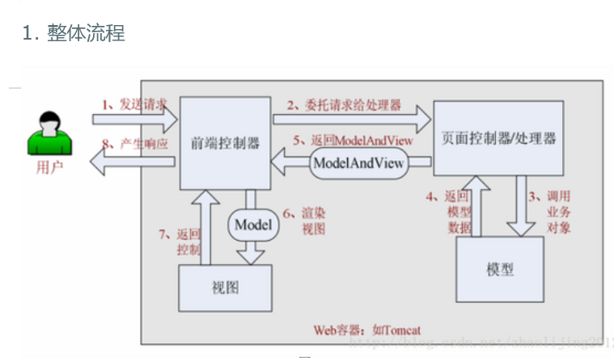

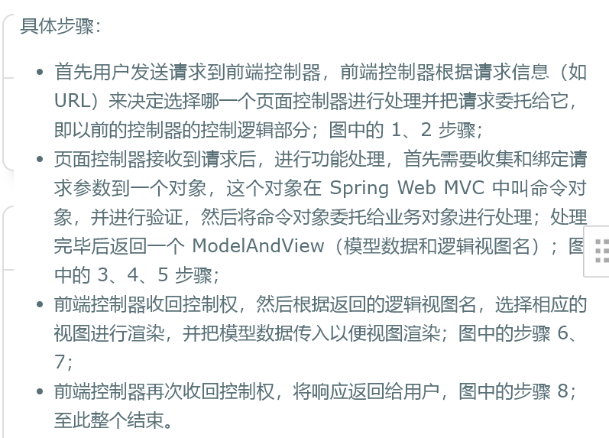

# **4 系统测试**

程序每个功能模块的运行结果截图由于图片太多放在文件夹”测试”中 分读者和管理员两类账户展示。

# **5 系统总结**

通过本次课程设计，我对Java开发有了一定的认识，对JSP技术和JAVA以及MsSQL数据库也有了进一步的了解，丰富了自己的知识。

在设计过程中,出现了许多错误,难处,为了解决问题查阅了不少相关的资料和前人写的教程和经验,锻炼了自我学习的能力,开阔了视野。