Synthetic astronomy worksheet
Task 1. Fill in the blanks
1. A planet orbits a ____ and has ____.
Answer: star; gravity
Word bank: star, gravity
Task 2. Multiple choice
2. Which object gives off light?
a) Star
b) Moon
Answer: a) Star
Task 3. Explain
3. Explain why we can see the Moon.
Use an example in your explanation.
Answer: Reflected sunlight.
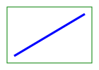
4. Describe the diagram.

