**3.1.2 ALGORITHMS**

**Algorithm of the room reservation for the Customer**

1. Start.
2. Select start date.
3. Select end date.
4. Check for the availability of the rooms.
5. If Rooms available = ‘Yes’, enter personal details

Else

End

1. If Details completely filled = ‘Yes’, then click on the PAYPAL logo

Else

Go back to ‘Check availability’ option.

1. Login
2. Pay through PAYPAL.
3. Get confirmation code.
4. Redirect homepage.
5. End

**Algorithm for Admin Login**

1. Start.
2. Login to Admin.
3. If username = ‘True’ and password= ‘True’,

then start session

otherwise stay on the login page.

1. Logout.
2. End.

**Algorithm for cancelling reservation**

1. Start
2. Get confirmation number.
3. Login.
4. Go to room reservation table.
5. If ‘provided confirmation number’ = ‘confirmation number on table’, then

truncate data.

else

End

1. End.

**3.1.3 FLOWCHART**

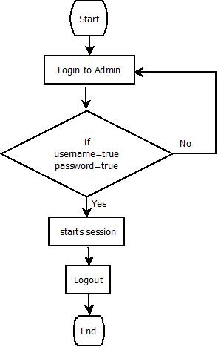

Fig. flowchart for Admin login

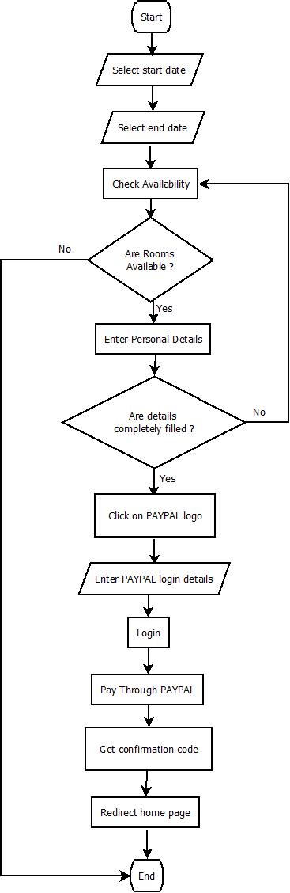

Fig.Flowchart for Customer booking

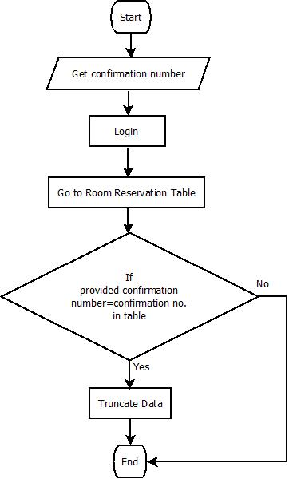

Fig. Flowchart for cancelling reservation

**3.1.5 ER DIAGRAM**

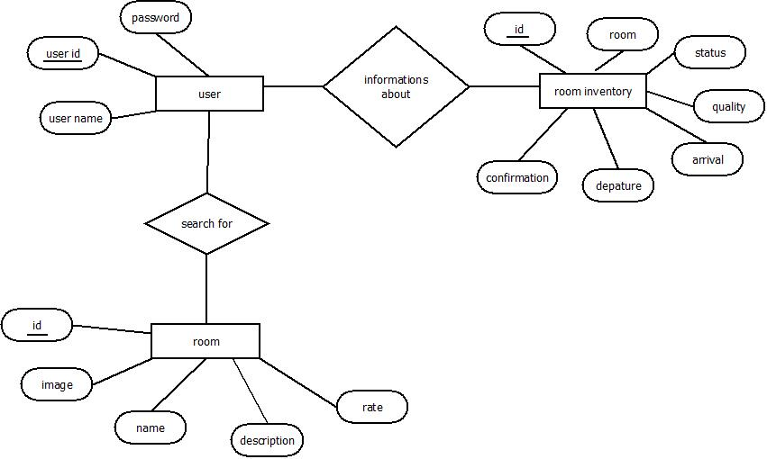

Fig. ER diagram of Online Room Reservation System

**3.1.6 SCREENSHOTS**

