**TRIBHUVAN UNIVERSITY**

**INSTITUTE OF ENGINEERING**

**PASHCHIMANCHAL CAMPUS**

LAMACHAUR-16, POKHARA



**A**

**PROJECT**

**ON**

**DYNAMIC HOTEL WEBSITE DEVELOPMENT**

**Aashish Adhikari (069/BCT/601)**

**Pradeep Devkota (069/BCT/625)**

**Samundra Adhikari (069/BCT/634)**

**Sushil Shrestha (069/BCT/645)**

Fall 2015

**ABSTRACT**

The purpose of this project was to model an interactive website with an online booking system that supports online transaction. Hotels and resorts in Pokhara have tried to maintain their websites but none have efficiently managed to make those websites interactive and include an online reservation system. An integrated online payment system has been anything but possible for these websites.

We studied a few hotel websites, tried to gain knowledge of the existing systems and found them to be difficult to handle. As far as our project is concerned, we developed a foundation of the website first, created and integrated a database in parallel and improved the website along the process with an incremental model of the project development. We have used several front-end, scripting and server-side languages in the project.

We developed a dynamic website which is neat and clean, integrates an online reservation system and processes reservation payments online.

**Table of Contents**

**Chapter 1**

* 1. INTRODUCTION…………………………………………………………………………………………………1
  2. OBJECTIVES……………………………………………………………………………………………………….2

**Chapter 2**

2.1 METHODOLOGY

2.1.1 DISCARDED METHODOLOGIES…………………………………………………………………..3

2.2.2 METHODOLOGY OF THE PROJECT………………………………………………………………4

**Chapter 3**

3.1 IMPLEMENTATION

3.1.1 EXISTING IMPLEMENTATION…………………………………………………………………5

3.1.2 IMPLEMENTATION OF THE PROJECT

3.1.2.1 ALGORITHMS…………………………………………………..…………………….6

3.1.2.2 FLOWCHARTS…………………………..………………..………………………….8

3.1.2.3 ER DIAGRAM………………………………….…………..……………….……….11

3.1.2.4 FUNCTIONS USED……………………………………….…………………………12

3.1.2.5 SCREENSHOTS……………………………………….………………………………13

**Chapter 4**

4.1 SUMMARY…………………………………………………………………………………………...………….15

4.2 LIMITATIONS…………………………………………………………………………………………………...16

4.3 APPENDIX………………………………………………………………………………………………………...17

**Chapter 1**

* 1. **INTRODUCTION**

Pokhara, the tourist-hub of Nepal, is on the verge of revolution in the tourism sector. New strategies like airplane-restaurant, water-ball, zip-flyer, bungee-jump and many more are challenging the rudimentary methods of attracting the tourists, may it be domestic or international. And with this, the demand for the accommodation services has also been up to the par. The number of tourists, and the hotels and resorts accommodating them are all-time high at the moment. To match this,several hotels in Pokhara and the periphery have launched their websites so as to inform the tourists about their services while some have tried to include online reservation services as well. With the rise in tourism in Pokhara more than ever before, it has become essential to find a viable alternative to ‘On-Arrival Reservation and Payment System’ for the hotels and resorts.

Some well-known hotels in Pokhara have tried to maintain online reservation systems but only a handful have succeeded in implementing this idea as of the moment of literature survey done prior to this project development.Although many hotels and resorts tend to feature the online reservation system in their websites,they failed to do so when tested by the developers of this project.Apart from that, only one hotel included the online payment system but the user interface of the payment system seemed to be dull and full of error messages even at the front-end of the website.

This project “HOTEL WEBSITE DEVELOPMENT WITH ONLINE ROOM RESERVATION AND PAYMENT SYSTEM” has come in light with the knowledge that the hotels in Pokhara and the periphery have failed to facilitate the clients with a proper website. The strategy adopted in this project is to develop a neat and clean hotel website that supports online room reservation and payment. This can be a crucial step in encouraging the guests to the respective hotels if this system is implemented by the hotels.With the increase in the number of hotels and resorts in recent times, this strategy can lead to a better arrival-rate of the guests.

**1.2 OBJECTIVES**

* To develop an interactive hotel website.
* To integrate an online room reservation system with a dynamic database.
* To include an online payment system for advanced payments.

**Chapter 2**

**2.1 METHODOLOGY**

**2.1.1 DISCARDED METHODOLOGIES**

There were a handful number of methodologies that could have been adopted for the development of the project but were not chosen because of substantial reasons.

* **Development of an application in Java**

Java wasn’t used for the project because even though it supports android platform which is a used worldwide, it would be inefficient in light to the Windows OS and iOS users.

* **Online transaction based on e-Sewa or iPay**

These online transaction services were not taken for reference since they did not have open-source policy and also their method was tedious.

* **Development of a website using templates from Bootstrap**

This method wasn't chosen because the aim of the project was to make the students as creative as possible and to encourage them to code and this method wouldn't work in the favour.

* **Development in Objective C or C#**

This method wasn't chosen because it either focused on iOS platform or on

Windows platform and the project was meant to be as generalized as possible so as to facilitate everyone from it.

**2.1.2 Methodology of the project**

The aim of this project was to develop a system that could handle and manage the activities involved in a hotel in an efficient and reliable way such that any browser could access the service on any platform. On the basis of drawbacks and shortcomings identified in the existing hotel room reservation systems, the solutions have been provided for better management.

* Developers visited a few hotel and restaurants to understand the existing system-architecture for online booking services.Some of them, for example, Rupakot Resort, has an online reservation system that might lead to online fraud.
* This project uses a number of languages like HTML, CSS, PHP, MySQL and JavaScript.
* HTML, CSS JavaScript have been used the front end programming.
* PHP is the scripting language i.e., the language that reacts only when an event is triggered.
* MySQL has been used for the database.
* MySQL server has been used.
* Paypal Sandbox Environment has been used for online transaction.
* No templates like Bootstraps have been used for the development of this project.
* The logo and the social-network site accounts used are authentic and have no copyright issues.
* Most of the images used in the project were captured by the developers during field visit at different hotels while some were randomly taken from the internet and the developers hold no credit.

**Chapter 3**

**3.1 IMPLEMENTATION**

**3.1.1 Existing Implementations**

Several hotel websites do not have a working online reservation system,let alone the payment system. Those which managed to feature the reservation system have now been non-functional as found on their websites.

Rupakot Resort Pvt. Ltd., Rupakot has an online reservation system that doesn’t work. [1]

Fewa Prince Hotel,Pokhara features an online reservation system that for some reason doesn’t let the clients select date prior to 2003. [2]

Fishtail Lodge, Pokhara has managed to include an online reservation and payment system but has scripting-language error messages in the user interface. [3]

**3.1.2 IMPLEMENTATION OF THE PROJECT**

**3.1.2.1 ALGORITHMS**

**Algorithm of the room reservation for the Customer**

1. Start.
2. Select start date.
3. Select end date.
4. Check for the availability of the rooms.
5. If Rooms available = ‘Yes’, enter personal details

Else

End

1. If Details completely filled = ‘Yes’, then click on the PAYPAL logo

Else

Go back to ‘Check availability’ option.

1. Login
2. Pay through PAYPAL.
3. Get confirmation code.
4. Redirect homepage.
5. End

**Algorithm for Admin Login**

1. Start.
2. Login to Admin.
3. If username = ‘True’ and password= ‘True’,

then start session

otherwise stay on the login page.

1. Logout.
2. End.

**Algorithm for cancelling reservation**

1. Start
2. Get confirmation number.
3. Login.
4. Go to room reservation table.
5. If ‘provided confirmation number’ = ‘confirmation number on table’, then

truncate data.

else

End

1. End.

**3.1.2.2 FLOWCHART**

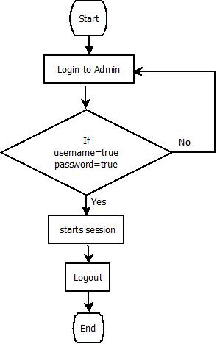

Fig. Flowchart for Admin login

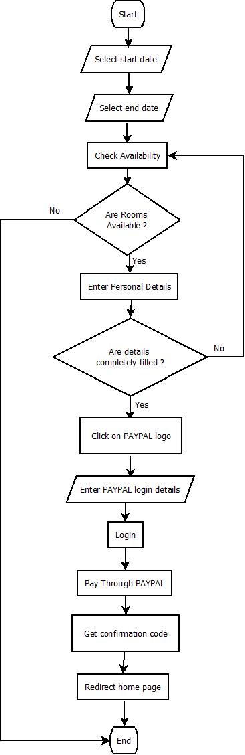

Fig. Flowchart for Customer booking

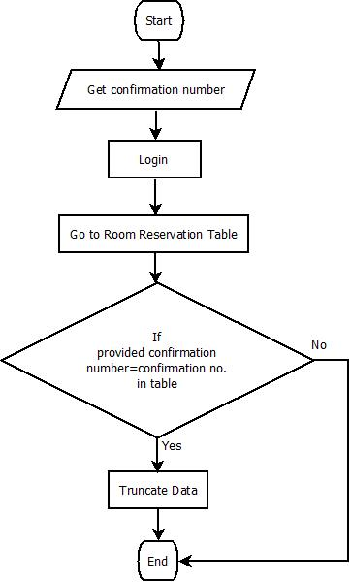

Fig. Flowchart for cancelling reservation

**3.1.2.3 ER DIAGRAM**

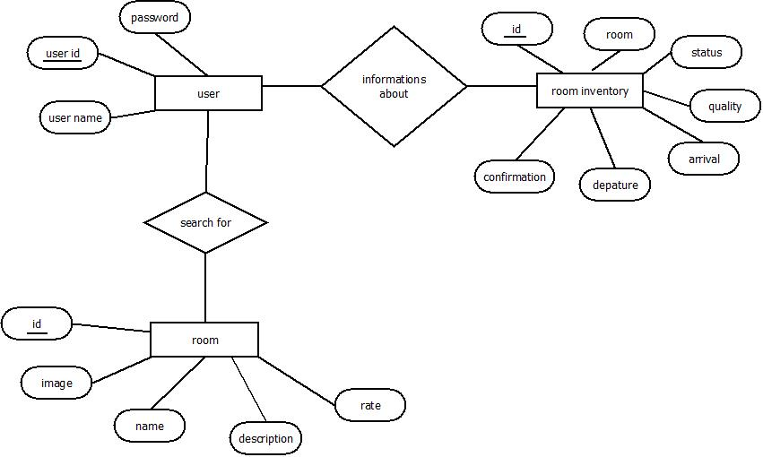

Fig. ER diagram of Online Room Reservation System

**3.1.2.4 Function used**

Functions used in this project are furnished below:

* **Home page**
* Date function through JavaScript
* Flip cards function through CSS
* Navigation bar cursor detection function through CSS
* Background image slideshow function through CSS
* **Reservation page**
* Navigation bar cursor detection function through CSS
* Select date function through JavaScript
* Auto hide login function through JavaScript
* MySQL connection through PHP
* Passing data from form through PHP
* **Admin dashboard page**
* Start session function through PHP
* Fetch data from MySQL through PHP
* Delete confirmation function through JavaScript
* Delete record through MySQL
* End session function through PHP
* Filter data through JavaScript
* Add room function through JavaScript
* **Drag and drop selection page**
* Fetch data from MySQL through PHP
* Display rooms with images through JavaScript
* Drag and drop rooms through JavaScript
* **Gallery page**
* Display images in a rows through JavaScript
* Click on image and display through JavaScript
* Zooming and category selection through JavaScript

**3.1.2.5 SCREENSHOTS**

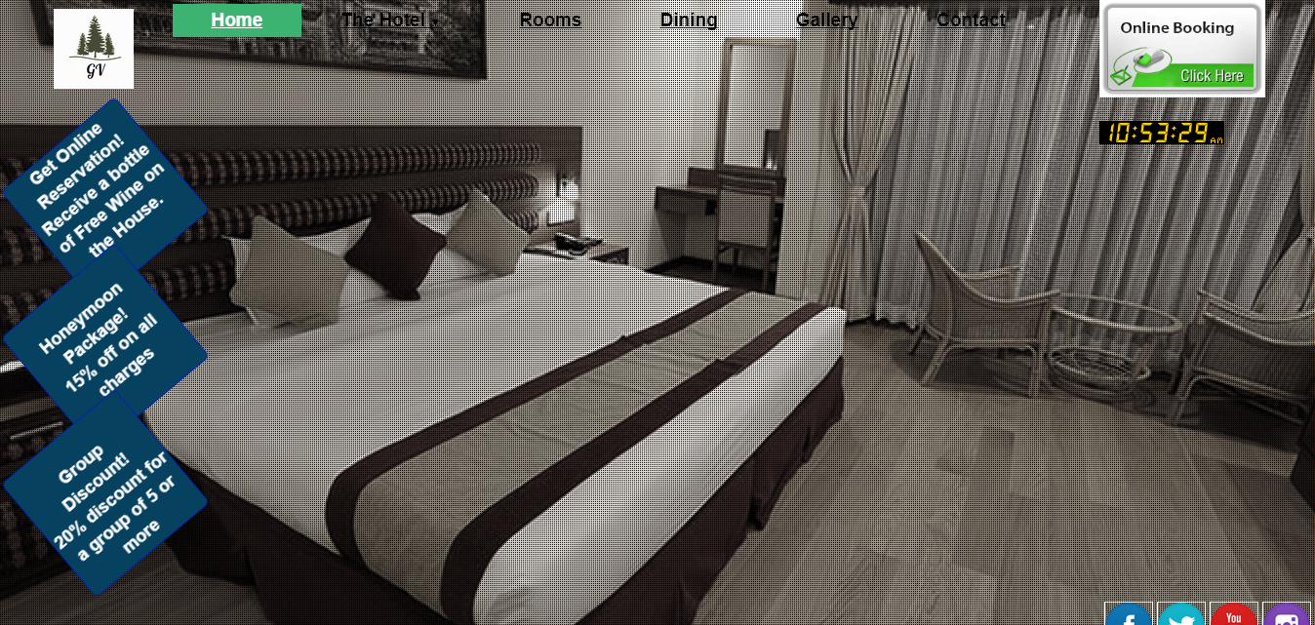

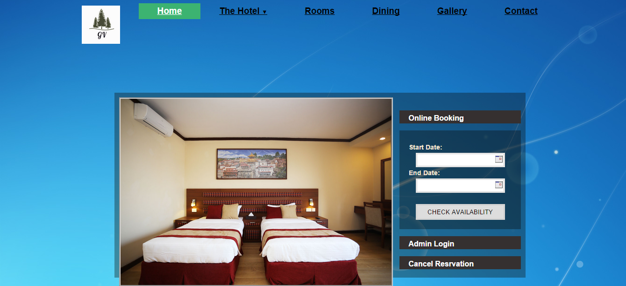

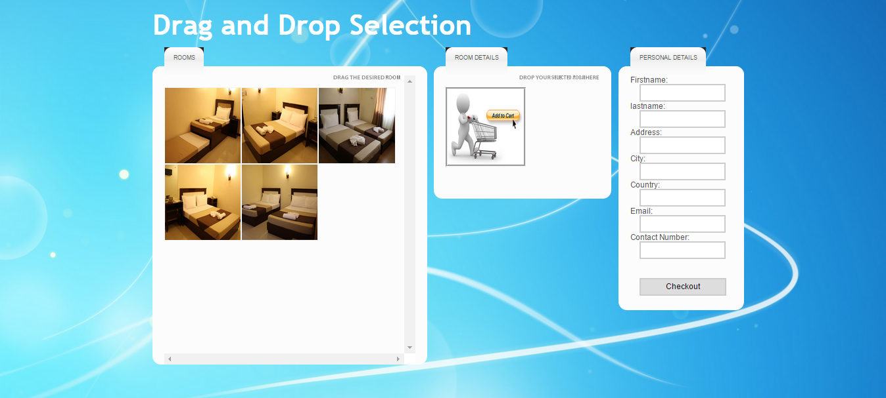

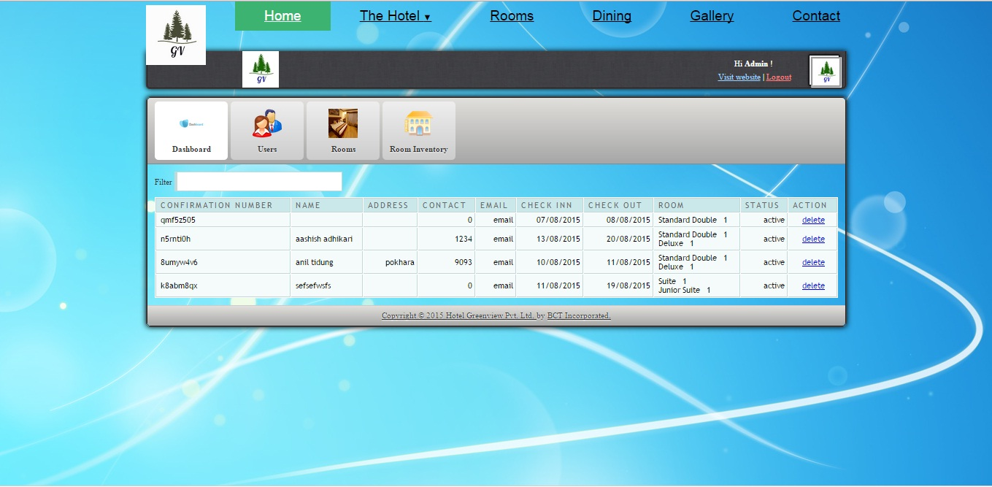

**Chapter 4**

**4.1 SUMMARY**

This project “HOTEL WEBSITE DEVELOPMENT WITH ONLINE ROOM RESERVATION AND PAYMENT SYSTEM”has successfully been developed meeting the promised goals and objectives.The project aims to replace dull and non-functional hotel reservation systems prevalent in Pokhara. It promises to serve the arriving guests and the executives who shall be using it in the coming days. We have tried our best to make the complicated process of hotel booking, payment and management system as simple as possible using structured and modular techniques and a menu-oriented interface. We have designed the project such that guests shall not have any difficulties in their packages. Database system has been designed to computerize the functions that were performed manually previously. Room booking, cancelling the reservation and payment, all have been made online. Clients need not spend time and energy to get desired rooms after arrival at the hotel.

Different languages were used to develop the user interface, scripting code, database and animations. We feel that this project will be able to out-throw the clumsy hotel reservation systems. This project will be approached with huge enthusiasm once the project is demonstrated to the hotel entrepreneurs of Pokhara. The success of this project shall be measured in terms of the number of interested entrepreneurs who shall approach the developers for the commercial implementation of this project

**4.2 LIMITATIONS**

* The clients cannot make any changes to the package once the booking is done.No rooms can be added in the same booking and must be done with a separate form submission through the website.
* No automatic refunds can be made in case the clients cancel their reservation. The decision of refund is solely up to the hotel executive. It needs to be done manually in case a refund is provided.

**4.3 APPENDIX**

**1.**

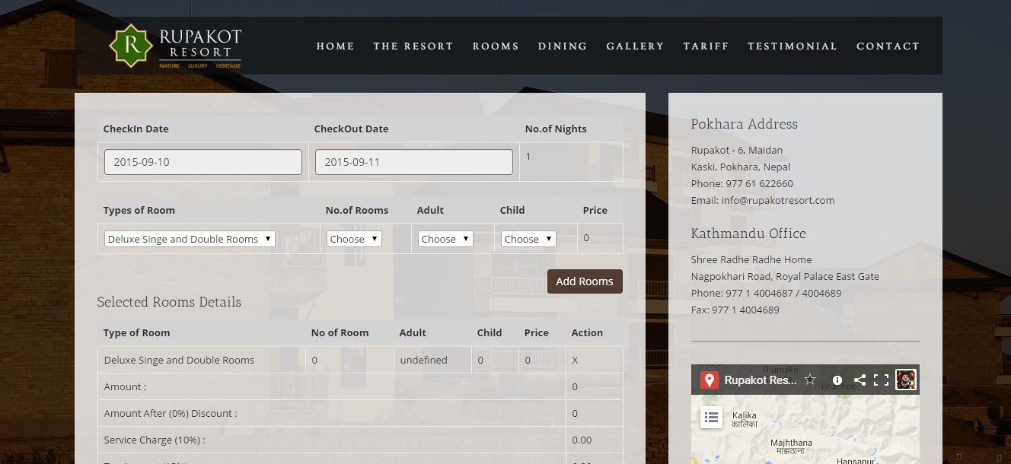

**2.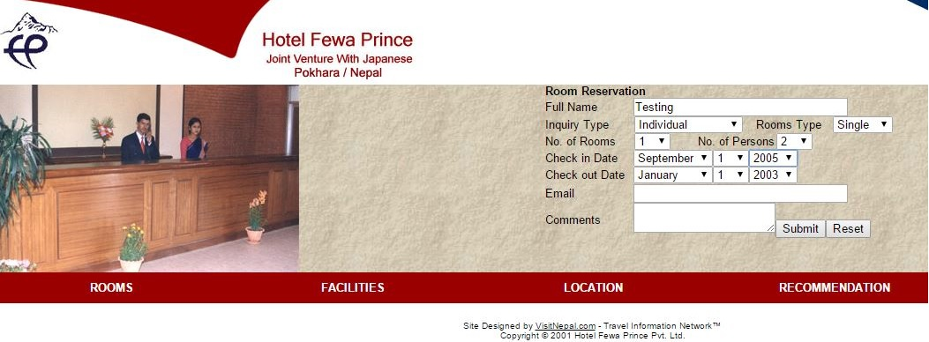3.**