**TRIBHUVAN UNIVERSITY**

**INSTITUTE OF ENGINEERING**

**PASHCHIMANCHAL CAMPUS**

**Lamachaur-16, Pokhara**



A

Project Report

On

**“ metroCab”**

**A NAVIGATION AND CAB**

**SERVICES APPLICATION ON ANDROID**

**Aashish Adhikari (069/BCT/601)**

**Samundra Adhikari (069/BCT/634)**

Aug 12,2016

**Declaration**

We hereby declare that the project report titled “metroCab- A Navigation and Cab Services Application on Android” submitted to the Department of Electronics and Computer Engineering, Pashchimanchal Campus, Institute Of Engineering, Tribhuvan University in partial fulfillment of the requirement for the degree of Bachelor’s in Computer Engineering is a record of an original project work carried out by us under the guidance of Er. Nabin Lamichhane. We further declare that the work reported in this project has not been submitted and will not be submitted, either in partial or in full, for the award of any other degree in this institute or any other institute or university.

Pokhara

August 12, 2016

Aashish Adhikari

Samundra Adhikari

**COPYRIGHT**

The authors have agreed that the Department of Electronics and Computer Engineering, Pashchimanchal Campus, Institute Of Engineering may take this freely available report for inspection. Moreover, the authors have agreed that permission for extensive copying of this project report for scholarly purpose may be granted by the supervisors who supervised the project work recorded herein or, in their absence, by the Head of the Department wherein the project report was done. It is understood that the recognition will be given to the author of this report and to the Department of Electronics and Computer Engineering, Paschimanchal Campus, Institute of Engineering in any use of the material of this project report. Copying or publication or any other use of this report for financial gain without approval of the Department of Electronics and Computer Engineering, Paschimanchal Campus, Institute of Engineering and the authors’ written permission is prohibited.

Request for permission to copy or to make any other use of the material in this report in whole or in part should be addressed to

The Head

Department of Electronics and Computer Engineering

Pashchimanchal Campus, Institute of Engineering

Lamachaur-16, Pokhara, Nepal

**ACKNOWLEDGEMENT**

“..… the beauty of destination is half veiled and the fragrance of success half dull until the traces of those enlightening the path are left to fly with the wind spreading the words of thankfulness.”

It is a great pleasure to acknowledge the support and guidance received from several individuals during the project development. Firstly, we would like to express our sincere thanks to Department of Electronics and Computer Engineering and Mr. Hari Prasad Baral, Head of Department, Electronics and Computer Engineering for providing us an opportunity to undertake this project. We are deeply indebted to our project supervisor Er. Nabin Lamichhane for providing us his valuable guidance throughout the project and to all the members of the faculty.

We would like to extend out heartfelt gratitude to our friends Mr. Nabin Bhandari, Mr. Dipesh Adhikari, Mr. Sagar Adhikari, Mr. David Gurung, Mr. Rajiv Giri and Mr. Mohammad J. Alam for their constant support, suggestions and technical guidance during the project development. We are thankful to all the classmates of 069/BCT batch without whom the milestones would not have been achieved. Finally, we would like to express gratitude to our family members, without the encouragement of whom, this journey wouldn’t have been possible.

Project members

Aashish Adhikari (069/BCT/601)

Samundra Adhikari (069/BCT/634)

**ABSTRACT**

The issue of transportation is very paramount in any society. Public transportation system in Nepal has never been efficient till date, may it be government-owned corporations or privately-owned networks. This has made time-loss inevitable to everyone without private vehicles. We, therefore, intend to provide a solution by presenting an easy-to-use android application that finds the nearest available cabs with respect to the GPS locations among a large number of available cabs connected through a system. It also implements a navigation system featuring a number of utility tools including, but not limited to, route generator, distance calculator and Estimated Arrival Time (ETA) calculator. The project boasts the use of newest advancements in the field of technology including Google Cloud Messaging (GCM) and PayPal online payment service. The application has a complete remote-cab request service. The feature of bargaining the price before the cab-service even starts is included. Payment transactions are made after the service-session ends using virtual currency topped-up through PayPal credits. A credit-deposit scheme avoids fake requests from the cab-service clients and fake acceptances from the driver. User X, may it be the driver or the passenger, can report about User Y at the other end if User Y isn’t present where they should have.

**TABLE OF CONTENTS**

**ACKNOWLEDGEMENT**

**ABSTRACT**

**LIST OF ABBREVIATIONS**

**LIST OF FIGURES**

**LIST OF TABLES**

**CHAPTER ONE……………………………………………………………… 1**

1. **INTRODUCTION……………………………………………………..1**
   1. BACKGROUND……………………………………………………1
   2. PROBLEM STATEMENT…………………………………….……2
   3. OBJECTIVES……………………………………………………….3
      1. GENERAL OBJECTIVES………………………………….3
      2. SPECIFIC OBJECTIVES…………………………………..3

**CHAPTER TWO………………………………………………………………4**

1. **LITERATURE SURVEY………………………………………..……4**

**CHAPTER THREE………………………………………………….. ……….7**

1. **METHODOLOGY…………………………………………...………..7**
   1. DISCARDED METHODOLOGIES………………………………..7

3.2 METHODOLOGY OF THE PROJECT…………………………….8

**CHAPTER FOUR………………………………………………..……………15**

1. **IMPLEMENTATION……………………………………..………….15**
   1. EXISTING IMPLEMENTATION……………………..…………..15
   2. IMPLEMENTATION OF THE PROJECT…………..…………….17
      1. ALGORITHMS………………………………………….….17
      2. FLOWCHARTS……………………………………..……...26
      3. ER DIAGRAM……………………………………..……….36
      4. FUNCTIONS USED……………………………..…………37
      5. SCREENSHOTS………………………………..…………..39

**CHAPTER FIVE……………………………………………………………...48**

1. **EPILOGUE…………………………………………....…………….....48**
   1. TESTING………………………………………….……………...…48
   2. RESULT………………………………………...…………………..50
   3. SCOPE………………………………………………………………51
   4. PROBLEMS FACED AND SOLUTION………………….……….52
   5. LIMITATIONS…………………………… .………….....…………53
   6. FURTHER ENHANCEMENT…………………………….………..54
   7. CONCLUSION………………………………………….…………..55
   8. REFERENCES………………………………………....……………56

**List of Abbreviations**

* ETA Estimated Time of Arrival
* GPS Global Positioning System
* GCM Google Cloud Messaging
* SMS Short Message Service
* MS Microsoft
* SUV Sub Urban Vehicle
* API Application Program Interface
* FCM Firebase Cloud Messaging
* UI User Interface
* OS Operating System
* HTTP Hyper-Text Transfer Protocol
* XAMP Cross-Platform, Apache, Maria DB, PHP, Perls
* TS Test Scenario
* IDE Integrated Development Environment
* XML Extended Markup Language
* DBMS Database Management System
* JSON Java Script Object Notation
* AJAJ Asynchronous Browser/ Server Communication

**LIST OF FIGURES**

1. Android…………………………………………….…………10
2. Android Studio UI …………………………………………..10
3. Google Map UI……………………………………………....11
4. Geofencing…………………………………………...………12
5. PayPal Transaction ………………………………………….13
6. Google Cloud Messaging …………………………..………13

**LIST OF TABLES**

1. Test Case Scenarios…………………………………………...48

**CHAPTER ONE**

**INTRODUCTION**

**1.1 BACKGROUND**

Transportation has been the backbone of development since the beginning of the human history and it will remain to do so for ages to come. A society is considered remote or developed weighing it on the scale of access from the outer world. While a country like Nepal is still lagging behind in the development of road network across the country, technology has brought computers to the doorsteps of transportation. The unmanaged and chaotic transportation system in Nepal is more than enough for a newcomer in the country to get lost on the road in the lack of proper traffic signs and information boards.

While new technologies are being introduced every day, we Nepalese have been unable to grab the advantages of these technologies. While different companies in the world have provided map services on mobile devices, none of them have made a significant impact in the Nepalese society. The use of map applications hasn’t even been scratched in the lack of knowledge on the usefulness of such applications. Apart from that, while government has failed to make proper transportation network across Nepal, the private transportation has not been ubiquitous. Many parts of the country still lack access to vehicles even though a majority of the local population isn’t shy of spending money on quality service. The best of examples can be Mustang, the “forbidden kingdom”, where people earn way more than an average Nepali, but are deprived of a proper transportation service. Not to forget are the hardships faced by the cab drivers around the country, who while earning a decent living, actually waste a decent amount of time in finding the clients on a daily basis.

On the brighter side, the time has changed. The access to computers and mobile computing devices has made it possible for anyone with a simple internet connection to learn the magic of coding. In such a scenario, we present a project entitled “metroCab – A Navigation and Cab Services Application on Android”.

Google defines navigation as the process or activity of accurately ascertaining one’s position and planning and following a route. Our application thus deals with ascertaining one’s position as well as leading them to their destination while showing a proper route till the end. Android is a new but very powerful platform having a very wide horizon of applications. It can be easily accessed by smartphones and thus makes computing portable.

This project is bound to be very helpful for the transportation agencies, drivers as well as the general public when launched on a commercial scale. It has a wide range of scope while being easy to use, practical, time-saving and wallet-friendly.

**1.2 PROBLEM STATEMENT**

The poor transportation sector of Nepal hasn’t been hidden to anyone within the country. The problems have been so wide in nature. News about someone going to Kathmandu for the first time and getting lost at broad daylight only to be found the other day at some corner of Kathmandu by the local police have been a spicy recipe in the social network sites like Facebook and Twitter these days. The other face of the problem reflects a very poor public transportation service. The lack of number of vehicles per 10000 people in Nepal is among the lowest in the world. In such a scenario cab rides can be very useful if made available whole over the country. Another issue to address can be the cab fare that cannot be neglected in a country like Nepal where people are obsessed with bargaining. Also, travelling at night from one place to another in Nepal is not a thing one can skip while discussing about public transportation problems.

These are just a few examples on up to what extent should the problems in the Nepalese transportation sector be addressed. These issues not only affect the villages and t He sub-urban cities but also major cities like Kathmandu and Pokhara. It is important that we fix these problems now . Not only does this angle of solution benefit the public but also other stakeholders like cab drivers who get benefitted economically, specially able people who feel uncomfortable in the crowded public vehicles and the senior citizens unable to make their trips to the public stops themselves. We want our transport services to go forward seamlessly, without defects, where everyone is aware and informed about the outcomes.

Today we have too many problems in the transportation sector that result in too many complications. If we ignore these problems, resources will need to increase to handle the problems, and we may miss the critical reasons for which the transportation service came into existence in the human history itself which could eventually lead to a chaotic network of roads.

Technology has advanced so much in the last decade that it has made lives very efficient and comfortable, at least in the developed and developing countries. And while it hasn’t failed to do so in an underdeveloped country like Nepal, its grasp can be tightened only by the youths of today who have learnt how easy it can be to solve such crucial problems just by the use of the internet and a few thousand lines of computer code. The comfort of being able to take control of devices from one particular location using new developments in computer science and enterprise application development has become so much imperative as it saves a lot of time and effort. Therefore, there arises a need to do so in a systematic manner which we have tried to implement in our system. The proposed project serves the systematic architecture of problem-solving.

**1.3 OBJECTIVES**

The main objective of this project is to develop an Android application that reads the GPS location of the users and manipulates the location values for further processing. The objective can be envisioned in the following two ways.

**1.3.1** **GENERAL OBJECTIVE**

* To design a system that records the GPS co-ordinates of the user and manipulates the input for navigation and Cab services
  + 1. **SPECIFIC OBJECTIVES**
* To develop a navigation system using Google Maps
* To implement Google Maps Directions API
* To implement Google Cloud Messaging(GCM)
* To implement online transaction using PayPal
* To be familiar with Android Development Environment
* To realize the use of web server to store database and scripts

**CHAPTER TWO**

**LITERATURE SURVEY**

The use of technology can be observed ranging from bicycles that use GPS services to prevent thefts to autopilot mode in the military jets. Today, the use of mobile devices for navigation as well as cab services has been found to be predominant in the first-world countries. Apart from that, developing countries like India have recently started to entertain a very successful reign of cab service applications like Uber, Lyft and Ola.

In 2005, Google Inc. launched Google Maps for mobile phones, intended to run on any Java-based device. Many features of the website version were included in this application. Google released Google Maps Navigation together with Android OS 2.0 Eclair on the Motorola Droid on November 4, 2009. This included extra features such as voice commands, traffic reports, and street view support. While the initial release was limited to the United States, It was later launched in the United Kingdom on 20 April 2010 and in many parts of the continental western Europe on June 9, 2010. In March 2011, Google reported that it provided map services to 150 million users. More than a year later, in June 2012, Apple announced that they would replace Google Maps with their own map service from iOS 6. Nonetheless, on December 13, 2012, Google released Google Maps in the Apple App Store.

On the other hand, Uber Technologies Inc. is the company that established a trend of cab services offered through smartphones. It is an American multinational online transportation network company with its headquarters in San Francisco, California. It develops, markets and operates the Uber mobile application, which allows consumers with smartphones to submit a trip request which is then routed to Uber drivers who use their own cars. As of May 2016, Uber service was available in over 66 countries and 449 cities globally. Since Uber's launch, several companies have replicated its business model which is referred to as "Uberification". As Uber grew internationally, it also began to experience disputes with governments and taxi companies in those regions. In April of 2014, Uber was banned by the government in Berlin. Nonetheless, the company remains active in other German cities like Munich and Frankfurt. Taxi drivers in London, Berlin, Paris, and Madrid staged a large protest against Uber on June 11, 2014.

In February 2015, Uber announced a collaboration with Carnegie Mellon University to establish the Uber Advanced Technologies Center to support research in the development of autonomous vehicles. In June 2015, Uber launched a leasing program called Xchange Leasing where it offers flexible, affordable leases designed for its driver-partners. Also in May 2015, Uber updated its app to include accommodations for drivers who are deaf or hard of hearing. By 2016, Uber launched partnerships with several transit agencies to encourage trips that connect first or last mile to public transit. Also in 2016, the company partnered with Airbus to test an Uber service with helicopters in Sao Paolo, a city famous for its extreme traffic congestion and for having the largest helicopter fleet of any city in the world. The one-month long test was Uber's first helicopter service that was not limited to specific events. Uber has offered helicopter service at the Cannes Film Festival. On July 28, 2016, the Chinese government claimed that the taxi booking app, such as Uber and Didi Chuxing would be legal. Several days later, when it was coming to August 1, this should be the memorable date for all the employers in Uber China. Uber announced that they had sold its China operations to its rival Didi Chuxing, a similar app with thousands of fans in China. Didi will invest $1 billion to Uber, and in return, Uber will receive 20% stake of the new combined company and also the app Uber China will be remained.

When it comes to online payment, PayPal Holdings Inc. is an American company operating a worldwide online payments system. Online money transfers serve as electronic alternatives to traditional paper methods like cheques and money orders. PayPal is one of the world's largest Internet payment companies. The company operates as a payment processor for online vendor, auctions site and other commercial users, for which it charges a fee. PayPal is without a doubt the most popular "middleman service" for purchasing online in the world. Currently more than 164 million accounts are in use worldwide by Internet users who prefer to use PayPal to send money to each other via email or make online purchases. PayPal has become such a convenient and trusted way to transfer money online, a staggering 95% of eBay's purchases go through PayPal. As an online financial transaction broker, PayPal allows people to send money to each others’ email addresses. At no time can either party see the other's credit card information or bank information.

PayPal acts as the 'middleman' and holds the money similar to an escrow service. Due to its outstanding business integrity, practices, and policies, PayPal has earned the trust of both parties involved in the transaction. With multiple guarantees in place, buyers and sellers entrust PayPal with their credit card and bank information. PayPal keeps the customers private information secret, which is the key to its great success. Because each party's confidential information is totally cloaked, strangers can safely send money to each other through PayPal and email. Moreover to the third-party developer part, sandbox test accountsare virtual PayPal accounts that exist only in the Sandbox environment. These accounts represent the user entities that partake in the mock transactions you create as you run your application in the test phase. Create at least one test account for each user represented in the transactions you generate with the PayPal APIs. The Sandbox supports two different test account types. One is personal, that represents the buyer, or sender in a transaction and the other one, a business account, that represents the merchant, or receiver, in a transaction.

The rise of companies like Uber and GrabCar and the changes they catalysed have started a discussion over the general transition to peer to peer transactions across industries. The parallel rise of platforms such as NetFlix and AppleTV in other industries have led to comparisons with the rise of Uber and debate over whether and to what extent uberisation may displace traditional business models.

It is inevitable to face challenges while developing an app that integrates navigation services with cab request services. To specify a few , one can start with what Maps infrastructure to use when there are many APIs available but for different platforms and with different depths of functionality. The accuracy of GPS location is an important part that completely defines the efficiency of the application. The online transaction methodology adopted also affects what and who is likely to use the service since the users are distributed among a significant number of online transaction systems ranging from eSewa to iPay. And last but not the list, the application that requires constant updates has a drawback of fast battery drainage. Battery optimization comes with a tradeoff of late location updates and this leads to inaccuracy. So the level of accuracy is inversely proportional to the battery life and this is still to this day a drawback of Google Maps.

**CHAPTER THREE**

**METHODOLOGY**

**3.1 DISCARDED METHODOLOGIES**

There were a handful of combinations that could’ve been adopted for the development of this project. However certain choices had to be made to make the project practical while making sure all the required functionalities could be derived .Thus the following methodologies couldn’t be used for substantial reasons.

**3.1.1 Waterfall model of software development**

In this era of Agile model development, use of waterfall model for the development of the application would be a poor choice. Waterfall model results in high amount of uncertainty. Once in testing phase, it would have been very difficult to go back and change something that had not been thought during conception.

**3.1.2 Development of application on non-palmtop devices**

While transportation services can be required not only from home and office but also from places like parks and restaurants where non-palmtop computers are not likely to be found or carried to, the palmtop devices were the ones chosen.

**3.1.3 Use of iOS, BlackBerry OS or Windows Phone platforms**

Windows Phone is the family of operating systems developed by Microsoft Corporation for its smartphones. However this platform wasn’t chosen because of its negligible presence in Nepal. Same is the case for BlackBerry OS. And when it comes to iOS, despite having a huge market in the first-world countries, it is yet to have a significant presence in Nepal. The fact that Apple Inc. doesn’t have even a single Apple Store in Nepal cannot be ignored.

**3.1.4 Use of transaction services of eSewa or iPay**

Despite having a significant influence in the Nepalese market, the implementations of eSewa or iPay were found to be time consuming as well as tedious. However, the main reason for discarding them was their isolation from open-source policy.

**3.1.5 Use of Firebase Cloud Messaging(FCM)**

Although Firebase Cloud Messaging (FCM) is an improvised version of Google Cloud Messaging(GCM), it hasn’t been implemented in the project because of its release during the closure quarter of the project development until which all cloud-messaging implementations of this project had been completed using GCM. It is to note that while FCM was introduced to improvise GCM, it inherits the reliable and scalable GCM infrastructure itself and Google Inc. has no intention of depreciating GCM anytime soon since it is the base for FCM.

**3.1.6 Use of Map APIs like Leaflet, Mapbox, OpenStreetMap**

While a few number of Map APIs were available to choose from, some of them had limited functionalities that could be expanded only with plugins while some required a knowledge of a completely different language just to manipulate the maps. This was far from the main feature of a good software : Simplicity.

**3.1.7 Use of email verification**

Email verification was put out of context because logging into an email account and checking the PIN provided in the email is not what clients like to do while they are creating a new account for this very application in the first place. This would just complicate the registration process and repel the users subconsciously.

**3.1.8 Use of local server solutions like XAMPP**

XAMPP is a  free and open-source cross-platform web server solution stack package developed by Apache Friends, consisting mainly of the Apache HTTP Server, MariaDB database, and interpreters for scripts written in the PHP and Perl. XAMPP stands for Cross-Platform (X), Apache (A), MariaDB (M), PHP (P) and Perl (P). It is a simple, lightweight Apache distribution that makes it extremely easy for developers to create a local web server for testing and deployment purposes. However, since this is a transition period from the academic level to the professional level, to experience the actual use of web servers, local server implementation wasn’t opted for.

**3.2 Methodology of the project**

The aim of the project was to develop a complete yet simple system that could handle and manage the activities involved during navigation as well as cab service usage in a simple, efficient as well as reliable way such that anyone with a basic knowledge of how to use an android smartphone could use the application. For this, a number of factors and obstacles had to be considered. In accordance to these factors, the following choices had to be opted for the development of the project.

* + 1. **Spiral model of software development**

Spiral model of software development was chosen for the risk-free development iterations. The win condition for each stake holder was identified. All possible alternative approaches for satisfying the win conditions were listed out. All consequent risks of those approaches were identified and resolved in each iteration and enough testing was done in each iteration to satisfy each stakeholder’s win condition.

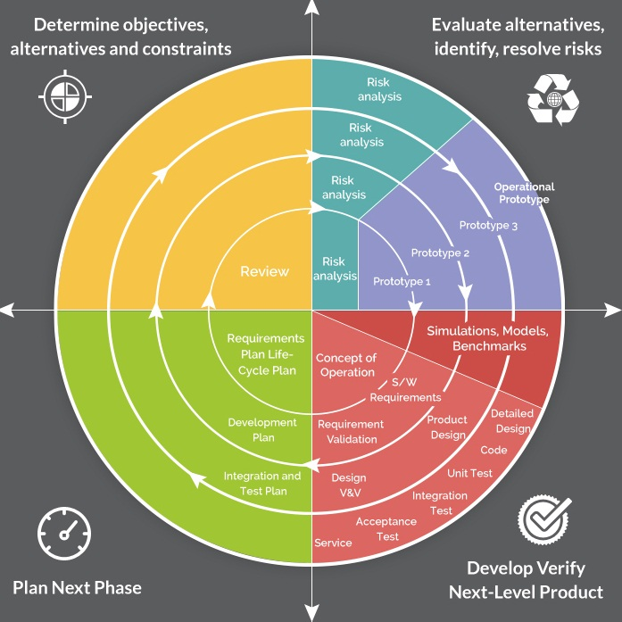

Fig. Spiral Model of Software Development

**3.2.2 Android OS platform**

The project uses Android OS platform . Android is a mobile operating system developed by Google, based on the Linux kernel and designed primarily for touchscreen devices like smartphones and tablets..Android user’s interface is mainly based on direct manipulation, using touch gestures that loosely correspond to real-world actions, such as swiping, tapping and pinching to manipulate on-screen objects.



Fig. Android logo

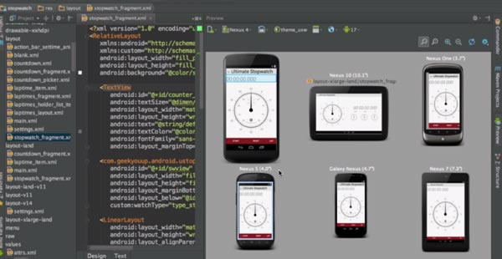

Fig. Android Studio UI

The project itself was developed on Android Studio which is powered by IntelliJ, a Java IDE for developing softwares. It is the official IDE for Android platform development.

**3.2.3. Programming Languages**

Java for Android is the frontend language while pHp is the backend scripting language used in the project. XML has been used in the project as markup language for layouts.

**3.2.4 Databases**

MySQL database has been used for the web server database. Is is an open-source relational database management system. SQLite database has been used for local database on the device itself. SQLite is a relational database management system contained in a C programming library. In contrast to many other DBMS, SQLite is not a client-server database engine. Rather, it is embedded into the end program. It is a popular choice as an embedded database software for local/client storage in application softwares such as android applications

**3.2.5 Maps API**

Google Maps APIv2 has been used as a source for the maps used in the project.

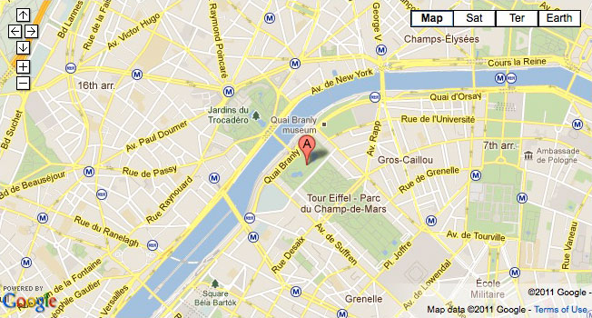

Fig. Google Map UI

**3.2.6 Routes API**

Google Maps Directions API has been used for getting routes between latitude-longitude pairs while PolyUtils class has been used to draw routes after parsing the routes returned in the JSON format.

**3.2.7. Geofencing**

Geofencing has been used to alert the passenger about the arrival of the driver. Geofencing combines awareness of the user’s current location with the awareness of the user’s proximity to locations that may be of interest. To mark a location of interest, user specifies his/her latitude and longitude. To adjust the proximity for the location, you add a radius. The latitude, longitude, and radius define a geofence, creating a circular area, or fence, around the location of interest.

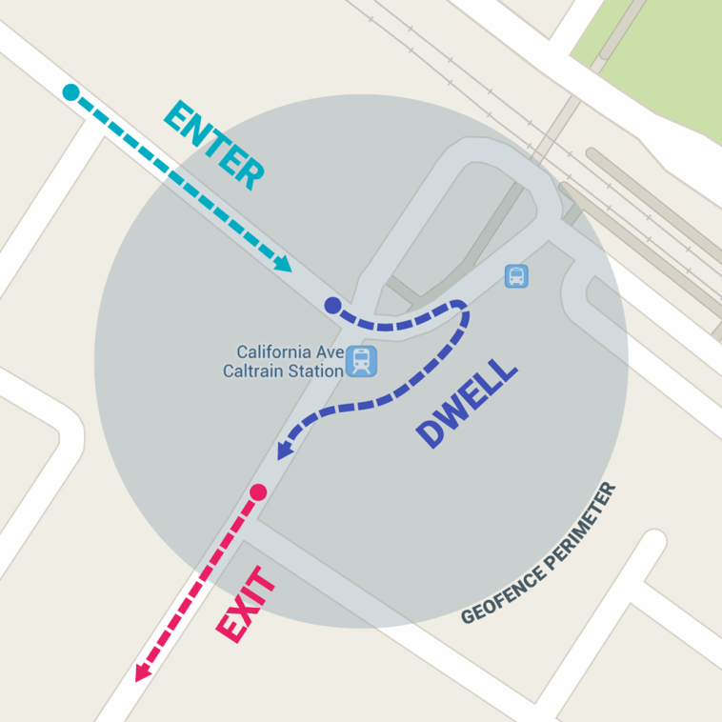

Fig. GeoFencing

**3.2.8.Server-response handling using JSON Parsing**

JSON Parsing has been used to parse location results provided by Google server. JSON stands for JavaScript Object Notation. It is an open-standard format that uses human-readable text to transmit data objects consisting of attribute-values pairs. It is the most common data format used for asynchronous browser/server communication (AJAJ) largely replacing XML which is used by AJAX. JSON is a language-independent format and derives from JavaScript. However, code to generate and parse JSON-format data is available in many languages like Java for Android today. The official file extension for JSON format is .json.

**3.2.9 PayPal Sandbox Environment**

Online payments have been made from Paypal Sandbox accounts and actual transactions have been carried out during the development and testing phases. PayPal services allow people to make financial transactions online by granting the ability to transfer funds electronically between individuals and businesses. Through Paypal, users can send or receive payments for online auctions on websites like eBay, purchase or sell goods and services, or donate money or receive donations. However, it is not necessary to have a PayPal account to use the company’s services.

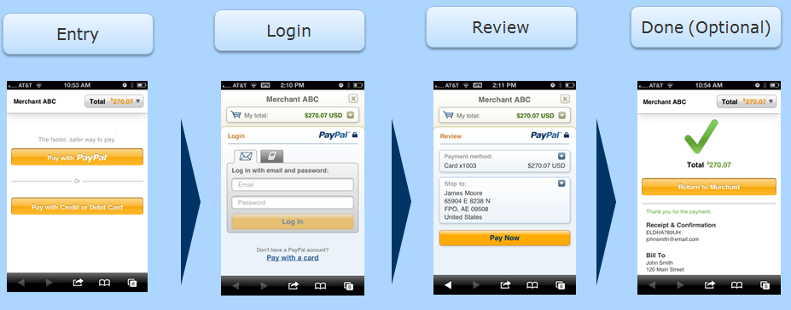

Fig. PayPal Payment Steps

**3.2.10 Google Cloud Messaging (GCM)**

Google Cloud Messaging (GCM) has been used for cloud messaging/notifications exchange. GCM is a mobile-service developed by Google that enables third-party application developers to send notification data or information from developer-run servers to applications that target the Android OS as well as applications or extensions developed for the Google chrome internet browser. It is free for developers but requires a paid key for commercial purposes.

.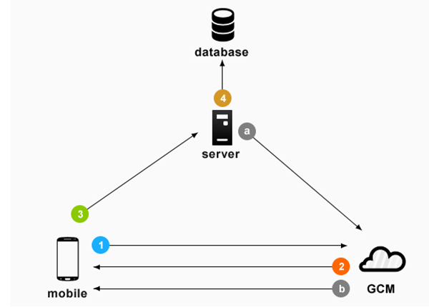

Fig. Google cloud messaging

**3.2.11 Sim Card verification**

The user’s own sim card has been used as a gateway for SMS verification. This is required during registration and password-changing steps. This is an easy process compared to email verification since the PIN can be viewed on the notification bar itself.

**3.2.12 Use of an actual web server**

Actual web server instead of local server has been used to store the MySQL database as well as backend scripts. A web server is a program that uses HTTP to server the files that form web pages to users, in response to their requests, which are forwarded by their computers’ HTTP clients. The domain used in our project is www.omkishan.com

**CHAPTER FOUR**

**IMPLEMENTATION**

**4.1 EXISTING IMPLEMENTATIONS**

The current implementations of the concept include navigation applications like Google Maps, Bing Maps, Apple Maps, etc while mobile cab request services include Uber, sidecar, etc. However, the navigation apps have never been used as utility tools in Nepal either because of lack of knowledge about such apps or because people have never found themselves free from misusing their time on social network sites like Facebook every time they are connected to the internet.

**Google Maps**

Google Maps is a web-mapping service developed by Google. It offer satellite imagery, street maps, 360° panoramic views of streets, real-time traffic conditions, and route planning for traveling by foot, car, bicycle (in beta phase), or public transportation.

Google Maps' satellite view is a "top-down" or "birds eye" view; most of the high-resolution imagery of cities is aerial photography taken from aircraft flying at 800 to 1,500 feet (240 to 460 m), while most other imagery is from satellites. Much of the available satellite imagery is no more than three years old and is updated on a regular basis. Google Maps uses a close variant of the Mercator projection , and therefore cannot accurately show areas around the poles.

**Bing Maps**

Bing Maps (previously Live Search Maps, Windows Live Maps, Windows Live Local, and MSN Virtual Earth) is a web mapping service provided as a part of Microsoft’s Bing suite of search engines and powered by the Bing Maps for Enterprise Framework. Users can browse and search topographically-shaded street maps for many cities worldwide. Maps include certain points of interest built-in, such as metro stations, stadiums, hospitals, and other facilities. It is also possible to browse public user-created points of interest. Searches can cover public collections, businesses or types of business, locations, or people. Five street map views are available: Road View, Aerial View, Bird’s Eye View, StreetSide View, and 3D View.

**Uber**

Uber Technologies Inc**.** is an American multinational online transportation network company headquartered in San Francisco, California, It develops, markets and operates the Uber mobile app, which allows consumers with smartphones to submit a trip request which is then routed to Uber drivers who use their own cars. As of May 2016, the service was available in over 66 countries and 449 cities worldwide. Since Uber's launch, several other companies have replicated its business model, a trend that has come to be referred to as "Uberification".

To passengers, Uber is essentially synonymous with taxis, and to drivers, it’s basically a referral service. The Android, iOS and Windows Phone app connects riders with drivers using their phone’s GPS capabilities, letting both parties know one another’s location and removing the question of when the ride will actually arrive. In cities where Uber operates, user uses the rider app to request a ride. When a nearby driver-partner accepts the request, the app displays an estimated time of arrival for the driver-partner heading to your pickup location. Your app notifies you when the driver-partner is about to arrive.

The app also provides info about the driver-partner with whom you will ride, including first name, vehicle type, and license plate number. This info helps the two of you connect at your pickup location. User uses the app to enter your preferred destination anytime before or during the ride. If you have a preferred route, it’s helpful to talk through the directions together. When you arrive at your destination and exit the vehicle, your trip ends. Your fare is automatically calculated and charged to the payment method you’ve linked to your Uber account. In some cities, Uber allows you to pay your fare in cash. This option must be selected before you request a ride.

Immediately after a trip ends, Uber app asks you to rate your driver from 1 to 5 Stars. Driver-partners are also asked to rate riders. Uber’s feedback system is designed to foster a community of respect and accountability for everyone. In addition, the tech company also processes all payments involved, charging the passenger’s credit card, taking a cut for itself (which ranges from 5% to 20%), and direct depositing the remaining money into the driver’s account, all in the background and completely cashless.

Depending on availability, Uber also offers several different levels of service. The service’s lowest-cost option, UberX, runs in everyday cars like the Toyota Prius. Uber Black is the company’s original service, costing a bit more but running in high-end town cars with professional drivers. Uber SUV is precisely what it sounds like, charging a premium for a larger vehicle. Uber LUX is the top-of-the-line option, operating in posh rides like Porsche Panameras and BMW 7 series sedans.

**4.2 IMPLEMENTATION OF THE PROJECT**

**4.2.1 ALGORITHM**

**Algorithm for User Registration**

1.Start

2.Enter registration details.

3.Click submit .

If details are valid, go to 4.

Else go to 2.

4.Enter verification code received through SMS.

If the entered code is valid, proceed to home activity..

Else go to 2.

5.Stop

**Algorithm for Passenger Operations**

1. Start

2. Enter details for login.

3. Press Login button.

3.1 If credentials are invalid, go to 2.

Else

3.2 If credentials are valid.

2.1.1 If session is on, go to Session page.

Else

Proceed to Home page.

4. Click driver icon.

5. If any driver is available

5.1 If any driver is unwanted, remove from list.

5.2 Select a driver.

5.3 Enter destination.

5.4 Send notification to driver.

5.4.1 If account balance is greater than the minimum threshold, send notification to the selected driver.

Else

Request the user to top-up the balance using PayPal account .

Go to 5.4.

6. If cab service fare proposed by the driver in the notification is acceptable. reply with a YES.

Else

6.1 Reply with your bargain for the cab fare.

7. If the driver agrees the proposed cab fare,

7.1 Wait for the driver to arrive while constantly observing the driver location on session Map.

Else

Go to 6.

8. If the driver accepts the request, deduct deposit amount from both the driver’s and the passenger’s accounts.

9. If the driver doesn’t arrive on expected time, select Report option.

9.1 If the time duration that the passenger waited for the driver after the driver accepted the request exceeds the server’s estimated time duration for the driver to arrive to the passenger

9.1.1 Transfer the deposit of both the passenger and the driver to the passenger as

a compensation to the passenger for the time loss.

9.1.2 Notify the driver about the end of current session.

9.1.3 Go to 4.

Else

Display that the driver’s estimated arrival time hasn’t passed yet and

recommend the use of CALL button to call the driver on phone if

necessary.

10. If the application produces a series of beeps, expect the driver to be around any time soon.

11. If the notification of driver-arrival pops up,

11.1 If the cab is visible to the client, reply with a YES and reach to the cab.

Else

11.1.1 Reply with a NO .

11.1.2 Find the cab in accordance to the Session Map location.

11.1.2 Make use of the CALL DRIVER option if required.

12. If the notification of session completion sent by the driver pops up,

12.1 If the destination is reached,

12.1.1 Reply with a YES.

12.1.2 Deduct the fare amount from the passenger’s account .

12.1.3 Transfer the fare to the driver’s account.

12.1.4 Refund the deposit amount to the passenger and the driver.

Else

12.1.5 Reply with a NO.

12.1.6 Go to 10.

13. Stop.

**Algorithm for Driver Operations**

1. Start
2. Enter login details.
3. Press login button.
   1. If details are invalid, go to 2.

Else

* + - 1. If session is on, go to session page.

Else

Go to Home page.

4. Check for Requests.

4.1 If request list is not empty,

4.1.1 If an unwanted request is on the list, reject the request.

4.1.2 If you want to accept a request, set the cab fare for the request and select

the accept option.

4.1.2.1 If the account balance is less than the minimum balance threshold, top up the account using PayPal .

4.1.2.1 Enter the proposed fare and send notification to the client.

5. If the passenger replies with an acceptance about the fare,

5.1 Deduct deposit amount from both the passenger’s and the driver’s accounts.

5.2 Change status of driver to BUSY.

.5.3 Proceed to the passenger’s location

Else

5.3 If the passenger rejects the proposed fare amount, sends back a fare bargain and the driver accepts the fare proposal of the passenger,

5.3.1 Deduct deposit amount from both the passenger’s and the driver’s

accounts.

5.3.2 Proceed to the passenger’s location.

Else

Go to 4.1.2.1

6. If the passenger’s location is reached, select the Arrived option to notify the passenger

about the arrival.

6.1 If the notification pops up stating that he passenger’s location hasn’t been reached, view the passenger’s location on map and proceed as required.

Else

6.1.1 Wait for the passenger to arrive.

6.1.1.1 If the passenger doesn’t arrive for a significant duration of

time, report the situation using the Report button.

6.1.1.2 If the passenger is not within the minimum threshold

distance from the starting point from where the original

cab request was made,

6.1.1.1.1 Transfer the passenger’s deposit amount along with the driver’s deposit amount to the driver’s account as a compensation for the driver.

6.1.1.1.2 Close the session and change status of driver to FREE.

6.1.1.1.3 Go to 9.

Else

6.1.1.1.4 Pop up the alert notifying that the passenger is around .

6.1.1.1.5 Make use of Call Button if required.

6.1.1.1.6 If the passenger arrives, Go to 7.

Else Go to 6.1.1.

7. Proceed to passenger destination.

8. Select COMPLETED option when passenger destination is arrived.

If distance between the driver and the passenger is less than 50 meters,

8.1 Send notification to the passenger for transaction of fare.

8.2 If the notification stating the transaction completion arrives, go to 9

Else

8.2 Display that the driver and the passenger are far apart.

8.3 Go to 8.

9. Stop

**Algorithm for Session Cancellation by the driver**

1. Start
2. Go to Session page.
3. Select Cancel Session option.

3.1 Display alert stating that deposit is non-refundable on session cancellation.

1. If session cancellation is successful,

4.1 Transfer deposit amount of both the driver and the passenger to the passenger.

* 1. Set STATUS of driver to FREE.
  2. Notify the passenger about the session cancellation.

Else

Display that session cancellation failed.

1. Stop

**Algorithm for Session Cancellation by the Passenger**

1. Start
2. Go to Session page.
3. Select Cancel Session option.

3.1 Display alert dialog stating that deposit is non-refundable on session cancellation.

1. If session cancellations is successful,

4.1 Transfer deposit amount of both the driver and the passenger to the driver.

* 1. Set STATUS of driver to FREE.
  2. Notify the driver about the session cancellation.

Else

Display that session cancellation failed.

1. Stop

**4.2.2 FLOWCHART**

**Flowchart for registration**

Add Registration Details

Valid?

False

True

Get verification code

Valid verification code?

False

True

Fig. flowchart for registration

Proceed to application

**Flowchart for session cancellation by passenger**

Go to session page

False

Session cancelled?

?

Display Session cancellation failed

Display deposit is non refundable on session cancellation

True

Transfer deposit of both driver and passenger to driver

Set status of driver to FREE

Notify the driver about session cancellation

Fig. flowchart for session end by passenger

**Flowchart for passenger map**

Fill Registration Form

Press Login

True

Session

False

Homepage

Click Driver Icon

Display No Cab available

True

Driver

Available

False

Select a Driver

Proceed

False

Remove Driver

True

Enter Destination

Request to top-up using PayPal

Balance greater than 30?

Send Notification to Driver

False

True

Send notification to driver

True

Propose Fare Cost

False

Reply with bargain fare

False

Agree

True

Deduct deposit from both account

View in session map and wait for cab arrive

Transfer both fund to passenger account

End of session

Display estimated arrival time

Is the waiting time exceeded the estimated time duration?

True

Report Driver

False

False

Is the app beeping?

False

Yes

Cab Arrived?

True

False

Is the cab visible?

True

Find cab according to map

Call driver

Reach to cab

Has the destination Arrived?

True

Deduct the fare amount from passenger

Deposit fare to driver account

Refund deposit to driver

Refund deposit to passenger

Fig. Flowchart for passenger map

**Flowchart for driver operation**

Enter login details

False

Valid

True

Start session of user

Home

Check for request

True

Is empty?

False

Select request

False

Delete request

Proceed

True

Set cab fare

True

Is balance less than min

Top-up using PayPal

False

Reply with bargain fare

Notify the passenger

False

Driver agreed reply bargain?

False

Passenger agreed?

True

Deduct deposit from both driver and customer

Proceed to passenger location

Is passenger location reached?

False

True

Notify passenger

Wait for passenger arrival

Has passenger arrived?

False

Report about it

False

Transfer passenger deposit to driver account

Make call

Proceed passenger destination

Close session

Select completed button

Display you are far apart from customer

Is distance between passenger and cab greater than threshold?

True

False

Transfer fare to driver account

**Flowchart for driver operation**

Yes

No

Session cancellation failed

Notify the passenger about session cancellation

Set status of driver to free

Transfer deposit amount to both driver and passenger

Deposit is non refundable on session cancellation

Cancel session

Go to session page

Fig. flowchart for session end by driver operation

**4.2.3 ER DIAGRAM**

Calls

Driver

Passenger

Sends

Receives

Notification

Fig. ER diagram of the system

**4.2.4 FUNCTIONS USED**

Functions used in the project are furnished below:

1. Login Page

* User Registration through pHp
* SMS verification service for authorization
* Password recovery using SMS verification

2. Client Maps Home Page

* Navigation on Map using Google Maps APIv2
* Route search for driving as well as walking mode from current location to a specified destination using Google Maps Directions API
* Map manipulation using Map view mode, zoom options and pinpoint.
* An option for retrieval of nearby and free drivers ‘ list

3. Drivers List Page

* Removal of unwanted driver from the list
* Selection of the desired driver

4. Call Activity Page

* Display of driver details
* Destination submission to the driver
* ‘Call Driver’ option
* Driver monitoring option

5. Client Map Fragment Page

* Driver’s arrival-route display
* Driver’s real-time location pinpoint
* Reporting option if the driver doesn’t arrive on time
* Call feature to call the driver if required
* ‘Geofencing’ for alerts on passenger device when the driver arrives

6. Driver Maps Home Page

* Navigation on Map using Google Maps APIv2
* Route search for driving as well as walking mode from current location to a specified destination using Google Maps Directions API
* Map manipulation using Map view mode, zoom options and pinpoint
* An option for retrieval of client requests

7. Request list Activity

* Removal/rejection of undesired clients
* Request acceptance of the desired client

8.Session Page of Driver

* Rejection /cancellation of the ongoing session
* ‘Arrived’ option to specify the arrival at the passenger’s location
* ‘Completed’ option to specify that the session has been completed
* ‘View on Map’ option
* ‘Request for Payment’ option
* ‘Report’ option for passenger unavailability at the requested location

9.Session Page of passenger

* ‘Go to home’ option
* ‘Cancel Session’ option
* ‘Report’ option if driver doesn’t arrive on time
* Online payment option after completion

10.Driver Map Fragment Activity

* Passenger location route display
* Passenger’s real-time location option
* Report of passenger unavailability at the requested location
* Call feature to call the passenger if required

**4.2.5 SCREENSHOTS**

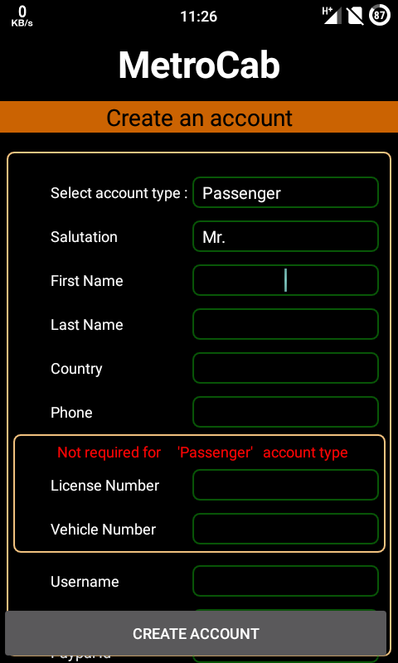

Fig . Registration UI

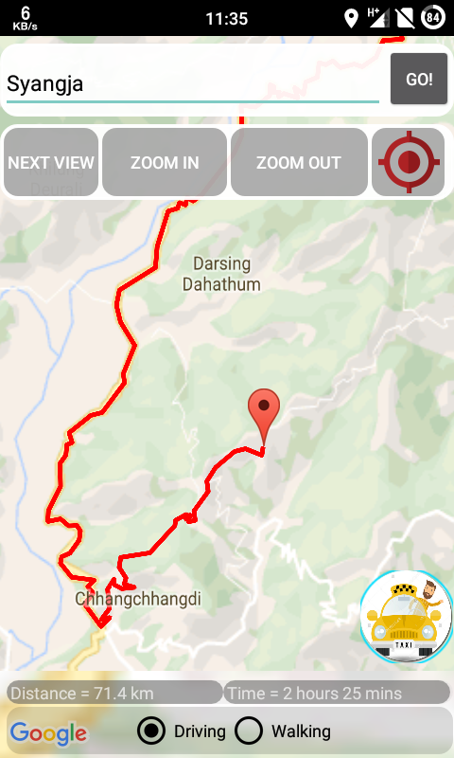

Fig . Route Generation

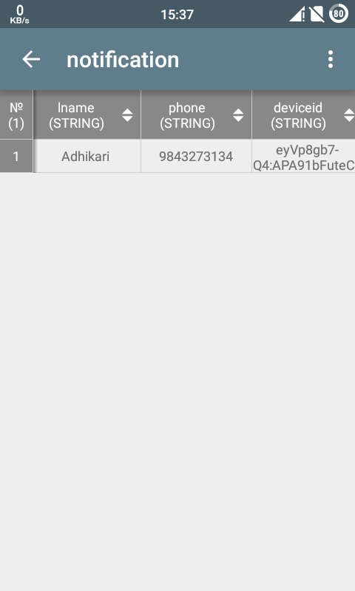

Fig . SQLite database

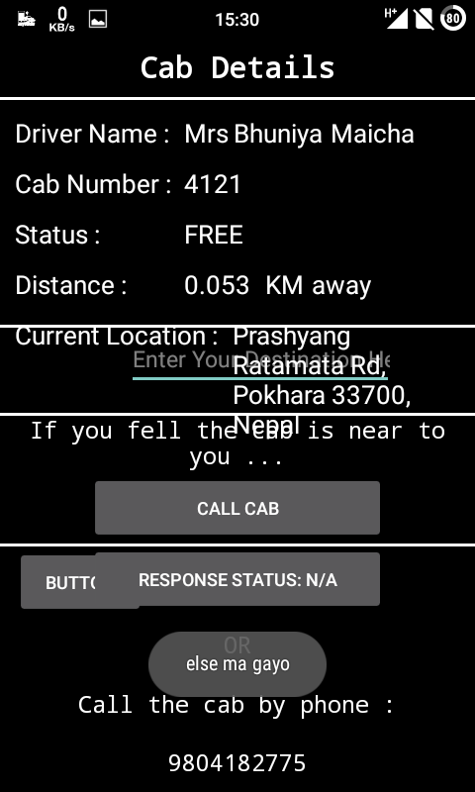

Fig . Call Activity

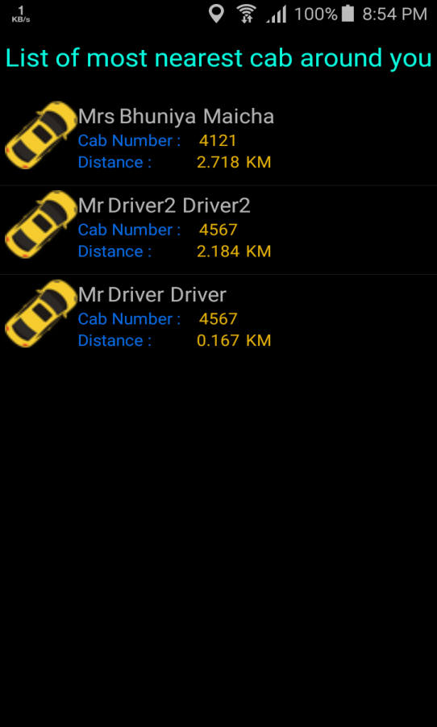

Fig . Available Drivers list

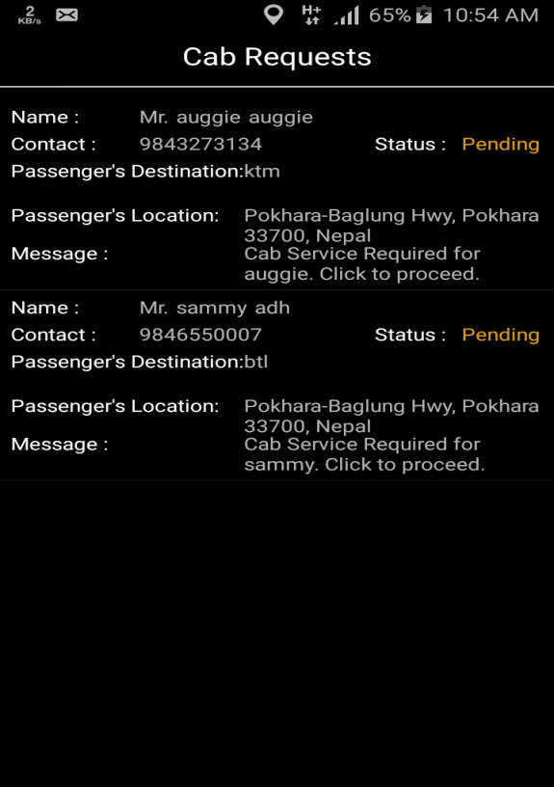

Fig . Passenger Requests List

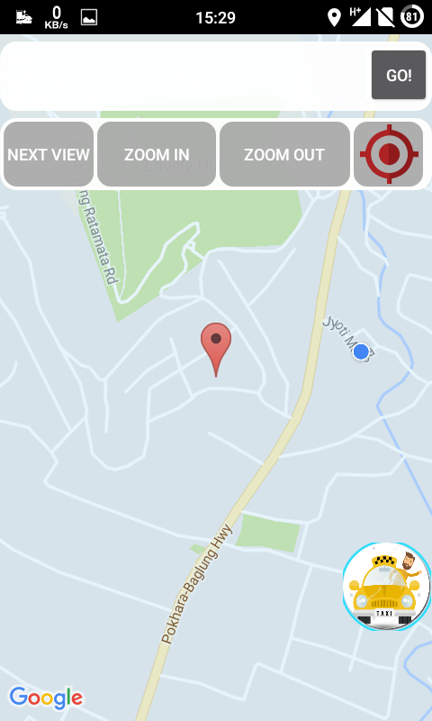

Fig . Passenger Home Activity

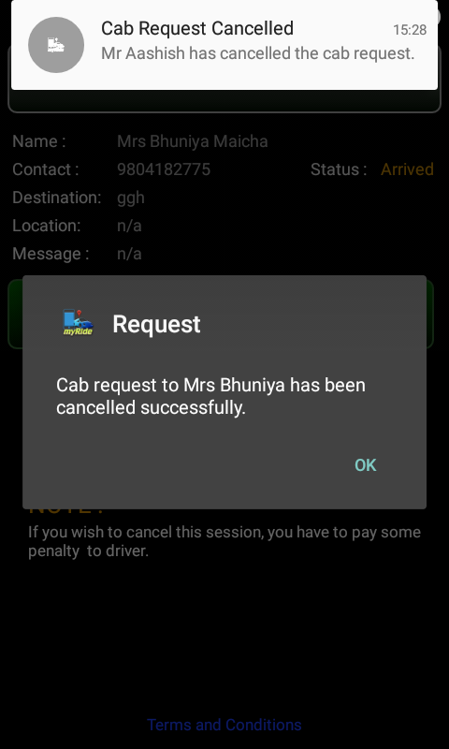

Fig . Session cancellation

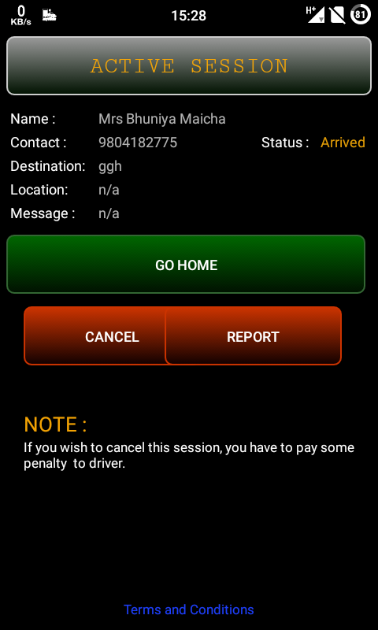

Fig . Active Session of Passenger

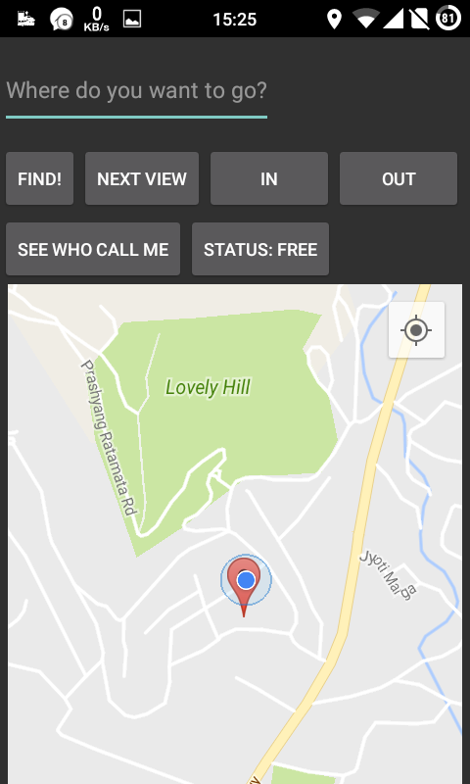

Fig . Driver Home Activity

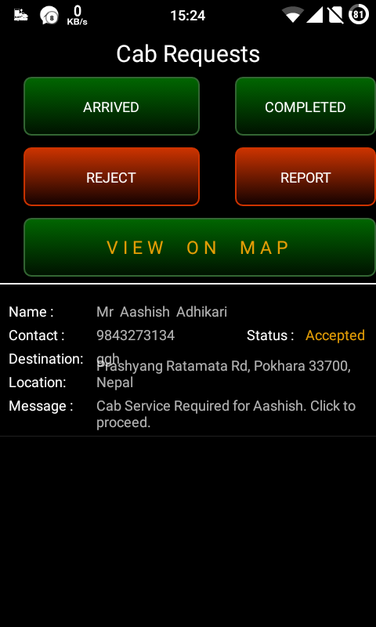

Fig . Driver Session

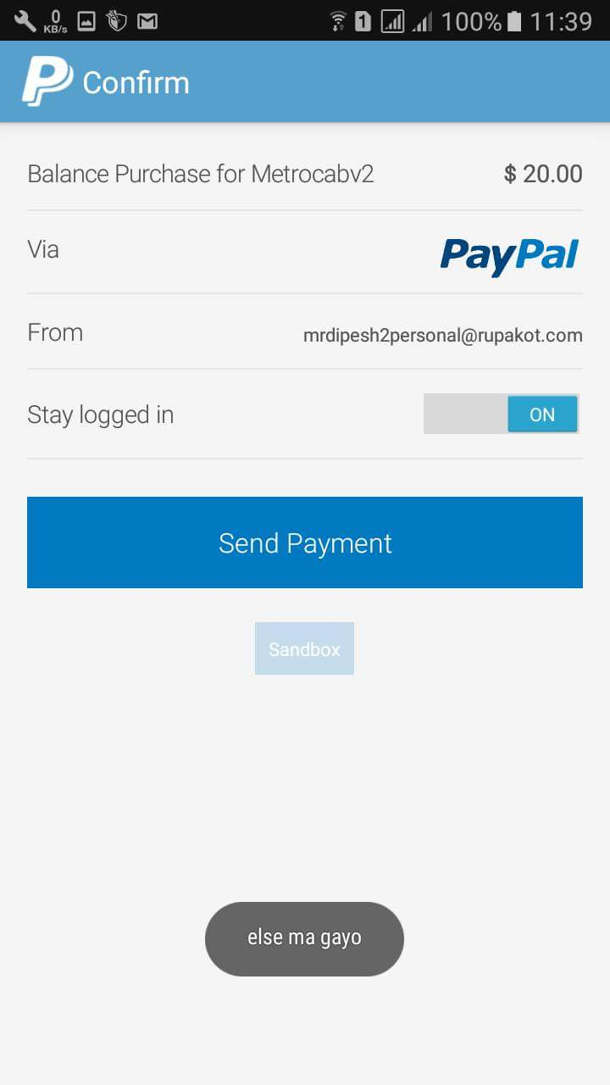

Fig . PayPal payment

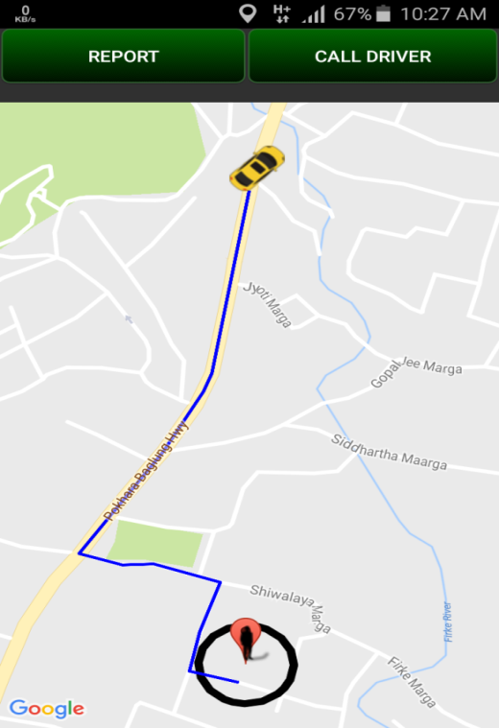

Fig . Geofencing

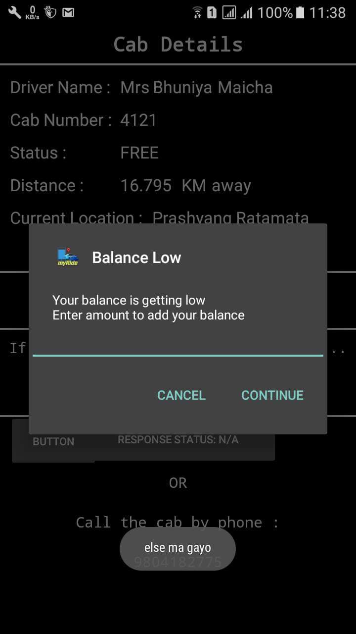

Fig . Balance Top-Up Alert

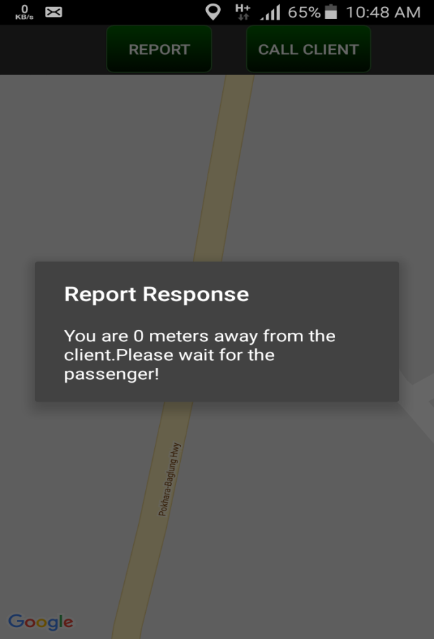

Fig . Response of Driver’s Report

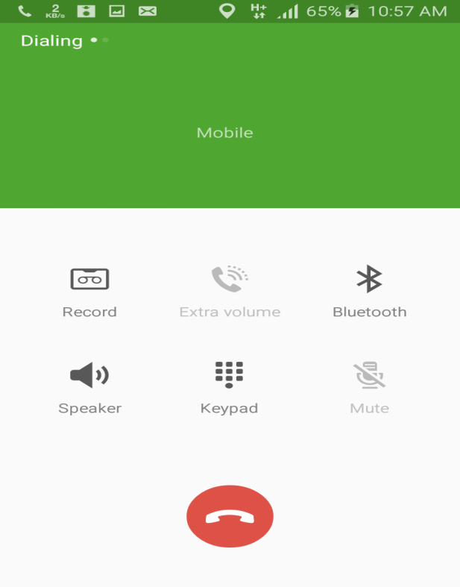

Fig . Call to the Driver

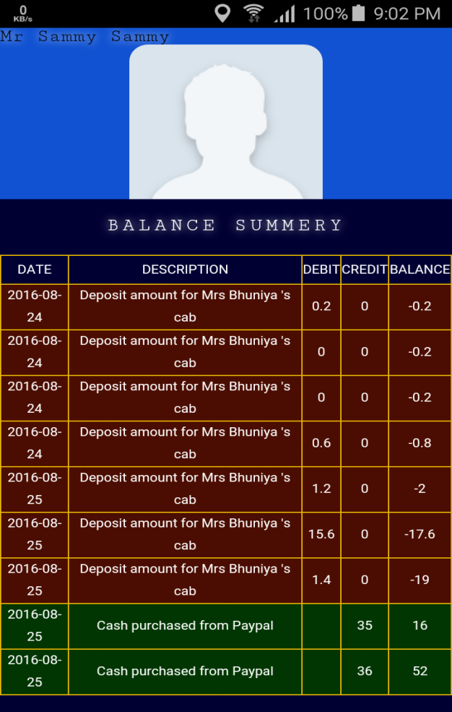

Fig . Web-View of User’s transaction history

**CHAPTER FIVE**

**EPILOGUE**

**5.1 TESTING**

Unit test cases and integrated test cases were tested and verified in the testing phases of the Spiral model of development.

|  |  |  |  |  |  |
| --- | --- | --- | --- | --- | --- |
| SN | Test Case Scenario ID | Test Case Description | Steps to Follow | Expected Result | Obtained Results |
| 1 | TS1.1 | Username and password match | Click login | Forwarded to Home Page | Forwarded to home page |
| 2 | TS2.1 | Destination Route Search | Click Search | Route generation | Route generated upto destination |
| 3 | TS2.2 | Destination Route mode change | Click desired mode | New route generation | New route generated |
| 4 | TS3.1 | Send Request to free driver | Click Send Request | Alert dialog stating request sent to driver | Alert dialog stating request sent to driver |
| 5 | TS3.2 | View Driver on Map | Click View on Map | Display driver location on map with route to comme from | Driver displayed on map with the route |
| 6 | TS3.3 | Call Driver | Click Call | Make a call to driver automatically | Call made to the driver |
| 7 | TS3.4 | Report Driver | Click Report | Get report response from server | Report response obtained |
| 8 | TS3.5 | Transfer Fare | Click Transfer | Deduct passenger balance and transfer to the driver | Passenger balance deducted and transferred to the driver |
| 9 | TS3.6 | Cancel Session | Click Cancel Session | Deduct balance from passenger and transfer to the driver ,cancel session, set driver FREE | Balance transferred to the driver, session cancelled, driver set FREE |
| 10 | TS4.1 | Driver checks Request | Click Check Request | Display request list | Request list displayed |
| 11 | TS4.2 | Reject request | Click Reject | Notify the client | Client notified |
| 12 | TS4.3 | Accept Request | Click Accept | Notify the client, set status of driver BUSY | Client notified, driver set BUSY |
| 13 | TS4.4 | Arrive to the passenger location | Click Arrived | Notify the client | Client notified |
| 14 | TS4.5 | Arrive to destination | Click Completed | Notify the client | Client notified |
| 15 | TS4.6 | Report passenger | Click Report | Get response from server | Response obtained |
| 16 | TS4.7 | Call client | Click Call | Make a call to the client | Call made to the client |

**5.2 RESULT**

Each and every step performed in this project has its own importance and values. What we learnt the most from this project is the practical implementations of different programming languages alongside the newest technologies on the market to develop a complete, independent and one-of-its-type system capable of performing certain desired functions. Although complete knowledge of one type of project cannot guarantee a total application to other areas, but it certainly broadens he area of knowledge.

After completing the project, the following are the results obtained.

* A complete and independent navigation system was developed.
* A complete cab –request service was developed.
* Application of online transaction was realized.
* Knowledge on application of cloud messaging was gained.
* Implementation of programming languages on a larger scale was realized.

**5.3 SCOPE**

This project has a wide range of applications in the field of navigation and transport. If the idea of the project, if not the project itself, is used in Nepal, the transportation sector is to flourish in the coming days. This can also be a milestone for the use of online transactions in Nepal. The scope can be listed out as below:

* Navigation applications
* Route generation
* Distance and time calculation for travel
* Cab services
* Online transactions and thus e-commerce
* Internet Messaging

**5.4 PROBLEMS FACED AND SOLUTIONS**

The process of designing the proposed system witnessed several hurdles. Despite successful development of the proposed system with the help of different technologies available, the implementation was never that easy. While performing the project, we came to that implementing the theoretical knowledge into practical use is not as easy as it sounds. Apart from that, several non-functional problems came into account.

* The very first problem faced was the not-so-uncommon problem in Nepal, loadshedding. Easiest solution was to hop between project partner’s house but this seem impractical with time and solar panels had to be install in the house for an uninterrupted power supply 24*7.
* The number of requests for travelling routes that can be made to Google server cannot exceed 25000 per day for the developer usage. This caused serious problem since we couldn’t continue with the project for the whole day when the limit count was reached and this was a major reason for time loss during the project development.
* Google Cloud Messaging although available for free, was sometimes unreliable and sent delayed and accumulated notifications at once. There was no replacement for this service since the Firebase Cloud Messaging also inherited the GCM.
* Testing and debugging of the application required multiple android devices which weren’t available all the time. Phones were burrowed from friends at times for testing and debugging.
* Running the application in lower versions of Android wasn’t possible and the devices had to be rooted to do so. A mobile phone was bricked in the process .

**5.5 LIMITATIONS**

Having limitations in the project is an unavoidable situation. All the effort required was applied to get the best of results. Since the project was completed in a limited timeframe and budget, further flexibility in the factors could have led to a more advanced system. However, it is to note that the developed application has met all the objectives specified. The following limitations couldn’t be avoided.

* This application works for devices running Android Lollypop 5.0 or higher so as to support different features that are available from Android 5.0 and onwards.
* Although the navigation system works fine even without the internet, the call requests cannot be made without an internet connection.
* If the user device is under some barrier and not under the open sky, the accuracy might vary by a small amount because of poor Google infrastructures in Nepal.
* Estimated Time of Arrival (ETA) is based on a variety of data sets, and may vary with each trip request. These data range from official speed limits and recommended speeds, likely speeds derived from road types, historical average speed data over certain time periods (sometimes just averages, sometimes at particular times of day), actual travel times from previous users, and real-time traffic information. In the context of Nepal, the traffic information is not the primary source for ETA since the infrastructure required for such applications isn’t available in Nepal. Thus, a traffic jam spanning a long duration cannot be addressed by the application in case of a report from one of the users of the session. However, the best prediction is used for ETA.
* Navigation services aren’t useful in remote places like upper Dolpa where there are no roads.

**5.6 FURTHER ENHANCEMENTS**

The following enhancements are possible only if further time is allocated for the project.

* Driver rating and recommendation system can be added .
* Firebase Cloud Messaging (FCM) can be used instead of GCM. However, it is to note that GCM isn’t in any way inferior to FCM.
* A simple modification in the project can then be used for public buses with the help of which public can know the current position of the bus as well as the arrival time.

**5.7 CONCLUSION**

Our early prediction was that it is applicable to use navigation system and cab request service even in a country like Nepal where Google infrastructures are poor. We also thought of implementing online transaction despite many claiming that it is impossible to implement online transaction in the lack of gateways in Nepal. We always stood positive about the project implementation and tried all the appropriate methodologies to achieve the objectives. We firmly believe that the tests that we did went smoothly and had no problems except for the fact that once in a day or two ,Google server failed to reply with correct results even for correct queries one . Therefore we had to handle errors in such situations. project came to an end in the estimated time

An interesting future enhancement might involve including a recommendation system and modifications to be practical for bus services as well. Slight modifications in the project show its flexibility and reusability for various applications like e-commerce and cloud messaging. Hence, the project itself is a foundation for more complex applications to come.

.

**5.8 REFERENCES**

* + Horstmann, Cay S., and Gary Cornell*. Core Java*. Harlow: Prentice Hall, 2012. Print.
  + Tamada, Ravi. "Android Integrating PayPal Using PHP, MySQL - Part 1."*Androidhive*. N.p., 24 Feb. 2015. Web. 21 Oct. 2016. <http://www.androidhive.info/2015/02/android-integrating-paypal-using-php-mysql-part-1/>.
  + Chafkin, Max.. "What Makes Uber Run." *Fast Company*. N.p., 08 Dec. 2015. Web. 21 Oct. 2016. <https://www.fastcompany.com/3050250/what-makes-uber-run>.
  + Lars Vogel (c) 2009, 2016 Vogella GmbH. "Quick Links." *Google Maps Android API V2*. N.p., n.d. Web. 21 Oct. 2016. <http://www.vogella.com/tutorials/AndroidGoogleMaps/article.html>.
  + "JSON - Introduction." *JSON Introduction*. N.p., n.d. Web. 21 Oct. 2016. <http://www.w3schools.com/js/js_json_intro.asp>.
  + "Creating and Monitoring Geofences." *Android Developers*. N.p., n.d. Web. 21 Oct. 2016. <https://developer.android.com/training/location/geofencing.html>.
  + "Google Cloud Messaging: Overview | Cloud Messaging | Google Developers." *Google Developers*. N.p., n.d. Web. 21 Oct. 2016. <https://developers.google.com/cloud-messaging/gcm>.
  + “Spiral Model-What is SDLC Spiral Model?” *Software Testing Help*. N.p.,17 Mar.2016.Web.23.Oct.2016.<http://www.softwaretestinghelp.com/spiral-model-what-is-sdlc-spiral-model/>
  + @Oshyn_Inc. "A Summary of Scaling Options for MySQL." *www.oshyn.com*. N.p., n.d. Web. 23 Oct. 2016. <http://www.oshyn.com/Blogs/2011/November/A-Summary-of-Scaling-Options-for-MySQL?page=NaN>.
  + "Company Information | Uber Newsroom." *Uber Newsroom*. N.p., 2016. Web. 23 Oct. 2016.