**Assignment 1:**

You have received the below mail from your CEO and you have to respond to that mail.

Hi,

So far, we have been thinking about customer value based solely on their first session conversion and revenue. But it might be possible that we have repeated customers and they might be of great value to us. In such a case, we might spend a bit more to acquire them.

Can you pull data from our database on how many of our website visitors come back for another session? 2014 to the date is good

Cheers!

From CEO,

Date: 1st November 2014

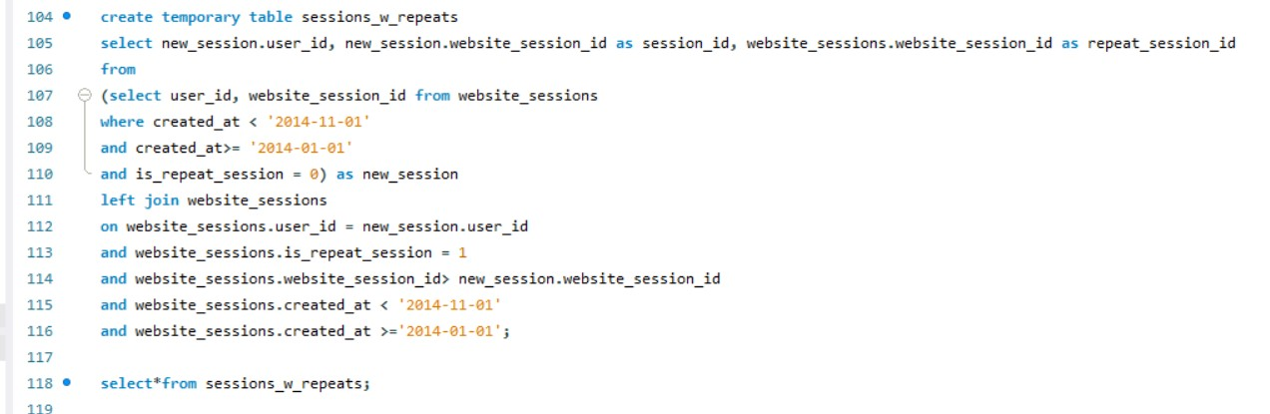

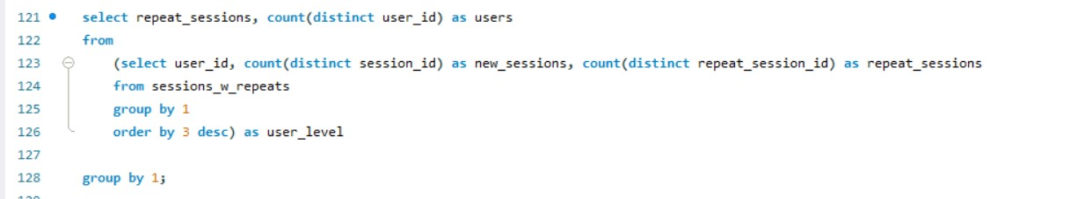

**Assignment 2:**

The result that you gave in assignment 1 should excite everyone.

We are trying to now understand the behaviour of these repeat customers.

Please help me in understanding the minimum, maximum, average time between the first and second session for customers when do they come back?

Consider time period form 2014 to this date.

From EA - CEO,

Date: 3rd November 2014

Solution:

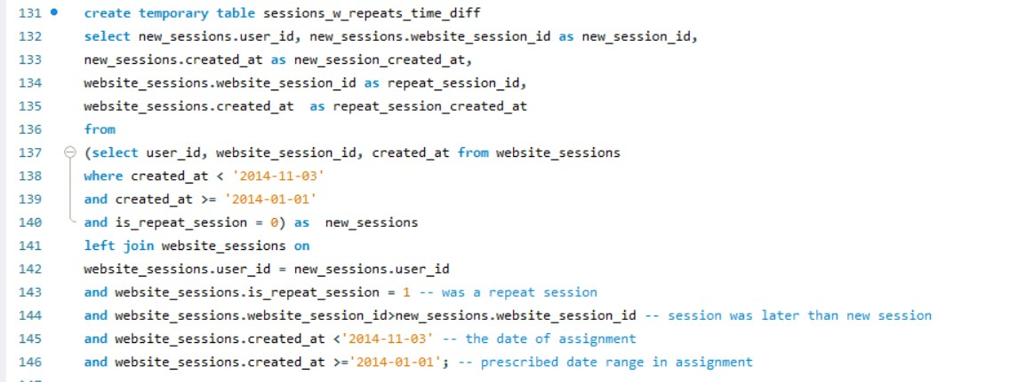

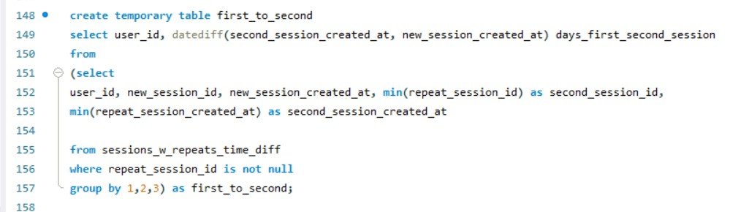

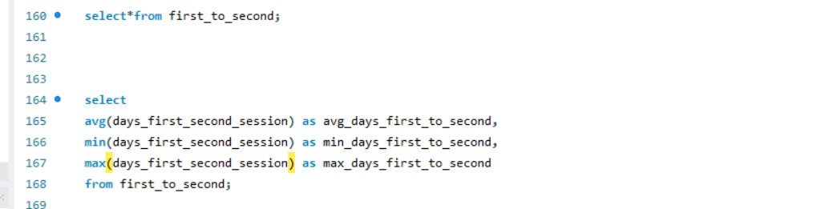

**Assignment 3:**

Hey,

Can you also help me in understanding the channels they come back through? We want to know if we are paying for these customers with paid search ads multiple times.

You can compare new vs repeat sessions by channel would be of great value. Time period: 2014 to this date.

From Marketing Director,

Date: 5th Nov 2014

Solution :

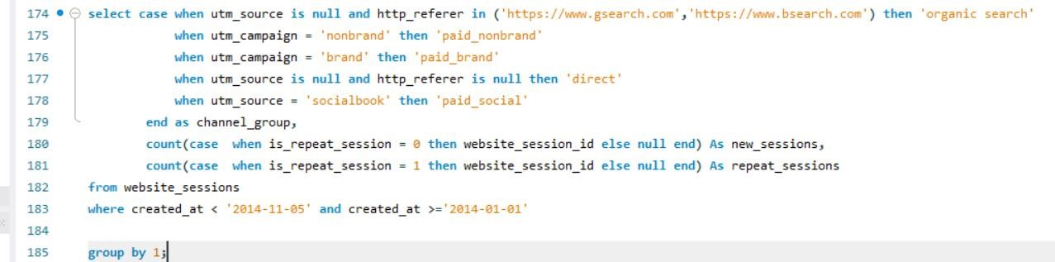

**Assignment 4**

Hi There,

Please do comparison of conversion rates and revenue per session for repeat session vs new sessions. Time period 2014 to this date.

From Marketing Director

Date: 8th Nov 2014

Solution:

