Speed up React-Apps

Refrence -> [Speed Up Your React Apps With Code Splitting](https://youtu.be/JU6sl_yyZqs)

1. Importing when needed instead of top

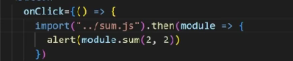

1. Use React.lazy so the component will downloaded in source folder in chrome

When we click on home

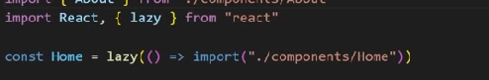

1. Another way of lazy [specially when we don’t have default export]

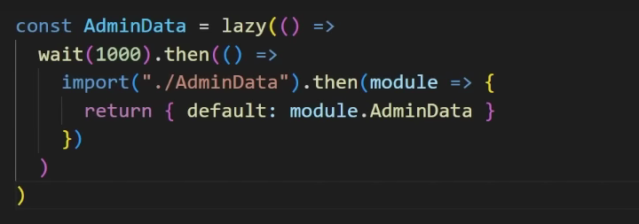

1. For (3) part we can export default function for lazy

