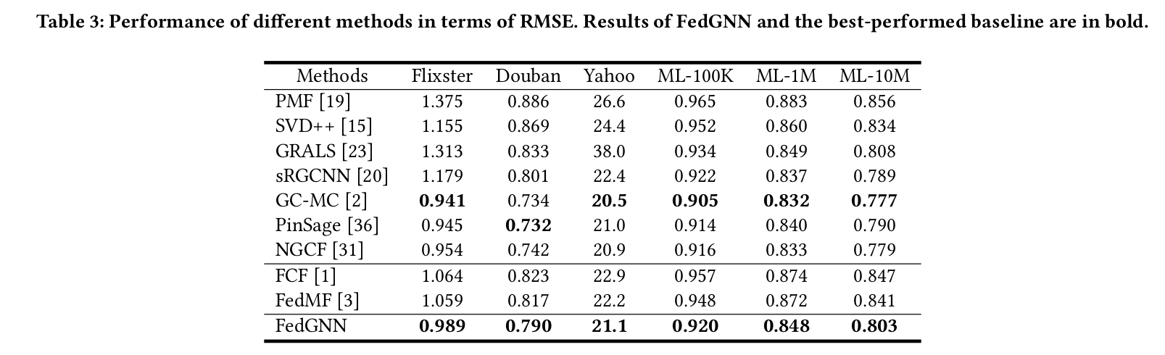

Training Loss

Epochs: 3

Rounds: 30

Optimizer: Adam

Learning Rate: 0.01

Averaging: weighted

