Name – Yogesh Mohan Lale

PRN NO – 12211532

Roll. No. : 32

Tut Assignment NO – 2

Using the code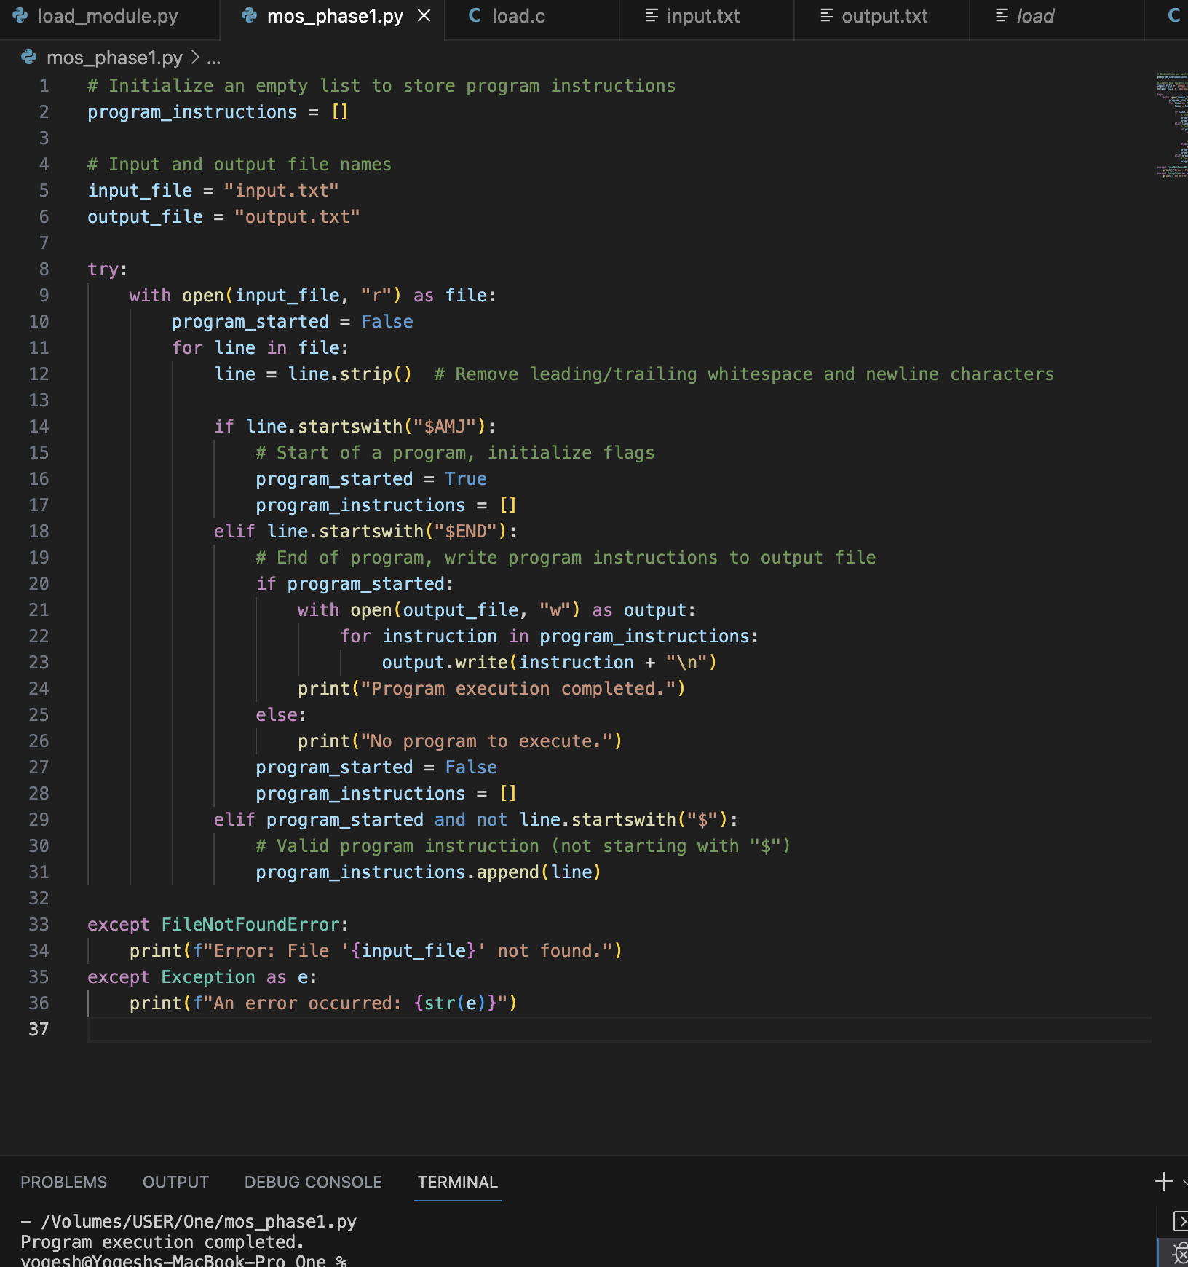

For the input file

Output file is

