**Web Scrapping for CS Supervisors:**

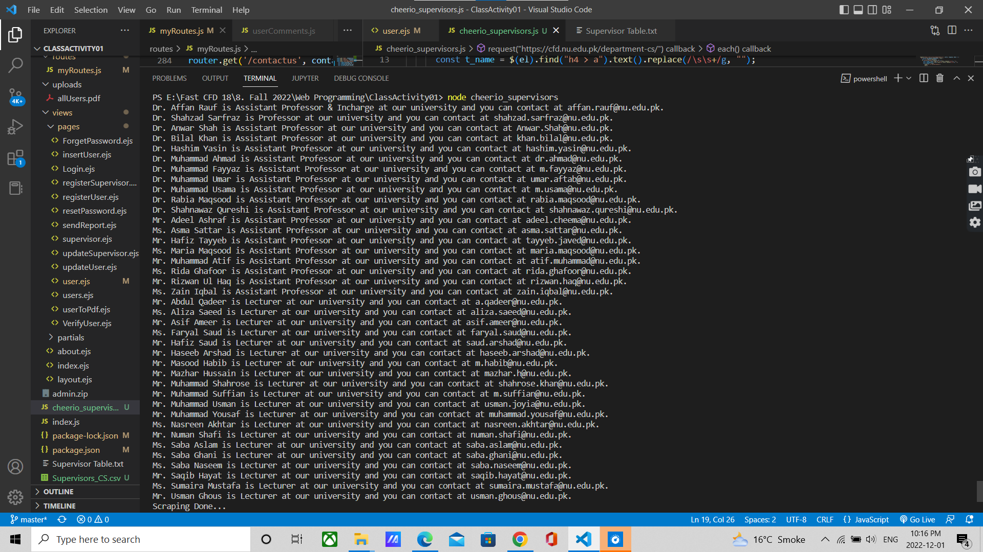

**Load Test on localhost:3000/users**

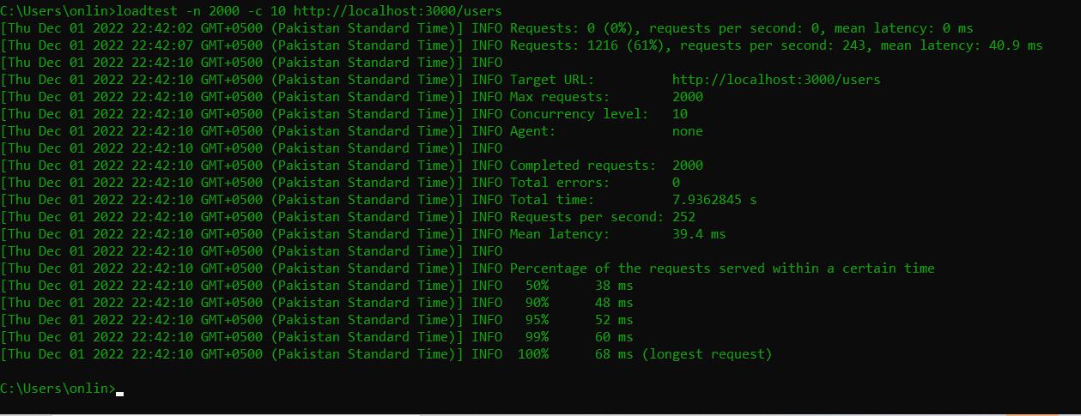

Unit Testing

