Being Home Foods
App UX & Feature Improvement Report
March 2026 · Covers UI Issues, New Features & Visual Mockups
Legend: 🔴 Critical Fix | 🔵 New Feature | 🟢 Enhancement

1. Top 5 Immediate Priorities
Resolve these before adding any new features — they directly impact user trust and core usability.

- Remove the duplicate Nutrition section on the recipe detail page
- 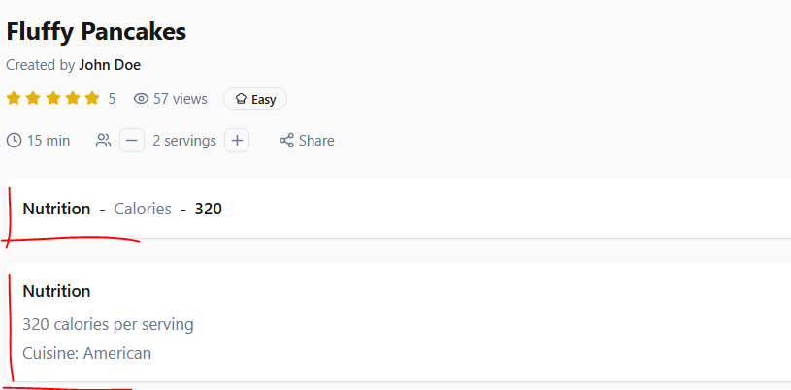
- Replace the Social Media feed on homepage with cuisine category filters 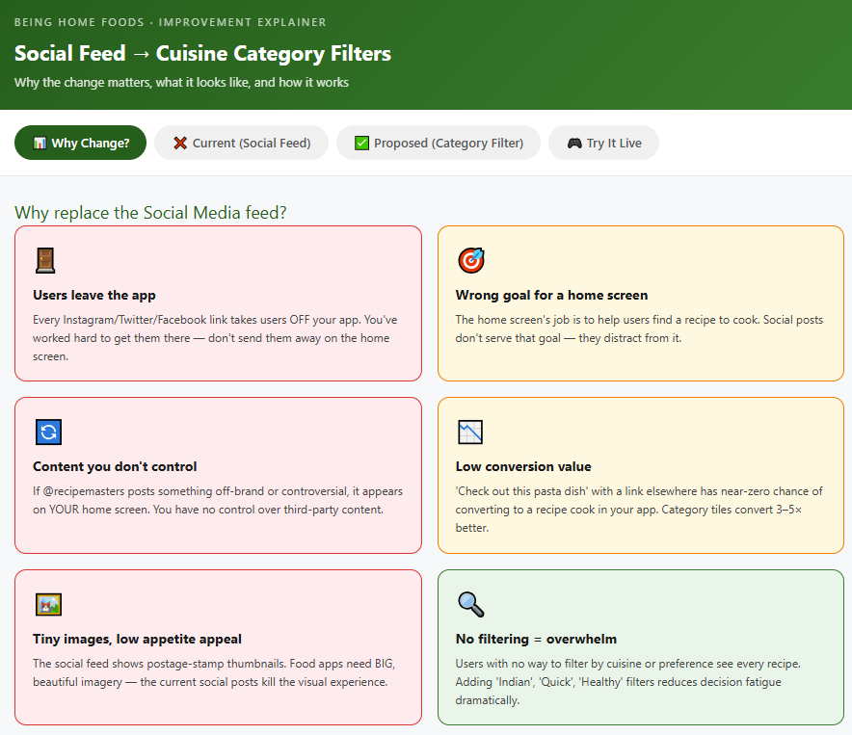
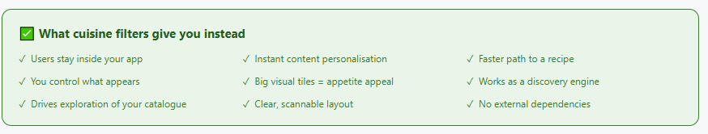

2. Home Screen Issues

2.1 Missing Hero Section & Branding
The current home screen opens with a bare search bar and no visual context. There is no app name visible — just an icon logo. The page needs a warm, inviting hero section with the brand name and a featured recipe.

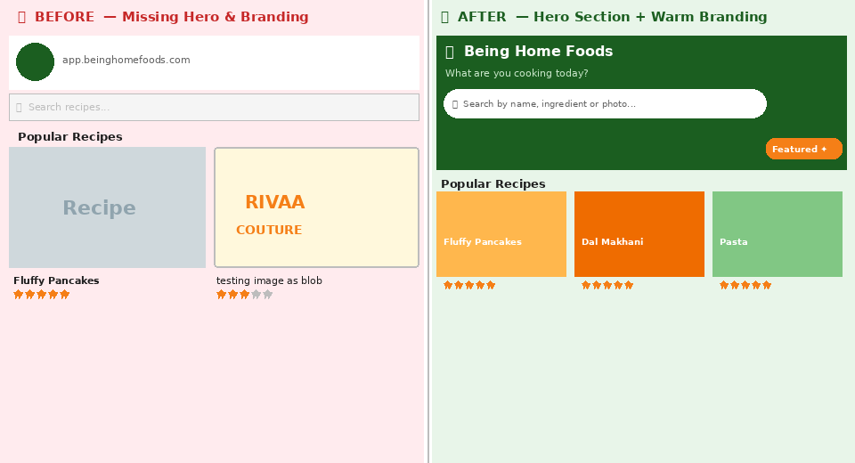
Fig 1 — Before: bare header with no hero | After: branded hero with featured recipe
- 🔴 Add 'Being Home Foods' wordmark beside the logo in the header
- 🔴 Add a hero banner with featured recipe, warm imagery and a search prompt
- Use warm, appetite-triggering tones (cream, amber, warm green) rather than cold grey

2.2 Missing & Broken Recipe Images
Recipe cards currently show grey placeholders or unrelated content (a fashion brand logo appeared in testing). This is a critical trust issue — food apps live and die by visuals.

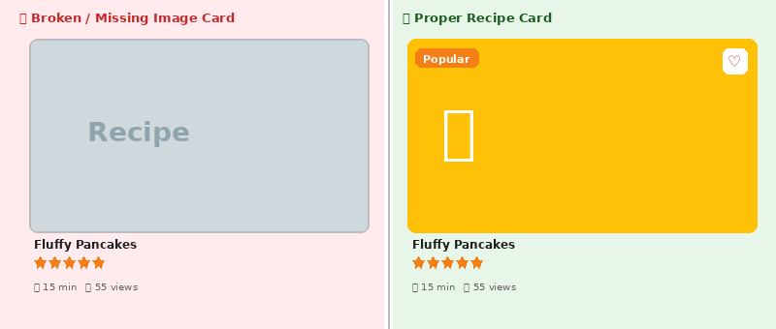
Fig 2 — Broken placeholder vs properly displayed recipe card with image
- 🔴 Make photo upload mandatory when creating a recipe
- 🔴 Assign a cuisine-based default image if no photo is uploaded
- 🔴 Add server-side validation to reject non-food or malformed image uploads
- Reject files that are not jpeg/png, or that fail content validation

3. Social Media Section
Recommendation: Remove or relocate the social feed from the homepage — it pulls users away from your own content and competes with your recipe listings.

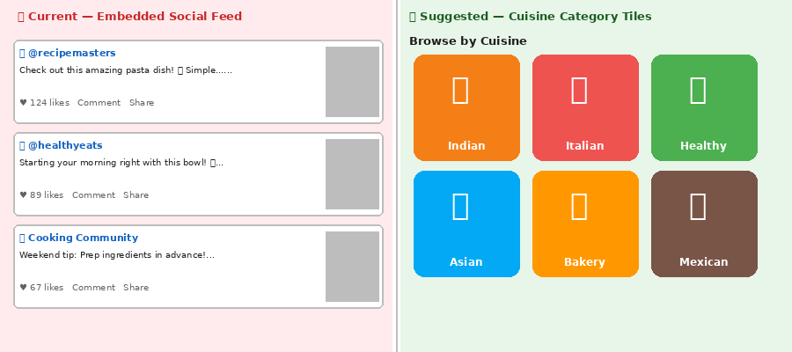
Fig 3 — Current social feed vs suggested cuisine category tiles
- 🔴 The embedded Twitter/Instagram/Facebook feed displaces recipe content on the homepage
- 🔴 Thumbnail images in the feed are too small to be visually enticing
- 🔴 'Follow / Follow / Like' buttons are confusing with identical styling
- Rename clearly: 'Follow on Instagram', 'Follow on X', 'Like on Facebook'
- 🔵 Replace with cuisine category tiles or a 'Trending this Week' recipe section

4. Recipe Detail Page
The recipe detail page has several critical issues: a missing hero photo, a broken floating video overlay, duplicate nutrition info, a table-style ingredients list, and — most critically — no cooking instructions at all.

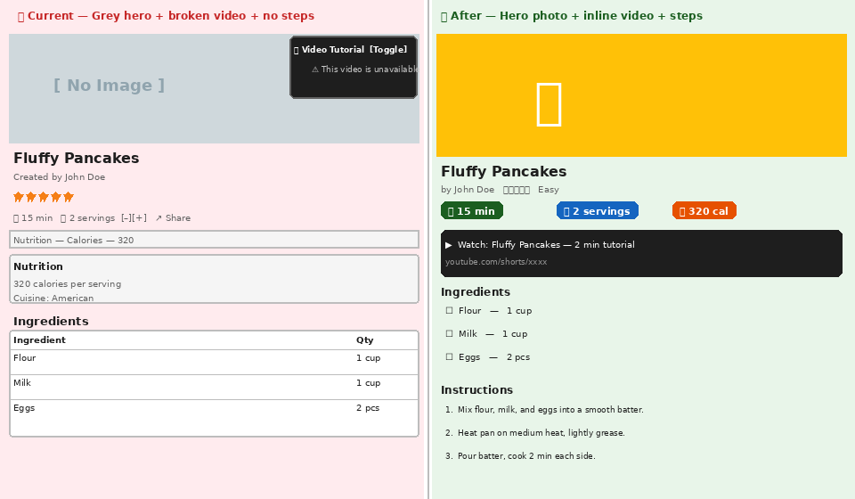
Fig 4 — Current detail page problems vs improved layout with hero, inline video, checklist & steps

4.1 Missing Hero Food Photo
- 🔴 The top section of the recipe page is an empty grey box — the most important visual moment is blank
- Display the recipe image as a full-width hero at the very top of the detail page

4.2 Broken Video Tutorial Overlay
- 🔴 Video panel shows 'This video is unavailable' as a floating overlay in the top-right corner
- Completely hide the video panel when no valid video is linked — never show error states
- When a valid video exists, embed it inline below the recipe header, not as a floating overlay

4.3 Duplicate Nutrition Section
- 🔴 Nutrition info appears twice: once as an inline 'Nutrition — Calories — 320' row and again as a full card below
- Remove the redundant inline row; keep only the expanded Nutrition card
- Add more nutrition detail: protein, carbs, fat, fibre — not just calories

4.4 Ingredients — Table vs Checklist
- 🔴 Ingredients displayed as a formal spreadsheet table (Ingredient | Quantity) is hard to follow while cooking
- Replace with a bulleted checklist: '☐ 1 cup Flour' with tap-to-check functionality
- Users can check off ingredients as they prep — a high-value cooking UX improvement

4.5 Missing Cooking Instructions
- 🔴 There are no cooking steps on the recipe detail page — this is the core function of a recipe app
- Add a numbered 'Instructions' section below the Ingredients
- Implement Cook Mode: full-screen, large text, screen stays on, one step at a time

5. Cook Mode — Step-by-Step View
Cook Mode is the most-requested feature across all recipe apps. It transforms the recipe into a distraction-free, full-screen experience with the screen kept awake — ideal for following along in the kitchen.

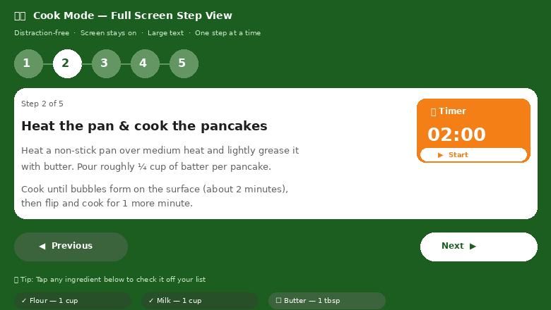
Fig 5 — Cook Mode mockup: full-screen, step indicator, inline timer, ingredient checklist
- 🔵 Show one instruction step at a time in large, readable text
- 🔵 Keep screen awake while Cook Mode is active
- 🔵 Add inline countdown timers for steps that mention time ('Cook for 2 minutes' → tappable timer)
- 🔵 Display ingredient checklist at the bottom — tap to check off items
- 🔵 Previous / Next navigation to move between steps

6. 'Start Cooking' Button — Remove or Repurpose
Question raised: What does the 'Start Cooking' button actually do? If it only scrolls to instructions that are already visible, it adds no value.

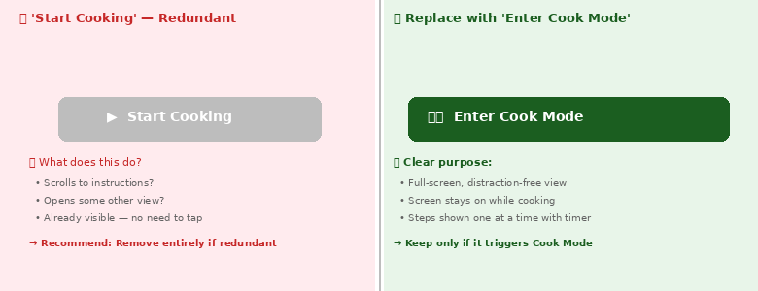
Fig 6 — Vague 'Start Cooking' button vs purposeful 'Enter Cook Mode' CTA
- 🔴 If the button only scrolls the page — remove it entirely, it is redundant
- 🔴 If it launches a dedicated Cook Mode view, keep it but rename clearly: 'Enter Cook Mode'
- Add a chef-hat icon and brief description: 'Step-by-step, screen stays on'
- Position it prominently below the ingredient list as a clear call-to-action

7. Buttons, Icons & Navigation Redesign

7.1 Bottom Navigation — Repositioning Icons
The current bottom nav has 'K-Bank' — a cryptic label that no user will understand without exploring. Search is also buried in the top search bar rather than accessible from the nav.

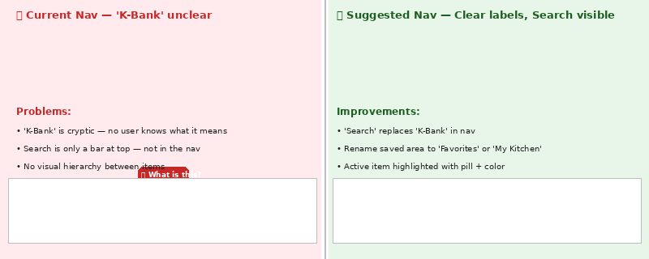
Fig 7 — Current nav with unclear 'K-Bank' vs redesigned nav with Search and clear labels
- 🔴 Rename 'K-Bank' to something intuitive: 'Saved', 'My Kitchen', or 'Collections'
- 🔴 Add a 'Search' tab to the nav bar — it is a primary action and must be persistent
- 🔴 Recommended nav order (left to right): Home | Recipes | Search | Favorites | Profile
- This mirrors patterns from leading apps: Allrecipes, Samsung Food, Kitchen Stories

7.2 Floating Action Buttons
- 🔴 The yellow '+' FAB overlaps recipe content — reposition to bottom-right with safe spacing
- 🔴 The dark green floating button icon is unclear — users don't know what it does
- Add a tooltip label on hover/long-press, or replace with a labelled button
- Consider merging both into a single expandable FAB with labelled sub-actions

8. New Features

8.1 Search by Ingredients
Let users enter ingredients they have at home and discover matching recipes. This is one of the highest-requested features in food apps and directly reduces food waste.

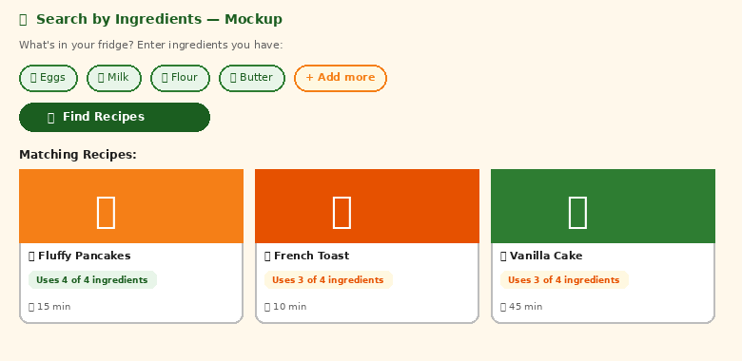
Fig 8 — Search by Ingredients: chip-based input, match scoring, and recipe results
- 🔵 User types or taps ingredients they have — app returns ranked matching recipes
- 🔵 Show match score: 'Uses 4 of 4 ingredients' vs 'Uses 3 of 4'
- 🔵 Add a 'What can I cook?' shortcut on the home screen hero section
- Start with pantry staples (salt, oil, eggs, flour) pre-selected for faster results

8.2 Search by Photo
Allow users to photograph a dish — in a restaurant, from social media, or a magazine — and find matching recipes using image recognition.

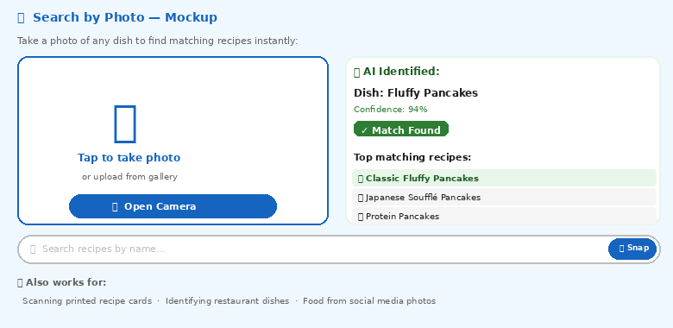
Fig 9 — Search by Photo: camera capture, AI dish identification, recipe matches
- 🔵 Add a camera icon inside the search bar as an alternate input method
- 🔵 Use vision AI to identify the dish and return the closest matching recipes
- 🔵 Also enables scanning printed recipe cards to digitise them automatically
- Works for: restaurant dishes, social media food photos, family recipe cards

8.3 Weekly Meal Planner
A drag-and-drop weekly calendar where users assign recipes to specific days and meals. The planner auto-generates a combined shopping list from all planned recipes.

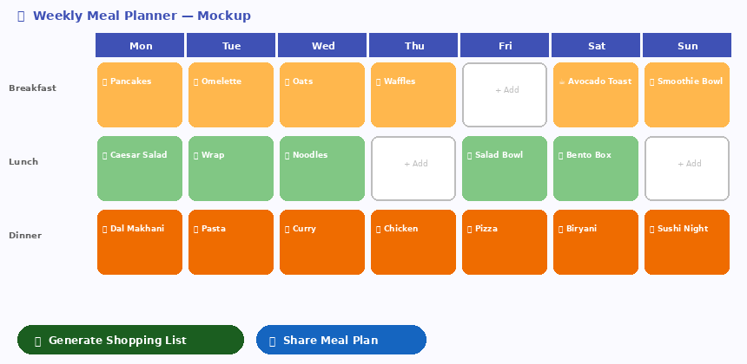
Fig 10 — Weekly Meal Planner: drag-drop calendar with breakfast/lunch/dinner slots
- 🔵 Drag recipes from your saved list onto Breakfast, Lunch, or Dinner slots
- 🔵 Auto-generate a combined, aisle-sorted shopping list from the full week
- 🔵 Share the meal plan with family members or send as a weekly email digest
- Duplicate ingredient quantities are merged automatically (e.g. 3 × 'eggs' = 6 eggs)

8.4 Recipe Translation
Translate recipes to the user's preferred language with a single tap. Auto-detect device language on first load and offer translation automatically.

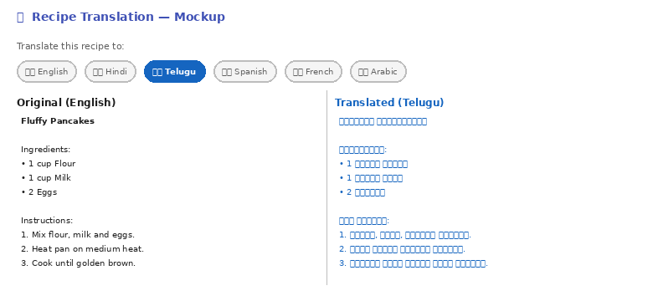
Fig 11 — Translation mockup: language selector chips with side-by-side English/Telugu view
- 🔵 Add a Translate button on every recipe detail page
- 🔵 Support: English, Hindi, Telugu, Tamil, Spanish, French, Arabic as priority languages
- 🔵 Translate ingredient names and convert units to local standards (cups → ml)
- Auto-detect device language and offer translation on first visit

8.5 YouTube Shorts Integration
Embed short-form cooking videos alongside recipes, and add a vertical discovery feed to the home screen. This significantly increases engagement and time-in-app.

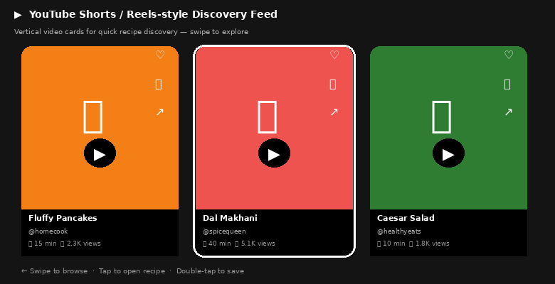
Fig 12 — YouTube Shorts feed: vertical video cards, swipe discovery, like/save actions
- 🔵 Creators can attach a YouTube Shorts URL when submitting a recipe
- 🔵 Video appears inline on the recipe detail page — replacing the current broken overlay
- 🔵 Add a vertical Shorts-style discovery feed on the home screen for exploration
- Swipe through 60-second recipe previews — tap to open full recipe
- Double-tap to save recipe to Favorites directly from the video feed

9. Visual Design & Global UX
- 🔴 Color palette is clean but lacks warmth — add cream, terracotta, warm green tones to evoke appetite
- 🔵 Add dark mode support — a baseline expectation for modern apps
- 🔴 Design empty states with friendly prompts: 'No favorites yet — start exploring recipes!'
- 🔴 Fix page load performance — skeleton loading states instead of blank white screens
- 🔵 Add 3–4 screen onboarding flow for new users showing key features

Move K-Bank to info section. Rename to Knowledge bank.
Profile section moves to info section.
Add WTC button in place of K-bank and Profile, it should be double size of other buttons at center of screen.

10. Summary of All Issues & Recommendations

Issue | Recommendation | Priority
Missing food photos | Require upload; add cuisine fallback images | 🔴 Critical
Broken image uploads | Validate file type and content on upload | 🔴 Critical
No cooking instructions | Add numbered steps + Cook Mode | 🔴 Critical
Duplicate nutrition info | Remove inline duplicate; keep full card | 🔴 Critical
Broken video overlay | Hide when no valid video; embed inline | 🔴 Critical
No hero/banner section | Add featured recipe hero with warm imagery | 🔴 Critical
Social media feed on homepage | Remove; add category/cuisine tiles | 🔴 Critical
'K-Bank' label unclear | Rename to 'Saved' or 'My Kitchen' | 🔴 Critical
'Start Cooking' button unclear | Remove if redundant; keep as Cook Mode only | 🔴 Critical
Floating buttons unclear | Add tooltips; consolidate into one FAB | 🔴 Critical
No app name visible | Show 'Being Home Foods' wordmark in header | 🔴 Critical
Ingredients as a table | Switch to tap-to-check checklist format | 🔴 Critical
Search by Ingredients | 'What can I cook?' with chip-based input | 🔵 New Feature
Search by Photo | Camera icon + AI dish identification | 🔵 New Feature
Weekly Meal Planner | Drag-drop calendar + auto shopping list | 🔵 New Feature
Recipe Translation | Translate to user's language with one tap | 🔵 New Feature
YouTube Shorts | Embed per recipe + vertical discovery feed | 🔵 New Feature
Cook Mode | Full-screen step-by-step with inline timers | 🔵 New Feature
Dark Mode | System dark mode support | 🔵 New Feature
Empty/onboarding states | Friendly prompts for new/empty screens | 🟢 Enhancement
Warmer color palette | Add cream and warm greens app-wide | 🟢 Enhancement
Performance / load speed | Skeleton screens; fix timeout on load | 🔴 Critical

— End of Report —

